**Phenological Responses of the Arctic, Ubiquitous and Boreal Copepod Species**

**to the Long-Term Changes in the Annual Seasonality of the Water Temperature in the White Sea**

***Nikolay V. Usov1*, Vadim M. Khaitov2,3, Inna P. Kutcheva1, and Daria M. Martynova1*\*\***

1 *White Sea Biological Station, Zoological Institute, Russian Academy of Sciences, St.Petersburg, Russia*

2 *Saint Petersburg State University, St. Petersburg, Russia*

3 *Kandalaksha State Nature Reserve, Kandalaksha, Russia*

*Corresponding author: [nikolay.usov@gmail.com](mailto:nikolay.usov@gmail.com); tel. +7 921 9785522;

ORCID ID: https://orcid.org/0000-0001-5093-5603

** ORCID ID: https://orcid.org/0000-0001-8279-9896

# Abstract

Climate change-derived temperature rise has been proved the most intensive in the high latitudes. However, absolute temperature increase is not the only sign of changing climate, which can manifest itself also through temporal shifts of seasonal temperature dynamics, which, in turn, causes temporal shifts of phenological processes in zooplankton. Long-term shift of the timing of seasonal water warming was registered in the north-western White Sea (Chupa Inlet, Kandalaksha Bay). Beginning of hydrological spring and summer have shifted by more than 3 weeks to an earlier time. The shifts of about the same magnitude and even greater were detected in timing of phenological events of *Calanus glacialis*, *Pseudocalanus* spp., *Microsetella norvegica*, *Acartia* spp., and *Temora longicornis*. These shifts caused significant changes of only *Acartia* spp. abundance. No significant influence of year-to-year changes in species phenology on population abundance was detected. Several mechanisms of such resilience were proposed: a) synchronization of changes in zooplankton and environment seasonal dynamics; b) switching of planktonic animals to omnivory in cases of trophic mismatch; c) prolongation of phytoplankton bloom with rising spring temperature, which is favourable for cold-water spring species (*Calanus* and *Pseudocalanus*). Interspecific interactions between ubiquitous species influenced their phenology and abundance: early development of *Microsetella* caused later development of *Oithona* and higher abundance of the former.

**Key words**: zooplankton, Copepoda, White Sea, phenology, long-term changes, water temperature.

# Introduction

Recent climate change, manifested through the temperature rise, has been proved the most intensive in high latitudes, especially in the Northern Hemisphere (IPCC, 2007, 2013). High latitudes are also characterized by the pronounced seasonality of solar energy supply and, as a result, seasonality of temperature, which governs the annual cycle of the phyto- and zooplankton production. Two main factors influencing marine ecosystems can be distinguished: the temperature fluctuations and the timing of seasonal warming/cooling. Thus, one can expect that the climate change influences not only absolute values of temperature and other registered environmental parameters but also timing of different events during seasonal cycle. Populations of planktonic organisms respond rather quickly to climatic fluctuations because of short life cycles. Besides that, many planktonic organisms inhabit the upper water layer of the Ocean, which is the most sensitive to the climatic fluctuations. Indeed, climatic changes in the Arctic affect planktonic organisms significantly (Richardson, 2008; Wassmann et al., 2011). Seasonal ice retreat occurs earlier in the Arctic, which causes respective shifts of the timing of phytoplankton bloom (Ji et al., 2012). Planktonic animals respond to long-term trends and year-to-year fluctuations of environmental parameters by temporal shifts of key events in their seasonal cycles (Edwards, Richardson, 2004; Mackas et al., 2012). For example, in the North Sea more than a half of studied species shifted their developmental season to an earlier time during period 1975–2006 (Greve et al., 2004; Mackas et al., 2012). An advance of *Calanus glacialis* development by about three weeks to an earlier time during period 1961–2010 was reported for the study area earlier (Usov et al., 2013). Large year-to-year fluctuations of *Calanus finmarchicus* CI abundance peak, spanning about 2 month (!), was detected in northern Norway (Mackas et al., 2012). Timing of appearance of warm-water *Acartia tonsa* in Narragansett Bay advanced by three weeks during warm period 1972–1990 (Borkman et al., 2018). The duration of *A. tonsa* presence in the water increased from 31 to 38 weeks. Timing of the biomass maximum of *Neocalanus plumchrus* in the North-East Pacific shifted in time according to the temperature in the upper mixed layer of the ocean: it was early by about 60 days in warm years than in cold ones (Mackas et al., 1998). Each species must be synchronized normally with its food, for successful reproduction and development (Post, Forchhammer, 2008). This is especially important in Arctic, where period of rich food is very short (Falk-Petersen et al., 2009; Ji et al., 2012). Temporal shifts in seasonal cycles of environmental parameters, zooplankton and trophic objects may lead to the trophic mismatch between consumers and their food, e.g. between zoo- and phytoplankton (Edwards and Richardson, 2004; Søreide et al., 2010; Atkinson et al., 2015), because rate of phenological changes at different trophic levels may differ (Thackeray, 2012). This may negatively affect zooplankton community, which inevitably translates to the next trophic level (Edwards, Richardson, 2004; Ji et al., 2012). Planktonic organisms are indispensable component of marine trophic webs, so, any changes in phyto- and zooplankton abundance or in the timing of phenological events in plankton may lead to the changes along the entire food chain and food web. This stresses the importance of observations of quantitative and phenological changes in plankton.

In order to track the changes in communities that occur gradually over many years, it is necessary to conduct observations for a long time. An important characteristic of such observations is their continuity, since interannual fluctuations of various parameters, both biological and abiotic (environmental), are great in natural environment. In order to separate the “signal” and the “noise”, it is necessary to register the parameters of interest constantly from year to year. Due to the short life span of planktonic organisms, the frequency of sampling and measuring environmental parameters is of great importance. There are not so many time series that meet the above requirements in the world. The monitoring of the zooplankton in the White Sea performed at the White Sea Biological Station of Zoological Institute, Russian Academy of Sciences, meets most of them (COPEPOD. Interactive Time-series Explorer METABASE, 2018).

The White Sea is a semi-enclosed sub-Arctic basin, so the intensive climatic changes, observed in high latitudes of the Northern Hemisphere, influence this sea inevitably. The White Sea has pronounced continental features, which manifest themselves among other in the long cold winter (surface layer cools down to -1.5 °C) and short, relatively warm summer with surface temperature up to 20 °C (Berger et al., 2001; Filatov et al., 2005; Usov et al., 2013). The sea is covered with ice for 4–6 months (Babkov, 1982; original data). In this regard, the seasonality of all processes, both abiotic and biological, is pronounced in the White Sea. Therefore, any shifts in the timing of events during the year, as mentioned above, can lead to disruption of the links between trophic levels in the biocenosis. This, in turn, can have negative consequences for pelagic communities. Our data obtained over almost 60 years with a high sampling frequency theoretically allow us to track such changes in the seasonal course of both environmental parameters and quantitative characteristics of plankton communities.

The long-term changes of the temperature seasonal cycle in the White Sea has been reported earlier for the period of 1961–2010 (Usov et al., 2013). However, the detailed analysis of the phenology of the arctic (*Calanus glacialis*), boreal-arctic (*Pseudocalanus* spp.), boreal (*Acartia* spp., *Centropages hamatus* and *Temora longicornis*) and ubiquitous (*Oithona similis*, *Microsetella norvegica*) organisms in the coastal region of the White Sea was not performed yet. Though some preliminary analysis was done in the work, mentioned above (Usov et al., 2013).

We hypothesize that the shifts in the temperature seasonal cycle may inevitably influences seasonal cycle of planktonic organisms with different temperature preferences, which, in turn, may potentially lead to the changes in the species abundance.

# Materials and methods

***Sampling site and the period of observations***. Water temperature, water salinity, and the zooplankton abundance have been monitored in Chupa Inlet (Kandalaksha Bay, the White Sea), at the standard station D-1 (65 m depth; 66°19′50″N; 33°40′06″E) since 1961 (Fig. 1). Data from this monitoring site are recorded in the database "White Sea Hydrology and Zooplankton Time-Series: Kartesh D1" (COPEPOD. Interactive Time-series Explorer METABASE, 2018); this dataset was used as the data source in this study. The period from 1963 to 2018 was used for the data analysis, because in the first two years there existed gaps in the data for several species. Some gaps in the observations occurred also during the periods of the ice formation and melting, because of danger of working on the instable ice. However, they did not influence the analysis because we chose seasons less affected by these gaps – spring and summer – to calculate average abundances of animals. We used approximating models for calculation of phenological indices, which allowed us to deal with gaps (see below).

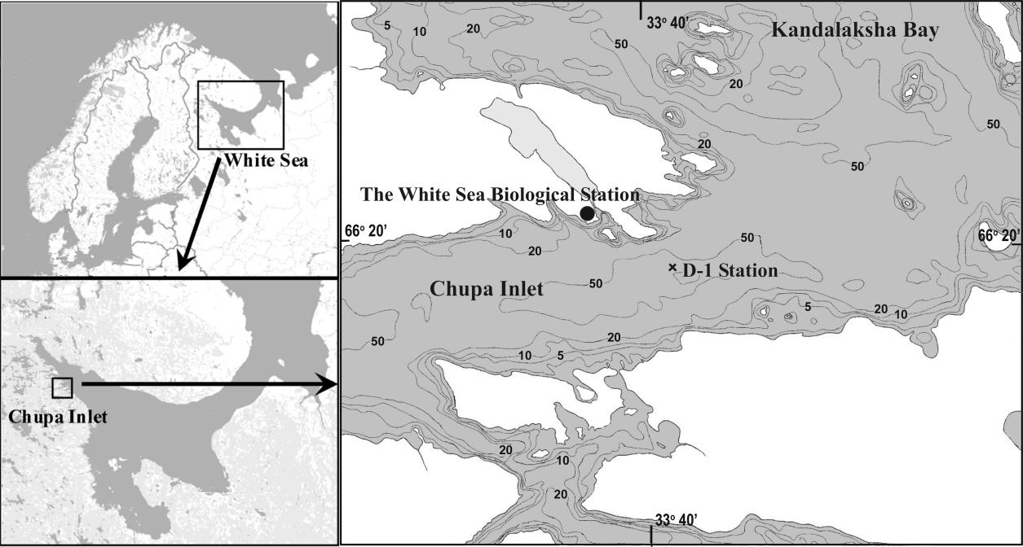

Fig. 1. Position of the ampling site (D-1 Station).

***Sampling scheme and methods***. Monitoring was conducted from research vessel during ice-free period and from the ice in winter. Zooplankton sampling was performed every ten days during the ice-free period and monthly from the ice, except for the period of 1962–1969, when the sampling was performed every ten days all the year round. The zooplankton were sampled from standard water layers (0–10 m, 10–25 m, and 25–65 m) by vertical hauls by closing Juday net (mesh size 200 μm; mouth diameter 37 cm, mouth area 0.1 m2).The samples have been immediately preserved with formaldehyde (final concentration 2–4%). In total, more than 3400 samples have been collected and processed since 1961. The sample processing was performed by the standard methods (Harris et al., 2000). Briefly, the samples were concentrated to 100-mL or 200-mL volume according to the organisms' concentration assessed visually, and three 1-mL aliquots were taken using a Hensen stempel pipette from concentrated sample to count the abundant species and their stages (whose numbers in an aliquot exceeded 10 ind.); less abundant and large species were counted individually in the whole sample. The counting was performed in the Bogorov’s counting chamber. Animals were identified down to the species or genus level. Developmental stages of the copepod species *Calanus glacialis* and *Pseudocalanus* spp. were determined to nauplii, CI–CV copepodites, and mature specimens of CVI, i.e. males and females. Copepodite stages of the other, smaller copepod species were combined at counting in a following way: [CI+CII] and [CIII+CIV+CV]. The abundance was expressed as a number of individuals per one cubic meter (ind. m-3).

Temperature was measured in parallel to the zooplankton sampling. During the period of 1961–2006, the water temperature was measured by reversing thermometers mounted on the Nansen bottle (BM-48) at 0-, 5-, 10-, 15-, 25-, 50-m depths and near the bottom (63–65 m) or by bathythermograph GM7-III. Since 2006, the water temperature has been measured by CTD probe MIDAS 500 (Valeport Ltd.) on continuous profiles from surface to bottom. Prior to active application of the new equipment, we intercalibrated CTD with reversing thermometers and bathythermograph. No significant discrepancies were found within the limits of accuracy of old equipment.

***Studied species and their ecological characteristics***. The phenology of the six species/genera of planktonic Copepoda were analyzed: cold-water arctic *Calanus glacialis* Jaschnov, 1955 and boreal-arctic *Pseudocalanus* spp., warm-water boreal species *Acartia* spp., *Centropages hamatus* (Lilljeborg, 1853), and *Temora longicornis* (Müller, 1792), and ubiquitous *Oithona similis* Claus, 1866 and *Microsetella norvegica* (Boeck, 1864). Arctic *C. glacialis* has temperature optimum at 3.1 °C (Zubakha and Usov, 2004) ranging from –0.39 to 4.86 °C (Prygunkova, 1974) and 2- to 3-year life cycle (Prygunkova, 1974; Kosobokova, 1999). This species reproduces at the study site in the end of winter–beginning of spring (in March–May). *Pseudocalanus* genus is presented by two species, *P. acuspes* and *P. minutus* (Markhaseva et al., 2012), which were not distinguished historically until the last years. These species are characterized by close temperature optima, according to the narrow seasonal peak of their combined abundance, the calculated temperature optimum for the pooled data is 3.5 °C (Zubakha and Usov, 2004). Boreal *C. hamatus* and *T. longicornis* have similar temperature optima at the study area: 10.3 and 9.9 °C, respectively; they produce 2–3 generations during a year (Prygunkova, 1974; Pertzova, 1990). Genus *Acartia* is presented in the White Sea by two boreal species, which were not distinguished during monitoring: *A. longiremis* and *A. bifilosa*. They differ slightly by salinity and temperature preferences: *A. bifilosa* withstands freshening and inhabits estuarine regions of the White Sea with low salinity and higher temperature compared to open sea (Prudkovsky, 2003). According to our observations, this species appeared a little later during the season, than *A. longiremis*, when water became warmer. Thus, speaking about timing of appearance of these species, we mean first of all *A. longiremis*. Season of high abundance of both these species takes place in warm period of year (June-September). All the studied boreal species overwinter as the dormant eggs, which hatch in the late spring–beginning of summer (June–July; original data). Only single individuals of *Acartia* spp. were encountered during winter (December--March), while *Centropages* and *Temora* were totally absent in that period. Both *Oithona similis* and *Microsetella norvegica* are present in the plankton during the whole year and both have the same optima in the study area, about 9 °C.

***Data preprocessing***. The values of water temperature and species/stage abundance in the layer 0-25 m on each sampling day were used in phenological analysis and Canonical correspondence analysis (see below). The upper 25-m layer lies above seasonal thermocline (10–25 m), and the major part of organic carbon is produced here in the White Sea (Prygunkova, 1974; Pertsova, 1980). The reproduction and early development of the studied species take place here too (Bogorov, 1941; Pertsova, 1971, 1974; Prygunkova, 1974; Pertsova and Kosobokova, 2010; Martynova et al, 2011). Average species abundance in the total water column (0-65 m) was used for analysis of influence of penological shifts on the population abundance. In this case total water column was considered because the whole populations of studied species (especially older developmental stages) occupy also layers beneath 25-m isobath. Thus, consequences for the whole populations were analyzed.

Long-term averages of each studied variable on every 10-th day of the year were calculated for analysis of seasonal dynamics. The dates here and throughout the paper were expressed as Julian days.

Several seasonal events in temperature dynamics were defined and calculated. For this purpose, the hydrological seasons in 0–25 m depth layer were defined according to methodology offered by Babkov (1985). According to this scheme, the hydrological winter is a season with water temperatures below 0 °C. Hydrological spring and autumn are the periods of the highest rate of the temperature change (increase or decrease, respectively); they correspond to the intervals between the dates of 0 °C and +5 °C thresholds. Hydrological summer is the period when the average temperature of the layer 0-25 m exceeds +5 °C. This value corresponds also to the upper limit of the optimal temperature range of cold-water zooplankton species (Zubakha, Usov, 2004). The date when average temperature in layer 0–25 m reached 3 °C was accepted as the threshold of spring beginning, because period between 0 and 3 °C thresholds coincides with the period of ice melting, when the work was technically impossible neither from ice nor from boat or ship. Other thresholds used in analysis are: 4 °C, 5 °C on ascending part of the seasonal curve and 5 °C on descending part (summer end). Summer duration was the period between these two 5 °C thresholds.

Average values of temperature in spring (May and June) and summer (July-September) of each year were calculated for analysis of long-term dynamics. These periods were used because on average they correspond to hydrological spring and summer, respectively. Average total species abundances (all developmental stages) for period from May through October were used in analysis of long-term dynamics. This is the period of year which covers the reproduction and active development of all studied species. First 4 years of the time series (1961–1964) was removed from analysis of the long-term population dynamics of *Microsetella* because of questionable abundance values.

***Defining the phenological events in populations of particular species.*** We identified four key events based on the available observations: the beginning of the species presence in plankton (Beginning-of-season), the middle of the time interval when the species is presented in plankton (Middle-of-season), the date of peak species abundance (Peak) and end date of the species in the plankton (End-of-season) (after Batten and Mackas, 2009).

The dates of key events could fall on the intervals between observations and, therefore, were missed. In this regard, we used the following method for detection of the dates of key events. For *Calanus glacialis*, the total number of copepodites I, II and III was considered, because they for sure belong to this year generation (CIV is overwintering stage and develops in deeper layers). Besides that, each of early stages is presented in plankton for a very short time, so their combination is more representative for the developmental season of this species. Number of CI of *Pseudocalanus* was considered, because it was representative (large enough for mesh size, used in sampling). We used the abundance of late copepodites (CIII–CV) of boreal and ubiquitous species as markers of the species presence in plankton, because they are better presented in samples taken by 200 μm mesh.

A cumulative abundances of mentioned developmental stages of each species, were calculated for each sampling date, starting from January 1 in each of the calendar years. These cumulative abundances were approximated using a logistic curve that described their dependence on the number of Julian days from January 1 of a given year.

The fitting of the logistic model was performed using the least squares method using the nls() function (Bates, Chambers, 1992) from the Stats package (R Core Team, 2019). After estimation of the logistic model parameters, we calculated three values:

1. Date (the number of Julian days that have passed since the beginning of the year), which accounted for 15% of the asymptote value of the logistic curve fitted for this species in a given year. This value was considered as the date of the beginning of the presence of the species in the plankton community (Beginning-of-season).

2. The date at which the inflection point was observed on the logistic curve. This value was considered as a characteristic of the “middle point” of the species presence in the plankton community (Middle-of-season).

3. The date on which 85% of the value of the asymptote was observed. This value was considered as a characteristic of the end of the stay of the species in the plankton (End-of-season).

4. The date of direct observation (without taking into account the approximating logistic curve) of the maximum species abundance for the entire observation period in a given year, was considered as the date of the peak of the species abundance (Peak).

In the case of *Oithona* (6 years) and *Microsetella* (1 year), when the proposed algorithm for searching phenological events gave improbable results (the end date of the season was not reached until 365-th day, i.e., the logistic curve did not reach the plateau and it was not possible to calculate the asymptote value of the logistic curve), these values were considered as missing and their replacement was performed by the algorithm described below (SSA – Singular Spectral Analysis).

***Environmental parameters.*** Timing of the ice disappearance (ice clearing) in Kovda estuary was used in analysis (Dumanskaya, pers. comm.). This is the nearest place (meteorological station) where ice observations have been conducted during the whole period of our observations.

Climatic index of North Atlantic Oscillations (NAO) represents winter (December through March) index of the NAO based on the difference of normalized sea level pressure (SLP) between Lisbon, Portugal and Stykkisholmur/Reykjavik, Iceland (Hurrell, 1995; retrieved from https://climatedataguide.ucar.edu/climate-data/hurrell-north-atlantic-oscillation-nao-index-station-based). Arctic Oscillations Index (AOI) data were taken from https://www.cpc.ncep.noaa.gov/products/precip/CWlink/daily_ao_index/ao.shtml. The latter is determined by the difference between sea-level pressure anomalies of one sign in the Arctic and anomalies of opposite sign centered at about 37–45°N.

***Abbreviations of the tested parameters.*** Main phenological events mentioned above: ‘Begin’ – Beginning-of-season; ‘Middle’ – Middle-of-season; ‘Peak’ – Peak; ‘End’ – End-of-season. Species abbreviations: *Pseudocalanus* - *Pseudocalanus* spp.; *Calanus* - *Calanus glacialis*; *Microsetella* - *Microsetella norvegica*; *Oithona* - *Oithona similis*; *Acartia* - *Acartia* spp; *Temora* - *Temora longicornis*; *Centropages* – *Centropages hamatus*. The combination of each two abbreviations is used below for indicating the phenological event for a given species (e.g. Calanus_Peak).

Environmental parameters: TPD – Julian day when temperature maximum was observed; SpSD – Julian day when hydrological spring started (water temperature reached 3 °C); SuSD – Julian day when hydrological summer started (water temperature reached 5 °C); SuFD – Julian day when hydrological summer ended (water temperature cooled down to 5 °C); SuDur – summer duration, Julian days; ICD – Julian day when ice clearing was observed; SpT – Mean spring temperature; SuT – Mean summer temperature; NAO – North Atlantic oscillation index; AOI – Arctic oscillation index. SuSDPY, SuFDPY, SuDurPY, SpTPY, NAOPY, AOIPY denote SuSD, SuFD, SuDur, SpT, NAO and AOI observed in the previous year.

Species name with index "N" (e.g. Calanus_N) – average total species abundance for period of May-October.

**Statistics**

### All statistical processing was carried out using the functions of the statistical programming language R 3.5.3 (R Core Team, 2019).

***Filling in missing values.*** In 1963, 1972 and 1990, the observations did not adequately describe the cumulative for *C. glacialis* (a very short species presence in plankton fell on the intervals between observations). In these cases, it was not possible to find a logistic curve. In this regard, the missing values of key events were reconstructed using a singular spectral analysis of time series, proposed as a tool for filling gaps in time series (Golyadina, Osipov, 2007; Golyadina, Korobeynikov, 2013). For this analysis, the *gapfill()* function from the *Rssa* package was used (Golyadina, Korobeynikov, 2014). A similar approach was applied to fill in missing values in a time series of environmental factors (see below).

***Analysis of the long-term dynamics of the studied parameters.*** The linear models that relate the value of a particular parameter to time (years of observation) were fitted to identify long-term linear trends in the dynamics of phenological indicators of species and their abundance, as well as environmental factors for each of them. The estimation of linear model parameters was carried out by the least squares method using the *lm()* function from the *stats* package (R Core Team, 2019).

However, due to the very high probability of the presence of temporal autocorrelations in the data, we did not use the standard estimates of the statistical significance of model parameters that require independent observations. Instead, we used the permutation assessment based on the “model matrix” approach (Clarke & Gorley, 2006; Legendre & Legendre, 2012). To do this, we calculated the matrix of pairwise Euclidean distances between years, based on a time series representing the long-term changes of a given value. The second so-called “gradient” model matrix reflected the pairwise Euclidean distances between the numbers of the natural series from 1961 to 2018 (the only exception was Microsetella abundance which was measured from 1965 thus model matrix for this variable was calculated for the natural numbers from 1965 to 2018). Next, the Mantel correlation between the two matrices was calculated. The assessment of statistical significance was carried out by the permutation method (here and in further cases of permutational significance estimates, 9999 permutations were used). Later we used the significance levels obtained in this analysis (the Mantel correlation per-se was not considered further). Since in all cases we had to deal with multiple hypotheses (several plankton species included in one analyses or several environmental parameters), all permutational p-values were adjusted in accordance with the False Discovery Rate monitoring procedure (Benjamini, Hochberg, 1995).

If the adjusted p-value was below the critical level (in all analysis, the value p = 0.05 was set as the critical level), this was considered as evidence of the presence of a certain directional (upward or downward) trend in the long-term dynamics. The trend sign was estimated by the value of the slope coefficient of the fitted linear model. The magnitude of the change of the variable over the observation period was estimated by the multiplication of slope coefficient by the duration of observations (57 years, 53 for Microsetella).

***Factors, influencing phenology.*** To identify the factors that influence the phenological events in the seasonal dynamics of the species, canonical correspondence analysis, CCA was applied (Ter Braak, 1986; Legendre, Legendre, 2012). The “phenological matrix” was used as a dependent matrix, 28 columns of which were formed by key events of each planktonic species (4 key events of 7 species), and the rows were the years of observation. The dates of key events (the numbers of Julian days) were given in the cells of the phenological matrix.

The matrix in which the rows were years and the parameters of the environment were columns (see above) acted as the predictor matrix. However, since phenological events in the life of plankton can be regulated not only by abiotic environmental parameters, but also by biotic interactions with other members of the plankton community, we also included abundance of species (total population abundance in the productive layer 0-25 m) in the predictor matrix (values were transformed using log(N+1)). The analysis was performed using the *cca()* function from the *vegan* package (Oksanen et al., 2019). We also supposed that some parameters observed in the previous year could be valuable that’s why

The CCA was performed as follow. Firstly, collinear predictors with variance inflation factor > 5 were removed from the model. Secondly, the complete model, including all possible variables from the predictor matrix, was fitted. Therdly, the permutation method was used to assess the statistical significance of both the final model as a whole, the individual constrained axes and the predictor variables. The estimates were considered statistically significant at a critical level of significance *p* = 0.05. And finaly, the results of CCA were visualized by the mean of biplot combining the ordination of species phenological events and predictors (but only those predictors, significant for the model, were presented in the illustration)..

.

***Relationship of the abundance of the species and its phenological indicators.***

For illustration of association between species abundance and their phenological characteristics (the date of beginning-of-season was considered as a phenological marker in the analysis) we constructed scatter diagrams where start-of-season of each studied species in particular year was plotted against respective abundance observed in the same year (log(N+1) ). However, we did not use any usual correlation coefficients to assess the relationship between these two values. It is well-known that the assessment of the correlation between population time series and external (density independent) parameters require some precautions: high correlations may appear even in the absence of any association between two time series (Royama, 1981, 1992). In this regard, more complicated approach is needed (Royama, 1992) and we used dichotomous nominal scale correlations between second differences (Royama, 1981, 1992) to identify the correlation between two time series.

The first stage of the analysis was to remove from abundance time series ({X} = {log (N+1)} and from a series of dates of beginning-of-season ({u}) their linear trends. It is necessary since he analysis require the stationarity of both time series. For this purpose we used not the raw data but the residuals from the linear models describing the relations of the values with time (see section about linear models).

The second stage is the analysis of the sign of the second derivative at each time point of the two time series. Both time series ({X} and {u}) were divided into sliding local segments consisting of the three observation points Xt−1, Xt, Xt+1 for a time series of abundances and ut−1, ut, ut+1 for the dates of the beginning of the season. If both segments at the points Xt and ut were concave or both were convex (the sign of the second derivative is positive or negative, respectively), then this was considered to be a local coincidence of trends in two time series. If the signs of the second derivatives were different, then it was considered a mismatch. Next, the number of matches (p) and the number of mismatches (q) were calculated when the segments were shifted along the time axis. After that, the correlation coefficient was calculated by the following formula:

δ=(p−q)/(p+q)

We did not evaluate statistical significance of the Royama’s correlation coefficients but used these values only as indicators of the tendencies in correlations between time series.

# Results

***Seasonal dynamics: temperature and zooplankton species abundance***

Average temperature of the 0–25 m depth layer at the study site changed during year from –0.8°C in February – April to 10.7°C in the beginning of August (Fig. 2). The winter lasted on average from the second 10-day period of December until the first week of May, when the temperature of this layer rose above zero, thus indicating the beginning of a spring period. Timing of other events in temperature dynamics will be considered later.

The peak of *Calanus glacialis* abundance was usually observed in the end of May, in the beginning of the spring period (Fig. 2). The nauplii were the absolute dominants in the population at this moment. Juveniles of *C. glacialis* (generation of the analyzed year) peaked in the middle of June and disappeared from the 0–25 m depth layer by the end of July. Peak of *Pseudocalanus* spp. abundance was rather prolonged, with the “plateau” from the middle of May until the end of June. These species were present during the whole year. *Oithona similis* was registered year round and demonstrated several peaks in July – September. Narrow peak in the middle of June was characteristic for *Microsetella norvegica*, which was also present during the whole year. The first individuals of *Centropages hamatus* appeared normally in early June; the maximum abundance of this species was observed usually in the end of August. *Temora longicornis* developed synchronously to *Centropages*: the timing of their appearance and the abundance peaks coincided. They were first found in the plankton in the first 10 days of June; the peaks of their abundances were observed in the last 10 days of August. These two boreal species disappeared totally by the beginning of December. *Acartia* spp. had prolonged development season with several peaks in August and September, and was totally absent only in February.

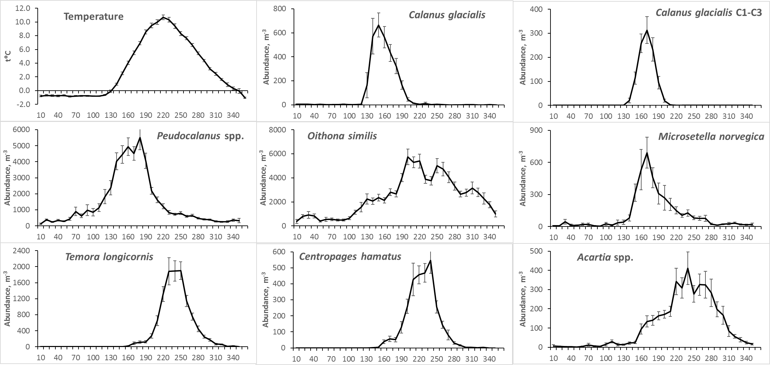

Fig. 2 Seasonal dynamics of temperature and species abundance at the D-1 station (data for the period 1961–2018). X-axis – number of Julian day. Long-term means of total population numbers in the layer 0-25 m for each 10-day period are shown. Error bars indicate standard errors of means.

Average dates of the key temperature thresholds and phenological events are present on the Fig. 3. The earliest of registered events in environment (Fig. 3B) was the timing of ice melt – it took place on average in the beginning of May (day 141). As it was mentioned before, spring normally started in the beginning of May according to temperature curve. However, the first key date in the seasonal temperature dynamics, that we could reliably register almost every year, was 3 °C threshold (arbitrary spring beginning). The latter was normally registered a month later, normally in the beginning of June (160-th day). Summer began only 2 weeks later, on 173-th day, and finished in the middle of October (day 287).

**A**

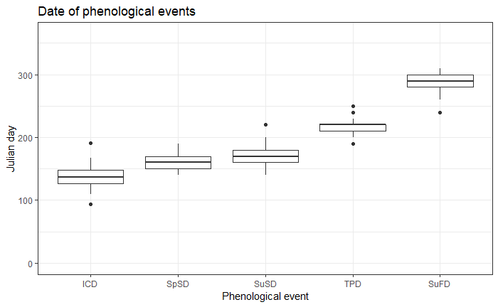

**B**

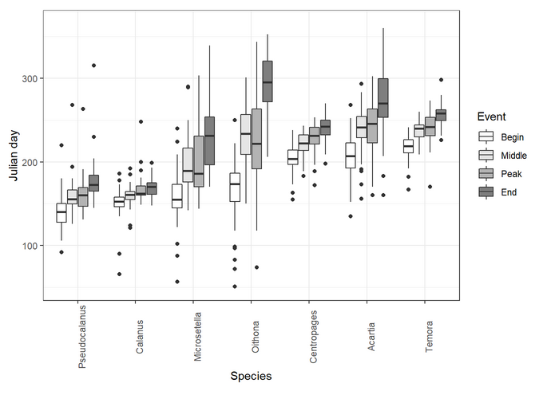

Fig. 3. Distribution of values of the key events taking place in the environment (A) and in the life cycles of the studied species (B). ICD – Ice clear date; SpSD – Spring start date (the day when the water temperature overcomes 3°C); SuSD – Summer start date (the day when the water temperature overcomes 5 Celsium degrees); TPD – The date when the highest water temperature was observed; SuFD – The date of summer end. Horizontal line refers to median. The box margin refers to the first quartile (lower) and third quartile (upper), i.e. the 25th and 75th percentiles. Vertical lines refer to 1.5 IQR (inter-quartile range, or distance between the first and third quartiles).

Species were ranged according to the timing of developmental season beginning. The season of *Pseudocalanus* spp. development started the earliest (middle of May, day 140). Then followed *Calanus* that had the narrowest developmental season (period between appearance of CI and disappearance of CIII from upper 25-meter layer). The latest season beginning was demonstrated by *Temora* (beginning of August, day 217). Narrow developmental seasons were characteristic for boreal species *Temora* and *Centropages* (39 and 36 days, respectively). The longest season was observed for ubiquitous (eurybiont) *Oithona* (133 days).

***Long-term dynamics: phenology timing and species abundance***

Long-term changes in phenology of the studied copepods demonstrated negative trends or were insignificant (Fig. 4). Only the end-of-season of *Oithona* tended to be later, but this trend was not significant.

Start of season of three species has significantly shifted to earlier time: *Calanus* (by 25 days), *Temora* (23 days) and *Microsetella* (21 days). End of season of the following species significantly shifted to an earlier time *Pseudocalanus* (39 days), *Calanus* (15 days), and *Acartia* (19 days). Thus, developmental season of *Calanus* shifted wholly to an earlier time. Seasons of *Pseudocalanus* and *Acartia* shortened, seasons of *Microsetella*, *Centropages* and *Temora* became longer.

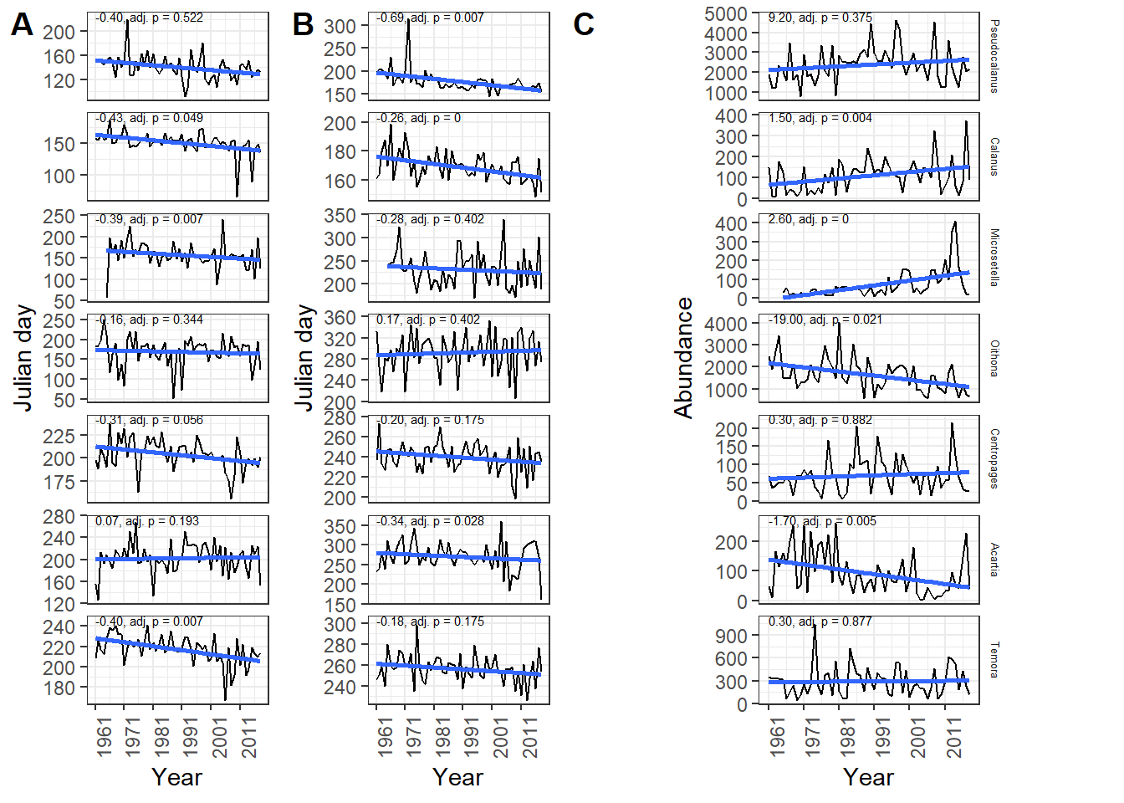

Fig. 4. Long-term changes in the timing of phenological events (beginning-of-season (A) and end-of-season (B)) in the seasonal dynamics of the studied species, and the dynamics of the total numbers of their populations in the layer 0-65 m (C). Abundance is given as ind./m3. The straight line represents the linear model connecting phenologucal indices and abundance with time. Numbers above the regression line are the slope coefficient of the model and the level of significance for the Mantel correlation (see Materials and Methods for details).

The significant interannual fluctuations were the feature of the long-term dynamics of abundance of all the studied species (Fig. 4). The minimal and maximal values differed in an order of magnitude, which was characteristic for almost all species. However some long-term directional trends were noticed. Substantial increase of abundance of *Calanus* and *Microsetella* was revealed. Numbers of *Oithona* and *Acartia* decreased significantly. No significant trends were found in the abundance dynamics of *Pseudocalanus*, *Centropages* and *Temora*.

***Long-term dynamics: factors influencing phenology timing***

Distinct long-term tendencies were revealed in the timing of the seasonal temperature dynamics (Fig. 5). Thus, dates of spring (SpSD) and summer beginning (SuSD) tended to shift to earlier time (*b* = -0.34 and -0.45, respectively; *p* < 0.05). This shift amounted to about 19 for spring and 27 days for summer beginning since 1961. These changes corresponded to the temporal shift of important indicator of the beginning of spring period – ice retreat (ICD, b =-0.39), which occurred about 22 days earlier by the end of the study period. Summer end (SuFD) date has not changed significantly. However, hydrological summer duration (SuDur, b = 0.61) increased by 35 days. Timing of the seasonal temperature peak (TPD) has not changed at all, in spite of pronounced fluctuations. Absolute values of temperature in “spring” (May--June, SpT, b = 0.04) increased significantly during study period by about 3°C. Increase of “summer” temperature (July--September, SuT) was weak and insignificant. Climatic index NAO also demonstrated significant tendency towards increase. Trend in the dynamics of AOI was not significant.

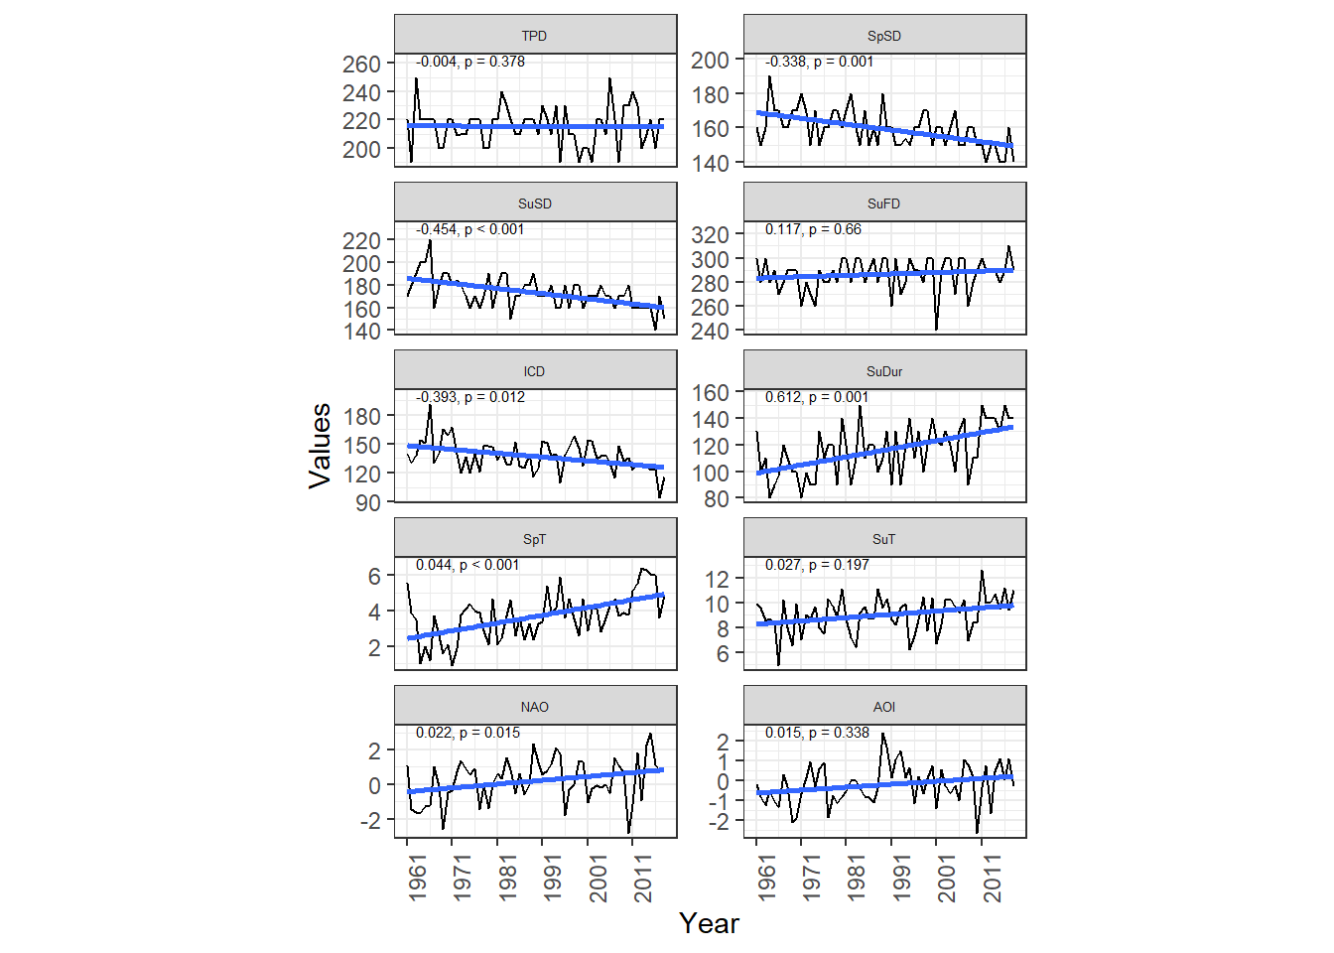

Fig. 5. Long-term changes in the timing of seasonal events in the environment. TPD – Julian day when temperature maximum was observed; SpSD – Julian day when hydrological spring started (water temperature reached 3°C); SuSD – Julian day when hydrological summer started (water temperature reached 5°C); SuFD – Julian day when hydrological summer ends; SuDur – summer duration; ICD – Julian day when ice clearing was observed; SpT – Mean spring temperature; SuT – Mean summer temperature; NAO – North Atlantic oscillation index; AOI – Arctic oscillation index. Meaning of lines and numbers – see Fig. 4.

Some of the hydrological and climatic factors described above (SpT, AOI) were not included in CCA since they displayed high varince inflation factor. Due to the same reason SuDurPY, NAOPY and SpTPY were not included into the model. All other environmenta variables combined with abundance of species were included in the model of CCA as predictors.

The whole model was statistically significant (Table 1a) and explained 40.9% of total inertia taking into account all canonical axes. At the same time, only the first constrained axis was statistically significant (Table 1b). It accounted for 14.6% of total inertia. Only three predictors were revealed as significant: the end of summer in the previous year (SuFDPY), the abundance of *Acartia* and *Microsetella*.

Table 1. Estimation of the significance of the CCA model.

|  |  |  |  |  |
| --- | --- | --- | --- | --- |
| 1. Permutation significance test of the final CCA model | | | | |
| Term | *df* | *ChiSquare* | pseudo-F | *p*-value |
| Model | 18 | 0.005 | 1.345 | 0.021 |
| Residual | 35 | 0.008 |  |  |
| 1. Permutation significance test of CCA constrained axis (only significant results are given) | | | | |
| term | *df* | *ChiSquare* | pseudo-F | *p*-value |
| CCA1 | 1 | 0.002 | 8.620 | 0.027 |
|  |  |  |  |  |
|  |  |  |  |  |
|  |  |  |  |  |
| Residual | 35 | 0.007 |  |  |
| c) Permutation significance test of terms included in the CCA model (only significant results are given) | | | | |
| term | *df* | *ChiSquare* | pseudo-F | *p*-value |
| SuFDPY | 1 | 0.0005683 | 2.6584227 | 0.0133 |
| Acartia_N | 1 | 0.0004497 | 2.1036286 | 0.0408 |
| Microsetella_N | 1 | 0.0005256 | 2.4583831 | 0.0171 |
| Residual | 35 | 0.0074825 |  |  |

Figure 6 shows the ordination of the phenological characteristics of species in the space of the first and second canonical axes. The date of the peak of *Microsetella* abundance (Microsetella_Peak), the date of the middle-of-season of this species (Microsetella_Middle), and the date of the end-of-season (Microsetella_End) had maximum positive values on the first axis. Beginning-of-season, middle-of-season and date of abundance peak of *Oithona* had the highest negative values on the first axis (CCA1). Two predictors, *Microsetella* numbers and date of summer end in the previous year (SuFDPY) were correlated with the first axis. The first one correlated negatively, the second one – positively. The greater were abundance of *Microsetella*, the later appeared juveniles of *Oithona similis*. The earlier develops *Microsetella*, the greater was abundance of this species. Late end of summer in the previous year corresponded to later development of *Microsetella*, but earlier development of *Oithona*.

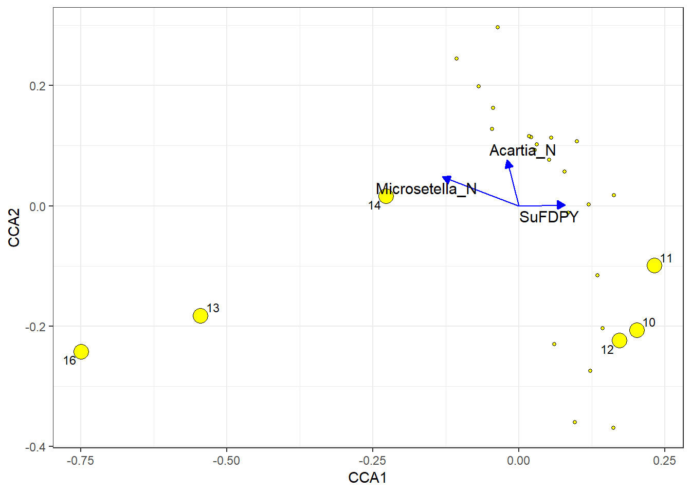

Fig. 6. Ordination of phenological characteristics of species in constrained axes of CCA. Large numbered points correspond to the phenological indicators that have absolute values on the first axis outside the 2-nd quartile. The arrows indicate the significant predictors included in the model. Abundances: M_N -- Microsetella_N, A_N -- Acartia_N. Phenological events: M_M -- Microsetella_Middle, M_E -- Microsetella_End; M_P -- Microsetella_Peak; O_B -- Oithona_Begin; O_M -- Oithona_Middle; O_P -- Oithona_Peak.

Табл. 3. Обозначения фенологических характеристик.

**Phenological Event Label**

Microsetella_Middle 10

Microsetella_End 11

Microsetella_Peak 12

Oithona_Begin 13

Oithona_Middle 14

Oithona_Peak 16

It is important to emphasize that the phenological events in *Oithona* and the phenological events in *Microsetella* occupy opposite positions along the CCA1, that is, the earlier the events in one species, the later the events in another.

We do not discuss the association of phenological events with abundnce of Acartia since the later is correlated well only the second canonical axis statistical significance of which was not revealed.

***Relationship of the abundance of the species and its phenological indicators***

We did not find any clearly expressed associations between species phenological events and its abundance (Fig. 7). However the correlation coefficients assessing the match between time series of phenological data and species abundance for two species (*Microsetella* and *Temora*) tended to be much higher than for all other species (; Table 4). The negative correlations indicate that the abundance of these species tended to be higher if the beginning of season shifted to earlier time. This tendency can also be traced in the dynamics of *Calanus*, though it was much weaker.

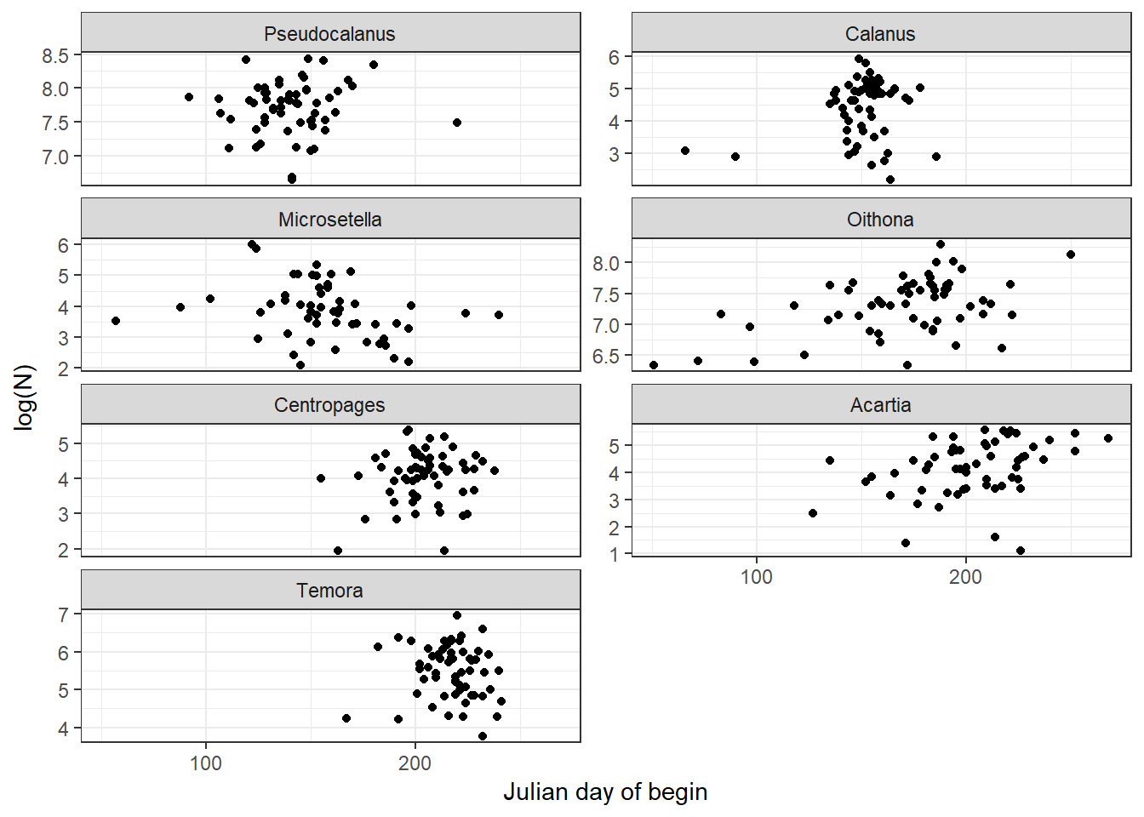

Fig. 7. The relationship between the abundance of the species (Log(N+1)) in a given year and the beginning-of-season. Each point corresponds to one year of observations.

Table 4. Correlation between dynamics of abundance and the start of season. Permutation p-level adjusted according to Benjamini-Hochberg procedure are provided. Correlation calculation – see Methods section.

Species Correlation

Pseudocalanus 0.04

Calanus -0.11

Oithona 0.04

Centropages 0.00

Acartia 0.04

Temora -0.50

Microsetella -0.42

# Discussion

Коллеги! По-моему, есть важный пропус в обсуждении. Практически не обыгрывается картина на рисунке 3 B. ТАм ведь четко прослеживается разделение сроков пребывания в планктоне у всех видов. Не есть ли это (для некоторых видов) не только проявление их биогеографической сущности, но еще и разделением ниш у близки видов? Я не могу судить так как не знаю биологии этих видов, но картинка уж больно напоминает расхождение конкурнетов. Например фенология ойтоны и микросетллы, которые, как кажется и должны конкурировать, явно раздвигаются во времени.

Significant trend in the long-term dynamics of the spring water temperature was detected at the study site, while summer temperature changed insignificantly, though slight tendency existed (~0.03°C per year). These changes correlated with the global trend towards warmer Arctic, when pronounced changes of temperature have been reported for many Arctic areas (ACIA, 2004; IPСС, 2012), and were higher than average for the Northern Hemisphere (Davy et al., 2018). Changes of the temperature may well be the consequence of the earlier seasonal spring warming of water: beginning of the spring and summer moved to an earlier time by about 3–4 weeks at the study site. It should be noted, that summer beginning shifted more (by 27 days) than start of spring (19 days), so spring duration decreased accordingly. Shift of spring beginning at the study site is confirmed by the documented shift of the ice retreat date in the adjacent areas of Kandalaksha Bay, which amounted 22 days by the end of study period. Similar trend for the timing of the ice retreat was documented in different areas over the Arctic during the last three decades (Ji et al., 2012).

Considerable change in seasonal temperature dynamics influences seasonal cycles of planktonic animals. The life-cycle events of Arctic, boreal and ubiquitous species advanced by up to a month and even more. The first copepodite stage of *Calanus glacialis* appeared 25 days earlier in the end of the study period compared to 1960-ies. It is reasonable to connect this shift to the advance of the seasonal water warming. However, it was shown that the start of *C. glacialis* reproduction depends more on the food availability than on the temperature (Ringuette et al., 2002). On the other hand, it is the temperature that governs the ice melting and, therefore, the timing of the phytoplankton bloom allowing more light penetrating through the ice and thus accelerating the production of ice and planktonic algae. Moreover, temperature influence phytoplankton photosynthetic activity later in the year, after light saturation of the upper water layer (Tilzer et al., 1986). Thus, the timing of the reproduction of *C. glacialis* depends on both food availability and temperature. The timing of *Calanus* juveniles’ disappearance also has shifted to an earlier time, however by 15 days only (compared to 25 days for appearance timing). Thus, season of active early development of *C. glacialis* has shifted to an earlier time and increased by more than a week. One may expect that with earlier appearance and faster development *Calanus* juveniles must leave upper layer much earlier. Indeed, *Calanus* CIII stay below 10 m depth by the end of spring (our observations), thus escaping unfavorable thermal conditions, but remains in the depth layer 0–25 m. High concentrations of chlorophyll *a* are observed only to 10 m depth by this time (Usov et al., 2013). So, feeding conditions below this depth are not favorable by the time CIII leave surface layer. This may be the cause of observed development prolongation. It was shown that starvation increases the developmental time of *Calanus glacialis* nauplii and may even terminate it (Daase et al., 2011).

It was reported about the possible mismatch between the ice melt and *Calanus glacialis* reproduction in the Beaufort Sea and Svalbard, which may have a negative effect on the success of this species (Søreide et al., 2010; Daase et al., 2013). In high Arctic, an early ice melting and intensive warming of upper water layer may cause shortening of period between ice-algae and phytoplankton blooms (Søreide et al., 2010). The complete disappearance of ice in the study area also is registered almost a month earlier than in 1960s. It may lead to discrepancy between *Calanus* juveniles' development and the spring peak of the phytoplankton abundance, because reaching the first feeding naupliar stage (NIII) requires certain time to develop, this process may take longer than the period between the two blooms (Søreide et al., 2010). Unfortunately, we cannot either prove, or refute this for the White Sea population, since no long-term data on phytoplankton abundance are available by now. However, long-term positive trend of *Calanus glacialis* abundance points out that at least at this temporal scale there is no tendency to mismatch. Our findings are supported by the results of modeling temperature increase in Arctic (Feng et al., 2017). The authors argue that rising temperature leads to prolongation of the period of abundant phytoplankton, which leads towards increasing success of *Calanus glacialis* in Arctic Ocean. This can also be reasonable explanation of *Calanus* success in the White Sea, as well as relative success of Pseudocalanus populations (see below).

Time of appearance of *Pseudocalanus* spp. juveniles shifted by about 23 days. However, due to sharp fluctuations of the phenological index in the early 1970s and in the early 1990s, the changes were insignificant (Fig. 5). The end of the developmental season of *Pseudocalanus* spp. has shifted by almost six weeks (39 days), therefore, we can talk about the reduction of the season of active development of *Pseudocalanus* spp. Shrinkage of the *Pseudocalanus* spp. developmental season may be also consequence of the reduction of spring duration and early summer beginning. However, population of *Pseudocalanus* spp. demonstrated insignificant, but positive tendency. . Taking into account the ecological similarity of *Pseudocalanus* spp. and *Calanus glacialis* in the White Sea and other regions (breeding dates and food preferences during the breeding season and early development; see: Lischka, Hagen, 2007; Falk-Petersen et al., 2009), the same conclusions can be drawn: a huge shift in the timing of the development of *Pseudocalanus* spp. does not lead to a noticeable trophic mismatch and population depression. Changes of temperature seasonal dynamics may be one of the drivers of the observed phenological shift and population increase. The negative shift of the center-of-gravity timing for *Pseudocalanus* species was noted in the central part of the North Sea, which coincided with a positive trend in the dynamics of the average annual water temperature at the sea surface (Mackas et al., 2012 and references therein).

A synchronization of the timing of the main events in the life cycles of cold-water species with changes in the environment may serve as one of the mechanisms of the resilience of the planktonic copepod populations to phenological shifts. Such synchronization was reported for phytoplankton in Arctic (Ji et al., 2012): planktonic algae develop earlier with earlier ice retreat.

Omnivory may be the alternative mechanism of resilience. Planktonic Copepoda consume heterotrophic plankton (microzooplankton) actively when suitable phytoplankton becomes deficient, which was found in other regions, in experiments and for related species (Levinsen et al., 2000; Lischka, Hagen, 2007; Fileman et al., 2010). The ability of many animals to switch to other food objects in conditions of the food shortage, or to be potentially omnivorous, is widely reported (Saiz, Calbet, 2010; Kiørboe, 2011; Benedetti et al., 2016; Brun et al., 2017). This ability may support *Calanus* and *Pseudocalanus* population success in the changing environment of the White Sea. These hypotheses may well apply to other species, demonstrating resilience to phenological changes, which will be discussed further.

The trends of phenology of the boreal *Centropages hamatus* and *Temora longicornis* were consistent with the changes of the seasonal cycle of temperature. The latter is one of the main triggers of their hatching in the White Sea (Pertzova, 1990) and other areas, such as the northern Baltic Sea (Katajisto et al., 1998). The temperature increase either induces hatching (Pertzova, 1990) or shortens egg developmental time (Katajisto et al., 1998). Thus, shift of spring warming might influence the timing of hatching of these species in the White Sea. Other boreal species, *Acartia* spp., demonstrated no shifts of the beginning of the developmental season. According to our observations (Fig. 2), adults of *Acartia[1]* were found in the plankton all year round, and the increase in their abundance began in March, under the ice. This suggests that *Acartia* depends on temperature to a lesser extent than *Temora* and *Centropages*. Tendency for the earlier development of boreal species was observed in other areas of the World Ocean. The timing of the appearance of the thermophilic *Acartia tonsa* in Narragansett Bay (West Coast of USA) in plankton shifted to an earlier time during period from 1972 to 1990, which coincided with a significant increase in spring temperature (Borkman et al., 2018). Approximately in the same period (from 1974 to 2004), the periods of the middle of the season (time of the 50% of the annual cumulative abundance threshold) of *Temora longicornis*, *Acartia* spp., and *Temora* spp. (nauplii) near the Helgoland Island in the North Sea has shifted to an earlier dates, 2.5 to 4 weeks (Mackas et al., 2012). In this case, changes in phenology coincided with an increase in average annual and summer (June-August) temperatures.

Of the two studied ubiquitous species , only the trend in dynamics of beginning-of-season of *Microsetella norvegica* was significant. The phenology of *Oithona similis* did not show significant changes. The described differences can be explained by the fact that the reproduction of *Microsetella* begins only in June (our own data), despite its presence all year round in the plankton community. At the same time, the nauplii of *Oithona* are found in plankton throughout the year. Probably, the temperature is not the main trigger of the beginning of the active development of this species. This is indirectly confirmed by its cosmopolitan distribution (OBIS, 2019). Meantime, a significant shift of the middle-of-season to an earlier dates in the seasonal dynamics of *Microsetella* spp. (15 weeks!) and *Oithona* spp. (~4 weeks) has been reported near Helgoland Island, and these changes coincided with an increase in average annual and summer temperatures (Mackas et al., 2012). The same trend to an ealier season was traced in the dynamics of *Oithona* spp. in the English Channel (Mackas et al., 2012). A similar dependence was observed in the northern part of the Pacific Ocean, where the seasonal peak of the biomass of the interzonal copepod *Neocalanus plumchrus* has shifted since the early 1970s by more than a month earlier, which coincided with an increase in spring temperature (Mackas et al., 2012). The timing of the abundance peak of *Calanus finmarchicus* CI in the Norwegian Sea was negatively associated with the temperature in April, but the trend was not traced, despite its presence in the dynamics of the water temperature in April (Mackas et al., 2012). In the same study, there was a lot of evidence of the negative connection of spring temperature with the phenological events of different species in the North Atlantic and the North Pacific. As can be seen, the pattern “the warmer the earlier” was traced in different regions of the World Ocean and for species with different temperature preferences. This is consistent with the trends observed in the study area in the White Sea.

Abundance of studied species either has not changed significantly (*Pseudocalanus* , *Centropages* and *Temora*), or increased (*Calanus* and *Microsetella*), or decreased (*Oithona* and *Acartia*). Only in the case of of *Acartia* spp. abundance decrease coinsided with significant reduction of developmental season duration. The season of *Pseudocalanus* spp. has also shortened, which, however, has not affected negatively the trend of their abundance. No such season reduction was observed in dynamics of *Oithona similis*. Thus, the majority of studied species are resilient to revealed phenological changes at the long-term temporal scale. The opposite trends in dynamics of *Oithona* and *Microsetella* abundance deserve special attention, because trophic niches of these species overlap. Moreover, *Oithona* demonstrated slight tendency since 1960-ies to finish season later as opposed to *Microsetella*, which tended to finish season earlier. All these point out to some competitive relationships between these species. The results of CCA confirm our suppositions.. Connection of year-to-year changes of phenology with changes in environment and biological variables manifested themselves in the results of canonical correspondence analysis. The CCA model includes only one significant abiotic predictor (end of summer in the previous year) and two biological (abundances of *Microsetella* and *Acartia*). The CCA results evidenced that the phenological phases of *Microsetella* season are positively associated with the date of summer end in the previous year. However, this association is weak and very difficult to explain. So, we may well ascribe this to some spurious ties. The real ones in this case are more likely caused by interspecific interactions.

We found that the timing of events in the *Oithona* and *Microsetella* seasonal cycles changes in the opposite directions: the earlier phenological events of one species, the later events of another. This is at least partly consistent with results of long-term trend analysis. This relationship may be explained by the fact that these two species have similar food preferences (González, Smetacek 1994; Maar et al., 2006) and may compete for food. Bothspecies, *Oithona similis* (Cyclopoida) and *Microsetella norvegica* (Harpacticoida), are omnivorous: they feed on detritus aggregates; *O. similis* also consumes microzooplankton (Paffenhöfer, 1993; Green and Dagg, 1997; Maar et al., 2006). Normal course of seasonal succession allows co-occuring species to reduce competition by partitioning resources through time, when they occupy different *temporal* niches (Pau et al., 2011). Phenological shifts may result in temporal overlaps between species with similar trophic preferences and affect competitive relationships (Nakazawa, Doi, 2012; Borkman et al., 2018). The overlapping of the trophic niches is aggravated by the high abundances of *MIcrosetella* and *Oithona* in the study area and the significant intersection of the temporal niches (Fig. 2). It appears that interspecific interactions play an important role in the seasonal dynamics of these two species. It should also be noted that the timing of phenological events in the *Microsetella* seasonal cycle is negatively related to its population size in the same year. In other words, the later the developmental season of his species begins, the lower its abundance. Probably, when *Microsetella* appears late, it does not have time to achieve high abundance before the mass development of the competitor, *Oithona similis*. However, the earlier *Microsetella* appears in the plankton, the greater the abundance it reaches, gaining a competitive advantage over *Oithona*, which in such years develops later than usual.

# Conclusions

The global climate change is manifested in the White Sea through temporal shift of the seasonal temperature cycle. The spring water heating has shifted since 1961 towards an earlier time: spring beginning shifted by 23 and summer beginning – by 29 days. This shift influences seasonal cycle of planktonic organisms. Key events of the life cycles of both cold- and warm-water copepods in the coastal area of Kandalaksha Bay of the White Sea have moved to an earlier time by up to a month. Main factors, which drive these shifts, are advance of ice melt and advance of spring water heating. For ubiquitous and boreal species, interspecific competition for resources plays an important role: in the years when the abundance of *Microsetella* is high, the key events in the *Oithona* seasonal cycle tend to occur later. The same relationship was revealed at the scale of long-term trends: end-of-season and abundance of these two species changed in the opposite directions. Period of active development of *Pseudocalanus* and *Acartia* has shortened, but this change had negative consequences only for *Acartia* spp. abundance. Revealed temporal shifts of phenological events had almost no effect on the abundance of the studied species at the scale of year-to-year fluctuations. Only abundance of *Microsetella* and *Temora* tended to be higher in years with early beginning-of-season. This point out to resilience of planktonic organisms to changes in seasonal cycles of environmental variables. Several mechanisms may underlie this resilience. First, organisms may synchronize key events in their life cycles with dynamics of environmental parameters. Second, to overcome temporal mismatch with feeding objects, planktonic copepods may switch their food preferences form herbivory to carnivory according to situation in plankton (presence/absence of suitable food), because the majority of Copepoda, at least at the study site, are potentially omnivorous. Third, the success of the cold-water species depends to some extent on the duration of the period of ample phytoplankton, because these species are predominantly herbivorous. These conclusions were made based on the long-term observational data, and need to be verified experimentally, where possible. Other factors, potentially important for planktonic animals but overlooked during monitoring, and their interactions with measured parameters should be analysed. We suppose this to be the focus of our further scientific efforts.

# Acknowledgments

We would like to express our gratitude to all the colleagues and vessel staff who took part in monitoring since 1957, especially to Dr. Regina V. Prygunkova, who kept running this program for almost 30 years and summarized the plankton data from 1960 to 1995. We are also grateful to oceanologist Alexey I. Babkov (worked in 1973–1995), who summarized the hydrological data of monitoring. Our thanks go to other participants of the program and to the captains and crews of the research vessels. This research is supported by the ongoing Basic Research Program of the Russian Academy of Sciences "The fauna of the White Sea and adjacent basins: adaptive traits of organisms and populations under the influence of the climate change" (reg. No АААА-А17-117021300219-7).

# References

ACIA (2004) Impacts of a Warming Arctic: Arctic Climate Impact Assessment. ACIA Overview report. Cambridge University Press.

Arendt KE, Juul-Pedersen T, Mortensen J, Blicher ME, Rysgaard S (2012) A 5-year study of seasonal patterns in mesozooplankton community structure in a sub-Arctic fjord reveals dominance of Microsetella norvegica (Crustacea, Copepoda), J Plankton Res 35: 105–120, https://doi.org/10.1093/plankt/fbs087

Atkinson A, Harmer RA, Widdicombe CE, McEvoy AJ, Smyth TJ, Cummings DG, Somerfield PJ, Maud JL, McConville K (2015) Questioning the role of phenology shifts and trophic mismatching in a planktonic food web. Prog Oceanogr 137: 498–512. https://doi.org/10.1016/j.pocean.2015.04.023

Babkov AI (1982) The brief hydrological characteristic of Chupa inlet, the White Sea. Explorations of the fauna of the seas 27(35): 3–16. [in Russian]

Babkov AI (1985) About the principles of determination of hydrological seasons (by the example of Chupa inlet, the White Sea. Explorations of the fauna of the seas 31(39): 84–88. [in Russian]

Bates DM, Chambers JM (1992) Nonlinear models. Chapter 10 of: Statistical Models. S. J. M. Chambers and T. J. Hastie, Eds., Wadsworth & Brooks/Cole.

Batten SD, Mackas DL (2009) Shortened duration of the annual *Neocalanus plumchrus* biomass peak in the Northeast Pacific. Mar Ecol Prog Ser 393: 189–198.

Beaugrand G, Kirby RR (2018) How Do Marine Pelagic Species Respond to Climate Change? Theories and Observations. Annu Rev Mar Sci 10: 15.1–15.29. <https://doi.org/10.1146/annurev-marine-121916-063304>

Benjamini Y, Hochberg Y (1995) Controlling the false discovery rate: a practical and powerful approach to multiple testing. Journal of the Royal statistical society: series B (Methodological) 57: 289–300.

Berger V, Dahle S, Galaktionov K, Kosobokova X, Naumov A, Rat'kova T, Savinov V, Savinova T (2001) White Sea. Ecology and Environment. Derzavets Publisher, St.-Petersburg, Tromsø.

Bogorov VG (1941) Diel vertical distribution of zooplankton in the polar conditions (in the White Sea). Transactions of The Polar Institute of Marine Fisheries and Oceanography, Murmansk 7: 287–311.

Bonnet D, Harris RP, Yebra L, Guilhaumon F, Conway DVP, Hirst AG (2009) Temperature effects on *Calanus helgolandicus* (Copepoda: Calanoida) development time and egg production. J Plankton Res 31: 31–44. <https://doi.org/10.1093/plankt/fbn099>

Borkman DG, Fofonoff P, Smayda TJ, Turner JT (2018) Changing *Acartia* spp. phenology and abundance during a warming period in Narragansett Bay, Rhode Island, USA: 1972–1990. J Plankton Res 40: 580–594. https://doi.org/10.1093/plankt/fby029

Box GEP, Jenkins GW (1976) Time Series Analysis: Forecasting and Control. CA: Holden-Day, San Francisco.

Carton JA*,* Ding Y*,* ArrigoKR(2015)The seasonal cycle of the Arctic Ocean under climate change. Geophys Res Lett 42:7681*–*7686. <https://doi.org/10.1002/2015GL064514>

Castellani C, Robinson C, Smith T, Lampitt RS (2005) Temperature affects respiration rate of Oithona similis. Mar Ecol Prog Ser 285: 129–135. <https://doi.org/10.3354/meps285129>

Clarke KR, Gorley RN (2006) PRIMER v6: User Manual/Tutorial. Primer-E Ltd., Plymouth.

COPEPOD. Interactive Time-series Explorer METABASE (2018): [https://www.st.nmfs.noaa.gov/ copepod/time-series/ru-10101/](https://www.st.nmfs.noaa.gov/%20copepod/%20copepod/time-series/ru-10101/)

Corkett CJ, McLaren IA, Sevigny JM (1986) The rearing of the marine calanoid copepods *Calanus finmarchicus* (Gunnerus), *C. glacialis* Jaschnov and *C. hyperboreus* Kroyer with comment on the equiproportional rule. Syllogeus 58, The National Museum of Natural Sciences, Ottawa: 539–546.

Daase M, Søreide J, Martynova D (2011) Effects of food quality and food concentration on naupliar development of *Calanus glacialis* at sub-zero temperatures. Mar Ecol Prog Ser 429: 111–124. https://doi.org/10.3354/meps09075

Daase M, Falk-Petersen S, Varpe Ø, Darnis G, Søreide JE, Wold A, Leu E, Berge J, Philippe B, Fortierc L (2013) Timing of reproductive events in the marine copepod *Calanus glacialis*: a pan-Arctic perspective. Can J Fish Aquat Sci 70: 871–884. https://doi.org/10.1139/cjfas-2012-0401

Danielsdottir MG, Brett MT, Arhonditsis GB (2007) Phytoplankton food quality control of planktonic food web processes. Hydrobiologia 589: 29–41. <https://doi.org/10.1007/s10750-007-0714-6>

Davy R, Chen L, Hanna E (2018) Arctic amplification metrics. Int J Climatol 38: 4384–4394. https://doi.org/10.1002/joc.5675

Devreker D, Souissi S, Forget-Leray J, Leboulenger F (2007) Effects of salinity and temperature on the post-embryonic development of *Eurytemora affinis* (Copepoda; Calanoida) from the Seine estuary: a laboratory study. J Plankton Res 29 (suppl 1): i117–i133. https://doi.org/10.1093/plankt/fbl071

Edwards M, Richardson AJ (2004) Impact of climate change on marine pelagic phenology and trophic mismatch. Nature 430: 881–884. https:// doi.org/10.1038/nature02808

Eilertsen HC, Sandberg S, Tøllefsen H (1995) Photoperiodic control of diatom spore growth; a theory to explain the onset of phytoplankton blooms. Mar Ecol Prog Ser 116: 303–307.

Engel M (2005) Calanoid copepod resting eggs – a safeguard against adverse environmental conditions in the German Bight and the Kara Sea? Berichte zur Polar- und Meeresforschung 508: 1–108.

Falk-Petersen, S., Mayzaud, P., Kattner, G., & Sargent, J. R. (2009). Lipids and life strategy of Arctic *Calanus*. Mar Biol Res 5: 18–39. https://doi.org/10.1080/ 17451000802512267

Feng Z, Ji R, Ashjian C, Campbell R, Zhang J. (2018) Biogeographic responses of the copepod *Calanus glacialis* to a changing Arctic marine environment. Glob Change Biol 24: e159–e170. https://doi.org/10.1111/gcb.13890

Filatov NN, Pozdnyakov DV, Johannessen OM, Petterson LH, Bobylev LP (2005) White Sea. Its Marine Environment and Ecosystem Dynamics Influenced by Global Change. Springer-Praxis Publishing, Chichester.

Fileman E, Petropavlovsky A, Harris R (2010). Grazing by the copepods Calanus helgolandicus and Acartia clausi on the protozooplankton community at station L4 in the Western English Channel. J Plankton Res (32): 709–724. https://doi.org/10.1093/plankt/fbp142

Gillooly JF (2000) Effect of body size and temperature on generation time in zooplankton. J Plankton Res 22: 241–251. <https://doi.org/10.1093/plankt/22.2.241>

Golyandina N, Osipov E (2007) The “Caterpillar” – SSA method for analysis of time series with missing values. Journal of Statistical Planning and Inference 137: 2642–2653. https://doi.org/10.1016/j.jspi.2006.05.014

Golyandina N, Zhigljavsky A (2013) Singular Spectrum Analysis for time series. Springer Science & Business Media.

Golyandina N, Korobeynikov A (2014) Basic Singular Spectrum Analysis and Forecasting with R. Computational Statistics and Data Analysis 71: 934-954. <https://doi.org/10.1016/j.csda.2013.04.009>

Gonzalez HE, Smetacek М (1994) The possible role of the cyclopoid copepod Oithona in retarding vertical flux of zooplankton faecal material. Mar Ecol Prog Ser 113: 233-246.

Green, E. P. Dagg, M. J. (1997). Mesozooplankton associations with medium to large marine snow aggregates in the northern Gulf of Mexico. J Plankton Res 19: 435–447.

Greve W, Reiners F, Nast J, Hoffmann S (2004) Helgoland Roads meso- and macrozooplankton time-series 1974 to 2004: lessons from 30 years of single spot, high frequency sampling at the only off-shore island of the North Sea. Helgol Mar Res 58: 274–288. https://doi.org/10.1007/s10152-004-0191-5

Harris RP, Wiebe PH, Lenz J, Skjoldal H-R, Huntley M (eds) (2000) ICES Zooplankton Methodology Manual. Academic Press, London.

Hays GC, Carr MR, Taylor AH (1993) The relationship between Gulf Stream position and copepod abundance derived from the Continuous Plankton Recorder Survey: separating biological signal from sampling noise. J Plankton Res 15: 1359–1373. https://doi.org/ 10.1093/plankt/15.12.1359

Hirche H-J (1987) Temperature and plankton. II. Effect on respiration and swimming activity in copepods from the Greenland Sea. Mar Biol 94: 347–356. https://doi.org/ 10.1007/BF00428240

Hunt GL Jr, Stabeno P, Walters G, Sinclair E, Brodeur RD, Napp JM, Bond NA (2002) Climate change and control of the southeastern Bering Sea pelagic ecosystem. Deep Sea Research Part II: Topical Studies in Oceanography 49: 5821–5853. https://doi.org/10.1016/S0967-0645(02)00321-1

Hurrell JW (1995) Decadal trends in the North Atlantic Oscillation and relationships to regional temperature and precipitation. Science, 269: 676–679.

.

IPCC (2007) Climate Change 2007. The Physical Science Basis. Working Group I, Contribution to the Fourth Assessment Report of the IPCC Intergovernmental Panel on Climate Change. Cambridge University Press, Cambridge.

IPCC (2013): Climate Change 2013: The Physical Science Basis. Contribution of Working Group I to the Fifth Assessment Report of the Intergovernmental Panel on Climate Change. Cambridge University Press, Cambridge.

Ji R, Edwards M, Mackas DL, Runge JA, Thomas AC (2010) Marine plankton phenology and life history in a changing climate: current research and future directions. J Plankton Res 32: 1355–1368. <https://doi.org/10.1093/plankt/fbq062>

Ji R, Jin M, Varpe Ø (2012) Sea ice phenology and timing of primary production pulses in the Arctic Ocean. Glob Change Biol 19: 734–741. https://doi.org/10.1111/gcb.12074

Katajisto T, Viitasalo M, Koski M (1998) Seasonal occurrence and hatching of calanoid eggs in sediments of the northern Baltic Sea. Mar Ecol Prog Ser 163: 133–143.

Katajisto T (2006) Benthic resting eggs in the life cycles of calanoid copepods in the northern Baltic Sea. W. & A. de Nottbeck Foundation Science Report 29: 1–46.

Koski M, Kuosa H (1999) The effect of temperature, food concentration and female size on the egg production of the planktonic copepod *Acartia bifilosa*. J Plankton Res 21: 1779–1789. <https://doi.org/10.1093/plankt/21.9.1779>

Koski M, Kiørboe T, Takahashi K (2005) Benthic life in the pelagic: Aggregate encounter and degradation rates by pelagic harpacticoid copepods. Limnol Oceanogr 50: 1254–1263. https://doi.org/10.4319/lo.2005.50.4.1254

Kosobokova KN (1999) The reproductive cycle and life history of the Arctic copepod *Calanus glacialis* in the White Sea. Polar Biol 22: 254–263. https://doi.org/10.1007/ s003000050418

Kosobokova KN, Rat’kova TN, Sazhin AF (2003) Zooplankton in the ice-covered Chupa Inlet (White Sea) in the early spring of 2002. Oceanology 43: 694–703.

Kwasniewski S, Walkusz W, Cottier FR, Leu E (2013) Mesozooplankton dynamics in relation to food availability during spring and early summer in a high latitude glaciated fjord (Kongsfjorden), with focus on *Calanus*. J Mar Syst 111: 83–96. <https://doi.org/10.1016/j.jmarsys.2012.09.012>

Legendre P, Legendre L (2012) Numerical Ecology. Elsevier, Third English edition.

Levinsen H, Turner JT, Nielsen TG, Hansen BW (2000) On the trophic coupling between protists and copepods in arctic marine ecosystems. Mar Ecol Prog Ser 204: 65–77. https://doi.org/10.3354/meps204065

Light B, Grenfell TC, Perovich DK (2008) Transmission and absorption of solar radiation by Arctic sea ice during the melt season. J Geophys Res 113: C03023. <http://dx.doi.org/10.1029/2006JC003977>

Lischka S, Hagen W (2007) Seasonal lipid dynamics of the copepods Pseudocalanus minutus (Calanoida) and Oithona similis (Cyclopoida) in the Arctic Kongsfjorden (Svalbard). Mar Biol 150: 443–454. https://doi.org/10.1007/s00227-006-0359-4

Maar M., Visser A.W., Nielsen T.G., Stips A., Saito H. (2006). Turbulence and feeding behaviour affect the vertical distributions of *Oithona similis* and *Microsetella norwegica*. Mar Ecol Prog Ser 313, 157–172.

Mackas DL, Goldblatt R, Lewis AG (1998) Interdecadal variation in developmental timing of *Neocalanus plumchrus* populations at Ocean Station P in the subarctic North Pacific. Can J Fish Aquat Sci 55: 1878-1893. <https://doi.org/10.1139/f98-080>

D.L. Mackas a,⇑, W. Greve b, M. Edwards c, S. Chiba d, K. Tadokoro e, D. Eloire f, M.G. Mazzocchi g, S. Batten h, A.J. Richardson i,j, C. Johnson k, E. Head k, A. Conversi l, T. Peluso (2012) Changing zooplankton seasonality in a changing ocean: Comparing time series of zooplankton phenology. Progress in Oceanography 97–100: 31–62. https://doi.org/ 10.1016/j.pocean.2011.11.005

Markhaseva EL, Abramova AA, Mingazov ND (2012) *Pseudocalanus acuspes* (Crustacea, Copepoda) from the White Sea. Proceedings of the Zoological Institute RAS 316 (1): 57–70.

Martynova DM, Graeve M, Bathmann UV (2009) Adaptation strategies of copepods (superfamily Centropagoidea) in the White Sea (66°N). Polar Biol 32: 133–146. https://doi.org/10.1007/s00300-008-0513-1

Martynova DM, Kazus NA, Bathmann UV, Graeve M, Sukhotin AA (2011) Seasonal abundance and feeding patterns of copepods *Temora longicornis*, *Centropages hamatus* and *Acartia* spp. in the White Sea (66°N). Polar Biol 34: 1175–1195. https://doi.org/ 10.1007/s00300-011-0980-7

McLaren, I. A., Sevigny, J. M., & Corkett, C. J. (1988). Body sizes, development rates, and genome sizes among *Calanus* species. Hydrobiologia 167: 275–284. <https://doi.org/10.1007/BF00026315>

Nakazawa T, Doi H (2012) A perspective on match/mismatch of phenology in community contexts. Oikos 121: 489–495. doi:10.1111/j.1600-0706.2011.20171.x

Norrbin F (1991) Gonad maturation as an indication of seasonal cycles for several species of small copepods in the Barents Sea. Polar Res 10: 421–432. https://doi.org/10.1111/ j.1751-8369.1991.tb00663.x

OBIS (2019) Ocean Biogeographic Information System. Intergovernmental Oceanographic Commission of UNESCO. www.iobis.org.

Oksanen J, Guillaume Blanchet F., Friendly M, Kindt R, Legendre P, McGlinn D, Minchin PR, O’Hara RB, Simpson GL, Solymos P, Stevens MHH, Szoecs E Wagner H (2019) Vegan: Community Ecology Package. R package version 2.5-4. <https://CRAN.R-project.org/package=vegan>

Pau S., Wolkovich EM, Cook BI, Davies TJ, Kraft NJB, Bolmgren K, Betancourt JL, Cleland EE (2011) Predicting phenology by integrating ecology, evolution and climate science. Global Change Biology17: 3633–3643. https://doi.org/10.1111/j.1365-2486.2011.02515.x

Paffenhöfer GA (1993) On the ecology of marine cyclopoid copepods (Crustacea, Copepoda). J Plankton Res 15: 37–55. https://doi.org/10.1093/plankt/15.1.37

Pertzova, NM (1971) On the quantitative vertical distribution of the zooplankton in Kandalaksha Bay of the White Sea. Integrated investigations of the ocean resources. 2-nd issue. Moscow University Publ., Moscow, pp 153–162.

Pertzova, NM (1974) Life cycle and ecology of warm-water copepod Centropages hamatus in the White Sea. Zoologicheskii Zhurnal 53: 1013–1022. (in Russian).Pertsova NM (1980) Distribution of the zooplankton in the Basin and Kandalaksha Bay of the White Sea. Transactions of the White Sea Biological Station of the Moscow University 5: 49–68. [in Russian]

Pertzova NM (1990) Ecology of the boreal copepods *Centropages hamatus* Lilljeborg and *Temora longicornis* Müller in the White Sea and within the range. In Matekin PV (ed), Biological resources of the White Sea. Moscow University Publ., Moscow, pp 80–92. [in Russian]

Pertsova NM, Kosobokova KN (2010) Interannual and seasonal variation of the population structure, abundance, and biomass of the arctic copepod *Calanus glacialis* in the White Sea. Oceanology 50: 531−541.

Post E, Forchhammer MC (2008) Climate change reduces reproductive success of an Arctic herbivore through trophic mismatch. Philos. Trans. R. Soc. B Biol. Sci. 363: 2367–2373.

Primakov IM (2005) The impact of hydro-meteorological conditions on primary production. Zoological Sessions. Annual Reports 308: 83–90.

Prudkovsky A (2003) Life cycle of *Acartia bifilosa* (Copepoda, Calanoida) in the White Sea (Chernorechenskaya Inlet, Kandalaksha Bay). Proc. of the White Sea Biological Station of the Moscow State University, 9: 164–168. [in Russian]

Prygunkova RV (1974) Some peculiarities of seasonal development of zooplankton in Chupa Inlet of the White Sea. Explorations of the fauna of the seas 13(21): 4–55. [in Russian]

Pyper BJ, Peterman RM (1998) Comparison of methods to account for autocorrelation in correlation analyses of fish data. Can J Fish Aquat Sci 55, 2127–2140. https://doi.org/ 10.1139/f98-104

Quenouille NH (1952) Associated Measurements. Butterworths, London. (есть ли в новом варианте?)

Quinn GP, Keough MJ (2002) Experimental design and data analysis for biologists. Cambridge University Press.

R Core Team (2019) R: A language and environment for statistical computing. R Foundation for Statistical Computing, Vienna, Austria. URL https://www.R-project.org/.

Richardson AJ (2008) In hot water: zooplankton and climate change. ICES J Mar Sci 65: 279–295. https://doi.org/10.1093/icesjms/fsn028

Ringuette M, Fortiera L, Fortier M, Runge JA, Bélanger S, Larouche P, Weslawski J-M, Kwasniewski S (2002) Advanced recruitment and accelerated population development in Arctic calanoid copepods of the North Water. Deep-Sea Res II 49: 5081–5099. <https://doi.org/10.1016/S0967-0645(02)00179-0>

Royama T (1981) Fundamental concepts and methodology for the analysis of animal population dynamics, with particular reference to univoltine species. Ecological Monographs, 51(4), 473-493.

Royama T (1992) Analytical Population Dynamics. Chapman & Hall, London.

Rusanova MN, Khlebovich VV (1967) About the influence of anomalous conditions in 1965 – 1966 on the fauna of the White Sea. Oceanology, 7: 164–167. [in Russian]

Saiz E, Calbet A (2011) Copepod feeding in the ocean: scaling patterns, composition of their diet and the bias of estimates due to microzooplankton grazing during incubations. Hydrobiologia 666: 181–196. https://doi.org/10.1007/s10750-010-0421-6

Sokal RR, Rohlf FJ (1995) Biometry. The principles and practice of statistics in biological research, 3-rd ed. W. H. Freeman, New-York.

Søreide JE, Leu E, Berge J, Graeve M, Falk-Petersen S (2010) Timing of blooms, algal food quality and *Calanus glacialis* reproduction and growth in a changing Arctic. Global Change Biol 16: 3154–3163. <https://doi.org/10.1111/j.1365-2486.2010.02175.x>

Tenth report of the joint panel on oceanographic tables and standards. UNESCO Technical Papers in Marine Science 36 (1981).

Ter Braak CJF (1986) Canonical Correspondence Analysis: a new eigenvector technique for multivariate direct gradient analysis. Ecology 67: 1167–1179. https://doi.org/10.2307/1938672

Thackeray SJ (2012). Mismatch revisited: What is trophic mismatching from the perspective of the plankton? J Plankton Res 34: 1001–1010. https://doi.org/10.1093/plankt/fbs066

Thompson DWJ, Wallace JM (1998). The Arctic oscillations signature in the wintertime geopotential height and temperature fields. Geophysical Research Letters 25: 1297–1300. https://doi.org/10.1029/98GL00950

Tilzer MM, Elbrachter M, Gieskes WW, Beese B (1986) Light-temperature interactions in the control of photosynthesis in Antarctic phytoplankton. Polar Biol 5: 105–111. <https://doi.org/10.1007/BF00443382>

Tourangeau S, Runge JA (1991). Reproduction of *Calanus glacialis* under ice in spring in southeastern Hudson Bay, Canada. Mar Biol 108: 227–233. https://doi.org/ 10.1007/BF01344337

Troshkov VA, Slonova SA (2000) Zooplankton of the White Sea and its role in the feeding of the White Sea herring. Biological resources of the coastal area of Russian Arctic*.* Symposium materials. VNIRO Publishers, Moscow: 150–164. [in Russian]

Turner JT, Levinsen H, Nielsen TG, Hansen BW (2001) Zooplankton feeding ecology: grazing on phytoplankton and predation on protozoans by copepod and barnacle nauplii in Disko Bay, West Greenland. Mar Ecol Prog Ser 221: 209–219. https://doi.org/ 10.3354/meps221209

Usov NV (2011) Zooplankton dynamics during winter in ice-covered sea by the example of coastal zone of the White Sea. Bulletin of Saint-Petersburg University (Series 3, Biology) 3: 3−14. [in Russian]

Usov N, Kutcheva I, Primakov I, Martynova D (2013) Every species is good in its season: Do the shifts in the annual temperature dynamics affect the phenology of the zooplankton species in the White Sea? Hydrobiologia 706: 11–33. https://doi.org/10.1007/s10750-012-1435-z

Wassmann P, Duarte CM, Agusti S, Sejr MK (2011) Footprints of climate change in the Arctic marine ecosystem. Global Change Biol 17: 1235–1249. <https://doi.org/10.1111/j.1365-2486.2010.02311.x>

Weijerman M, Lindeboom H, Zuur AF (2005). Regime shifts in marine ecosystems of the North Sea and Wadden Sea. Mar. Ecol. Prog. Ser. 298: 21–39. https://doi.org/10.3354/meps298021

Zubakha MA, Usov NV (2004) Optimum temperatures for common zooplankton species in the White Sea. Russian Journal of Marine Biology 30: 293–297. https://doi.org/ 10.1023/B:RUMB.0000046547.26708.3e

Zhang J, Ashjian C, Campbell R, Spitz YH, Steele M, Hill V (2015) The influence of sea ice and snow cover and nutrient availability on the formation of massive under-ice phytoplankton blooms in the Chukchi Sea. Deep Sea Res II 118: 122–135. https://doi.org/10.1016/ j.dsr2.2015.02.008

1. Most likely, this is *A. longiremis*, one of the two species inhabiting the study area, which differs by its neritic distribution from *A. bifilosa* characterized by living in the coastal and estuarine areas (Prudkovsky, 2003).