RESTORING A STRONG TROPHIC LINK BETWEEN COD AND STICKLEBACK IN THE WHITE SEA ECOSYSTEM

Abstract
Atlantic cod Gadus morhua are important predators in the North Atlantic and adjacent Arctic-subarctic ecosystems. Understanding the feeding ecology of such key species clarifies trophic processes and ecological responses to environmental drivers. This study uses an 18-year time-series of stomach content data (2007-2025) from nearshore waters of the Chupa Inlet, Kandalaksha Bay, White Sea. We examine adult cod (body length > 25 cm) during active summer feeding (June-August) in coastal areas. Regression models were developed to assess temporal (seasonal and interannual) and ontogenetic variation in diet composition. Prey-specific patterns indicate that the diet of adult cod in near-shore waters was dominated by fish and fish eggs, with polychaetes playing a lesser role. Stickleback was the primary forage species, consumed in large quantities. Ontogenetic shifts were evident, as fish prey increased in importance with cod size. Cod exhibited distinct intra-seasonal variation in feeding habits linked to prey availability, largely driven by stickleback population dynamics. Spawning of this species in early summer in shallow waters shapes diets at the beginning of the season. Herring and polychaetes contributed substantially in mid-to-late summer. Long-term analysis revealed remarkable stability in the trophic structure of cod during summer foraging. Stickleback consistently dominated cod diet across the entire monitoring period; no directed long-term trends were detected for other prey species.

Key words: Gadus morhua, White Sea, trophic ecology, stomach content analysis, stickleback, ontogenetic shifts, long-term monitoring

INTRODUCTION
Trophic interactions play an important role in shaping interspecific relationships, flows of matter and energy, and the dynamics of species abundance within communities (Gerking 1994). A detailed analysis of such interactions provides essential insights into the structure and functioning of marine ecosystems. Trophic relationships can vary considerably depending on the availability and abundance of prey items (Holt et al. 2019). Potential drivers of this variation include global climatic changes, fluctuations in environmental factors, intensive commercial exploitation of both prey species and predators, and the introduction of invasive species into ecosystems (Gjøsæter et al. 2009; Durant et al. 2014; Neuenfeldt et al. 2020; Dupont et al. 2024). Elucidating the mechanisms underlying these changes is crucial for assessing the state of marine ecosystems and for developing measures aimed at the sustainable management of fish stocks and other aquatic living resources.
Atlantic cod Gadus morhua Linnaeus, 1758 is a demersal fish inhabiting the North Atlantic and the adjacent Arctic. There are several large stocks of cod that are fished by a number of countries (Brander 1994; Nordeide and Båmstedt 1998; Dolgov 2009; Hilborn and Litzinger 2009). Cod is one of the main top predators, feeding on a variety of pelagic and demersal fishes and invertebrates, primarily crustaceans (Zatsepin and Petrova 1939; Rae 1967; Pálsson 1994; Methven 1999; Link and Garrison 2002; Johansen 2003; Bogstad and Gjøsæter 2001; Dolgov et al., 2011). The abundance and availability of the main prey items of Atlantic cod in different areas of the North Atlantic and adjacent waters undergo periodic changes under the influence of various abiotic, anthropogenic, and biotic factors (Link et al. 2009; Holt et al. 2019). Fragmentary studies of cod diet composition typically allow only a "here and now" description of its feeding characteristics. To identify changes in the trophic structure of multispecies marine communities, including cod prey dynamics and cod population dynamics, it is necessary to conduct "the continued monitoring and tracing of cod feeding, even at minimal levels" (Link and Sherwood 2019, p. 226). Considerable amounts of data on diet composition exist for some exploited cod stocks from the Baltic Sea, Icelandic waters and other regions (Neuenfeldt and Beyer 2006; Pálsson and Björnsson 2011; etc.), but the most comprehensive multiyear studies of cod trophic patterns have been conducted only in the Barents Sea and nearby areas (Orlova and Dolgov 2004; Michalsen et al., 2008; Yaragina et al., 2009; Holt et al., 2019; Townhill et al., 2021). This region harbors the world's largest stock of Atlantic cod, the fishery for which is of great commercial importance (Kjesbu et al., 2014).
Intensive exploitation of cod stocks can cause changes in population structure and trophic interactions of this predator, making it difficult to distinguish between the effects of natural and anthropogenic factors on cod feeding ecology. In this regard, marine ecosystems in which cod populations and their prey species are not subjected to intensive fishing pressure are of particular interest. Data obtained on the trophic relationships of such non-commercial species can be interpreted in light of ongoing significant environmental changes, shifts in community species structure, and dynamics of individual food web components, without considering the potential influence of fishery pressure on them. Among such areas weakly affected by human economic activity is the White Sea basin, which is located in the northeastern part of the Atlantic cod's range (Fig. 1).
The White Sea cod Gadus morhua marisalbi Derjugin, 1920 is a subspecies of the Atlantic cod and represents one of the most important components of coastal ecosystems in this subarctic region. Throughout its life cycle, the cod inhabits predominantly the coastal waters of Kandalaksha Bay and the vicinity of the Solovetsky Islands, without undertaking extensive feeding migrations (Altukhov et al. 1958). It is in these areas that the most abundant aggregations of cod are observed, whereas in Dvina Bay, Mezen Bay, and most of Onega Bay, the cod is absent (Sonina 1957; Altukhov et al. 1958). The White Sea cod stock is not subject to commercial fisheries, and its resources are used primarily for local consumption.
The cod is the most abundant predator in the coastal ecosystems of the White Sea, and information on its feeding ecology is crucial for understanding the variability of predator-prey interactions in this region. According to published data, the White Sea cod is an omnivorous species with a broad spectrum of consumed organisms. The main groups of prey organisms for the cod include fishes, crustaceans, and polychaetes, and during ontogenesis there is a transition to a predominantly piscivorous lifestyle (Yevropeytzeva 1937; Sonina 1957; Izvekova 1964; Kudersky 1966; Parukhina 2005; Ershov 2010). Among fish prey, the cod prefers to consume the three-spined stickleback Gasterosteus aculeatus Linnaeus, 1758 and the herring Clupea pallasii marisalbi Berg, 1923. To a lesser extent, the cod eat representatives of several other fish species inhabiting coastal waters, including the rock gunnel Pholis gunnellus (Linnaeus, 1758), the slender eelblenny Lumpenus fabricii Reinhardt, 1836, the shorthorn sculpin Myoxocephalus scorpius (Linnaeus, 1758),the dab Limanda limanda (Linnaeus, 1758), and some others.
The role of the stickleback, the primary prey item of cod, has changed considerably over the last 100 years. This is due to the fact that the stickleback population size underwent drastic changesduring this period . It is known that from the 1920s until the early 1960s, the stickleback was highly abundant and, during its spawning period in coastal areas, constituted the main component of the cod's diet in various parts of Kandalaksha Bay of the White Sea (Yanushevich 1933; Yevropeytzeva 1937; Il'in and Pevzner 1939; Sonina 1957; Izvekova 1964; Kudersky 1966). Moreover, the stickleback was fished commercially in this region of the White Sea during the 1930s-1950s, but was of very low commercial importance (Lajus et al. 2013, 2020a). In the early 1960s, a population collapse of the stickleback occurred, related in particular to the drastical decrease of eelgrass Zostera marina Linnaeus, 1753 in the White Sea (Kolevatova 1963; Kuznetsov and Matveeva 1963), in the beds of which it spawned. The abundance of stickleback declined sharply, and it completely disappeared from the diet of cod until the late 1990s (Parukhina 2005). The first signs of recovery of this species' population in the White Sea appeared in 1997 (Lajus et al. 2013), and ten years later, in 2007-2008, according to studies in Chupa Inlet, the stickleback again became dominant in the diet of predatory fish species — cod and shorthorn sculpin (Ershov 2010; Yershov 2010). Subsequent studies of the diet composition of cod and shorthorn sculpin from the same area of Chupa Inlet confirmed the significant role of the stickleback in the diet of these fish species (Bakhvalova et al. 2016, 2017; Melentev et al. 2021; Lajus et al. 2020b). According to quantitative assessments of stickleback abundance, the population of this species has remained high for over ten years, and it is currently considered one of the most abundant fish species in the White Sea (Ivanova et al. 2016; Lajus et al. 2020a). However, the patterns of interannual changes in the trophic relationships of cod in the coastal ecosystems of Kandalaksha Bay, which occurred under conditions of increased abundance of the three-spined stickleback in the White Sea, remain unexplored. From the beginning of the 21st century to the present, the diet of cod in this part of the White Sea has been documented only on a local scale and over short time periods (Ershov 2010; Bakhvalova et al. 2016; Lajus et al. 2020b).
The main objective of our study was to address the following question: how has the role of stickleback in the diet of White Sea cod changed, and what transformations have occurred overall in its trophic interactions over the past two decades ? Additionally, we aimed to determine how the diet composition of cod varied throughout the summer period and to what extent it depended on predator size. To identify interannual, intraseasonal, and ontogenetic trends in the dietary composition of cod, we performed a statistical comparative analysis of a multiyear collection dataset obtained from the estuarine part of Chupa Inlet (Kandalaksha Bay, White Sea), and discussed the obtained results in light of previously published data.

MATERIAL AND METHODS

Collection and processing
The material for the study was collected in June-August 2007-2025 in the mouth of the Chupa Inlet (Kandalaksha Bay, White Sea) at sites traditionally used by local residents for cod fishing. In 2011, 2016, and 2020, collections were not conducted. Fishing was carried out along a shoreline section of approximately 1.5 km total length (from Seldyanaya Bight to Cape Kartesh) (Fig. 1). During the observation period, fishing was conducted in the summer months using gillnets 30 m in length with a mesh size of 30-40 mm, set perpendicular to the shoreline. The fishing sites covered areas of the coastal zone at depths ranging from 3 to 15 m, where adult cod actively feeds during the summer period. The time spent by nets in sea was approximately 12 hours (usually from 9:00 PM to 9:00 AM). A total of 2172 specimens were caught and used for analysis over the entire observation period. Total body length (L) was measured for all captured fish to the nearest 0.1 cm, and body mass to the nearest 1 g. Sex was determined after dissection.
Qualitative and quantitative characteristics of cod diet were examined in 1622 individuals. The stomachs of the remaining fish were empty. Prey organisms were identified to the lowest taxonomic level. The species list was checked for taxonomic validity according to the World Registry of Marine Species database (WoRMS 2026). Unidentifiable remains of fish and invertebrates from different taxonomic groups were included in our analysis as separate prey categories. Total stomach content weight and the mass of each prey item were measured to the nearest 0.1 g. The importance of each prey item was assessed using its frequency of occurrence (%) and percentage by wet mass as a proportion of the total prey mass present in the stomachs of the analyzed fish, considering only those fish with food detected (Anon 1974; Hislop 1980). Important prey taxa were defined as those comprising >5% of prey weight in any stomach group. Feeding intensity was assessed by the frequency of fish with empty stomachs.

Data analysis
Statistical processing of the general array of long-term data on the composition of cod diet was performed using functions of the R statistical programming language, version 4.4.3 (R Core Team 2025). To examine long-term and seasonal changes in the studied characteristics, Generalized Additive Models (GAM; Wood 2011) were constructed. Five models were constructed, a description of which is provided in Table 1. Using Model 1, we analyzed the long-term and seasonal dynamics of body size in the captured fish. To analyze variability in the sex composition of cod catches, Model 2 was constructed, in which the frequency of occurrence of females among the captured fish was used as the dependent variable. Two other models characterized the long-term and seasonal dynamics of the frequency of individuals with empty stomachs (Model 3) and the total mass of stomach contents (Model 4). Fish size was also included as a covariate in these two models. Model 5 was constructed to characterize the long-term and seasonal dynamics of fish diet. Among the prey species, the five most important food items were selected for further analysis. To fit this model, we used data from individuals whose stomachs were not empty. As the dependent variable in this model, we considered the probability of encountering a prey item. This metric was chosen instead of the proportion by mass because frequency of occurrence is more usable for statistical analysis, and the proportion by mass of each dietary component in our dataset was strongly correlated with its frequency (Spearman's R = 0.9). Validation of all obtained models was performed using functions of the "gratia" package (Simpson 2024).
Table 1. Structure of GAMs fitted to describe long-term and seasonal changes in the population characteristics and diet composition of cod.

Model number | Dependent variable | Predictors | Residual distribution type
1 | Body length of fish | Year, Day of Year (DOY) | Gaussian
2 | Female proportion in the catch | DOY | Binomial
3 | Proportion of fishes with empty stomach | Year, DOY, Body length (TL) | Binomial
4 | Total wet mass of stomach content | Year, DOY, TL | Gaussian
5 | Occurrence probability of prey items in fish stomachs | Species  Year|Species  DOY|Species  TL|Species | Binomial

RESULTS

Dynamics of size structure
The body length of cod specimens caught during the study period in Chupa Inlet ranged from 22.1 to 82.1 cm, and body mass ranged from 144 to 5670 g. The size composition of cod catches is shown in Fig. 2A. Mature individuals with a body length of 27 to 35 cm dominated the overall sample, comprising approximately 80% of the total number of fish caught. Smaller cod and individuals with a body length exceeding 40 cm accounted for a minor proportion of the total catch.
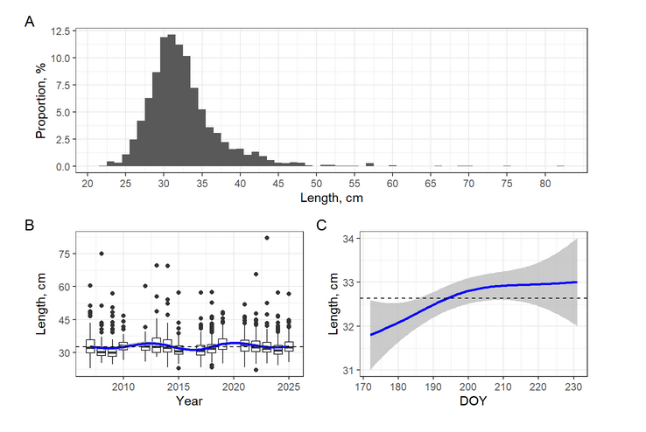
Fig. 2. Total size composition of cod catches during the period 2007-2025 y. (A), long-term (B) and seasonal (C) dynamics of mean fish length in catches from Chupa Inlet (Model 1) . The dashed line represents the long-term mean fish length.

The mean size of cod in samples from different years ranged from 31.4 to 34.6 cm, and individuals of the size class 30-35 cm consistently dominated the catches each year. No long-term trend in the size structure of cod catches from Chupa Inlet was detected (Fig. 2B). Interannual fluctuations in mean fish length relative to the long-term mean value (32.6 cm, SD = 5.05) were statistically significant (Table 2) but small in absolute terms.
Table 2. Parameters of the generalized additive model (Model 1) describing the long-term and seasonal variability of mean cod length in catches from Chupa Inlet.

Smoother term | edf | ref.df | F | p-value
s(Year) | 7.5 | 8.4 | 6.4 | <0.001
s(DOY) | 1.9 | 2.4 | 3.3 | 0.030

The results of the analysis of Model 1 (Table 2), which describes the relationship between fish length and capture date, revealed a small but statistically significant increase in the mean length of cod in catches during the summer period (Fig. 2C). This is evidently related to fish growth over the course of the studied feeding period.
The sex ratio was characterized by a predominance of females (67%), with female dominance observed in all years of the study. The results of the analysis of Model 2 showed no significant seasonal dynamics (June-August) in the frequency of females occurrence.

Stomach content analysis
Table 3 presents the overall diet composition of cod in Chupa Inlet over the studied period. The predator's feeding spectrum included representatives of four groups of prey organisms (crustaceans, polychaetes, fish, and echinoderms). A total of 28 prey items were recorded in the cod's diet. According to the data summarized for all years of observation, fish and their eggs constituted the most important component of the cod's diet during the summer months (77% by frequency of occurrence and 82% by mass). Among fish, the cod predominantly consumed the three-spined stickleback (46% by frequency of occurrence and 33% by mass), which was the major component of the cod diet. Herring, as well as the eggs of fish (lumpfish, herring, stickleback) that spawn in June-July in the coastal zone, also constituted a substantial portion of the cod's diet (Table 3). The remaining nine fish species found in the predator's stomachs played no significant role in its summer feeding. The second most important group of prey organisms was polychaetes (20.5% by frequency and 11.6% by mass), specifically the nereids Alitta virens and Nereis pelagica. The contribution of each of the remaining invertebrate groups (crustaceans and echinoderms) to the cod's diet was negligible (<3% by mass). Highly digested remains of fish and crustaceans constituted an insignificant proportion of the total mass of food consumed by cod.
The number of species comprising the diet varied among years. However, the observed variations were primarily associated with organisms that did not play a significant role in the predator's feeding. The highest number of prey species (21) in the cod's diet was recorded in 2007. No significant long-term trend in the number of prey organisms consumed by cod was observed over the studied period.

Table 3. Total diet composition of cod in Chupa Inlet in June-August of 2007-2025 y. (all stomachs combined), %.

Prey taxon, species | Frequency | Wet mass
Polychaeta, incl.  Alitta virens + Nereis pelagica | 20.46  20.46 | 11.63  11.63
Crustacea, incl.  Sclerocrangon boreas | 9.27  3.32 | 2.86  1.67
Hyas araneus | 0.19 | 0.29
Eualus gaimardii | 3.58 | 0.27
Anonyx nugax | 1.6 | 0.16
Mysidacea | + | +
Pandalus montagui | + | +
Paroediceros propinguus | + | +
Pagurus pubescens | + | +
Rhachotropis aculeata | + | +
Sabinea septemcarinata | + | +
Crustacea remains  Ophiuroidea, incl. | +  7.42 | +  2.95
Ophiopholis aculeata | 6.65 | 2.72
Ophiura robusta  Holothuroidea, incl. | 0.83  0.06 | 0.23  0.02
Ekmania barthii  Pisces, incl. | 0.06  77.24 | 0.02  82.54
Gasterosteus aculeatus | 46.29 | 32.84
Clupea pallasii marisalbi | 7.03 | 15.28
Fish eggs | 16.43 | 13.9
Ammodytes marinus | 3.71 | 4.32
Lumpenus sp. | 4.28 | 4.14
Gadus morhua marisalbi | 1.73 | 3.21
Limanda limanda | 2.11 | 2.13
Pholis gunnelus | 1.92 | 1.8
Myoxocephalus scorpuis | 1.6 | 1.51
Mallotus villosus | 0.38 | 1.35
Agonus cataphractus | + | +
Cyclopterus lumpus | + | +
Fish remains | 3.39 | 1.9
Note: "+" indicates values less than 0.1%.

Feeding intensity
The proportion of fish with empty stomachs over the entire study period was 25%. The feeding intensity of cod varied both within the summer season and among individual years of observation. As the analysis of the constructed Model 3 showed, both the long-term and seasonal dynamics of the frequency of specimens with empty stomachs were statistically significant (Table 4).
Table 4. Parameters of the additive model (Model 3) describing the dynamics of the frequency of occurrence of fish with empty stomachs in Chupa Inlet.

Smoother term | edf | ref.df | Chi.sq | p-value
s(Year) | 7.3 | 8.2 | 33.6 | <0.001
s(DOY) | 6.9 | 7.9 | 68.4 | <0.001
s(TL) | 3.3 | 4.2 | 5.4 | 0.286
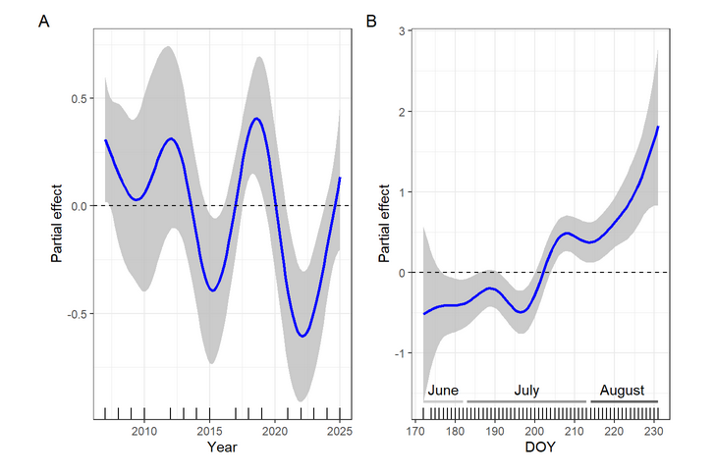
Fig. 3. Long-term (A) and seasonal (B) changes in the frequency of occurrence of fish with empty stomachs in Chupa Inlet (Model 3). Here and throughout, the horizontal dotted line represents a partial effect of zero, corresponding to the adjusted mean of the dependent variable (i.e., the mean after removing the influence of all other covariates in the model). Positive partial effects indicate values above the adjusted mean; negative partial effects indicate values below the adjusted mean. The gray area around regression line represents 95% confidence interval.
Visualization of Model 3, which describes the variability in the frequency of occurrence of "hungry" individuals, is shown in Fig. 3. Throughout the long-term monitoring period, "well-fed" years (2015, 2021-2023) were identified for cod, during which the proportion of fish with empty stomachs (on average 15%) was significantly lower compared to other study years (Fig. 3A). During the remainder of the study period, "hungry" cod individuals occurred much more frequently in the catches. For example, in the 2007 catches, such individuals accounted for 36%.
Seasonal changes in the feeding intensity of cod consisted of an increase in the proportion of fish with no food in their stomachs toward the end of summer (Fig. 3B). A decrease in feeding intensity was observed from the end of July onward, with the occurrence of feeding fish being even lower in August. No relationship was found between the frequency of occurrence of "hungry" fish in the catches and their body length (Table 4).

Dynamics of food weight
The parameters of Model 4, which describes the dynamics of food mass in cod stomachs over the observation period, are presented in Table 5. The constructed model revealed long-term dynamics in the total mass of all organisms found in the stomachs (Fig. 4A). The total amount of food consumed was maximal in those years when the proportion of individuals with empty stomachs in the catches was the lowest. These data confirm the above-reported occurrence of "well-fed" and "hungry" years for cod over the monitoring period. No seasonal dynamics of food weight in cod stomachs was detected (Table 5). As expected, the relationship between food weight and fish size was positive and statistically significant (Fig. 4). The food mass consumed by cod exceeded the long-term mean value when the fish were over 35 cm in body length.
Table 5. Parameters of the additive model (Model 4) describing the dynamics of total food weight in cod stomachs from catches in Chupa Inlet

Smoother term | edf | ref.df | F | p-value
s(Year) | 6.8 | 7.9 | 4.6 | <0.001
s(DOY) | 1.9 | 2.4 | 1.2 | 0.333
s(L) | 3.7 | 3.9 | 37.9 | <0.001

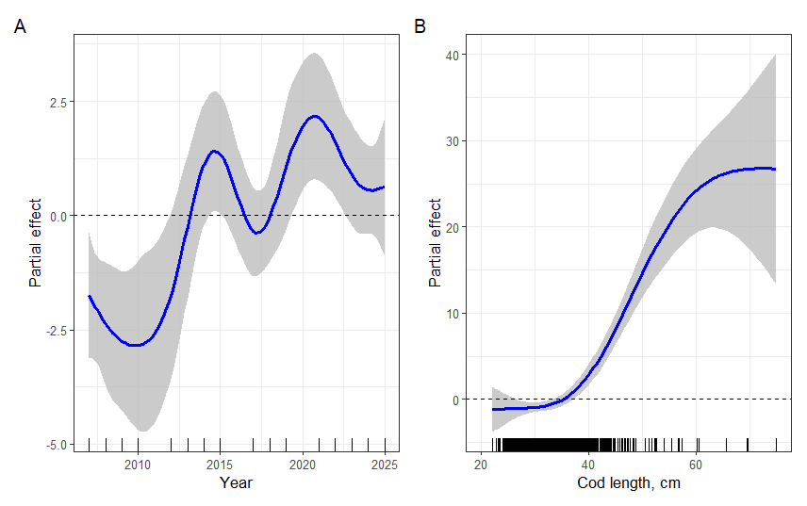
Fig. 4. Long-term dynamics of total food weight (A), relationship between food weight in cod stomachs and predator size (B) in Chupa Inlet (Model 4).

Dynamics of prey occurrence

Influence of predator size
Analysis of the constructed Model 5 revealed a relationship between the frequency of occurrence of the five most important prey items (stickleback, herring, fish eggs, nereids, ophiuroids) and the size of the predator (Table 6, Fig. 5). The obtained results indicate a species-specific nature of the detected relationship. The three-spined stickleback was more frequently encountered in the diet of medium-sized fish (30-45 cm), whereas smaller cod measuring 22-30 cm rarely fed on adult stickleback. Herring was recorded predominantly in the diet of large cod individuals. The remaining prey items (nereids, ophiuroids, fish eggs) were observed mainly in the diet of fish with a body length of 20-30 cm. Thus, the degree of consumption of individual prey items depended on the size of the predator itself.

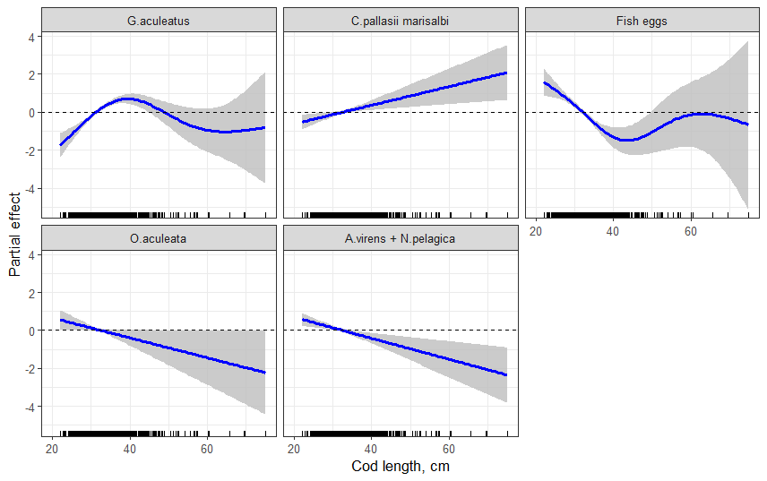
Fig. 5. Relationship between the probability of occurrence of the main prey items and cod size from catches in Chupa Inlet.
Table 6. Parameters of the additive model (Model 5) describing the long-term and seasonal dynamics of the frequency of occurrence of the most important prey species in cod stomachs and the relationship between the frequency of their occurrence and cod size..
Smoother term | edf | ref.df | Chi.sq | p-value
s(Year): G.aculeatus | 2 | 2.4 | 8.7 | 0.018
s(Year): C.pallasii marisalbi | 4 | 4 | 41.8 | <0.001
s(Year): Fish eggs | 1 | 1 | 4.3 | 0.039
s(Year): O.aculeata | 1 | 1 | 0.4 | 0.508
s(Year): A.virens+N.pelagica | 3.9 | 4 | 78.9 | <0.001
s(DOY): G.aculeatus | 3.1 | 3.6 | 99.3 | <0.001
s(DOY): C.pallasii marisalbi | 2.9 | 3.4 | 18.7 | 0.001
s(DOY): Fish eggs | 3.2 | 3.6 | 71.2 | <0.001
s(DOY): O.aculeata | 3.4 | 3.8 | 14.6 | 0.004
s(DOY): A.virens + N.pelagica | 4 | 4 | 82.5 | <0.001
s(L): G.aculeatus | 3.3 | 3.8 | 68.3 | <0.001
s(L): C.pallasii marisalbi | 1 | 1 | 7.8 | 0.005
s(L): Fish eggs | 3.4 | 3.8 | 56.7 | <0.001
s(L): O.aculeata | 1 | 1 | 4 | 0.045
s(L): A.virens+N.pelagica | 1 | 1 | 10.2 | 0.001

Intra-seasonal cod diet variability
The results of the analysis of Model 5 revealed changes in the frequency of occurrence of prey organisms constituting the core of the cod's diet during the summer season (Table 6, Fig. 6). The graphs presented in Fig. 7 show seasonal changes in the proportions by weight of the most important prey items in the cod's diet over the summer. In the first half of summer, cod actively fed on stickleback, which spawns in shallow waters during this period. This species constituted a substantial proportion (approximately 40% by mass) of the diet of cod caught from mid-June to the end of the second decade of July. A decrease in the level of stickleback consumption occurred at the end of July (30% by mass), and by mid-August adult stickleback almost completely disappeared from the predator's diet. Young-of-the-year stickleback were very rarely found in the stomachs of adult cod in August. In addition to stickleback, nereids (up to 20% by mass) and fish eggs (20%) of species spawning in June-July (stickleback, lumpfish, herring) also played an important role in cod feeding from late June to early July. The proportion of fish eggs in the cod's diet decreased by mid-July (8%), which is primarily associated with the completion of mass spawning of stickleback. However, fish eggs continued to occur in small quantities in the cod's diet until early August. In the second half of summer, as stickleback moved away from the coast, cod switched to feeding on herring (Fig. 6, 7) and juveniles of other fish species. Furthermore, the proportion of nereids in the cod's diet increased in August.

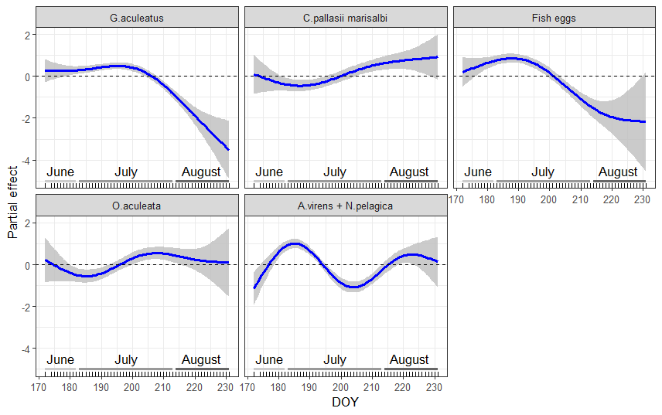
Fig. 6. Relationship between the probability of occurrence of the main prey items in cod stomachs and date of fish capture (DOY) in Chupa Inlet.

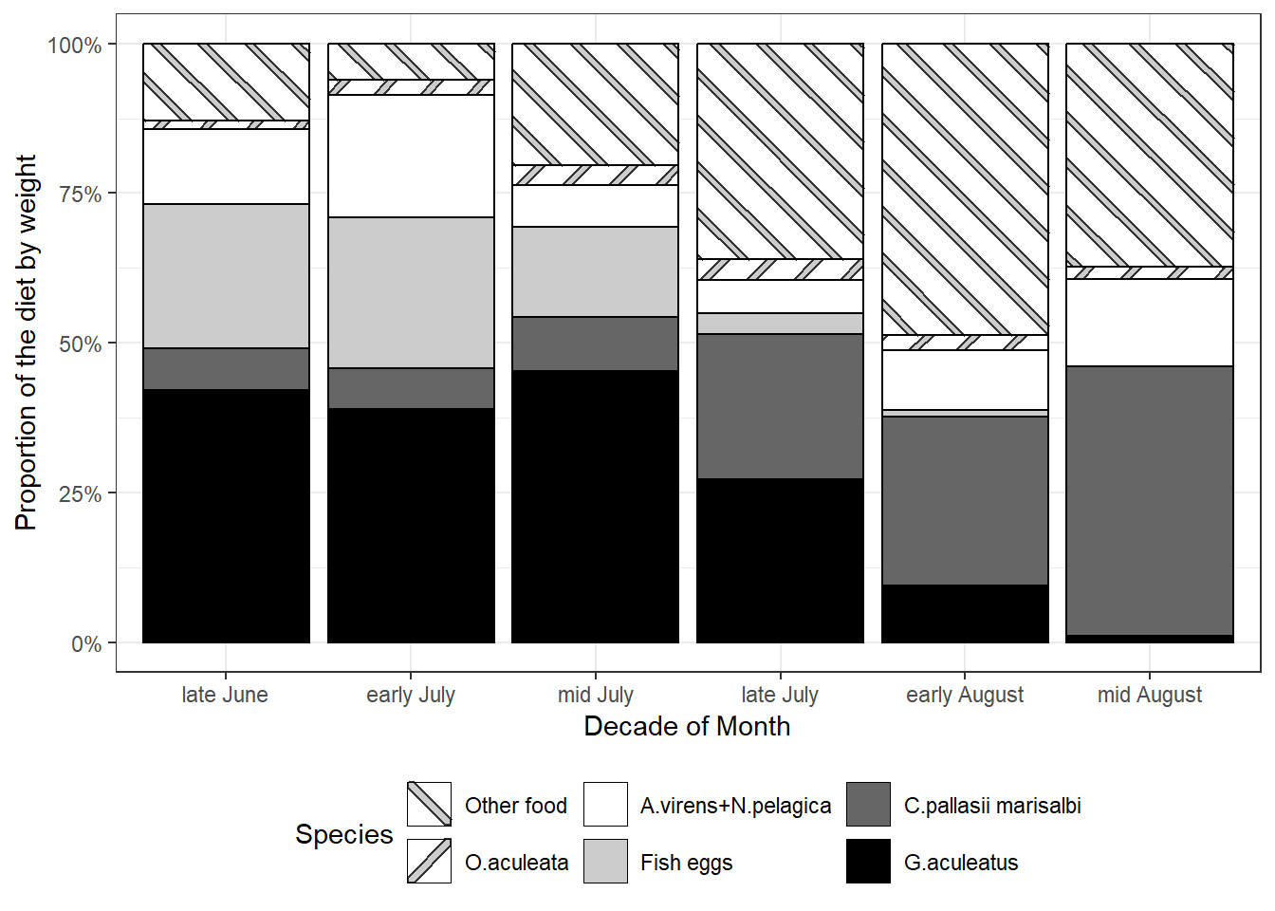
Fig. 7. Seasonal dynamics of the proportions by weight of the main food items in the stomachs of cod caught by summer in Chupa Inlet

Inter-annual cod diet variability
Using Model 5, the long-term variability in the frequency of occurrence of prey constituting the core of the predator's diet during the summer period was analyzed (Table 6, Fig. 8). Fig. 9 presents graphs of long-term changes in the proportions by weight of the most important prey items in the summer diet of cod. The data showed a clear dominance of stickleback in the cod's diet throughout almost the entire observation period. The frequency of occurrence and the proportion of this species fluctuated within narrow limits around the long-term mean values. A slight decrease in the proportion of stickleback was observed only in 2025. Herring was another important prey item throughout the entire monitoring period. The graphs reveal long-term dynamics in the occurrence of herring in cod stomachs. In certain years (2012, 2021-2022), cod consumed more herring than in the remaining years of observation (Fig. 8). Fish eggs also played a significant role in cod feeding during the studied period. The frequency of occurrence of this prey type increased somewhat in recent years, while its proportion by mass showed little interannual variation overall. Nereids constituted a minor proportion of the cod's diet in 2007-2014, whereas in 2023-2024 their role increased slightly. Ophiuroids occupied a small and relatively stable proportion of the cod's diet throughout almost the entire monitoring period.

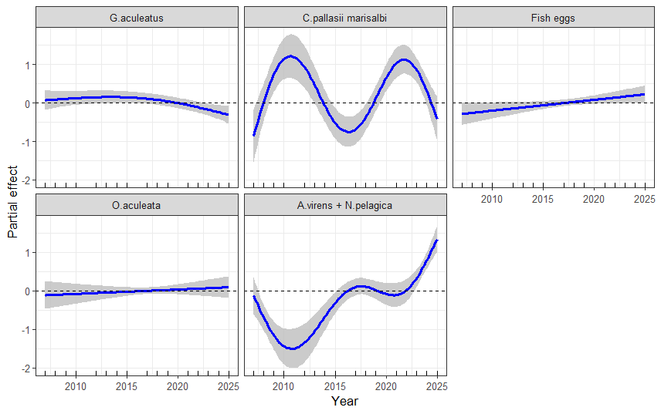

Fig. 8. Relationship between the frequency of occurrence of the main prey items in cod stomachs and year of fish capture in Chupa Inlet.

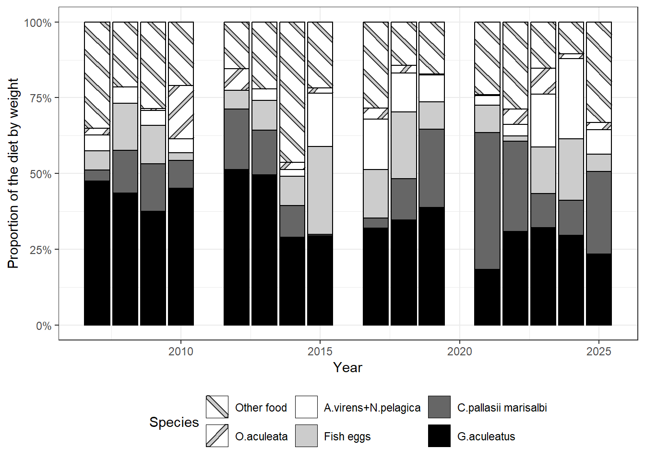

Fig. 9. Interannual variations in the proportions by weight of the main prey items in the stomachs of cod, caught by summer in Chupa Inlet.

DISCUSSION
Throughout its life, cod inhabits many inlets of the Kandalaksha Bay of the White Sea with diverse environmental conditions. It has previously been shown that White Sea cod is an omnivorous species feeding on fish and a large array of other prey items (Yevropeytzeva 1937; Sonina 1957; Izvekova 1964; Kudersky 1966). The highest number of prey species found in cod stomachs was 79 and was recorded for fish caught in the Velikaya Salma region (Kandalaksha Bay) in the 1960s (Izvekova 1964). According to our data (2007-2025 y.), the dietary spectrum of cod in Chupa Inlet was considerably narrower, rarely exceeding 20 species. Although cod feeds on many taxa, relatively few make up the majority of the diet. Overall, the diet of cod in Chupa Inlet was dominated by fish and their eggs (>80% by weight), with polychaetes being the most important invertebrates. These two prey categories ranked first and second in the cod diet throughout our monitoring period.

Ontogenetic diet changes
The main trend in the ontogenetic shift in cod diet is a gradual decrease in benthic invertebrates and a corresponding increase in the proportion of fish and the size of fish prey consumed (Link and Garrison 2002; Dalpadado and Bogstad 2004; Smith et al., 2007; Michalsen et al., 2008; Yaragina et al., 2009; Holt et al., 2019). White Sea cod begins to actively feed on fish, particularly stickleback, upon reaching 25 cm body length (Yevropeytzeva 1937; Kudersky 1966; present data). Our data agree with published reports from other parts of the species' range: larger individuals consumed more fish, and the size of prey fish (herring, cod, shorthorn sculpin) also increased with predator size. The ontogenetic shift is clearly evident when comparing our results with data on immature cod of small size classes (Bakhvalova et al., 2016; Boeva et al., 2024).

Factors of seasonal diet variation
Since our long-term study was conducted in a single and small area of Chupa Inlet, the obtained results cannot be explained by spatial variability. The observed shifts in diet composition are therefore primarily attributable to the dynamics of abundance and availability of prey items (fish and polychaetes) that formed the basis of the cod's summer diet. Among fish, stickleback plays the primary role in the observed changes in cod diet during summer feeding. This small pelagic fish migrates in large swarms from the open sea to coastal areas in late May–early June to spawn. Spawning occurs from June to mid-July in beds of eelgrass Zostera marina (Linnaeus, 1753) or among fucoid seaweeds (Mukhomedyarov, 1966; Bakhvalova et al., 2016; Ivanova et al., 2016). According to our results, adult cod intensively consumes mature stickleback at spawning grounds and adjacent areas, where this prey forms dense aggregations. Consumption of this high-calorie prey in large quantities during June and July is important for replenishing energy reserves depleted during the winter-spring period and spawning, as well as for growth. From mid-July, post-spawning migration of stickleback to open sea begins, and its importance in cod feeding gradually declines; by mid-August, this species almost disappears from the cod's diet. In addition to adult stickleback, fish eggs contributed significantly to cod feeding in June and early July, predominantly stickleback eggs, the total biomass of which is very high at mass spawning sites (Refs). Active consumption of stickleback eggs by cod during stickleback spawning has been reported previously (Sonina 1957; Bakhvalova et al., 2016, 2017). To a lesser extent, cod feeds on the eggs of herring and lumpfish, which spawn in shallow waters in early summer (Parukhina 2005; Ershov 2010; Kozminsky and Yershov 2024). As the role of stickleback and fish eggs decreases, the proportion of herring in the cod's diet increases in the second half of summer. According to our observations, in August, herring periodically enters coastal areas of Kandalaksha Bay for feeding and becomes a prey item for cod.

Comparison with published data on the seasonal diet of cod from the same area of Chupa Inlet (Bakhvalova et al., 2016) revealed substantial differences. Those authors collected samples only in small shallow Seldyanaya Bight, whereas our collections covered a larger area (approximately 1.5 km of coastline with varying depths) to sample mature cod in typical feeding locations. Our results demonstrated a greater importance of the fish component (stickleback, other fish, fish eggs), while Bakhvalova et al. (2016) reported significant dietary importance of small invertebrates (polychaetes, crustaceans) alongside stickleback and its eggs. Partial agreement was observed only for the proportion of adult stickleback in early July. The smaller mean fish size (22 cm) studied by Bakhvalova et al. (2016) likely explains these differences. Immature White Sea cod (15-25 cm) feed primarily on small benthic organisms (Yevropeytzeva 1937), and the transition to piscivory on adult stickleback (mean length 7.2 cm; Yershov and Sukhotin 2015) occurs mainly upon reaching 25 cm (Kudersky 1966). Similar size-dependent predation has been reported for Northeast Arctic cod on herring in the Barents Sea - fishes L<25 cm rarely consumed juvenile herring (Johansen 2003). According to Bakhvalova et al. (2016, 2017), stickleback eggs dominated the June diet (50-90% by mass), while adult stickleback accounted for only 10-20%, likely due to insufficient mouth gape size in small cod (Scharf et al., 2000). The greater proportion of invertebrates in their study may also reflect smaller cod size. In contrast, our material showed dominance of adult stickleback in the diet of adult cod (L>25 cm) in early summer, with fish eggs playing a secondary role.

Regarding other prey, Bakhvalova et al. (2016) and Boeva et al. (2024) reported that small cod in the estuarine part of Chupa Inlet consumed substantial amounts (up to 50% by mass) of young-of-the-year stickleback and polychaetes in August. However, these prey were not significant in the diet of adult cod in our study. These differences highlight the importance of spatial scale: at shallow depths (3-5 m) juvenile cod predominate, while adult fish (L>25 cm) inhabit deeper areas (15-20 м), periodically entering shallow waters to feed. Aggregations of small cod in Seldyanaya Bight are associated with the large stickleback spawning ground there, which determines the local feeding habits of cod. However, the diet of adult cod across a larger area with different habitats will obviously differ, as our research has shown.

Regarding the summer dynamics of polychaetes (Nereididae) in the cod diet, two periods (early July and mid-August) were identified when consumption of this prey category was significantly higher. Since species identification of nereids was not performed, this increase most likely reflects seasonal dynamics in the abundance of spawning epitokous Alitta virens and Nereis pelagica. Outside the reproductive period, these polychaetes inhabit burrows that they construct in the silty-sand sediment layer (Rasmussen, 1973), making them inaccessible to cod. Mass reproduction of A. virens in the White Sea occurs in early summer (Khlebovitch, 1963), explaining the first peak. No mass appearance of epitokous forms of this species occurs in the second half of summer. The biology of N. pelagica in the White Sea remains largely unstudied; however, we do not exclude the possibility that the two nereid peaks observed in the cod diet are associated with different reproductive periods of the two worm species.

Thus, adult cod exhibits clear changes in summer diet composition in Chupa Inlet, primarily associated with seasonal dynamics of stickleback and herring migrating into coastal waters for spawning and feeding, as well as with nereids forming dense aggregations during reproduction. The mass arrival of stickleback in late May-June leads to a shift of cod feeding toward predominantly this prey. As a result, a stable cod-stickleback food link formed in coastal ecosystems that function for nearly two months. Cod feeds on adult stickleback and the eggs of stickleback, herring, and lumpfish. Nereids during mass spawning are also a preferred prey. Under conditions of high prey abundance, cod consumes other benthic invertebrates (echinoderms, crustaceans) only in small quantities. After stickleback spawning and its migration away from shore (August), cod switches to herring and juveniles of other fish, as well as crustaceans and ophiuroids. Under fish prey scarcity, cod consumes greater quantities of polychaetes, crustaceans, and even low-calorie ophiuroids. Rapid switching from piscivory to alternative prey is a characteristic feature of the foraging strategy of White Sea cod under conditions of unstable food supply. Another feature of the cod's foraging strategy in this part of its range is constant shuttle movements from depths of 15-20 m to shallow areas of the upper sublittoral and back in search of food, allowing more complete utilization of limited coastal food resources. As a visual predator (Refs) that responds to prey movement, cod consumes primarily fish, nektonic invertebrates, and epibenthic infaunal prey, preferentially selecting larger individuals.

Long-term diet variation
Long-term observations on cod diet composition are of great importance for understanding the dynamics of trophic relationships in coastal ecosystems of the White Sea. Over the last century, three-spined stickleback abundance in the White Sea has undergone large-scale long-term fluctuations (Berger 2007; Lajus et al., 2013), which were likely related to climate change in this region (Lajus et al., 2020a). Fluctuations in stickleback abundance have led to corresponding changes in food webs within coastal and pelagic communities. During periods of high stickleback abundance (1920s-1950s), this species was a significant prey for cod and shorthorn sculpin in different parts of Kandalaksha Bay, whereas during periods of population depression (1960s-1990s), it was absent from their diet (Marimon 1988; Poltermann 1992; Parukhina 2005). In the late 1990s, a gradual increase in stickleback abundance began, and by 2007-2008 this species had again become a dominant component in the summer diet of cod and shorthorn sculpin (Ershov 2010; Yershov 2010). Our monitoring results (2007-2025) demonstrate that throughout this period the trophic link between cod and stickleback has been the primary one for the predator during summer feeding in Chupa Inlet. There is no consistent interannual trend in the change in the dominant position of the stickleback in the diet of adult cod was observed. It has previously been shown that consumption of a given prey species by cod is generally proportional to its abundance in the environment (Fahrig et al., 1993; Link et al., 2009). The stability of the cod-stickleback trophic link in Chupa Inlet therefore reflects the high abundance of this prey in the White Sea over the last two decades. Importantly, the mean level of stickleback consumption during our observation period was similar to data from the first half of the 20th century (Yevropeytzeva 1937; Sonina 1957), when stickleback abundance was high. In this regard, we suggest that the general feeding patterns described here are also characteristic of other inlets of Kandalaksha Bay where stickleback spawns in large numbers in aquatic vegetation beds. Regarding other fish prey, the increased level of herring consumption by cod in certain years was most likely due to its mass arrivals in coastal waters of Chupa Inlet in the second half of summer. No consistent dynamics in the occurrence of invertebrates or fish eggs were observed throughout the study period; some interannual fluctuations were likely related to spatial heterogeneity of species composition of biocenoses at different feeding grounds.

Conclusion
The surge in stickleback population abundance at the beginning of the 21st century, following a 50-year absence of this species from the ecosystem, led to a significant and rapid restructuring of cod's trophic relationships that had existed in previous decades in the coastal areas of Kandalaksha Bay. Adult cod (L>25 cm) began to predominantly consume stickleback spawning near shore in June-July, as was noted by researchers in the period 1920s-1950s.. Stickleback has dominated the summer diet of adult cod for nearly 20 years (2007-2025), due to its high abundance, caloric value, and availability at spawning and feeding grounds. Changes in cod diet during the summer season are closely related to the dynamics of adult stickleback abundance at spawning grounds and its post-spawning spatial distribution in coastal areas. The key trophic interaction established between the two most abundant fish species in Kandalaksha Bay evidently plays a significant role in coastal ecosystem functioning, related to the summer utilization of a substantial portion of matter and energy transported by stickleback from open sea into coastal ecosystems. Further research on changes in trophic relationships among different aquatic species in the coastal zone will allow a better understanding of processes occurring in marine ecosystems under conditions of increased stickleback abundance in the White Sea.

