Two lineages of blue mussel transmissible neoplasia (MtrBTN1, MtrBTN2) respond differently to local environmental gradients and exert different effects on the reproduction and growth of their hosts.
Abstract (150 words).
Transmissible cancers, the malignant cell lineages that metastasize between individuals through the transfer of living cancer cells, are compared to parasitic species. Within the framework of this hypothesis, different cancer lineages must manipulate their hosts and possess distinct ecological phenotypes. Here, we test these predictions using two lineages of blue mussel transmissible neoplasia (MtrBTN1, MtrBTN2) parasitizing Mytilus trossulus in the Sea of Okhotsk. The prevalence of MtrBTN1 correlated positively with wave exposure, distance from the harbour, lifetime growth rates and abundance of old mussels, while the prevalence of BTN2 varied insignificantly against all predictors but growth rate. Conclusions on higher eurybionticity of MtrBTN2 fits knowledge on its wider geographic distribution and range of host species. Both lineages reduced the host's fertility, but MtrBTN2 did so from earlier stages of the disease and, unlike MtrBTN1, stimulated mussel growth. Thus, the two cancers follow different parasitic strategies, with the MtrBTN2’s strategy resembling parasitic castration accompanied by a host’s gigantism.

Intro
Clonally transmissible cancer (CTC) is a neoplastic disease passed from individual to individual by transfer of living cancer cells (Murchison 2008). Thirteen such cancers are known, the Canine transmissible veneral tumour (CTVT) in domestic dogs (Murgia et al., 2006; Rebbeck et al., 2009), two independently evolved lineages of Devil facial tumour disease (DFTD1, DFTD2) in Tasmanian devils Sarcophilus harrisii (Pearse & Swift, 2006, Pye et al., 2016), and 10 lineages of Bivalve transmittable neoplasia (BTN), including three cases when two lineages derived from the same species, in marine bivalves (Metzger et al. 2015, 2016; Garcia-Souto et al. 2022; Michnowska et al., 2022; Yonemitsu et al., 2019, 2025). CTVT and DFTDs are solid tumors and cancer cells are transmitted between animals through sexual contacts and biting, respectively. BTN is a hemolympharic cancer, or disseminated neoplasia (DN) (see references above). Under DN, the disease primarily affects the hemolymph but eventually infiltrates all tissues and organs (Carballal et al. 2015; Odintsova 2020). The cancerous cells - neoplastic hemocytes - are passed between molluscs through water column where cells survive for days and even weeks (Burioli et al., 2021; Giersch et al., 2022). In addition, vertically transmitted cancers are known in cnidarian Hydra oligactis when cancer cells are transmitted through the asexual reproduction of its host, by budding (Domazet-Lošo et al. 2014; Tissot et al. 2024).
Transmissible cancers are basically asexual but may be prone to horizontal transfer of mtDNA from their hosts (Rebbeck et al. 2011; Yonemitsu et al. 2019; 2025; Bruzos et al. 2023), and even nuclear DNA, as have been shown in a recent CTVT study (Gori et al. 2025). The estimates of evolutionary age are available for CTVT, 4 to 8.5 thousand years (Baez-Ortega et al., 2019), DFTD1 and DFTD2, about 40 and 15 years respectively (Stammnitz et al. 2023), and BTN of soft shell clam Mya arenaria, several hundred years (Hart et al. 2023). Fatal outbreaks of CTC were recorded in molluscs (mya story - Weinandt et al. 2024; Skazina et al. 2023b – что церастодерма?) and in devils (Cunningham et al. 2021). The later may be explained by the young age of DFTD lineages, hence short history of host-pathogen coevolution (Storfer et al. 2025 and references therein).
СТС is a distinct modality of the infectious agent (Metzger, Goff 2016). Like any parasites, transmissible cancers may manipulate their hosts i.e. to change the host’s phenotype in order to increase the parasite fitness (Tissot et al. 2016). Convincing evidence in support of this hypothesis has been obtained for vertically transmitted cancers in Hydra: the cancer triggers the growth of additional tentacles in their hosts, which provides the host with higher foraging efficiency and the cancer itself with increased proliferation (Boutry et al. 2025). One potential example of host’s manipulation by horizontally transmissible cancer will be given below.
It is obvious CTC lineages can be interpreted as species (e.g. Vincent 2010; Ujvari et al. 2016), but their supposed ephemerality prevents most experts from recognizing them species as a matter of fact (e.g. Metzger, Goff 2016; Leathlobhair, Lenski 2022). Taking this controversial stance - that CTC lineages are species, and adopting the idea that different species should have different “ecological niches” (Van Valen 1976) - we arrive at a testable hypothesis: they must possess unique ecological phenotypes, and exert differential effects on their hosts. The best models for studying ecological distinction of CTC lineages are “twin lineages”, different lineages derived from the same hosts, in sympatry. Comparative ecological data on such lineages are scarce, which is partly due to their recent discovery in devils and bivalves and by the methodological difficulties of diagnosing BTN (Skazina et al. 2023a, Skazina et al. 2023b). Based on indirect evidence—features of metabolism and proliferation in cell culture of DFTD1 and DFTD2, the second, more young, lineage is more aggressive (Gérard et al. 2024; Gérard et al. 2026). For BTN, the best studied are the blue mussel Mytilus trossulus derived lineages, MtrBTN1 and MtrBTN2, which are the subjects of the present study.
Что накопали про мию?
The age MtrBTN1 and MtrBTN2 is not known for certain. According to limited molecular data, their age appears to be similar and closer to the age of Mya BTN than to CTVT or DFTD (Yonemitsu et al. 2019; Buriloi et al. 2023). MtrBTN1 parasitizes its parent species, M. trossulus, and is distributed in the northern Pacific Ocean and European subarctic. MtrBTN2 parasitizes three other species of Mytilus in addition to M. trossulus and has a broad range in the temperate seas of the Atlantic and Pacific Oceans in both hemispheres. In Europe, its range extends from the Mediterranean Sea to the subarctic and covers the temperature ranges of three host species (Hammel et al. 2022; Skazina et al. 2023a; Skazina et al. 2023b). The geographically disjunct distributions of MtrBTN1 and MtrBTN2 are explained through anthropogenic introductions, together with diseased mussels in the fouling of ship hulls (Yonemitsu et al. 2019; Skazina et al. 2023b). To sum up, according to available data, the MtrBTN2 is more eurybiontic than MtrBTN1 both in respect to host genotypes and abiotic environment.
While nothing is known about MtrBTN1 beyond its geographic distribution, progress has been made in understanding the ecology of MtrBTN2 due to studies of Bouroli et al. 2021 and Hammel et al. 2024. Both studies were conducted on the Atlantic coast of France, where the M. trossulus-derived MtrBTN2 parasitizes M. edulis and M. galloprovincialis and exhibits a low overall prevalence of about five cancerous mussels per thousand (Hammel et al. 2022). Hammel et al. (2024) studied the spatial ecological patterns of MtrBTN2 prevalence, taking into account mussel density, species identity, and a set of environmental predictors, including surf intensity and proximity to ports. They found similar cancer prevalence in both species, and a higher prevalence in ports. The latter result can be explained both by ports serving as epidemiological hubs through the transport of affected mussels in the fouling of ships' hulls, and by the conditions within ports, including increased mussel density, reduced surf intensity and high levels of anthropogenic pollution (Hammel et al. 2024). Of note, the idea of increased DN prevalence in anthropogenically polluted habitats was considered in old studies of the disease predating the BTN discovery and assuming that it is directly provoked by carcinogens. No convincing evidence was obtained however (Barber 2004; Carballal et al. 2016).
Что recent review of Bramwell?
Using histological data on control healthy and 16 MtrBTN2-infected M. edulis sampled through different seasons, Burioli et al. (2021) demonstrated lack of ripe gametes in most cancerous mussels and suggested that MtrBTN2 inhibit hosts gametogenesis since early stages of disease. They hypothesize that MtrBTN2 follows a parasitic castration strategy, that is, a strategy that requires the eventual intensity-independent elimination of host reproduction as the primary means of acquiring energy for parasite (Lafferty, Kuris 2002). Given the limited material in Burioli et al. (2021) study, their inspiring hypothesis cannot be considered definitively proven. As the disease progresses, BTN colonizes all organs and tissues of the mussel, including the gonads (Carballal et al. 2016; Odintsova 2020), and inevitably negatively affects the mussel's health. It is unclear whether the "castration" in this case is an adaptive strategy of the parasite, rather than a secondary outcome of infection with no adaptive value.
Recently, the MtrBTN1 and MtrBTN2 were found in sympatry in M. trossulus in Taui Bay of the Sea of Okhotsk, with cumulative prevalence of about 5% (Skazina et al. 2023a). Here we use this model, the co-infected Taui Bay mussel populations, for a comparative ecological study of the two lineages. Our questions are as follows. What are the patterns of MtrBTN1 and MtrBTN2 prevalence between mussel populations with different demographics and from different habitats? How these lineages affect mussel's reproduction and growth? By conducting our research, we, firstly, continue the studies of MtrBTN2 initiated by Hammel et al. (2024) and Burioli et al. (2021) in Europe and verify their results in the other ocean on populations of another host species—specifically, the parental species for this cancer. Secondly, we conduct an ecological study of MtrBTN1 for the first time. Finally, we check the hypothesis of individuality of the two lineages. If MtrBTN1 and MtrBTN2 are indeed different parasitic species, then they should respond differently to local environmental gradients and exert different effects on their hosts. Or perhaps theoretical expectations regarding the essence of transmissible cancers as species, as applied to MtrBTN, are exaggerated, and, being recently feral clones of the same cancer, the disseminated neoplasia, without long history of co-evolution with a host and competition with each other, they are indistinguishable ecologically?

**Site Characteristics**

The material was collected from the intertidal zone within Tauiskaya Bay, Sea of Okhotsk, in June 2021 and 2023. Among the 18 surveyed sites, 6 were described twice. In most cases, mussel populations consisted of mollusk patches of varying sizes attached to rock surfaces. Such patches were found both on exposed surfaces of rocks, boulders and stones and in the spaces between them. In some cases, settlements were found exclusively between stones, the surfaces of which remained uncolonized. In a few cases (Ola, Arm, Fig. ++), aggregations formed on the surface of muddy sediment, where mussels created a continuous mat by attaching to one another via byssal threads.

Sites differed markedly in their degree of exposure to wave action. However, other hydrological conditions were broadly similar. Salinity in the area showed no significant variation, ranging from 21.7 to 32 ppm. Only at the mouth of the Arman River (ARM) and Marchikan stream (MAR) salinity being measured during low tide drop substantially (to 6.8 and 16.7 ppm, respectively).

The only major human settlement along the surveyed coastline is the city of Magadan (approximately 90,000 inhabitants). Magadan’s residential districts extend to two bays – Nagaeva Bay to the west and Gertner Bay to the east (Fig. +++). However, the main residential quarters and industrial facilities are located closer to the former. On the eastern coast (at the mouth of the Magadanka River, Fig. ++), an extensive silty-sand beach is presented.
The coastline at the surveyed sites is largely uninvolved in industrial activities, with the exception of a large seaport located in Nagaeva Bay on the western edge of Magadan (Fig. +++).

**Collections for BTN Infection Analysis**

At each site, ++ to ++ large mollusks (shell length ++–++ mm) were collected. In 2021, collections were carried out across the entire area designated for sampling, within a radius of several tens of meters. In 2023, the scheme was modified: within each site, 3–5 small subplots (radius ≤10 m ?), separated from one another by several tens of meters, were established. Collections from each such subplot were treated as separated samples.

**Collections for Mussel Population Structure Analysis**

At each site, three quantitative samples were taken from randomly selected locations. Each sample consisted of all mussels taken from a known area. Samples were placed in plastic bags and transported to the laboratory.

At all sites in both years, overall views of mussel settlements were photographed (Fig. S++). Based on a visual assessment of substrate coverage by mussel aggregations, each site was assigned to one of four classes. The first class included sites where mussel settlements were sparse and covered less than 10% of the substrate area. The fourth class included sites where mussels occupied more than 50% of the bottom surface. Classes 2 and 3 included sites with coverage below and above 25% of the substrate surface, respectively. Next, according to this classification, each site described in a given year was assigned a point-based coverage score. To validate the proposed coverage scale, several tens of surface plots were photographed at each site in 2023. A smartphone mounted on a remotely controlled selfie stick was used for photography. The camera was positioned approximately 2.5 m above the substrate surface.

**Processing of Quantitative Samples**

Samples were washed through a 1 mm mesh sieve. All alive mussels were picked from the samples. Shell length was measured for all collected individuals to the nearest 1 mm.

From several samples, 112 mollusks of varying sizes were selected to determine the relationship between shell length and mollusk weight. The resulting regression equation was used to estimate mollusk biomass reconstructed from the size structure.

**Processing of Photographs**

From the set of shots taken to assess cover by mussel patches at each site, 30 frames were randomly selected. Each selected frame was divided into 100 cells (10 horizontal × 10 vertical rows). Subsequently, 30 cells were randomly selected, and the number of cells in which mussel patches occupied more than a quarter of the cell area was counted. For each frame, the ratio of such cells to 30 was calculated. For all frames taken at a given site, the mean value of this index was calculated and used as an objective characteristic of the cover of mussel patches. These values were then compared with the point-based coverage scores described above.

**Analysis of Mussel growth rate**
+++++++

**Shell increment assessment**
Using the analysis of growth rings described above, we estimated the relative shell length increment in healthy mussels and in individuals infected with different BTN lineages. The increment was measured from the last ring to the shell margin (Fig. ++), representing growth that occurred during the warm periods of 2021 and 2023 prior to mussel collection. These values were then normalized by the total shell length.

**Gonad condition assessment**
+++++++

**Statistical processing**

**Predictor Assessment for Statistical Models**

Population-based predictors included mollusk abundance across different size classes, mussel biomass, and the cover scores. Since all these variables were highly correlated with one another, they were processed using principal component analysis (PCA).
For this analysis the size scale was divided into 5 mm interval classes, and for each class, the mean number of mollusks per three quantitative samples was calculated for each site. The resulting matrix characterized mussel abundance across different sizes within each site. These values, together with mussel biomass (calculated as the mean of three samples) and cover, were used as a matrix of population descriptors, which was then subjected to PCA. The scores of the PC1 and PC2, the most informative principal components, were treated as predictors, characterizing mussel population structure. In addition to PCs we used OGP as an independent biotic predictor.
In addition to biotic predictors described above we used two abiotic ones.The first abiotic predictor was the distance along the shoreline from the Magadan’ seaport to the sampling site. The second predictor of this category characterized the degree of coastal exposure to wave action. For this purpose, the fetch value (+++), which describes the average distance a wind wave can travel from all directions to a given site without encountering geographic obstacles, was used. This value was determined using functions from the “waver” package (Marchand P, Gill D (2023)).

**Statistic model describing dependence of BTN prevalence on predictors**

To analyze the effects of environmental and biotic predictors on the proportion of neoplastic cells in mollusk populations, we employed a binomial Generalized Mixed effect Additive Model (GAMM) with a logit link function (Model 1). To account for lineage-specific responses, separate smooth functions were fitted for each level of the factor “Lineage” for the following continuous predictors: distance from the port (“Dist_Port”), wave exposure (“Fetch”), the first and second principal components of correlated population descriptors (“PC1”, “PC2”), and a proxy for mollusk growth rate (“OGP”). Each smooth term was implemented using a cubic regression spline with a shrinkage basis to allow for potential nonlinear patterns. A parametric term for “Lineage” was also included to assess the differences in intercepts among lineages. To control for unmeasured temporal and spatial variation, we included a smooth random effect which treats the interaction of year and site as a random intercept. The model was fitted using restricted maximum likelihood method. To assess the validity of the Model 1, we performed a residual diagnostic analysis using the DHARMa package (Hartig, 2022). No violations of model assumptions were detected.

**Statistic model describing dependence of shell gonad condition on BTN infection (Model 2)**
Only infected mussels were used for this analysis. The dependent variable in the model was the frequency of grid nodes falling on acini (positive response) versus the frequency of nodes falling on connective tissue (negative response). This value characterizes the acini size relative to the area of the section occupied by connective tissue, i.e., the degree of gonad development. The predictors considered were the cancer cell line (a discrete factor with two levels) and the proportion of aneuploid cells in the hemolymph (a continuous predictor). The latter was used as a proxy for assessing the stage of disease progression. The model also included an interaction term between the predictors. These variables were used to fit a binomial logistic regression model. Additionally, we calculated the mean probability of grid nodes falling on acini for healthy mussels. Confidence intervals for both cases were estimated using the bootstrap method.
The functions from package “sats” ( R Core Team, 2025) and “boot” (Canty, Ripley, 2025) were used for this analysis.

**Statistic model describing dependence of shell increment on BTN infection (Model3)**
The dependent variable in this model was the ratio of last year's increment to mussel size. This value was subjected to Fisher's z-transformation to approximate a normal distribution. The model included a fixed effect of BTN line (BTN_Type, a discrete factor with three levels: healthy, BTN1, and BTN2). To account for the effect of mussel size on the increment, a covariate representing the distance from the shell umbo to the last growth ring (Last_ring) was included in the model. The effect of this covariate was described using a nonparametric smoothing function based on cubic splines, with the shape of the spline allowed to vary depending on the level of the BTN_Type factor. To account for random variation among sites, a random site effect was included in the model. Model parameters were estimated using Restricted Maximum Likelihood ("REML").

Variations in Mytilus trossulus population structure

For SEM
Principal component analysis revealed that the main variation in population structure (PC1, explaining 34.0% of the total variance) was associated with variability in abundance of mussels of different sizes (SFig. ++). The smallest mollusks (size classes L3–L28) exhibited high positive loadings on PC1, whereas the largest mussels (L38–L58) were characterized by high negative loadings on PC1. The second principal component (17.3% of the total variance) was related to variation in mussel coverage (high positive loadings on PC2) and biomass (high negative loadings on PC2). PC2 was also associated with the abundance of intermediate size classes (L28–L38), which showed high negative loadings on PC2.
When ordered according to PC1 scores, the size frequency distributions (SFig. ++) demonstrated a clear gradient. Negative PC1 values corresponded to bimodal distributions with distinct peaks at both high and low sizes. In such settlements, large mollusks generally predominated. Positive PC1 values corresponded to unimodal distributions dominated by small mollusks.
Comparison of PC1 scores between 2021 and 2023 (SFig. ++) indicated a substantial change in this parameter, suggesting significant interannual dynamics in settlement structure. Most settlements resampled in 2023 exhibited marked positive shifts in PC1 values in comparison with 2021 (SFig. ++). Thus, PC1 also characterizes a temporal gradient associated with the transition of settlements from dominance by large, old mussels to dominance by juveniles.

Main text
The most informative first principal component (PC1) characterizes variation in the size-structure of mussel settlements (SEM ++). High negative PC1 values indicate the dominance of large, old mollusks within the settlements. This type of settlement structure was most pronounced at sites MAR_21, VES_21, VES_23, and OLA_23. High positive PC1 values characterize settlements dominated by small mollusks (NUK-1_23, MAM_23, BAT_23, ZHEM_23, TIKH_23).
Variation along PC2 reflects variability in mussel biomass and cover. Settlements characterized by high biomass but low cover exhibit high negative PC2 values. High positive PC2 values are typical for settlements with high cover but low biomass.

BTN prevalence variation
A total of +++ individuals were examined, with sizes ranging from ++ to ++ mm (median ++). Among these, +++ infected individuals were found, with sizes varying from +++ to +++ mm (median +++). The frequencies of both transmissible cancer lineages (BTN1 and BTN2) ranged from 0 (no infected mollusks were found in ++ sites) to +++% (BTN1, site +++) and +++% (BTN2, site ++++). On average, the frequencies of BTN1 and BTN2 were similar, amounting to 2.07% and 2.04%, respectively.
Analysis of the spatial distribution of prevalence revealed highly heterogeneous patterns for both BTN1 and BTN2 (Fig. ++). No significant correlation was detected between the frequencies of the two lineages (Spearman's R = 0.27, p = 0.208, n = 24).



Dependence of BTN prevalences on predictors

Model 1 (Table ++) accounted for 72% of the deviance (adjusted R² = 0.67). Statistically significant associations were found only between BTN1 prevalrnce and distance to port (Dist_Port), wave exposure level (Fetch), and the parameter characterizing the size structure of the mussel settlement (PC1). BTN2 prevalence was not associated with any of these predictors. Additionally, an association was detected between BTN2 frequency and the group growth score (OGP). The association between BTN1 and this predictor was marginally significant.
According to Model 1 (Fig. ++), BTN1 frequency increases linearly with increasing distance to port and increasing degree of coastal exposure. The relationship between BTN1 frequency and PC1 was nonlinear (edf = 2.0, Table ++). Model 1 predicts the highest BTN1 prevalence at the lowest PC1 values. The minimum BTN1 prevalence predicted by Model 1 occurs at PC1 values close to zero. At high positive PC1 values, Model 1 predicts a slight increase in BTN1 frequency. Both lineages exhibit a near-linear positive relationship with OGP.

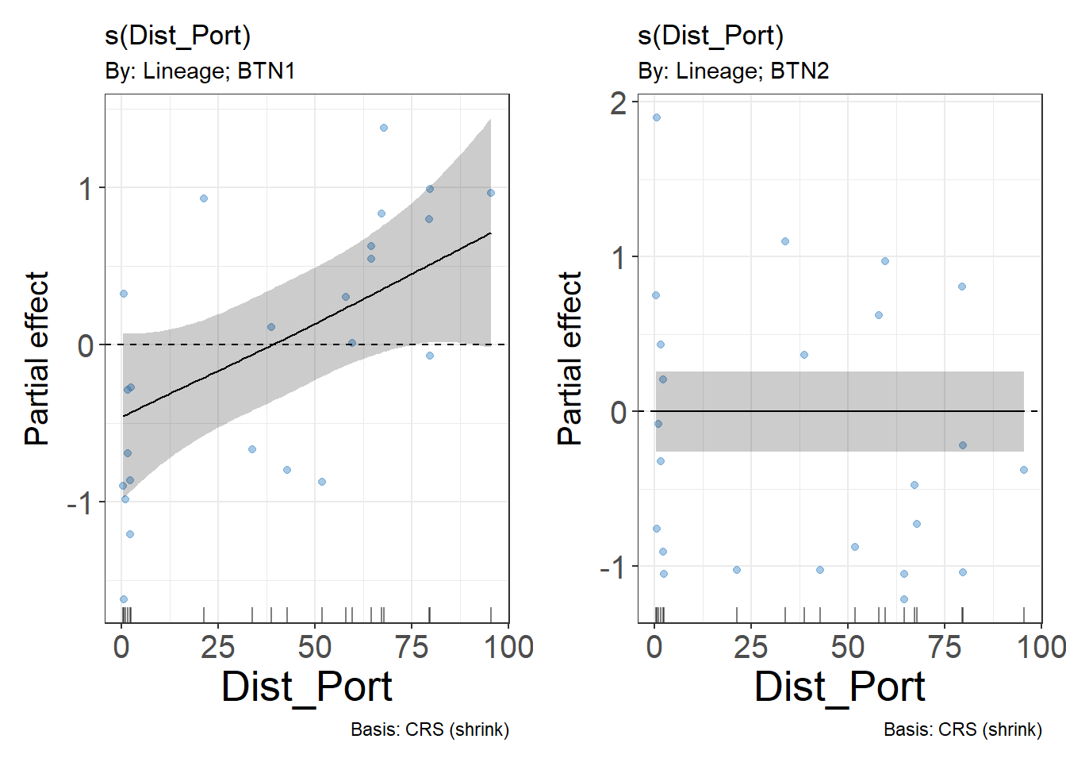

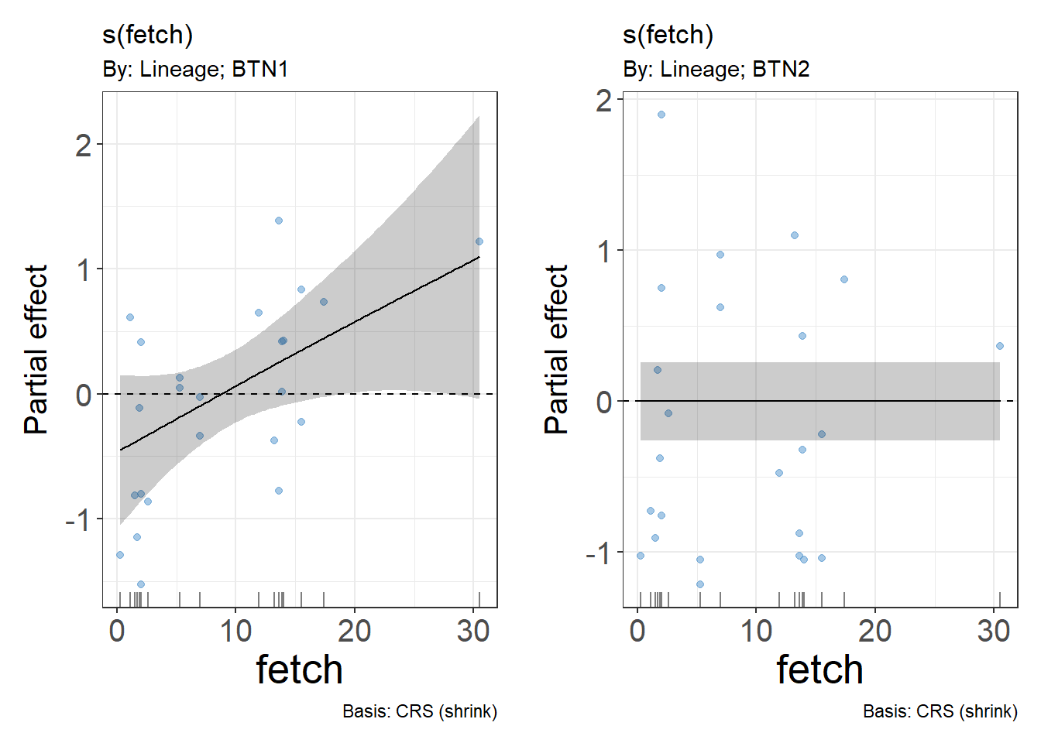
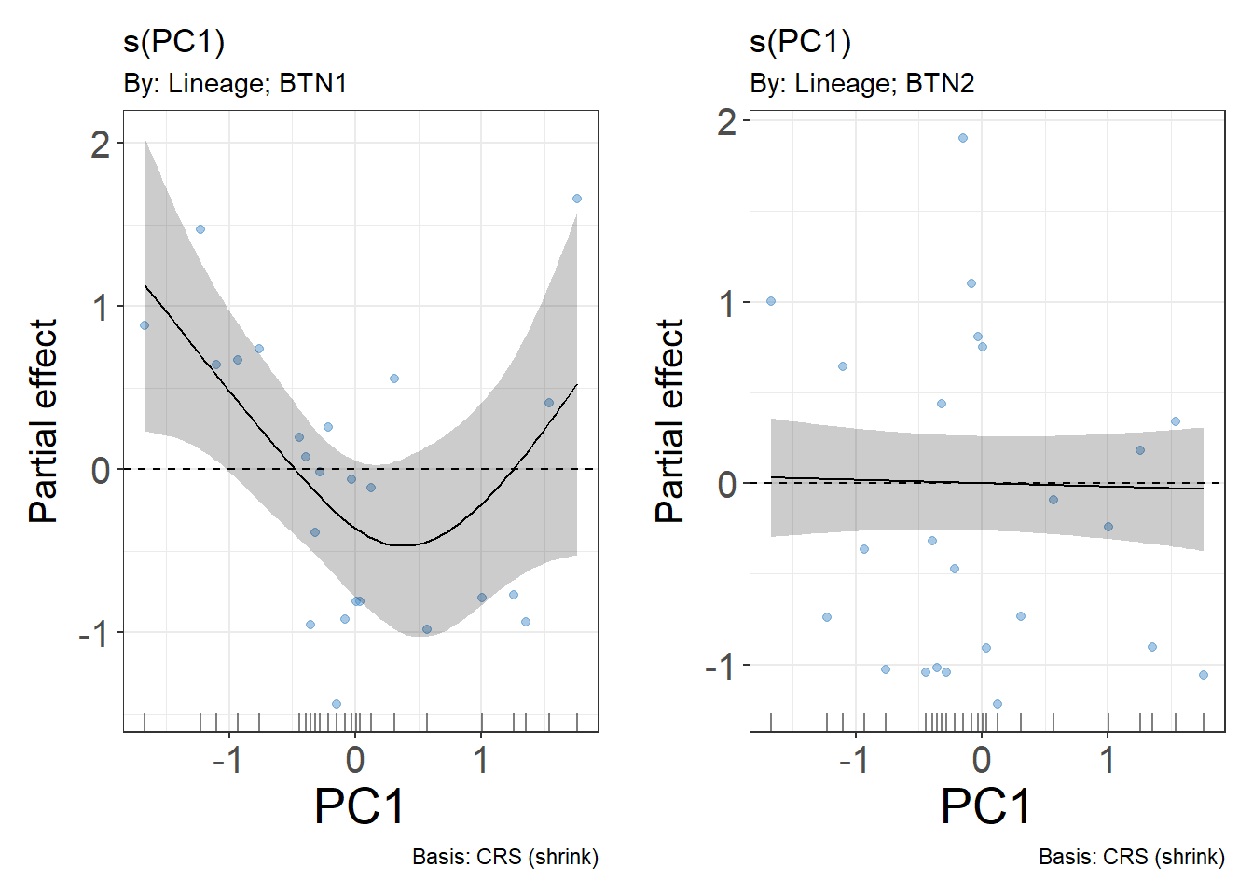

Effects of BTN infection on reproductive function of the host
Gamete production in healthy and infected mussels
Analysis of gonad smears revealed no gametes in more than half of the infected mollusks (++% for BTN1, ++% for BTN2, Fig. +++). Among healthy individuals, the frequency of mussels with no detectable gametes was markedly lower (+++%).

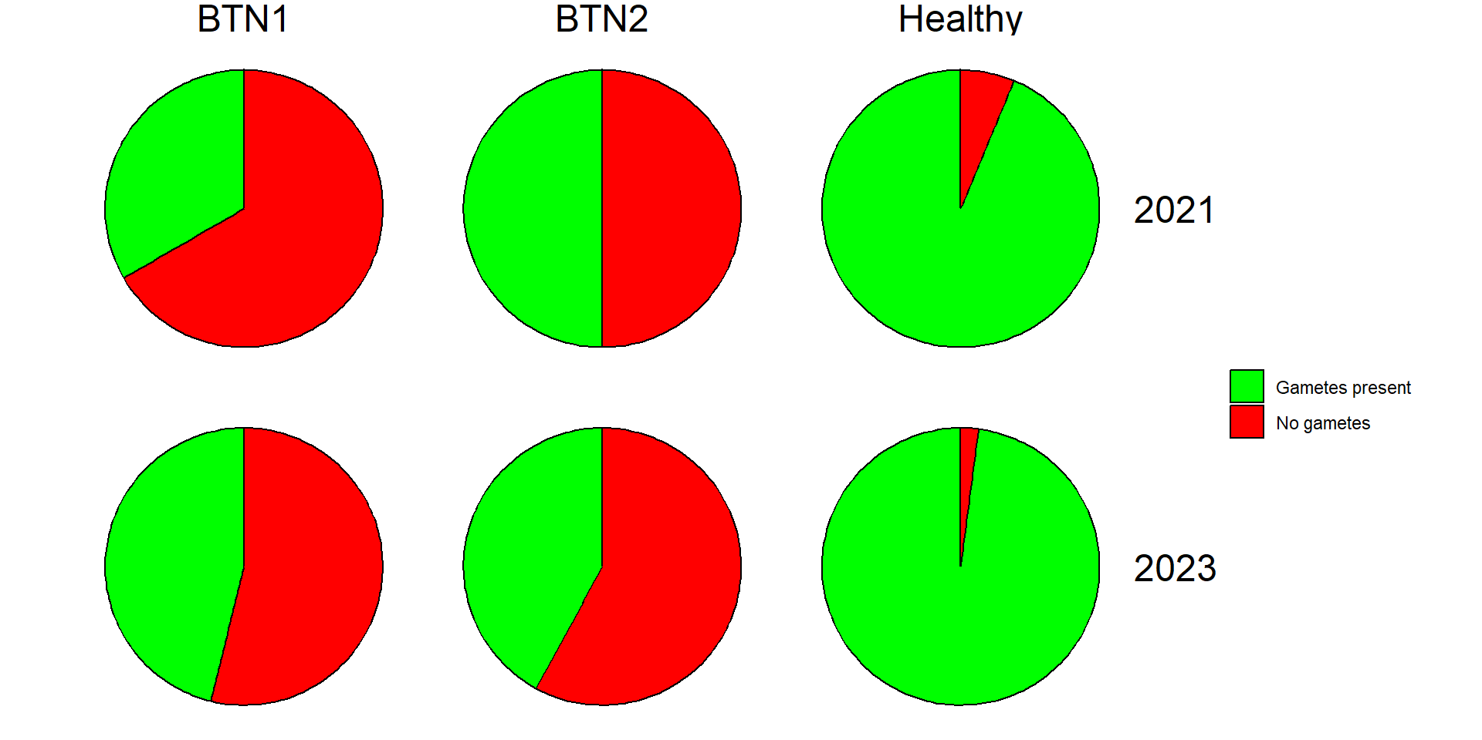

Relationship between gonad acinus size and the abundance of aneuploid cells in the hemolymph of two BTN lineages
According to Model 2 (Table +++), a statistically significant interaction exists between the proportion of aneuploid cells in the hemolymph and the BTN lineage. This indicates a different, lineage-specific pattern in the relationship between acinus size and disease progression, as characterized by the proportion of aneuploid cells in the hemolymph (Fig. ++). According to Model 2, acinus size in mussels infected with BTN2 remains low at all stages of disease progression (i.e., across all values of aneuploid cell abundance in the hemolymph). A different pattern is observed in mussels infected with BTN1. At early stages of the disease (less than 50% aneuploid cells in the hemolymph), the mean acinus size does not differ significantly from that of healthy mussels. At later stages (proportion of aneuploid cells exceeding 50%), acinus sizes decrease, becoming significantly smaller than the mean values observed in healthy mollusks.

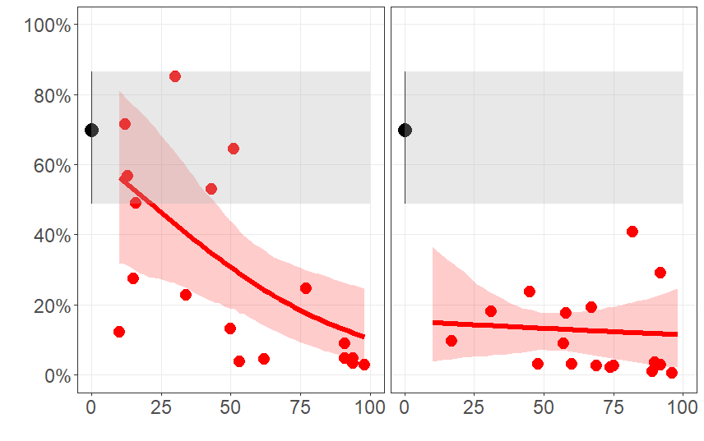

Effect of BTN on mollusk growth
Analysis of raw data (Fig. ++) revealed that mussels infected with BTN2 exhibited a slightly higher last-year growth increment compared to both BTN1-infected and healthy individuals. The distribution of growth increment values was similar between the latter two groups.
Last-year growth increment was statistically significantly associated with mussel size, which was included as a covariate in Model 3. After accounting for the effect of this covariate, a significant relationship between growth increment and the factor BTN_Type was detected. Analysis of adjusted mean growth increment values for each level of this factor (Fig. ++) showed that the mean increment for BTN2-infected mussels was significantly higher than that for BTN1-infected and healthy mussels. No statistically significant differences were found between the latter two groups.

