Variations in Mytilus trossulus population structure

For SEM
Principal component analysis revealed that the main variation in population structure (PC1, explaining 34.0% of the total variance) was associated with variability in abundance of mussels of different sizes (SFig. ++). The smallest mollusks (size classes L3–L28) exhibited high positive loadings on PC1, whereas the largest mussels (L38–L58) were characterized by high negative loadings on PC1. The second principal component (17.3% of the total variance) was related to variation in mussel coverage (high positive loadings on PC2) and biomass (high negative loadings on PC2). PC2 was also associated with the abundance of intermediate size classes (L28–L38), which showed high negative loadings on PC2.
When ordered according to PC1 scores, the size frequency distributions (SFig. ++) demonstrated a clear gradient. Negative PC1 values corresponded to bimodal distributions with distinct peaks at both high and low sizes (except NUK-I_21 and KHOL_21). In such settlements, large mollusks generally predominated. Positive PC1 values corresponded to unimodal distributions dominated by small mollusks.
Comparison of PC1 scores between 2021 and 2023 (SFig. ++) indicated a substantial change in this parameter, suggesting significant interannual dynamics in settlement structure. Most settlements resampled in 2023 exhibited marked positive shifts in PC1 values in comparison with 2021 (SFig. ++). Thus, PC1 also characterizes a temporal gradient associated with the transition of settlements from dominance by large, old mussels to dominance by juveniles.

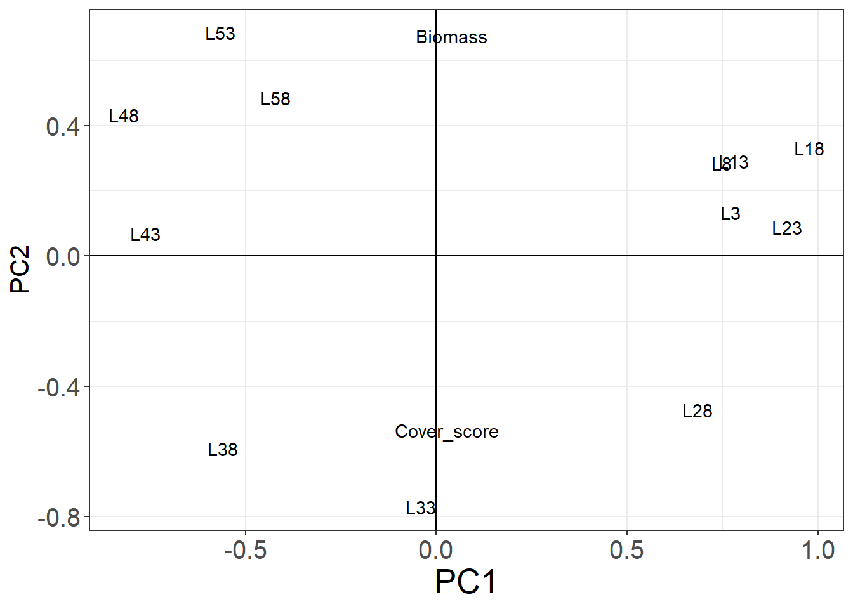

SFig. ++ Ordination of population parameters (abundance of size classes, biomass and mussel cover) in PCA axes.

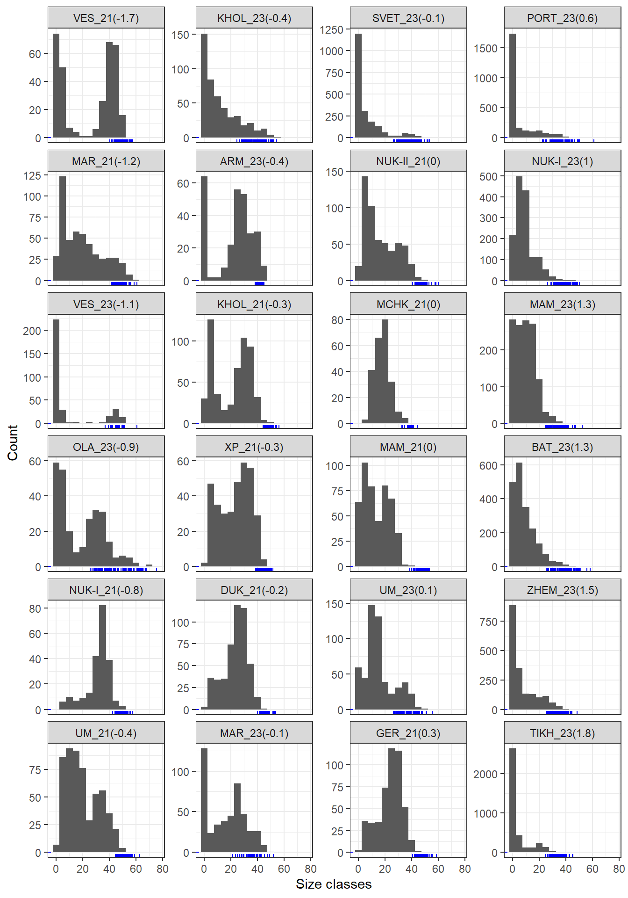

SFig. +++ Population size structures ordered by PC1 (PC values in brackets). Blue rug at OX axis marks sizes of mussels collected for BTN analysis.

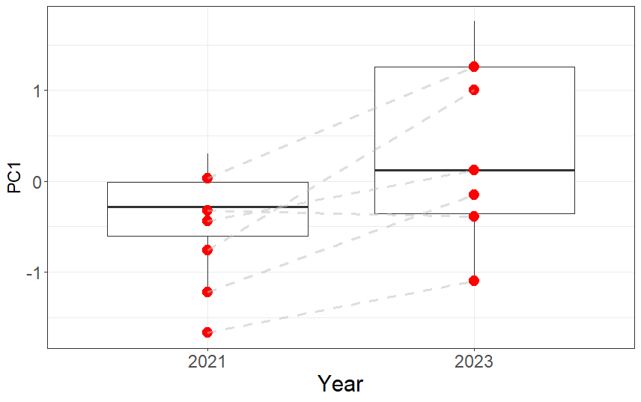

SFig. ++ PC1 values for sites collected in 2021 and 2023. Red dots marks sites sampled in both years, gray dot-lines join resampled sites.

Main text
Variations in population structure of mussel populations
The population structure of mussel settlements at the studied sites varied significantly both in space and interannually (SEM ++). As a result of principal component analysis, all studied parameters of mussel settlements (abundance of size classes, biomass, and cover) were reduced to two principal components, which together account for 51.3% of the total variance of population parameters. The most informative PC1 characterizes variation in the size-structure of mussel settlements (SEM ++). High negative PC1 values indicate the dominance of large, old mollusks within the settlements. This type of settlement structure was most pronounced at sites MAR_21, VES_21, VES_23, and OLA_23. High positive PC1 values characterize settlements dominated by small mollusks (NUK-1_23, MAM_23, BAT_23, ZHEM_23, TIKH_23). Variation along PC2 reflects variability in mussel biomass and cover. Settlements characterized by high biomass but low cover exhibit high negative PC2 values. High positive PC2 values are typical for settlements with high cover but low biomass. Both PC1 and PC2 were further considered as generalized population structure discriptors.

BTN prevalence variation
A total of 2840 individuals were examined, with sizes ranging from 21.4 to 75.6 mm (median 41.1 mm). Among these, 123 infected individuals were found, with sizes varying from 25.8 to 60.7 mm (median 40.8 mm). The frequencies of both transmissible cancer lineages (BTN1 and BTN2) ranged from 0 (no infected mollusks were found in ARM_23, BAT_23, MAM_21) to 7.3% (BTN1, site ZHEM_23) and 10.4% (BTN2, site MAR_23). On average, the frequencies of BTN1 and BTN2 were similar, amounting to 2.07% and 2.04%, respectively.
Analysis of the spatial distribution of prevalence revealed highly heterogeneous patterns for both BTN1 and BTN2 (Fig. ++). No significant correlation was detected between the prevalences of the two lineages (Spearman's R = 0.27, p = 0.208, n = 24).

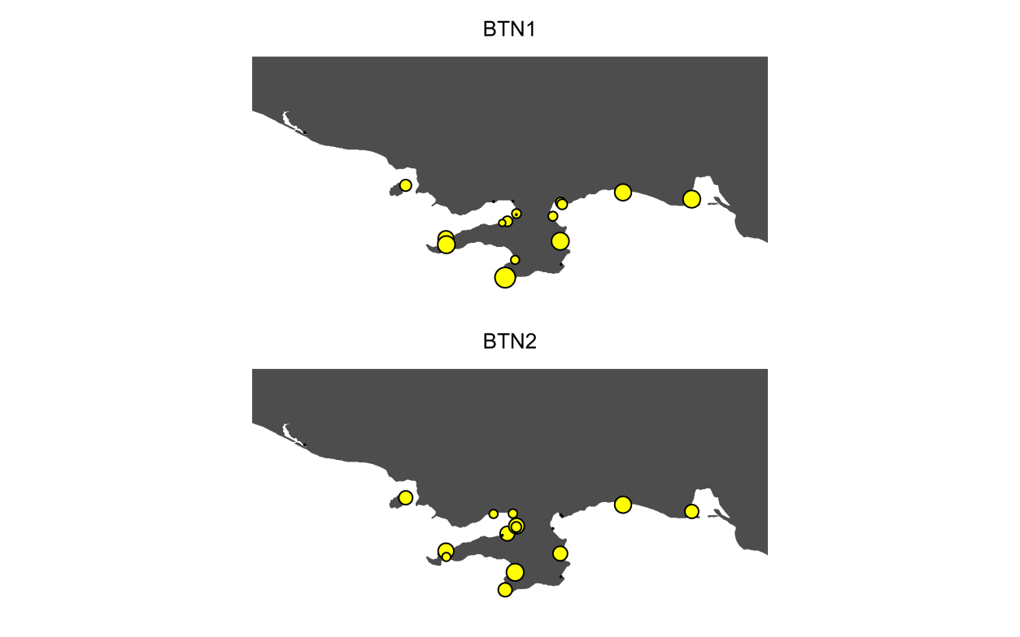

Dependence of BTN prevalences on predictors

Model 1 (Table ++) accounted for 72% of the deviance (adjusted R² = 0.67). Statistically significant associations were found only between BTN1 prevalrnce and distance to port (Dist_Port), wave exposure level (Fetch), and the parameter characterizing the size structure of the mussel settlement (PC1). BTN2 prevalence was not associated with any of these predictors. Additionally, an association was detected between BTN2 frequency and the group growth score (OGP). The association between BTN1 and this predictor was marginally significant.
According to Model 1 (Fig. ++), BTN1 frequency increases linearly (edf was close to 1, Table ++) with increasing distance to port and increasing degree of coastal exposure. The relationship between BTN1 frequency and PC1 was nonlinear (edf = 2.0, Table ++). Model 1 predicts the highest BTN1 prevalence at the lowest PC1 values. The minimum BTN1 prevalence predicted by Model 1 occured at PC1 values close to zero. At high positive PC1 values, Model 1 predicts a slight increase in BTN1 frequency. Both lineages exhibit a near-linear positive relationship with OGP.

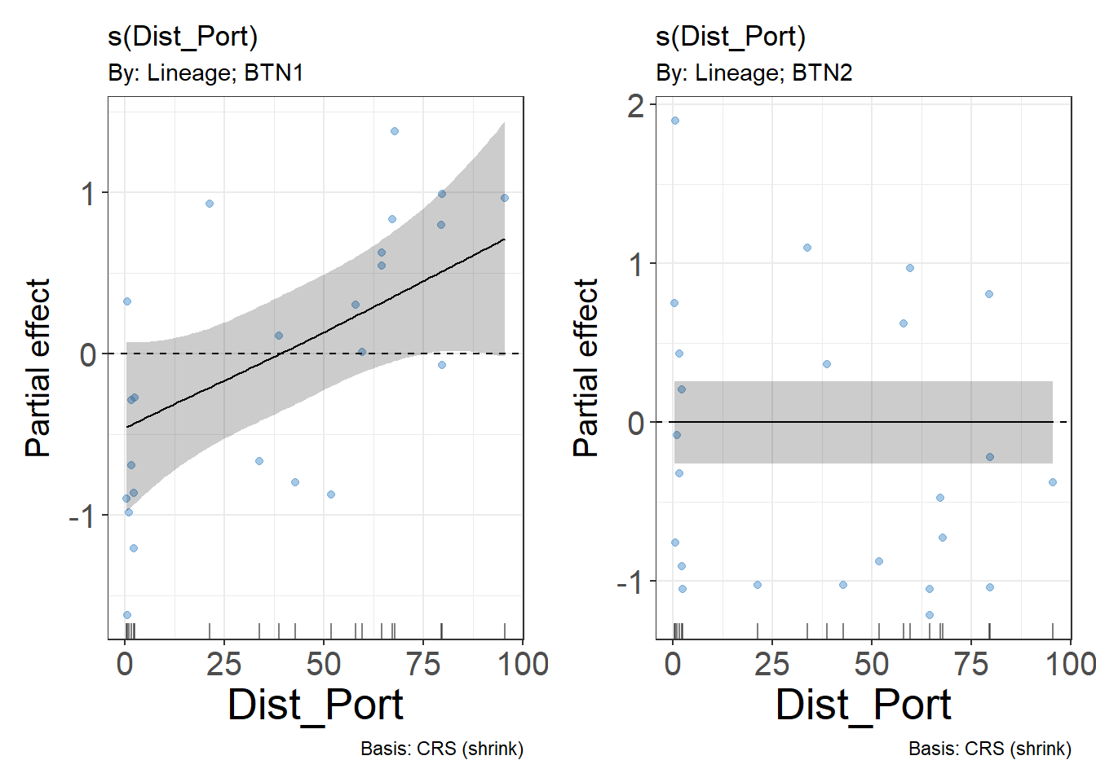

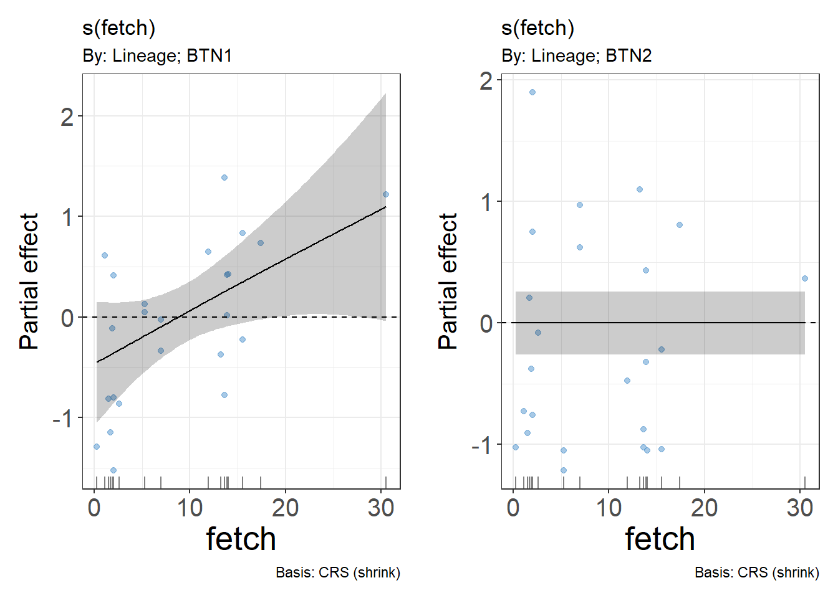
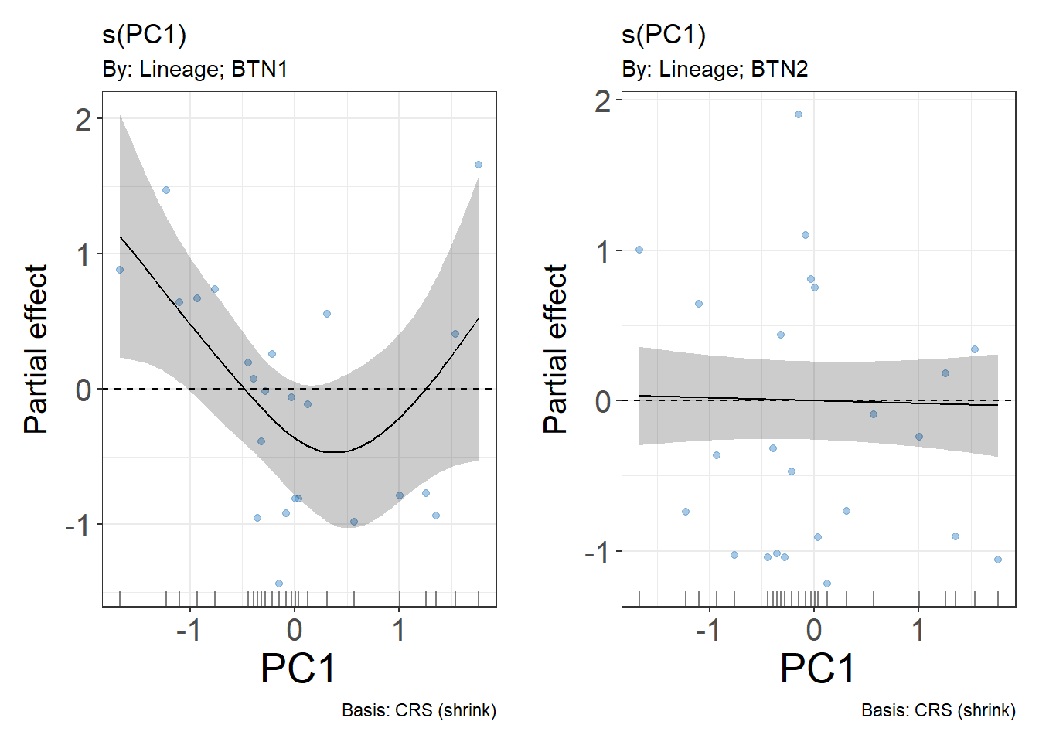

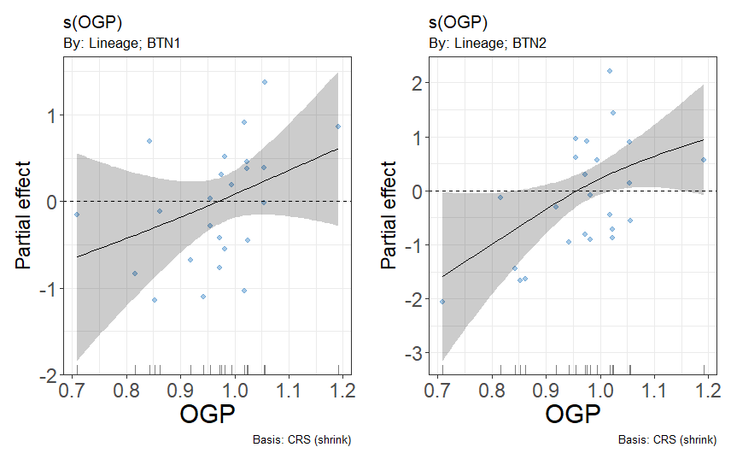

Effects of BTN infection on reproductive function of the host
Gamete production in healthy and infected mussels
Analysis of gonad smears revealed no gametes in more than half of the infected mollusks (57.9% for BTN1, 56.8% for BTN2, SFig. +++). Among healthy individuals, the frequency of mussels with no detectable gametes was markedly lower (3.5% SFig. +++).

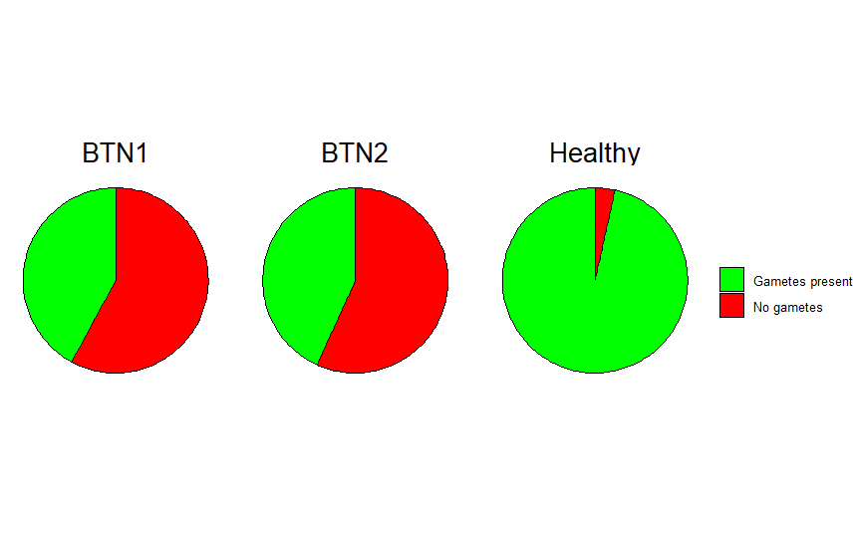

SFig ++. Frequency of mussels with gametes in gonad smears and without gametes among infected with different BTN lineages, compared to healthy specimens

Relationship between gonad acinus size and the abundance of aneuploid cells in the hemolymph of two BTN lineages
According to Model 2 (Table +++), a statistically significant interaction exists between the proportion of aneuploid cells in the hemolymph and the BTN lineage. This indicates a lineage-specific pattern in the relationship between acinus size and disease progression, as characterized by the proportion of aneuploid cells in the hemolymph. According to Model 2 (Fig. ++), acinus size in mussels infected with BTN2 remains low at all stages of disease progression (i.e., across all values of aneuploid cell abundance in the hemolymph). A different pattern is observed in mussels infected with BTN1. At early stages of the disease (less than 50% aneuploid cells in the hemolymph), the mean acinus size does not differ significantly from that of healthy mussels. At later stages (proportion of aneuploid cells exceeding 50%), acinus sizes decrease, becoming significantly smaller than the mean values observed in healthy mollusks.
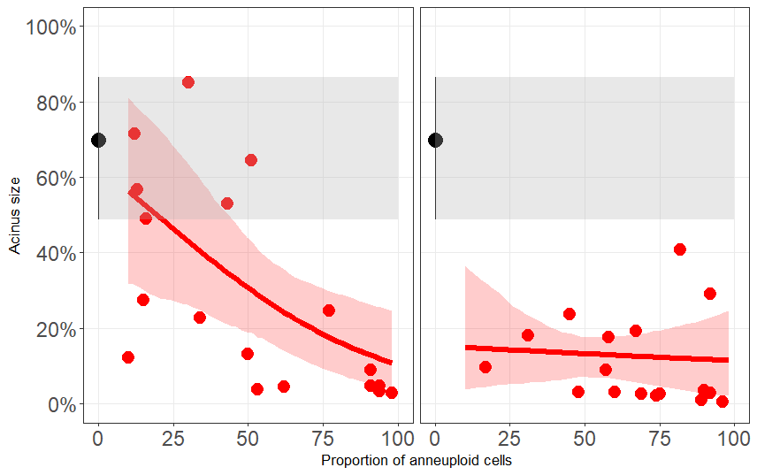

Fig. ++ Relationship between the proportion of aneuploid cells and the relative acinus size (proportion of gonadal tissue per section). Points represent raw data, red lines show predictions of Model 2 with confidence intervals. The black point shows the mean acinus size with confidence interval for healthy cells. For comparison with diseased mussels, the confidence interval for the mean in healthy individuals is conditionally extended across all values along the OX axis.

Effect of BTN on mollusk growth
Analysis of raw data (Fig. ++ А) revealed that mussels infected with BTN2 exhibited a slightly higher last-year growth increment compared to both BTN1-infected and healthy individuals. The distribution of growth increment values was similar between the latter two groups.
Last-year growth increment was statistically significantly associated with mussel size, which was included as a covariate in Model 3. After accounting for the effect of this covariate, a significant relationship between growth increment and the factor BTN_Type was detected. Analysis of adjusted mean growth increment values for each level of this factor (Fig. ++) showed that the mean increment for BTN2-infected mussels was significantly higher than that for BTN1-infected and healthy mussels. No statistically significant differences were found between the latter two groups.

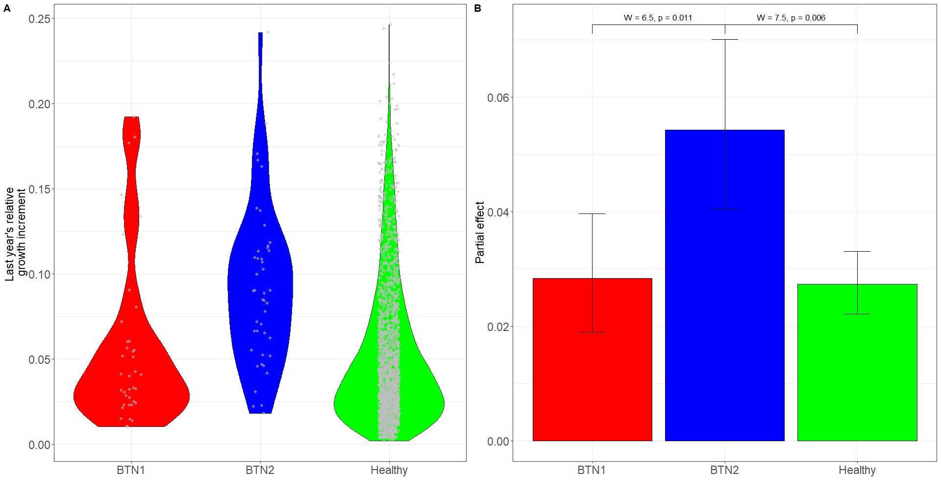

Fig. ++ Relative growth increment over the last year in mollusks infected with BTN1 and BTN2 and in healthy individuals. A. Kernel density plots showing the distribution of raw values of RL. B. Model predictions adjusted for covariates. Whiskers indicate the 95% confidence interval. Wald test statistics are shown above the whiskers.

