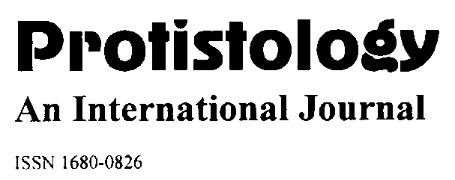
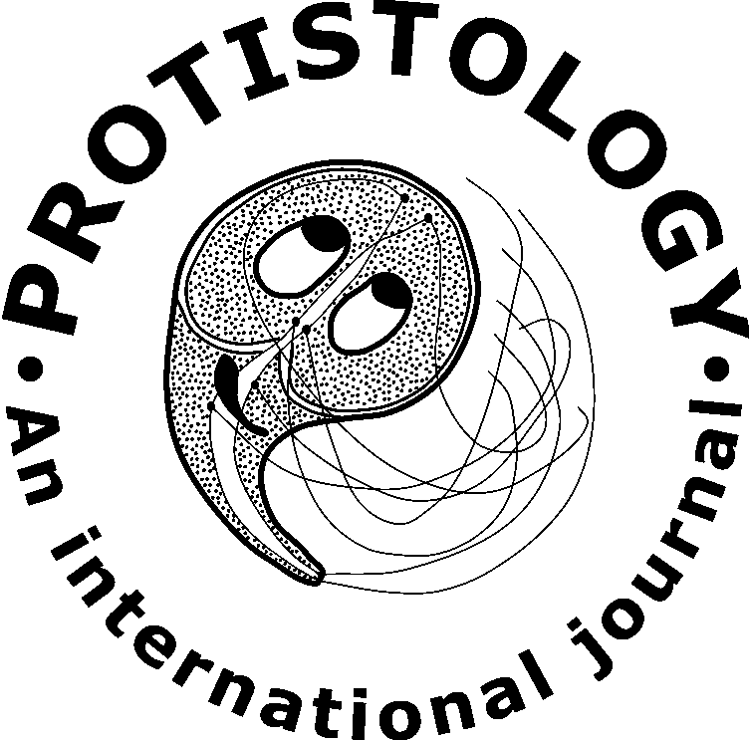

REFEREE REPORT

Reviewer 2

Manuscript: JP2026-05
Title: Diversity of ciliates – endosymbionts of the intestine of Przewalski’s horses from the Orenburg Nature Reserve
Authors: Olga S. Alekseeva, Ludmila V. Chistyakova, Vadim M. Khaitov, Evgeny A. Bulgakov, and Olga A. Kornilova

Ratings | Originality | Significance | Methods | Clarity | Organization
Superior | [ ] | [ ] | [ ] | [ ] | [ ]
Good | [ x ] | [ x ] | [ x ] | [ ] | [ x ]
Fair | [ ] | [ ] | [ ] | [ x ] | [ ]
Poor | [ ] | [ ] | [ ] | [ ] | [ ]

[ ] Acceptable as is.
[ x ] After minor revision.
[ ] After major revision.
[ ] Reconsider after major revision.
[ ] Reject.
________________________________________________________________________________

COMMENTS FOR AUTHORS CONSIDERATION:

The reviewing article contains new data on the diversity of intestinal ciliates in Przewalski's horses from an artificial wild population and is worthy of publication.

However, the text of the article is missing some sufficient information:
1. Have similar studies been conducted in other reintroduced populations of Przewalski's horses?
2. In the Materials and Methods section lacks information on the quantitative parameter processed. Are these the abundance of ciliate species or any other data?
3. Were the quantitative data tested for normality (which determines their suitability for PERMANOVA)?
4. Is it possible to exclude contacts between Przewalski's horses and domestic horses, for example, when the latter graze?
5. In addition to the previous question: are the "Origin" and "Type" factors independent? Was any test for non-additivity performed, for example, Tukey's post-hoc?

After adding this information, the article can be recommended for publication in Protistology.

