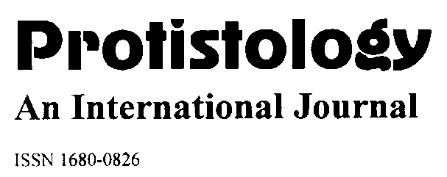
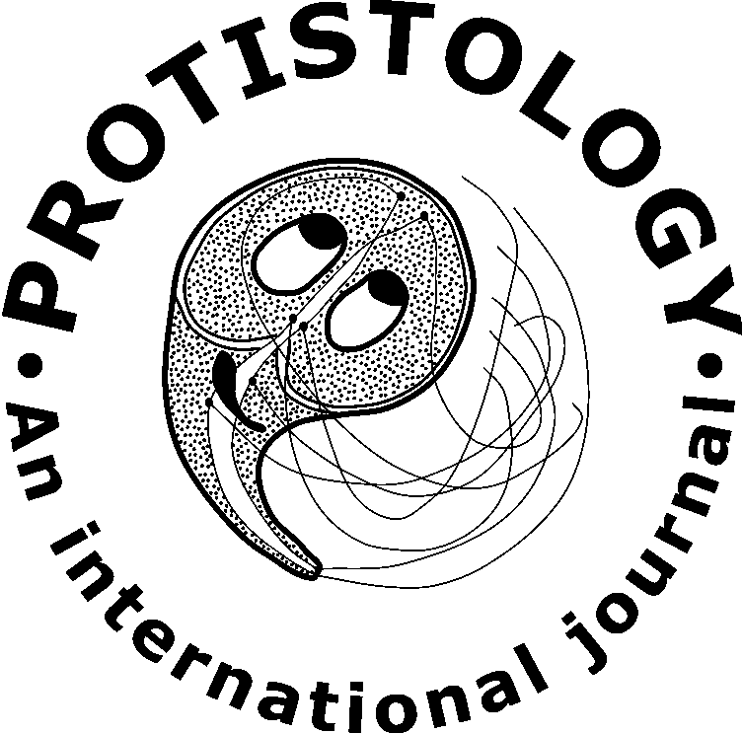

REFEREE REPORT

Reviewer 2

Manuscript: JP2026-05
Title: Diversity of ciliates – endosymbionts of the intestine of Przewalski’s horses from the Orenburg Nature Reserve
Authors: Olga S. Alekseeva, Ludmila V. Chistyakova, Vadim M. Khaitov, Evgeny A. Bulgakov, and Olga A. Kornilova

Ratings | Originality | Significance | Methods | Clarity | Organization
Superior | [ ] | [ ] | [ ] | [ ] | [ ]
Good | [ x ] | [ x ] | [ x ] | [ ] | [ x ]
Fair | [ ] | [ ] | [ ] | [ x ] | [ ]
Poor | [ ] | [ ] | [ ] | [ ] | [ ]

[ ] Acceptable as is.
[ x ] After minor revision.
[ ] After major revision.
[ ] Reconsider after major revision.
[ ] Reject.
________________________________________________________________________________

COMMENTS FOR AUTHORS CONSIDERATION:

The reviewing article contains new data on the diversity of intestinal ciliates in Przewalski's horses from an artificial wild population and is worthy of publication.

However, the text of the article is missing some sufficient information:
1. Have similar studies been conducted in other reintroduced populations of Przewalski's horses?

Тут Вам виднее

2. In the Materials and Methods section lacks information on the quantitative parameter processed. Are these the abundance of ciliate species or any other data?

Здесь надо расписать про методику количественного учета. У меня нет перед глазами конечного варианта, но в люом случае, это лучше сделать Вам.

- Were the quantitative data tested for normality (which determines their suitability for PERMANOVA)?

We should note that we used the PWRMANOVA method, not MANOVA. The latter (being a parametric test) does indeed require normality of the original data for constructing the test statistic distribution. However, the distance‑based method proposed by M. J. Anderson (2014), PERMANOVA, constructs a reference distribution of the test statistic (pseudo F‑statistic) based on permutations of the original data. This method does not require assumptions related to a normal (or any other) distribution.

Reference
Anderson, M. J. (2014). Permutational multivariate analysis of variance (PERMANOVA). Wiley statsref: statistics reference online, 1-15.

- Is it possible to exclude contacts between Przewalski's horses and domestic horses, for example, when the latter graze?

Здесь Вам виднее.

- In addition to the previous question: are the "Origin" and "Type" factors independent? Was any test for non-additivity performed, for example, Tukey's post-hoc?

Тут какая-то мешанина. Независимость факторов это одно, а Tukey's post-hoc - это совсем другое.
Но попробуем вот так ответить.

We note that PERMANOVA is a distance‑based permutation method and does not rely on a linear model in the traditional sense. Therefore, applying standard linear model diagnostics for predictor collinearity (e.g., Variance Inflation Factor, VIF) in this case has no theoretical foundation. Consequently, we cannot formally assess the degree of collinearity. That said, in our sample, both levels of the factor Type included horses of different origins. The only issue was that French‑origin horses (Fr) were all kept under free‑range conditions. However, given the absence of a statistically significant effect of the factor Origin (see Results section), we decided not to pursue further analysis of this factor.

Pairwise post‑hoc comparisons concerned only the factor Type. Again, standard linear model tests such as Tukey’s HSD, developed for classical ANOVA, are not appropriate for our analysis. However, since the factor Type has only two levels, post‑hoc comparisons are unnecessary in this case.

After adding this information, the article can be recommended for publication in Protistology.

