Инфузории в фекалиях лошадей Part 2
В. М. Хайтов
2025-11-15

Вставка для MM
To visualize differences in ciliate species composition among horse groups, non-metric multidimensional scaling (nMDS; Shepard, 1962) was performed using the metaMDS() function from the vegan package (Oksanen et al., 2025) based on Bray-Curtis dissimilarity matrix. Group centroids were labeled by calculating the mean coordinates from the resulting ordination. To assess the degree of between-group differences, the R-statistic from ANOSIM (Analysis of Similarities; Clarke, 1993) was computed. This value was used solely to evaluate the magnitude of group separation, without testing its statistical significance. To test the hypothesis regarding differences in ciliate community composition across three factors (sex, management conditions, and origin of Przhevalsky’s horses), PERMANOVA (Permutational Multivariate Analysis of Variance; Anderson, 2001) was employed. P-values were estimated using permutation tests (9,999 permutations). The PERMANOVA model included only main effects, without factor interactions. All calculations were performed using the adonis2() function from the vegan package. To assess the contribution of ciliate species to differences between groups, Similarity Percentage (SIMPER) analysis was employed (Clarke, 1993). The analysis was performed with simper() function from the vegan package.
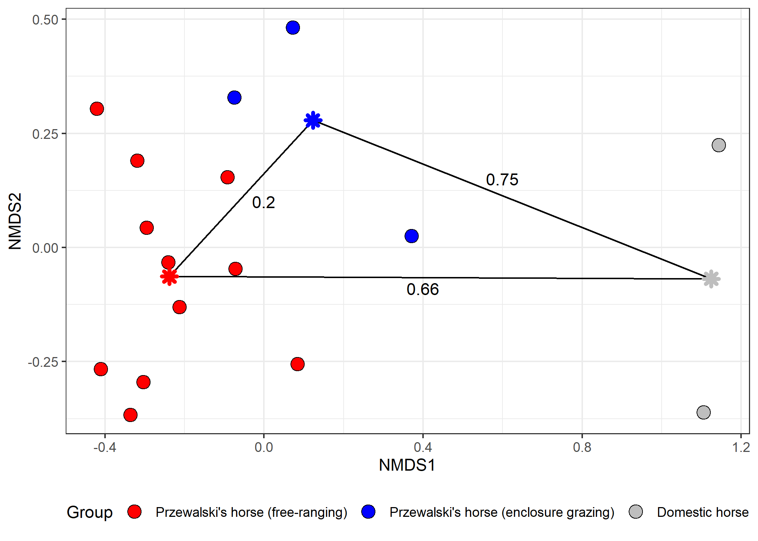
Figure ++. Non-metric multidimensional scaling (nMDS) ordination of samples from Przewalski’s horse (free-ranging and enclosure populations) and domestic horse groups. Group centroids and between-group dissimilarities (ANOSIM R-statistic) are shown.
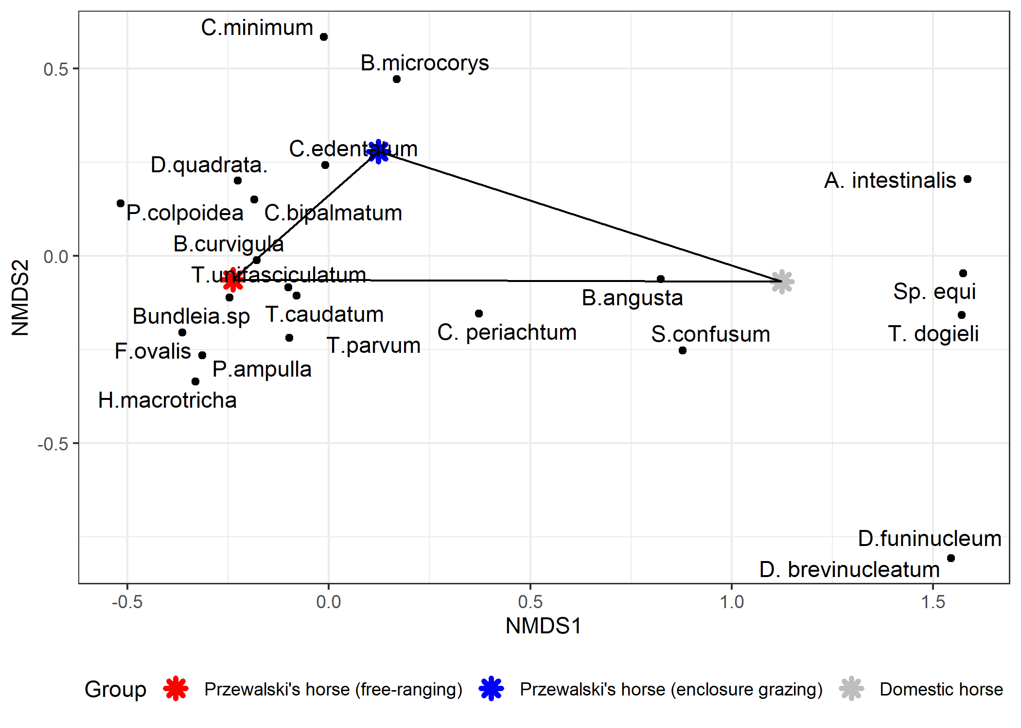
Figure ++. Species ordination in nMDS axes consistent with Figure ++
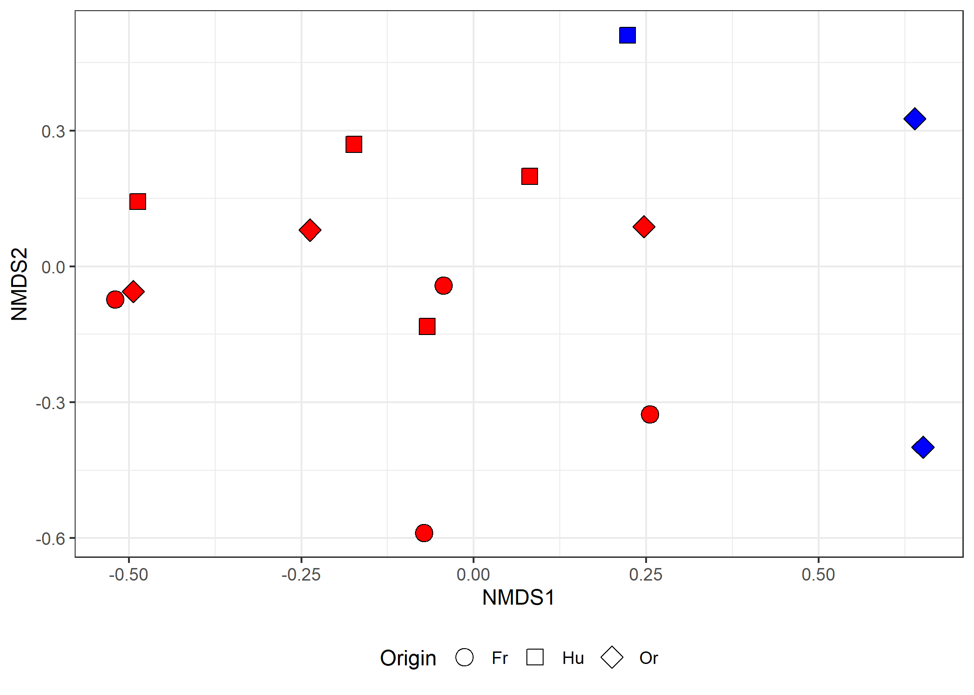
Figure ++. Non-metric multidimensional scaling (nMDS) ordination of samples from Przewalski’s horse with with varying origins and management regimes.
Table +++. Results of PERMANOVA for comparisons of three groups
Term | Df | SS | R² | F-statistic | p-value
Sex | 1 | 0.23 | 0.07 | 1.28 | 0.2638
Type | 1 | 0.70 | 0.22 | 3.92 | 0.0117
Origin | 2 | 0.81 | 0.25 | 2.26 | 0.0416
Residual | 9 | 1.61 | 0.51
Total | 13 | 3.18 | 1.00
Важное дополнение. Все-таки PERMANOVA дает значимый результат и для фактора Origin. Я не до конца понимаю эти группы. Если они в фокусе исследования, то по ним надо проводить SIMPER и приводить прочие результаты.
Table ++. Mean species abundance in samples from free-ranging and enclosure grazing Przewalski's horse and cumulative contribution to between-group dissimilarity (SIMPER analysis)
Species | Free | Enclosure | Cumulative  Contribution
Bundleia.sp | 24.8 | 3.3 | 0.28
P.ampulla | 17.8 | 1.2 | 0.47
H.macrotricha | 12.7 | 0.2 | 0.62
B.curvigula | 4.4 | 3.3 | 0.71
F.ovalis | 4.1 | 0.1 | 0.76
D.quadrata. | 1.6 | 0.5 | 0.80
B.microcorys | 0.6 | 1.3 | 0.84
C.edentatum | 0.7 | 1.6 | 0.88
C.bipalmatum | 1.1 | 1.2 | 0.91
T.caudatum | 2.2 | 0.3 | 0.93
T.unifasciculatum | 1.2 | 0.4 | 0.95
T.parvum | 1.2 | 0.2 | 0.97
C.minimum | 0.1 | 0.3 | 0.98
C. periachtum | 0.1 | 0.3 | 0.99
S.confusum | 0.0 | 0.1 | 0.99
B.angusta | 0.0 | 0.1 | 1.00

