When the app is opened, we see a sign in window. The button ‘Sign In’ is disabled until we input something in both fields.

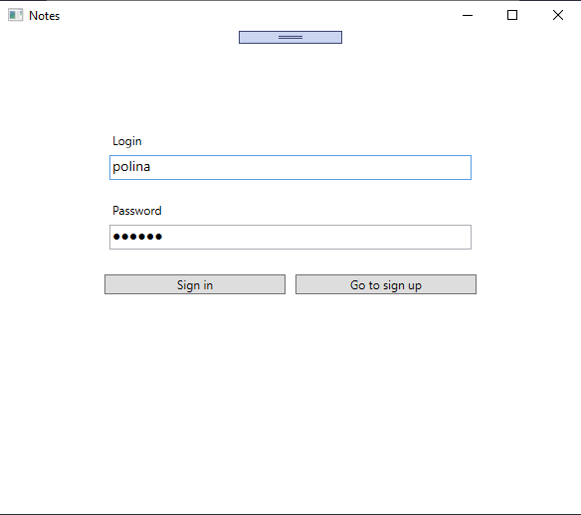

If we input an incorrect login and/or password, we see an appropriate message.

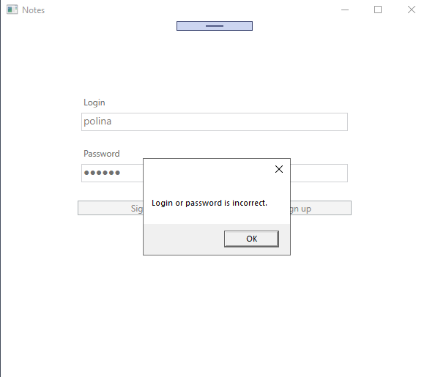

From here we can go to sign up. ‘Sign Up’ button is disabled until we enter something in all fields.

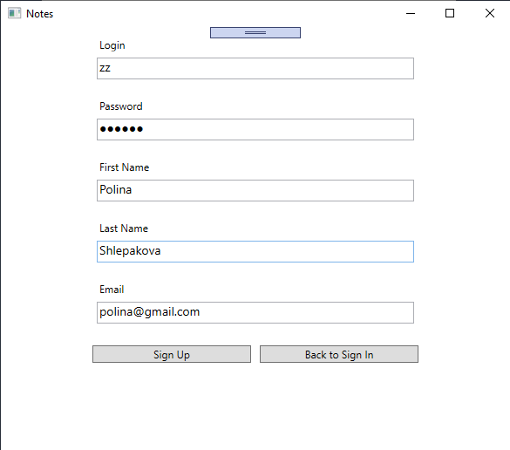

If login is not unique, an appropriate message is shown.

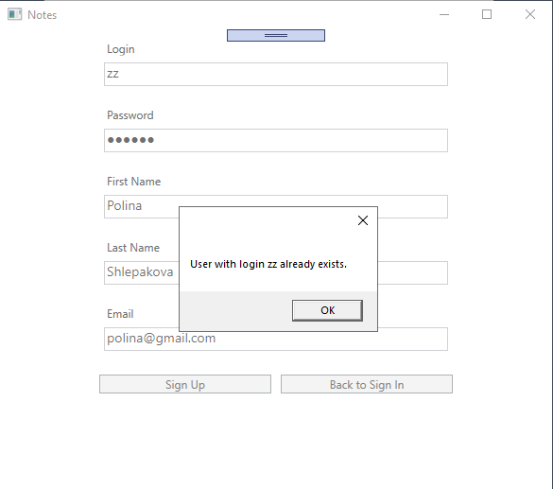

If email is not valid, an appropriate message is also shown.

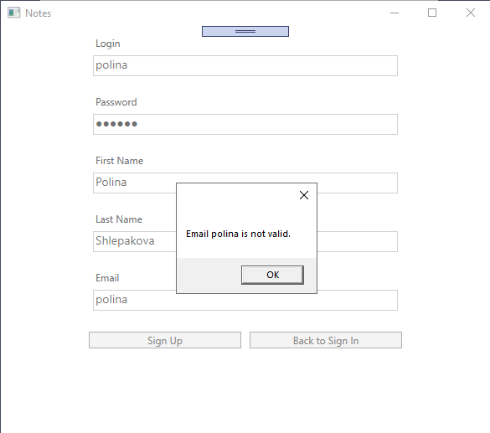

After successful sign in or sign up, the list of notes is shown. If a user logged in before and exited the app while still being logged in, then he doesn’t have to sign in again, and he goes to the page with all notes right away.

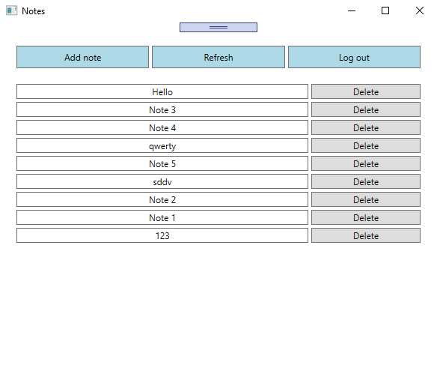

We can log out, and then we will be forwarded to sign in page.

We can also refresh the list of notes. If notes were changed in other session, we will see an updated list.

We can delete a note. It will be deleted on the server and also from the list on the client.

We can open a note. If it was deleted in other session, we will see an appropriate message. Otherwise, we will see note’s title and text and will be able to edit and save it.

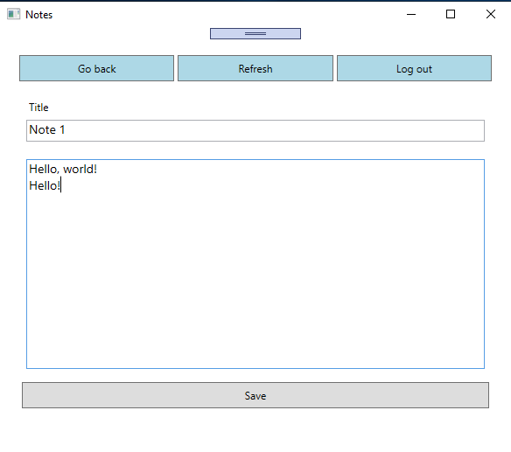

We can go back to the list of all notes or logout. We can also refresh a note, in case it was changed by other session.

From the list of all notes, we can add new note. Note is saved only if we click ‘Save’. ‘Save’ is disabled until we enter something in all fields. ‘Refresh’ is disabled because the note does not exist yet and there is nothing to refresh.

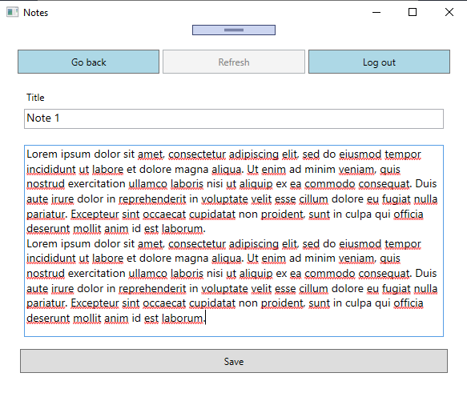

All time consuming tasks are executed asynchronously, and the loader is shown in the meantime.