Specs for iOS Plastivision App

Exhibitors – Search
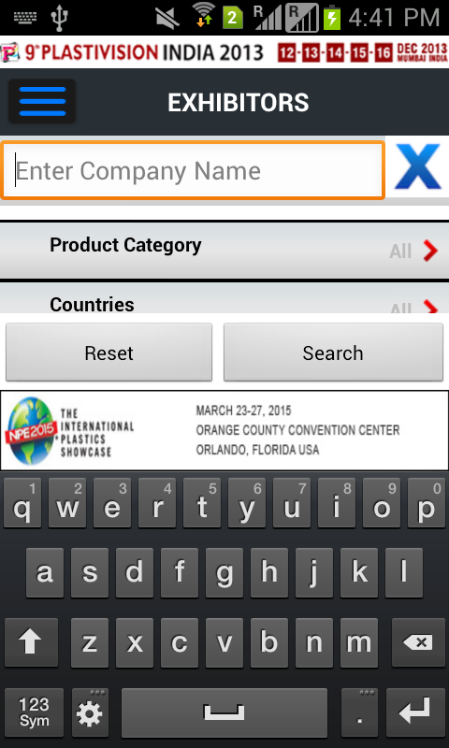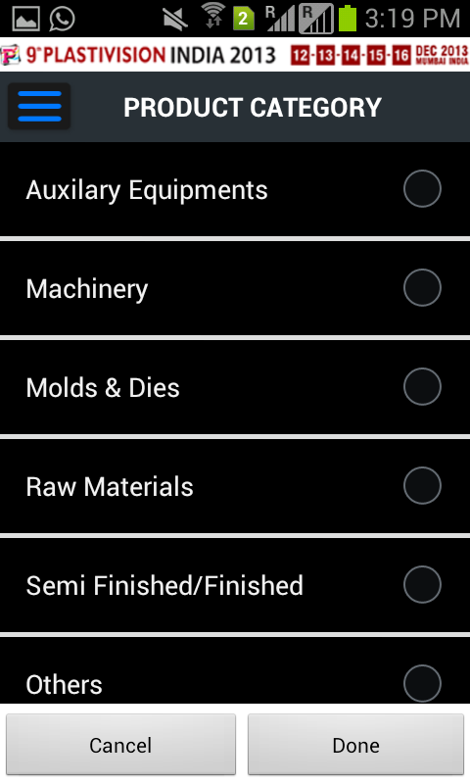
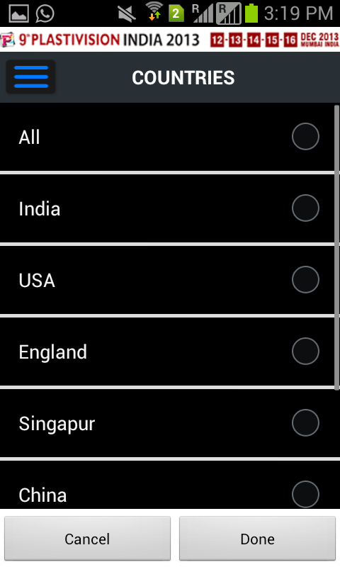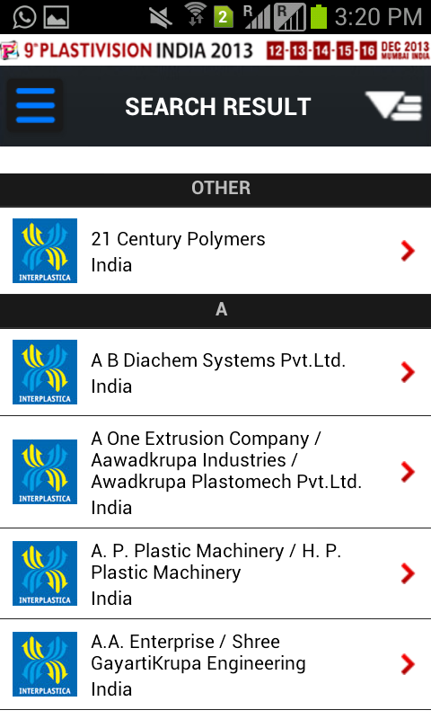

Webservice url : http://pu786.polymerupdate.com/plastivision2013/web/exhibitors.asmx?op=ListExhibitors
Parameters: imei or vendor/device id (this is just authentication to webservices so that it won’t be used outside)

Result : <Exhibitor>
<Table1>
<id>1</id>
<company>21 Century Polymers</company>
<state>Delhi</state>
<city>Delhi</city>
<address>A-108 Group Indl. Area, Wazirpur</address>
<phone>09953355814</phone>
<email>rajeshpahwa71@gmail.com</email>
<website>www.21centurypolymers.in</website>
<country>India</country>
<segment>Raw Materials</segment>
<segmentid>1</segmentid>
<hall_no>1</hall_no>
<stall_no>1</stall_no>
<logo_url>
http://pu786.polymerupdate.com/plastivision2013/images/2013911131350787635145020307874077.jpg
</logo_url>
<thumb_url>
http://pu786.polymerupdate.com/plastivision2013/images/thumb-nails/thumb_2013911131350787635145020307874077.jpg
</thumb_url>
<segment1>Raw Materials</segment1>
</Table1>
</Exhibitor>

Error message: No data found
Error Log: send mail to salim.it@polymerupdate.com with brief error

Exhibitors – Add Schedule
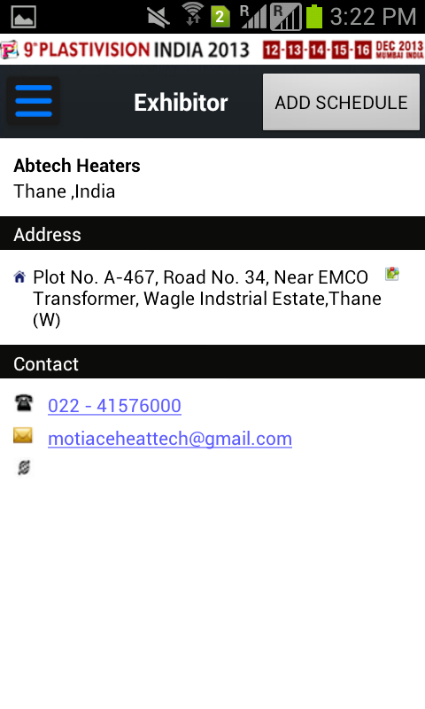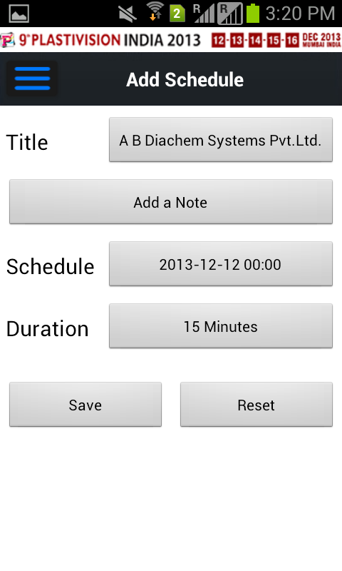

Webservice url : http://pu786.polymerupdate.com/plastivision2013/web/exhibitors.asmx?op=AddSchedule

Parameters: exhibitorid, visitorid, date, time, duration, note
Result: true or false

Error message: No data found
Error Log: send mail to salim.it@polymerupdate.com with brief error
News
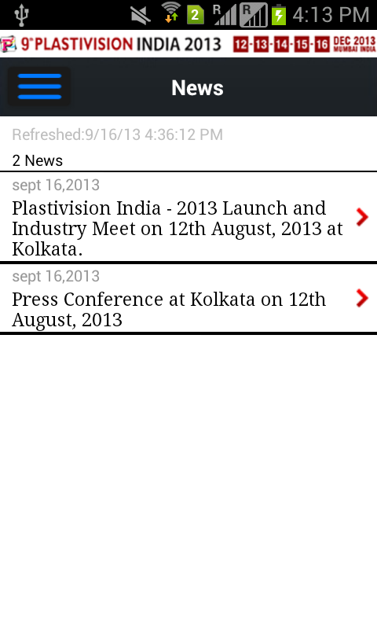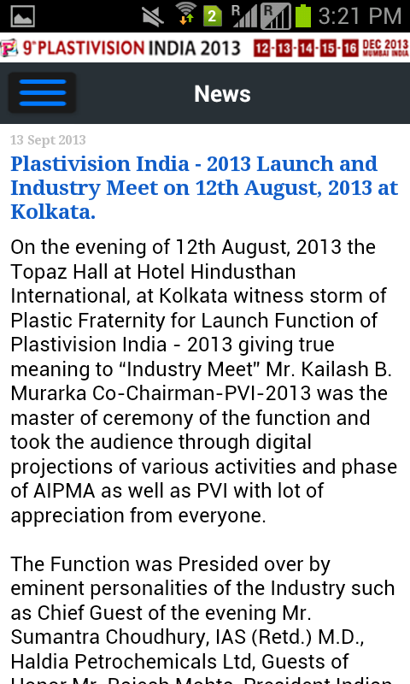

Webservice url : http://pu786.polymerupdate.com/plastivision2013/web/plastivision-news.asmx?op=listNews
Parameters: imei or vendor/device id (this is just authentication to webservices so that it won’t be used outside)
Result : <News>
<Table1>
<id>17</id>
<headline>
Plastivision India - 2013 Launch and Industry Meet on 12th August, 2013 at Kolkata.
</headline>
<detail>
On the evening of 12th August, 2013 the Topaz Hall at Hotel Hindusthan International, at Kolkata witness storm of Plastic Fraternity for Launch Function of Plastivision India - 2013 giving true meaning to “Industry Meet” Mr. Kailash B. Murarka Co-Chairman-PVI-2013 was the master of ceremony of the function and took the audience through digital projections of various activities and phase of AIPMA as well as PVI with lot of appreciation from everyone.<br /><br />The Function was Presided over by eminent personalities of the Industry such as Chief Guest of the evening Mr. Sumantra Choudhury, IAS (Retd.) M.D., Haldia Petrochemicals Ltd, Guests of Honor Mr. Rajesh Mohta, President Indian Plastics Federation Kolkata.<br /><br />President Dr. Asutosh K. Gor welcomed the Honourable Guests as well as the Audience and spoke on prevailing Industry scenario and its projected growth up to 2020. He also spoke on 9% average growth in West Bengal versus 14% of All India average growth and Per capita consumption of polymers in Eastern India 2.8 Kg versus National average of 8Kg giving huge scope of opportunities to the ….… Plastic Processing Industry of this part of our country which will see significant upwards graph thereby creating volumes of employment. He further informed that AIPMA holds job fair to address employment issues of the Industry… and appealed to join hands with AIPMA in its rising graph of services. He also thanked all members present for extending great support which has resulted in setting up and inaugurating our own New Eastern Zone Office this morning. A short video film was shown for appraise the audience.<br /><br />Mr. Raju Desai Chairman, Plastivision India 2013 discussed about new initiatives taken in 9th Plastivision, in form of various focused areas of value additions for the exhibitors and visitors such as Green Pavilion – to promote industrial applications of renewable energy in energy-intensive manufacturing, India Mold® - a focused pavilion of mould making, design and application development, PlastiWorld - a dedicated display for processed plastics finished products<br /><br />Plastics in Agriculture – an arena to showcase the application of plastics in water conservation and crop optimisation, Automation & Robotics in Plastics - a massive display of innovative & productive automation engineering, Solar Energy Pavilion – an area to demonstrate how solar energy could be utilised economically in plastics processing machinery and its resultant industry<br /><br />He also appraised that Business delegations from ASEAN countries, Middle East, African continent, Latin America & Eastern European countries for our machinery exhibitors and expected to throng in PVI-2013 and for plastic processors, buyers from American continent, Europe & other Develop countries have confirmed to make their presence. PLASTIVISION INDIA 2013 will also include the industry’s first ever Vendor Development Programme, where large/institutional buyers of plastics will present mid-term demand projections to a select group of suppliers, taking business to entirely new level. He departed the podium with the promotional film of PVI and requested all those who have still not booked their space, to do the same immediately.<br /><br />Mr. Arvind Mehta, Chairman Advisory Board gave details of spectrum of his NAB members consisting of 20 Indian and 16 International Stalwarts from the Plastic Industry. He also informed of the first Indo-US Summit in pipe line during PVI-2013. He underlined growing relations between Indian Plastic Industry with that of various countries which is a sign of India being preferred business place in the world. He gave country report of 13 countries including Japan, Italy, Spain, Canada, South Africa, Netherlands, Turkey, USA, Belgium, Germany and UK.<br /><br />Our Guests were honoured with bouquets of flowers and mementos. Both the guests i.e Chief Guest Mr. Sumantra Choudhury, IAS (Retd.) M.D.,Haldia Petrochemicals Ltd, Guests of Honor Mr. Rajesh Mohta, President Indian Plastics Federation Kolkata thanked AIPMA for inviting them to preside over the function and assured of their fullest support and co-operation to AIPMA at all times. Mr Choudhary overwhelmingly acknowledged the fact that Eastern Zone has now caught the eyes of the Plastic Industry and appreciated AIPMA for the initiatives.<br /><br />Mr. Jayesh Rambhai, Chairman Plastivision Arabia 2014 also gave his presentation and requested the audience to support and participate forthcoming PVA-2014 which is expected to be much larger in size and business turnover.<br /><br />Industry stalwarts like Mr. M. L. Lahoti, Past President and Mr. Amar Seth Past VP, of Plastindia Foundation were honoured in hands of Mr R. K. Aggarwal VP (North) AIPMA and Mr. Harish Dharamsi Co-Chairman PVI-2013<br /><br />Vote of Thanks was given by Shri Ashok Aggarwal, Vice President (East), AIPMA.<br /><br />Over 435 people all belonging to Plastics Associations of Eastern Region, exhibitors of PVI-2013 Industry stalwarts, and VIP guests of the Industry participated and the venue was truly a happening place for the evening and also projected the strong network of AIPMA & Team PVI in this region.<br /><br />Team PVI offered Memento of PVI wall clocks to all guests. There were enquiries for PVI-2013, and membership from among the gathering.
</detail>
</Table1>

</News>

Error message: No data found
Error Log: send mail to salim.it@polymerupdate.com with brief error

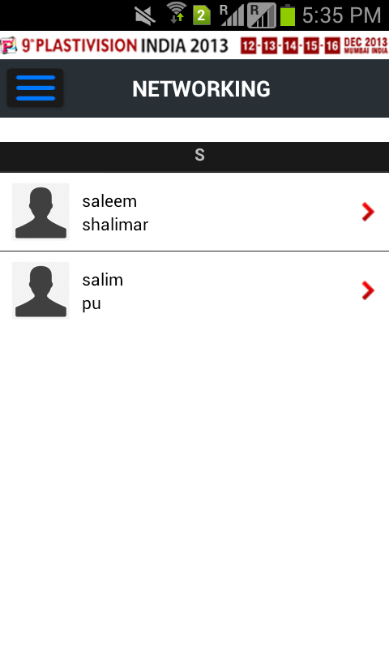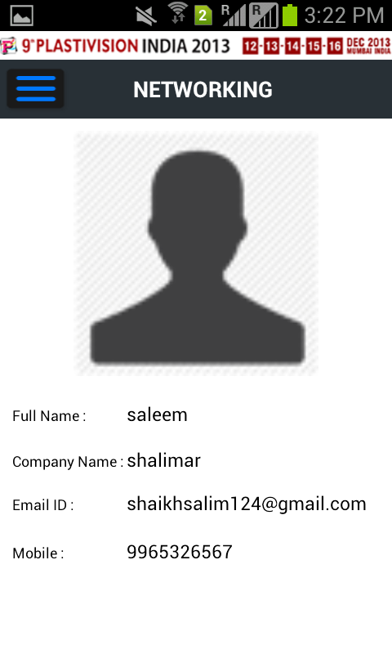
Networking
Webservice url : http://pu786.polymerupdate.com/plastivision2013/web/visitors.asmx?op=ListVisitors
Parameters: imei or vendor/device id (this is just authentication to webservices so that it won’t be used outside)
Result : <Visitor>
<Table1>
<imei>789654566</imei>
<fullname>Rujatata</fullname>
<company>Polymerupdate</company>
<mobile>8082548811</mobile>
<email>rujata.it@polymerupdate.com</email>
<dateadded>2013-09-24T15:09:55.067+05:30</dateadded>
</Table1>

</Visitor>

Error message: No data found Error Log: send mail to salim.it@polymerupdate.com with brief error

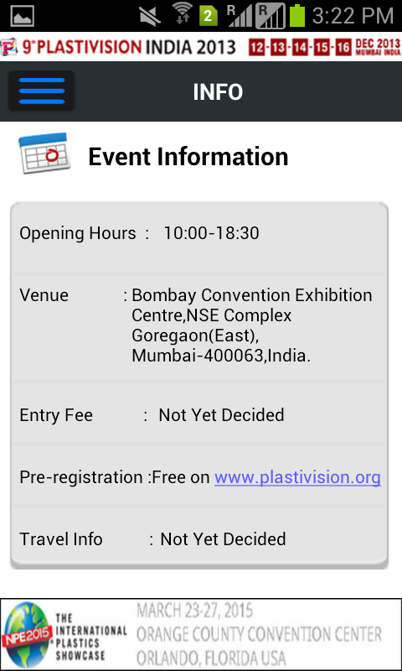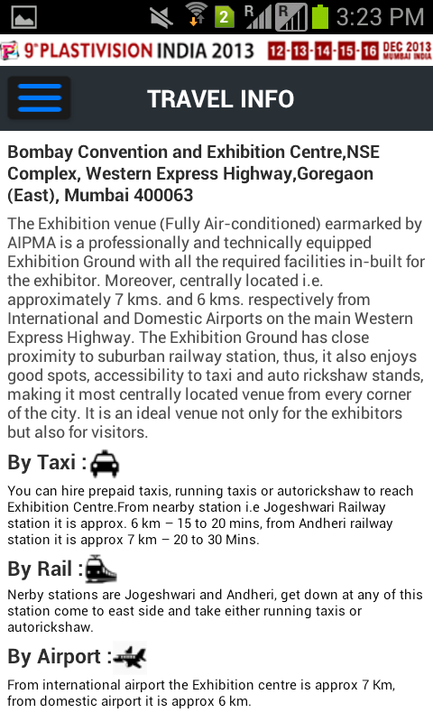

Floor Plan
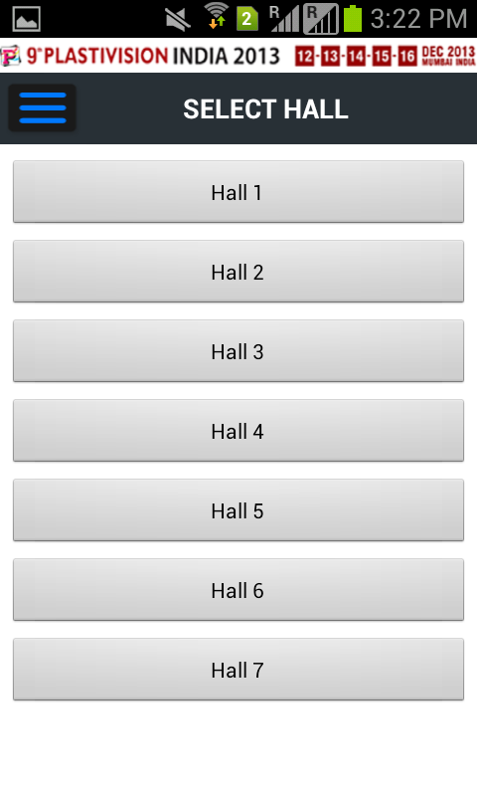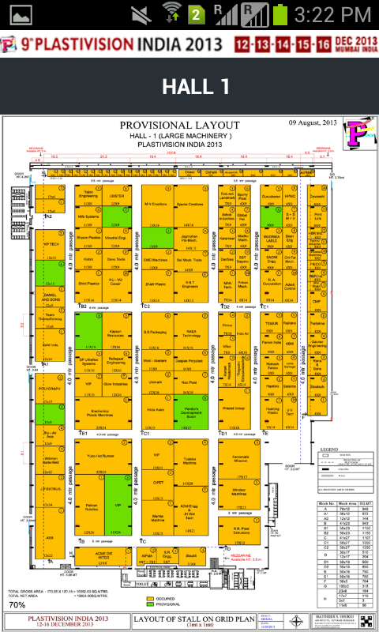
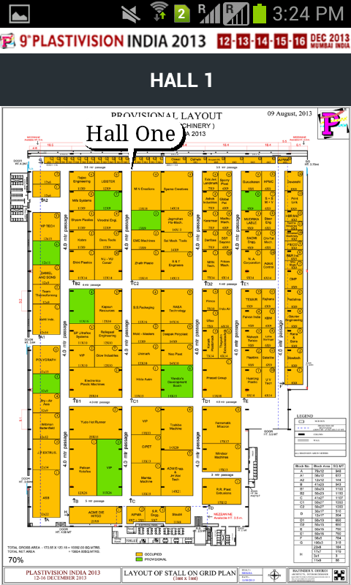
XML data will be sent to you using web services which will have x1, y1, x2, y2 co-ordinates. Using this co-ordinates
You will plot clickable region on map. When clicked it opens popup giving company name from xml webservice.
Error Log: send mail to salim.it@polymerupdate.com with brief error
e.g. <map name="hallmap">
<area shape="rect" coords="279,135,343,218" id="@+id/area1" name = "Hall One"/>
<area shape="rect" coords="348,137,410,219" id="@+id/area2" name = "Hall Two"/>
</map>
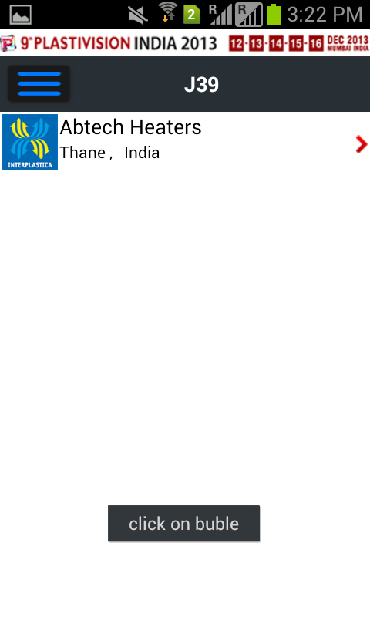

Add Schedule – same as earlier

