**Design Thinking**

**Report**

**Theme**: Design Thinking Final Process

Performed by: Designated Thinkers

An Eui Hyun (201939089)

Son Chang Hyeok (201939446)

Saidakhmad Nuriddinov (201839139)

Abrar Sami Alabdulwahab (201939090)

Lee Jae Woon (201939449)

Professor: 장문경

**1. Empathize**

These days, kiosks have been installed in many stores in Korea. It's convenient and easy to use. However, have you ever seen an elderly person use a kiosks? Everyone uses a smartphone, but why isn't everyone famailiar with kiosk yet? Let's find out what the problem is and find a solution

**Persona- interview**

Questions

1. What’s your age?
2. Are you famililar with technology?
3. Did you take the covid-19 vaccine?
4. What’s your favorite payment method?
5. What’s your personality?
6. Are you near sighted or far sighted?

|  |  |  |  |  |  |
| --- | --- | --- | --- | --- | --- |
|  | Abrar | Paul | Saidahmad | Jae woon | Chang Hyeok |
| **What's your age?** | 66 years old | 70 years old | 67 years old | 80 years old | 80 years old |
| **Are you familiar with technology?** | Yes, I know how to use a smartphone. | No, I am not familiar with technology. | I only know how to use a smartphone | No, I am not familiar with technology | No, I am not familiar with technology |
| **Did you take the covid-19 vaccine?** | Yes, I took the vaccine. | Yes, I took the vaccine. | Yes, I took the vaccine | Yes, I took the vaccine | Yes, I took the vaccine |
| **What's your favorite payment method?** | I use both cash and card. | I use cash only. | I use card. | I only use cash | I only use cash |
| **What's your personality?** | Im a calm person. | Im a calm person. | Im a hasty person | Im a calm person. | Im a hasty person |
| **Are you near sited or far sighted?** | Im farsighted. | Im farsighted. | Im nearsighted | Im farsighted | Im nearsighted |

**2. Define**

**5 whys**

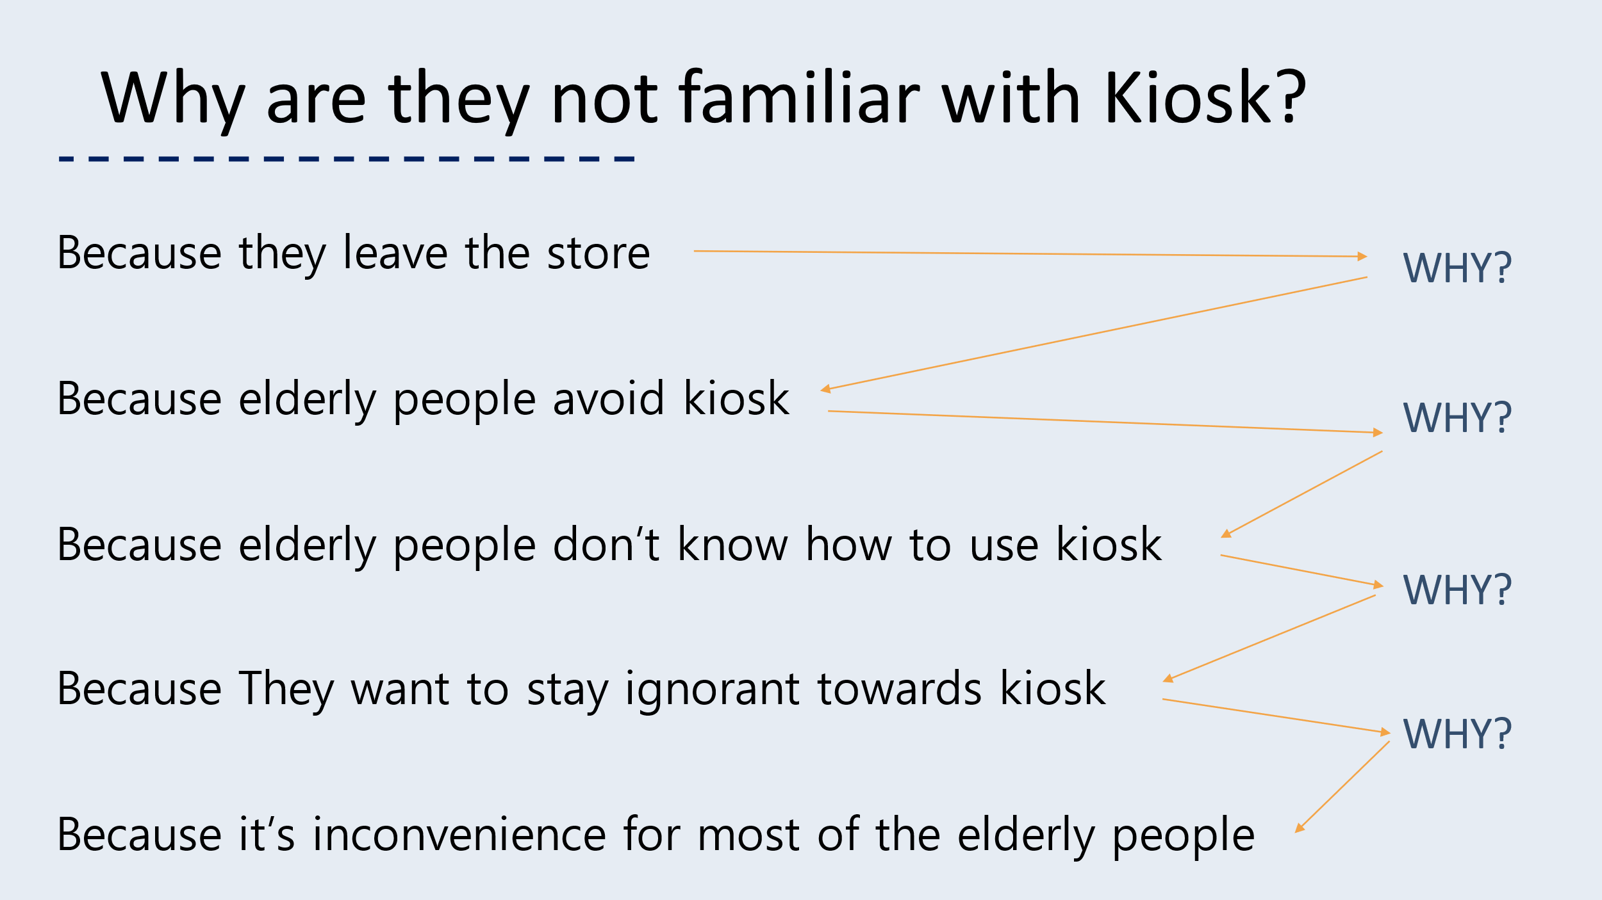

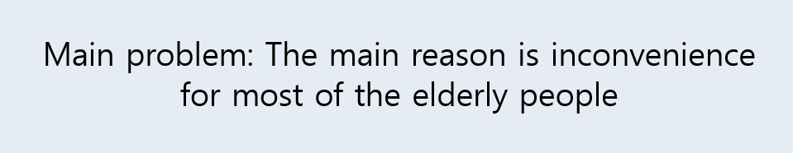

Through the 5 whys method, the reason why it is difficult for elderly people to use kiosk is that they do not have knowledge of kiosks and are uncomfortable.

So what makes Kiosk uncomfortable to elderly people? Let's go into a little more detail.

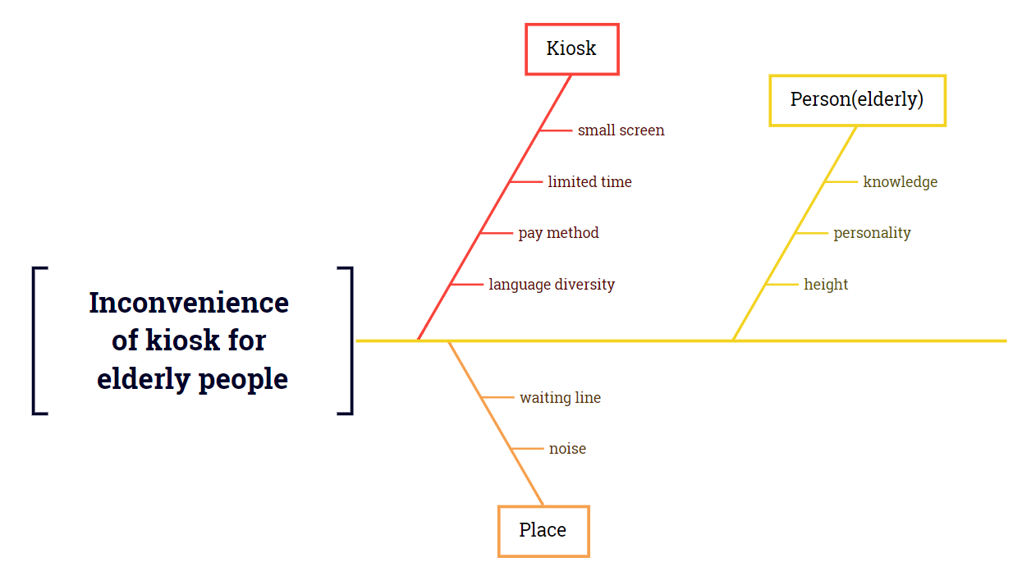**Cause-and-effect diagram**

**※ Description**

**Kiosk**

Limited time: If you do not touch it for a long time or order it for too long, the kiosk will return to the first screen. Of course, Elderly people who do not have knowledge of kiosk suffer.

Pay method: Most kiosks pay by credit card. Most elderly people have credit cards. But still many elderly people only carry cash when they go out. So, when they use kiosk, they became embarrassed.

Language diversity: Few kiosks provide language diversity option. So, they cannot place an order if a language other than his or her native language comes out.

Small screen: Most elderly people have eye-related diseases. If Kiosk's screen is small, it will be hard for the elderly to order.

**Person**

Knowledge: Elderly people who are not familiar with kiosk or have no knowledge are not available to use kiosk.

Personality: Elderly people’s personality that is difficult to learn new things or that is lazy to learn new things makes it difficult to use kiosk.

Height: It is difficult for short or bent-back elderly people to use kiosks.

**Place**  
waiting line: There are many kiosks in places like franchise restaurants and movie theaters, but most private stores have fewer kiosks. This makes elderly people reluctant to use kiosk.  
noise: When the elderly people order through speakers and microphones because they do not know how to use kiosk well, it becomes difficult to order if the noise of the store is loud.

**3. Ideate**

**Possbile Ideas**

**P=Plus | M= Minus | I= Interesting**

**1. Adding a microphone**

P. No need to touch screen

M. Microphone catches other sounds and wont be accurate

I. Kiosk will have more functionality

Usually coffee shops are noisy so it’s hard to catch someone’s voice or kiosk can get distracted.

**2. Bigger or taller screen**

P. Elderly people can see bigger texts which is more convenient for them

M. As people get older, they get shorter so short people can’t use big screen

I. Bigger screen attracts more attention

If we use taller screen, it will be expensive, and it may be very inconvenient to the short people.

**3. Using AI kiosk**

P. They can feel like they’re talking to a real human

M. AI has limitation

I. People don’t get bored

First of all AI kiosks have limited intelligence and if an elderly doesn’t understand, it can’t explain, it just keeps repeating.

**4. Using QR**

P. Anyone can scan QR and order through their phones

M. always need to scan

I. People are comfortable with their phones

We can put QR code just bottom of the screen of kiosk. Through scanning by phone they can easily access the menu through their phones. Most elderly have cell phones and they’re comfortable with their phones. In Korea through the pendamic everyone needed to check their QR code to go anywhere in the building to see if the person is vaccinated or not. Therefore, everyone in Korea knows how to use their phones.

**Conclusion:** Using QR can be best solution since everyone has cell phones. And then they don’t need to wait in lines.

**4. Prototype**

**Kiosk Prototype**

I (An Eui Hyun) have developed a website for a business such as a coffee shop. Then we inserted our website's Uniform Resource Locator (URL) into a Quick Response code (QR) generator to create a QR code.

This QR code is not operational at the moment. However, I was able to create this website using Html, CSS, and Python. I used Html and CSS to create a layout and design it, and i used python to use flask to host through my localhost. Then I used ngrok to use my local host to make an encrypted URL which will change everytime i restart ngrok.

This was to just show a demonstration of how the kiosk should impliment their QR method.

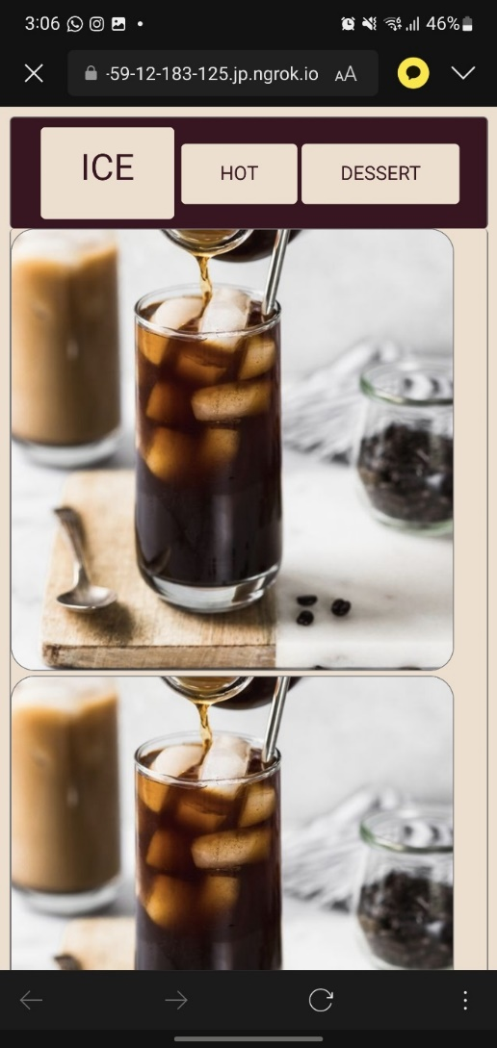 **Kiosk**



Summary

Our main topic was Kiosk and why it used throughout our daily lives specially in 2022. Which was because pandemic and aging society. They both played a big role of popularizing kiosk in the year 2022. However, not everyone knows how to use Kiosk especially the elders. Therefore, our team picked a problem that was regarded to the elderly people. We tried to emphasize with the elderly people by using the persona interview and created different personality traits but at the end of the day most of the elderly people would know how to use a smartphone due to the covid-19 restriction policy that required people to take the vaccine. Therefore, everyone needed to check in every time they go into a building or a restaurant. Our young Designated Thinkers were confused. We wondered why the elderly people were able use their smartphones but not kiosk. Then we thought it could be a fear of approaching a new technology. We asked the big question “Why are the elderly people not familiar with Kiosk” using the “5 Why” method to come down to a narrow reason. Then we figured out the main problem which was, it was inconvenient for the elderly people. That’s when our team tried to think of main possible solution that would cater to the elderly people. Then we came to a solution of QR code which happens to be used more frequently due to the pandemic. Therefore, we created a prototype that had to involve our phones because most of the elderly people have phones and they know how to use it.