**MEMS Nanopositioning for On-Chip Atomic Force   
Microscopy**

S.O.R. Moheimani*, A. C. Hammond, A. N. Laskovski, A. Fowler

School of Electrical Engineering and Computer Science, The University of Newcastle, Callaghan, NSW Australia 2308

*Corresponding author: Email [Reza.Moheimani@newcastle.edu.au](mailto:hoe.tan@anu.edu.au)

**Abstract:** A new MEMS-based parallel kinematics nanopositioner is presented, being designed, fabricated and implemented using the MEMSCAP Silicon on Insulator process. The device was used as the scanning stage of an Atomic Force Microscope (AFM).

**Introduction:** Nanopositioners have been used in applications including scanning tunneling microscopy [1], atomic force microscopy [2] and ultrahigh-density probe storage systems [3,4]. The nanopositioner reported here is designed for use in atomic force microscopy wherein the scan table is made to track a raster pattern in the x and y plane while a micro-cantilever conducts measurements in the z direction. The device is designed such that the position of the stage can be estimated from the input voltage with a high degree of confidence. The layout of components has been designed such that unwanted vibration modes are shifted to frequencies far from the operating frequencies.

**Nanopositioner Design:** The design consists of a central positioning stage, actuating combs, connecting springs, and the substrate base, as shown in Fig. 1. Two actuating combs are positioned at the edges of the device for actuating the stage in the x and y directions. These are connected to the substrate with beam springs that are oriented perpendicular to the direction of actuator movement. The central positioning stage is connected to the actuating combs using beam springs which are oriented parallel to the direction of actuation of the comb.

For accurate positioning of the actuated stage, it is desirable to have a high stiffness in the out of plane (z) direction. The stiffness of the device in the x and y planes is chosen such that the displacement due to the maximum applied voltage is equal to the desired stroke of the nanopositioner. To prevent rotational oscillations of the stage within the plane, a high degree of torsional rigidity is required about the z-axis.

Earlier nanopositioner stage implementations have suffered from low torsional rigidity in both the actuating combs and the positioning stage. By using a layout that uses many thin beam flexures, the stability of the positioner is increased.

**Characterisation:** The in-plane behaviour of the nanopositioner was characterised using a Polytec MSA-400 Micro System Analyzer. Fig. 2 illustrates the static displacement of the stage versus actuation voltage along both axes. At a maximum applied voltage of 45V, the obtained displacements were 16µm and 15.1µm along the X and Y axes respectively. The frequency response of the nanopositioner along both axes is shown in Figs. 3 and 4, with the experimental data showing that the first resonant modes along the X and Y axes are located at 816Hz and 820Hz respectively. This result compares favourably with a modal simulation of the nanopositioner performed using Coventorware and shown in Fig. 5, which indicates that the first resonant mode along each axis is located at approximately 916Hz.

**Scan:** The nanopositioner was used as the scanning stage of a commercial AFM (NTMDT-NTEGRA) to perform an open-loop scan. The nanopositioner’s scan table was designed with repeated features 500nm high, spaced 5mm apart as shown on the bottom right corner of Fig. 1. The image produced from the AFM scan is shown in Fig. 6.

These initial investigations establish the capability of this device to function as the nanopositioning stage of a miniaturized atomic force microscope. This design has opened the scope for the development of feedback controllers and high accuracy low frequency sensing interface circuitry. These aspects are currently being investigated based on this device, with the view to realize high-speed atomic force microscopy on a chip.

**Acknowledgements:** This work was supported by Australian Research Council. The authors wish to thank Dr. Yuen Yong for her assistance in generating the AFM image.

**References**

[1] G. Binning et al. Sci. Amer., vol. 253, pp. 50–56, 1986.

[2] G. Binning et al. Phys. Rev. Lett., vol. 56, no. 9, pp. 930–933, Mar. 1986.

[3] N.B.Hubbard et al. Appl. Mech. Rev., vol. 59, no. 6, pp. 324– 334, Nov. 2006.

[4] A. Pantazi et al. Nanotechonology, vol. 15, no. 10, pp. S612–S621, Oct. 2004.

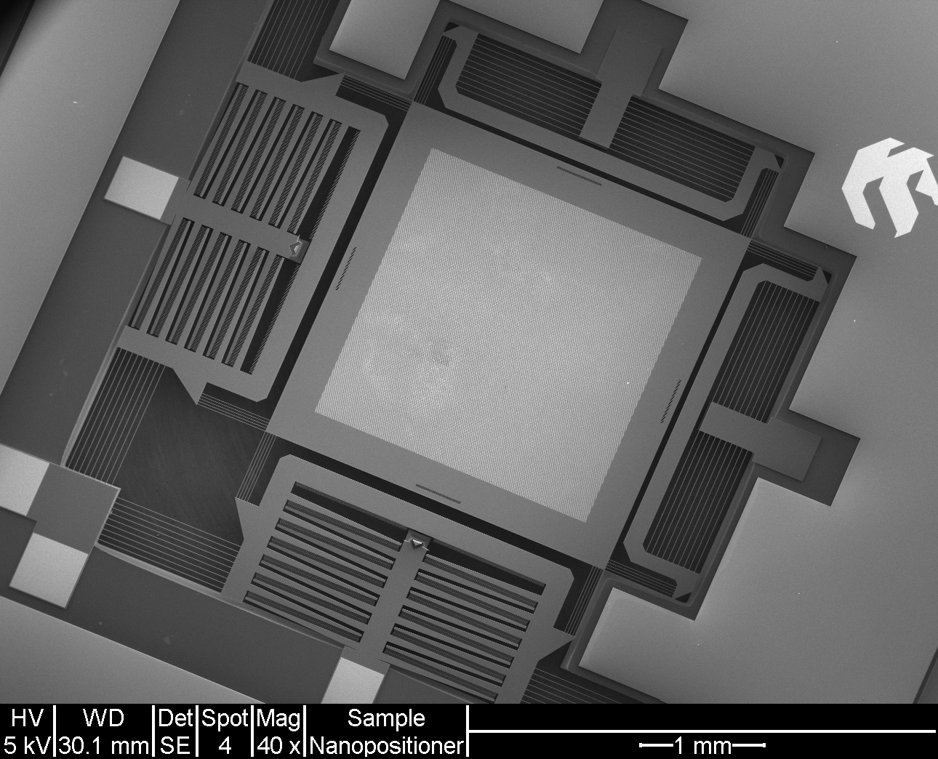

Fig. 1. MEMS nanopositioner

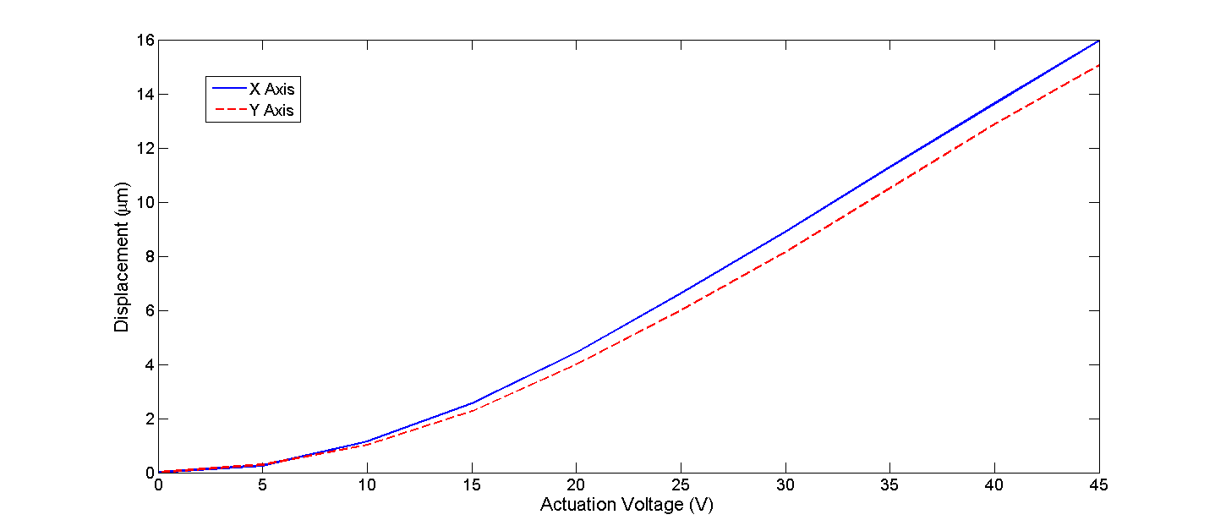

Fig. 2. Displacement vs actuation voltage

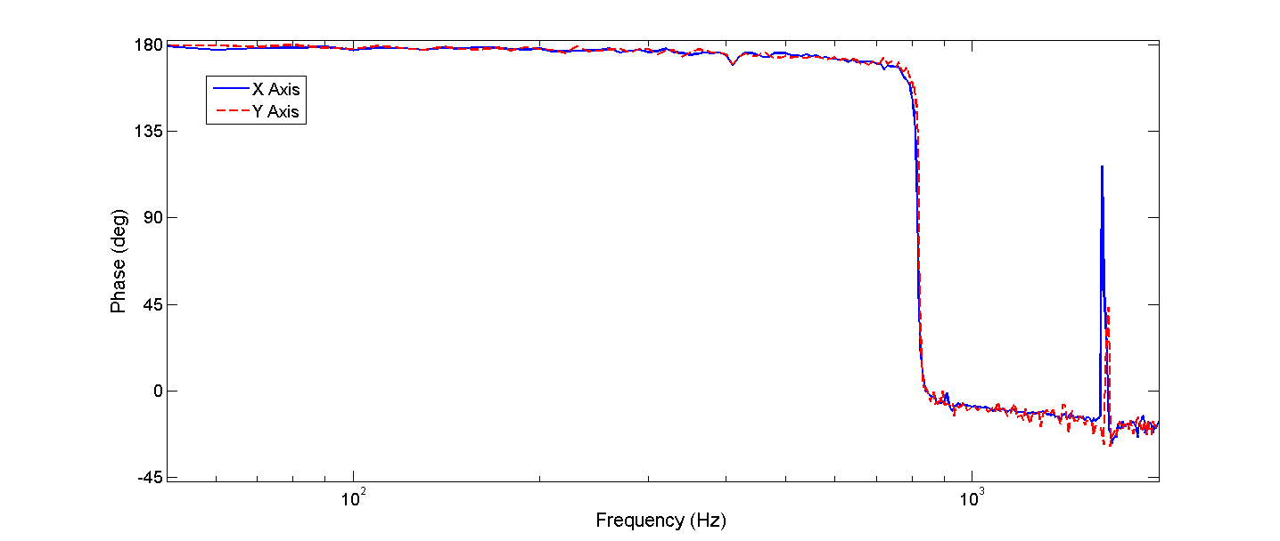

Fig. 4. Frequency response phase

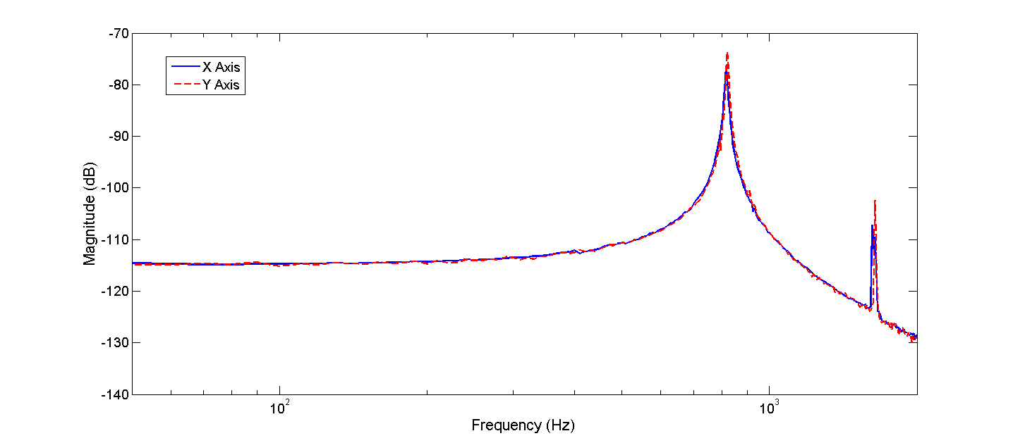

Fig. 3. Frequency response magnitude

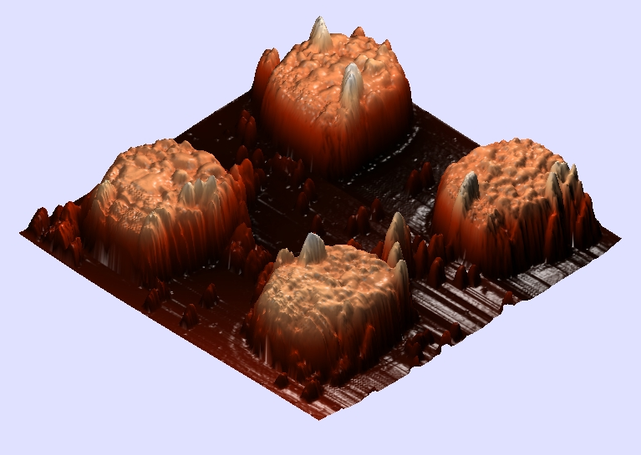

Fig. 6. Atomic Force Microscope image of the features of the nanopositioner

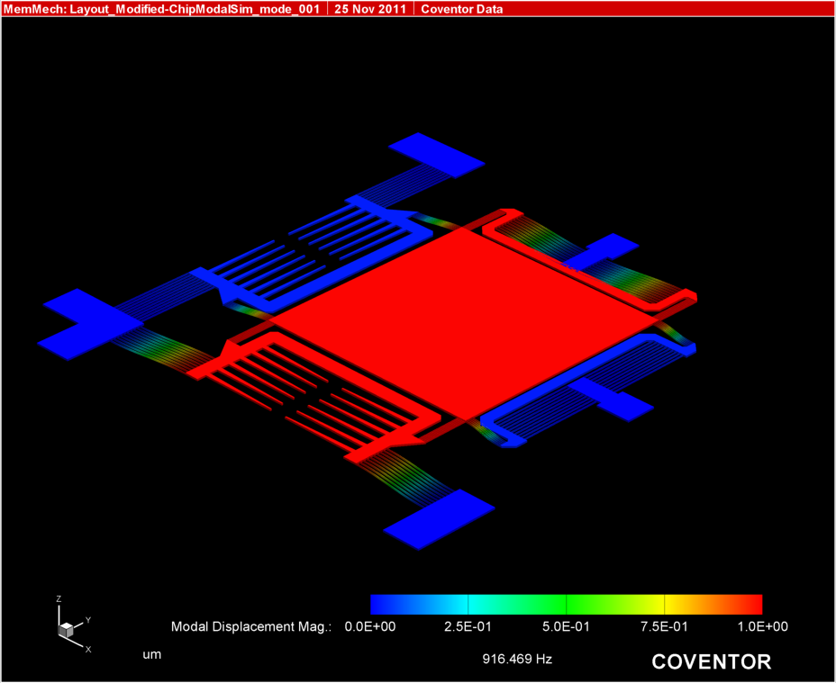

Fig. 5. Finite element simulation of the nanopositioner at the first resonant mode