Social Connection: Registration and Attendance Managing Application

User Manual

*------by Group 14*

*ZHOU Yi 14109328D*

*xxx xxxxxxxxxx*

*GU Jinshan 14110914D*

*ZHOU Moyuan xxxxxxxxxxx*

Access Method:

1. Via URL: [http://58.96.176.223:9001/](http://58.96.176.223:9000/) .

2. Via local host: The index.html is under /public folder.

Login

User needs to log in the system first. The system will link to administration page or attendee page according to the different usernames entered by user.

Since all the users are pre-generated (or added by administrator), there is no registration function.



Administration Page

//admin username and password

../../../../../../Desktop/Screen%20Shot%202015-12-19%20at%20Profile

User can view or edit his/her profile by pressing button on the left top corner.

After click, the user profile will be shown. User can click “Update” button so the profile will become editable.

User can click “Save” to save the profile after edit.

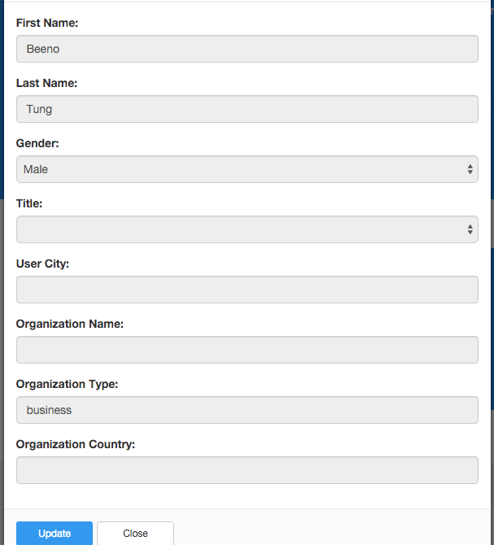

Add User

Administrator can create users by clicking “Add User” button. A form for creating user will be shown and administrator can enter user information in the form.

When creating user, the account type should be specified as Administrator/Attendee/Speaker.

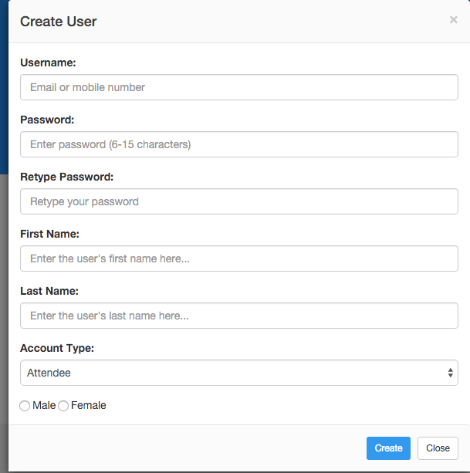

Show Users

Administrator can click “Show Users” button to view all the users. The detail of each user can be viewed by clicking on the name. Administrator can also send mail to the specified user by clicking the small mail button besides it.

//picture

Announcement

Administrator can view and create announcements. The detail about the announcement can be viewed by clicking on it.

//picture

Administrator can create an announcement by click on “Create”. The title and content of the announcement should be entered and the creation time will also be recorded. After submission, the announcement will be sent to all users.

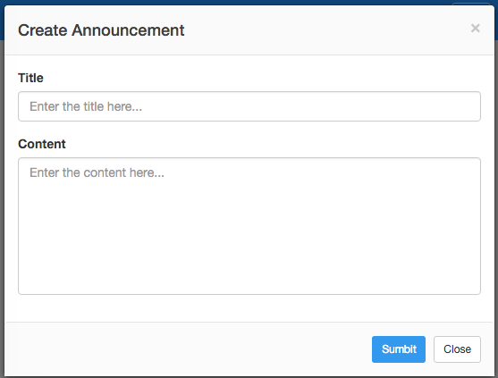

Reward

//

Exhibition

Administrator can view and create exhibition. The detail about the exhibition can be viewed by clicking on it.

//picture

Administrator can create an exhibition by click on “Create”. The detail of the exhibition should be entered. After submission, the exhibition can be viewed by all the users.

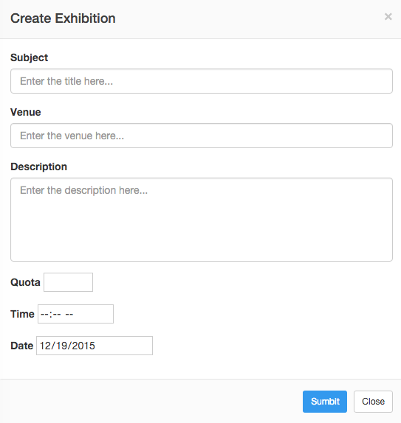

Analytics

//

Attraction

Administrator can add attraction information, which can be viewed by attendees to learn and find nearby attractions.

Administrator can click “Add Attractions” to create an attraction introduction. The information about the attraction should be entered.

