Table of Contents
Setting Up 1
Configure Path 1
Define Node Host Environment Variables 1
Add pwfarm_set Function to .bashrc 1
Verify SSH Public Key 1
Define a Farm 2
Execute a Farm Build 2
Running Polyworld 3
Analysis of a Previous Run 4
Running Passive Mode 4
Recovering from Workstation Crash/Reboot 5
Killing the Dispatcher 5
Nuking the World 5

Setting Up

Configure Path
Your PATH environment variable should include the scripts/farm directory. For example, update your ~/.bashrc to include the statement:

export PATH=/home/foo/polyworld/scripts/farm

Define Node Host Environment Variables
For each machine on the farm, you must declare an environment variable containing its hostname/IP. For example, you might place the following in your .bashrc:

export pw00="192.168.0.73"
export pw01="192.168.0.216"
export pw100="192.168.0.100"

Note that the numbers in the variable names must be padded to two places with zeros.

Add fset Function to .bashrc
Although not strictly necessary, it is convenient to add the fset function to your ~/.bashrc. The implementation is contained in scripts/farm/example_bashrc.
One advantage of this function is that it creates some aliases for you. For example, the alias 'frun' will invoke pwfarm_run.sh. The rest of this document will assume you are using this function.

Verify SSH Public Key
You need to either not have any SSH key configured, or you need to have a public RSA key for which no password is set. If you don't have a key (stored in ~/.ssh/id_rsa.pub), then move on to next step. If you have a key with a password, you're going to need to delete it. Otherwise, you're going to be typing passwords a lot to get pwfarm to operate.

Define a Farm
You must use pwfarm_config.sh to define a farm. An example invocation is (using 'config' alias):

fconfig define farm mini sean larryy /farmruns {0..9}

Where the usage is:

fconfig define farm <farm_name> <pwuser> <osuser> <dstdir> <field_number>...

For the name of the farm, choose something that is meaningful to you. The name should consist of only numbers and letters.

For the pwuser, you can use anything you like, perhaps your first name. The name should consist of only numbers and letters.

For osuser, you must use a Unix account that is valid on all machines. As of the writing this document, the “farm” is a collection of 10 Mac Minis at IU. If you are using those machines, you must use larryy as the user so that graphical applications can be executed. If you are not using those machines, then you must use a valid UNIX user name for those machines.

For dstdir, you can choose any directory on your local workstation. It needn't exist yet. This is where portions of run data will be placed.

The “{0..9}” is a bash macro that expands to “0 1 2 3 4 5 6 7 8 9”, where these are the IDs of the farm machines. Note that for each of these IDs, you should have defined a pwNN environment variable.

Note that the first machine ID passed to this script must already be configured to be able to SSH into the other machines without a password. If you are using the IU Mini farm, then you needn't worry about this, except that you must always use ID 0 as your first machine.

Set Farm Context
Before executing any tasks on the farm, you must set your farm context. If you have only one farm and one session – this is your state if you're just following this document – then you can issue the following:

fset

If you have multiple farms or sessions, then issuing fset with no arguments will select the first farm and session you defined. You can explicitly specify which farm and session:

fset <farm_name> [<session_name>]

Execute a Farm Build
From your polyworld home directory, use pwfarm_build.sh. Invocation will typically look like:

fbuild

This will transfer the source in your polyworld directory to each machine on the farm and execute a build. Note that it will prompt you for the administrator password for the machines on the farm.

If all goes well, after you enter the password, you will see a screen like the following:

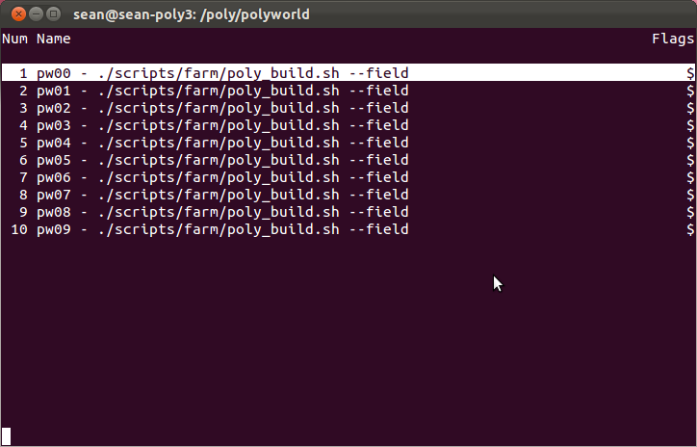
This is a GNU Screen “window menu” that allows you to look at the console for each machine. To look at the contents of a specific machine, use the up/down arrows to select it from the menu, and press enter. To return to the menu, press CTRL-A “. That is, press “control” and “a” at the same time, then release those keys and press “shift” and “,” at the same time. Not intuitive? Well, that's GNU Screen.

So, everything went perfectly, right? Good.

Running Polyworld
To run Polyworld on the farm, you must use the script pwfarm_run.sh. For example, an invocation might look like:

frun -w ./example.wf -a scripts/farm/example_postrun.sh example/driven

The meaning of the arguments in this invocation is:

-w ./example.wf : This is the local worldfile that will be executed on the farm. Note it will be transferred to the farm machines.

-a scripts/farm/example_postrun.sh: This is a script on the local machine that you want to execute on the farm machines. Note it will be transferred to them. Also note that this particular script actually does exist in CVS for the sake of reference. Look at it if you want to do your own analysis.

example/driven: This is the so-called “run ID”, which should be a unique identifier for this run. Essentially, it's just used as part of file paths when storing run data on the farm and on your local workstation. In this case, the experiment being run is identified as “example” and this is intended to be a “driven” run.

Analysis of a Previous Run
You may perform analysis of a run previously executed on the farm. To do so, you must use the poly_run.sh script, but don't specify a worldfile, and pass a valid run id from a previous run. For example, let's say we make an analysis script that writes the names of all files in the run directory to a text file, where the script is located on our local workstation at ./listrun.sh. To use this script to list the run contents for the example in the “Running Polyworld” section, the invocation would look like:

frun -a ./listrun.sh example/driven

After this invocation, we will see updated content in /farmruns/example/driven.

Let's also say the content of our ./listrun.sh script is the following:

#!/bin/bash

find run > run/foo.txt

echo 'foo.txt' >> $PWFARM_RUNZIP

First note that the script assumes that the run directory is located at run/. This can always be assumed. The echo statement is then specifying paths relative to run/ that should be pulled back to your local workstation. You can specify as many paths that you want. For example, if there was also a file “run/genome/bar.txt”, then you script would look like:

echo 'foo.txt' >> $PWFARM_RUNZIP
echo 'genome/bar.txt' >> $PWFARM_RUNZIP

Running Passive Mode
To run Polyworld in passive “lockstep” mode, use the script pwfarm_passive.sh. Note that in order to use this, you must have already executed a driven simulation on the farm. For example, to execute a passive version of the example in section “Running Polyworld”, the invocation would look like:

fpassive -a scripts/farm/example_postrun.sh example/a example/a_passive

Where the arguments are:

-a scripts/farm/example_postrun.sh: Analysis script to run after passive run completes.

example/driven: Run ID of existing driven run.

example/passive: Run ID for passive run.

Running Multiple Tasks on Farm
To run more than one task on the farm at a time, you must define multiple sessions. To define a session, you must use pwfarm_config.sh like the following:

fconfig define session mini sessionb

You can now use sessionb to execute tasks on the farm. In order to do so, you must set it as your context:

fset mini sessionb

If you execute fset with no parameters, it will try to select a reasonable default for you.

If you ever need to see what farm and session are definitions are available or which are set as your current context, execute:

fconfig stat

Running Polyworld with Different Worldfiles
You can run with different worldfile parameters on each machine by using an “overlay” file. For example, if you want to run with MinMutationRate=0.01 on pw00 and MinMutationRate=0.02 pw01, you would create an overlay file with the following content:

pw00 {
MinMutationRate 0.01
}

pw01 {
MinMutationRate 0.02
}

If this file had the path “mutate.wfo” and your worldfile was “alifexi.wf”, then your invocation would look like:

frun -p ./mutate.wfo -w ./alifexi.wf runid/foo

When you execute frun with the -p option, before the task is dispatched to the farm you will be presented with a GUI window showing the worldfiles resulting from the overlay operation. You will then be prompted as to whether you approve and should proceed. Note that you may not make edits to the worldfiles you are presented, since they are just temporary copies for your benefit.

If a given machine on your farm does not match any clauses in your overlay file, then no simulation will be executed on that machine. A warning message will be displayed if any of your machines do not match your overlay file. If no machines on your farm match your overlay file, then frun will exit with an error status.

Note that when you use an overlay file, the pwfarm scripts will not automatically change the simulation's RNG seed on a per-machine basis.

Inspecting Run Data on Farm
The script pwfarm_lsrun.sh allows you to perform operations similar to an ls on your local machine. To see a list of the top level of run IDs owned by you, execution would look like:

flsrun /

Renaming Runs on Farm
To rename/move a run on the farm, use pwfarm_mvrun.sh. For example, to rename run foo/x to foo/bar/baz/z:

fmvrun foo/x foo/bar/baz/z

Deleting Runs on Farm
To delete a run on the farm, use pwfarm_rmrun.sh. Note that by default it will only delete failed runs. For example, to delete a failed run named foo/x:

frmrun foo/x

Recovering from Workstation Crash/Reboot
If your workstation has shut down while you are running tasks on the farm, you must use pwfarm_dispatcher.sh to recover. Invocation will be:

fdisp recover

This should reconnect your workstation to the farm, and show you the GNU Screen Window Menu. If the tasks on the farm are already complete, then the results files will be pulled to your workstation in the normal fashion.

Killing the Dispatcher
To kill the dispatcher on your workstation without also killing tasks on the farm, execute:

fdisp disconnect

Nuking the World
Sometimes things go wrong. Especially if you are changing the low-level pwfarm scripts. If you want to kill all pwfarm processes and clear all pwfarm execution state on both your workstation and the farm machines (for your current session), execute the following command:

fdisp clear

This will abruptly kill everything in your current farm session. Note that you needn't have any pwfarm processes running on your workstation for this to work.

