# Understanding the Adult Data Set: A Comprehensive Overview

## Abstract

The Adult Data Set, often referred to as the 'Census Income' data set, is a widely utilized data source for classification tasks in machine learning. Originating from the 1994 U.S. Census database, this data set serves as an excellent foundation for exploring predictive modeling techniques and analyzing socioeconomic trends.

## Background and Purpose

The primary objective of the Adult Data Set is to predict whether an individual's income exceeds $50,000 per year based on a variety of demographic factors. The data has been extensively used in training and testing algorithms for binary classification problems, making it a cornerstone in educational and practical applications of machine learning.

## Key Features of the Data Set

The data set comprises approximately 48,842 instances and 14 attributes, including:  
- Age: The individual's age in years.  
- Education: Highest level of education completed (e.g., 'Bachelors', 'HS-grad').  
- Occupation: Type of job or profession (e.g., 'Tech-support', 'Craft-repair').  
- Hours-per-week: Number of hours worked per week.  
- Native-country: The country of origin of the individual.  
  
These attributes, combined with the class label indicating income ('<=50K' or '>50K'), provide a broad spectrum for analyzing trends related to age, work hours, and educational attainment.

## Sample Data from the Adult Data Set

Below is a sample from the data set that highlights key attributes across 30 records:

### Table 1: Sample Data from the Adult Data Set

|  |  |  |  |  |
| --- | --- | --- | --- | --- |
| Age | Education | Occupation | Hours-per-week | Income |
| 39 | Bachelors | Adm-clerical | 40 | <=50K |
| 50 | Doctorate | Exec-managerial | 60 | >50K |
| 28 | HS-grad | Tech-support | 40 | <=50K |
| 37 | Masters | Prof-specialty | 45 | >50K |
| 49 | Bachelors | Craft-repair | 48 | <=50K |
| 45 | Some-college | Sales | 35 | <=50K |
| 33 | 7th-8th | Handlers-clean. | 38 | <=50K |
| 52 | HS-grad | Exec-managerial | 60 | >50K |
| 23 | Bachelors | Adm-clerical | 30 | <=50K |
| 41 | HS-grad | Machine-op-insp | 40 | <=50K |
| 37 | Bachelors | Prof-specialty | 40 | >50K |
| 29 | HS-grad | Sales | 30 | <=50K |
| 42 | Masters | Exec-managerial | 55 | >50K |
| 34 | 10th | Machine-op-insp | 40 | <=50K |
| 38 | Some-college | Tech-support | 40 | <=50K |
| 43 | Assoc-acdm | Protective-serv | 40 | <=50K |
| 30 | HS-grad | Other-service | 20 | <=50K |
| 54 | Doctorate | Prof-specialty | 60 | >50K |
| 32 | Bachelors | Exec-managerial | 50 | >50K |
| 36 | Some-college | Sales | 30 | <=50K |
| 44 | Masters | Exec-managerial | 50 | >50K |
| 48 | 5th-6th | Farming-fishing | 35 | <=50K |
| 27 | HS-grad | Handlers-clean. | 40 | <=50K |
| 40 | Assoc-voc | Craft-repair | 40 | >50K |
| 35 | HS-grad | Transport-moving | 40 | <=50K |
| 56 | Doctorate | Prof-specialty | 60 | >50K |
| 47 | Bachelors | Sales | 45 | <=50K |
| 38 | Some-college | Exec-managerial | 50 | >50K |
| 31 | Assoc-acdm | Adm-clerical | 30 | <=50K |
| 49 | HS-grad | Machine-op-insp | 40 | <=50K |

## Applications and Insights

The data set provides valuable insights into the correlations between education, work hours, and income levels. It reveals that higher education levels and managerial roles often correlate with an income exceeding $50,000 annually. Such findings underscore the importance of education and job type in income determination.

## Loading the dataset to a RAG system

If you want to add the data to our RAG system, you can for example translate the data into text by transforming each line of the dataset into a paragraph (you can find an example in the image below)

## 

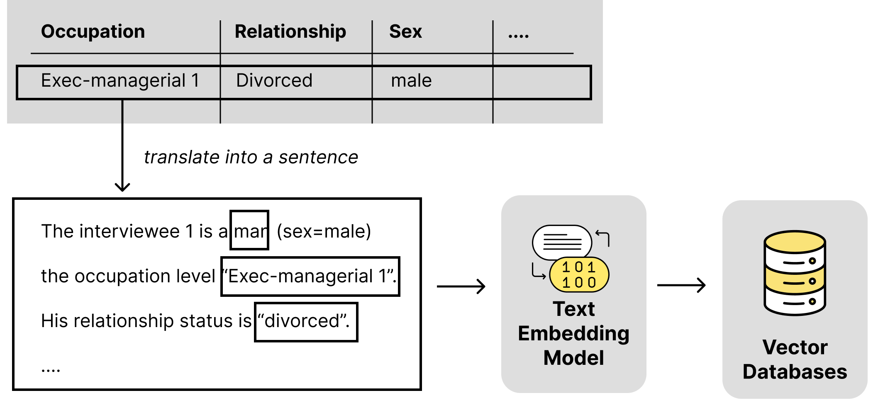

Figure 1: Loading CSV Files: Option 1 - Transforming CSV rows into text