Федеральное государственное бюджетное образовательное

учреждение высшего образования

«Национальный исследовательский университет «МЭИ»

|  |  |  |  |
| --- | --- | --- | --- |
| Институт: | ИВТИ | Кафедра: | ПМИИ |
| Направление подготовки/специальность: | | 01.03.02 Прикладная математика и информатика | |

**ЗАДАНИЕ**

**на выполнение КП/КР по дисциплине**

**«**Программная инженерия**»**

|  |  |
| --- | --- |
| **Тема КП/КР:** | Разработка оконного приложения с помощью библиотеки PyQT5 на Python. Создание приложения для загрузки видео с Rutube по ссылке. |
|  | |
| **Студент:** | Кокляева Мария Оскаровна |
|  | *(Фамилия, имя, отчество (при наличии) полностью)* |
| **Группа:** | А-13-22 |
|  | *(номер учебной группы)* |

|  |
| --- |
| **Содержание задания:** |
| 1.Проведение анализа предметной области |
| 2.Разработка структуры программы |
| 3.Выбор среды реализации. Обоснование выбора |
| 4.Разработка программной реализации |
| 5.Тестирование и отладка |
| 6.Оформление КР |
| *(вопросы, подлежащие изучению в соответствии с планируемыми результатами обучения,*  *заполняются руководителем КП/КР)* |

|  |  |  |
| --- | --- | --- |
| Руководитель | 09.09.2024 | М.М. Маран |
|  | *(дата)* | (*Фамилия и инициалы*) |

|  |  |  |
| --- | --- | --- |
| Студент | 18.09.2024 | М.О. Кокляева |
|  | *(дата)* | (*Фамилия и инициалы*) |

**1.Проведение анализа предметной области**

Для реализации приложения, нам потребуется, скачать сам язык Python (в работе использовалась версия 3.9), а также подключить библиотеки PyQt5 и rutube. И некоторые системные библиотеки OS и SYS

**2.Разработка структуры программы**

*Основная программа:*

Программа состоит из двух классов.

Один из них отвечает за разработку функционала кнопок приложения (хранение ссылки для скачивания видео, пути к папке, куда будет загружено видео).

Второй отвечает за поток загрузки, т.е. в нем реализованы функции для скачивания и отображения состояния загрузки.

*Файл с дизайном:*

Потребуется реализовать макет приложения в *QtDesigner* и конвертировать из .ui в .py

Его также нужно импортировать в основной код программы.

**3.Выбор среды реализации.**

Среда разработки кода *PyCharm IDE*. Среда разработки для дизайна *QtDesigner.*

**4.Разработка программной реализации**

Для того, чтобы начать разработку макета приложения, нужно отдельно скачать приложение QtDesigner. В нем можно только создать макет и настроить дизайн нашего будущего приложения.

Создаем макет, оформляем дизайн.

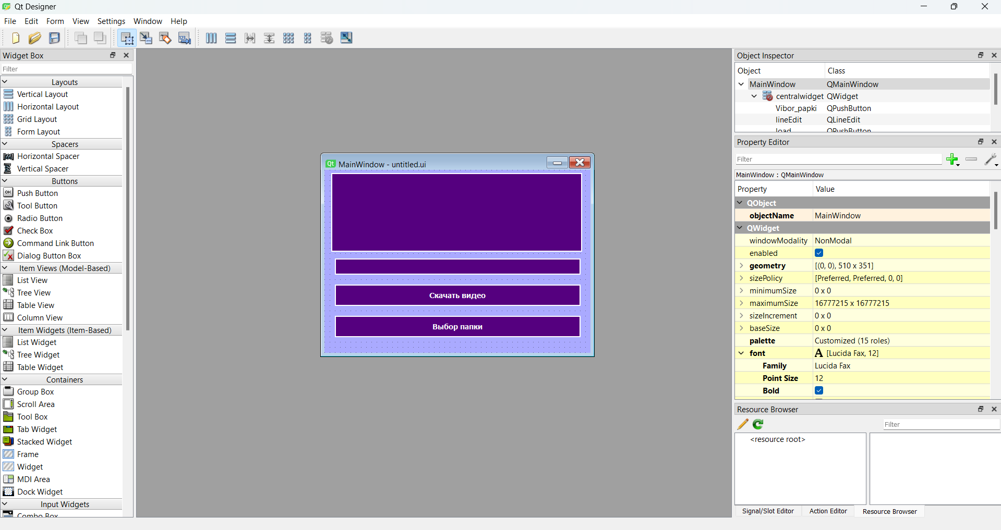

Теперь нужно его сохранить в папку с проектом, в которой лежит основной код программы. Далее реализовать конвертирование из .ui в .py (далее смотреть фото):

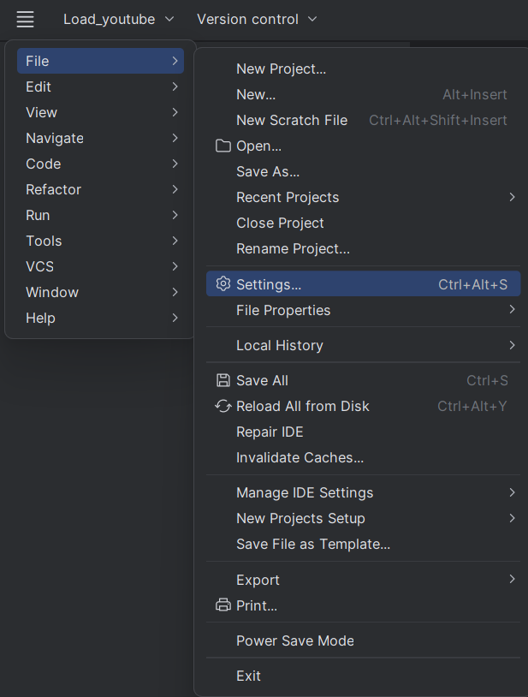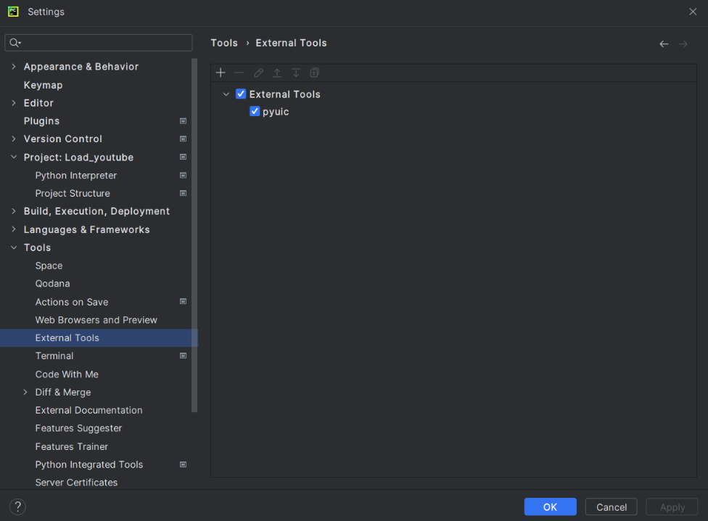

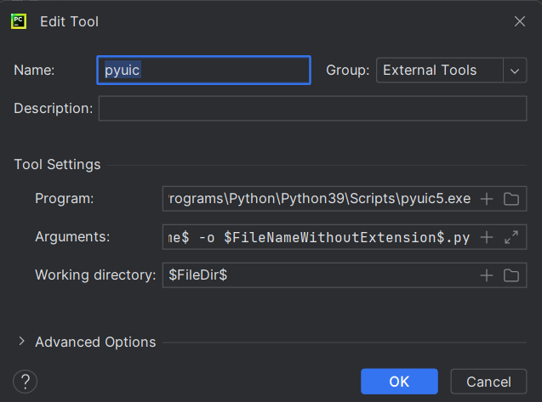

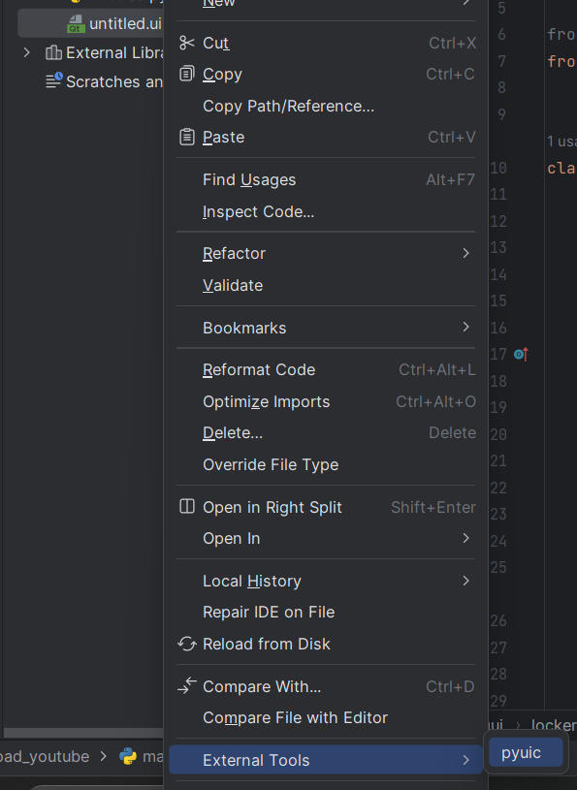

Результат:

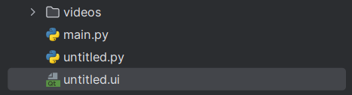

Затем переходим к реализации основного кода. Импортируем библиотеки и файл с дизайном:

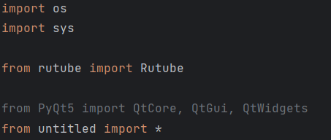

Реализуем классы описанные выше в п.2.

*1.Класс для загрузки*

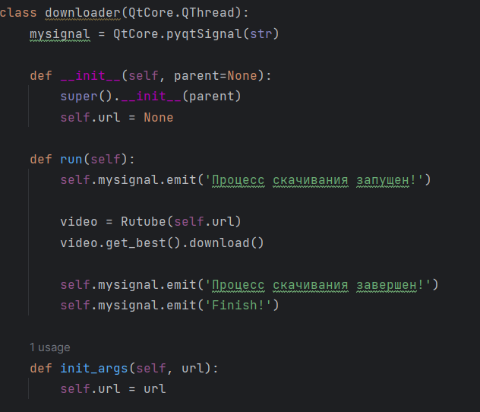

Def __init__(self,parent=None) – конструктор

Def run(self) – запускает скачивание, с отображением состояния скачивания.

Создаем объект Rutube и применеям функцию getbest().downoloader(), она выбирает поток с самым высоким разрешением. Это вернет "обычный" поток (т.е. с видео и аудио).А downoloader() его загрузит.

*2.Класс для обработчика событий кнопок, хранения данных адреса ссылки и пути к папке.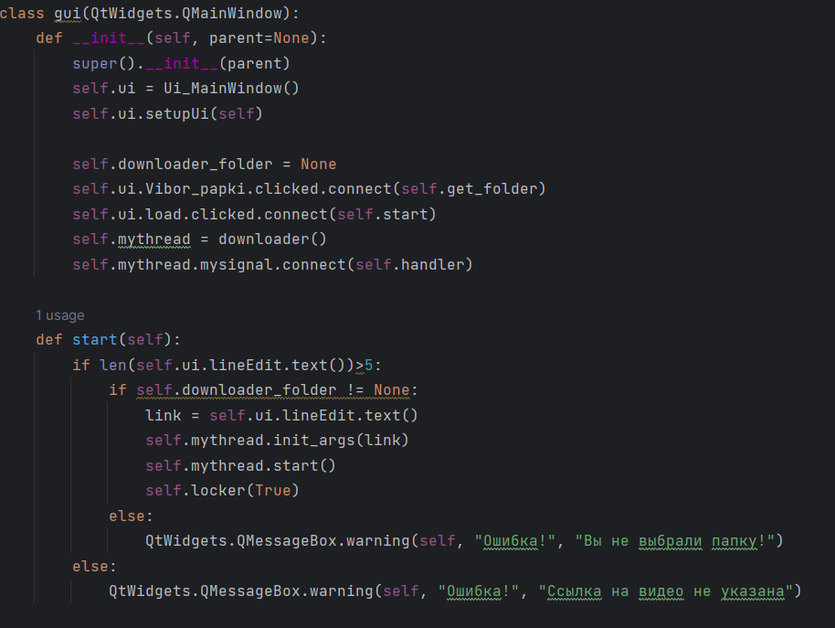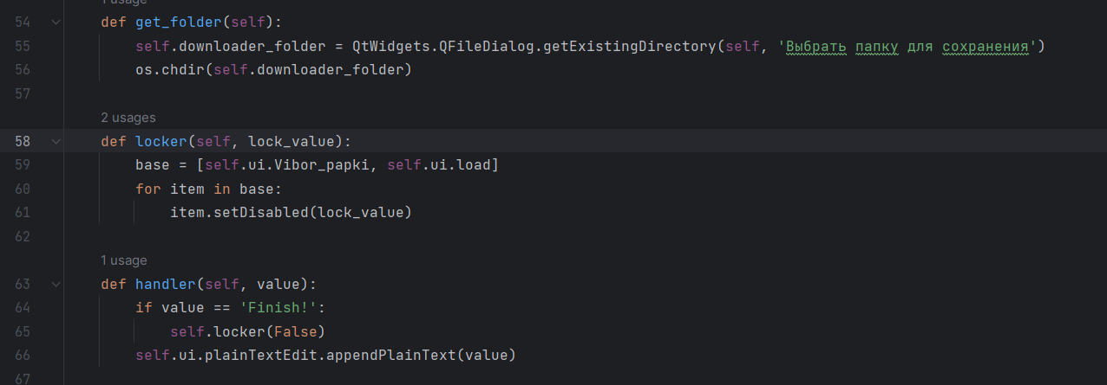*

*В этом классе расписан по большей части функционал кнопок, с обработкой возможных событий.*

Последнее, запуск программы.

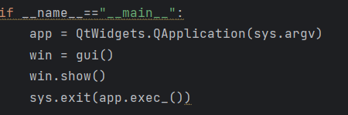

**5.Тестирование и отладка**

Рассмотрим следующие варианты событий:

1.Не указана ссылка для скачивания. 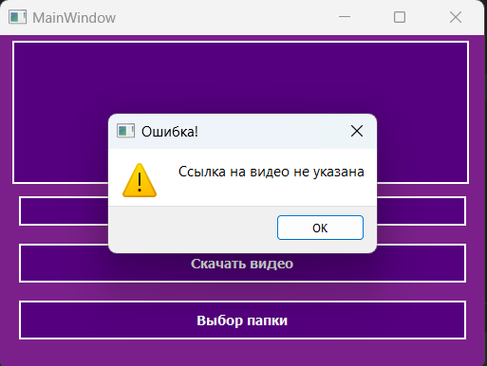

2.Ссылка на видео указана, но не выбрали папку.

Для этого возьмем ссылку прямо с Rutube, на какое-нибудь короткое видео:

<https://rutube.ru/video/c382ca7df9599211eb4d42392a916d22/>

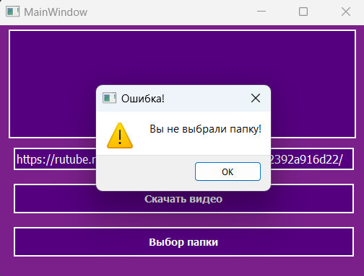

3.Всё указано корректно.

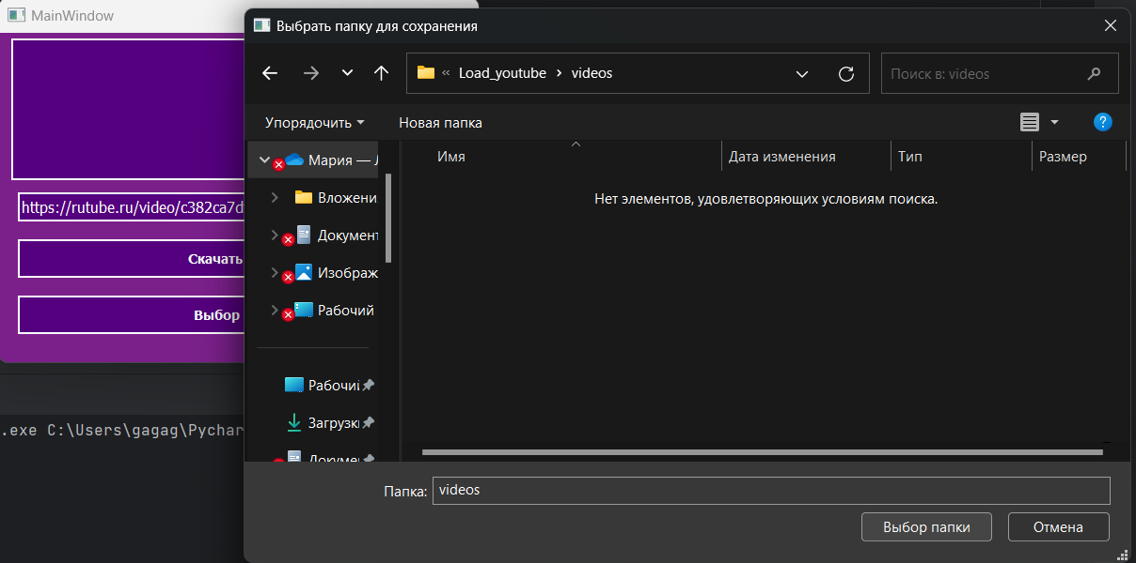

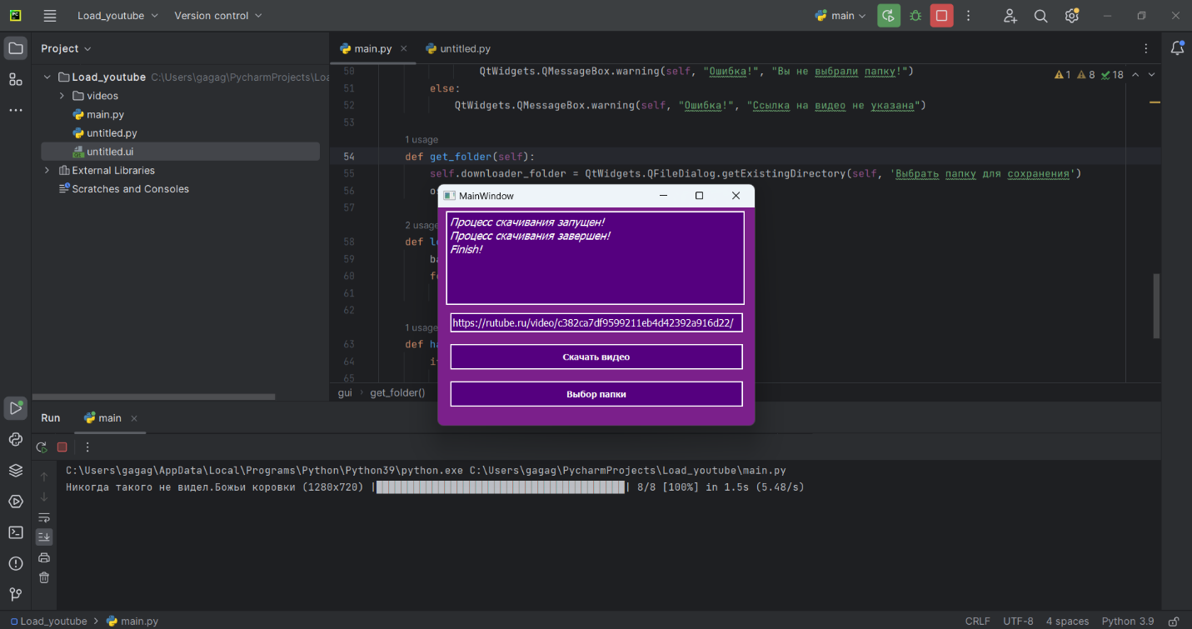

Переходим в указанную папку. Видим, что видео успешно загрузилось.

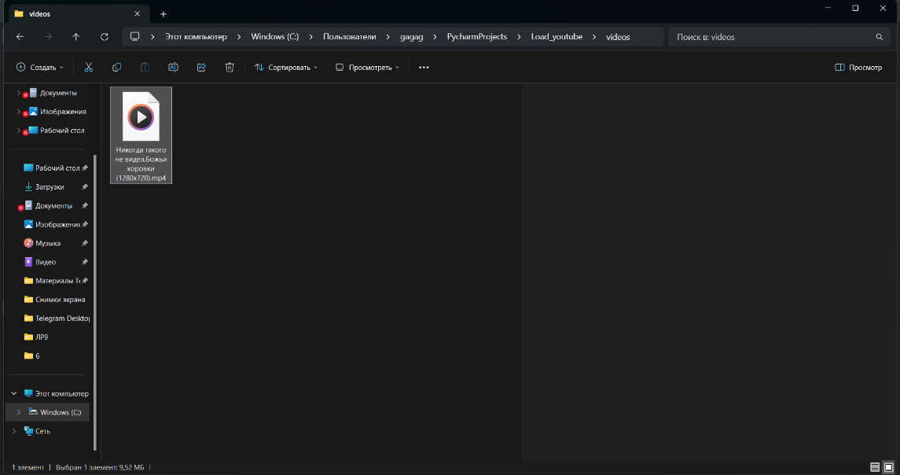

Проверим корректность скачанного видео. Работает.

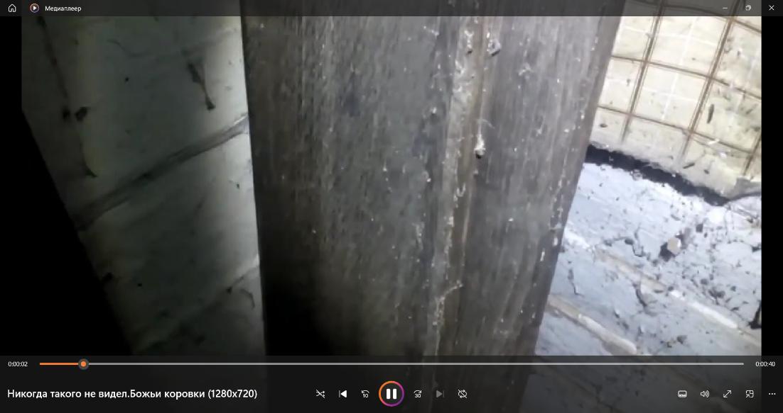

***Заключение***. Программа на тестах отработала корректно.

***Листинг кода:***

***Main.py***

import os  
import sys  
  
from rutube import Rutube  
  
from PyQt5 import QtCore, QtGui, QtWidgets  
from untitled import *  
  
  
class downloader(QtCore.QThread):  
 mysignal = QtCore.pyqtSignal(str)  
  
 def __init__(self, parent=None):  
 super().__init__(parent)  
 self.url = None  
  
 def run(self):  
 self.mysignal.emit('Процесс скачивания запущен!')  
  
 video = Rutube(self.url)  
 video.get_best().download()  
  
 self.mysignal.emit('Процесс скачивания завершен!')  
 self.mysignal.emit('Finish!')  
  
 def init_args(self, url):  
 self.url = url  
  
  
class gui(QtWidgets.QMainWindow):  
 def __init__(self, parent=None):  
 super().__init__(parent)  
 self.ui = Ui_MainWindow()  
 self.ui.setupUi(self)  
  
 self.downloader_folder = None  
 self.ui.Vibor_papki.clicked.connect(self.get_folder)  
 self.ui.load.clicked.connect(self.start)  
 self.mythread = downloader()  
 self.mythread.mysignal.connect(self.handler)  
  
 def start(self):  
 if len(self.ui.lineEdit.text())>5:  
 if self.downloader_folder != None:  
 link = self.ui.lineEdit.text()  
 self.mythread.init_args(link)  
 self.mythread.start()  
 self.locker(True)  
 else:  
 QtWidgets.QMessageBox.warning(self, "Ошибка!", "Вы не выбрали папку!")  
 else:  
 QtWidgets.QMessageBox.warning(self, "Ошибка!", "Ссылка на видео не указана")  
  
 def get_folder(self):  
 self.downloader_folder = QtWidgets.QFileDialog.getExistingDirectory(self, 'Выбрать папку для сохранения')  
 os.chdir(self.downloader_folder)  
  
 def locker(self, lock_value):  
 base = [self.ui.Vibor_papki, self.ui.load]  
 for item in base:  
 item.setDisabled(lock_value)  
  
 def handler(self, value):  
 if value == 'Finish!':  
 self.locker(False)  
 self.ui.plainTextEdit.appendPlainText(value)  
  
if __name__=="__main__":  
 app = QtWidgets.QApplication(sys.argv)  
 win = gui()  
 win.show()  
 sys.exit(app.exec_())

***Untitled.py***

# -*- coding: utf-8 -*-  
  
# Form implementation generated from reading ui file 'untitled.ui'  
#  
# Created by: PyQt5 UI code generator 5.15.11  
#  
# WARNING: Any manual changes made to this file will be lost when pyuic5 is  
# run again. Do not edit this file unless you know what you are doing.  
  
  
from PyQt5 import QtCore, QtGui, QtWidgets  
  
  
class Ui_MainWindow(object):  
 def setupUi(self, MainWindow):  
 MainWindow.setObjectName("MainWindow")  
 MainWindow.resize(510, 351)  
 palette = QtGui.QPalette()  
 brush = QtGui.QBrush(QtGui.QColor(0, 0, 0))  
 brush.setStyle(QtCore.Qt.SolidPattern)  
 palette.setBrush(QtGui.QPalette.Active, QtGui.QPalette.WindowText, brush)  
 brush = QtGui.QBrush(QtGui.QColor(123, 32, 139))  
 brush.setStyle(QtCore.Qt.SolidPattern)  
 palette.setBrush(QtGui.QPalette.Active, QtGui.QPalette.Button, brush)  
 brush = QtGui.QBrush(QtGui.QColor(185, 48, 209))  
 brush.setStyle(QtCore.Qt.SolidPattern)  
 palette.setBrush(QtGui.QPalette.Active, QtGui.QPalette.Light, brush)  
 brush = QtGui.QBrush(QtGui.QColor(154, 40, 174))  
 brush.setStyle(QtCore.Qt.SolidPattern)  
 palette.setBrush(QtGui.QPalette.Active, QtGui.QPalette.Midlight, brush)  
 brush = QtGui.QBrush(QtGui.QColor(61, 16, 69))  
 brush.setStyle(QtCore.Qt.SolidPattern)  
 palette.setBrush(QtGui.QPalette.Active, QtGui.QPalette.Dark, brush)  
 brush = QtGui.QBrush(QtGui.QColor(82, 21, 93))  
 brush.setStyle(QtCore.Qt.SolidPattern)  
 palette.setBrush(QtGui.QPalette.Active, QtGui.QPalette.Mid, brush)  
 brush = QtGui.QBrush(QtGui.QColor(0, 0, 0))  
 brush.setStyle(QtCore.Qt.SolidPattern)  
 palette.setBrush(QtGui.QPalette.Active, QtGui.QPalette.Text, brush)  
 brush = QtGui.QBrush(QtGui.QColor(255, 255, 255))  
 brush.setStyle(QtCore.Qt.SolidPattern)  
 palette.setBrush(QtGui.QPalette.Active, QtGui.QPalette.BrightText, brush)  
 brush = QtGui.QBrush(QtGui.QColor(0, 0, 0))  
 brush.setStyle(QtCore.Qt.SolidPattern)  
 palette.setBrush(QtGui.QPalette.Active, QtGui.QPalette.ButtonText, brush)  
 brush = QtGui.QBrush(QtGui.QColor(255, 255, 255))  
 brush.setStyle(QtCore.Qt.SolidPattern)  
 palette.setBrush(QtGui.QPalette.Active, QtGui.QPalette.Base, brush)  
 brush = QtGui.QBrush(QtGui.QColor(123, 32, 139))  
 brush.setStyle(QtCore.Qt.SolidPattern)  
 palette.setBrush(QtGui.QPalette.Active, QtGui.QPalette.Window, brush)  
 brush = QtGui.QBrush(QtGui.QColor(0, 0, 0))  
 brush.setStyle(QtCore.Qt.SolidPattern)  
 palette.setBrush(QtGui.QPalette.Active, QtGui.QPalette.Shadow, brush)  
 brush = QtGui.QBrush(QtGui.QColor(189, 143, 197))  
 brush.setStyle(QtCore.Qt.SolidPattern)  
 palette.setBrush(QtGui.QPalette.Active, QtGui.QPalette.AlternateBase, brush)  
 brush = QtGui.QBrush(QtGui.QColor(255, 255, 220))  
 brush.setStyle(QtCore.Qt.SolidPattern)  
 palette.setBrush(QtGui.QPalette.Active, QtGui.QPalette.ToolTipBase, brush)  
 brush = QtGui.QBrush(QtGui.QColor(0, 0, 0))  
 brush.setStyle(QtCore.Qt.SolidPattern)  
 palette.setBrush(QtGui.QPalette.Active, QtGui.QPalette.ToolTipText, brush)  
 brush = QtGui.QBrush(QtGui.QColor(0, 0, 0))  
 brush.setStyle(QtCore.Qt.SolidPattern)  
 palette.setBrush(QtGui.QPalette.Inactive, QtGui.QPalette.WindowText, brush)  
 brush = QtGui.QBrush(QtGui.QColor(123, 32, 139))  
 brush.setStyle(QtCore.Qt.SolidPattern)  
 palette.setBrush(QtGui.QPalette.Inactive, QtGui.QPalette.Button, brush)  
 brush = QtGui.QBrush(QtGui.QColor(185, 48, 209))  
 brush.setStyle(QtCore.Qt.SolidPattern)  
 palette.setBrush(QtGui.QPalette.Inactive, QtGui.QPalette.Light, brush)  
 brush = QtGui.QBrush(QtGui.QColor(154, 40, 174))  
 brush.setStyle(QtCore.Qt.SolidPattern)  
 palette.setBrush(QtGui.QPalette.Inactive, QtGui.QPalette.Midlight, brush)  
 brush = QtGui.QBrush(QtGui.QColor(61, 16, 69))  
 brush.setStyle(QtCore.Qt.SolidPattern)  
 palette.setBrush(QtGui.QPalette.Inactive, QtGui.QPalette.Dark, brush)  
 brush = QtGui.QBrush(QtGui.QColor(82, 21, 93))  
 brush.setStyle(QtCore.Qt.SolidPattern)  
 palette.setBrush(QtGui.QPalette.Inactive, QtGui.QPalette.Mid, brush)  
 brush = QtGui.QBrush(QtGui.QColor(0, 0, 0))  
 brush.setStyle(QtCore.Qt.SolidPattern)  
 palette.setBrush(QtGui.QPalette.Inactive, QtGui.QPalette.Text, brush)  
 brush = QtGui.QBrush(QtGui.QColor(255, 255, 255))  
 brush.setStyle(QtCore.Qt.SolidPattern)  
 palette.setBrush(QtGui.QPalette.Inactive, QtGui.QPalette.BrightText, brush)  
 brush = QtGui.QBrush(QtGui.QColor(0, 0, 0))  
 brush.setStyle(QtCore.Qt.SolidPattern)  
 palette.setBrush(QtGui.QPalette.Inactive, QtGui.QPalette.ButtonText, brush)  
 brush = QtGui.QBrush(QtGui.QColor(255, 255, 255))  
 brush.setStyle(QtCore.Qt.SolidPattern)  
 palette.setBrush(QtGui.QPalette.Inactive, QtGui.QPalette.Base, brush)  
 brush = QtGui.QBrush(QtGui.QColor(123, 32, 139))  
 brush.setStyle(QtCore.Qt.SolidPattern)  
 palette.setBrush(QtGui.QPalette.Inactive, QtGui.QPalette.Window, brush)  
 brush = QtGui.QBrush(QtGui.QColor(0, 0, 0))  
 brush.setStyle(QtCore.Qt.SolidPattern)  
 palette.setBrush(QtGui.QPalette.Inactive, QtGui.QPalette.Shadow, brush)  
 brush = QtGui.QBrush(QtGui.QColor(189, 143, 197))  
 brush.setStyle(QtCore.Qt.SolidPattern)  
 palette.setBrush(QtGui.QPalette.Inactive, QtGui.QPalette.AlternateBase, brush)  
 brush = QtGui.QBrush(QtGui.QColor(255, 255, 220))  
 brush.setStyle(QtCore.Qt.SolidPattern)  
 palette.setBrush(QtGui.QPalette.Inactive, QtGui.QPalette.ToolTipBase, brush)  
 brush = QtGui.QBrush(QtGui.QColor(0, 0, 0))  
 brush.setStyle(QtCore.Qt.SolidPattern)  
 palette.setBrush(QtGui.QPalette.Inactive, QtGui.QPalette.ToolTipText, brush)  
 brush = QtGui.QBrush(QtGui.QColor(61, 16, 69))  
 brush.setStyle(QtCore.Qt.SolidPattern)  
 palette.setBrush(QtGui.QPalette.Disabled, QtGui.QPalette.WindowText, brush)  
 brush = QtGui.QBrush(QtGui.QColor(123, 32, 139))  
 brush.setStyle(QtCore.Qt.SolidPattern)  
 palette.setBrush(QtGui.QPalette.Disabled, QtGui.QPalette.Button, brush)  
 brush = QtGui.QBrush(QtGui.QColor(185, 48, 209))  
 brush.setStyle(QtCore.Qt.SolidPattern)  
 palette.setBrush(QtGui.QPalette.Disabled, QtGui.QPalette.Light, brush)  
 brush = QtGui.QBrush(QtGui.QColor(154, 40, 174))  
 brush.setStyle(QtCore.Qt.SolidPattern)  
 palette.setBrush(QtGui.QPalette.Disabled, QtGui.QPalette.Midlight, brush)  
 brush = QtGui.QBrush(QtGui.QColor(61, 16, 69))  
 brush.setStyle(QtCore.Qt.SolidPattern)  
 palette.setBrush(QtGui.QPalette.Disabled, QtGui.QPalette.Dark, brush)  
 brush = QtGui.QBrush(QtGui.QColor(82, 21, 93))  
 brush.setStyle(QtCore.Qt.SolidPattern)  
 palette.setBrush(QtGui.QPalette.Disabled, QtGui.QPalette.Mid, brush)  
 brush = QtGui.QBrush(QtGui.QColor(61, 16, 69))  
 brush.setStyle(QtCore.Qt.SolidPattern)  
 palette.setBrush(QtGui.QPalette.Disabled, QtGui.QPalette.Text, brush)  
 brush = QtGui.QBrush(QtGui.QColor(255, 255, 255))  
 brush.setStyle(QtCore.Qt.SolidPattern)  
 palette.setBrush(QtGui.QPalette.Disabled, QtGui.QPalette.BrightText, brush)  
 brush = QtGui.QBrush(QtGui.QColor(61, 16, 69))  
 brush.setStyle(QtCore.Qt.SolidPattern)  
 palette.setBrush(QtGui.QPalette.Disabled, QtGui.QPalette.ButtonText, brush)  
 brush = QtGui.QBrush(QtGui.QColor(123, 32, 139))  
 brush.setStyle(QtCore.Qt.SolidPattern)  
 palette.setBrush(QtGui.QPalette.Disabled, QtGui.QPalette.Base, brush)  
 brush = QtGui.QBrush(QtGui.QColor(123, 32, 139))  
 brush.setStyle(QtCore.Qt.SolidPattern)  
 palette.setBrush(QtGui.QPalette.Disabled, QtGui.QPalette.Window, brush)  
 brush = QtGui.QBrush(QtGui.QColor(0, 0, 0))  
 brush.setStyle(QtCore.Qt.SolidPattern)  
 palette.setBrush(QtGui.QPalette.Disabled, QtGui.QPalette.Shadow, brush)  
 brush = QtGui.QBrush(QtGui.QColor(123, 32, 139))  
 brush.setStyle(QtCore.Qt.SolidPattern)  
 palette.setBrush(QtGui.QPalette.Disabled, QtGui.QPalette.AlternateBase, brush)  
 brush = QtGui.QBrush(QtGui.QColor(255, 255, 220))  
 brush.setStyle(QtCore.Qt.SolidPattern)  
 palette.setBrush(QtGui.QPalette.Disabled, QtGui.QPalette.ToolTipBase, brush)  
 brush = QtGui.QBrush(QtGui.QColor(0, 0, 0))  
 brush.setStyle(QtCore.Qt.SolidPattern)  
 palette.setBrush(QtGui.QPalette.Disabled, QtGui.QPalette.ToolTipText, brush)  
 MainWindow.setPalette(palette)  
 font = QtGui.QFont()  
 font.setFamily("Lucida Fax")  
 font.setPointSize(12)  
 font.setBold(True)  
 font.setWeight(75)  
 MainWindow.setFont(font)  
 MainWindow.setFocusPolicy(QtCore.Qt.NoFocus)  
 MainWindow.setStyleSheet("QMainWindow{\n"  
" background-color: qlineargradient(spread:pad, x1:0.493, y1:0, x2:0.517, y2:1,stop 0 rgba(74, 0, 112, 255), stop:1 rgba(129, 0, 193, 255));\n"  
"}")  
 self.centralwidget = QtWidgets.QWidget(MainWindow)  
 palette = QtGui.QPalette()  
 brush = QtGui.QBrush(QtGui.QColor(0, 0, 0))  
 brush.setStyle(QtCore.Qt.SolidPattern)  
 palette.setBrush(QtGui.QPalette.Active, QtGui.QPalette.WindowText, brush)  
 brush = QtGui.QBrush(QtGui.QColor(170, 170, 255))  
 brush.setStyle(QtCore.Qt.SolidPattern)  
 palette.setBrush(QtGui.QPalette.Active, QtGui.QPalette.Button, brush)  
 brush = QtGui.QBrush(QtGui.QColor(255, 255, 255))  
 brush.setStyle(QtCore.Qt.SolidPattern)  
 palette.setBrush(QtGui.QPalette.Active, QtGui.QPalette.Light, brush)  
 brush = QtGui.QBrush(QtGui.QColor(212, 212, 255))  
 brush.setStyle(QtCore.Qt.SolidPattern)  
 palette.setBrush(QtGui.QPalette.Active, QtGui.QPalette.Midlight, brush)  
 brush = QtGui.QBrush(QtGui.QColor(85, 85, 127))  
 brush.setStyle(QtCore.Qt.SolidPattern)  
 palette.setBrush(QtGui.QPalette.Active, QtGui.QPalette.Dark, brush)  
 brush = QtGui.QBrush(QtGui.QColor(113, 113, 170))  
 brush.setStyle(QtCore.Qt.SolidPattern)  
 palette.setBrush(QtGui.QPalette.Active, QtGui.QPalette.Mid, brush)  
 brush = QtGui.QBrush(QtGui.QColor(0, 0, 0))  
 brush.setStyle(QtCore.Qt.SolidPattern)  
 palette.setBrush(QtGui.QPalette.Active, QtGui.QPalette.Text, brush)  
 brush = QtGui.QBrush(QtGui.QColor(255, 255, 255))  
 brush.setStyle(QtCore.Qt.SolidPattern)  
 palette.setBrush(QtGui.QPalette.Active, QtGui.QPalette.BrightText, brush)  
 brush = QtGui.QBrush(QtGui.QColor(0, 0, 0))  
 brush.setStyle(QtCore.Qt.SolidPattern)  
 palette.setBrush(QtGui.QPalette.Active, QtGui.QPalette.ButtonText, brush)  
 brush = QtGui.QBrush(QtGui.QColor(255, 255, 255))  
 brush.setStyle(QtCore.Qt.SolidPattern)  
 palette.setBrush(QtGui.QPalette.Active, QtGui.QPalette.Base, brush)  
 brush = QtGui.QBrush(QtGui.QColor(170, 170, 255))  
 brush.setStyle(QtCore.Qt.SolidPattern)  
 palette.setBrush(QtGui.QPalette.Active, QtGui.QPalette.Window, brush)  
 brush = QtGui.QBrush(QtGui.QColor(0, 0, 0))  
 brush.setStyle(QtCore.Qt.SolidPattern)  
 palette.setBrush(QtGui.QPalette.Active, QtGui.QPalette.Shadow, brush)  
 brush = QtGui.QBrush(QtGui.QColor(212, 212, 255))  
 brush.setStyle(QtCore.Qt.SolidPattern)  
 palette.setBrush(QtGui.QPalette.Active, QtGui.QPalette.AlternateBase, brush)  
 brush = QtGui.QBrush(QtGui.QColor(255, 255, 220))  
 brush.setStyle(QtCore.Qt.SolidPattern)  
 palette.setBrush(QtGui.QPalette.Active, QtGui.QPalette.ToolTipBase, brush)  
 brush = QtGui.QBrush(QtGui.QColor(0, 0, 0))  
 brush.setStyle(QtCore.Qt.SolidPattern)  
 palette.setBrush(QtGui.QPalette.Active, QtGui.QPalette.ToolTipText, brush)  
 brush = QtGui.QBrush(QtGui.QColor(0, 0, 0))  
 brush.setStyle(QtCore.Qt.SolidPattern)  
 palette.setBrush(QtGui.QPalette.Inactive, QtGui.QPalette.WindowText, brush)  
 brush = QtGui.QBrush(QtGui.QColor(170, 170, 255))  
 brush.setStyle(QtCore.Qt.SolidPattern)  
 palette.setBrush(QtGui.QPalette.Inactive, QtGui.QPalette.Button, brush)  
 brush = QtGui.QBrush(QtGui.QColor(255, 255, 255))  
 brush.setStyle(QtCore.Qt.SolidPattern)  
 palette.setBrush(QtGui.QPalette.Inactive, QtGui.QPalette.Light, brush)  
 brush = QtGui.QBrush(QtGui.QColor(212, 212, 255))  
 brush.setStyle(QtCore.Qt.SolidPattern)  
 palette.setBrush(QtGui.QPalette.Inactive, QtGui.QPalette.Midlight, brush)  
 brush = QtGui.QBrush(QtGui.QColor(85, 85, 127))  
 brush.setStyle(QtCore.Qt.SolidPattern)  
 palette.setBrush(QtGui.QPalette.Inactive, QtGui.QPalette.Dark, brush)  
 brush = QtGui.QBrush(QtGui.QColor(113, 113, 170))  
 brush.setStyle(QtCore.Qt.SolidPattern)  
 palette.setBrush(QtGui.QPalette.Inactive, QtGui.QPalette.Mid, brush)  
 brush = QtGui.QBrush(QtGui.QColor(0, 0, 0))  
 brush.setStyle(QtCore.Qt.SolidPattern)  
 palette.setBrush(QtGui.QPalette.Inactive, QtGui.QPalette.Text, brush)  
 brush = QtGui.QBrush(QtGui.QColor(255, 255, 255))  
 brush.setStyle(QtCore.Qt.SolidPattern)  
 palette.setBrush(QtGui.QPalette.Inactive, QtGui.QPalette.BrightText, brush)  
 brush = QtGui.QBrush(QtGui.QColor(0, 0, 0))  
 brush.setStyle(QtCore.Qt.SolidPattern)  
 palette.setBrush(QtGui.QPalette.Inactive, QtGui.QPalette.ButtonText, brush)  
 brush = QtGui.QBrush(QtGui.QColor(255, 255, 255))  
 brush.setStyle(QtCore.Qt.SolidPattern)  
 palette.setBrush(QtGui.QPalette.Inactive, QtGui.QPalette.Base, brush)  
 brush = QtGui.QBrush(QtGui.QColor(170, 170, 255))  
 brush.setStyle(QtCore.Qt.SolidPattern)  
 palette.setBrush(QtGui.QPalette.Inactive, QtGui.QPalette.Window, brush)  
 brush = QtGui.QBrush(QtGui.QColor(0, 0, 0))  
 brush.setStyle(QtCore.Qt.SolidPattern)  
 palette.setBrush(QtGui.QPalette.Inactive, QtGui.QPalette.Shadow, brush)  
 brush = QtGui.QBrush(QtGui.QColor(212, 212, 255))  
 brush.setStyle(QtCore.Qt.SolidPattern)  
 palette.setBrush(QtGui.QPalette.Inactive, QtGui.QPalette.AlternateBase, brush)  
 brush = QtGui.QBrush(QtGui.QColor(255, 255, 220))  
 brush.setStyle(QtCore.Qt.SolidPattern)  
 palette.setBrush(QtGui.QPalette.Inactive, QtGui.QPalette.ToolTipBase, brush)  
 brush = QtGui.QBrush(QtGui.QColor(0, 0, 0))  
 brush.setStyle(QtCore.Qt.SolidPattern)  
 palette.setBrush(QtGui.QPalette.Inactive, QtGui.QPalette.ToolTipText, brush)  
 brush = QtGui.QBrush(QtGui.QColor(85, 85, 127))  
 brush.setStyle(QtCore.Qt.SolidPattern)  
 palette.setBrush(QtGui.QPalette.Disabled, QtGui.QPalette.WindowText, brush)  
 brush = QtGui.QBrush(QtGui.QColor(170, 170, 255))  
 brush.setStyle(QtCore.Qt.SolidPattern)  
 palette.setBrush(QtGui.QPalette.Disabled, QtGui.QPalette.Button, brush)  
 brush = QtGui.QBrush(QtGui.QColor(255, 255, 255))  
 brush.setStyle(QtCore.Qt.SolidPattern)  
 palette.setBrush(QtGui.QPalette.Disabled, QtGui.QPalette.Light, brush)  
 brush = QtGui.QBrush(QtGui.QColor(212, 212, 255))  
 brush.setStyle(QtCore.Qt.SolidPattern)  
 palette.setBrush(QtGui.QPalette.Disabled, QtGui.QPalette.Midlight, brush)  
 brush = QtGui.QBrush(QtGui.QColor(85, 85, 127))  
 brush.setStyle(QtCore.Qt.SolidPattern)  
 palette.setBrush(QtGui.QPalette.Disabled, QtGui.QPalette.Dark, brush)  
 brush = QtGui.QBrush(QtGui.QColor(113, 113, 170))  
 brush.setStyle(QtCore.Qt.SolidPattern)  
 palette.setBrush(QtGui.QPalette.Disabled, QtGui.QPalette.Mid, brush)  
 brush = QtGui.QBrush(QtGui.QColor(85, 85, 127))  
 brush.setStyle(QtCore.Qt.SolidPattern)  
 palette.setBrush(QtGui.QPalette.Disabled, QtGui.QPalette.Text, brush)  
 brush = QtGui.QBrush(QtGui.QColor(255, 255, 255))  
 brush.setStyle(QtCore.Qt.SolidPattern)  
 palette.setBrush(QtGui.QPalette.Disabled, QtGui.QPalette.BrightText, brush)  
 brush = QtGui.QBrush(QtGui.QColor(85, 85, 127))  
 brush.setStyle(QtCore.Qt.SolidPattern)  
 palette.setBrush(QtGui.QPalette.Disabled, QtGui.QPalette.ButtonText, brush)  
 brush = QtGui.QBrush(QtGui.QColor(170, 170, 255))  
 brush.setStyle(QtCore.Qt.SolidPattern)  
 palette.setBrush(QtGui.QPalette.Disabled, QtGui.QPalette.Base, brush)  
 brush = QtGui.QBrush(QtGui.QColor(170, 170, 255))  
 brush.setStyle(QtCore.Qt.SolidPattern)  
 palette.setBrush(QtGui.QPalette.Disabled, QtGui.QPalette.Window, brush)  
 brush = QtGui.QBrush(QtGui.QColor(0, 0, 0))  
 brush.setStyle(QtCore.Qt.SolidPattern)  
 palette.setBrush(QtGui.QPalette.Disabled, QtGui.QPalette.Shadow, brush)  
 brush = QtGui.QBrush(QtGui.QColor(170, 170, 255))  
 brush.setStyle(QtCore.Qt.SolidPattern)  
 palette.setBrush(QtGui.QPalette.Disabled, QtGui.QPalette.AlternateBase, brush)  
 brush = QtGui.QBrush(QtGui.QColor(255, 255, 220))  
 brush.setStyle(QtCore.Qt.SolidPattern)  
 palette.setBrush(QtGui.QPalette.Disabled, QtGui.QPalette.ToolTipBase, brush)  
 brush = QtGui.QBrush(QtGui.QColor(0, 0, 0))  
 brush.setStyle(QtCore.Qt.SolidPattern)  
 palette.setBrush(QtGui.QPalette.Disabled, QtGui.QPalette.ToolTipText, brush)  
 self.centralwidget.setPalette(palette)  
 self.centralwidget.setObjectName("centralwidget")  
 self.lineEdit = QtWidgets.QLineEdit(self.centralwidget)  
 self.lineEdit.setGeometry(QtCore.QRect(20, 170, 471, 31))  
 self.lineEdit.setStyleSheet("QLineEdit{\n"  
"border: 2px solid white;\n"  
"background-color:rgb(85, 0, 127);\n"  
"color:white;\n"  
" font: 16px;\n"  
"}")  
 self.lineEdit.setObjectName("lineEdit")  
 self.load = QtWidgets.QPushButton(self.centralwidget)  
 self.load.setGeometry(QtCore.QRect(20, 220, 471, 41))  
 self.load.setStyleSheet("QPushButton {\n"  
" background-color: rgb(85, 0, 127);\n"  
" border-color: rgb(170, 170, 255);\n"  
" border: 2px solid white;\n"  
" font: bold 14px;\n"  
" color: white;\n"  
"}\n"  
"\n"  
"QPushButton:pressed {\n"  
" background-color: rgb(68, 0, 103);\n"  
" border-color:rgb(114, 0, 171);\n"  
" border: 2px solid;\n"  
" font: bold 14px;\n"  
" color: rgb(104, 74, 125);\n"  
"}")  
 self.load.setObjectName("load")  
 self.Vibor_papki = QtWidgets.QPushButton(self.centralwidget)  
 self.Vibor_papki.setGeometry(QtCore.QRect(20, 280, 471, 41))  
 self.Vibor_papki.setStyleSheet("\n"  
"QPushButton {\n"  
" background-color: rgb(85, 0, 127);\n"  
" border-color: rgb(170, 170, 255);\n"  
" border: 2px solid white;\n"  
" font: bold 14px;\n"  
" color: white;\n"  
"}\n"  
"\n"  
"QPushButton:pressed {\n"  
" background-color: rgb(68, 0, 103);\n"  
" border-color:rgb(114, 0, 171);\n"  
" border: 2px solid;\n"  
" font: bold 14px;\n"  
" color: rgb(104, 74, 125);\n"  
"}")  
 self.Vibor_papki.setObjectName("Vibor_papki")  
 self.plainTextEdit = QtWidgets.QPlainTextEdit(self.centralwidget)  
 self.plainTextEdit.setGeometry(QtCore.QRect(13, 6, 481, 151))  
 self.plainTextEdit.setStyleSheet("QPlainTextEdit{\n"  
"border: 2px solid white;\n"  
"background-color:rgb(85, 0, 127);\n"  
"color:white;\n"  
" font: italic 18px;\n"  
"}")  
 self.plainTextEdit.setObjectName("plainTextEdit")  
 MainWindow.setCentralWidget(self.centralwidget)  
  
 self.retranslateUi(MainWindow)  
 QtCore.QMetaObject.connectSlotsByName(MainWindow)  
  
 def retranslateUi(self, MainWindow):  
 _translate = QtCore.QCoreApplication.translate  
 MainWindow.setWindowTitle(_translate("MainWindow", "MainWindow"))  
 self.load.setText(_translate("MainWindow", "Скачать видео"))  
 self.Vibor_papki.setText(_translate("MainWindow", "Выбор папки"))

***Untitled.ui***

<?xml version="1.0" encoding="UTF-8"?>  
<ui version="4.0">  
 <class>MainWindow</class>  
 <widget class="QMainWindow" name="MainWindow">  
 <property name="geometry">  
 <rect>  
 <x>0</x>  
 <y>0</y>  
 <width>510</width>  
 <height>351</height>  
 </rect>  
 </property>  
 <property name="palette">  
 <palette>  
 <active>  
 <colorrole role="WindowText">  
 <brush brushstyle="SolidPattern">  
 <color alpha="255">  
 <red>0</red>  
 <green>0</green>  
 <blue>0</blue>  
 </color>  
 </brush>  
 </colorrole>  
 <colorrole role="Button">  
 <brush brushstyle="SolidPattern">  
 <color alpha="255">  
 <red>123</red>  
 <green>32</green>  
 <blue>139</blue>  
 </color>  
 </brush>  
 </colorrole>  
 <colorrole role="Light">  
 <brush brushstyle="SolidPattern">  
 <color alpha="255">  
 <red>185</red>  
 <green>48</green>  
 <blue>209</blue>  
 </color>  
 </brush>  
 </colorrole>  
 <colorrole role="Midlight">  
 <brush brushstyle="SolidPattern">  
 <color alpha="255">  
 <red>154</red>  
 <green>40</green>  
 <blue>174</blue>  
 </color>  
 </brush>  
 </colorrole>  
 <colorrole role="Dark">  
 <brush brushstyle="SolidPattern">  
 <color alpha="255">  
 <red>61</red>  
 <green>16</green>  
 <blue>69</blue>  
 </color>  
 </brush>  
 </colorrole>  
 <colorrole role="Mid">  
 <brush brushstyle="SolidPattern">  
 <color alpha="255">  
 <red>82</red>  
 <green>21</green>  
 <blue>93</blue>  
 </color>  
 </brush>  
 </colorrole>  
 <colorrole role="Text">  
 <brush brushstyle="SolidPattern">  
 <color alpha="255">  
 <red>0</red>  
 <green>0</green>  
 <blue>0</blue>  
 </color>  
 </brush>  
 </colorrole>  
 <colorrole role="BrightText">  
 <brush brushstyle="SolidPattern">  
 <color alpha="255">  
 <red>255</red>  
 <green>255</green>  
 <blue>255</blue>  
 </color>  
 </brush>  
 </colorrole>  
 <colorrole role="ButtonText">  
 <brush brushstyle="SolidPattern">  
 <color alpha="255">  
 <red>0</red>  
 <green>0</green>  
 <blue>0</blue>  
 </color>  
 </brush>  
 </colorrole>  
 <colorrole role="Base">  
 <brush brushstyle="SolidPattern">  
 <color alpha="255">  
 <red>255</red>  
 <green>255</green>  
 <blue>255</blue>  
 </color>  
 </brush>  
 </colorrole>  
 <colorrole role="Window">  
 <brush brushstyle="SolidPattern">  
 <color alpha="255">  
 <red>123</red>  
 <green>32</green>  
 <blue>139</blue>  
 </color>  
 </brush>  
 </colorrole>  
 <colorrole role="Shadow">  
 <brush brushstyle="SolidPattern">  
 <color alpha="255">  
 <red>0</red>  
 <green>0</green>  
 <blue>0</blue>  
 </color>  
 </brush>  
 </colorrole>  
 <colorrole role="AlternateBase">  
 <brush brushstyle="SolidPattern">  
 <color alpha="255">  
 <red>189</red>  
 <green>143</green>  
 <blue>197</blue>  
 </color>  
 </brush>  
 </colorrole>  
 <colorrole role="ToolTipBase">  
 <brush brushstyle="SolidPattern">  
 <color alpha="255">  
 <red>255</red>  
 <green>255</green>  
 <blue>220</blue>  
 </color>  
 </brush>  
 </colorrole>  
 <colorrole role="ToolTipText">  
 <brush brushstyle="SolidPattern">  
 <color alpha="255">  
 <red>0</red>  
 <green>0</green>  
 <blue>0</blue>  
 </color>  
 </brush>  
 </colorrole>  
 </active>  
 <inactive>  
 <colorrole role="WindowText">  
 <brush brushstyle="SolidPattern">  
 <color alpha="255">  
 <red>0</red>  
 <green>0</green>  
 <blue>0</blue>  
 </color>  
 </brush>  
 </colorrole>  
 <colorrole role="Button">  
 <brush brushstyle="SolidPattern">  
 <color alpha="255">  
 <red>123</red>  
 <green>32</green>  
 <blue>139</blue>  
 </color>  
 </brush>  
 </colorrole>  
 <colorrole role="Light">  
 <brush brushstyle="SolidPattern">  
 <color alpha="255">  
 <red>185</red>  
 <green>48</green>  
 <blue>209</blue>  
 </color>  
 </brush>  
 </colorrole>  
 <colorrole role="Midlight">  
 <brush brushstyle="SolidPattern">  
 <color alpha="255">  
 <red>154</red>  
 <green>40</green>  
 <blue>174</blue>  
 </color>  
 </brush>  
 </colorrole>  
 <colorrole role="Dark">  
 <brush brushstyle="SolidPattern">  
 <color alpha="255">  
 <red>61</red>  
 <green>16</green>  
 <blue>69</blue>  
 </color>  
 </brush>  
 </colorrole>  
 <colorrole role="Mid">  
 <brush brushstyle="SolidPattern">  
 <color alpha="255">  
 <red>82</red>  
 <green>21</green>  
 <blue>93</blue>  
 </color>  
 </brush>  
 </colorrole>  
 <colorrole role="Text">  
 <brush brushstyle="SolidPattern">  
 <color alpha="255">  
 <red>0</red>  
 <green>0</green>  
 <blue>0</blue>  
 </color>  
 </brush>  
 </colorrole>  
 <colorrole role="BrightText">  
 <brush brushstyle="SolidPattern">  
 <color alpha="255">  
 <red>255</red>  
 <green>255</green>  
 <blue>255</blue>  
 </color>  
 </brush>  
 </colorrole>  
 <colorrole role="ButtonText">  
 <brush brushstyle="SolidPattern">  
 <color alpha="255">  
 <red>0</red>  
 <green>0</green>  
 <blue>0</blue>  
 </color>  
 </brush>  
 </colorrole>  
 <colorrole role="Base">  
 <brush brushstyle="SolidPattern">  
 <color alpha="255">  
 <red>255</red>  
 <green>255</green>  
 <blue>255</blue>  
 </color>  
 </brush>  
 </colorrole>  
 <colorrole role="Window">  
 <brush brushstyle="SolidPattern">  
 <color alpha="255">  
 <red>123</red>  
 <green>32</green>  
 <blue>139</blue>  
 </color>  
 </brush>  
 </colorrole>  
 <colorrole role="Shadow">  
 <brush brushstyle="SolidPattern">  
 <color alpha="255">  
 <red>0</red>  
 <green>0</green>  
 <blue>0</blue>  
 </color>  
 </brush>  
 </colorrole>  
 <colorrole role="AlternateBase">  
 <brush brushstyle="SolidPattern">  
 <color alpha="255">  
 <red>189</red>  
 <green>143</green>  
 <blue>197</blue>  
 </color>  
 </brush>  
 </colorrole>  
 <colorrole role="ToolTipBase">  
 <brush brushstyle="SolidPattern">  
 <color alpha="255">  
 <red>255</red>  
 <green>255</green>  
 <blue>220</blue>  
 </color>  
 </brush>  
 </colorrole>  
 <colorrole role="ToolTipText">  
 <brush brushstyle="SolidPattern">  
 <color alpha="255">  
 <red>0</red>  
 <green>0</green>  
 <blue>0</blue>  
 </color>  
 </brush>  
 </colorrole>  
 </inactive>  
 <disabled>  
 <colorrole role="WindowText">  
 <brush brushstyle="SolidPattern">  
 <color alpha="255">  
 <red>61</red>  
 <green>16</green>  
 <blue>69</blue>  
 </color>  
 </brush>  
 </colorrole>  
 <colorrole role="Button">  
 <brush brushstyle="SolidPattern">  
 <color alpha="255">  
 <red>123</red>  
 <green>32</green>  
 <blue>139</blue>  
 </color>  
 </brush>  
 </colorrole>  
 <colorrole role="Light">  
 <brush brushstyle="SolidPattern">  
 <color alpha="255">  
 <red>185</red>  
 <green>48</green>  
 <blue>209</blue>  
 </color>  
 </brush>  
 </colorrole>  
 <colorrole role="Midlight">  
 <brush brushstyle="SolidPattern">  
 <color alpha="255">  
 <red>154</red>  
 <green>40</green>  
 <blue>174</blue>  
 </color>  
 </brush>  
 </colorrole>  
 <colorrole role="Dark">  
 <brush brushstyle="SolidPattern">  
 <color alpha="255">  
 <red>61</red>  
 <green>16</green>  
 <blue>69</blue>  
 </color>  
 </brush>  
 </colorrole>  
 <colorrole role="Mid">  
 <brush brushstyle="SolidPattern">  
 <color alpha="255">  
 <red>82</red>  
 <green>21</green>  
 <blue>93</blue>  
 </color>  
 </brush>  
 </colorrole>  
 <colorrole role="Text">  
 <brush brushstyle="SolidPattern">  
 <color alpha="255">  
 <red>61</red>  
 <green>16</green>  
 <blue>69</blue>  
 </color>  
 </brush>  
 </colorrole>  
 <colorrole role="BrightText">  
 <brush brushstyle="SolidPattern">  
 <color alpha="255">  
 <red>255</red>  
 <green>255</green>  
 <blue>255</blue>  
 </color>  
 </brush>  
 </colorrole>  
 <colorrole role="ButtonText">  
 <brush brushstyle="SolidPattern">  
 <color alpha="255">  
 <red>61</red>  
 <green>16</green>  
 <blue>69</blue>  
 </color>  
 </brush>  
 </colorrole>  
 <colorrole role="Base">  
 <brush brushstyle="SolidPattern">  
 <color alpha="255">  
 <red>123</red>  
 <green>32</green>  
 <blue>139</blue>  
 </color>  
 </brush>  
 </colorrole>  
 <colorrole role="Window">  
 <brush brushstyle="SolidPattern">  
 <color alpha="255">  
 <red>123</red>  
 <green>32</green>  
 <blue>139</blue>  
 </color>  
 </brush>  
 </colorrole>  
 <colorrole role="Shadow">  
 <brush brushstyle="SolidPattern">  
 <color alpha="255">  
 <red>0</red>  
 <green>0</green>  
 <blue>0</blue>  
 </color>  
 </brush>  
 </colorrole>  
 <colorrole role="AlternateBase">  
 <brush brushstyle="SolidPattern">  
 <color alpha="255">  
 <red>123</red>  
 <green>32</green>  
 <blue>139</blue>  
 </color>  
 </brush>  
 </colorrole>  
 <colorrole role="ToolTipBase">  
 <brush brushstyle="SolidPattern">  
 <color alpha="255">  
 <red>255</red>  
 <green>255</green>  
 <blue>220</blue>  
 </color>  
 </brush>  
 </colorrole>  
 <colorrole role="ToolTipText">  
 <brush brushstyle="SolidPattern">  
 <color alpha="255">  
 <red>0</red>  
 <green>0</green>  
 <blue>0</blue>  
 </color>  
 </brush>  
 </colorrole>  
 </disabled>  
 </palette>  
 </property>  
 <property name="font">  
 <font>  
 <family>Lucida Fax</family>  
 <pointsize>12</pointsize>  
 <weight>75</weight>  
 <bold>true</bold>  
 </font>  
 </property>  
 <property name="focusPolicy">  
 <enum>Qt::NoFocus</enum>  
 </property>  
 <property name="windowTitle">  
 <string>MainWindow</string>  
 </property>  
 <property name="styleSheet">  
 <string notr="true">QMainWindow{  
 background-color: qlineargradient(spread:pad, x1:0.493, y1:0, x2:0.517, y2:1,stop 0 rgba(74, 0, 112, 255), stop:1 rgba(129, 0, 193, 255));  
}</string>  
 </property>  
 <widget class="QWidget" name="centralwidget">  
 <property name="palette">  
 <palette>  
 <active>  
 <colorrole role="WindowText">  
 <brush brushstyle="SolidPattern">  
 <color alpha="255">  
 <red>0</red>  
 <green>0</green>  
 <blue>0</blue>  
 </color>  
 </brush>  
 </colorrole>  
 <colorrole role="Button">  
 <brush brushstyle="SolidPattern">  
 <color alpha="255">  
 <red>170</red>  
 <green>170</green>  
 <blue>255</blue>  
 </color>  
 </brush>  
 </colorrole>  
 <colorrole role="Light">  
 <brush brushstyle="SolidPattern">  
 <color alpha="255">  
 <red>255</red>  
 <green>255</green>  
 <blue>255</blue>  
 </color>  
 </brush>  
 </colorrole>  
 <colorrole role="Midlight">  
 <brush brushstyle="SolidPattern">  
 <color alpha="255">  
 <red>212</red>  
 <green>212</green>  
 <blue>255</blue>  
 </color>  
 </brush>  
 </colorrole>  
 <colorrole role="Dark">  
 <brush brushstyle="SolidPattern">  
 <color alpha="255">  
 <red>85</red>  
 <green>85</green>  
 <blue>127</blue>  
 </color>  
 </brush>  
 </colorrole>  
 <colorrole role="Mid">  
 <brush brushstyle="SolidPattern">  
 <color alpha="255">  
 <red>113</red>  
 <green>113</green>  
 <blue>170</blue>  
 </color>  
 </brush>  
 </colorrole>  
 <colorrole role="Text">  
 <brush brushstyle="SolidPattern">  
 <color alpha="255">  
 <red>0</red>  
 <green>0</green>  
 <blue>0</blue>  
 </color>  
 </brush>  
 </colorrole>  
 <colorrole role="BrightText">  
 <brush brushstyle="SolidPattern">  
 <color alpha="255">  
 <red>255</red>  
 <green>255</green>  
 <blue>255</blue>  
 </color>  
 </brush>  
 </colorrole>  
 <colorrole role="ButtonText">  
 <brush brushstyle="SolidPattern">  
 <color alpha="255">  
 <red>0</red>  
 <green>0</green>  
 <blue>0</blue>  
 </color>  
 </brush>  
 </colorrole>  
 <colorrole role="Base">  
 <brush brushstyle="SolidPattern">  
 <color alpha="255">  
 <red>255</red>  
 <green>255</green>  
 <blue>255</blue>  
 </color>  
 </brush>  
 </colorrole>  
 <colorrole role="Window">  
 <brush brushstyle="SolidPattern">  
 <color alpha="255">  
 <red>170</red>  
 <green>170</green>  
 <blue>255</blue>  
 </color>  
 </brush>  
 </colorrole>  
 <colorrole role="Shadow">  
 <brush brushstyle="SolidPattern">  
 <color alpha="255">  
 <red>0</red>  
 <green>0</green>  
 <blue>0</blue>  
 </color>  
 </brush>  
 </colorrole>  
 <colorrole role="AlternateBase">  
 <brush brushstyle="SolidPattern">  
 <color alpha="255">  
 <red>212</red>  
 <green>212</green>  
 <blue>255</blue>  
 </color>  
 </brush>  
 </colorrole>  
 <colorrole role="ToolTipBase">  
 <brush brushstyle="SolidPattern">  
 <color alpha="255">  
 <red>255</red>  
 <green>255</green>  
 <blue>220</blue>  
 </color>  
 </brush>  
 </colorrole>  
 <colorrole role="ToolTipText">  
 <brush brushstyle="SolidPattern">  
 <color alpha="255">  
 <red>0</red>  
 <green>0</green>  
 <blue>0</blue>  
 </color>  
 </brush>  
 </colorrole>  
 </active>  
 <inactive>  
 <colorrole role="WindowText">  
 <brush brushstyle="SolidPattern">  
 <color alpha="255">  
 <red>0</red>  
 <green>0</green>  
 <blue>0</blue>  
 </color>  
 </brush>  
 </colorrole>  
 <colorrole role="Button">  
 <brush brushstyle="SolidPattern">  
 <color alpha="255">  
 <red>170</red>  
 <green>170</green>  
 <blue>255</blue>  
 </color>  
 </brush>  
 </colorrole>  
 <colorrole role="Light">  
 <brush brushstyle="SolidPattern">  
 <color alpha="255">  
 <red>255</red>  
 <green>255</green>  
 <blue>255</blue>  
 </color>  
 </brush>  
 </colorrole>  
 <colorrole role="Midlight">  
 <brush brushstyle="SolidPattern">  
 <color alpha="255">  
 <red>212</red>  
 <green>212</green>  
 <blue>255</blue>  
 </color>  
 </brush>  
 </colorrole>  
 <colorrole role="Dark">  
 <brush brushstyle="SolidPattern">  
 <color alpha="255">  
 <red>85</red>  
 <green>85</green>  
 <blue>127</blue>  
 </color>  
 </brush>  
 </colorrole>  
 <colorrole role="Mid">  
 <brush brushstyle="SolidPattern">  
 <color alpha="255">  
 <red>113</red>  
 <green>113</green>  
 <blue>170</blue>  
 </color>  
 </brush>  
 </colorrole>  
 <colorrole role="Text">  
 <brush brushstyle="SolidPattern">  
 <color alpha="255">  
 <red>0</red>  
 <green>0</green>  
 <blue>0</blue>  
 </color>  
 </brush>  
 </colorrole>  
 <colorrole role="BrightText">  
 <brush brushstyle="SolidPattern">  
 <color alpha="255">  
 <red>255</red>  
 <green>255</green>  
 <blue>255</blue>  
 </color>  
 </brush>  
 </colorrole>  
 <colorrole role="ButtonText">  
 <brush brushstyle="SolidPattern">  
 <color alpha="255">  
 <red>0</red>  
 <green>0</green>  
 <blue>0</blue>  
 </color>  
 </brush>  
 </colorrole>  
 <colorrole role="Base">  
 <brush brushstyle="SolidPattern">  
 <color alpha="255">  
 <red>255</red>  
 <green>255</green>  
 <blue>255</blue>  
 </color>  
 </brush>  
 </colorrole>  
 <colorrole role="Window">  
 <brush brushstyle="SolidPattern">  
 <color alpha="255">  
 <red>170</red>  
 <green>170</green>  
 <blue>255</blue>  
 </color>  
 </brush>  
 </colorrole>  
 <colorrole role="Shadow">  
 <brush brushstyle="SolidPattern">  
 <color alpha="255">  
 <red>0</red>  
 <green>0</green>  
 <blue>0</blue>  
 </color>  
 </brush>  
 </colorrole>  
 <colorrole role="AlternateBase">  
 <brush brushstyle="SolidPattern">  
 <color alpha="255">  
 <red>212</red>  
 <green>212</green>  
 <blue>255</blue>  
 </color>  
 </brush>  
 </colorrole>  
 <colorrole role="ToolTipBase">  
 <brush brushstyle="SolidPattern">  
 <color alpha="255">  
 <red>255</red>  
 <green>255</green>  
 <blue>220</blue>  
 </color>  
 </brush>  
 </colorrole>  
 <colorrole role="ToolTipText">  
 <brush brushstyle="SolidPattern">  
 <color alpha="255">  
 <red>0</red>  
 <green>0</green>  
 <blue>0</blue>  
 </color>  
 </brush>  
 </colorrole>  
 </inactive>  
 <disabled>  
 <colorrole role="WindowText">  
 <brush brushstyle="SolidPattern">  
 <color alpha="255">  
 <red>85</red>  
 <green>85</green>  
 <blue>127</blue>  
 </color>  
 </brush>  
 </colorrole>  
 <colorrole role="Button">  
 <brush brushstyle="SolidPattern">  
 <color alpha="255">  
 <red>170</red>  
 <green>170</green>  
 <blue>255</blue>  
 </color>  
 </brush>  
 </colorrole>  
 <colorrole role="Light">  
 <brush brushstyle="SolidPattern">  
 <color alpha="255">  
 <red>255</red>  
 <green>255</green>  
 <blue>255</blue>  
 </color>  
 </brush>  
 </colorrole>  
 <colorrole role="Midlight">  
 <brush brushstyle="SolidPattern">  
 <color alpha="255">  
 <red>212</red>  
 <green>212</green>  
 <blue>255</blue>  
 </color>  
 </brush>  
 </colorrole>  
 <colorrole role="Dark">  
 <brush brushstyle="SolidPattern">  
 <color alpha="255">  
 <red>85</red>  
 <green>85</green>  
 <blue>127</blue>  
 </color>  
 </brush>  
 </colorrole>  
 <colorrole role="Mid">  
 <brush brushstyle="SolidPattern">  
 <color alpha="255">  
 <red>113</red>  
 <green>113</green>  
 <blue>170</blue>  
 </color>  
 </brush>  
 </colorrole>  
 <colorrole role="Text">  
 <brush brushstyle="SolidPattern">  
 <color alpha="255">  
 <red>85</red>  
 <green>85</green>  
 <blue>127</blue>  
 </color>  
 </brush>  
 </colorrole>  
 <colorrole role="BrightText">  
 <brush brushstyle="SolidPattern">  
 <color alpha="255">  
 <red>255</red>  
 <green>255</green>  
 <blue>255</blue>  
 </color>  
 </brush>  
 </colorrole>  
 <colorrole role="ButtonText">  
 <brush brushstyle="SolidPattern">  
 <color alpha="255">  
 <red>85</red>  
 <green>85</green>  
 <blue>127</blue>  
 </color>  
 </brush>  
 </colorrole>  
 <colorrole role="Base">  
 <brush brushstyle="SolidPattern">  
 <color alpha="255">  
 <red>170</red>  
 <green>170</green>  
 <blue>255</blue>  
 </color>  
 </brush>  
 </colorrole>  
 <colorrole role="Window">  
 <brush brushstyle="SolidPattern">  
 <color alpha="255">  
 <red>170</red>  
 <green>170</green>  
 <blue>255</blue>  
 </color>  
 </brush>  
 </colorrole>  
 <colorrole role="Shadow">  
 <brush brushstyle="SolidPattern">  
 <color alpha="255">  
 <red>0</red>  
 <green>0</green>  
 <blue>0</blue>  
 </color>  
 </brush>  
 </colorrole>  
 <colorrole role="AlternateBase">  
 <brush brushstyle="SolidPattern">  
 <color alpha="255">  
 <red>170</red>  
 <green>170</green>  
 <blue>255</blue>  
 </color>  
 </brush>  
 </colorrole>  
 <colorrole role="ToolTipBase">  
 <brush brushstyle="SolidPattern">  
 <color alpha="255">  
 <red>255</red>  
 <green>255</green>  
 <blue>220</blue>  
 </color>  
 </brush>  
 </colorrole>  
 <colorrole role="ToolTipText">  
 <brush brushstyle="SolidPattern">  
 <color alpha="255">  
 <red>0</red>  
 <green>0</green>  
 <blue>0</blue>  
 </color>  
 </brush>  
 </colorrole>  
 </disabled>  
 </palette>  
 </property>  
 <widget class="QLineEdit" name="lineEdit">  
 <property name="geometry">  
 <rect>  
 <x>20</x>  
 <y>170</y>  
 <width>471</width>  
 <height>31</height>  
 </rect>  
 </property>  
 <property name="styleSheet">  
 <string notr="true">QLineEdit{  
border: 2px solid white;  
background-color:rgb(85, 0, 127);  
color:white;  
 font: 16px;  
}</string>  
 </property>  
 </widget>  
 <widget class="QPushButton" name="load">  
 <property name="geometry">  
 <rect>  
 <x>20</x>  
 <y>220</y>  
 <width>471</width>  
 <height>41</height>  
 </rect>  
 </property>  
 <property name="styleSheet">  
 <string notr="true">QPushButton {  
 background-color: rgb(85, 0, 127);  
 border-color: rgb(170, 170, 255);  
 border: 2px solid white;  
 font: bold 14px;  
 color: white;  
}  
  
QPushButton:pressed {  
 background-color: rgb(68, 0, 103);  
 border-color:rgb(114, 0, 171);  
 border: 2px solid;  
 font: bold 14px;  
 color: rgb(104, 74, 125);  
}</string>  
 </property>  
 <property name="text">  
 <string>Скачать видео</string>  
 </property>  
 </widget>  
 <widget class="QPushButton" name="Vibor_papki">  
 <property name="geometry">  
 <rect>  
 <x>20</x>  
 <y>280</y>  
 <width>471</width>  
 <height>41</height>  
 </rect>  
 </property>  
 <property name="styleSheet">  
 <string notr="true">  
QPushButton {  
 background-color: rgb(85, 0, 127);  
 border-color: rgb(170, 170, 255);  
 border: 2px solid white;  
 font: bold 14px;  
 color: white;  
}  
  
QPushButton:pressed {  
 background-color: rgb(68, 0, 103);  
 border-color:rgb(114, 0, 171);  
 border: 2px solid;  
 font: bold 14px;  
 color: rgb(104, 74, 125);  
}</string>  
 </property>  
 <property name="text">  
 <string>Выбор папки</string>  
 </property>  
 </widget>  
 <widget class="QPlainTextEdit" name="plainTextEdit">  
 <property name="geometry">  
 <rect>  
 <x>13</x>  
 <y>6</y>  
 <width>481</width>  
 <height>151</height>  
 </rect>  
 </property>  
 <property name="styleSheet">  
 <string notr="true">QPlainTextEdit{  
border: 2px solid white;  
background-color:rgb(85, 0, 127);  
color:white;  
 font: italic 18px;  
}</string>  
 </property>  
 </widget>  
 </widget>  
 </widget>  
 <resources/>  
 <connections/>  
</ui>