|  |  |
| --- | --- |
| Name: | Corbin Haughawout |
| Group: | Yocto/SPDX |
|  |  |
| 1) Explain how you were involved in the group. | Developer/Project Lead |
| 2) What did you specifically contribute to the group? Not, how did you help someone else. | Git setup and organization, communication w/ class (mySQL) |
| 3) What would you like me to specifically grade **you** on because you feel that it is most representative of **your** work? | Coordinated git, worked with team to plan changes |
| 4) How did you coordinate your group activities between the various components? | Email, text, in person meetings |
| 5) What were your experiences and difficulties with this assignment? | None |
| 6) What are you going to do differently next assignment to overcome these difficulties? | N/A |
| Signed Off By: <<Your team members>> | Ethan Harner, Joe Meyer |

|  |  |
| --- | --- |
| Name: | Joe Meyer |
| Group: | Yocto/SPDX |
|  |  |
| 1) Explain how you were involved in the group. | Developer/Documentation |
| 2) What did you specifically contribute to the group? Not, how did you help someone else. | Found the Python tutorial the group took. Research. Contributed to this document |
| 3) What would you like me to specifically grade **you** on because you feel that it is most representative of **your** work? | Organizing group to get familiar with Python, DFD |
| 4) How did you coordinate your group activities between the various components? | Email, text, in-class meetings |
| 5) What were your experiences and difficulties with this assignment? | None yet, but Yocto setup might prove difficult |
| 6) What are you going to do differently next assignment to overcome these difficulties? | Meet more with group |
| Signed Off By: <<Your team members>> | Corbin Haughawout, Ethan Harner |

|  |  |
| --- | --- |
| Name: | Ethan Harner |
| Group: | Yocto/SPDX |
|  |  |
| 1) Explain how you were involved in the group. | Research/Documentation |
| 2) What did you specifically contribute to the group? Not, how did you help someone else. | Found the Yocto Build Appliance for non-linux systems |
| 3) What would you like me to specifically grade **you** on because you feel that it is most representative of **your** work? | Research on project; organizing group meeting |
| 4) How did you coordinate your group activities between the various components? | Email/Text mostly - in-person meetings; meeting with Liang |
| 5) What were your experiences and difficulties with this assignment? | None |
| 6) What are you going to do differently next assignment to overcome these difficulties? | N/A |
| Signed Off By: <<Your team members>> | Joe Meyer, Corbin Haughawout |

**Project Description and Charter**

The Yocto/SPDX project will be focusing on changes to the file caching services implemented in the current Yocto build and a new command line interface with the do_spdx function, thus separating the do_spdx process from the Yocto project.

**System Service Request**

We’d like to set up a linux box at UNO that will provide the database access to the other teams as well as the functionality of the do_spdx function at the command line once the project is up and running. We are developing the solution locally on our boxes and will merge the changes to the master branch on the yocto git repo when finished.

**Stakeholders**

Stakeholders include: Mark Hatle @ Wind River, Kate Stewardt, the Fossology Ninka group, SPDX dashboard group

**Communication Management Plan**

We will primarily communicate through emails and in person meetings. We have a weekly meeting planned with Mark Hatle Wednesdays @ 3. We will maintain an open line of communications with our stakeholders through email.

**Distribution System**

We will use git as our distribution system. The build will be managed by bitbake and a simple script that will also be available on the git repo.

**Structured Data Flow Diagram**

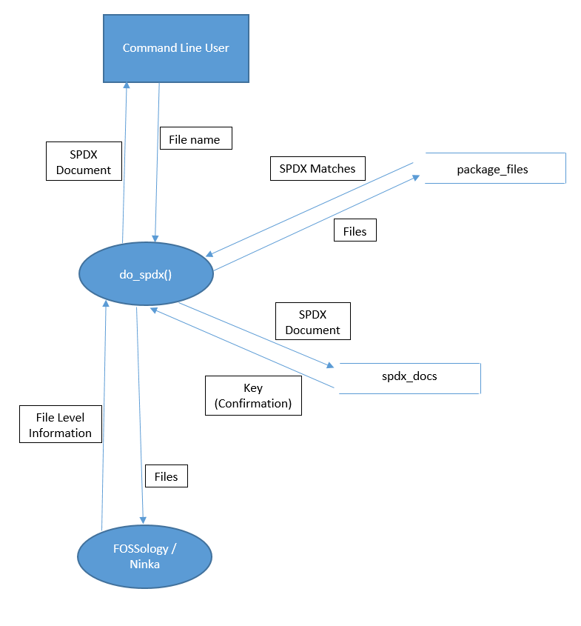

**Database/Datastore Structures**

The database will be implemented in mySql, the open source SQL standard. The schema has been provided to the team by Liang Cao and has been forwarded to the class through email. Any changes that they need will be supported through our team as the primary channel of communication. We plan on working closely with Liang on the design if necessary.

**Copyright Declarations and License Choice**

Our source will be licensed under an MIT license.

**Change Log**

|  |  |  |  |
| --- | --- | --- | --- |
| **Date** | **Version** | **Contributors** | **Description** |
| 1/29/14 | 1.0 | Corbin, Joe, Ethan | Created document |
| 2/3/14 | 1.1 | Corbin | Individual contributions |
| 2/4/14 | 1.2 | Joe, Ethan | Individual contributions |