Nazarbayev Intellectual school of Science and Mathematics in Karagandy

Smart Wheelchair: Automatic Route Navigation Using AI

Category: Hardware control

Student: Lucher Andrey
Supervisor: Kirill Nabiyev

Karaganda, 2026

Table of contents:

Abstract: 3
Research objective: 3
Hypothesis: 3
Research stages: 3
Methodology of the experiment: 3
Novelty of the research: 3
Results and conclusion: 3
Introduction: 4
Purpose of the study: 4
Objectives of the work: 4
Methods for solving the problem: 4
Relevance of the research topic: 4
Main Part: 5
Collection of information: 5
Platform selection. 6
Implemented functions: 8
Design of the program and prototype: 9
Application development: 14
Result and conclusions: 15
Conclusion: 16
Sources: 17

Abstract:

Research objective:
Development and prototyping of an affordable, portable autonomous wheelchair control system connected to a mobile app, navigation services, and artificial intelligence to improve mobility for people with disabilities.

Hypothesis:
The study hypothesizes that an affordable hardware and software system can be created. By leveraging a smartphone's computing power and cloud neural networks, it provides safety and independence comparable to expensive medical equivalents.

Research stages:
Stages included analyzing mobility issues and existing solutions, selecting hardware (Arduino, ESP32, motors), and assembling a physical prototype. Key steps involved developing navigation algorithms, computer vision, and adding Gemini AI.

Methodology of the experiment:
Experiments utilized the mobile device for geodata processing, testing route accuracy via waypoints, verifying collision avoidance speeds, and evaluating AI environmental descriptions.

Novelty of the research:
Currently, the market of rehabilitation devices offers either fully manual mechanisms or very expensive electric wheelchairs, which, however, lack smart features.
The novelty of this project lies in a hybrid approach: transferring complex computing (navigation, AI) to the user's smartphone and cloud servers, leaving motor control to the microcontroller. This uniquely introduces autonomous movement and generative scene description to the budget segment.

Results and conclusion:
A fully functional prototype was created, capable of navigating map-set routes. The system includes voice control with feedback and a safety module that automatically stops for obstacles. Furthermore, the study proved the effectiveness of using LLM (Gemini) for recognizing traffic light signals and providing detailed contextual descriptions of the surroundings to assist visually impaired users.

Introduction:

Purpose of the study:
Create an application and a hardware module that allow transforming a standard wheelchair into a "smart assistant" with an autopilot function and a voice assistant.

Objectives of the work:
- Analyze statistical data and conduct a survey of the target audience to identify the main problems.
- Develop an algorithm to convert the GPS route into motor control commands.
- Establish a connection between the smartphone and the microcontroller via Bluetooth.
- Implement computer vision functions (recognizing traffic lights and obstacles).

Methods for solving the problem:
- Using the Arduino UNO microcontroller to control motor drivers.
- Using the ESP32-CAM module to capture images and interact with neural network APIs.
- Integrating Google Maps API to build routes and get coordinates of turning points.
- Using Google Gemini API for intelligent analysis of visual information.
- Development of a mobile application using the Dart language (Flutter).

Relevance of the research topic:
According to the World Health Organization, more than 2.5 billion people need one or more assistive products and more than 200 million people need wheelchairs.[1] Limited mobility leads to social isolation and a lower quality of life. Existing solutions often ignore users' cognitive and sensory impairments (for example, poor vision or problems with fine motor skills that make joystick control difficult).
The digitalization of the urban environment (Smart City) requires integrating assistive devices into a single system.[2] The project solves an economic problem by offering to modernize existing wheelchairs instead of buying expensive new equipment, and also a social problem by giving users back a sense of independence from caregivers (guardians).

Main Part:

Collection of information:
Currently, robotic wheelchairs are available on the market (for example, models from Whill or Permobil), but their cost ranges from 5,000 to 10,000 US dollars and more, making them inaccessible to most users in developing countries.[3] Analogues developed in laboratory conditions often require installing bulky lidars and laptops directly on the wheelchair.[4]
To confirm the need for development, a focus group survey was conducted at a rehabilitation center in Karaganda. 15 respondents (wheelchair users and their caregivers) took part in the survey.
The following questions were asked:
- Do you encounter difficulties when controlling the wheelchair in unfamiliar places?
- Have you had dangerous situations (risk of falling, collision) due to obstacles you did not notice?
- Do you consider the function of voicing the surroundings useful?
- Are you interested in a system that can automatically take you to a selected point?
Table 1. Survey results
Question | Yes | No
Do you encounter difficulties when controlling the wheelchair in unfamiliar places? | 73% | 27%
Have you had dangerous situations (risk of falling, collision) due to obstacles you did not notice? | 60% | 40%
Do you consider the function of voicing the surroundings useful? | 86% | 14%
Are you interested in a system that can automatically take you to a selected point? | 93% | 7%

Diagram 1. Survey results in percentage

Platform selection.
At the moment, some statistical agencies focused on studying the use of mobile devices in Central and Southeast Asia show that, at this time period, in Kazakhstan, a significant part of mobile devices use the Android operating system. For example, information from the Statcounter bureau[5]:
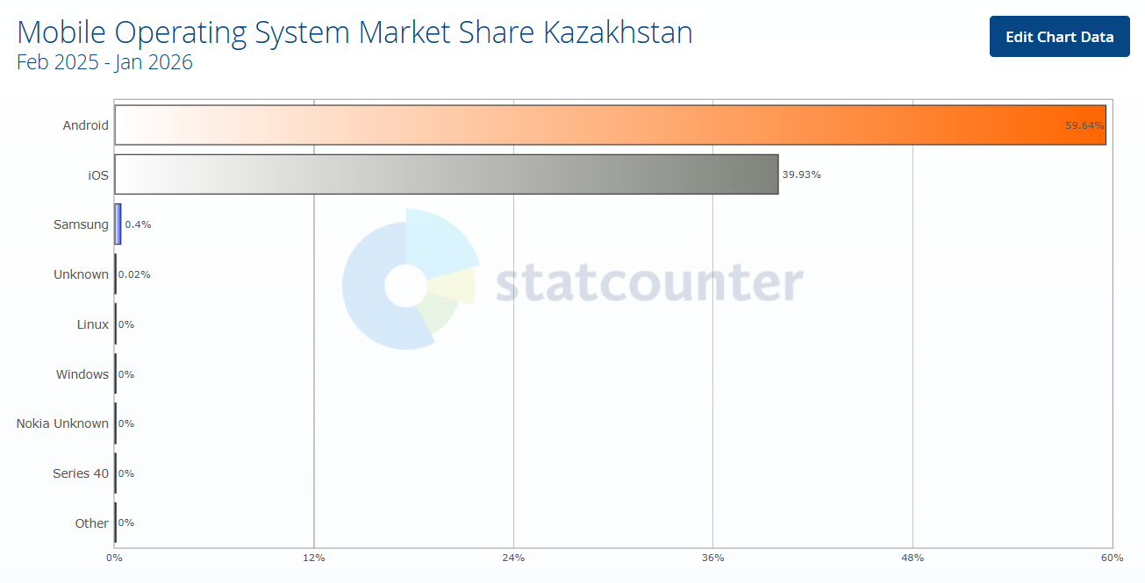
Diagram 2. Percentage of OS usage of mobile devices in Kazakhstan

Thus, the Android operating system was chosen as the platform for creating the future application, which allows us to reach the maximum number of potential users of the application and not damage its quality, which is impossible when creating a multi-platform application.
Visual Studio Code is one of the most popular integrated development environments for creating mobile applications.
- Mobile application: Performs resource-intensive tasks (working with maps, gyroscope, speech synthesis). This saves money on the wheelchair's onboard computer.
- Arduino UNO: Chosen for its reliability and ease of working with PWM signals for motors. Quantity: 1. Price per unit: 30 dollars.
- HC-05: Provides a reliable Bluetooth Serial Port Profile (SPP) communication channel, which is sufficient for transmitting control commands. Quantity: 1. Price per unit: 10 dollars.
- ESP32-CAM: One of the few budget solutions on the market combining Wi-Fi (for sending photos to the cloud) and a camera in a compact module. Quantity: 1. Price per unit: 25 dollars.
- Livall PikaBoost 2 eBike Conversion Kit: Portable electric motors that attach to the armrests of the wheelchair.[6] Quantity: 2. Price per unit: 439 dollars.
- HC-SR04: High-quality and fast ultrasonic sensors. Quantity: 2. Price per unit: 8 dollars.
- Additionally: wires, breadboard, case – 30 dollars.

Total price for the entire system: 700-1000 dollars.

Wiring and circuit diagram:
Motor driver:
- OUT1 – first motor terminal
- OUT2 – first motor terminal
- OUT3 – second motor terminal
- OUT4 - second motor terminal
- 12V – switch terminal positive battery terminal
- GND – negative battery terminal and Arduino UNO GND
- 5V – 5V Arduino UNO
- ENA – Arduino UNO pin 3
- IN1 – Arduino UNO pin 2
- IN2 – Arduino UNO pin 4
- IN3 – Arduino UNO pin 5
- IN4 – Arduino UNO pin 7
- ENB – Arduino UNO pin 6

Bluetooth:
- RX – Arduino UNO pin 1
- TX – Arduino UNO pin 0
- GND – GND Arduino UNO
- VCC – 5V Arduino UNO

HC-SR04:
- GND – GND Arduino UNO
- ECHO – Arduino UNO pin 9
- TRIG – Arduino UNO pin 8
- VCC – 5V Arduino UNO

Implemented functions:
At this point in planning, several application functions are planned for implementation, which will provide a basic framework for further development.
This:
Navigation algorithm:
- The user selects a destination by voice or by tapping on the map.
- The app requests a route via Google Directions API.[7]
- The route is converted from Polyline format into an array of coordinates (latitude/longitude).
- The app reads data from the phone's compass/gyroscope.
- The azimuth to the next route point and the distance to it are calculated.
- Commands are sent via Bluetooth: "Turn by angle X", "Move forward Y meters".

Artificial intelligence algorithm:
A unique feature is the integration of Gemini AI.
- Upon command from the app, the ESP32-CAM takes a picture.
- The image is encoded in Base64 and sent via a POST request to Google servers.
- The prompt for the neural network is configured in a special way: "Describe the scene for a blind person. Are there obstacles? What is the traffic light color?".
- The received text response is returned to the app and voiced to the user.
- If the AI detects a red traffic light, an emergency STOP command is automatically generated.

Hardware protection:
Regardless of the application commands, the HC-SR04 ultrasonic sensor continuously scans the space. If the distance to an object is less than 30 cm, a hardware interrupt stops the motors, preventing a collision even in case of a navigation error.

Additional functions that could be implemented were also thought out, such as:
- Implementation of an Indoor Navigation system: since the GPS signal is unavailable or unstable inside buildings (shopping centers, hospitals), it is planned to use SLAM (Simultaneous Localization and Mapping) technology with visual markers to build a map of the premises and navigate within it.[8]
- Integration of biometric safety sensors: installation of pulse sensors and a gyroscope-accelerometer to analyze the user's physical condition and detect emergency situations (for example, the wheelchair tipping over). In a critical situation, the system will automatically send SOS message with coordinates.
- Dynamic obstacle avoidance algorithms: upgrading the software code to move from a simple stop in front of an obstacle (as implemented now) to actively searching for a detour. This requires installing additional side ultrasonic sensors and implementing more complex navigation logic.
- Caregiver mode: control and tracking - allows a trusted person to track the wheelchair’s location in real-time and take control if necessary to ensure safety.

Design of the program and prototype:
A certain level of planning also requires the design, which was created using Visual Studio Code:

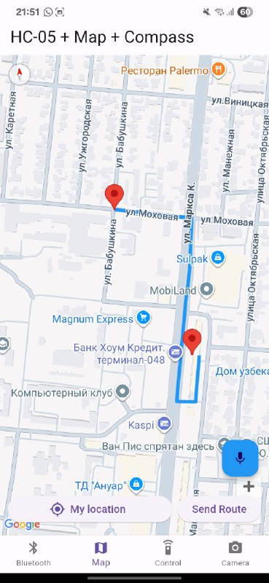
Figure 1. Route planning and visualization within the mobile application interface.
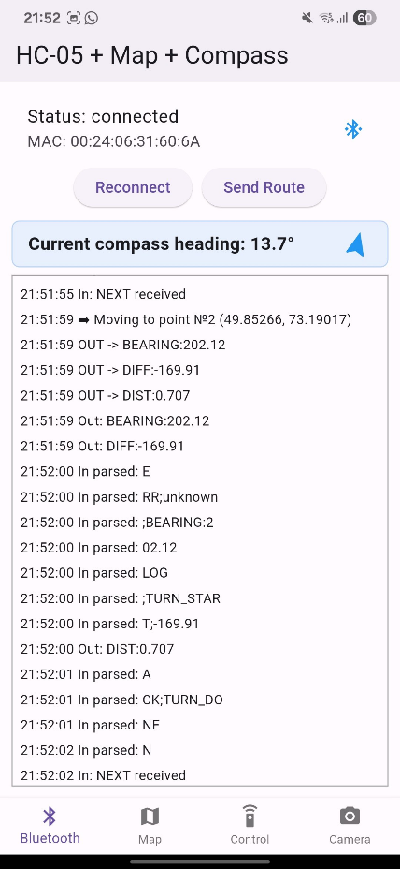
Figure 2. Navigation log displaying waypoint segmentation and command transmission.

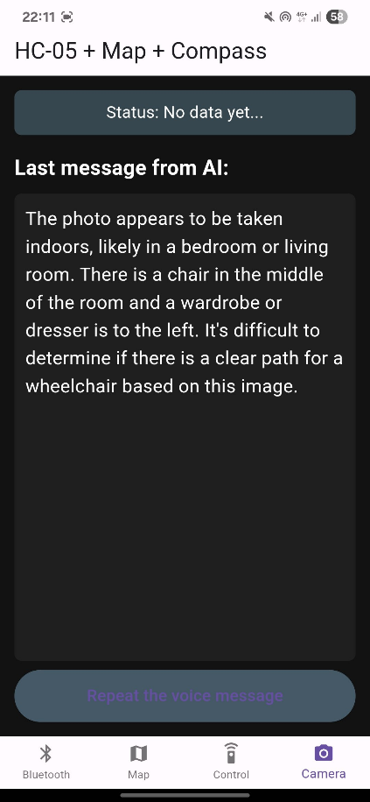
Figure 3. Computer vision log and environment analysis response generated by Gemini AI.
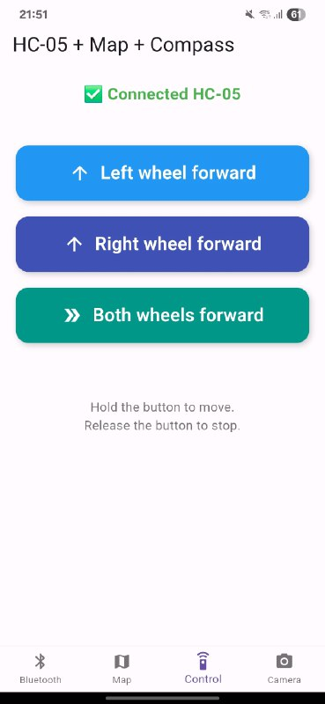
Figure 4. Manual control interface.

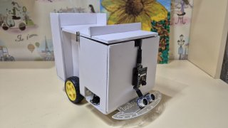
Figure 5. Front view of the assembled control system prototype.

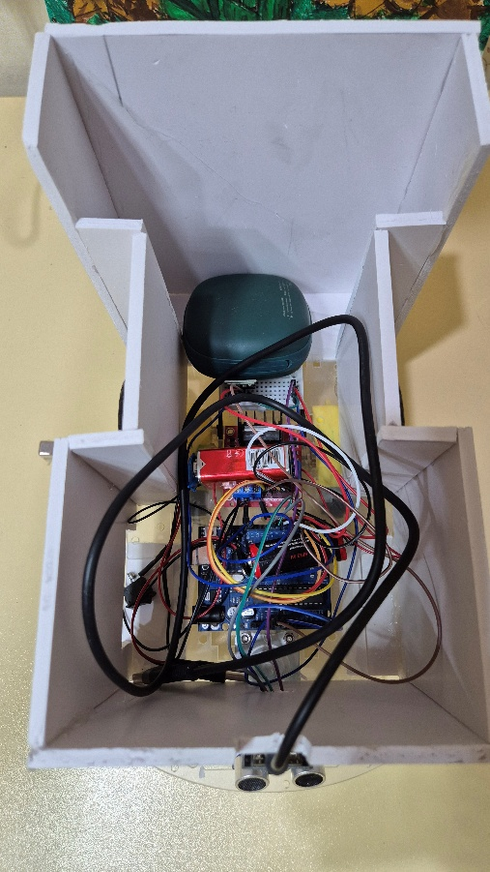
Figure 6. Internal hardware arrangement: wiring and component layout.

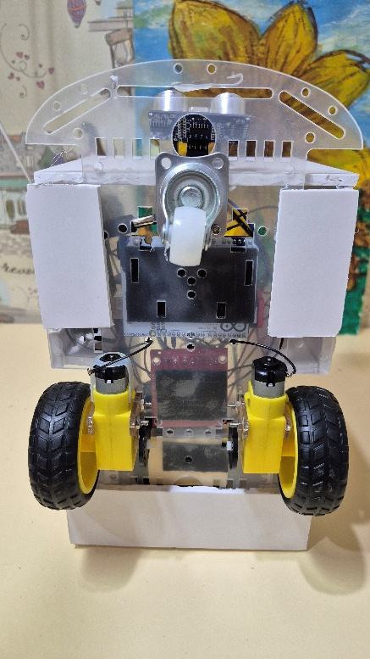
Figure 7. Bottom view of the prototype.

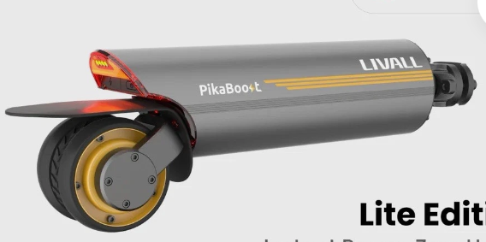
Figure 8. The Livall PikaBoost 2 electric motor unit used for propulsion.

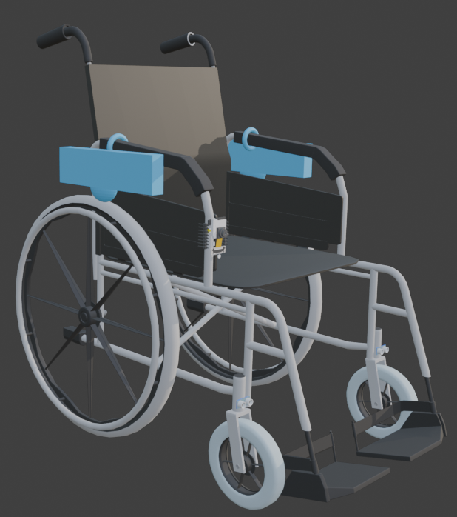
Figure 9. General view of the standard modernized wheelchair: Side-angle perspective.

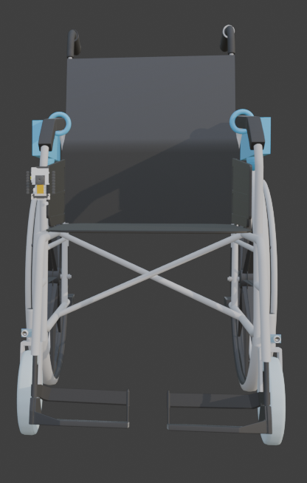
Figure 10. Front view of the wheelchair model.

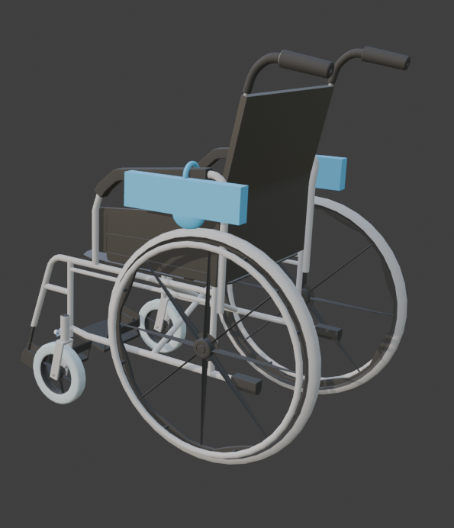
Figure 11. Rear-angle view of the wheelchair model.

Application development:
Further development of the application shifted to programming in Dart using the Flutter framework in Visual Studio Code (VS Code). The Arduino IDE and C++ were used to implement the hardware logic, which is the standard for Arduino UNO microcontrollers and ESP32 modules. The development process was significantly simplified by using the official documentation for the Google Maps API and Google Gemini API, along with educational materials and articles on specialized resources (Habr, GitHub), which allowed me to implement complex navigation and image processing algorithms.[9]

Result and conclusions:
The evaluation of the project at the prototype stage, with the main functions created, leads to the following conclusions:

- An application and a hardware system have been created that allow controlling the wheelchair via Bluetooth and automatically following a route.
- Information has been collected about previous similar developments and the limitations of existing models on the market.
- Work has been carried out to study public opinion regarding this project (focus group survey).
- The function of voice control and selecting a place on the map, which is necessary for users with limited motor skills, has been implemented.
- A function for remote obstacle recognition and intelligent description of the surroundings (using the Gemini neural network and the ESP32 camera) has been introduced.
- The prospects and possibilities for further improvement of the project and its integration into the urban environment were rated highly.
The reaction of the community (users with disabilities and their caregivers) indicates interest and the relevance of this work, which confirms the hypothesis put forward at the beginning of the study and highlights the need for such projects not only as scientific activity, but also for finding truly effective rehabilitation methods that are suitable for the social system and possible for further use.

Conclusion:
The following main tasks were achieved:
- A system has been created that allows transforming a standard wheelchair into a "smart" one, accessible for use by people with severe motor impairments.
- Information has been collected about previous similar developments.
- Work has been conducted to study public opinion about this project.

This portable system can serve as a foundation for building a future inclusive navigation system. There is a steadily growing trend in society towards using AI assistants and automation, which indicates the need for the digitalization of technical rehabilitation devices and the functions provided by this project.
Thus, the goal of the research was achieved: "Development and testing of a prototype of a portable intelligent autonomous wheelchair control system with a mobile application and artificial intelligence elements," and the hypothesis was confirmed: "A relatively inexpensive and portable hardware and software system based on available components (Arduino, ESP32, Gemini, Livall PikaBoost 2) is capable of providing practically autonomous movement, timely alerts, and safety," which demonstrates the success of the project.

Sources :

World Health Organization. (2023, May 15). Assistive technology. https://www.who.int/news-room/fact-sheets/detail/assistive-technology

Akimat of Astana City. (n.d.). Sotsialnaya zashchita [Social protection]. Gov.kz. https://www.gov.kz/memleket/entities/astana/activities/14795?lang=ru

WHILL, Inc. (n.d.). WHILL power chairs. https://whill.inc/us/whill-power-chairs/

Aspire2. (n.d.). Permobil electric wheelchairs. https://aspire2.co.uk/collections/permobil-electric-wheelchairs

StatCounter. (n.d.). Mobile operating system market share Kazakhstan. https://gs.statcounter.com/os-market-share/mobile/kazakhstan/#monthly-202502-202601-bar

LIVALL. (n.d.). LIVALL PikaBoost 2: Electrify your rides with ease. https://livall.com/products/livall-pikaboost-2-electrify-your-rides-with-ease

Google. (n.d.). Google Cloud console APIs library. https://console.cloud.google.com/apis/library

MathWorks. (n.d.). What is SLAM? https://www.mathworks.com/discovery/slam.html

Google. (n.d.). Gemini API documentation. Google AI for Developers. https://ai.google.dev/gemini-api/docs?hl=ru

