**How to Run**

1. Install: mvn install
2. Deploy to tomcat (for example using web interface)

Also I provided the war file withing the archive so no need to install





Game has two Modes:

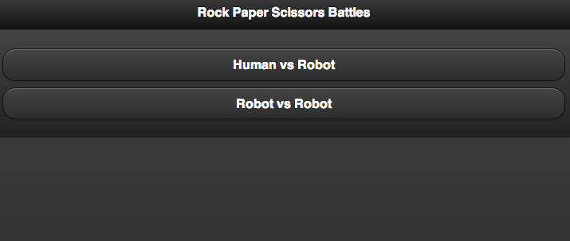

For Human vs Robot select your fighter

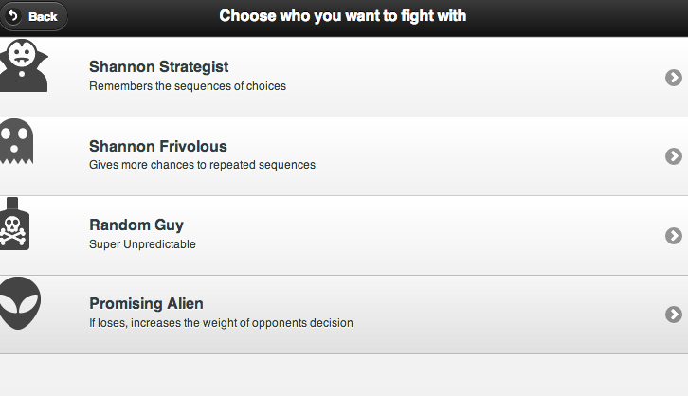

And play by clicking images on the left side:

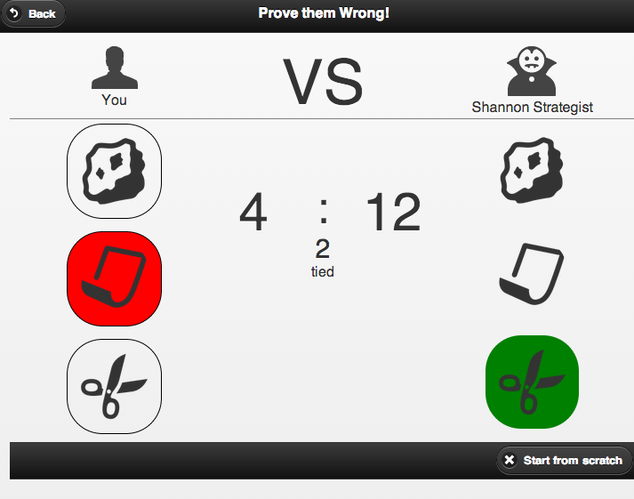

Also you can start from scratch by clicking the button in the footer

For PC vs PC

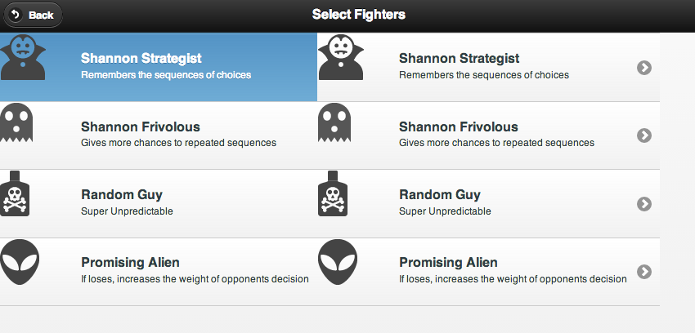

Select fighter on the left, then on the right

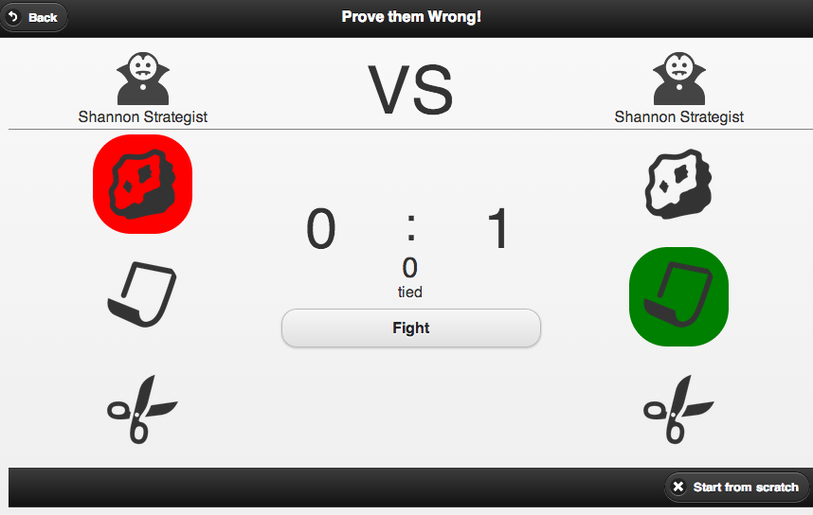

Click ‘Fight’ to play