AFRICA SMART
PREFABRICATED HOUSING SOLUTIONS

WORLD-CLASS WEBSITE BLUEPRINT
Front-End Experience • Back-End Architecture • Government & Corporate Conversion • SEO & Traffic Growth • Digital Platform Roadmap

STRATEGIC POSITIONING
Build Smarter. Build Faster. Build Africa.
A digital platform designed to position the company as a credible African partner for rapid, compliant, sustainable and scalable prefabricated housing and modular infrastructure.

Prepared as a digital design, technology and growth specification
September 2026

A. DOCUMENT ROADMAP
A practical specification that can be handed to a professional web design and development team.

Section | Purpose
1 | Executive Vision & Website Objectives
2 | International Benchmark Findings
3 | Brand Positioning & Message Architecture
4 | Target Audiences & Conversion Journeys
5 | Front-End Information Architecture
6 | Homepage UX & Exact Content Blueprint
7 | Core Website Pages & Content Requirements
8 | Government & Public-Sector Portal
9 | Corporate, Developer & Investor Experience
10 | Technical Library & Compliance Centre
11 | Project Feasibility & Smart Estimator
12 | Back-End Platform Architecture
13 | CMS, Database & API Specification
14 | CRM, Automation & Lead Management
15 | SEO, Content & Traffic Growth Strategy
16 | Performance, Security, POPIA & Accessibility
17 | Analytics & Executive Dashboard
18 | Design System & Visual Direction
19 | Implementation Roadmap & Indicative Budget
20 | Launch Checklist & 12-Month Growth Plan
21 | Benchmark & Regulatory References

1. EXECUTIVE VISION & WEBSITE OBJECTIVES
The website must operate as a commercial growth platform, not a digital brochure.

AFRICA SMART PREFABRICATED HOUSING SOLUTIONS (ASPHS) should present itself online as an African industrialised-building and housing delivery platform serving government, developers, investors, mines, institutions and communities. The website must combine premium international design with technical credibility, measurable project evidence and simple pathways for decision-makers to request feasibility studies, quotations, site assessments and strategic meetings.
THE DIGITAL GOAL
Every important visitor should be able to answer five questions within 90 seconds: Who are you? What can you build? Why should I trust you? Can you deliver my type of project? What is the next action?

Primary commercial outcomes:
- Generate qualified projects: Convert government, developer, mining, education, healthcare and corporate traffic into structured project briefs.
- Build institutional trust: Make verified technical documents, project evidence, governance information and compliance information easy to find.
- Own high-intent search demand: Rank for prefab, modular, rapid housing and sector-specific construction searches across South Africa and selected African markets.
- Accelerate procurement: Provide downloadable capability material, technical specifications and a secure document exchange process.
- Support expansion: Use reusable country, province, sector and solution templates to enter new markets without redesigning the website.
- Create a data advantage: Capture what markets, project sizes, sectors and solutions are generating demand and feed this into the commercial pipeline.

Recommended north-star conversion:
REQUEST A PROJECT FEASIBILITY STUDY
This is stronger than a generic “Contact Us” button because it asks the visitor to describe a real site, number of units, use case, location, services, budget range and required delivery date. It produces a higher-quality lead and gives the commercial team an immediate starting brief.

Market timing and South African institutional context
South Africa is actively elevating Innovative Building Technologies (IBTs) within human-settlements policy. The Department of Human Settlements hosted an IBT Summit in February 2026, and its 2026/27 Budget Vote states that a Consolidated IBT Implementation Plan has been approved to institutionalise IBTs within existing housing programmes. This creates a timely reason for the website to speak the language of compliant, scalable, climate-resilient and bankable delivery rather than presenting prefab only as a cheaper alternative.

2. INTERNATIONAL BENCHMARK FINDINGS
What leading modular and industrialised-building brands do well — and how ASPHS should go further.

Benchmark | What works | ASPHS opportunity
BOXABL | Clear consumer/developer/public-sector segmentation; product catalogue; technical documentation; strong CTAs; project proposal tools. | ASPHS should combine sector segmentation with an Africa-specific feasibility tool, government capability centre and technical library.
Veev | Premium “future of home” positioning; strong explanation of factory precision; smart/energy features integrated into the product story. | Use premium storytelling to avoid a “temporary structure” perception. Present smart energy, quality control and finishes as core value.
Modulous | Technology-led feasibility story; software plus kit-of-parts approach; cost and embodied-carbon outputs. | Create a site/project feasibility workflow that turns a visitor into a structured development opportunity.
Karmod | Global scale proof; extensive sector navigation; project references across many countries. | Build country and sector hubs, a visual project map and verifiable project portfolio as the company expands.
Algeco / Modulaire | Simple value language; strong public-administration, education, energy and infrastructure positioning; global operational scale. | Use simple institutional messaging: faster space, predictable delivery, flexible deployment, clear sector expertise.

Benchmark conclusion
The strongest global websites do not lead with engineering jargon. They lead with a clear outcome, then provide progressively deeper proof. ASPHS should therefore use a three-layer experience: (1) simple executive messaging, (2) sector- and solution-specific commercial proof, and (3) a serious technical/compliance library for professional teams and procurement reviewers.
HOW ASPHS CAN OUTPERFORM
Become the easiest modular-housing supplier in Africa to evaluate online: clear solutions, credible compliance, downloadable evidence, project feasibility in minutes, strong case studies, transparent process and a responsive commercial team.

3. BRAND POSITIONING & MESSAGE ARCHITECTURE
A premium African infrastructure brand — modern, technical, credible and scalable.

Recommended master tagline:
BUILD SMARTER. BUILD FASTER. BUILD AFRICA.

Alternative campaign lines:
- Smart Homes. Faster Delivery. Sustainable Africa.
- From Factory Precision to Finished Communities.
- Industrialised Building for Africa’s Housing Future.
- Rapid Housing • Smart Infrastructure • Sustainable Communities.

One-sentence positioning statement
Africa Smart Prefabricated Housing Solutions delivers design-led, industrialised building systems for housing, education, healthcare, mining, hospitality and public infrastructure — integrating rapid construction, quality-controlled manufacturing, smart energy and scalable project delivery.

Message hierarchy
Layer | Message | Evidence
1 — Outcome | Faster, smarter, scalable delivery | Time, delivery process, project timeline
2 — Quality | Factory-controlled precision | QA process, material specs, engineering
3 — Compliance | Designed for local approvals | Verified certifications, standards, registrations
4 — Sustainability | Lower waste + smart energy options | Material efficiency, solar/battery/water packages
5 — Impact | Local jobs and enterprise participation | Training, localisation, SMME and job metrics
6 — Bankability | Structured for serious projects | Feasibility, phased delivery, procurement and finance pathways

4. TARGET AUDIENCES & CONVERSION JOURNEYS
Design the website around different decision-makers, not one generic visitor.

Audience | Primary need | Best CTA
National / Provincial / Municipal Government | Human settlements, infrastructure, schools, clinics, disaster response | Public-sector capability pack • feasibility meeting • tender enquiry
Developers & Landowners | Residential estates, affordable housing, student accommodation, mixed use | Site feasibility • concept estimate • developer meeting
Mines, Energy & Industry | Workforce villages, offices, clinics, camps, change houses | Remote-site solution brief • RFQ • technical call
Universities & Education | Student housing, classrooms, labs, staff accommodation | Capacity plan • project briefing
Healthcare | Clinics, modular wards, staff housing, admin blocks | Clinical infrastructure consultation
Hospitality & Tourism | Lodges, resorts, staff accommodation, eco-units | Concept package • pricing range
Investors / DFIs / Banks | Project pipeline, scalable delivery, ESG and bankability | Investment deck • project data room request
NGOs / Humanitarian | Emergency, transitional and community infrastructure | Rapid-response briefing
Private Buyers | Smart prefab homes and accessory buildings | Home selector • consultation

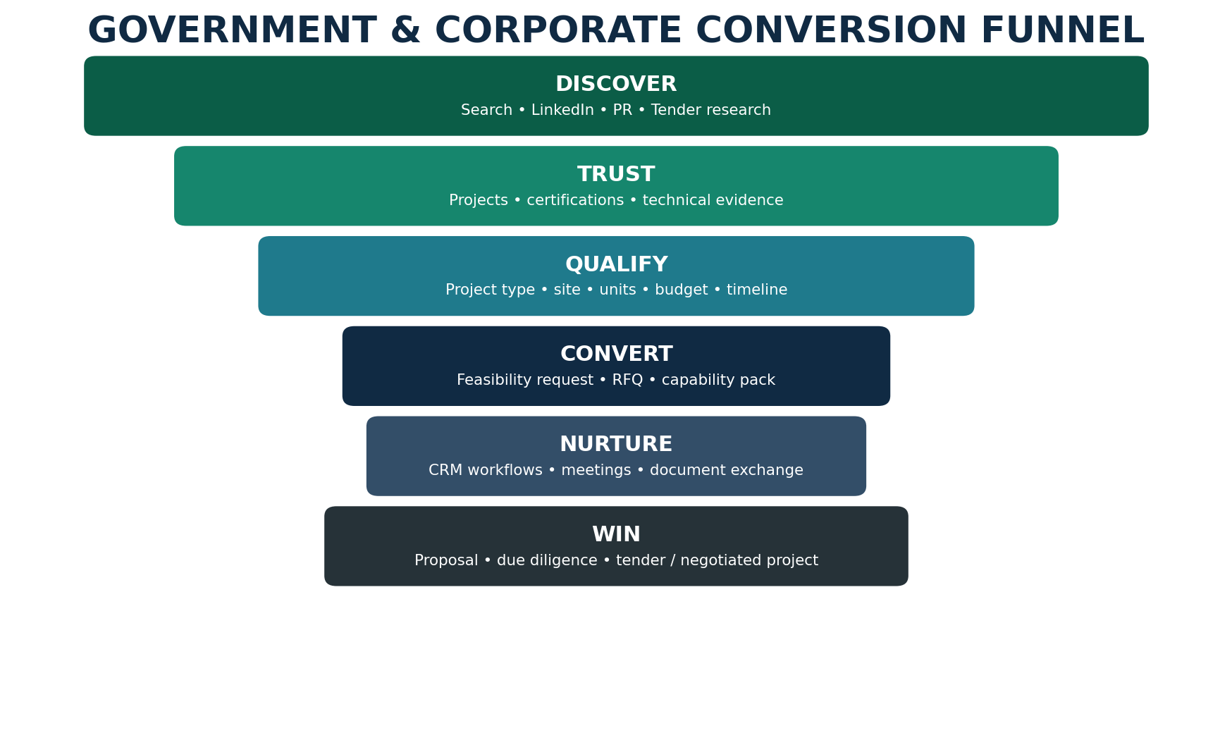
Figure 1. Recommended institutional conversion funnel.

5. FRONT-END INFORMATION ARCHITECTURE
A simple global navigation with deep sector and technical content.

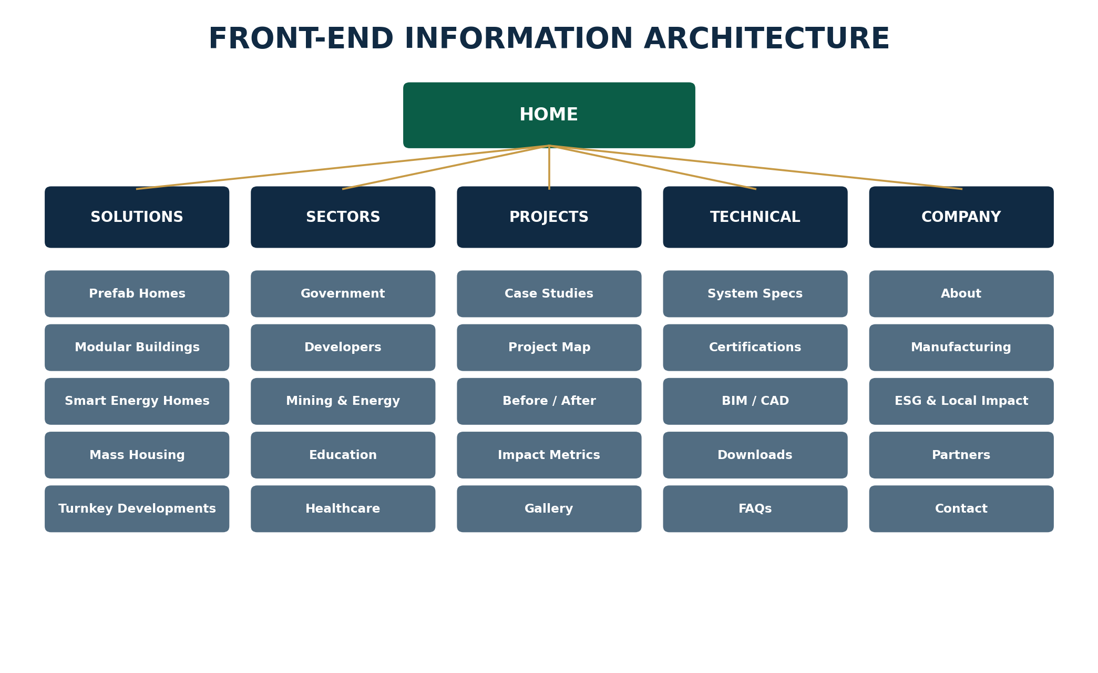
Figure 2. Recommended top-level site architecture.

Primary navigation
Navigation | Key destinations
Solutions | Prefab Homes • Modular Buildings • Mass Housing • Smart Energy Homes • Turnkey Developments • Modular Pods
Sectors | Government • Developers • Mining & Energy • Education • Healthcare • Hospitality • NGOs / Disaster Response
Projects | Case Studies • Project Map • Gallery • Completed / Current / Pipeline
Technology | Building System • Manufacturing • Smart Energy • Water • Digital / IoT • Sustainability
Technical Library | Specifications • Certifications • Drawings • BIM/CAD • FAQs • Downloads
Company | About • Leadership • ESG • Local Impact • Partners • Careers • News
Contact | Project Feasibility • Request Quote • Book Meeting • General Enquiry

Persistent header actions
- REQUEST FEASIBILITY
- DOWNLOAD CAPABILITY STATEMENT
- GOVERNMENT & INSTITUTIONAL
- PROJECT LOGIN (secure portal)
- Language selector and country/region selector where required

6. HOMEPAGE UX & EXACT CONTENT BLUEPRINT
The homepage should feel like an international infrastructure company, not a catalogue.

Section 1 — Hero
AFRICA SMART PREFABRICATED HOUSING SOLUTIONS
BUILD SMARTER. BUILD FASTER. BUILD AFRICA.
Industrialised building systems for governments, developers, mines, institutions and communities across Africa.
Primary CTA: REQUEST A PROJECT FEASIBILITY STUDY | Secondary CTA: EXPLORE SOLUTIONS

Recommended hero visual: cinematic aerial footage of a modern modular community transitioning to factory precision, transport, assembly and a finished neighbourhood. Avoid stock imagery that makes the company look like a container reseller.

Section 2 — Trust / audience strip
GOVERNMENT • DEVELOPERS • MINING & ENERGY • EDUCATION • HEALTHCARE • HOSPITALITY • COMMUNITIES

Section 3 — Value proposition
Pillar | Homepage wording
FASTER | Parallel factory production and site preparation can compress programme time where the project system permits.
SMARTER | Digital design, repeatable components, quality control and integrated energy/water options.
SCALABLE | From a single building to schools, clinics, workforce villages and mass-housing programmes.
LOCAL IMPACT | Designed to support local assembly, skills transfer, jobs and enterprise participation.
EVIDENCE-LED | Technical documents, approvals, project data and verified credentials available for professional review.

Section 4 — Solutions selector
- Affordable & Social Housing
- Residential Estates & Smart Homes
- Student Accommodation
- Schools & Classrooms
- Clinics & Healthcare Facilities
- Mining & Workforce Accommodation
- Hotels, Lodges & Tourism Units
- Emergency & Transitional Housing
- Modular Offices & Public Facilities
- Bathroom / Kitchen / Service Pods

Section 5 — “How we deliver”
DISCOVER → FEASIBILITY → DESIGN & ENGINEERING → APPROVALS → FACTORY PRODUCTION → SITE WORKS → DELIVERY & ASSEMBLY → COMMISSIONING → AFTERCARE

Section 6 — Featured project proof
Use three to six verified projects with consistent cards: location, sector, unit count / floor area, delivery model, construction system, project status, measurable outcomes and gallery. If the business is pre-project, label concept projects clearly as “Concept / Proposed” and never present renders as completed work.

Section 7 — Government & institutional banner
“Accelerating sustainable human settlements and public infrastructure through innovative building technologies.” CTA: VIEW GOVERNMENT SOLUTIONS.

Section 8 — Smart systems
- Solar PV + battery readiness
- Smart metering / energy monitoring
- Water harvesting and efficient fixtures
- Thermal-performance packages
- EV charging readiness
- Remote monitoring for institutional estates

Section 9 — Technical confidence
Display only verified certificates, registration numbers, professional affiliations and test results. Provide links to evidence or downloadable documents where commercially appropriate.

Section 10 — Lead conversion
“Tell us what you need to build.” Use a structured project brief rather than a long generic contact form. Offer WhatsApp and phone as secondary channels, not the only conversion route.

7. CORE WEBSITE PAGES & CONTENT REQUIREMENTS
Detailed page templates for a scalable corporate website.

Page | Required content
Solutions landing | Outcome-led overview; product families; comparison cards; process; FAQs; relevant projects; CTA.
Prefab homes | 1–4 bedroom concepts; finishes; energy options; floor-plan downloads; buyer/developer CTA.
Mass housing | Masterplanning; repeatability; local assembly; delivery phases; infrastructure interfaces; government CTA.
Modular public buildings | Schools, clinics, offices, police/security buildings, community centres; technical specifications.
Student accommodation | Bed count, room types, communal areas, utilities, fire/accessibility requirements, delivery models.
Mining/workforce | Remote logistics, durability, ablutions, kitchens, offices, clinics, camps, relocation/reuse options.
Smart energy homes | PV, batteries, efficient envelope, smart meters, water systems, optional IoT dashboard.
Turnkey developments | Land review, feasibility, design, approvals, infrastructure, factory, installation, commissioning.
Manufacturing | Factory process, QA checkpoints, capacity, supply chain, local assembly and traceability.
Projects | Filter by sector, country, status, system and scale. Searchable project map and proof.
About | Company story, mission, governance, leadership, operating model, footprint and partnerships.
ESG & impact | Jobs, local content, SMME participation, skills, waste reduction, energy, community outcomes.
News & insights | Policy explainers, project news, guides, research commentary and case-study releases.
Careers / skills | Jobs, artisan pathways, internships, supplier opportunities and training partnerships.

8. GOVERNMENT & PUBLIC-SECTOR PORTAL
A procurement-friendly experience that reduces due-diligence friction.

The public-sector section should feel closer to an infrastructure capability portal than a marketing page. It should make it easy for technical evaluators, SCM officials, project managers and human-settlements teams to understand scope, compliance and delivery capability.

Recommended portal structure
- Public-sector overview and problem statements
- Human settlements / mass housing
- Schools and education infrastructure
- Clinics and community health infrastructure
- Disaster and emergency housing
- Municipal / community buildings
- Workforce and infrastructure accommodation
- Public-private partnership / developer models
- Local jobs, SMME and skills-development model
- Compliance and verified registrations
- Tender / RFQ contact desk
- Secure government document room (where required)

Government trust checklist
Area | Website treatment
CSD | Show verified supplier status only when current; provide verification/document where appropriate.
CIDB | Show applicable grading/classes only when verified and relevant to the scope. CIDB rules differ by work type; do not overclaim.
NHBRC | Provide current home-builder registration and project enrolment information where applicable.
Agrément South Africa | For non-standard systems, publish valid certificate details and scope if certified; link technical documents.
SANS / building regulations | State the standards/design basis applied to each system; avoid generic “SABS approved” claims without precise evidence.
B-BBEE | Publish current certificate/affidavit and expiry date if strategically appropriate.
Tax / COIDA / insurance | Keep in secure data room or procurement pack rather than exposing sensitive documents publicly.
Professional team | List verified SACAP/ECSA/SACQSP/SACPCMP or other registrations for appointed professionals where relevant.

IMPORTANT TRUST PRINCIPLE
Never use “approved”, “certified”, “accredited”, “government supplier”, “NHBRC compliant”, “SABS approved” or similar wording unless the exact claim can be evidenced and is currently valid.

9. CORPORATE, DEVELOPER & INVESTOR EXPERIENCE
Turn commercial visitors into qualified development opportunities.

Developer hub
- Land / site feasibility request
- Unit-mix configurator
- Indicative programme comparison
- Development phasing scenarios
- Design catalogue and customisation levels
- Infrastructure interface checklist
- Project finance / investor enquiry
- Downloadable developer capability pack

Investor / DFI hub
- Corporate profile and governance
- Project pipeline — only with authorised, accurate status labels
- Delivery model and manufacturing strategy
- ESG and impact measurement framework
- Localisation and job-creation model
- Technology / certification status
- Data-room request with NDA workflow
- Investment / strategic partnership enquiry

Corporate procurement hub
- RFQ submission
- Vendor onboarding / supplier questionnaire
- Technical review request
- Project-specific document exchange
- Meeting booking
- Request for factory/site visit

10. TECHNICAL LIBRARY & COMPLIANCE CENTRE
This is where an international-looking website becomes institutionally credible.

Recommended technical categories
Category | Documents / content
Building system | System description • wall/roof/floor build-ups • module dimensions • connections
Structural | Design basis • engineer statements • wind/load assumptions • foundations interface
Fire | Fire performance evidence • materials • compartmentation notes • applicable approvals
Thermal & energy | U-values / thermal performance • insulation • glazing • energy-efficiency options
Water & damp | Weatherproofing • wet-area details • drainage • damp-proofing
Acoustics | Partitions / floor sound performance where relevant
Durability | Corrosion protection • coatings • maintenance cycles • warranties
MEP | Electrical • plumbing • HVAC • solar/battery integration • smart monitoring
Drawings | Typical plans • sections • details • BIM/CAD resources
QA / installation | Factory QA • inspection stages • transport • assembly • commissioning
Certifications | Agrément / NHBRC / test reports / professional sign-off — as applicable and verified

South African compliance positioning
Agrément South Africa evaluates the fitness for purpose of non-standardised construction products and systems, including quality-system assessment. Its guidance explains that innovative systems outside conventional SANS coverage may rely on rational design or Agrément certification, depending on the system and regulatory route. NHBRC separately maintains an Innovative Building Technologies framework. These realities make a transparent Technical Library a commercial advantage for ASPHS.

11. PROJECT FEASIBILITY & SMART ESTIMATOR
The most important interactive conversion tool on the website.

Recommended flow
1. Choose project type: housing, student accommodation, school, clinic, mining camp, hotel, office or other.
2. Enter location: country, province/region, municipality/city and site address or map pin.
3. Site status: owned / optioned / government-owned / community / still searching.
4. Enter scale: number of units, floors, bedrooms/beds or approximate floor area.
5. Select desired construction system / finish level, or “advise me”.
6. Confirm services: water, sewer, power, roads, stormwater and telecoms availability.
7. Select smart options: solar, battery, water harvesting, smart metering, EV charging, security.
8. Enter target budget band and target completion date.
9. Upload site plan, RFP, drawings or brief if available.
10. Enter organisation and contact details; consent to processing; submit.
11. Receive confirmation, a unique enquiry number and the next-step checklist.
12. CRM automatically scores, routes and assigns the lead to the relevant commercial team.

What the tool should NOT do initially
Do not display a binding construction price from a few inputs. Early-phase cost estimates can be misleading because land, foundations, infrastructure, logistics, approvals, specifications, quantity, geography and finishes materially affect total project cost. The tool should generate a preliminary feasibility range only when a robust cost model exists and should state assumptions clearly.

12. BACK-END PLATFORM ARCHITECTURE
Enterprise-ready, modular and easy to operate.

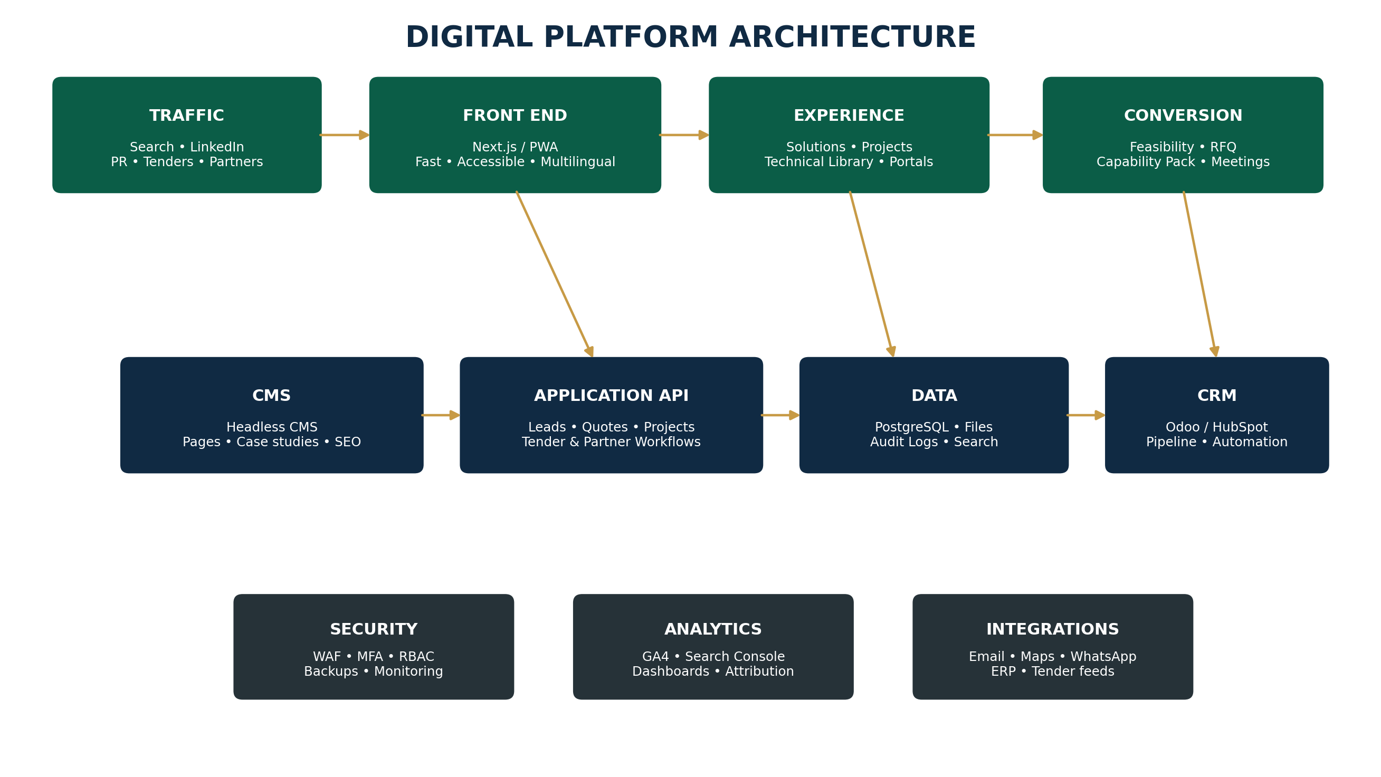
Figure 3. Recommended logical platform architecture.

Recommended technology stack
Layer | Recommended approach | Why
Front end | Next.js + React + TypeScript | Fast server-rendered pages, strong SEO, reusable components, enterprise developer ecosystem.
Design system | Tailwind CSS or token-based component library | Consistent visual system and rapid, maintainable UI development.
CMS | Headless CMS: Sanity, Contentful or self-hosted Strapi | Marketing team can publish without changing application code.
Application API | Node.js / NestJS or equivalent enterprise API layer | Structured workflows for feasibility, RFQs, portals and integrations.
Database | PostgreSQL + PostGIS | Reliable transactional data plus geospatial project/site capabilities.
Search | PostgreSQL full-text initially; Meilisearch/Elastic when scale justifies | Fast technical-library, project and content search.
Files | S3-compatible object storage with signed links | Secure large-document and drawing storage.
Cache / queues | Redis | Performance, jobs, notifications and rate-limiting support.
Edge / WAF | Cloudflare or equivalent | CDN, DDoS protection, bot controls and performance.
Identity | Microsoft Entra ID / Auth0 / Keycloak depending environment | MFA and role-based access for staff and external portal users.
CRM | Odoo CRM, HubSpot or Salesforce depending budget/process maturity | Lead routing, opportunity pipeline, follow-up and reporting.
Hosting | Azure / AWS / managed cloud; choose regional/data-residency configuration based on legal and client needs | Resilience, scale, backup and enterprise controls.

13. CMS, DATABASE & API SPECIFICATION
A reusable content and data model prevents the site from becoming a collection of hard-coded pages.

CMS content types
- Solution
- Sector
- Project / Case Study
- Building System
- Module / Model
- Country / Region
- News / Insight
- Technical Document
- Certification / Registration
- Team Member
- Partner
- FAQ
- Testimonial
- Event
- Landing Page
- Campaign

Core application entities
Entity | Key fields / relationships
Organisation | Name, type, country, registration data, contacts, CRM link
Contact | Name, title, email, mobile, organisation, consent, source
Lead | Source, campaign, interest, score, owner, status, next action
Project Brief | Sector, location, site, scale, units/area, services, budget, timeline, uploads
Site | Coordinates, land status, size, municipality, utility notes
Opportunity | Value range, stage, probability field for internal use, tender/ref, close date
Tender / RFQ | Issuer, reference, deadline, documents, owner, status
Document | Type, confidentiality, version, expiry, permissions
Portal User | Role, organisation, MFA status, permissions
Audit Event | Actor, event type, timestamp, object, IP/device metadata

Priority API endpoints
Endpoint | Purpose
POST /api/project-briefs | Create structured feasibility enquiry
POST /api/rfq | Submit corporate/government RFQ
POST /api/partner-applications | Supplier / technology / developer partnership interest
GET /api/projects | Public filtered project/case-study feed
GET /api/technical-documents | Permission-aware technical library
POST /api/data-room/request | Request access to restricted material
POST /api/meeting-request | Request commercial/technical meeting
POST /api/newsletter | Consent-based subscription
GET /api/search | Unified site search
POST /api/webhooks/crm | Synchronise relevant events to CRM

14. CRM, AUTOMATION & LEAD MANAGEMENT
Traffic has no value if qualified enquiries disappear into email inboxes.

Lead routing rules
Condition | Route / action
Government / public body | Government & Institutional Desk; priority SLA; capability-pack workflow
100+ units / large floor area | Strategic Projects team; executive notification
Mining / energy | Industrial & Remote Projects team
Investor / DFI | Executive / investment relations workflow
Home buyer / small unit | Residential sales workflow
Technical-document request | Technical sales / engineering follow-up
Tender with deadline | Tender desk; deadline reminders; document checklist

Automation sequence
1. Immediate acknowledgement with enquiry number and summary.
2. Lead enrichment and scoring.
3. Internal assignment and SLA timer.
4. Automated capability pack relevant to sector — only if appropriate.
5. Human follow-up task within agreed service window.
6. Meeting booking and discovery checklist.
7. Proposal / feasibility document version tracking.
8. 30/60/90-day nurture for opportunities not yet ready.
9. Closed-won projects trigger onboarding and project-portal invitation.

Recommended CRM stages
NEW → QUALIFIED → DISCOVERY → FEASIBILITY → PROPOSAL / TENDER → DUE DILIGENCE → NEGOTIATION → WON / LOST / NURTURE

15. SEO, CONTENT & TRAFFIC GROWTH STRATEGY
Build a search asset around real project intent, not vanity traffic.

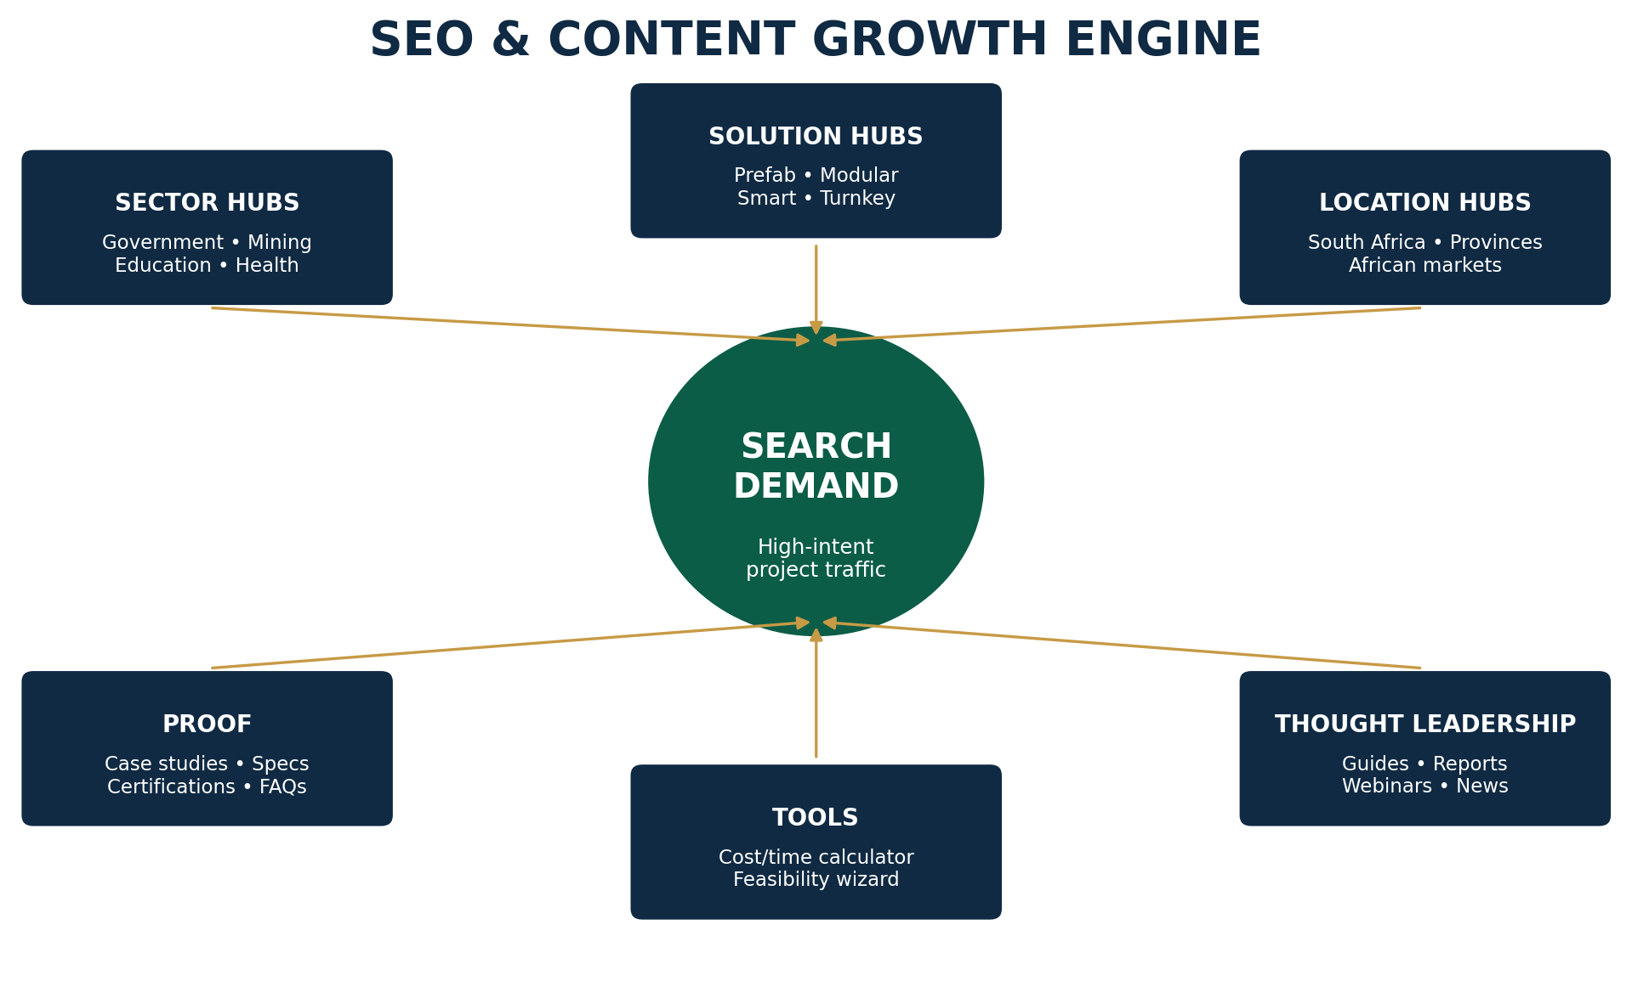
Figure 4. Search and content growth engine.

High-intent SEO clusters
Cluster | Example topics / queries
Prefab / modular | prefabricated houses South Africa • modular homes South Africa • prefab housing Africa • modular building systems
Government housing | innovative building technology housing • rapid housing construction • affordable modular housing • social housing construction
Education | modular classrooms • prefab schools • rapid school infrastructure • student accommodation modular
Healthcare | modular clinics • prefab healthcare buildings • rapid clinic construction
Mining / remote | mining camp accommodation • modular workforce housing • prefab site offices • remote accommodation
Developer | modular housing developer • rapid residential development • prefab apartment systems
Smart / sustainable | solar prefab homes • energy-efficient modular housing • smart housing Africa
Location | modular housing Mpumalanga / Gauteng / KZN / Limpopo etc. only where the business can genuinely serve

SEO page strategy
- One authoritative page per core solution and sector.
- Country/province pages only where they provide unique service, logistics, regulatory or project value — never thin duplicate pages.
- Case studies written as searchable evidence: problem, system, location, scale, timeline, outcome.
- Technical explainers answering procurement and professional-team questions.
- Comparison content: prefab vs conventional, modular vs container, CAPEX vs lifecycle considerations, programme risk, foundations, approvals.
- Structured data: Organisation, Service, Product, Project/CreativeWork where appropriate, Article, FAQ and Breadcrumb schemas.
- Strong internal linking between sector, solution, project and technical pages.

Traffic channels
Channel | Role
Google organic | Capture long-term high-intent demand and technical research.
LinkedIn | Primary channel for government, developer, mining, investor and professional audiences.
Google Ads | Capture urgent/high-intent project enquiries; tightly controlled campaign landing pages.
PR / media | Publish credible project milestones, certifications, factory announcements and partnerships.
Email | Nurture project stakeholders and distribute sector-specific insight.
Webinars / events | Generate institutional leads around IBT, affordable housing, energy and procurement.
Partner referrals | Architects, engineers, landowners, financiers, municipalities, DFIs and suppliers.
WhatsApp | Fast follow-up and campaign conversion, but route data into CRM rather than leaving it only in chats.

16. PERFORMANCE, SECURITY, POPIA & ACCESSIBILITY
A government-facing site must be demonstrably robust.

Performance standards
- Server-side rendering / static generation for public pages.
- Modern image formats (AVIF/WebP), responsive sizes and lazy loading.
- Global CDN with South African/African edge performance where available.
- Target excellent Core Web Vitals; monitor field performance after launch.
- Avoid autoplay-heavy video on mobile; use optimized poster images and adaptive media.
- Cache technical downloads intelligently while protecting confidential documents.

Security controls
- TLS everywhere; HSTS and secure headers.
- Web Application Firewall and DDoS protection.
- MFA for staff and privileged portal users.
- Role-based access control and least privilege.
- Encrypted databases and object storage; signed URLs for restricted files.
- Rate limiting, bot protection and secure form handling.
- Malware scanning for uploaded drawings/documents.
- Audit logs for portal access and sensitive document actions.
- Automated backups, tested restores and documented incident response.
- Regular dependency scanning, penetration testing and patching.

POPIA and privacy
- Collect only information necessary for project qualification.
- Display a clear privacy notice at forms and maintain a complete privacy policy.
- Record consent where consent is the lawful basis, especially for marketing.
- Define retention rules for unsuccessful leads and uploaded documents.
- Provide processes for data-subject requests.
- Use compliant contracts and data-processing terms with cloud, CRM and marketing vendors.
- Separate essential cookies from analytics/advertising consent where required.

Accessibility
- Design to WCAG 2.2 AA as the target.
- Keyboard-accessible navigation and forms.
- Sufficient contrast and visible focus states.
- Alt text for meaningful project images.
- Captions/transcripts for video.
- Logical heading structure, form labels and error messages.
- Accessible PDFs and downloadable documents wherever possible.

17. ANALYTICS & EXECUTIVE DASHBOARD
Measure business outcomes, not page views alone.

KPI group | Metrics
Demand | Users, organic sessions, branded/non-branded search, country/province demand
Engagement | Solution views, sector views, technical downloads, project case-study depth
Conversion | Feasibility submissions, RFQs, meeting requests, calls, WhatsApp clicks
Quality | Qualified-lead rate, government/corporate mix, target project size, duplicate/spam rate
Pipeline | Opportunities created, pipeline value, proposals issued, tender participation, won value
Speed | First-response time, time to qualify, time from enquiry to meeting, proposal turnaround
Content ROI | Leads influenced by case study / article / download / webinar
SEO | Rankings, indexed pages, click-through rate, referring domains, technical SEO health

Event tracking plan
- project_brief_started / completed
- rfq_submitted
- capability_pack_downloaded
- technical_document_downloaded
- project_case_study_viewed
- government_hub_viewed
- meeting_requested
- whatsapp_clicked
- phone_clicked
- data_room_requested
- newsletter_subscribed
- portal_login

18. DESIGN SYSTEM & VISUAL DIRECTION
Premium African infrastructure — clean, architectural and evidence-led.

Recommended visual language
Element | Direction
Palette | Deep navy + architectural green + warm gold accent + white / light stone backgrounds.
Typography | Modern sans-serif with strong numerals and high legibility. Use one primary family with disciplined weights.
Photography | Real projects, factories, assembly, professionals and communities. Avoid over-reliance on generic AI renders.
Renders | Use only for proposed/concept projects and label them clearly.
Motion | Subtle reveal, project transitions and micro-interactions; avoid gimmicks.
Icons | Simple line icons for sectors, systems, sustainability and process.
Data | Large numeric callouts only for verified metrics; pair every claim with context.
Layouts | Wide editorial grid, strong whitespace, clean cards, technical tables and full-width project imagery.

Suggested homepage aesthetic
Think international architecture / infrastructure group: dark cinematic hero, crisp white content zones, architectural green for action and sustainability, gold used sparingly for premium emphasis. Content density increases as users move from homepage to technical library.

Mobile-first requirements
- Sticky “Request Feasibility” button
- Fast thumb-friendly sector navigation
- Short forms split into steps
- Click-to-call and WhatsApp secondary actions
- Swipeable project galleries
- Downloads clearly show file type and size
- No tiny technical tables — convert to cards or horizontal scroll

19. IMPLEMENTATION ROADMAP & INDICATIVE BUDGET
Build in phases so the platform can launch early and deepen over time.

Phase | Duration | Deliverables
0 — Discovery | 2–3 weeks | Brand/message audit, audiences, content inventory, benchmark, requirements, data/compliance workshop.
1 — UX & UI | 3–5 weeks | Sitemap, wireframes, design system, homepage, key templates, mobile prototypes.
2 — Core Build | 6–10 weeks | Front end, CMS, forms, solutions/sectors/projects/technical library, SEO foundations.
3 — Commercial Systems | 3–6 weeks | CRM integration, feasibility workflow, document automation, dashboards, secure areas.
4 — Advanced Platform | 6–12+ weeks | Estimator, project portal, supplier portal, data room, multilingual/country roll-out, advanced integrations.
5 — Growth | Ongoing | SEO content, case studies, paid campaigns, conversion optimization, analytics.

Indicative South African development bands — planning only
Package | Indicative range | Typical scope
Premium Corporate | R180k–R350k | Custom design, CMS, core pages, basic CRM/forms, technical library, SEO foundations.
Growth / Institutional | R350k–R750k | Deeper content architecture, project filtering, government hub, CRM automation, multilingual readiness, dashboards.
Enterprise Platform | R750k–R1.8m+ | Custom feasibility engine, secure portals, data rooms, integrations, complex workflows, enterprise DevOps/security.
Advanced 3D / Configurator | Separate scope | 3D home configurator, real-time pricing logic, BIM integrations or complex digital-twin features.

These are strategic planning ranges, not supplier quotations. Final cost depends on content volume, design complexity, integrations, languages, security requirements, 3D assets and data migration.

20. LAUNCH CHECKLIST & 12-MONTH GROWTH PLAN
Treat launch as the start of a commercial programme.

Pre-launch checklist
- All legal entity details and contact information verified.
- All certifications/registrations checked and dated.
- No concept render presented as completed construction.
- Technical documents version-controlled.
- Privacy policy, PAIA/POPIA obligations and cookie controls reviewed by counsel where appropriate.
- Forms tested end-to-end into CRM.
- Automated acknowledgement emails tested.
- Mobile/tablet/desktop QA completed.
- Accessibility checks completed.
- Performance and security tests completed.
- XML sitemap, robots, redirects, metadata and schema validated.
- Analytics and conversion events tested.
- Backup/restore procedure tested.
- Response ownership and commercial SLA agreed internally.

12-month growth programme
Quarter | Priority | Outputs
Q1 | Authority foundation | Launch, 10–15 core solution/sector pages, technical library, 3–5 flagship case studies/concepts correctly labelled, CRM dashboards.
Q2 | Search expansion | Province/country pages where justified, comparison guides, government and mining content clusters, monthly thought leadership.
Q3 | Conversion scale | Estimator v2, webinars, tender content, targeted LinkedIn/Google campaigns, retargeting, CRO tests.
Q4 | Institutional platform | Partner portal, secure data room, investor/DFI content, multilingual priority markets, annual impact report.

THE WINNING MODEL
Premium front end + credible technical evidence + project qualification + disciplined CRM + search authority. This combination turns the website into a business-development infrastructure asset.

21. BENCHMARK & REGULATORY REFERENCES
Selected benchmark sources. Verify current regulatory requirements before publication.

BOXABL — corporate site: https://www.boxabl.com/
BOXABL — developer series: https://www.boxabl.com/developers
BOXABL — technical documents: https://www.boxabl.com/technical-docs
Veev — precision-built modern homes: https://www.veev.com/
Modulous — digital construction platform: https://www.modulous.com/
Karmod — prefabricated / modular solutions: https://www.karmod.com/en/
Algeco Global — modular space solutions: https://www.algeco.com/
NHBRC — Innovative Building Technologies: https://www.nhbrc.org.za/innovative-building-technologies/
Agrément South Africa — certification process: https://agrement.co.za/certification-process/
Agrément South Africa — FAQ / certification role: https://agrement.co.za/faq/
CIDB — Register of Contractors overview: https://www.cidb.org.za/contractors/register-of-contractors/overview/
South African Government — National Building Regulations and Building Standards Act: https://www.gov.za/documents/national-building-regulations-and-building-standards-act-16-apr-2015-1302
SABS — Standards: https://www.sabs.co.za/sabs-standards
Central Supplier Database: https://secure.csd.gov.za/
Information Regulator — eServices / privacy: https://eservices.inforegulator.org.za/
Department of Human Settlements — IBT Summit 2026: https://www.dhs.gov.za/node/2097
South African Government — Human Settlements Budget Vote 2026/27: https://www.gov.za/news/speeches/minister-thembi-simelane-human-settlements-dept-budget-vote-202627-27-may-2026
Benchmark reviewed: September 2026. Websites, regulations, registrations and standards can change; confirm current requirements before implementation.
AFRICA SMART PREFABRICATED
HOUSING SOLUTIONS
BUILD SMARTER. BUILD FASTER. BUILD AFRICA.

Digital Strategy • Web Experience • Government & Corporate Growth Platform

