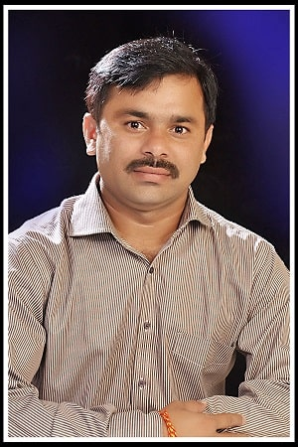

EDUCATION
Bachelors in Computer Science Engineering | ---------College/ University,
Session: 2019-2023 | Score: 7.5 CGPA

Intermediate (CBSE) |XYZ Public School, Delhi
Session: 2018-2019 | Percentage: 89%

Matriculation/SSC (CBSE) | XYZ Public School, Delhi
Session: 2016-2017 | Percentage: 92%

INTERNSHIPS

COMPANY NAME | POSITION
October 2019-Present
- Designed a program…..
- Performed an analysis on…..

PROJECTS
Project Description in one or two sentences
- Role:
- Duration:
- Size:

ACADEMIC ACHIEVEMENTS
- Bronze medal in Maths Olympiad in 2019 by XYZ University
- First position in Hackathon 2019 at NIT Jalandhar
- Certificate of Merit in Machine Learning, XYZ University

CERTIFICATIONS & AWARDS
- Google Ad Words
- Digital Marketing Certification from Symbiosis
- Microsoft Google Ambassador 2018-19, Chandigarh University

CODING PROFILES

Platform | Global Rank/score | Handle
Hackerrank |  | @munisek
Leetcode | 337,872 (Rank) | munisek
Geeksforgeeks
Codechef
Codeforce

RESEARCH & DEVELOPMENT ACHIEVEMENTS
- Publications, if any (in IEEE reference format)
- Patents, if any
- Product developed, if any

EXTRA CURRICULAR & CO-CURRICULAR ACHIEVEMENTS
- Level A Ethical Hacker
- Black Belt in Judo

MUNI SEKHAR VELPURU
Address: #1, Hyderabad- 520003
E-mail: 1234abcde@gmail.com
Phone: +91 9999999999
LinkedIn: https://in.linkedin.com/in/muni-sekhar-velpuru-774505172

CAREER OBJECTIVE
A well-organized, creative and goal-oriented graduate possessing excellent communication, problem-solving and leadership skills with a flair to explore suitable avenues in Computer Science Engineering while developing advanced projects with efficiency and quality.

TECHNICAL COMPETENCIES
C++ | JAVA | PYTHON | REDHAT
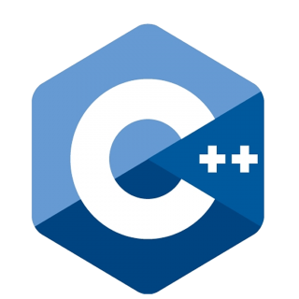

INTERPERSONAL SKILLS
Team Leadership | Management & Coordination | Decision Making

INTERESTS & HOBBIES
Writing | Blogging | Painting | Travelling | Reading | Gardening

LANGUAGES KNOWN
English | Hindi | Telugu

PERSONAL DETAILS
Mother’s Name:
Father’s Name:
D.O.B.:
Languages Known:

