

**Figure 1**. Preferred Reporting Items for Systematic Reviews and Meta-Analyses (PRISMA) flow diagram of studies selection process.

Triggers of thyroid cancer diagnosis

N = 4 470

Incidental imaging

n = 1 537

Incidental diagnosis

n = 2 338

Non-incidental diagnosis

n = 2 132

Incidental histological

n = 801

Cases when a thyroid nodule harboring thyroid cancer was found during the use of imaging test requested for reasons unrelated to a thyroid nodular disorder or symptoms

When thyroid cancer was found incidentally in the histological examination of the thyroid gland removed for a benign condition

Cases when a thyroid nodule harboring thyroid cancer was found because a clinician or patient noted an abnormality on physical examination possibly related to the thyroid mass, patient presented with neck compression symptoms including dysphagia, dysphonia, and neck-pain

**Figure 2**. Definition of triggers of thyroid cancer diagnosis.



**Figure 3**. Frequency of incidental thyroid cancer diagnosis around the world.

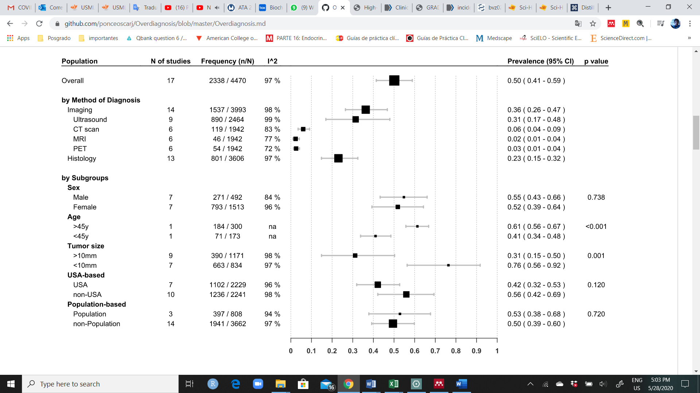

**Figure 4**. Subgroup analysis of overall i**ncidental diagnosis in patients with thyroid cancer.**

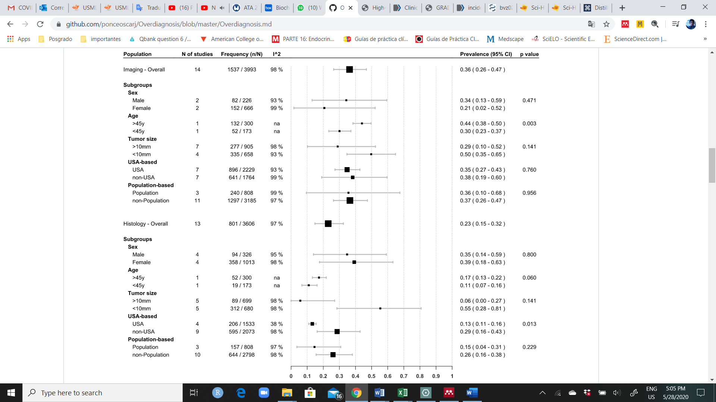

**Figure 5.** Subgroup analysis of i**maging and histological incidental diagnosis in patients with thyroid cancer.**