**Updated figures based on reviewer feedback on 2024-04-02**

**Assessing the Use of Quality Tolerance Limits in the Pharmaceutical Industry**

**PHUSE RBM Working Group – Quality Tolerance Limits Industry Survey 01Feb2022**

Author: Steven Ponce ([Steven.Ponce@bms.com](mailto:Steven.Ponce@bms.com))

GitHub repo: <https://github.com/poncest/PHUSE_RBM_QTL>

Contents

Fig 04 2

Fig 05 3

Fig 6 4

Fig 7 5

Fig 9 6

Fig 10 7

Fig 11 8

Fig 12 10

Fig 15 11

Fig 04 - *Risk-based approaches applied by trial type*

(ggplot2 - Plot 06 option 1)

Fig 05 - *Risk-based approaches applied by trial attribute*

(ggplot2 - Plot 06 option 2)

Fig 6 - *RBQM approaches are applied differently depending on trial attribute*

(ggplot2 - Plot 8 Option 2)

Fig 7 - *Details of other RBQM approaches by organisation response*

(ggplot2 - Plot 7)

Fig 9 - *Actions taken in response to a QTL deviation*

(ggplot2 - Plot 19)

Fig 10 - *Evaluating primary QTL deviations for importance*

(ggplot2 - Plot 20.3)

Fig 11 - *Use of TransCelerate parameters*

(ggplot2 - Plot 23)

There is a white space after the en dash (–); it's just how the plot is rendered. See below for an R code snipped.

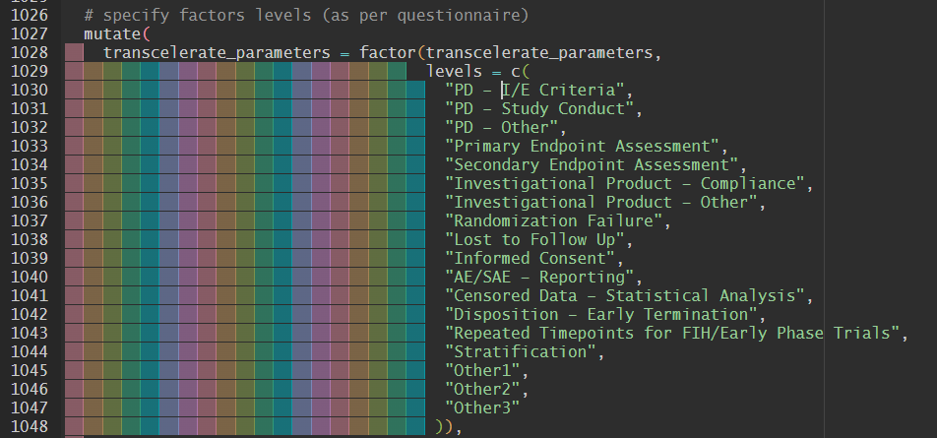

Fig 12 - *Rating the parameters defined for QTLs by TransCelerate guidance*

(ggplot2 - Plot 23 option 2 - rates)

* I sorted the percentage by the rate scale (‘high’). It's easier to read and search for insight.

Fig 15 - *Perceived value of additional parameters (note rounding errors)*

(ggplot2 - Plot 23 option 2 - rates)

* I sorted the percentage by the rate scale (‘high’). It's easier to read and search for insight.

­