**Assessing the Use of Quality Tolerance Limits in the Pharmaceutical Industry**

**PHUSE RBM Working Group – Quality Tolerance Limits Industry Survey 01Feb2022**

Steven Ponce ([Steven.Ponce@bms.com](mailto:Steven.Ponce@bms.com))

**Selected Figures**

Contents

Plot 3 3

Plot 3: Other 3

Plot 4 4

Plot 4: Other 4

Plot 5 5

Plot 5: Comments 5

Plot 6 option 1 6

Plot 6 option 2 7

Plot 7 8

Plot 8 Option 1 9

Plot 8 Option 2 10

Plot 10 11

Plot 18 12

Plot 19 13

Plot 19: Comments 14

Plot 23 15

Plot 25 16

**From:** Wells, Chris   
**Sent:** Friday, November 24, 2023 6:48 AM

Hi Steven

Thank you so much for the work you have completed. The new stacked bar charts look good and retain all the information we require. Just a couple of comments and if possible, request for some new plots. Could you review and advise how much work this would be and if this is too time consuming, i can work with Mike and Mireille to identify if we can remove any.

General point: for the plots that are stacked bar charts and where there are a number of different plots within the main plot (like plot 6) would it be possible to put the x axis at the top of the first plot as well as below the last plot? Just that it will enable the reviewer to follow the axis up and down easier.  Think this would apply to plots 6

Plot 3 - looks great.

Plot 3: Othercategory breakdown

Total Count = 08

|  |  |
| --- | --- |
| Response Number | Other Functional Area |
| 1 | Clinical Trial Supplies, Contracts, and Imaging / Diagnostics |
| 2 |  |
| 3 |  |
| 4 |  |
| 5 |  |
| 6 | Central Monitoring, Imaging / Diagnostics, Risk Manager or RBQM lead, and SaaS programmers |
| 7 | Central Monitoring |
| 8 | Central Monitoring |
| 9 |  |
| 10 |  |
| 11 |  |
| 12 |  |
| 13 |  |
| 14 |  |
| 15 | Medical Monitoring, Medical Writing, and Project Management |

Plot 4 - this one equates to question 4 and is Which functional area Leads the trial level risk based approach to Quality.  - Could we have the same plot as you have created in plot 3.  this is very similar to plot 3 but plot 3 is asking which functional area is involved and plot 4 asks which function LEADS, so very slightly different

Plot 4: Othercategory breakdown

Total Count = 08

|  |  |
| --- | --- |
| Response Number | Other Functional Area |
| 1 | Risk Manager |
| 2 |  |
| 3 |  |
| 4 |  |
| 5 | RBQM working group |
| 6 | Risk Manager |
| 7 | Central Monitoring |
| 8 | Central Monitoring |
| 9 |  |
| 10 | Oversight Team |
| 11 |  |
| 12 |  |
| 13 | Clinical Quality Management |
| 14 |  |
| 15 | Project Management |

Plot 5 - Question 5 - Trial types where company does not apply Risk Based Approaches to Quality   - could we have a plot like plot 3 by trial type (trial type on y-axis)

Plot 5: Commentscategory breakdown

Total Count = 09

|  |  |
| --- | --- |
| Response Number | Comments |
| 1 |  |
| 2 | Studies with less sites or small sample size. |
| 3 |  |
| 4 |  |
| 5 | We try and offer something on Phase 1, Phase II, Phase III, and complex designs but its  not always possible. |
| 6 | Risk management to all studies but cetralized monitoring not for small sample size  studies or single site studies or with short duration studies - process under  implementation |
| 7 | RBQM concept driven by early/late clinical operations. |
| 8 | All studies are in scope. |
| 9 |  |
| 10 | All areas look at risk. |
| 11 |  |
| 12 | It’s been difficult to establish meaningful QTLS. |
| 13 | Observational and epidemiology study. |
| 14 |  |
| 15 | All studies considered to take risk-based approach as risk assessments and mitigation  planning are done for all. |

Plot 6 option 1 - Looks great but could we have the x axis at the top as well as the bottom.

Not great….

Plot 6 option 2 - Looks great but could we have the x axis at the top as well as the bottom.

Better option.

Plot 7  - Could we have one for Question 7 like plot 3 but with the attributes on the y axis

Plot 8 Option 1- Could we have one for question 8 like plot 6b and the attributes on the y axis and responses on the x-axis.

**Not great….**

Plot 8 Option 2 - Could we have one for question 8 like plot 6b and the attributes on the y axis and responses on the x-axis.

Better option.

Plot 10 - could we have a plot on question 10 - like plot 6 with attributes on y axis and response on x axis (top & bottom of the plot)

Plot 18 - Question 18 - could we have a plot like plot 6b.02

Plot 19 - Question 19 - could we have a plot like plot 6b

Plot 19: Commentsfree-text

Total Count = 04

|  |  |
| --- | --- |
| Response Number | Comments |
| 1 |  |
| 2 |  |
| 3 |  |
| 4 | Unknown at this time |
| 5 | We are still working on some of these areas. For secondary breaches, we may take  mitigating actions but would not report these in the CSR unless it lead to a protocol  amendment or something like this. For primary breaches, these would be discussed in  the CSR however sometimes the qtl setting using the historic data may not be applicable if the historic study was not a good match. So then this may result in the review of the  distribution and also may result in an amendment of the QTL thresholds. |
| 6 |  |
| 7 |  |
| 8 |  |
| 9 |  |
| 10 |  |
| 11 |  |
| 12 | Have not yet happened - the action would depend on kind of breach, severity etc. |
| 13 | None of these actions are planned in advance.  We try to mitigate the critical to quality  risks proactively, and then meet to assess on an ongoing basis.  There have been  instances where we needed to change the QTL because it was set incorrectly, although  that has not happened since we put the dedicated RBQM team in place to manage the  process. |
| 14 |  |
| 15 |  |

Plot 23 - question 20.3, could we have a plot like plot 3

Plot 25 - question 25  - Could we have new plots for these or should we stay with those we have?

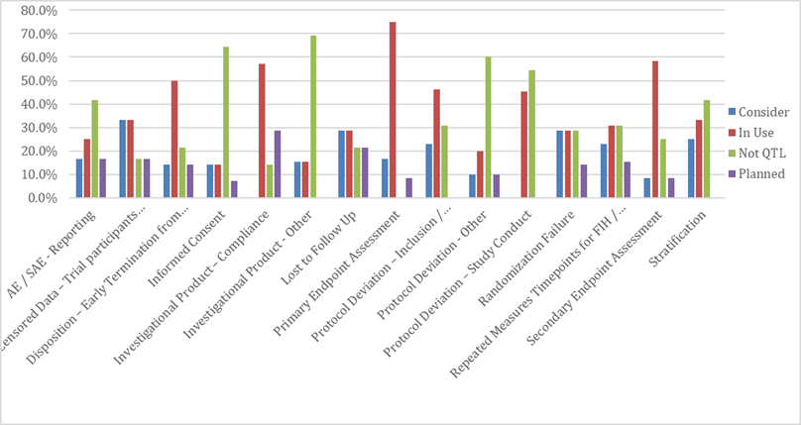

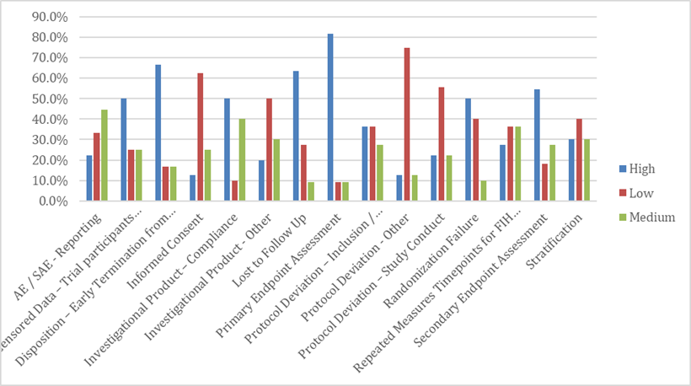

Again, thank you so much

kind regards