Lab 15 NP-Complete

- Suppose Prob1, Prob2, and Prob3 are decision problems and Prob1 is polynomial reducible to Prob2, and Prob2 is polynomial reducible to Prob3. Explain why Prob1 must be polynomial reducible to Prob3.
Solution:
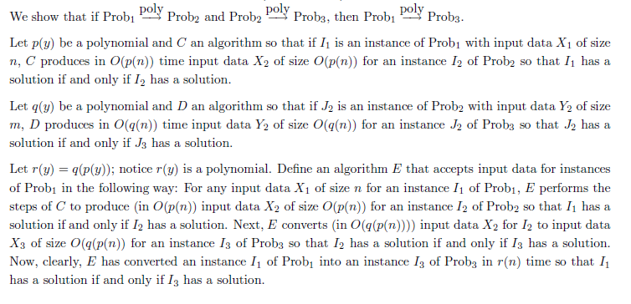
A simpliefied representation:
C, p(y) - in O(p(n)); I1;
Prob. 1
D, q(y) – in O(q(n)); I2
Prob. 2
X1
X2
X3

Prob. 3

Size O(q(p(n)))
Above is Equivalent to the diagram below:

E, r(y) – in O(q(p(n))) time
r(y) = q(p(y));
Prob. 1 & 2
X1
X3

Prob. 3

- Illustrate the proof that the HamiltonianCycle problem is polynomial reducible to TSP by considering the following Hamiltonian graph—an instance of HamiltonianCycle—and transforming it to a TSP instance in polynomial time so that a solution to the HC problem yields a solution to the TSP problem, and conversely.
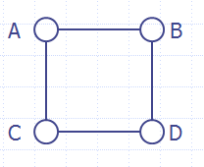
Solution:
The HC instance G = (V,E) given in the problem is the graph below.
We use the algorithm discussed in class for transforming HC instances into TSP
instances. We first add the missing edges in G to produce a complete graph
H = (V_{H}, E_{H}), and then define c: H  N by c(e) = 0 if e  E, but c(e) = 1 if e  E. Finally, let k = 0. Our TSP instance is (H, c, k).
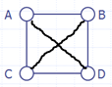
TSP Graph H
Verification: Solution to HC instance  Solution to TSP instance
Suppose K is a solution to the HC problem – this means that K is a Hamiltonian cycle in G. In this case, K must be precisely the edges of E. We show K is a solution to the TSP instance we have generated: For each e  K, c(e) = 0, and so the sum of the weights of edges in K is 0. We have shown the sum of the weights of edges in K is
≤ k, and so K is a solution to the TSP instance.
Verification: Solution to TSP instance  Solution to HC instance
Suppose K is a solution to the TSP problem – this means that K is a Hamiltonian cycle in H and the sum of the edge weights in K is ≤ k, in other words, the sum is 0. Since the sum is 0, c(e) = 0 for each e  K. By definition of c, this means that each e  K belongs to the set E of edges of G. Therefore, K is also a Hamiltonian cycle in G. We have shown that K is a solution to the HC instance.

- Show that TSP is NP-complete. (Hint: use the relationship between TSP and HamiltonianCycle discussed in the slides. You may assume that the HamiltonianCycle problem is NP-complete.)
Solution:
Suppose R is an NP problem. We must show that R TSP (since R can be any NP problem, it would imply that any NP problem can be reduced to TSP). Notice that
R HC TSP
The first is because HC is NP-complete; the second is because of the fact shown previously.
It now follows from Problem 1 that R TSP.

Alternatively, just show HC TSP (as done previously) and show that TSP in in NP. Since HC is an NP-Complete problem and it can be reduced to TSP and TSP belongs to NP, TSP is an NP-Complete problem.

4. Find an O(n) algorithm that does the following: Given a size n input array of integers, output the first numbers in the array (from left to right) whose sum is exactly 10 (or indicate that no such numbers can be found).

Solution: Let S = {s₀, s₁, . . ., s_{n-1}} be the array elements in the original order. Fill in the memoization table for the SubsetSum problem given by S and k = 10. As the table is filled in from row 0 through row n – 1, look for a solution T to appear in any cell in the column headed by 10. Suppose the first such solution occurs in the row labeled by si. This means that T is a subset of s₀…s_{i} whose sum is 10. Notice that no set of numbers lying in s₀ … s_{i-1} sums to 10 since the s_{i} row is the first in which such a solution occurs. Therefore, T is the solution to the problem. The running time to fill in the table and watch for the occurrence of T is O(10n)= O(n).

5. Work through the steps of the Dynamic Programming solution to SubsetSum in the case in which S = {3,2,1,5} and k = 4 (Hint: Very similar to the DP on Knapsack covered in class).

