1) My Load Balancer For ALB

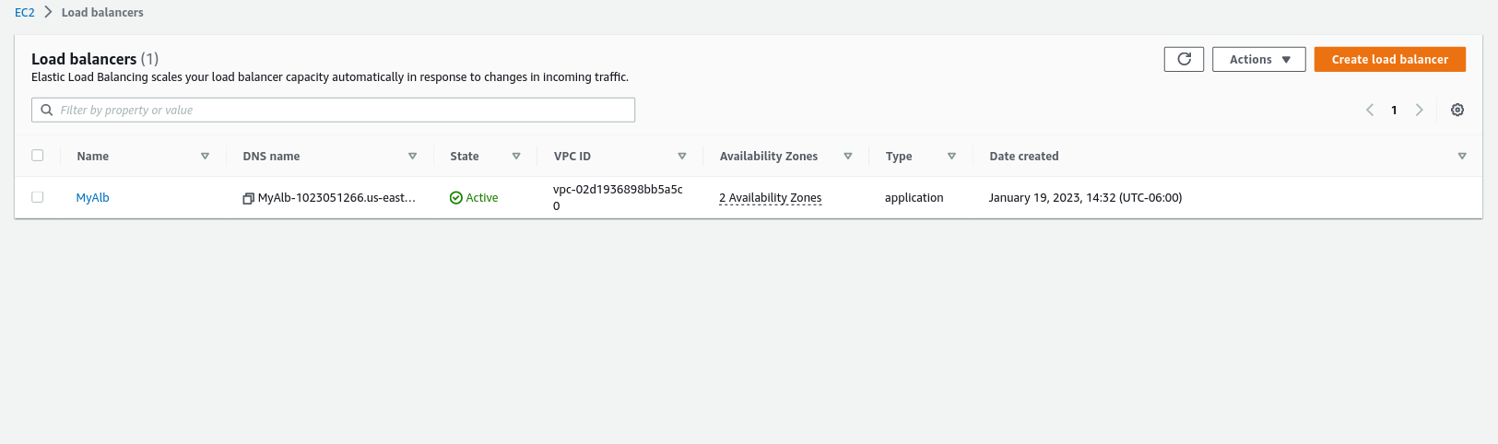

2) ALB Target Group

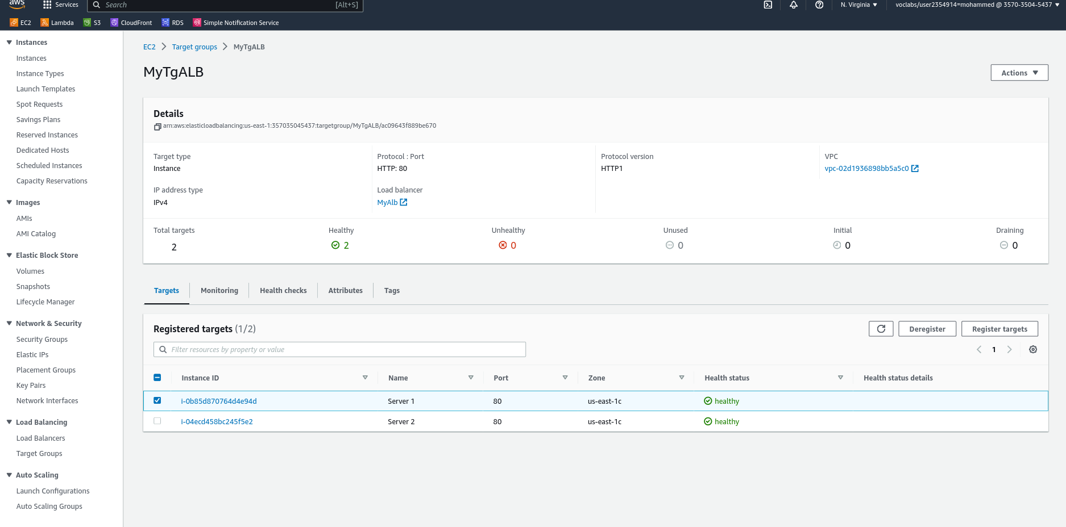

3) Listner Rules

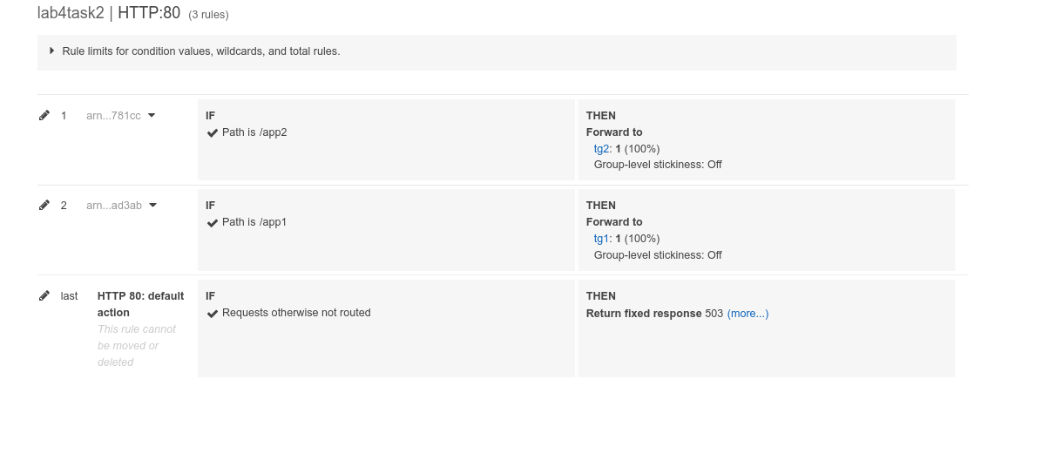

3) My Load balancer DNS <http://myalb-1023051266.us-east-1.elb.amazonaws.com/>

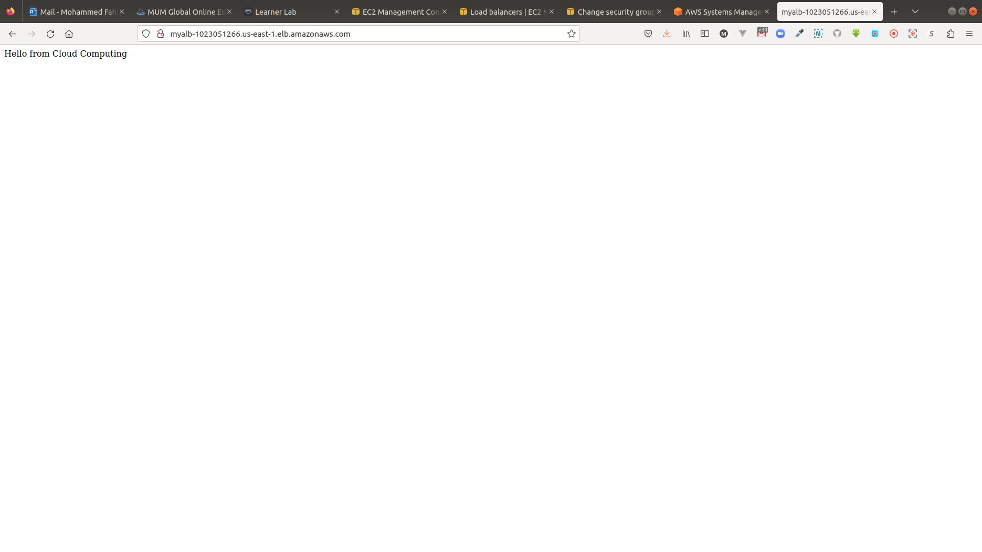

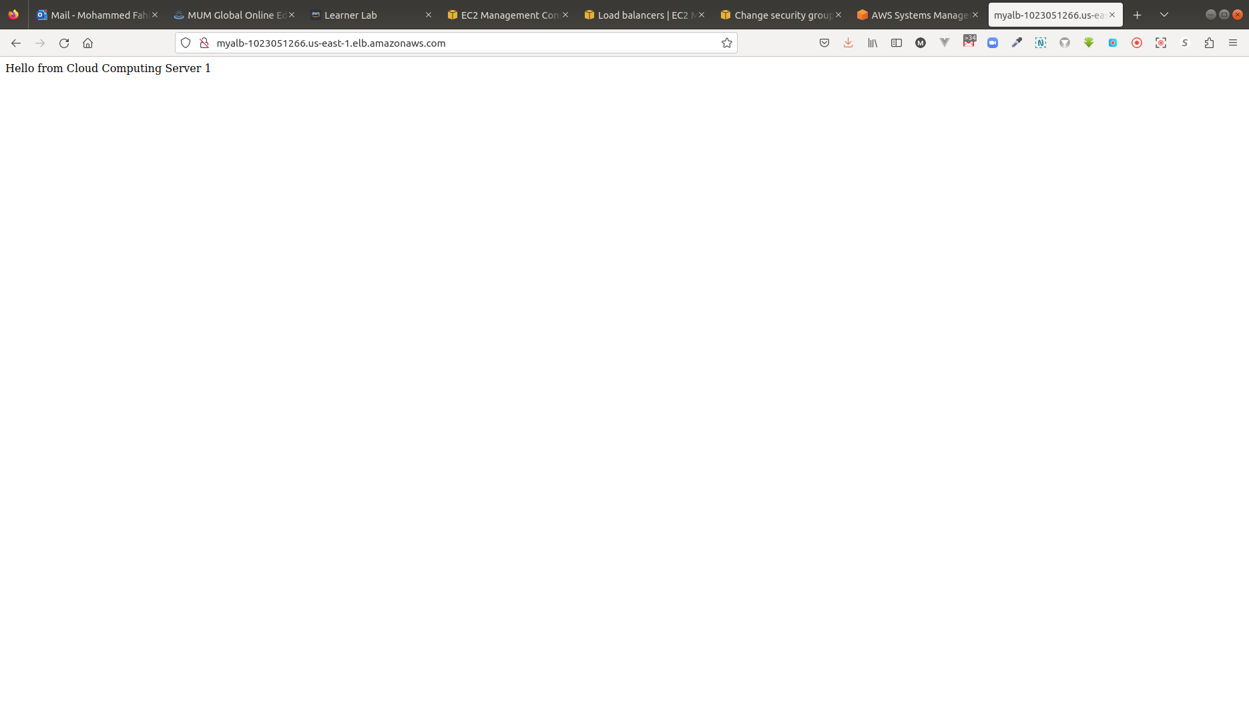

4)