1) Security Group for RDS

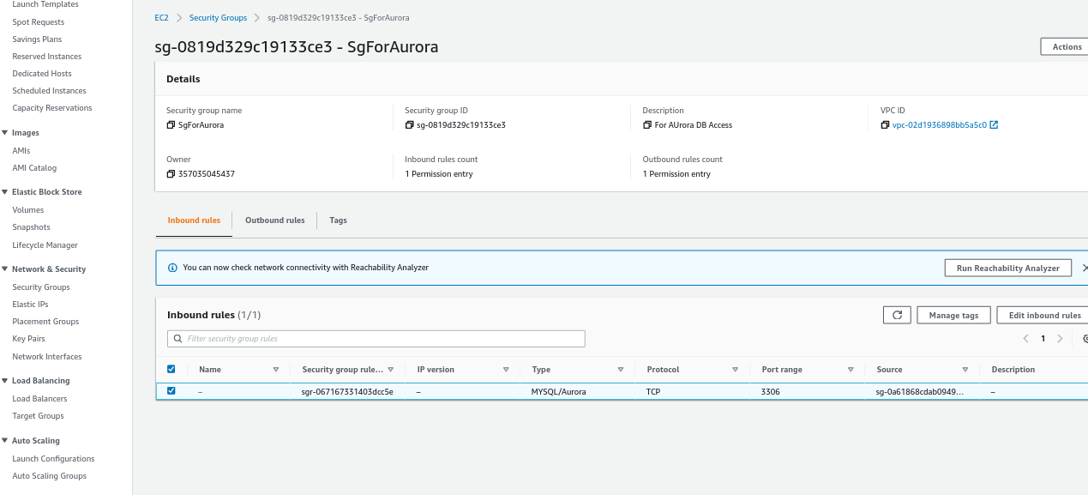

2) Create RDS

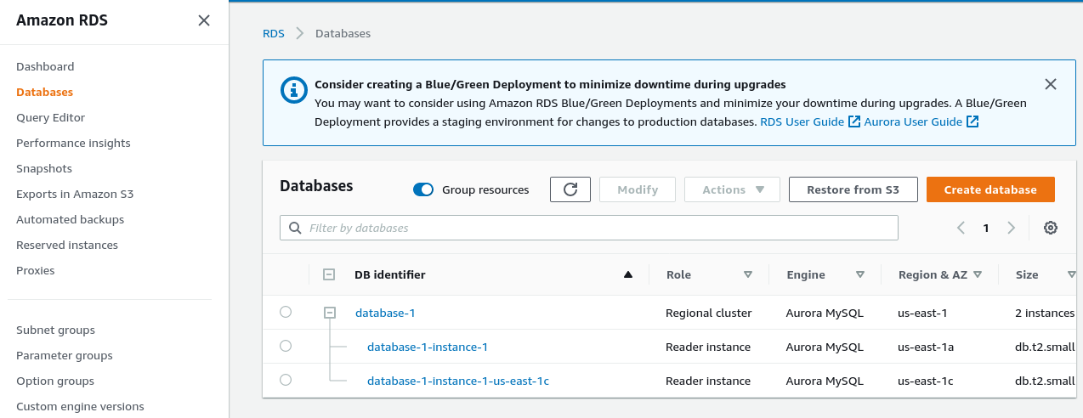

3) after connecting with RDS from ec2 panel

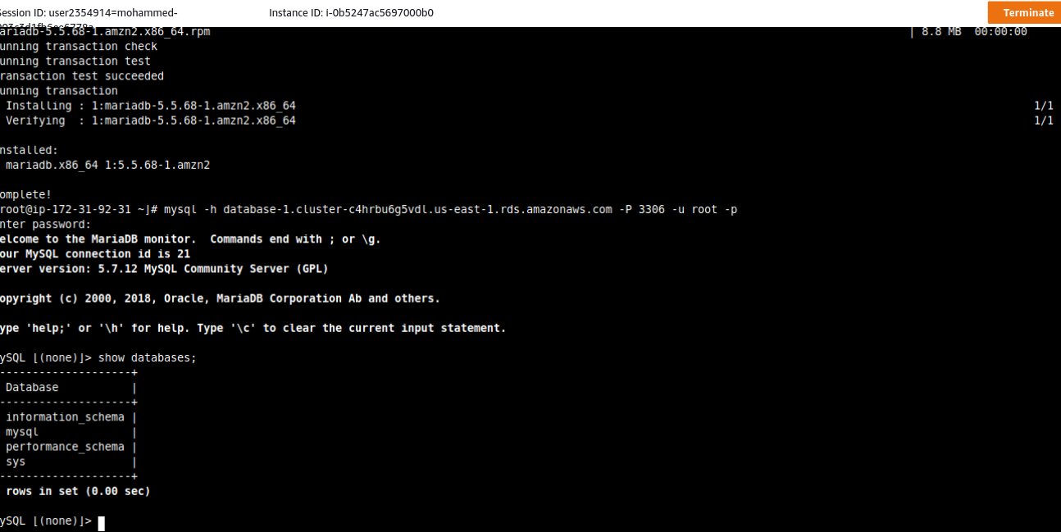

4) Running querys in RDS writer instance

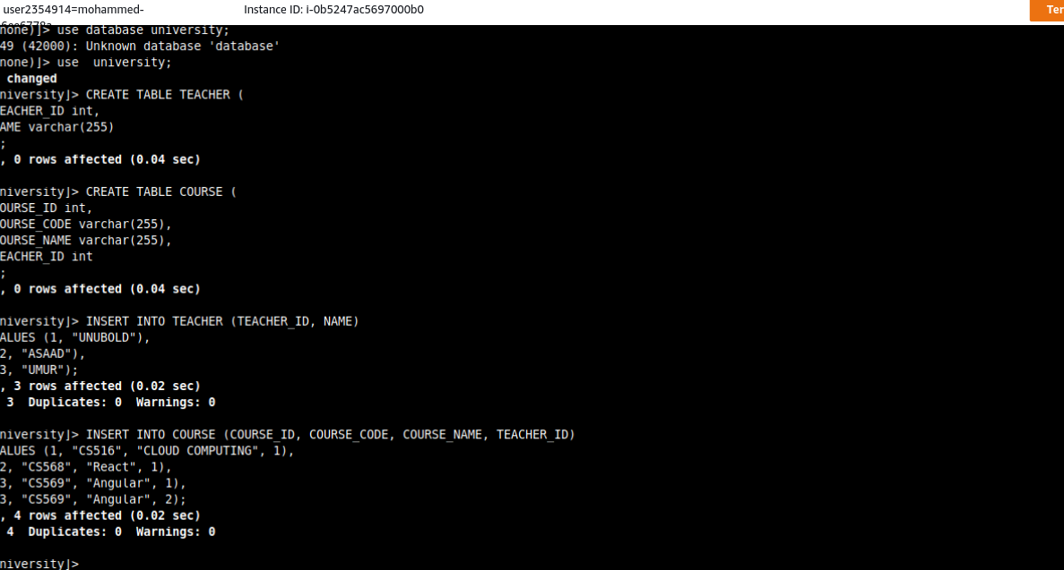

5) Connecting to reader instance and executing querys. Also tried to delete row and got error.

