1)

{

"Version": "2012-10-17",

"Statement": [

{

"Sid": "VisualEditor0",

"Effect": "Allow",

"Action": [

"sns:Publish",

"sqs:SendMessage"

],

"Resource": [

"arn:aws:sns:us-east-1:357035045437:myTopic",

"arn:aws:sqs:us-east-1:357035045437:MyQueue"

]

}

]

}

2) Message in inbox

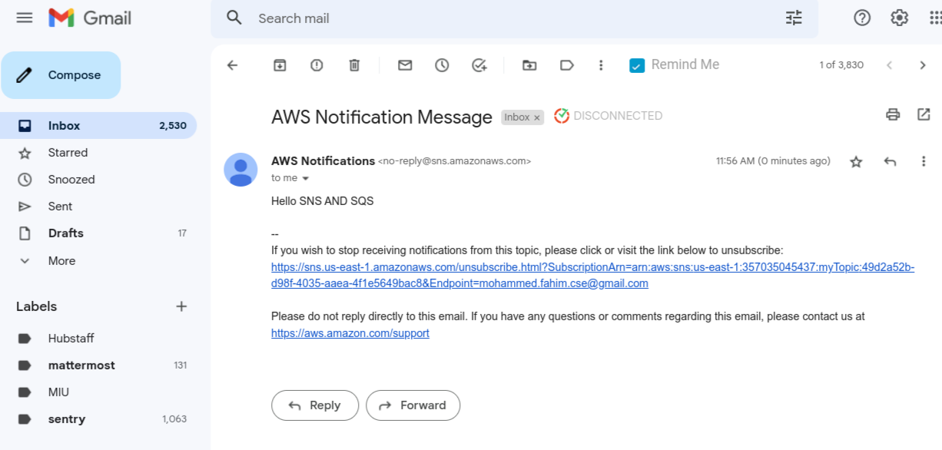

3) Event Bus

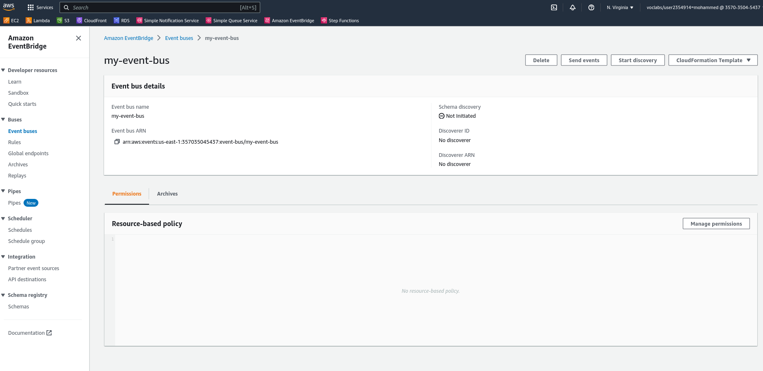

4) Email from eventbus

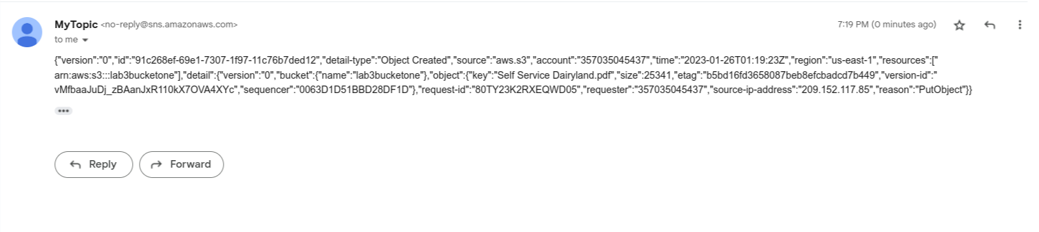

5) Step function

