1) CourseLambda

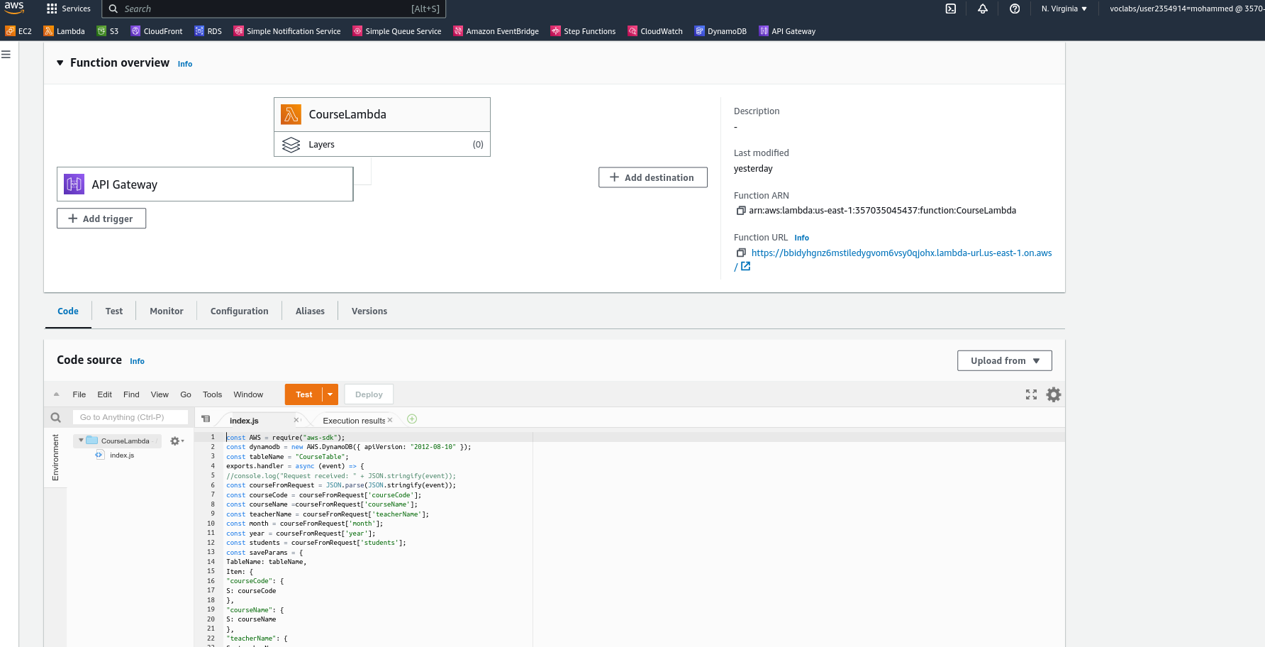

2) CourseTable in dynamodb

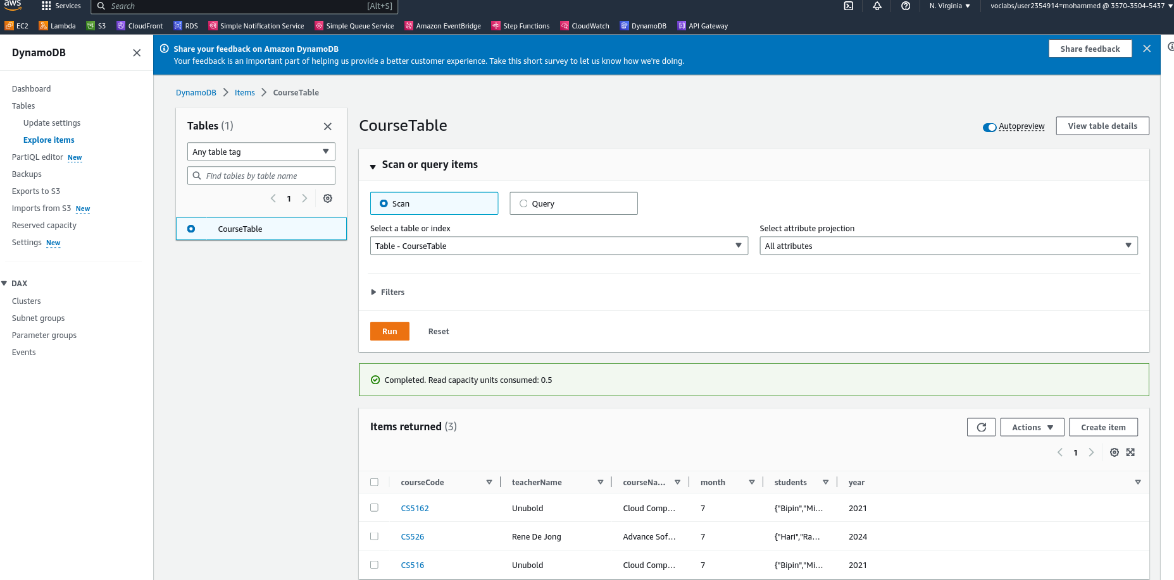

3) Policy

{

"Version": "2012-10-17",

"Statement": [

{

"Sid": "VisualEditor0",

"Effect": "Allow",

"Action": [

"dynamodb:DeleteItem",

"dynamodb:DescribeContributorInsights",

"dynamodb:RestoreTableToPointInTime",

"dynamodb:ListTagsOfResource",

"dynamodb:CreateTableReplica",

"dynamodb:UpdateContributorInsights",

"dynamodb:UpdateGlobalTable",

"dynamodb:CreateBackup",

"dynamodb:DeleteTable",

"dynamodb:UpdateTableReplicaAutoScaling",

"dynamodb:UpdateContinuousBackups",

"dynamodb:PartiQLSelect",

"dynamodb:DescribeTable",

"dynamodb:PartiQLInsert",

"dynamodb:GetItem",

"dynamodb:DescribeContinuousBackups",

"dynamodb:UpdateGlobalTableVersion",

"dynamodb:CreateGlobalTable",

"dynamodb:DescribeKinesisStreamingDestination",

"dynamodb:EnableKinesisStreamingDestination",

"dynamodb:ImportTable",

"dynamodb:BatchGetItem",

"dynamodb:DisableKinesisStreamingDestination",

"dynamodb:UpdateTimeToLive",

"dynamodb:BatchWriteItem",

"dynamodb:ConditionCheckItem",

"dynamodb:PutItem",

"dynamodb:PartiQLUpdate",

"dynamodb:Scan",

"dynamodb:Query",

"dynamodb:StartAwsBackupJob",

"dynamodb:UpdateItem",

"dynamodb:DeleteTableReplica",

"dynamodb:DescribeTimeToLive",

"dynamodb:CreateTable",

"dynamodb:UpdateGlobalTableSettings",

"dynamodb:RestoreTableFromAwsBackup",

"dynamodb:RestoreTableFromBackup",

"dynamodb:ExportTableToPointInTime",

"dynamodb:UpdateTable",

"dynamodb:PartiQLDelete",

"dynamodb:DescribeTableReplicaAutoScaling"

],

"Resource": [

"arn:aws:dynamodb:us-east-1:357035045437:table/CourseTable",

"arn:aws:dynamodb:us-east-1:357035045437:table/CourseTable/index/courseName-index"

]

},

{

"Sid": "VisualEditor1",

"Effect": "Allow",

"Action": [

"dynamodb:DescribeReservedCapacityOfferings",

"dynamodb:DescribeReservedCapacity",

"dynamodb:PurchaseReservedCapacityOfferings",

"dynamodb:DescribeLimits",

"dynamodb:DescribeEndpoints",

"dynamodb:ListStreams"

],

"Resource": "\*"

}

]

}

4)CourseLambda CRUD

