STC506A-2023-02A-02b-01

Thursday, Feb 16, 2023

Assignment 04

Prepared BY: Ponchanon Datta Rone Student ID : 615866

## Meditation in the Laboratory

This chapter discussed about how meditation has been studied in the laboratory using various methods, such as electroencephalography (EEG), functional magnetic resonance imaging (fMRI), and positron emission tomography (PET). These studies have shown that meditation can produce measurable changes in brain function and structure, as well as changes in physiological measures such as heart rate, blood circulation and cortisol levels.

## Most interesting Laboratory Study on meditation

There are several interesting studies happened in the laboratory on meditation. It’s tough to share only one study. still I’m sharing one study on healthcare and public health which attracts me a lot.

In USA, 40% of total people have at least one chronic disease and the country healthcare expenditure is increasing significantly over the last 100+ years. Uses of modern medicine have a lots of side effects and it’s leading the of death which is the 4th topmost causes of death in USA.

The study found that patients who participated in the meditation program had significantly lower rates of heart attack, stroke, and death compared to a control group who received traditional cardiac rehabilitation. Additionally, the patients in the meditation group had significantly lower healthcare costs over a 5-year follow-up period compared to the control group, suggesting that the meditation program may have cost-saving benefits in addition to health benefits.

Statistics from 2 different entities (Blue cross and Canadian Government’s insurance statistics) yielded analogous results. For the senior citizens, practicing TM had a 70%+ drop in overall expenditure for healthcare. TM has a magical power for the wellbeing of mankind, and it has an incremental contribution of more than 10% every year in the healthcare cost.

There are no other techniques so far which have a extraordinary power to reduce the costs and to improve the health.

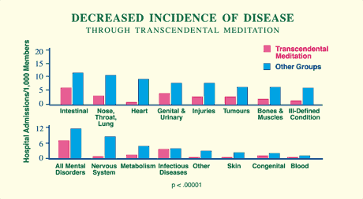

As shown in the above study of healthcare improvements in USA, the TM participants (TM Meditation & TM Shidhi programs) are getting the benefits of a good health in all 16 categories including the hospitalization rate, cancer, nervous system disorder, nose throat & lung problem, and other chronic diseases.

Some other studies on education, functional performance, rehabilitation, post-traumatic stress, world peace, and 50 more studies characterizes the evidence of TM effectively.

## areas of research that address my concern

There are many different areas of research that addressed my main interest. The areas listed below are the types of research that have a significant impact on the world around us as I concerned.

1. Mental health research: Mental health issues such as anxiety, depression, and post-traumatic stress disorder (PTSD) affect a significant portion of the population. Research in this area can help identify effective treatments and interventions to help individuals dealing with these conditions.
2. Climate change research: Climate change is a global issue that poses a significant threat to the health and well-being of individuals and societies around the world. Research in this area can help identify the causes and impacts of climate change, as well as potential solutions to address it.
3. Artificial intelligence research: As AI technology continues to advance, there are concerns about the potential impact on the workforce, privacy, and ethical considerations. Research in this area can help identify potential solutions and mitigate the negative impacts of AI.
4. Medical research: Medical research focuses on developing new treatments and cures for diseases, as well as understanding the underlying causes of various medical conditions. This type of research can be important for improving the health and well-being of individuals and society as a whole.
5. Education research: Education research can help identify effective teaching methods and interventions to improve student outcomes and success. This type of research can be important for improving the educational system and the overall well-being of society.