Artificial Intelligence: Capabilities, Constraints, and Societal Impact
Artificial intelligence is no longer an abstract research topic or a niche technical discipline. It has become a general-purpose technology that affects how economies function, how organizations make decisions, and how individuals interact with information. This document provides a structured, substantive overview of modern AI, written as a real analytical report rather than a placeholder example.

1. What Artificial Intelligence Actually Is
At its core, artificial intelligence refers to systems that perform tasks typically associated with human cognitive abilities, such as pattern recognition, language understanding, prediction, and decision support.
Modern AI systems are predominantly based on statistical learning. They do not possess intent, beliefs, or goals of their own. Instead, they optimize mathematical objectives derived from data and human-defined criteria.
This distinction is critical. Misunderstanding AI as an autonomous agent leads to unrealistic expectations and poor governance decisions.
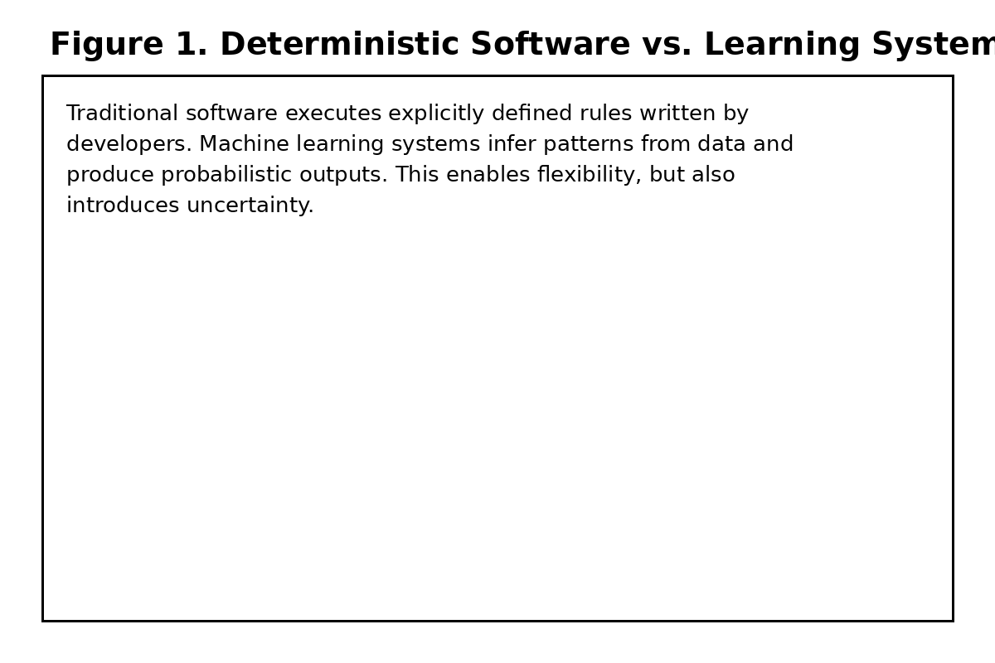

2. How Modern AI Systems Are Built
Most contemporary AI systems rely on machine learning models trained on large datasets. Training involves adjusting millions or billions of parameters to minimize error on historical examples.
Large language models extend this approach by learning statistical relationships between words, phrases, and concepts across massive text corpora. The resulting systems can generate fluent language, summarize documents, and answer questions within learned distributions.
Importantly, these models do not retrieve truth in a symbolic sense. They generate outputs that are likely given their training data, which is why verification remains essential.

3. Practical Capabilities
In practice, AI excels at tasks involving scale and repetition. It can analyze datasets far larger than any human team, identify correlations, and surface anomalies that warrant further investigation.
In knowledge work, AI is most effective as a drafting and exploration tool. It reduces the cost of producing first versions, enabling humans to focus on refinement, judgment, and decision-making.
Used correctly, this shifts effort rather than eliminating it.
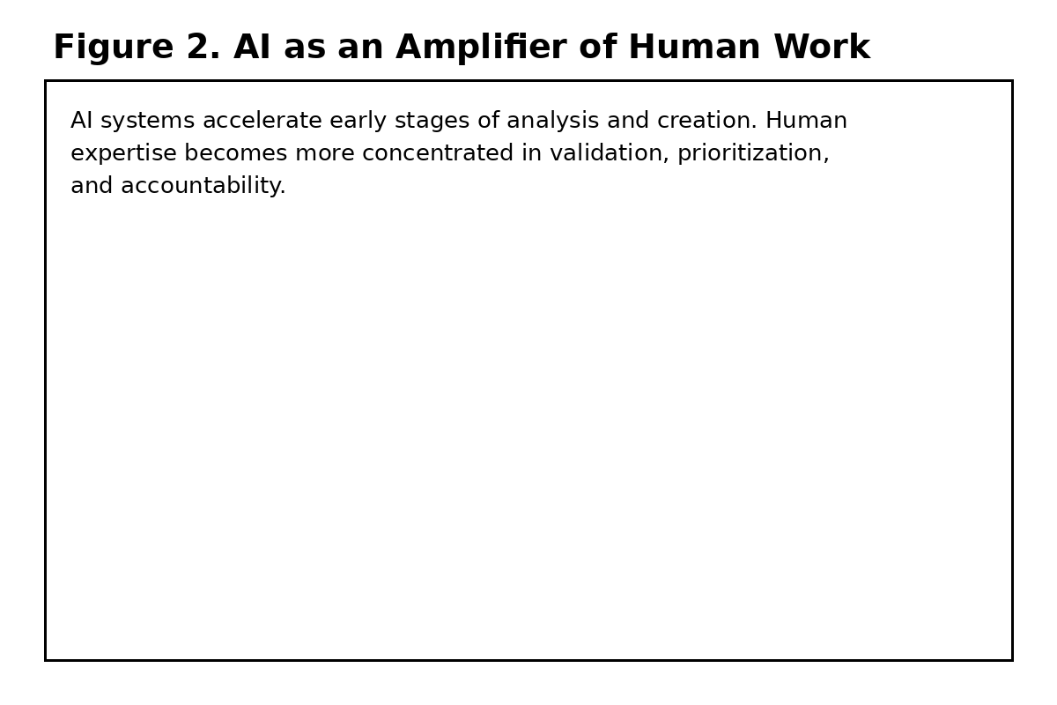

4. Failure Modes and Limitations
Despite impressive performance, AI systems fail in systematic ways. They can produce outputs that sound confident while being factually incorrect, especially when prompted outside well-represented training distributions.
Bias is another structural limitation. Models reflect patterns present in their training data, including social, cultural, and institutional biases. Mitigation requires deliberate intervention rather than passive expectation.
These limitations are not bugs that can be entirely eliminated; they are inherent properties of data-driven systems.
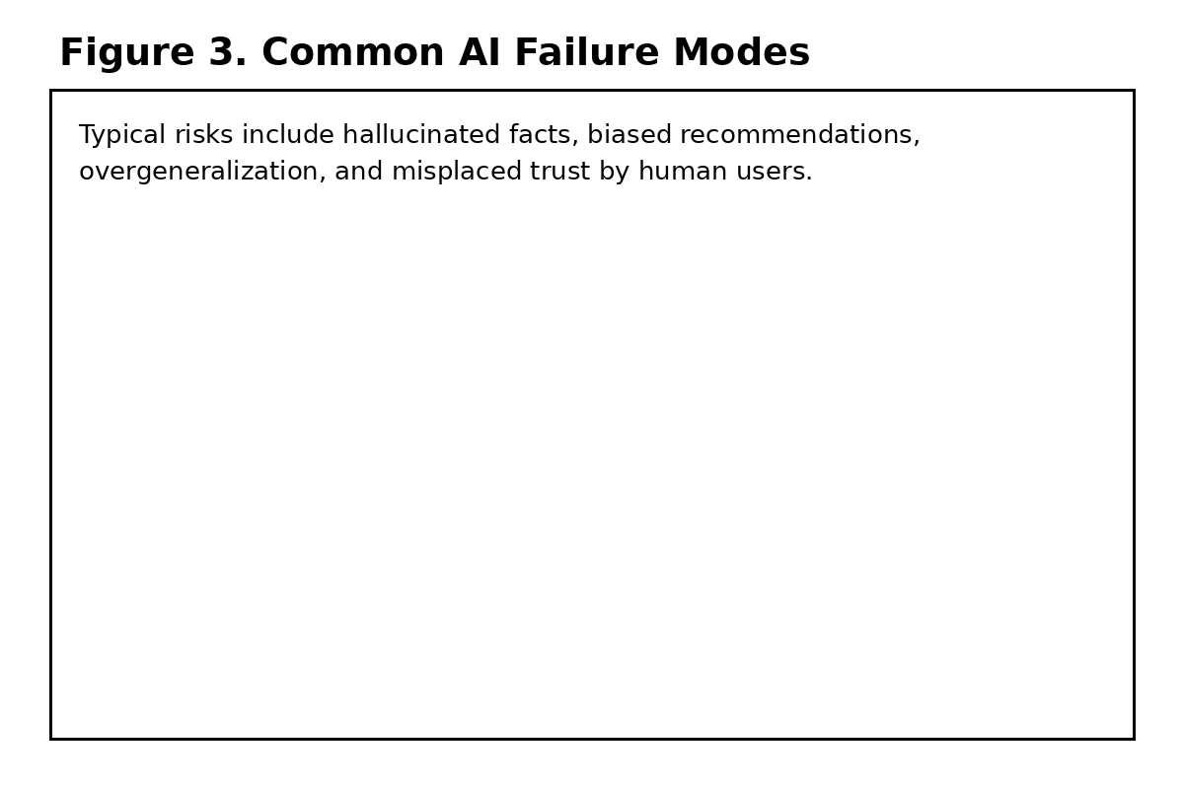

5. Organizational Adoption
Organizations adopting AI often underestimate non-technical challenges. Tool availability alone does not create value. Processes, incentives, and training determine outcomes.
Teams that succeed tend to define clear usage boundaries, require human review for high-impact decisions, and continuously monitor performance.
Failures usually stem from over-automation, unclear accountability, or unrealistic expectations set by leadership.

6. Economic and Labor Implications
AI alters labor demand unevenly. Routine cognitive tasks are most affected, while roles involving complex judgment, coordination, and responsibility become more valuable.
Rather than mass replacement, the more likely outcome is task-level restructuring within jobs. This creates both opportunity and disruption.
Policy responses must therefore focus on reskilling and transition support rather than simplistic automation narratives.

7. Ethical and Governance Considerations
Ethical AI governance centers on accountability. Systems do not bear responsibility; organizations and individuals do.
Transparency, auditability, and the ability to contest automated outputs are essential safeguards, especially in domains such as finance, healthcare, and public administration.
Regulation is evolving, but effective governance often begins internally, long before legal requirements apply.
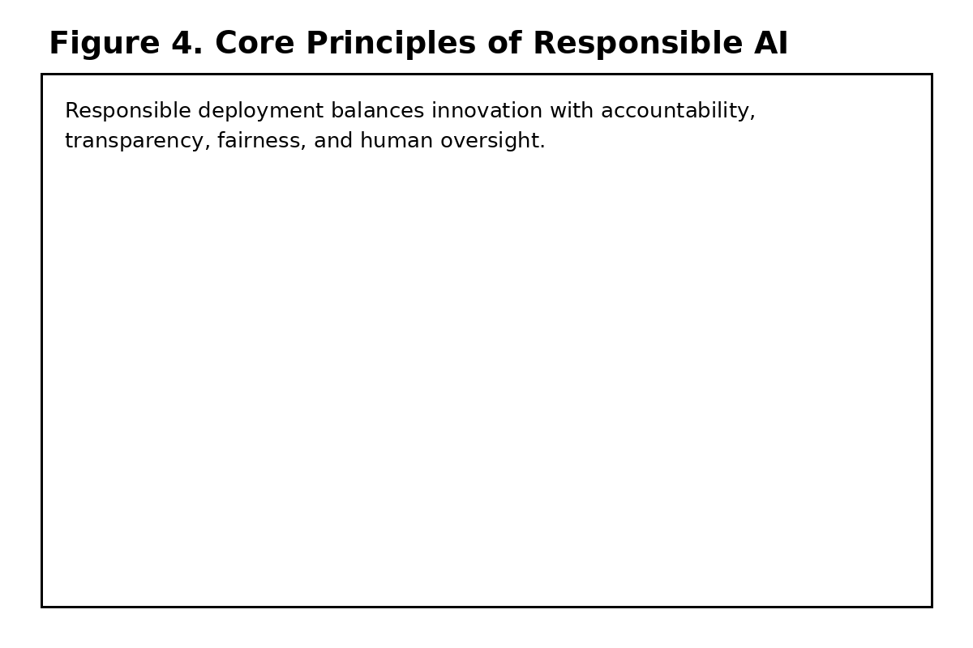

8. The Likely Trajectory of AI Development
Future AI systems will likely become more integrated rather than more autonomous. Improvements will focus on reliability, contextual awareness, and tighter coupling with human workflows.
Progress will be constrained less by model size and more by data quality, evaluation methods, and governance frameworks.
The most impactful innovations are therefore likely to be organizational and social, not purely technical.

9. Conclusion
Artificial intelligence is best understood as an enabling infrastructure rather than an independent actor. Its value depends on how well humans design, deploy, and govern it.
Treating AI seriously requires moving beyond hype and fear, toward clear-eyed analysis of capabilities, risks, and responsibilities.
Used thoughtfully, AI can enhance human decision-making. Used carelessly, it can amplify existing failures at scale.

AI System Pipeline
This diagram illustrates the fundamental flow of modern AI systems, from raw data through trained models to actionable outputs.This diagram illustrates the fundamental flow of modern AI systems, from raw data through trained models to actionable outputs.This diagram illustrates the fundamental flow of modern AI systems, from raw data through trained models to actionable outputs.
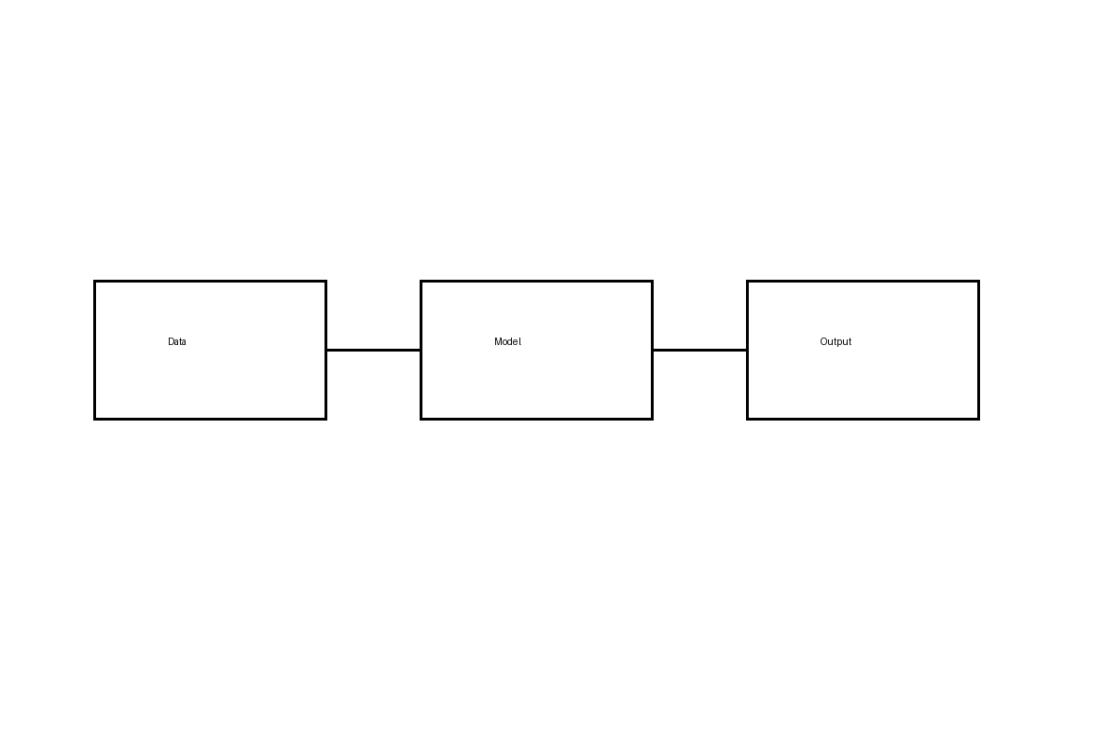

Human–AI Feedback Loop
Effective AI systems rely on continuous human feedback to validate, correct, and contextualize automated outputs.Effective AI systems rely on continuous human feedback to validate, correct, and contextualize automated outputs.Effective AI systems rely on continuous human feedback to validate, correct, and contextualize automated outputs.


Governance Layers
AI governance operates across multiple layers, from external regulation to internal technical controls.AI governance operates across multiple layers, from external regulation to internal technical controls.AI governance operates across multiple layers, from external regulation to internal technical controls.
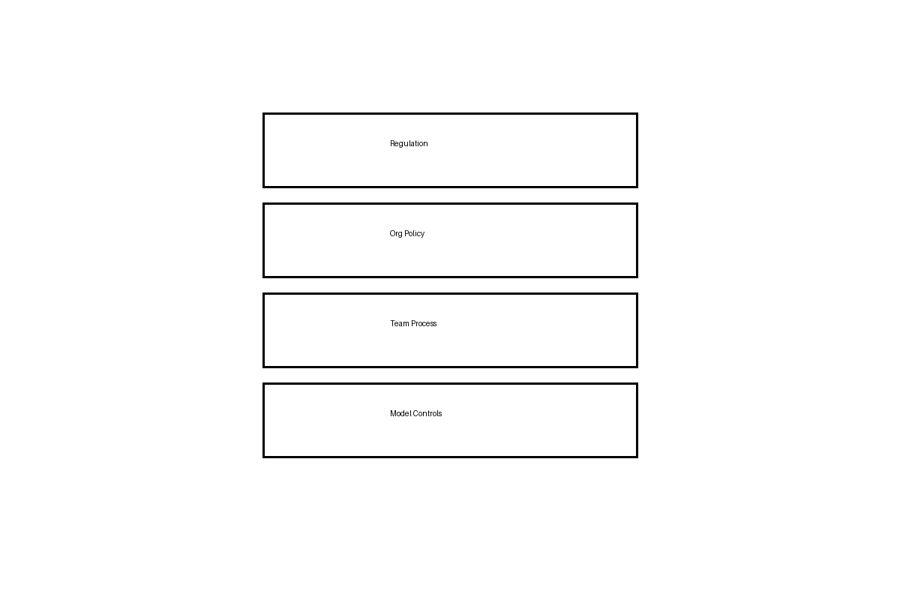

Capability–Risk Tradeoff
As AI capabilities increase, associated risks often scale non-linearly, requiring proactive governance mechanisms.As AI capabilities increase, associated risks often scale non-linearly, requiring proactive governance mechanisms.As AI capabilities increase, associated risks often scale non-linearly, requiring proactive governance mechanisms.


AI System Pipeline
This diagram illustrates the fundamental flow of modern AI systems, from raw data through trained models to actionable outputs.This diagram illustrates the fundamental flow of modern AI systems, from raw data through trained models to actionable outputs.This diagram illustrates the fundamental flow of modern AI systems, from raw data through trained models to actionable outputs.

Human–AI Feedback Loop
Effective AI systems rely on continuous human feedback to validate, correct, and contextualize automated outputs.Effective AI systems rely on continuous human feedback to validate, correct, and contextualize automated outputs.Effective AI systems rely on continuous human feedback to validate, correct, and contextualize automated outputs.

Governance Layers
AI governance operates across multiple layers, from external regulation to internal technical controls.AI governance operates across multiple layers, from external regulation to internal technical controls.AI governance operates across multiple layers, from external regulation to internal technical controls.

Capability–Risk Tradeoff
As AI capabilities increase, associated risks often scale non-linearly, requiring proactive governance mechanisms.As AI capabilities increase, associated risks often scale non-linearly, requiring proactive governance mechanisms.As AI capabilities increase, associated risks often scale non-linearly, requiring proactive governance mechanisms.

AI System Pipeline
This diagram illustrates the fundamental flow of modern AI systems, from raw data through trained models to actionable outputs.This diagram illustrates the fundamental flow of modern AI systems, from raw data through trained models to actionable outputs.This diagram illustrates the fundamental flow of modern AI systems, from raw data through trained models to actionable outputs.

Human–AI Feedback Loop
Effective AI systems rely on continuous human feedback to validate, correct, and contextualize automated outputs.Effective AI systems rely on continuous human feedback to validate, correct, and contextualize automated outputs.Effective AI systems rely on continuous human feedback to validate, correct, and contextualize automated outputs.

Governance Layers
AI governance operates across multiple layers, from external regulation to internal technical controls.AI governance operates across multiple layers, from external regulation to internal technical controls.AI governance operates across multiple layers, from external regulation to internal technical controls.

Capability–Risk Tradeoff
As AI capabilities increase, associated risks often scale non-linearly, requiring proactive governance mechanisms.As AI capabilities increase, associated risks often scale non-linearly, requiring proactive governance mechanisms.As AI capabilities increase, associated risks often scale non-linearly, requiring proactive governance mechanisms.

AI System Pipeline
This diagram illustrates the fundamental flow of modern AI systems, from raw data through trained models to actionable outputs.This diagram illustrates the fundamental flow of modern AI systems, from raw data through trained models to actionable outputs.This diagram illustrates the fundamental flow of modern AI systems, from raw data through trained models to actionable outputs.

Human–AI Feedback Loop
Effective AI systems rely on continuous human feedback to validate, correct, and contextualize automated outputs.Effective AI systems rely on continuous human feedback to validate, correct, and contextualize automated outputs.Effective AI systems rely on continuous human feedback to validate, correct, and contextualize automated outputs.

Governance Layers
AI governance operates across multiple layers, from external regulation to internal technical controls.AI governance operates across multiple layers, from external regulation to internal technical controls.AI governance operates across multiple layers, from external regulation to internal technical controls.

Capability–Risk Tradeoff
As AI capabilities increase, associated risks often scale non-linearly, requiring proactive governance mechanisms.As AI capabilities increase, associated risks often scale non-linearly, requiring proactive governance mechanisms.As AI capabilities increase, associated risks often scale non-linearly, requiring proactive governance mechanisms.

