Artificial Intelligence: Operational Maturity, Risk, and Long-Term Integration
This document serves as a continuation of the previous report on artificial intelligence. While the initial analysis focused on foundational concepts, capabilities, and limitations, this follow-up develops the discussion toward operational maturity, long-term integration, and systemic consequences of AI adoption at scale.

AI Maturity Models
Organizations progress through identifiable stages in AI adoption. Early experimentation often focuses on isolated use cases, while mature implementations embed AI into core workflows with defined ownership and governance.Organizations progress through identifiable stages in AI adoption. Early experimentation often focuses on isolated use cases, while mature implementations embed AI into core workflows with defined ownership and governance.Organizations progress through identifiable stages in AI adoption. Early experimentation often focuses on isolated use cases, while mature implementations embed AI into core workflows with defined ownership and governance.
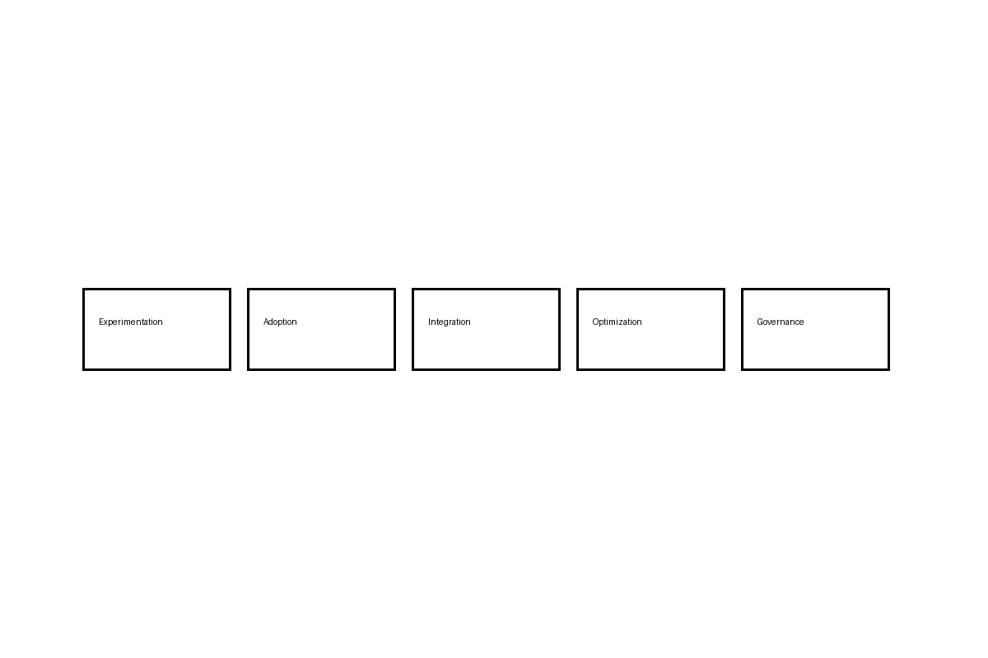

Decision Authority and Accountability
As AI systems influence higher-impact decisions, clarity around decision authority becomes critical. Automation without accountability increases systemic risk.As AI systems influence higher-impact decisions, clarity around decision authority becomes critical. Automation without accountability increases systemic risk.As AI systems influence higher-impact decisions, clarity around decision authority becomes critical. Automation without accountability increases systemic risk.
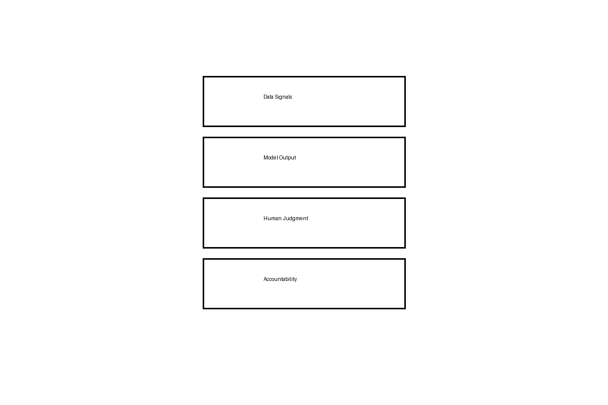

Operational Risk and Resilience
AI systems depend on upstream data pipelines, downstream consumers, and human oversight. Failures often arise from neglected dependencies rather than model quality alone.AI systems depend on upstream data pipelines, downstream consumers, and human oversight. Failures often arise from neglected dependencies rather than model quality alone.AI systems depend on upstream data pipelines, downstream consumers, and human oversight. Failures often arise from neglected dependencies rather than model quality alone.
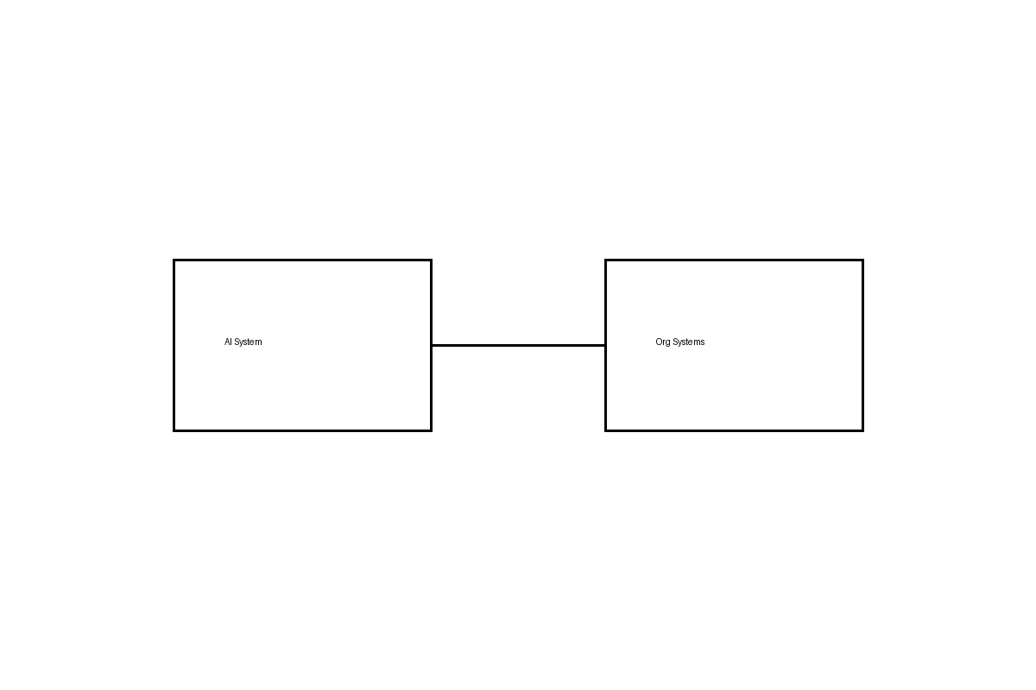

Scaling Beyond Pilots
Many organizations stall after initial success. Scaling AI requires investment in platform reliability, monitoring, documentation, and internal education.Many organizations stall after initial success. Scaling AI requires investment in platform reliability, monitoring, documentation, and internal education.Many organizations stall after initial success. Scaling AI requires investment in platform reliability, monitoring, documentation, and internal education.

Long-Term Societal Effects
Over time, AI reshapes institutional norms, expectations of speed, and tolerance for uncertainty. These second-order effects deserve as much attention as immediate efficiency gains.Over time, AI reshapes institutional norms, expectations of speed, and tolerance for uncertainty. These second-order effects deserve as much attention as immediate efficiency gains.Over time, AI reshapes institutional norms, expectations of speed, and tolerance for uncertainty. These second-order effects deserve as much attention as immediate efficiency gains.

AI Maturity Models
Organizations progress through identifiable stages in AI adoption. Early experimentation often focuses on isolated use cases, while mature implementations embed AI into core workflows with defined ownership and governance.Organizations progress through identifiable stages in AI adoption. Early experimentation often focuses on isolated use cases, while mature implementations embed AI into core workflows with defined ownership and governance.Organizations progress through identifiable stages in AI adoption. Early experimentation often focuses on isolated use cases, while mature implementations embed AI into core workflows with defined ownership and governance.

Decision Authority and Accountability
As AI systems influence higher-impact decisions, clarity around decision authority becomes critical. Automation without accountability increases systemic risk.As AI systems influence higher-impact decisions, clarity around decision authority becomes critical. Automation without accountability increases systemic risk.As AI systems influence higher-impact decisions, clarity around decision authority becomes critical. Automation without accountability increases systemic risk.

Operational Risk and Resilience
AI systems depend on upstream data pipelines, downstream consumers, and human oversight. Failures often arise from neglected dependencies rather than model quality alone.AI systems depend on upstream data pipelines, downstream consumers, and human oversight. Failures often arise from neglected dependencies rather than model quality alone.AI systems depend on upstream data pipelines, downstream consumers, and human oversight. Failures often arise from neglected dependencies rather than model quality alone.

Scaling Beyond Pilots
Many organizations stall after initial success. Scaling AI requires investment in platform reliability, monitoring, documentation, and internal education.Many organizations stall after initial success. Scaling AI requires investment in platform reliability, monitoring, documentation, and internal education.Many organizations stall after initial success. Scaling AI requires investment in platform reliability, monitoring, documentation, and internal education.

Long-Term Societal Effects
Over time, AI reshapes institutional norms, expectations of speed, and tolerance for uncertainty. These second-order effects deserve as much attention as immediate efficiency gains.Over time, AI reshapes institutional norms, expectations of speed, and tolerance for uncertainty. These second-order effects deserve as much attention as immediate efficiency gains.Over time, AI reshapes institutional norms, expectations of speed, and tolerance for uncertainty. These second-order effects deserve as much attention as immediate efficiency gains.

AI Maturity Models
Organizations progress through identifiable stages in AI adoption. Early experimentation often focuses on isolated use cases, while mature implementations embed AI into core workflows with defined ownership and governance.Organizations progress through identifiable stages in AI adoption. Early experimentation often focuses on isolated use cases, while mature implementations embed AI into core workflows with defined ownership and governance.Organizations progress through identifiable stages in AI adoption. Early experimentation often focuses on isolated use cases, while mature implementations embed AI into core workflows with defined ownership and governance.

Decision Authority and Accountability
As AI systems influence higher-impact decisions, clarity around decision authority becomes critical. Automation without accountability increases systemic risk.As AI systems influence higher-impact decisions, clarity around decision authority becomes critical. Automation without accountability increases systemic risk.As AI systems influence higher-impact decisions, clarity around decision authority becomes critical. Automation without accountability increases systemic risk.

Operational Risk and Resilience
AI systems depend on upstream data pipelines, downstream consumers, and human oversight. Failures often arise from neglected dependencies rather than model quality alone.AI systems depend on upstream data pipelines, downstream consumers, and human oversight. Failures often arise from neglected dependencies rather than model quality alone.AI systems depend on upstream data pipelines, downstream consumers, and human oversight. Failures often arise from neglected dependencies rather than model quality alone.

Scaling Beyond Pilots
Many organizations stall after initial success. Scaling AI requires investment in platform reliability, monitoring, documentation, and internal education.Many organizations stall after initial success. Scaling AI requires investment in platform reliability, monitoring, documentation, and internal education.Many organizations stall after initial success. Scaling AI requires investment in platform reliability, monitoring, documentation, and internal education.

Long-Term Societal Effects
Over time, AI reshapes institutional norms, expectations of speed, and tolerance for uncertainty. These second-order effects deserve as much attention as immediate efficiency gains.Over time, AI reshapes institutional norms, expectations of speed, and tolerance for uncertainty. These second-order effects deserve as much attention as immediate efficiency gains.Over time, AI reshapes institutional norms, expectations of speed, and tolerance for uncertainty. These second-order effects deserve as much attention as immediate efficiency gains.

Conclusion
Artificial intelligence maturity is less about model sophistication and more about organizational discipline. The long-term impact of AI will be determined by how well institutions align technology, incentives, and responsibility.

