**Android Application Project**

**Youtube Viewer**

**By**

**Mr. Titiwat Kuarkamphun 5904062660086**

**Mr. Burapa Tainsakuldej 5904062663107**

**Present**

**Index**

* What do we use ?
* Application UI.
* Main Code.
* Program Architecture.
* JSON Structure.

**What do we use**

* JSON

For getting data from Youtube to store in application

* Volley

Data fuction

* ReCyclerview & Cardview

To Show the information that we get from Youtube

JSON Object

* Glide

Function that show the image from URL

* Youtube

Import Youtube player

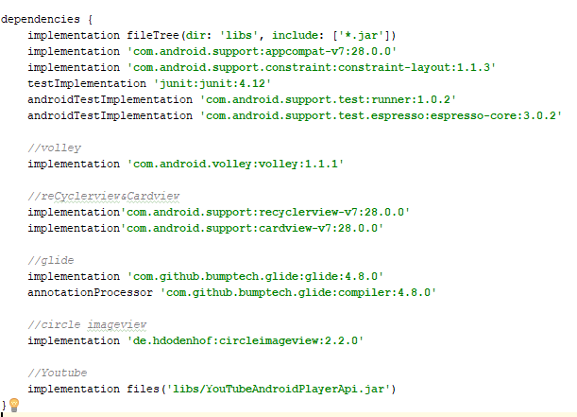

**Application UI**

The first page of the app will contain the playlist that we call from JSON and store in list. We can select the video from the list below to watch it later.

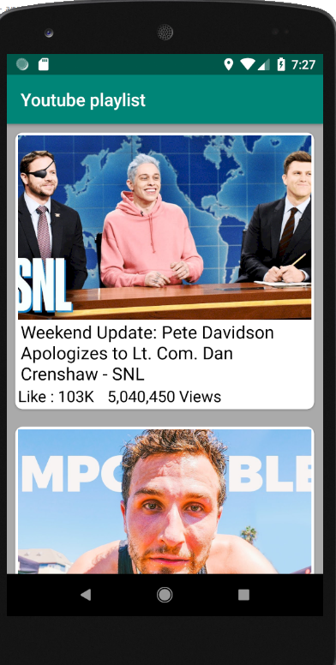

Picture 1.1 : Show the first page of application

After we select 1 of the videos in the list. The Application will swap to video information page. Contain videoname , Like and dislike , video picture preview , and playbutton.

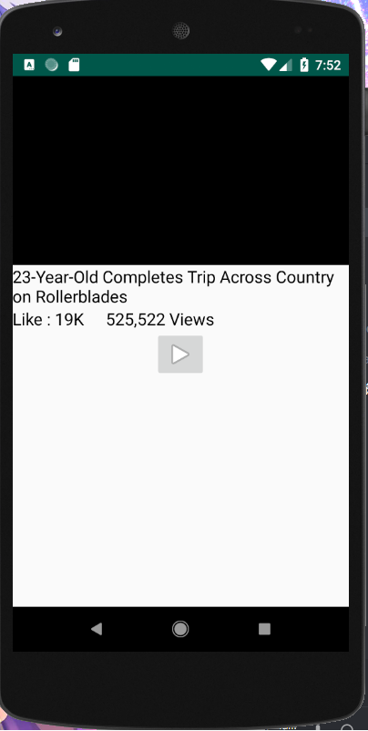 Picture 1.2 : The information of video

After we tap on play button the screen will turn

to horizontal and video will play from youtube api like we watch in youtube.

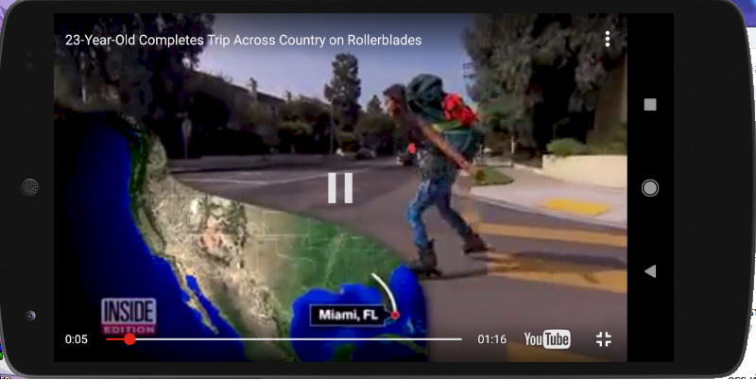 Picture 1.3 : Video player

**Main Code**

The main code we split to 4 part of java

1. YoutubeConfig Class

This class use for calling Youtube api to application.

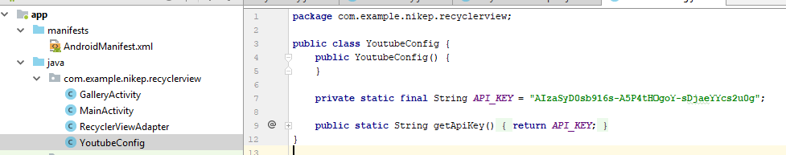

2. GalleryActivity Class

We will discribe this class to 2 part

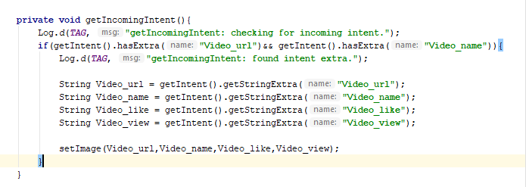

2.1 “getIncomingIntent” : Use check that Intent we

get has a correct String and get text that come

with intent String and image url from POJO

(in RecycleViewAdapter class) and prase all of theme that we get from intent to setImage method.

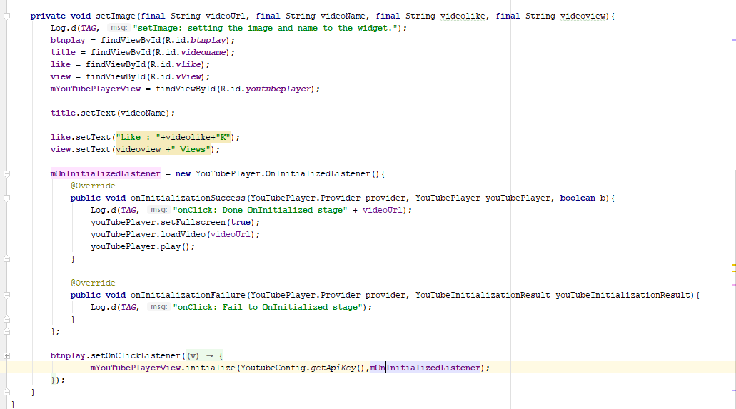

2.2 “setImage” : This object will bring text and

image from 2.1 to set into interface for show

(Picture 1.3). OnInitializedListener will prepare the video for playing. The last is Onclicklistener, This class is in the play button to wait user tap on the button to play the video

3. MainActivity Class

This class will contain the JSON class to send the

input to ReCyclerView class.

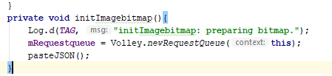

3.1 “initImagebitmap” : Use to make requestqueue

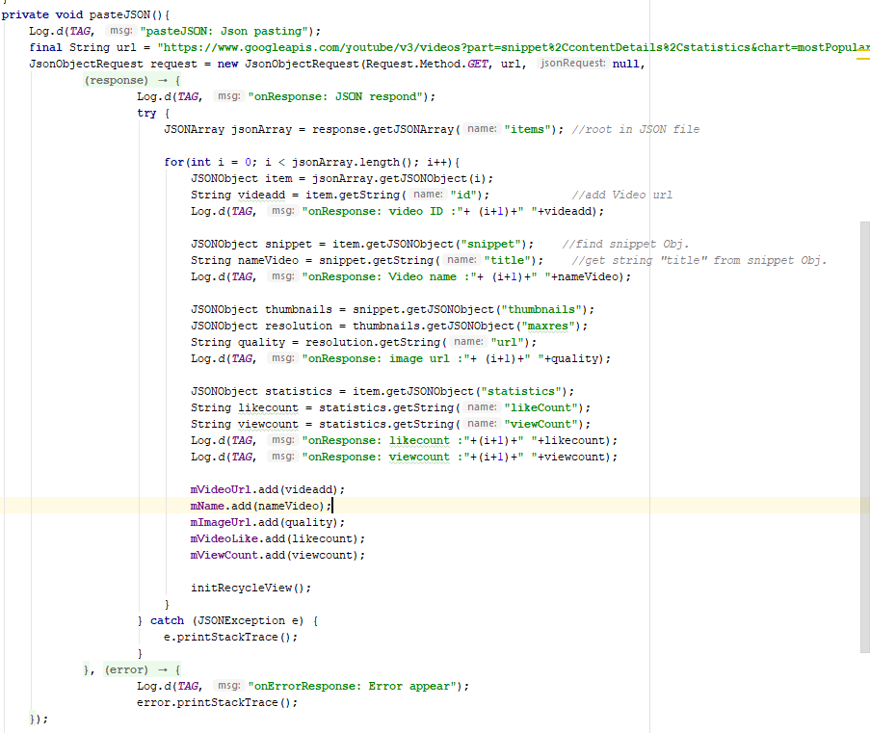

3.2 JSON : This object is the main object of this

application. Use for get videoinfomation from

Youtube JSON request URL

(as u see in “final String url”).

After we get a data from url we will split the

data to 1.videoID 2.videotitle 3.PreviewpictureResolution

4.statistic to inset in application (Picture 1.1)

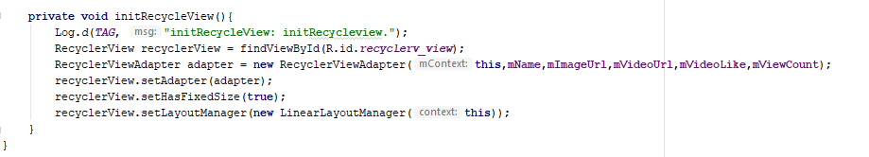

3.3 initRecycleView : This object will call the recycle

continuous from the loop in JSON.

4. RecycleViewAdapter Class

This class will contain constructor of this app. To get the

information to set the videoname , videoname ,

videopreviewpicture , likecount and viewcount that we get

from JSON class to set in CardView.

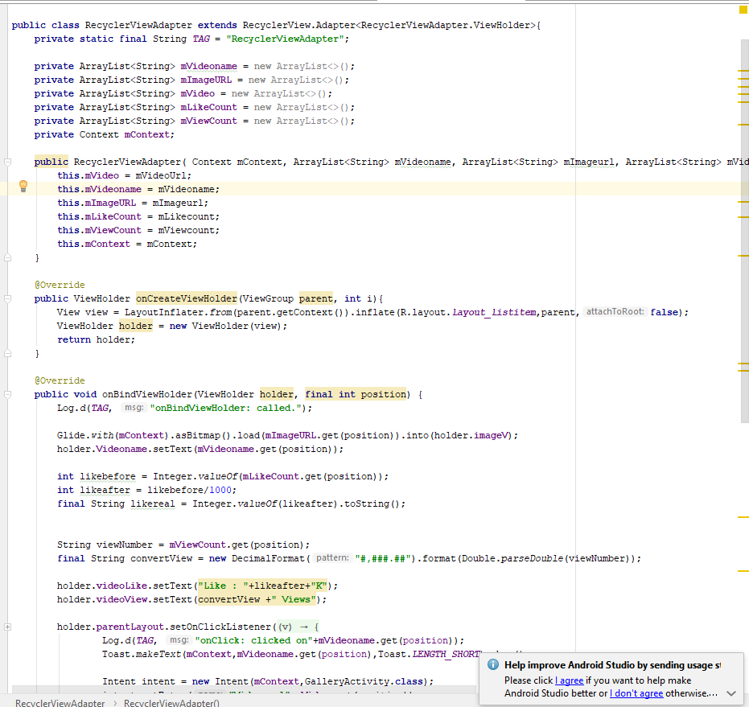

4.1 onCreateViewHolder : To create viewholder

4.2 onBindViewHolder : To set the Data from POJO to

Cardview.

4.3 ViewHolder : To find the content ID in side layout

Program Architecture

Youtube Server

All of video data

JSON Object

Parse all of data that get from praseJson method.

ReCyclerviewAdapter

+

GalleryActivity

Show the infomation if user touch one of this video that show on ReCyclerview.

USER

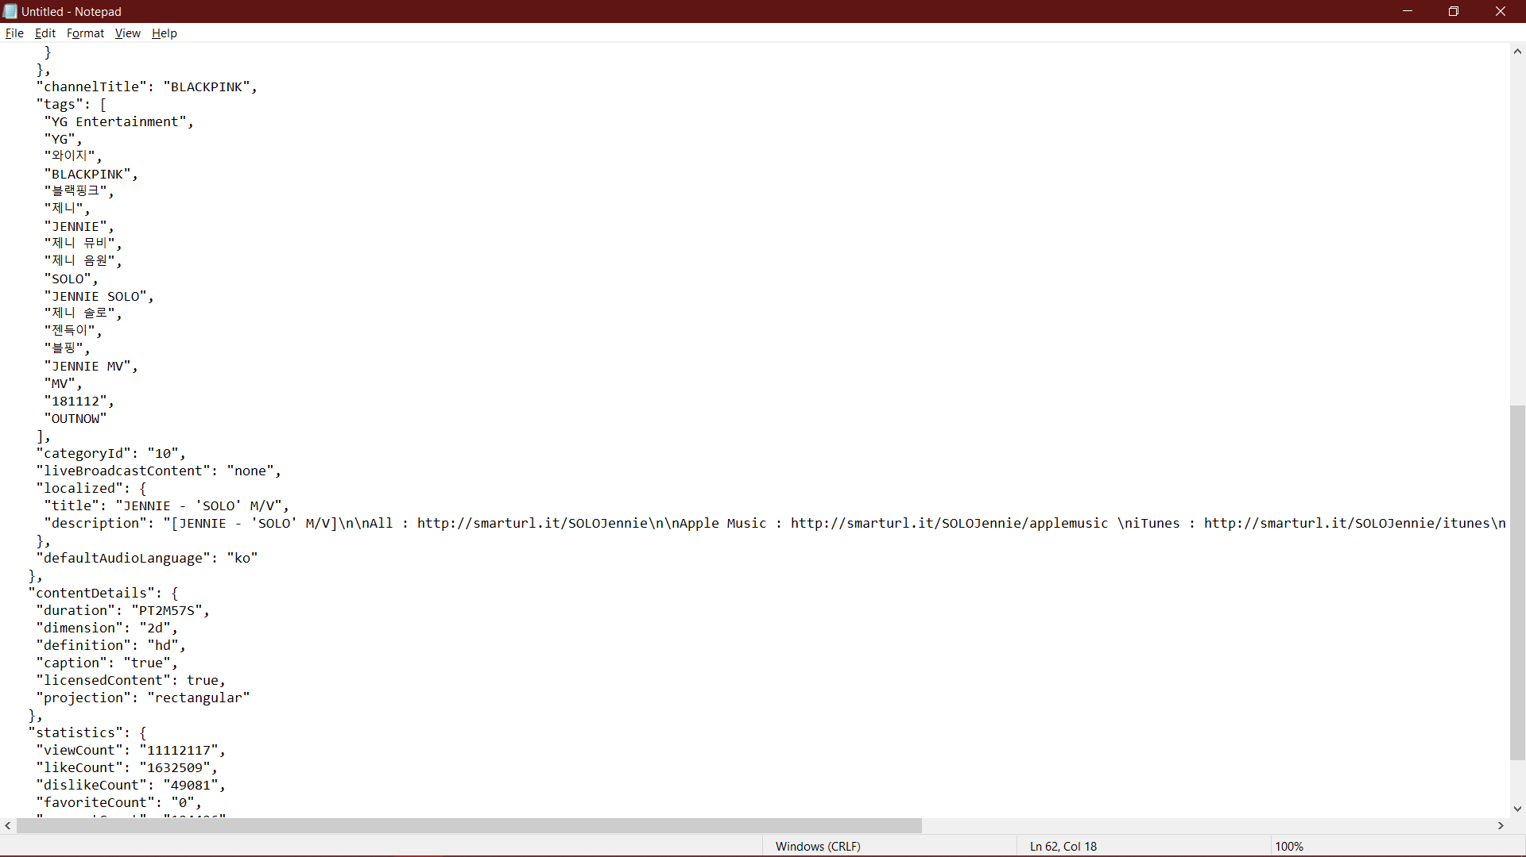**JSON Structure**

