# 1 Defining Big Data

*Small data are slow and sampled. Big Data are quick and n=all.*

Kitchin & McArdle (2016)

*This chapter searches for defining properties of big data, focusing on characteristics with possible implications for cartographic practice. Review of related works outlines the main attitudes towards grasping the concept.*

## 1.1 Ontological characteristics

Despite the lively interest triggered by the subject, the explanation of the term *big data*[1] remains hazy and there is no widely accepted definition to the date. Perhaps the most systematic effort in this matter by Kitchin (2014) (refined in Kitchin & McArdle (2016)) summarizes the key properties attributed to big data. Kitchin critically evaluates these properties and goes on to assign them a relative importance in distinguishing big from “small” data. He also takes care to separate the concept in itself from accompanying social phenomena, hence he speaks of *ontological* characteristics.

Kitchin’s taxonomy provides a useful starting point for our thinking of big data from the cartographic standpoint, so let us list the ontological characteristics including some of the Kitchin’s comments:

**Volume** — can be measured in storage requirements (terabytes or petabytes) or in number of records **Velocity** — data generation happens in real-time either constantly (e.g. CCTV) or sporadically (e.g. web search); we can distinguish the frequency of generation from the frequency of data *handling*, *recording*, and *publishing*, where all three can be delayed from the time of generation **Variety** — data are heterogeneous in nature, though this property is rather weak as various levels of organization are allowed (*structured*, *semi-structured* or *unstructured*) **Exhaustivity** — an entire system is captured (*n=all*), rather than working with a subset created by sampling **Resolution and indexicality** — fine-grained (in resolution) rather than being aggregated; uniquely indexical (in identification), which enables linking to other datasets **Relationality** — containing common fields that enable the conjoining of different datasets **Extensionality and scalability** — flexibility of data generation, possibility to add or change new fields easily, possibility to rapidly expand in size

In relation to these characteristics it is important to mention two open questions that for many people make attempts to define big data vague at best, sometimes to the point of questioning the existence of the phenomenon itself.

First, there are no quantitative thresholds that would define exactly how large the “big” volume is, how fast the “big” velocity is, and so on. Some properties would even be hard to describe in quantitative terms (for example extensionality). Other properties sound too general or vague to act as a sound defining parameter (scalability). What is more, one could extend the properties ad absurdum, for example *variety* could refer to differences in structure, origin, quality, or any other property of a dataset. Such multilevel hierarchy of parameters and sub-parameters does not add to the overall comparability of datasets, especially when we consider that data generation procedures may be unique to certain domains and not found in others. Finally, many datasets lack metadata detailed enough to allow to judge all mentioned properties. It is possible that these issues will clear out with time, but parameter thresholds may as well remain blurry and ever in flux.

The second problem is that even if we had a clearly defined set of criteria, in practice we could hardly find a dataset that would fit all of them. Therefore not all properties are deemed mandatory, which in turn leads to confusion and labeling almost anything as big data. To articulate the gist of the term, more work is needed on the relations of the parameters, some might be merged (resolution is a consequence of exhaustivity, indexicality enables relationality) or discarded (extensionality and scalability seem to describe the infrastructure rather than data).

Aware of these problems, Kitchin & McArdle (2016) argues that *velocity* and *exhaustivity* are qualities that set big data apart and distinguish them from “small” data. We can add that these two characteristics also present the most interesting challenges to cartographic presentation of such data. So even though we will continue to use the established term in the following chapters, the little too simplistic adjective “big” will be meant as a proxy for **generated continuously in real time and containing an unreduced set of elements**.

## 1.2 Other ways of understanding big data

In this section we briefly review the writing of authors seeking to define big data. The term itself was fist used in context of dealing with massive datasets in mid-1990s by John Mashey (Diebold et al., 2012), but the heaviest circulation of the term in scientific and popular media takes place only in recent years. From the breadth of works, several tendencies can be identified, providing more or less illuminating interpretations of the subject.[2]

### 1.2.1 Vs and keywords

Kitchin’s taxonomy mentioned in the previous section is based on a review of older definitions, starting with the often-cited three Vs (standing for *volume*, *velocity*, and *variety*) by Laney (2001). The notion of *exhaustivity* was added by Mayer-Schönberger & Cukier (2013), concepts of *resolution* and *indexicality* came from Dodge & Kitchin (2005), Boyd & Crawford (2012) adds *relationality*, and the qualities of *extensionality* and *scalability* were taken from Marz & Warren (2012).

Other properties attributed to big data include *veracity* (data can be messy, noisy and contain uncertainty and error) and *value* (many insights can be extracted, data can be repurposed), both brought forward by Marr (2014) referring to the messiness and trustworthiness that is usually less controllable in case of big data. One could argue that these properties are just an another aspect of variety, as data vary not only in type and structure, but also in quality. This is can be the case for small data as well, however as Marr (2014) hopes, “the volumes often make up for the lack of quality or accuracy”, which is sure debatable.

Moreover, *variability* (the meaning obtainable from data is shifting in relation to the context in which they are generated) was identified by David Hopkins in relation to text analysis (Brunelli, 2011). Li et al. (2016) name also *visibility* (efficient access to data via cloud storage and computing) and more curiously *visualistation* as big data properties.

Suthaharan (2014), dealing with a task of early recognition of big data characteristics in computer network traffic, argues that three Vs do not support such early detection in continuous data streams. Instead he proposes three Cs: *cardinality* (number of records), *continuity* (meaning both representation of data by continuous functions, and continuous growth of size with time), and *complexity* (which is again a combination of three parameters: *large varieties of data types*, *high dimensionality*, and *high speed of processing*). One might ask why authors seek to propose parameters in triples, even at the cost of occluding additional properties as sub-parameters. Possible answer might be that such triples allow to create three-dimensional parameter spaces or “cubes” where we can place datasets to create neat visualisations. Humor aside, Suthaharan’s approach is interesting in observing the rate of change in parameters in real time.

Laney’s 3 Vs were brought into commercial management-speak and became a slogan further powering the hype of big data. Nevertheless, it inspired a number of other authors to extend it quite creatively. For example Uprichard (2013) lists other v-words to be considered, both in positive (*versatility*, *virtuosity*, *vibrancy*…) and negative (*valueless*, *vampire-like*, *violating*…) light. Marr (2014) describes five Vs of big data, Van Rijmenam (2013) sees seven Vs, Boellstorff & Maurer (2015) propose three Rs and Lupton (2015) even uses thirteen p-words to describe the subject. But as Kitchin & McArdle (2016) notes, “these additional v-words and new p-words are often descriptive of a broad set of issues associated with big data, rather than characterising the ontological traits of data themselves”.

### 1.2.2 A challenge for technical infrastructure

Several authors understand big data mainly as a management issue, which is probably due to the fact that handling large datasets is challenging. Hence, the computational difficulties of storing and processing a dataset on a single machine often act as a defining measure. Consider for instance Storm (2012) quoting Hillary Mason: “Big Data usually refers to a dataset that is too big to fit into your available memory, or too big to store on your own hard drive, or too big to fit into an Excel spreadsheet.” Or similarly Shekhar, Gunturi, Evans, & Yang (2012) state that “the size, variety and update rate of datasets exceed the capacity of commonly used spatial computing and spatial database technologies to learn, manage, and process the data with reasonable effort”.

The problem with such definitions is determining exactly what size is “too big to fit” and what is the “reasonable effort”. The computational power of hardware accessible for personal use is constantly increasing,[3] not to mention the technical infrastructure accessible to large enterprises and governmental organizations — datacenter construction is steadily growing and is expected to almost double the current capacity in 2021 (Networking, 2018; statista.com, 2018).

At the same time, new technologies emerge to address the issue — virtualization of storage, networking, and memory make it possible to rent computational infrastructure from “cloud” providers, or to delegate workloads previously carried out by the operating system to remote platforms.[4] Other innovations take place in data processing algorithms, analytic engines, and in database design (a whole range of No-SQL databases as well as enablement of distributed processing in traditional databases).[5] Some attempts to summarize technical solutions for big data can be found in Pääkkönen & Pakkala (2015), or Jin, Wah, Cheng, & Wang (2015).

As we can see, the “too big to fit” definitions are highly dependent on the resources currently available, plus we need to take into account future improvements that are hard to predict. That being said, understanding the subject as *data that prevent local offline processing on common desktop in reasonable time* is a useful shorthand for judging big from “small” data. The border between local (offline) and remote (cloud-dependent) processing exists even though it is a blurry and a dynamic one. As the remote processing may be more widely accessible in the future, it can be best advised to consider the scalability of any data-processing workflows early on. In other words, any workflow designed as a potential big data process will likely have an advantage, as design limitations may prove to be overcome harder than the technical ones.

One point of confusion for readers of big data related literature that often reoccurs is mixing the characteristics of the subject (stored information) with properties of technologies used to process it (storage, analytics, visualisation, etc.). It is debatable if this is a fallacy, depending on to what degree we consider digital data independent from the technical infrastructure around it[6]. To illustrate the difference, compare the following two definitions. Fist by Gartner (2018a):

*Big data is high-volume, high-velocity and/or high-variety information assets that demand cost-effective, innovative forms of information processing that enable enhanced insight, decision making, and process automation.*

The second by Gantz & Reinsel (2011) defines big data as:

*A new generation of technologies and architectures designed to economically extract value from very large volumes of a wide variety of data by enabling high-velocity capture, discovery, and/or analysis.*

The understanding of big data as an asset prevails, though the second type portraying big data as an ecosystem is not uncommon (e.g. Demchenko, De Laat, & Membrey (2014) or Olshannikova, Ometov, Koucheryavy, & Olsson (2015)). Eventually, this division may lead to dual understanding of big data in narrow sense as a fuel or raw material and in broad sense as an ecosystem, architecture, or framework. A good example of broader thinking is Demchenko et al. (2014) that proposes a “Big Data Architecture Framework” comprised of big data infrastructure, big data analytics, data structures and models, big data life cycle management, and big data security.[7]

### 1.2.3 Showing example sources and quantities

A very common description of big data goes along the lines of “I will give you some numbers and you will get what I mean”. Such writing may not provide an exact understanding of the concept, but can put us into context about the scales we are moving at. Doubtlessly the mass of retained data is growing, as McNulty (2014) put it, “90% of all data ever created was generated in the past 2 years” (that was in 2014). In a notable attempt to estimate the World’s overall data generation between 1986 and 2007, Hilbert & López (2011) claim that more then 300 exabytes[8] of stored data existed in 2007 (for the methodology of reckoning see Hilbert & López (2012)). The key insight is the growing domination of digital technologies accounting for the majority of the annual growth after year 2000. More recent accounts report on machines potentially capable of processing brontobytes[9] of data (Bort, 2014).

Increasing the storage capacity itself does not speak of any qualitative change in what is stored, therefore some archives could indeed be described as big piles of small data. Under certain circumstances, new quality can arise from increased quantity, for example as Norvig (2011) points out, an array of static images projected at a sufficient frame rate creates an illusion of movement, and hence the new medium also known as film. Multiplication of an old medium creates a new one. The remaining question is under what conditions this change of essence arises, and if such thing occurs or will occur in case of big data. To fast forward a bit, the cartographic version of this question would be: *will a digtal map based on big data (fast and n=all) be essentially different from web maps based on static and sampled data sources?*.

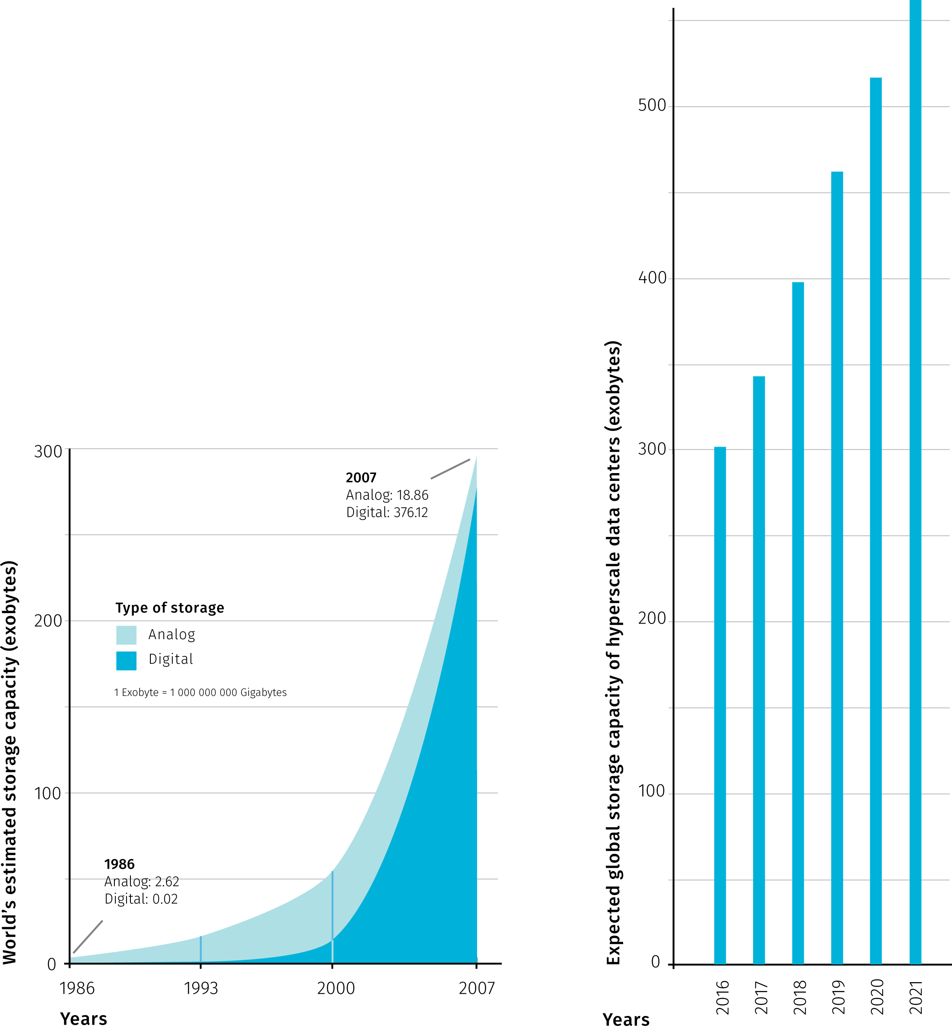

**Fig.1** Comparison of the World’s estimated data storage capacity between years 1968 and 2007 (modified after Hilbert & López (2011)) and the expected storage capacity of large scale data centers in the period from 2016 to 2021 (modified after Networking (2018))

Rather than putting up to a gargantuan task of counting the mass of all existing data items, authors use the available statistics related to operations of large companies (Kambatla, Kollias, Kumar, & Grama (2014), McNulty (2014), Marr (2014) and others). For example, Facebook was said to process 10 billion messages, 4.5 billion button clicks and 350 million picture uploads each day (Marr, 2014). It goes without saying these numbers are outdated and certainly outgrown today. Other companies prominently mentioned in context of big data are Google, Wallmart, or Amazon. This connection is justified, as these companies have put user (or customer) data analytics to the core of their businesses, thus supporting the progress in the field. Social media, web search and browsing data, online or offline shopping patterns, but also mobile devices, sensors and large scientific projects are mostly named as generators of big data.

Another quantity tying to big data that is surely of interest is, according to estimates potentially huge, market value. For example Kayyali, Knott, & Van Kuiken (2013) reports on promise in reduced health care costs of 12 to 17 percent thanks to emerging big data related initiatives in USA health care. On the other hand, the use of poor data is also estimated to have vast impacts on businesses, mainly in form of unrealized opportunities (McNulty (2014)). Another financial aspect is the costs incured by creating and maintaining big data itself, it is sound to remind that apart from all the promise, big data also has the potential to cost unlimited amounts of money Fischer (2015).

The type of data source is another classification property. Authors distinct “traditional” ways of collecting data from the new, technology-powered sources. The definition of big data then comes as simple as data coming from these new sources. The United Nations Economic Commission for Europe proposed a taxonomy that recognizes three main sources of big data (UNECE (2013)):

* *Social Networks (human-sourced information)* — this information is the record of human experiences
* *Traditional Business systems (process-mediated data)* — these processes record and monitor business events of interest
* *IoT (machine-generated data)*[10] — information is derived from sensors and machines used to measure and record the events and situations in the physical world

Data sources labeled as big differ from traditional sources such as surveys and official administrative statistics — Florescu et al. (2014) and Kitchin (2015) closely examine those differences as well as the potential for big data to extend the official statistics. Interesting point is that volume is not actually distinctive as governmental offices tend to store large amounts as well. What makes the difference is that classical data sources have statistical products and by-products specified beforehand, big data tend to be reused beyond the original intent. On the other hand, big data sources tend to be volatile and unstructured, therefore their representativeness is harder (if possible) to assess.

The estimation in the fig1 couldn’t have predicted the spread of COVID-19 pandemic. According to International Data Corporation (IDC), more than 59 zettabytes (ZB) were to be created, captured, copied, and consumed around the world in 2020. The COVID-19 pandemic contributed to this figure by causing an abrupt increase in the number of work from home employees and changing the mix of data being created to a richer set of data that includes video communication and a tangible increase in the consumption of downloaded and streamed video. IDC also measures the amount of data created and consumed in the world each year. The ratio of unique data (created and captured) to replicated data (copied and consumed) is roughly 1:9, and it is expected to move to 1:10 by 2024. This trend is also fuelled by increased consumption of replicated data due to COVID-19 pandemic. (Corporation, 2020)

### 1.2.4 Metaphors

Metaphors rely on a notion of analogy between two dissimilar things, but can also become independent verbal objects, aesthetically appealing but not overly revealing. Despite that, we should not ignore metaphoric accounts as they contribute to the mythology surrounding big data that reflects what many people expect.

Puschmann & Burgess (2014) identified two prevailing ways of imagining the subject: big data seen as a *natural force* to be controlled and as a *resource* to be consumed.

The utilitarian mindset comparing digital world to excavation of valuable minerals in far from new (think of “data mining” or more recently “cryptocurrency mining”) but it is tempting pursue to this analogy further. For example, how to estimate the ratio of valuable information to “debris”, and shouldn’t such estimation be done before any data “mining” endeavour? The value of real-world analogies may be in provoking some common-sense reasoning often missing in wannabe-visionary proclamations.

For example mayer2013big: “Data was no longer regarded as static or stale, whose usefulness was finished once he purpose for which it was collected was achieved […]. Rather, data became a raw material of business, a vital economic input, used to create a new form of economic value. Every single dataset is likely to have some intristic, hidden, not yet unearthed value…”. So what is yet to be unearthed is not the data itself but new way of using it.

As Lupton (2013) notes, by far the most commonly employed rhetorical descriptions of big data are those related to water or liquidity, suggesting both positive and negative connotations. For example Manyika et al. (2013) argues for unlocking data sources to become “liquid” in a sense of open and free-flowing, at the same time keeping privacy concerns in mind — what is liquid is also susceptible to unwanted leaks.

Big data has also been described as a *meme* (a unit of cultural transmission) and as a *paradigm* (a set of thought patterns), in both cases not without certain concerns. Gorman (2013) explores big data as a technologic meme: “[t]he reductionist methods of understanding reality in big data produce new knowledge and methods for the control of reality. Yet it is not a reality that reflects the larger society but instead the small minority contributing content.” To Graham & Shelton (2013) “big data could be defined as representing a broader computational paradigm in research and practice, in which automated algorithmic analysis supplants domain expertise”.

Of course, big data descriptions are not limited to verbal form, visual means can be much more expressive and informative — not a surprising claim to be found in a thesis on visual analytics. We will discuss cartographic tools later, here we can mention artistic renderings that employ more free-form visual analogies. We should distinguish pursuits like *information visualisation* that are close to graphic design (for good overview see Klanten, Ehmann, Bourquin, & Tissot (2010) or Lima (2011)) from artistic projects that use data as a raw material and don’t aim to convey information or comfort to general user’s cognitive expectations (like some projects at Network (2018)). From the cartographer’s standpoint, aspects of visual art can be inspiring (graphic quality, employment of computation and rendering software, creative uses of interaction and animation), though artistic means are often too different to be transposed. Without referring back to the source phenomenon, data-driven art becomes unrecognizable from the generative art that uses artificially generated data rather than any existing information.

### 1.2.5 Holistic accounts

Multifaceted phenomena tend to provoke descriptions that narrowly focus on specific components, ignoring other parts as well as relationships between them. Experts of different specializations notice aspects of phenomena that are close to their research interests and priorities, cross-disciplinary definitions then try to combine these views to paint the full picture. Naturally, listing holistic accounts will include topics already mentioned, therefore pardon some repetition in this section.

For instance Murthy, Bharadwaj, Subrahmanyam, Roy, & Rajan (2014) prepared a taxonomy of big data comprised of:

* *data* — with various levels of temporal latency and structure
* *compute infrastructure* — batch or stream processing
* *storage infrastructure* — distributed, sql or nosql databases
* *analysis* — supervised, semisupervised, unsupervised or reenforcement machine learning
* *visualisation* — maps, abstract, interactive, real-time
* *privacy and security* — data privacy, management, security

As another example, Boyd & Crawford (2012) define big data as a “cultural, technological, and scholarly phenomenon that rests on the interplay of”:

* *technology* — maximizing computation power and algorithmic accuracy to gather, analyze, link, and compare large data sets
* *analysis* — drawing on large data sets to identify patterns in order to make economic, social, technical, and legal claims
* *mythology* — the widespread belief that large data sets offer a higher form of intelligence and knowledge that can generate insights that were previously impossible, with the aura of truth, objectivity, and accuracy

As the two taxonomies above illustrate, there are many ways to slice a cake. The fate of overreaching definitions is that they are often too intricate to explain the phenomena crisply, yet they are never complete as there is always a point of view that hasn’t been included yet. So here we arrive at a trade-off between preciseness of a definition and its practicality. One way out of this is simply rejecting the view of big data as a singular phenomenon. Big data is then a non-specific covering term that could mean different things to different people. As Helles & Jensen (2013) observes, “[d]ata are made in a process involving multiple social agents — communicators, service providers, communication researchers, commercial stakeholders, government authorities, international regulators, and more. Data are made for a variety of scholarly and applied purposes […]. And data are processed and employed in a whole range of everyday and institutional contexts.” The process, the actor, the purpose and the context then determine what big data “is” in that given constellation.

We can conclude the section on holistic approaches with a historical view that is rarely taken in commentaries on the nature of big data, probably because the perceived novelty of the concept. For Barnes (2013) “[b]ig data has been made possible because of the particular conjuncture of different elements, each with their own history, coming together at this our present moment. But precisely because these different elements have a history, the issues, problems and questions that were there in their earlier incarnation can remain even in the new form”. We can add that some issues can get worse in the new incarnation and totally new set of problems can arise. For example, as Mayer-Schönberger & Cukier (2013) note, current anonymization techniques can be rendered ineffective as combining several “data traces” of online activity can still identify the person. Or, as Taleb (2012) realizes, if big data come with too many variables but with too little data per variable, it becomes nearly impossible not to find high but spurious correlations, which can tempt researchers to cherry-pick the results that “support” their hypothesis. Considering wider implications of technology can potentially make such unintended effects less surprising, which is certainly a virtue of holistic thinking.

## 1.3 Spatial big data

Apart from the general definitions mentioned above, there have also been field-specific efforts to contextualize big data. The fields include governance (Crampton, 2015), journalism (Lewis & Westlund, 2015), ecology (Shin & Choi, 2015), social sciences (Ovadia, 2013), business administration (Wamba, Akter, Edwards, Chopin, & Gnanzou, 2015), urban studies (Thakuriah, Tilahun, & Zellner, 2017), learning analytics (Wilson et al., 2017), education (Kabakchieva, Stefanova, & others, 2015), health informatics (Herland, Khoshgoftaar, & Wald, 2014) and doubtlessly many others. Authors here consider existing data processing and analytical practices in their respective disciplines in light of possibilities created by big data. Some expect forthcoming changes such as enrichment in available methods (e.g. analysing social networks in epidemiology), others analyze the adaptability of currently used processes to conditions of higher data load. With some generalization, the overall mood of these works seems to be welcoming towards big data as a possible toolbox extension, though doubting that the core scientific methods could be deeply altered by it. When it comes to defining big data, field-specific accounts use one or more of the aforementioned definitions by *keywords*, *constraints*, *examples*, *metaphors* or combination of all in a*holistic* description.

Within geography, Kitchin (2013) highlights possible opportunities, challenges and risks posed by big data, encouraging geographers to engage in big data related case studies. He also lays some groundwork for definitions, he later developed into ontological characteristics cited at the beginning of this chapter. González-Bailón (2013) understands big data predominantly as a rich set of observations of intricate and nested social life that can improve theories of human geography, for example by exposing diversity that would otherwise go unnoticed in scientific models. Barnes (2013) reminds us of the so called *quantitative revolution* in geography (starting from 1950’s) that besides bringing many good to the discipline has also been criticized on various levels. Some of this critique, Barnes argues, “continue[s] to apply to the *über* version of the quantitative revolution that is big data”. For Goodchild (2013) geography provides a distinct context for discussion about what kinds of science might be supported by big data. He is also concerned with the potential for building rigorous quality control and generalizability into big data operations, because so far “instead of relying on the data producer to clean and synthesize, in the world of big data these functions are largely passed to the user”. We could go on much further with how geographic thought internalizes big data, those interested in the topic may refer to Thatcher, Shears, & Eckert (2018).

Cartographers and GIS practitioners like to say that 80% of all data is geographic, and even though such claim is hard to prove[11], few would doubt that spatial reference can unlock additional value, if only as a platform for joining otherwise un-joinable datasets. Much of data in the world is or can be georeferenced, which underlines the importance of geospatial big data handling.

Cartography and geographic information science have both developed distinct and elaborate notions of data in general. Scientists and practitioners from these fields are in good position to contribute to the way big data is understood and utilized, given their focus on the space as a unifying factor and with visual analysis being at the core of their practice. For these reasons, we will first take an aside to briefly outline how cartography and geoinformatics conceptualize spatial data, before moving on to how the disciplines contended with the adjective big. We consider the following points important:

* Data describing spatial phenomena used in GIS are traditionally divided into *spatial* and *non-spatial* (thematic, attribute) components. Spatial component holds information on location and geographic extent of an entity and can be thought of as a geometry that is visualized on a map or used for spatial analysis (spatial querying, overlay algebra, network analysis, etc.). Attribute information can be used to set visual parameters of geometries on a map as well as in spatial analysis. Visualising attributes lets us observe the variability of a phenomenon across the area of interest. Andrienko & Andrienko (2006) offer more general view of data as a correspondence between referential and characteristic components. Referential components (or referrers) are described as independent variables — mostly employed referrers are *location*, *time* and *population*. Referrer or a combination of referrers provides context and unique identification for dependent variables — attributes.
* Literature distinguishes two approaches to representing the spatial component of data in GIS: *object-based* and *location-based* (Peuquet, 1994). The object-based approach arranges spatial and non-spatial information into discrete geographic objects (features). In the location-based approach, attribute information is stored relative to specific locations. With this approach, a territory is divided into same-size elements that represent locations to assign attributes to. Object-based approach is manifested in *vector data model*, location-based approach corresponds to *raster data model*. In vector data model objects have either point, line or polygon representation. Objects are usually grouped into layers of same theme and geometry type. In raster data model, representation is defined by the size of the element (almost always being a rectangular pixel). Raster model suits better for displaying spatially continuous phenomena, whereas vector model tends to be more appropriate for discrete objects, though reverse situation is not uncommon and transformation between models is a frequent practice.
* Attributes are typically distinguished according to the levels of measurement introduced by Stevens (1946): *nominal* (named variables), *ordinal* (allow ordering), *interval* (allow measuring difference), and *ratio* (having natural zero). Jung (1995) proposed an alternative classification more tailored to spatial data handling: *amounts* (absolute quantities), *measurements* (quantities requiring units of measurement), *aggregated values* (amounts or measurements summarized by area), *proportional values* (normalised by a fixed value), *densities* (divided by corresponding area), *coordinates* (position in some coordinate system).
* The temporal aspect of a phenomenon includes the existence of various objects at different moments, and changes in their properties (spatial and thematic) and relationships over time (Andrienko & Andrienko, 2006). Including the temporal aspect into the data model is problematic as it is treated separately from spatial and attribute components despite having influence on both. For the attribute part, the time changes can be stored by adding table columns with new values. However, changes in the spatial component are not easily stored, which complicates linking the past forms of geometries with corresponding past values of attributes[12]. Incorporating flexible time changes into GIS data model remains a challenge for spatialization of big data.
* Spatial component of data may be displayed at various scales. The scale along with the purpose of the map influences the level of comprehensible detail in displayed geometry. Cartographic generalisation is the process of adjusting the map geometry to the spatial scale in which the area is displayed. This goes beyond mere simplification, as factors as *highlighting the important*, *maintaining the object relationships* and *preserving the aesthetic quality* come to play. The dynamic change of scale comes naturally to users of digital interfaces, the generalization is however hard to automate as it involves complex reasoning and considerations of object relationships that span through the strict topic-based separation of layers common in spatial datasets[13]. The same phenomenon can be studied at various levels of detail even without changing the scale of the map. Some spatial datasets, such as administrative units, exhibit the nesting property that allows to vary the granularity of the displayed spatial pattern.

The above summary is inevitably simplistic as there are many other research areas in cartography and GIS that are relevant to big data efforts. Some will be touched on later in the thesis, others are unfortunately out of its scope. One such case for all is spatial imagery that is an example of truly big data source that is inherently spatial. “Big” in this case means unprecedented spatial, temporal and spectral resolutions brought about by improvements in global monitoring systems.

In light of big data advent, authors form spatial fields consider what difference does it make to conceptualize a specifically *spatial* big data as opposed to big data per se. Is spatial big data a subset or an extension of big data? From the GIS point of view of view there are two ways of understanding spatial big data: either as *adding a spatial reference to big data* or as *adjusting the current spatial data models and processes to higher data load*. We can say that these two approaches arrive at the concept of spatial big data form the opposite sides, in the first case the path is *from big data to spatial big data*, whereas in the second case it is *from spatial data to spatial big data*.

Authors from the first group use some of the previously mentioned definition styles. For example to Jiang & Shekhar (2017), spatial big data refer to “georeferenced data whose volume, velocity, and variety exceed the capacity of current spatial computing platforms”. This combines definitions by V-words and computational difficulties. Lee & Kang (2015), on the other hand, combines definition by constraints and by example. In this context we can mention some early critique that condemned narrow understanding of big data, aiming mainly at analyzing geotagged social media content (labeled as “burger cartographies” by Crampton et al. (2013) and Shelton (2017)). As Leszczynski & Crampton (2016) note, social media content covers just a limited facet of the data productions, presences, and practices that fall under spatial big data.

Representing the second group, Yao & Li (2018) recognizes five categories of spatial big data (while admitting some intersections): *remote sensing data*, *large data from surveying*, *location-based data from mobile devices*, *social network data*, and *Internet of Things (IoT) data*. Yao and Li then focus on a subgroup they name *big spatial vector data* (BSVD), and provide a comprehensive survey of techniques applicable for managing such data. In short, adjusting the vector spatial data model for distributed storage impacts how the data is indexed[14] and queried for processing and application. Yao & Li (2018) also provide an overview of other authors’ approaches to thinking about GIS in the era of big data.

In context of transportation, Shekhar et al. (2012) distinguish between *traditional* and *emerging* spatial big data. Traditional stands for topological vector data representing transportation infrastructure, emerging represents sensor and positional data from large number of vehicles — termed as *spatio-temporal engine measurement data*. Shekhar, Evans, Gunturi, Yang, & Cugler (2014) call for performance testing of existing and new algorithms to assess proper comparison between spatial big data processing techniques.

To Li et al. (2016), main sources of spatial big data are in *volunteered geographic information (VGI)*[15] and in *geo-sensor networks* (with extended understanding of sensor including CCTV and mobile devices). Li et al. (2016) also touches on a wide range of topics, ranging from quality assessment (big data properties challenge the current error propagation methods) to the importance of parallel processing of data streams (where the advantages of functional programming languages are recognized). Zee & Scholten (2014) mentions the *Internet of Things* concept as a main future source of big data — here understood as a sum of sources from “smart” devices. Geospatial technologies are considered a binding principle that would eventually help to meaningfully combine data from devices to facilitate the rise of smart city[16].

In relation to big spatial data processing, we should mention the work of Bin Jiang that is somewhat isolated from the categories mentioned above, but provides interesting thought on how the current GIS processes could be altered. Jiang (2018) recognizes the following dichotomies and potential paradigm shifts:

* *Gaussian* vs *Paretian statistics*[17] — the first suits better for sets with elements of more or less similar size and expects normal distribution, the latter is based on the notion of far more “smalls” than “larges” and expects Poisson or other fat-tailed distribution.
* *Tobler law* vs *scaling law* — complementary concepts, where the first expects inverted proportionality between the distance and similarity of objects, which is often justified locally but does not attribute to abrupt spatial heterogeneity brought about by fat-tailed distributions. Scaling law, as Jiang formulates it, accounts for uneven distributions across scales.
* *Euclidean* vs *fractal (natural) geometry* — the first is needed “to measure things”, the second can help us to “develop new insights into structure and dynamics of geographic features”. (Jiang & Brandt (2016))
* *data quality* vs *data character* — Jiang defines data character mainly as topological relationships between meaningful geographic objects (e.g. connectivity of street network), which for many purposes can be more important than the precision of geometric primitives.
* *mechanistic thinking* vs *organic thinking* — the latter promotes the understanding of geographic space as a living structure shaped by the interaction of elements at various scales.

Though some of Jiang’s distinctions may seem unclear and he is silent about how to incorporate organic approaches to GIS data models, he recognises that big data would be vital in changed GIS practices. For example in his notion of natural cities, social media data are used to define the “natural” extent of the city, so a city is understood more as a bottom-up emergence rather than a top-down administrative demarcation.

As we have seen in this section, geospatial authors rarely diverge from general definitions of big data, but when it comes to spatial big data, they consider the topic from the standpoint of pre-existing theory generated in the field. This conscious assessing of current data models and processes and possible creation of new ones can bring interesting developments in the future.

The potential role of cartography will be examined in more detail later in the thesis, here let us briefly go over the big data properties listed at the beginning of the chapter to see the most obvious cartographic concepts and challenges that could possibly tie to them:

* *Extensionality & Indexicality* — spatial reference in itself is a unifying platform to combine data from various sources and map is a proven tool to explore spatial interrelations. From the perspective of data processing workflows spatial extensionality poses a challenge for geocoding services to spatialize previously unchartable data. From the map design perspective the task is to support recognition of spatial co-ocurrence in dense displays. Indexicality is a natural prerequisite for thematic mapping.
* *Volume* — from the cartographic standpoint, the number of records is the most interesting measure of volume (compared to storage size or attribute length). Extensive volume does not necessarily present a problem for effective visualisation, especially if it plays out in the attribute space and the spatial reference is static. Maps that use the right visualisation methods naturally support information compression and clarification.
* *Scalability & Resolution* — adjusting visualisation to different scales both in terms of spatial extent and in terms of data load is a domain of cartographic generalization. Effects of varying time, space, and attribute resolution on displayed information has long been studied within cartography.
* *Variety* — digital mapping requires some structure in data, though it is not a requirement for attributes as long as the spatial reference is valid. There is though a gap in incorporating unstructured data to digital mapping, for example in adjusting metadata profiles (e.g. move from hierarchical classification to messier but more flexible methods like tagging), or in determining data quality from spatial context. Cartography is in a good position to search for ways to combine structured and unstructured data in meaningful way.
* *Velocity & Exhaustivity* — these parameters will be dealt with in chapters 4 and 5, they relate to a large set of topics internal to cartography. Velocity is mainly concerned with rate of visualization update and time span of the depicted theme. Cartography is ideal for depicting time-space regularities and relationships within and between datasets. Exhaustivity then projects into the longtime problem of graphic fill and tailoring cartographic visualisation to human cognitive capabilities.

It is not within the scope of this thesis (and within the author’s powers) to consider all directions and areas where cartography and geographic information science may be impacted by big data. The whole project of GIS might need to to be rethinked again, but this is not unprecedented. From the desktop GIS (1960s) to the web GIS (1980s), and the distributed GIS (1990s), to the cloud GIS (2010s), it is well known that the development of GIS is greatly influenced by computer science technology (Yang, Raskin, Goodchild, & Gahegan (2010)). Another turn in might come as a response to big data.

## 1.4 Assessing impacts, threats and opportunities

Often times big data are described indirectly by the impacts (real or imagined) they have on the society. For some authors, the debate on the definition of big data may be dismissed as unproductive. The popularity of the term itself may diminish like many other buzzwords that went through the technology hype cycle.[18] Many ideas in the IT industry exist under changing or concurrent names, and big data have indeed a lot in common with concepts such as *data mining*, *business intelligence* or *visual analytics* to name just a few. For many the term is just too underdefined and overused. But we should not forget that even though the technological industry is largely fashion-driven, its societal impacts are real, event though at times unevenly distributed.

It is beyond the scope of this thesis to consult all of these impacts in detail (for such discussions see Bollier & Firestone (2010), Swan (2015), or Mayer-Schönberger & Cukier (2013)), though the puzzle of big data definitions would miss an important piece without touching on some of the consequences in *scientific inference* and *knowledge-based decision making* — the areas cartography aims to support. Closely related are the issues of *surveillance* trough big data and the *emerging digital divides*.

The scientific reflection on big data revolves mainly around the question if the advances in data acquisition change the definition of knowledge. The anticipated mindset changes voiced in mayer2013big can be summarized into the following points:

* Reduced need for sampling with accessibility of n=all datasets
* Loosened requirements for exactitude as minimizing sampling errors would leave room for more relaxed standard for measurement error (will to sacrifice a bit of accuracy in return for knowing the general trend faster)
* Departure from the search for causality: “big data is about *what* not *why*.” Multi factor correlation with large data enables decision making even without understanding the mechanisms behind the relationship. In words of Anderson (2008): “Who knows why people do what they do? The point is they do, and we can track it and measure it with unprecedented fidelity. With enough data, the numbers speak for themselves.”

Correlation does not necessarily imply causation, though if we do not aim for understanding the phenomenon and just want to obtain some instruction for action, correlation might be enough to provide some backing. For the optimistic commentators, this abandoning of theory can open door to iterative experimentation and building of useful heuristics that are independent of preconceptions and biases of our thought processes. To others, this sounds scary at best, as such naive data appreciation can dangerously rationalize incompetent guesswork. As Silver (2012) puts it, most of the data is just noise, as most of the universe is filled with empty space.

Claims to objectivity and accuracy of big data are often criticized as misleading, numbers obviously never do the speaking, as there is always a need for human interpretation. For such interpretation bigger data are not always better. For example, multidimensionality of datasets can increase probability of spurious correlations. Data-driven rhetoric can be suspicious as it allows decision makers to evade responsibility or to ignore alternative decisions. Furthermore, in decision making under opacity, over-reliance to historical records can catch us ill-prepared for unprecedented large scale events (so called black swans). Despite the air of progress and innovation Barnes (2013) sees big data as an inherently conservative project: “By utilizing the numbers as they are given, big data is stuck with what is rather than what should be”. In both innovation and risk management, *imagination* is the vital virtue, that is something big data cannot supplant.

The proposition of theory-free science using powerful exploratory potential of big data to opportunistically exploit new avenues as they appear sounds promising to many. Though there is no need to discard hypotheses as they are generated inevitably in some form and can be modified dynamically in the research process. In words of P. Gross: “In practice, the theory and the data reinforce each other. It’s not a question of data correlations versus theory. The use of data for correlations allows one to test theories and refine them.” (Bollier & Firestone (2010))

Apart from possible fallacies (like *more is better* or *big data = smart data*), there is a philosophical concern of *representational authenticity* (Swan (2015)) — the degree to which the representation (in this case big data) corresponds to the represented (onthology) as well as how to measure this correspondence (episthemology). Any mode of interacting with big data is representation and not necessarily reality, and the reality gap may be so big that data however big might not be relevant (Siegfried (2013)). In words of uprichard2013focus: “If we are creating a mess by generating so many haystacks of big data that we are losing all the needles, then we need to figure out a different kind of way of doing things, as we cannot sew new cloth without any needles. Whatever else we make of the ‘big data’ hype, it cannot and must not be the path we take to answer all our big global problems. On the contrary, it is great for small questions, but may not so good for big social questions.”

The critical accounts however do not negate big data as a tool, rather they dismiss the shallow reflection of its usage. As a good outcome, such discussions can strip bare our conceptual gaps and turn our attention the right direction. Big data can then be leveraged to support an optimistic goal, for to create *overreaching predictive mathematical frameworks for complex systems* (West (2013)). Big global issues in ecology, pandemics or financial markets exhibit traits of complex systems[19]. “The trouble is, we don’t have a unified, conceptual framework for addressing questions of complexity. We don’t know what kind of data we need, nor how much, or what critical questions we should be asking. ‘Big data’ without a ‘big theory’ to go with it loses much of its potency and usefulness, potentially generating new unintended consequences” (West (2013)). All things considered, “[…] the arrival of Big Data should compel scientists to cope with the fact that nature itself is the ultimate Big Data database. Old style science coped with nature’s complexities by seeking the underlying simplicities in the sparse data acquired by experiments. But Big Data forces scientists to confront the entire repertoire of nature’s nuances and all their complexities” (Fan, Han, & Liu (2014)).

The aforementioned discussions point to lock-step evolution of science and technology, and most importantly, to strong reflection and self-correcting mechanisms inherent to science that usually set in motion when innovation is accompanied with some troubling signals[20]. In broader society we also need such a reflection of new realities created by big data and the accompanying ethical issues.

One set of ethical issues revolves around data collection without giving people the choice to opt out, or without asking for explicit and informed consent. Even if consent is solicited, for users it is often impossible to audit the secondary uses that the collected data will cater to. It is hard to track what additional sources and analytical engines will be applied on collected user data and what third parties will get hold of it through reselling. At the time of writing, the legislation to address these issues is catching up[21], but it is unsurprising that it lags behind the new kinds of abuse stemming from the extending scope of personal information that can be collected. Even with legislation in place, enforceability is low and even learning about misuse is difficult without the rare help from whistleblowers.

Furthermore, the anonymization methods may no longer work as combining digital traces from several sources allows for re-identification of an individual. Another topic is the ability of user to access the collected data, either to use it for own self-analysis, or to issue its removal (tough how to verify is has actually happened?). In an alternative vision of big data economics, individuals may gain power to sell their data themselves of through intermediaries.

Penalties based on propensities — that is a short description of a concern that with increased surveillance and predictive analytics there will be a possibility to issue preventive penalties for offences that did not happen yet solely based on individual’s observed tendencies (similarly to the movie Minority report) (Mayer-Schönberger & Cukier (2013)). It is a fact that the technical infrastructure for close personal scrutiny and behaviour enforcing has been already implemented at the scale of a warehouse (Amazon Head (2014)) as well as a country (most (in)famously in China), with little room for individuals to object. At the time of this writing, the global pandemics of COVID-19 created a justification for public scrutiny at unprecedented levels, on the other hand laid bare the inability of some state apparatuses to recast their data stacks into meaningful action.

Social media has created a new platform that apart from all good created unexpected avenues for illicit actions, sometimes at a scale that can shake up a state. Fake news, troll farms, data breaches used to manipulated election results are all examples of the weaponization of the platform. Data literacy is then one of the prerequisites for defence against malicious effects on one side and to make the most of the data availability on the other. In words of D’Ignazio (2017): “[…] although there is an explosion of data, there is a significant lag in data literacy at the scale of communities and individuals. This creates a situation of data-haves and have-nots. But there are emerging technocultural practices that combine participation, creativity, and context to connect data to everyday life. These include citizen science, data journalism, novel public engagement in government processes, and participatory data art.”

The definition of big data is elusive perhaps also because the majority of involved actors, being positioned in the business world, is more focused on building productive big data ventures without much conceptual attention to the subject in itself. Then of course, the underlying technologies become a subject of marketing which often uses inflated overstatements based on expectations rather than reality. So far there is no settled consensus around big data definition in the academia either, but as Kitchin & McArdle (2016) predict, the “genus” of big data will probably be further delineated and its various “species” identified. The question is if then such an umbrella term will be necessary. Anyways, the lack of common ground in understanding what big data is (illustrated by this chapter) may be a good predictor of the term’s future relevance. Problems with definition is exactly what leads Davenport (2014) to predict “a relatively short life span for this unfortunate term”. Indeed, looking at the peak of big data excitement in publications that took place around 2014 from the current perspective, the hype moved towards machine learning that gets inflated nowadays. On the other hand, the number of researchers and practitioners willing to invest their time in big data related endeavours is relatively high[22], which sheds some positive light on the future vitality of the concept.

To Mayer-Schönberger & Cukier (2013) big data stand for “the ability of society to harness information in novel ways to produce useful insights or goods and services of significant value”. Here, more than an exact definition, the importance lies in the real-life impacts that are likely to stay even when the big data hype is over. Even if we dismiss the term as a buzzword, the fact that more digital information gets created and can be linked more easily has many implications on the way we live. Together with that, there are changing attitudes to putting data to work. In the next chapter, we will look at how we can derive insight from big data as well as on the possible role cartography can take in these endeavours.

# 2 Making sense of spatial big data

*Technology is the answer, but what was the question?*

Cedric Price

*This chapter first outlines the types of point spatial data, then explores the methods of spatio-temporal knowledge discovery. Then we explore how cartography can support understanding the world trough the lens of big data. In conclusion, some objections to using visualisation to generate insight are discussed.*

## 2.1 Spatial big data classification: stations, events, and agents

The vast majority of what is presently understood as spatial big data has point spatial reference. This prevalence comes naturally if we realize that the “data point” location is described basically as a coordinate pair – two digits that can be easily stored in standard database systems without the need to observe topological rules and other constraints that GIS vector data model enforces on line and polygon geometries. Point data are spatial data that are easily created and handled by non-spatial (meaning not GIS-enabled) systems that account for majority of data production. For this reason and due to the scope limits of this thesis, we will almost exclusively focus on visualisation issues related to point data[23].

Point spatial data are not a homogeneous group. We can describe three kinds of objects differentiated by their behaviour in space and time. More precisely, the difference is in how dynamic the object’s *existence*, *location* and *attributes* are over the course of observation. These properties are determined by the source of data, so for convenience we can label the three object types as *stations*, *agents* and *events*:

* stationary objects (*stations*) have static position and existence, meaning that they don’t move or disappear during observation. What is dynamic is the set of attributes attached to the object – in big data world these attributes can come as a continuously updated streams. Basic examples include weather stations, traffic cameras, or any kind of stationary sensors.
* moving objects (*agents*) move around, so their position changes during observation, also their existence can be dynamic, meaning they can enter or exit the area of interest. Various kinds of dynamic attributes can be attached. We can reconstruct the history of movement of these objects, which invites conversion to linear representation. Examples are vehicles or pedestrians carrying GPS and sensor equipped devices.
* episodic objects (*events*) exist in a specific point of space and time. As they are short-lived, we can say that position and associated attributes are static. Prime example are data collected from social networks (tweets, posts, comments, etc.)

The difference between stations and events is dependent on the frame of reference, as objects seen as stationary in shorter observation periods can become mere events if the observation time frame is significantly extended. For example, the existence of a building usually spans over decades, though if we stretch the perspective to a century or a millennium, most buildings will become glimpses existing a tiny fraction of time[24]. Geographers would note that also the location of seemingly static environmental features doesn’t hold over time (think of a meandering riverbed or a volcanic landscape). So again, longer time frame changes our assumptions of static location.

Furthermore, the spatial extent of the observed area and hence the scale of the map influences the distinction between moving and stationary objects – if the movement is too limited to be recognized at a given scale, we can model it as a stationary object. Also, some events can be reimagined as moving objects with discrete presence across observation time frame, for example if social media events dislocated in space and time are traced back to a single moving source device[25].

These notes underline that the distinction to stations, agents and events is just a convenience model that works because most big data sources are temporally and spatially limited to near real time and urban environment)[26]. Judging by the real data samples we can say that stations are usually physically present in the environment while events are mainly records of something that happened at the location, either physically expressed in the environment and observable by onlookers (“I was at a restaurant”) or not (“I was shopping online while waiting at the bus stop”).

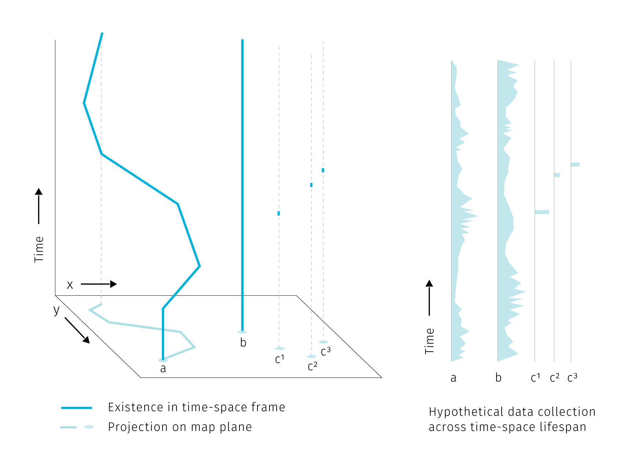

**Fig.** Three types of point spatial objects in a time-space cube. Stations, actors and events generate different attribute histories.

**Tab1** Properties of point spatial object. Existence is marked by records of spatial and temporal reference. Agent can have discrete existence if exiting and re-entering the area of interest.

type of object | existence | attribute collection | location |

|––––––––––––––––|–––––––––––––––––––––––––|––––––––––––––––––––––––|––––––––––| | station | continuous | continuous or discrete | static | | agent | continuous or discrete | continuous or discrete | dynamic | | event | discrete | discrete | static |

In the above image and a table we assume that the attribute collection is happening continuously for stations and agents. This does not mean that the attributes have to be collected continuously at all times. Some sensors can record at a regular time interval or only in case of an event. The data output can then contain several “no data” records or even no records at all if the triggering event did not happen. It then depends on the goal of the analysis how such data are conceptualized. For example a traffic camera is a stationary object but some part of its data collection is episodic – a photo is taken just when a speeding vehicle drives by. The above classification differentiates between the existence of an object and the act of recording data by the object. We assume that the sensor’s presence without recording has also some analytical potential as it proves the absence of event, while with no sensor in place we cannot say if the event did take place or not.

Compared to stations and agents, events with episodic presence seem to be the least data-rich, but their analytic potential stems from their large numbers. Clusters of georeferenced point events, a.k.a. point clouds are at the core of spatial analysis based on mobile data.

## 2.2 Spatio-temporal knowledge discovery and visual analytics

In this section we will briefly discuss techniques for exploring spatio-temporal data, with emphasis on practices that would benefit from enhanced cartographic visualisation.

The expectation that motivates people engaged in data-related practices is that their work can help to provide some insight into how the world works, that there is some knowledge that can be unlocked, mined, or distilled from otherwise inconceivable piles of data. Such insight seeking is the crux of *data mining*, *spatio-temporal knowledge discovery* and *visual analytics* that we will explore further.

*Data mining* is exploring databases using low-level algorithms to find patterns. *Knowledge discovery* is then a higher-level extension of data-mining techniques that requires human-level intelligence and domain knowledge to guide the process and interpret the results (Miller (2015)). In the knowledge discovery process, computation is seen as an extension of human force rather than its replacement — the goal is to marry the best of the both worlds. This is in line with the (current) capabilities of information technologies: there are tasks that are very simple for computers and very hard for humans (e.g. calculate the square root of 567789898) and vice-versa (basically any task requiring imagination and improvisation).

If we imagine a continuum ranging from “work done purely in human brain” towards “work done by machines”, knowledge discovery places itself somewhere in the middle. *Visual analytics*, the science of analytical reasoning supported by interactive visual interfaces (Thomas & Cook (2005)), then zooms in at the human-machine frontier in order to find the best tools for *visual* interaction.

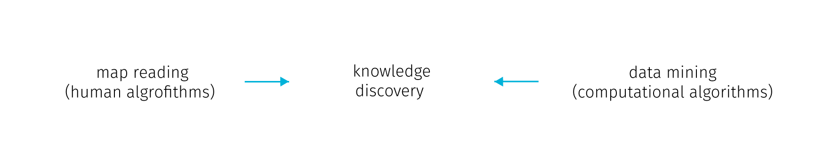

**Fig.** Human-machine continuum, knowledge discovery as the best from the both worlds (the wording could be different, for example Keim et al. (2008) lists on the “machine” side: statistical analysis, data management, data mining, compression and filtering; on the “human” side: cognition, perception, visual intelligence, decision making theory, information design; and in the “middle”: human-centered computing, semantics-base approaches, graphics and rendering, and information visulaisation). With emphasis on cartography, we summarize the human cognitive tasks as “map reading”.

We can very well imagine the human-machine continuum in the field of digital cartography. Here, the human cognitive abilities are applied to seek patterns, explore spatial context or to make decisions, while computational aspects include data management and processing. The computation heavy algorithms like optimal route calculation already step in to unburden people from some decision making so the distinction shouldn’t be taken as something rigid. Cartography provides an interface at the human side. Some authors go on to define *visual analytics for spatio-temporal data* as interlinked techniques in interfaces with map as a central metaphor (Guo, Chen, MacEachren, & Liao (2006)). We can think of it as map reading with robot assistants.

### 2.2.1 Spatio-temporal relations

To develop further on the kinds of interaction with spatial data, we can explore the concept of *spatial* and *temporal* queries. On the general level we can search for spatial and temporal relations in all there types of point objects mentioned in the first section. In addition, moving agents can generate specific relations not innate to stations and events.

**Spatial relations** are at the very basis of map reading for orientation clues, but are also vital for interpreting thematic information. We perceive these relations between the dominant themes (e.g. in weather maps of precipitation and atmospheric pressure zones) or between the theme and the topographical base map. The major classes of spatial relations are: *set-oriented* (union, difference, intersection, complement, etc.), *topological* (connectivity, interior, exterior, boundary), *directional* (cardinal, object-centered, ego-centered directions) and *metric* (e.g. Euclidean or network-based distance) (Worboys & Duckham (2004)).

Point spatial data of large extent complicate observing such relations. We rarely ask about a single specific point from the set, more often we seek to extract some tendency of the whole point cloud. The nature of some data sources can dictate some spatial relationships (such as vehicles being spatially bound the road network), but in many cases the density of point cloud obscures the base map and precludes depicting of attribute variability within the set.

Spatial relations between point clusters are harder to conceptualize than it is with polygonal features. Egenhofer & Franzosa (1991) describe 16 types of spatial relations (9 if reduced to spatial regions relevant in GIS) in two dimensional space. However, in their approach Egenhofer & Franzosa (1991) define the point sets by their exterior boundary and then treat them as polygons. But delineating the exterior boundary is a challenge in itself, for example when dealing with smooth transitions in point density at the border, or when outliers are present. Spatial relations between point clouds in three dimensions are the subject of extensive research in the fields of computer vision and indoor navigation (e.g tran2017extracting or chen2019deep). However, the motivation here is object identification. In these lines of research the point cloud is representing distinct solid objects in the real space that need to be extracted, so the point cloud itself is not an object of research. For cartography, the point sets already come with some assigned attributes, so there is usually no need to label them algorithmically. Large point sets tend to get unruly, and saying anything meaningful about spatio-temporal relations of multiple such clouds is increasingly challenging for the basic set theory (see Fig ).

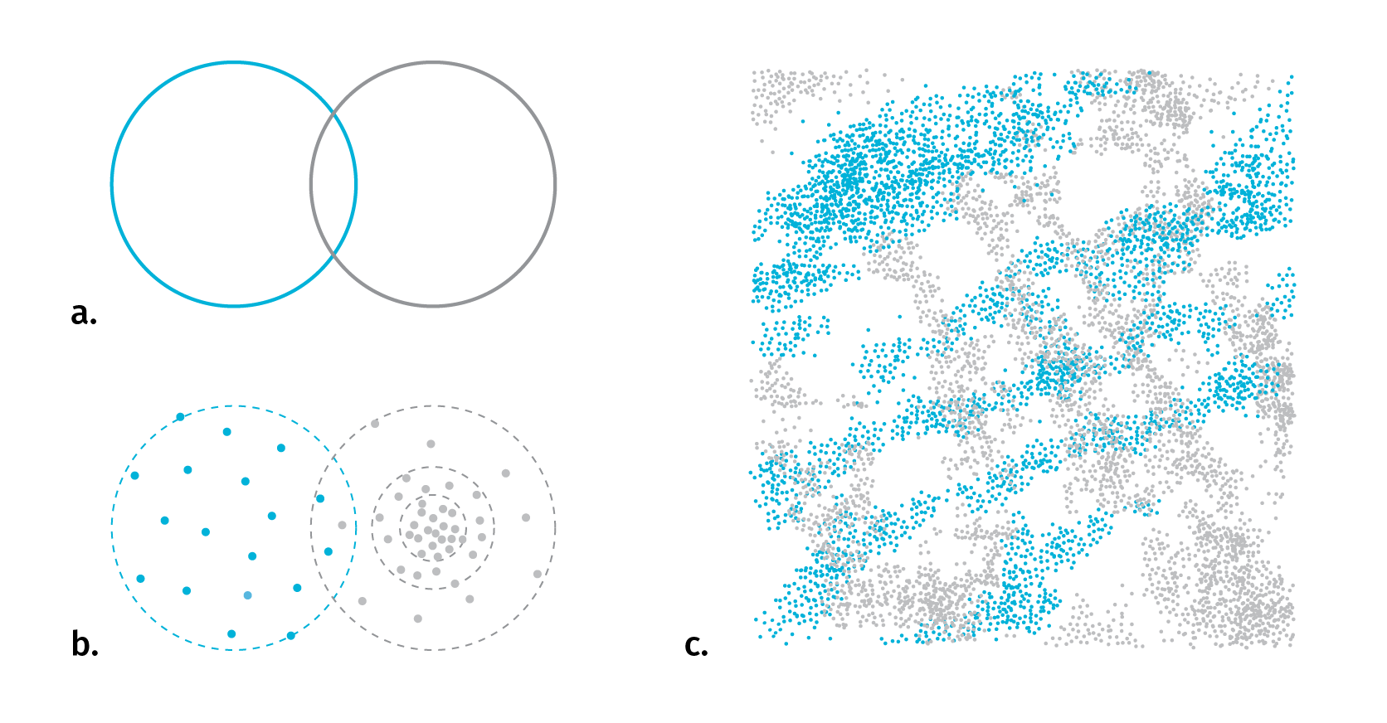

**Fig.** With polygonal features it is usually straightforward to identify the type of spatial relationship in 2D space (a). When replacing point clouds with polygon representations to apply set logic, the problem of meaningful boundary delineation arises (b). For several complex layers it is hard to say anything revealing about their spatio-temporal relationship (c)

**Temporal relations** are measures of coincidence. There are thirteen possible relations between two temporal records described in Allen (1984). As we have seen with stations, agents and events, the existence and data collection of any entity can be either continuous or discrete in time, it is therefore useful to distinguish between *time point* and *time interval* when investigating temporal relations (see figures). Linear conceptualization of time can be supported with cyclical and branching time, there can be discrepancies between the temporal parameters of the base map and the thematic overlay, or between the time interval of existence and representations. We’ll untangle these complexities in chapter 5.

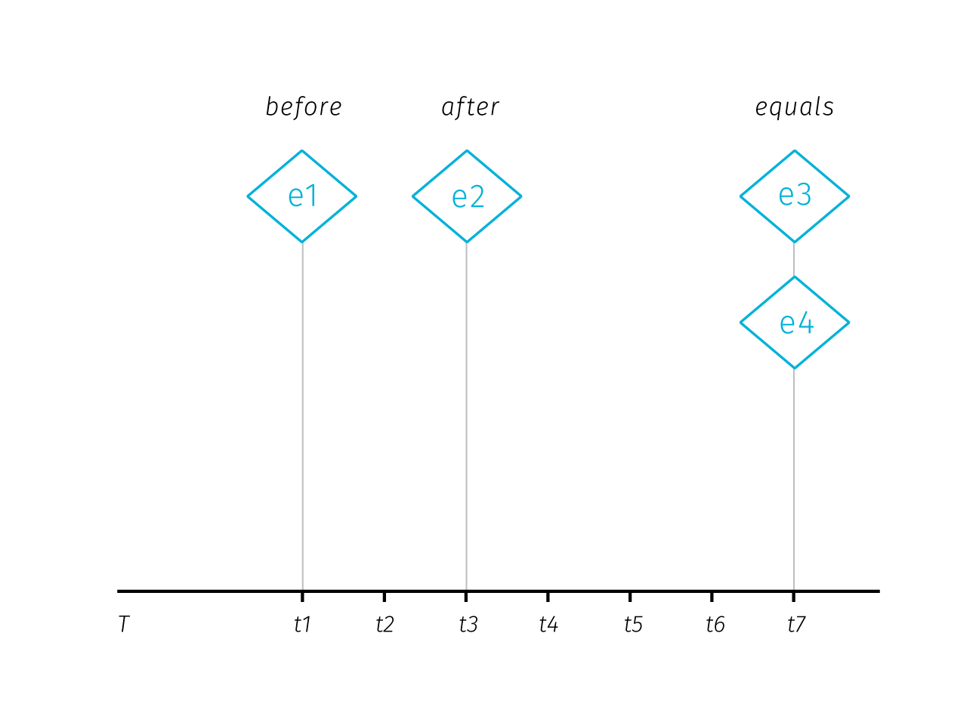

**Fig.** Temporal relations between time points. Adopted from Aigner, Miksch, Schumann, & Tominski (2011)

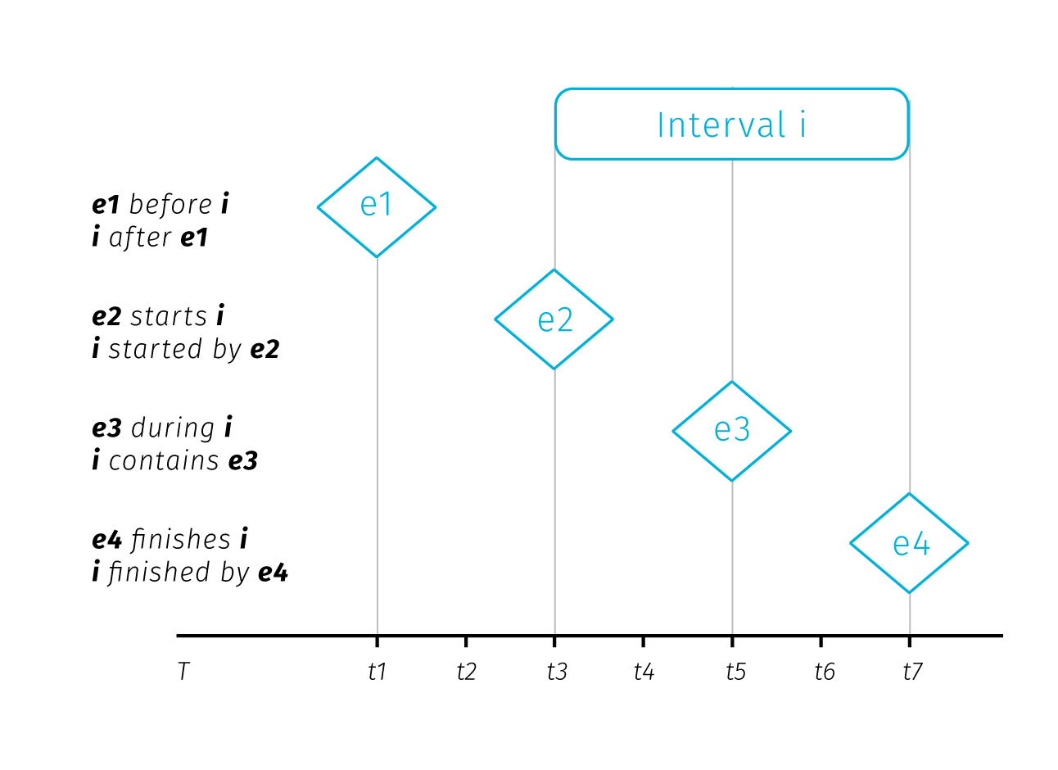

**Fig.** Temporal relations between time point and time interval. Adopted from Aigner et al. (2011)

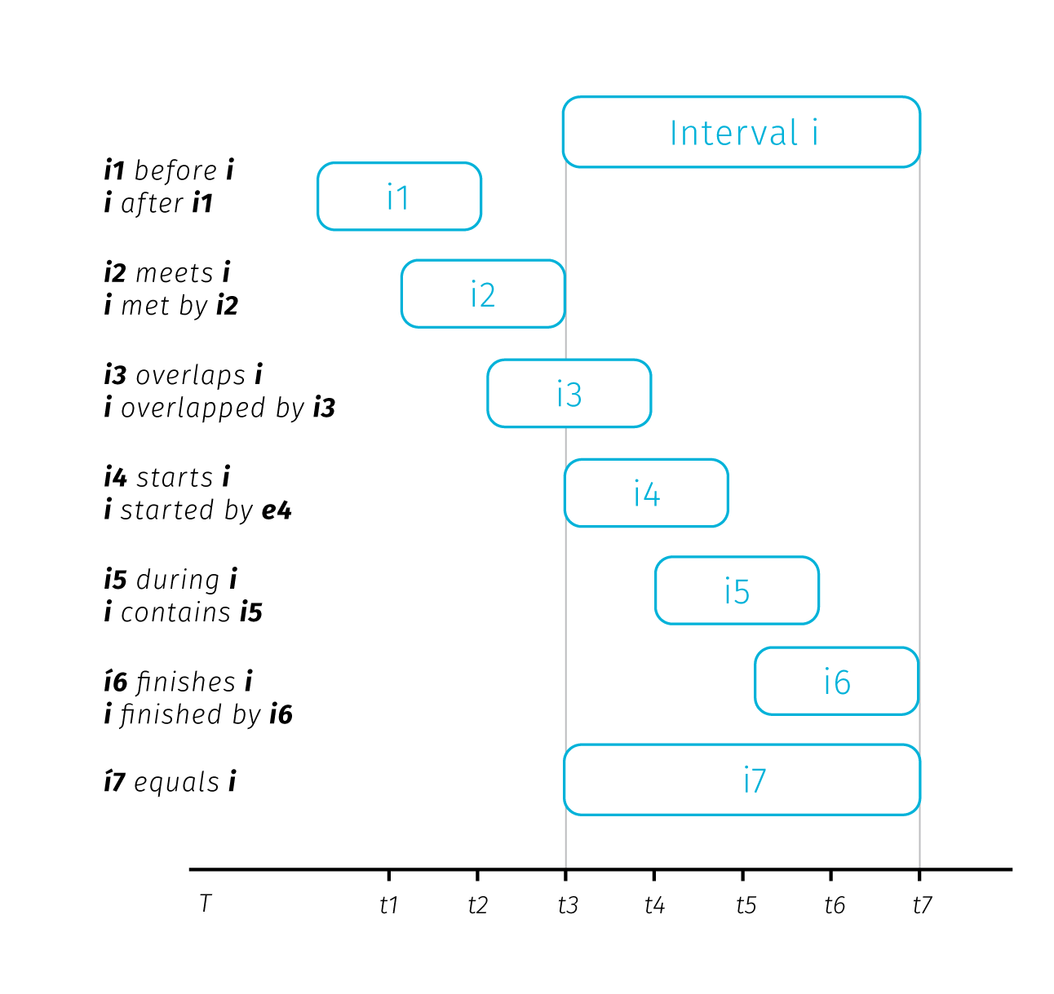

**Fig.** Temporal relations between two time intervals. Adopted from Aigner et al. (2011)

**Relations specific to moving objects** – moving objects have a specific set of properties based on their spatio-temporal circumstances. These can be *instantaneous* (actual position and speed), *interval-based* (e.g. travel distance from departure), *episodic* (related to external event) or *total* (related to entire trajectory). (Laube, Dennis, Forer, & Walker (2007), andrienko2008basic).

### 2.2.2 From data mining to visual analytics

Having described the fundamental spatio-temporal relations in big data sets, we can briefly describe some of the methods to uncover them. Recalling the human-machine continuum at Fig., we will start at the machine side with methods from the data mining group to eventually move towards the causality interpretation on the human side.

Several data mining concepts are of interest. *Association rule mining* is searching in databases for conditions occurring together frequently. We can describe an association rule as:

*x => y (s%,c%)*

Where *x,y* are conditions, together forming an *itemset* and *s,c* are levels of support and confidence. Support and confidence are basic rule performance measures, support being the measure of how often the itemset occurs in the whole database and confidence being the proportion of x being a member of an itemset x => y. For example: *park => school (4%, 55%)* means that 55 percent of parks are near schools, for 4% of items in the database (Han, Pei, & Kamber (2011)). The measures of support and confidence allow us to set thresholds for significantly frequent co-occurrence.

*Spatio-temporal association rules* extend association rules to describe how objects move among a set of regions over time (Verhein & Chawla (2008)). Incorporation of spatiality into association rules takes form of a simple binary conditions telling if the items co-occurred in the same predefined sets of regions or not.

*Sequence mining* is searching for patterns in time and other sequences. Similarly to association rules, we search for events occurring frequently together by considering three parameters: the *duration* of the whole sequence, the *event window* (time-horizon for considering events as temporally coincident) and the *time interval* between events (Miller (2015)). These parameters allow us to turn the temporal relations between two items into binary parameter telling if the items co-occurred (that is when the time interval between them fits into the event window).

*Periodic pattern mining* is a type of sequence mining that searches for recurrent patterns in time sequences. Such patterns can be: *full periodic patterns*, *partial periodic patterns* (e.g. just on Mondays), and *cyclic or periodic association rules* that associate events that occur periodically together (Han et al. (2011)).

Considering the breadth of possible spatial and temporal relations described earlier, the conceptualization of spatial and temporal co-occurrence in the association rules may seem rather simplistic. Basically, it is reduced to a yes/no parameter. Moreover, moving from the level of individual database entries towards assessing relations between compound entities such as spatial point clusters seems to be out of the scope of these methods. Of course, the way how spatiality is inscribed into association rules could be made more sophisticated, though with inevitable implications for mining performance. With large datasets, mining even the simple rules forces us to consider time constraints. For such tasks, a simple visual exploration is more efficient and reliable then basic algorithmic solutions.

At this point we can step back from mining algorithms to invite some human interpretation and to consider what conclusions we can actually draw from spatial and temporal co-occurrence of events. The usual assumption is that such co-occurrence can point to some form of causality. Drawing from approaches by Allen, Edwards, & Bédard (1995) and Galton (2012); Bleisch, Duckham, Galton, Laube, & Lyon (2014) distinguish between the trigger that apparently causes the event and the environmental conditions that have to be fulfilled for the effect to occur.

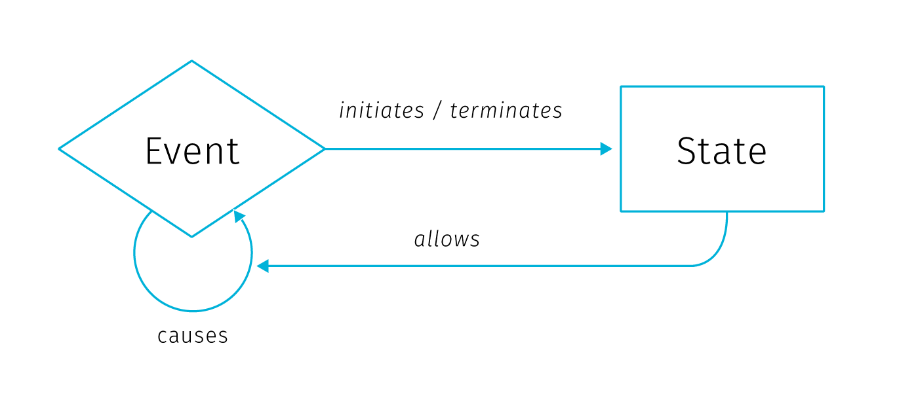

**Fig** Ontological model of causation, adopted from Galton (2012). Description in text.

In this model, *state* is an environmental condition and *event* is a change of state. Events are caused only by other events, while states only affect causation by allowing events to cause other events. Events *initiate* and *terminate* states, while states *allow* causation. The *initiate*, *terminate* and *allow* relationships are then dubbed *causal-like* to distinguish them from the event-to-event causation.

In conceptual framework for finding *candidate* causal relationships in movement patterns Bleisch et al. (2014) distinguish between three kinds of granularity at which we can describe phenomena: *spatial*, *temporal*, and *causal*. While the first two are defined by the smallest spatial and temporal units, causal granularity is given by the kinds of events observed. Spatial and temporal granularities can be easily reduced to “see the bigger picture” (by changing the spatial scale, or extending the time range of observation), but causal granularity is more firmly determined by the data collection design.

El-Geresy, Abdelmot, & Jones (2002) note that although the general expectation would be that the effect occurs immediately after the cause, some delay between the effect and the cause can occur, possibly because the cause must attain some intensity threshold to trigger the event or because the effect and cause are spatially separated and it takes time until the influence of the cause reaches the location where it takes effect. Bleisch et al. (2014) suggest that these apparent delays result from lower causal granularity of observation, i.e. there is some intermediary chain of effect and cause that happens during the delay but it is not recorded by the observation. Whether we accept the effect delays as real or illusionary might be more of an academic question, tracing down the potential causal link between the initial and the final event can yield predictive potential even when the intermediary causal chain remains undiscovered.

Discussing the interpretation of spatio-temporal co-occurrence we have moved on the human-machine continuum towards the human end. At this point, visualisation becomes important as an interface between the user and the data. One of the general models describing how knowledge discovery proceeds via inference and interaction is the sense-making loop (fig).

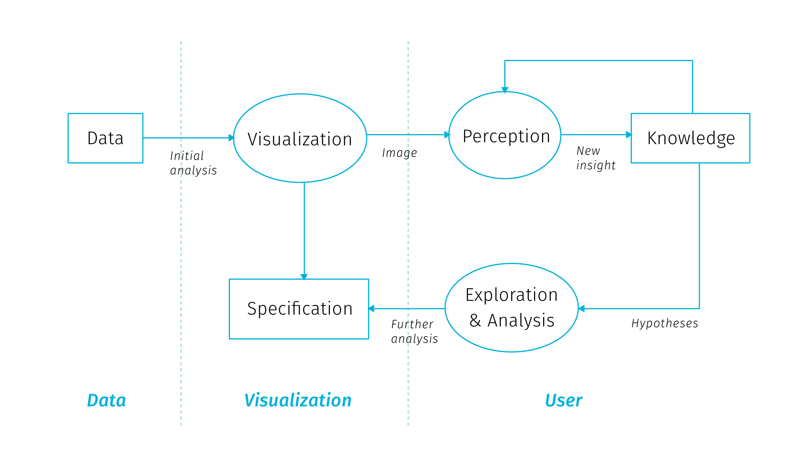

**Fig** The sense-making loop for Visual Analytics, adopted from Van Wijk (2005). User can interactively manipulate the visualisation to gain understanding of both the data and the representation itself.

Visual analytics extends the concept of visualisation: not only it provides a visual interface to the database, but also makes the data processing pipelines transparent for an analytic discourse. Keim2008visual in their introductory paper say the goal of visual analytics is the creation of tools and techniques to enable people to:

* Synthesize information and derive insight from massive, dynamic, ambiguous, and often conflicting data
* Detect the expected and discover the unexpected
* Provide timely, defensible, and understandable assessments
* Communicate assessment effectively for action

This is truly a long way from the low-level search for co-occurrences, though it is not clear how should these grand goals materialize in practice. Keim2008visual call for broad inter-disciplinary collaboration between related fields (Visualisation, Data Management, Data Analysis, Perception and Cognition, Human-Computer interaction) and identify a range of application and technical challenges.

The brief tour we just went trough lets us appreciate the prospect of gaining the best of the both worlds — to support human analytical efforts with algorithmic power doing the heavy lifting around data manipulation. We have seen that inscribing spatiality a and temporality to data mining processes can be both cumbersome and simplistic. Furthermore, the co-occurrence we want to search for needs to be defined beforehand, so in many cases data mining is insufficient to provide the required insight. Search algorithms can be performance heavy, which invites some coordination with human observer that is able to easily gain an overview of clusters beyond individual database entities. Visualization and visual analytics provide this exploratory potential, especially for big data in situation where we don’t yet know what questions we want to ask. Visualisation as a sense-making tool gives us a way to find things that we had no theory about and no statistical models to identify and to explore the space of models in more expansive ways (Bollier & Firestone (2010)).

Many possible data transformations may be applicable to a particular problem, but it is not necessarily clear which ones will be of most value in facilitating insight. Also, because visual analytics is qualitative as well as quantitative, there are no assumptions of exact parameters and well-defined boundaries between what is interesting and what is not. A priori criteria of significance may be manipulated based on the judgment of the analyst (Thomas & Cook (2005)). As we will see next, digital cartography has great potential and means to dynamically support cognitive tasks in the manner of visual analytics.

## 2.3 The role of cartography

Cartography has a long tradition of making data comprehensible to our visual minds. Beautiful and authoritative maps in school atlases explaining for example the formation of air masses or the flows of ocean streams give off an impression of exactitude and definitiveness. But the fact is that these maps are based on data from loads of observations. These data had to be collected, brushed and analyzed for the presence of meaningful patterns, and than visualised in a way that would appeal to human comprehension. The process for creating such maps is nowhere near “real-time” but allows for fine-tuning of all aspects of the map: from carefully shading the outlines of water bodies to making the street connections visually pleasing. This process allows for perfectionism, and the resulting maps remain beloved by collectors long after their ‘utilitarian’ function is gone.

For digital cartography[27] it took a long time to come any closer to the visual quality of the best works of cartography in print. Arguably, there is still some unfulfilled potential in getting towards graphic excellence in web mapping, though recent improvements in available tools open new possibilities for innovation. Digital maps have the obvious advantage of allowing interaction – user can zoom, pan, change, filter and combine the displayed data. The second big advantage is the possibility to update the displayed data real-time as the data source is updated. Sure, many digital maps are not dynamically updated, simply because the theme does not require it (e.g. medieval monasteries in France or 1991 election results in Yugoslavia). But interactive maps based on dynamically updated data are of special interest as they pose a whole new set of challenges to authors. Ensuring cartographic quality now means designing for yet unseen changes in data with user-induced modifications in mind.

School atlases serve as a presentation of knowledge, are *confirmatory*. Digital cartography allowed for *exploratory* mode of map interaction to emerge, or more precisely, the data exploration step moved from *before* to *after* map publication, and from the cartographer/author to the map user. Visual analytics based on spatial data provides interfaces to manipulate and visualize information, or better to say to pick from the pre-designed visualisation modes. This has implications for both the cartographer and the user.

In the following few sections we will describe what kinds of inference digital cartography aims to support, then we will outline big data related research challenges for cartography, as well as issues of collaboration and user engagement.

### 2.3.1 Maps for answering questions, maps for asking them

Interactive map as a data manipulation interface is useful for those who know what questions they want to ask, but also for those who want to find out what they might be asking. So what kind of inference should an interactive map support?

We can start simple, with basic quantitative questions. A big advantage of interactive maps over print is that we can display the exact quantities on demand (e.g. with some pop-up window bound to cursor hover action) and not rely on the viewer’s ability to infer quantities form the legend (especially if categorized to some interval scale). The ability to answer simple quantitative queries shouldn’t be left in vain, because as Tufte, McKay, Christian, & Matey (1998) warns: “when scientific images become dequantified, the language of analysis may drift toward credulous descriptions of form, pattern and configuration […] rather than answer to questions *How many? How often? Where? How much? At what rate?*”.

We can say that these questions are at the basic level of map reading. bertin1983semiology distinguishes three reading levels for the thematic map, and at each level, different sorts of questions that can be asked:

* *elementary level* – questions introduced by a single element of the visualisation (What is the level of unemployment in this district?)
* *intermediate level* – questions introduced by a group of elements or categories in the visualisation (What are the five most populous districts in the region?)
* *overall or global level* – questions introduced by the whole visualisation (What are the spatio-temporal trends of traffic in this city?)

It is obvious that even a simple map has a potential to introduce countless possible combinations of questions at various levels. As we will see in the next chapter, showing the basic quantities gets complicated in the context of big data, when the number of records to be displayed precludes displaying them individually. Another challenge comes with multiparametric visualisation, especially if we want to support both elementary and global levels of reading for individual parameters.

Besides the importance of supporting elementary-level questions, in thematic cartography we are often interested mainly in the global level of reading as it is hardly achievable with non-cartographic means. Often times, just to *see* the overall level is a revelation — an overreaching macroscope perspective unique to maps. But what else we can do with the overall patterns?

Are there any examples of cartographic visualisation successfully supporting the analytical reasoning? Maybe the most frequent answer for this question would be the celebrated map of the cholera outbreak in London 1855 by John Snow that helped to identify the source of the epidemics in a polluted water pump. This feat is lauded for launching spatial epidemiology and for bringing the thematic cartography to the fore (Clarke & Pickles (2015)). But what exactly made the Snow’s method worth following? Tufte et al. (1998) notes four features:

* Placing data in appropriate context for assessing cause and effect
* Making quantitative comparisons
* Considering alternative explanations and contrary cases
* Assessment of possible errors in the numbers reported in graphics

These characteristics describe Snow’s thought process which both resulted in and was guided by the map in the making. Indeed, creating effective visualizations is itself a process of exploration and discovery. Working on an interactive map is an iterative process that often yields new questions about the data that were not asked during the early analysis, which enhances the application for the user’s benefit.

Modelling what kinds of tasks can be supported by the data is one of the first steps towards a successful visualisation. As Fisher & Meyer (2017) note, high-level questions need to be refined into specific, data-driven tasks. To do this, we can break down the question into four specific components: objects, measures, groupings, and action. Ability to discern those components is a good indicator of weather the task is specific enough and can be computed from data:

* *Objects*: when a task is specific enough, each object will be something that is represented in data.
* *Measures*: In a sufficiently specific task, the measure is either an existing attribute in the dataset or one that can be directly computed from the data.
* *Groupings (or partitions)*: Attributes or characteristics of the data that separate the data items into groups. In a specific task, partitions are attributes of the objects or can be calculated directly from those attributes.
* *Actions*: Specific operation being done with the data such as compare, identify, characterize, etc. Actions guide the process of choosing appropriate visualizations.

There has to be a traceable path from the high-level abstract questions to a set of concrete, actionable tasks in the map based application, otherwise some additional data may be needed for the questions at hand.

Maps allow for basic quantitative questions on the elementary level, pattern descriptions on the global level. There is much we can do to quantify the pattern descriptions using GIS tools and geostatistics and we can observe spatial correlations between datasets. Spatial patterns in the real world are rarely independent from the geographic context, usually there some observable non-random tendency or some visible or quantifiable relationship with other data layers.

However, the search for patterns and correlations is not the full picture of the feasible use cases. Searching for outliers is interesting for ventures looking for a unobvious opportunities. Similarly, finding areas where the mapped phenomenon is absent can point to development potential. Another use case is searching for deliberate randomness when illicit actors attempt to operate in a fashion that is not predictable from large datasets (Bollier & Firestone (2010)). And then there is a modeling faculty of digital maps that enables what-if questions and comparison of various scenarios. As we have seen, the types of analysis that maps support is broad and each project can yield its own specific kinds of observations, to which we can adjust the custom-made map applications.

### 2.3.2 What next? Research challenges

Researchers in cartography and geovisualisation see big data as an opportunity and also as a certain call to action. The research agenda for geospatial big data and cartography laid down in Robinson et al. (2017) shows the general interest of moving the field toward fulfilling its potential to make maps that “pique interest, are tacitly understandable and are relevant to our society”. It is certainly reassuring that the community is aware that new sources of data “stretch the limits of what and how we map”. Building on this, Robinson et al. (2017) list several large-scale and long-term research challenges to face cartography in relation to big data as well as some short-term research opportunities for more concentrated investigation (see appendix A for the overview). Even though some of the points seem vague or repetitive, and the influence of the distinct ICA[28] commissions is clearly visible, the agenda states some truly exciting challenges to tackle. In relation with the scope to this thesis we can highlight the following challenges for cartography:

* *Develop visual analytical reasoning systems that can help users add meaning to and organize what they discover form geospatial big data* – we need to move beyond naive exploration and focus attention on tools that help people reason about what they are seeing. Users need to be able to save, annotate and compare their findings as they work on complex problems.
* *Develop methods that embody the volume of geospatial big data* – we need cartography that can intelligently process and display big data at a size and a format that users can realistically handle. This will require solutions that support coupled analysis and visualisation as big data often need to be analysed before they are visualised (the order is reversed in exploratory visualisation).
* *Create maps and map-oriented interfaces that prompt attention to important changes in dynamic geospatial big data sources* – We will need to work with global changes, local changes and combinations across scales. In addition, if we display every possible change at once, then the graphical displays become cluttered. Creating summaries of change may be the solution, but we do not yet know how to select important patterns and generalize to something that a user can understand.
* *Leverage what we know about map animation and interactive cartography to construct visual solutions for dynamic sources of geospatial big data* – Conventional solutions for interactive mapping, animated mapping or geovisual analytics can be used for representing big data. However, because of the high velocity characteristic of big data, it is necessary to develop solutions that can automate map design decisions to support interactive design solutions that respond (or potentially precede based on modelled outcomes) as the data changes.

[TODO later link to sections that resonate with the above goals]

As Thomas & Cook (2005) describes, “an emerging discipline progresses through four stages. It starts as a craft and is practiced by skilled artisans using heuristic methods. Later, researchers formulate scientific principles and theories to gain insights about the processes. Eventually, engineers refine these principles and insights to determine production rules. Finally, the technology becomes widely available. The challenge is to move from craft to science to engineering to systems that can be widely deployed”. Cartography, being a university study field had arguably crossed the four stages in the past, though with constant advances in tools for data processing and building interactive applications, the field could benefit from regularly revisiting the craft stages to see how the new tools alter our concepts of mapmaking.

This thesis does not have the ambition to imagine all the paths cartography could take in the future. However, in addition to mentioned agendas, we would like to highlight three overreaching questions that we feel are not widely discussed within cartography. Much of the work described in the remaining chapters of this thesis is rooted in pondering on the following questions about the practice of digital mapmaking:

*(a) Is cartography fully exploiting the digital medium?*

Before hopping on the wagon of augmented reality and immersive experiences (that make roughly a tenth of the population sick) cartographers could consider if they made the most of the previous medium shift. Even in the plain world of regular screens and everyday web traffic there is still a lot to be achieved for cartography to be truly useful for everyone.

Web is inherently a map-friendly platform where map products will be increasingly commonplace. Yet from the cartographic perspective, the great portion of thematic maps on the web seems rather underwhelming. Default-style markers for points of interest and numbered marker clusters to “solve” high point densities are just the tiny portion of what could be done. Cartographers should be the first to go beyond the pre-set graphic means.

Apart from the limitations posed by opinionated mapping frameworks there are also certain mindset limitations that come from transferring a visual artifact from one medium to another. Rules and practices that were to a large degree dictated by the old medium of transmission (print) get involuntary transposed to the new medium that may not require them at all. This was apparent for example in the grid-like organization of the web news pages transferred initially from the design of printed newspapers. Are there such taken-for-granted givens that linger meaninglessly in digital cartography?

There are of course many limitations that are not imaginary, like data interoperability issues and vendor lock-ins. The skill sets needed for data analysis, desktop GIS operation and web development seem painfully detached. But all the problems apart, a good mental exercise for cartographers would be to imagine map creation and interaction detached from any medium – what would we design if anything was possible?

In cartographic research, we often test the cognitive efficiency of the visualisation methods that already exist. This is all good, but we should not assume that the cartography’s quest to *extend* the arsenal of visualisation and interaction methods is completed. As we will see further, interaction and increasing data load pose new challenges to cartographic visualisation, with opportunities for creative inclusion and combination of new methods.

*(b) What inspiration can digital cartography take from the heritage of pre-digital mapping?*

Same as we asked about the preconceptions of the old medium, we can reverse the question and ask if there are any good tricks from the rich history of cartography that did not make it to digital mapping toolbox. What was lost in transition to digital? Even though paper maps and atlases age in the sense of content, cartographic methods used in them often remain inspirational and valid — the old map products many not be outdated for cartographers.

Some of the classical cartographic techniques may be demanding to implement in the variable scale environment, same other may provide solutions to the visualisation issues like high density displays. Again, we arrive at the problem of opinionated web mapping libraries that are not easy to customize or extend. Cartographers usually aren’t software developers, and software developers are usually unaware of old map stocks, but there are already examples of positive trends in collaboration towards richer visualisation in digital maps.

*(c) Should cartography focus more on the interaction design?*

Creating digital maps is not only about assigning appropriate visualisation type to the data at hand. It also becomes increasingly about designing user interactions with map elements. The ways how the map application enables user actions, the way how map controls and map elements react to user-induced changes, the way how the whole map composition adapts to screen space constraints, this all weaves a complex net of interdependent design decisions that will become an inherent part of digital cartography. What is more, the challenges of high data density affect both map intra-composition as well as extra-composition[29].

As Robinson et al. (2017) note, too often in the visual analytic process, researchers tend to focus on visual representations of the data but interaction design is not given equal priority. We need to develop a “science of interaction” rooted in a deep understanding of the different forms of interaction and their respective benefits.

In the IT industry there is a discipline of UX (user experience) that could provide some inspiration for example in accessibility evaluation, though most of its methods doesn’t fit very well to the specifics of interactive maps. At the same time, large web map providers probably collect user interaction data that could power cartographic research if they were accessible.

But we shouldn’t limit our sight to software interfaces to get inspiration. There are tons of well designed devices in the physical world that could serve as an example of clever interface design. There is a potential on expanding the repertoire of interaction techniques for digital maps. As mapped themes vary greatly the interactions could be tailor-fit as is often is with visualisations. As we have seen many times in history of innovation, progress is often hampered by mental roadblocks we don’t even realize we have.

### 2.3.2 How next? Challenges in collaborative practice

Having described the ontological models of causation as well as visions for the future of cartographic research, we can now take an aside to dwell a bit on the nitty-gritty realities of mapmaking in practice. Practical aspects of the profession are often overlooked in literature, as well as the fact that cartographer often needs to operate within a greater team. The smoothness of collaboration within the team is then a determining factor of its productivity.

There is a (somewhat mythical) notion of “full-stack” visualization designer-developer capable of conducting the broad range of tasks needed for a visualisation project (Gray, Chambers, & Bounegru (2012)). Though some such individuals do exist (possibly working on smaller applications for customers or on PhD projects), it is clear that cartographer can take only so much of additional roles (data analyst, UX designer, front-end developer, database administrator…) before getting on thin ice. Real-life visualisation projects often include a range of team members or even teams with disjoint skill sets. The question then arises on how to modularize the work. One possible model of decomposition is the information visualisation reference model (**Fig**).

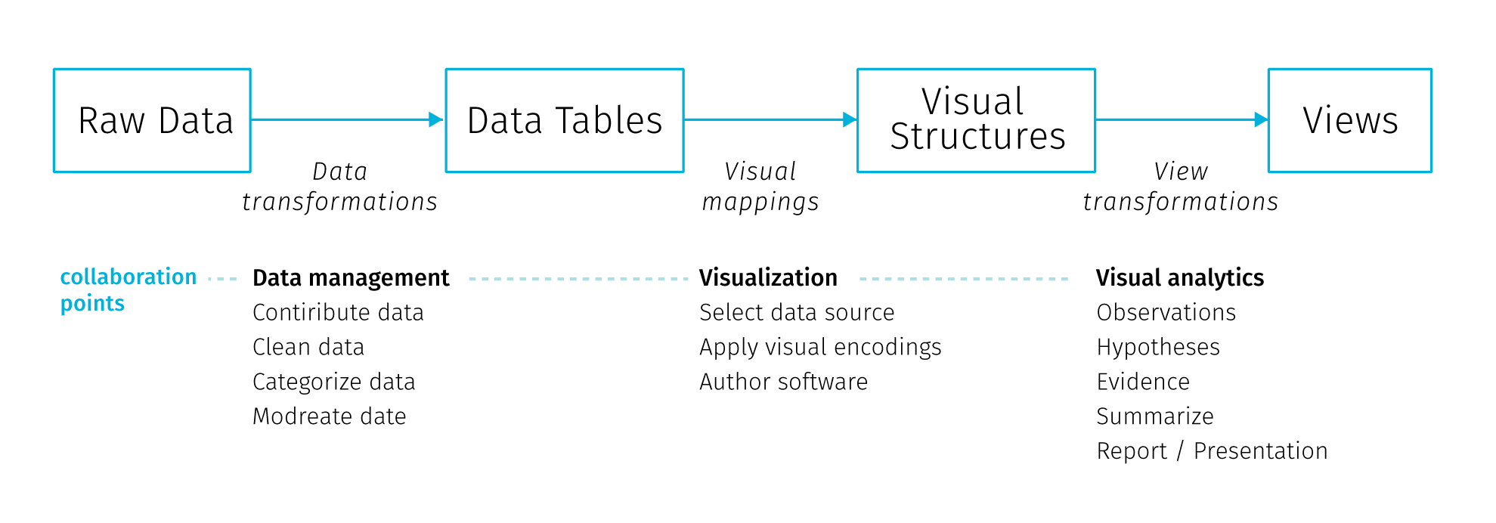

**Fig** Information visualization reference model. Adopted from Heer & Agrawala (2008)

In this model the collaboration points lie at the transitions between the stages and involve decisions on data management, visualisation and analytical capabilities (Heer & Agrawala (2008)). Physical and temporal separation of teams and institutional and disciplinary divides lead to early-stage partitioning of tasks both in the *design* (data profilation, ideation, mockup creation and prototyping) and *development* (implementation, testing, deployment and maintenance) phase (Walny et al. (2019)). Such divisions are not unique to data visualisation projects, it could match any web development project.

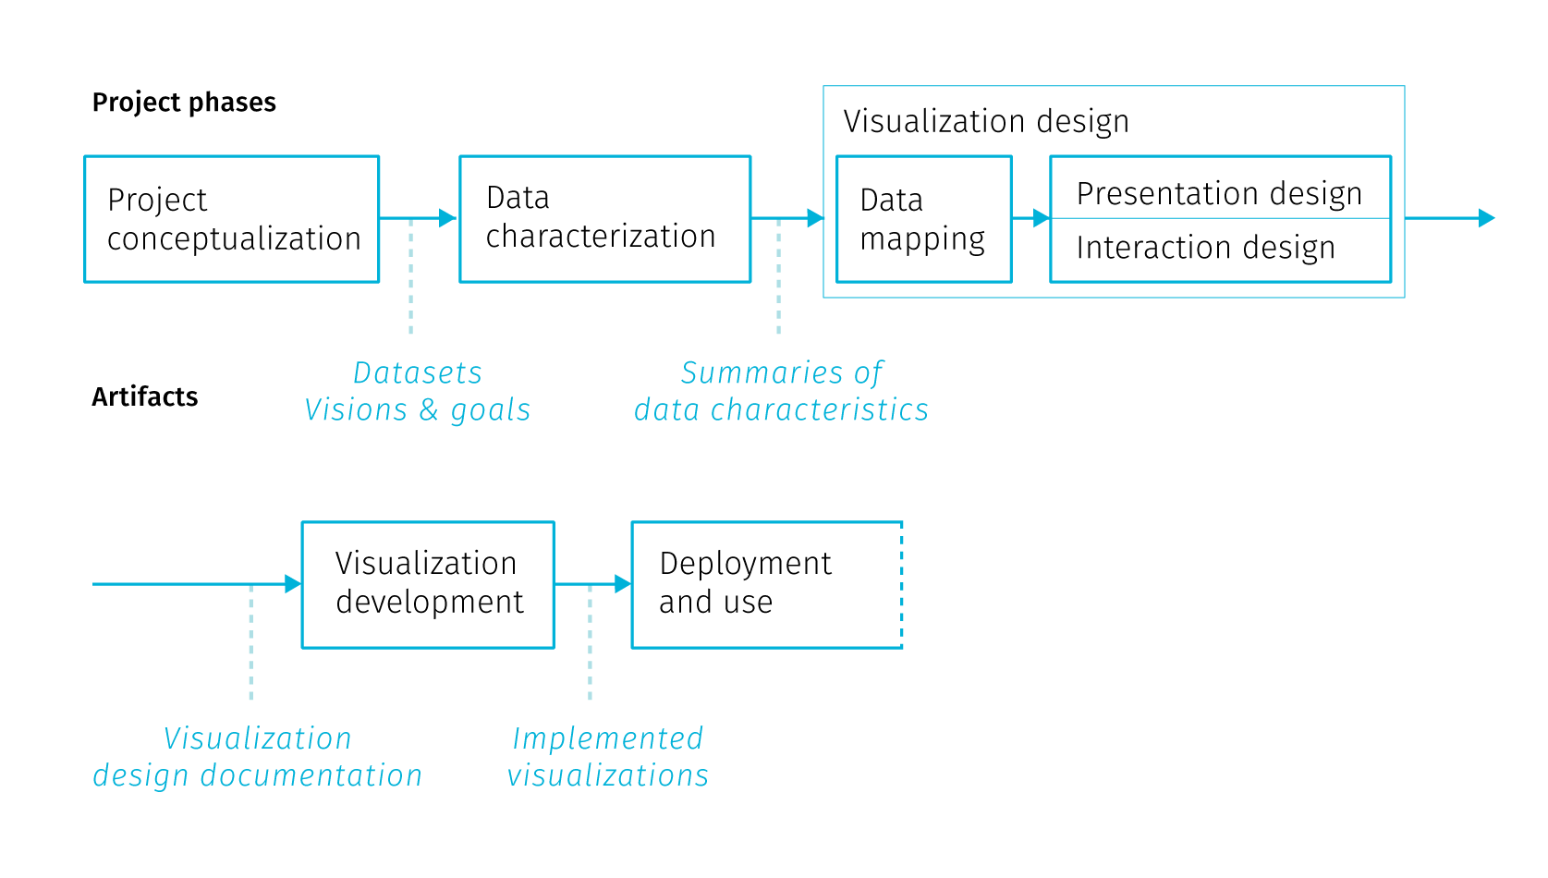

**Fig** Stages of data visualization development process. Adopted from Walny et al. (2019)

Walny et al. (2019) formalize stages of data visualisation process based on experience with several assignments (Fig.). In the iterative process the division of labor gives rise to *handoff* events, when one team passes work products and requirements to the next team. Particularly the handoff between the design and development team is where issues can arise to affect the end result. Speaking from the position of design team Walny et al. (2019) articulate several key challenges that affect the success of the handoff and in turn the smoothness of the whole project:

* *Adapting to data changes* – changes in input data can have cascading effects throughout the stages of the process. Some breakages are inevitable (e.g. API changes) and fixing them is a part of project maintenance. It is advisable to have data transformations automated to the largest extent possible, as it is highly likely there will be a need to reiterate them. In this sense, the scripts and the processing tool chain developed during the project can be actually more valuable to creators than the project outputs.
* *Anticipating edge cases* – though this is incredibly hard for real-time data inputs, best effort should be made to foresee at least the main application states resulting from the user interactions, such as filtering, changes of scale, etc.
* *Understanding technical challenges* – knowledge of technical constraints helps to produce feasible design ideas. Development team’s concerns differ form the design team’s, they include cross-browser compatibility or future code maintainability. In some areas the goals can overlap, for example in accessibility considerations or performance optimization.
* *Articulating data-dependent interactions* – prototyping interactions such as linking and brushing using conventional graphic tools is challenging, not to mention animations or transitions between views. There are wireframing tools that try to address this, though misunderstandings still occur.
* *Communicating data mappings* – this is a concern when delivering static mockups for the development team. The mapping between data and the interface controls may not be obvious, especially when the complexity of data does not allow to exemplify all possible application states. Annotations within mockups try to ease this.
* *Preserving data mapping integrity across iterations* – tracking implementation adherence to the design, finding errors, as well as checking if change requests from previous iterations got implemented is solely a matter of visual inspection and therefore prone to error. This can be fixed by automated testing, though it is not feasible for all types of projects, and even if implemented, the test coverage can rarely reach 100%.

Project examples form Walny et al. (2019) show that the above challenges were formulated based on project experience with relatively static data inputs. This underlines why interactive cartographic visualisation of real-time data is hard: much of the advice is hard to impossible to follow when the real-time data inflow is volatile. [TODO link on chapter on data mocking]

### 2.3.3 Who cares? Building user engagement

The ability to interact with the map-based application can surely be empowering for the user, triggering the sensation of exploring the unknown. On the other hand, things can go wrong as it is very hard to create an immersive experience from a complex dataset that would be immediately understandable to the newcomer. Exploratory map applications intended for the general public can leave users overwhelmed with the amount of possible interaction points. Left to their own devices and without any stated framework for interpretation, users need to create their own narration about what is displayed. Visual interfaces are prone to be terrifyingly cluttered, untroubled with dangers of fostering misinterpretation. Lack of guidance on where to start results in poor engagement with the application that is quickly abandoned. With specialized applications for professional audience, this can be mitigated by training, because users are basically forced to work with the application as part of their job. Similar problems occur in business analytic dashboards proliferating in enterprises, which fail to make sense to users, or worse, fake insight with vaguely understood and hardly interpretable metrics. All these caveats pose a challenge to application designers.

Building engagement with an application is mainly about sparking curiosity in users. Previously in this chapters we discussed what kinds of questions can interactive maps answer, assuming that there is someone who wants to ask them. But this assumption shouldn’t be taken for granted. Adding hints and motivations to map interfaces should get more interest from cartographers, not only because it is a way to make our work resonate in general public but also it provides some options to work around the cognitive difficulties connected with visualizing large amounts of data.

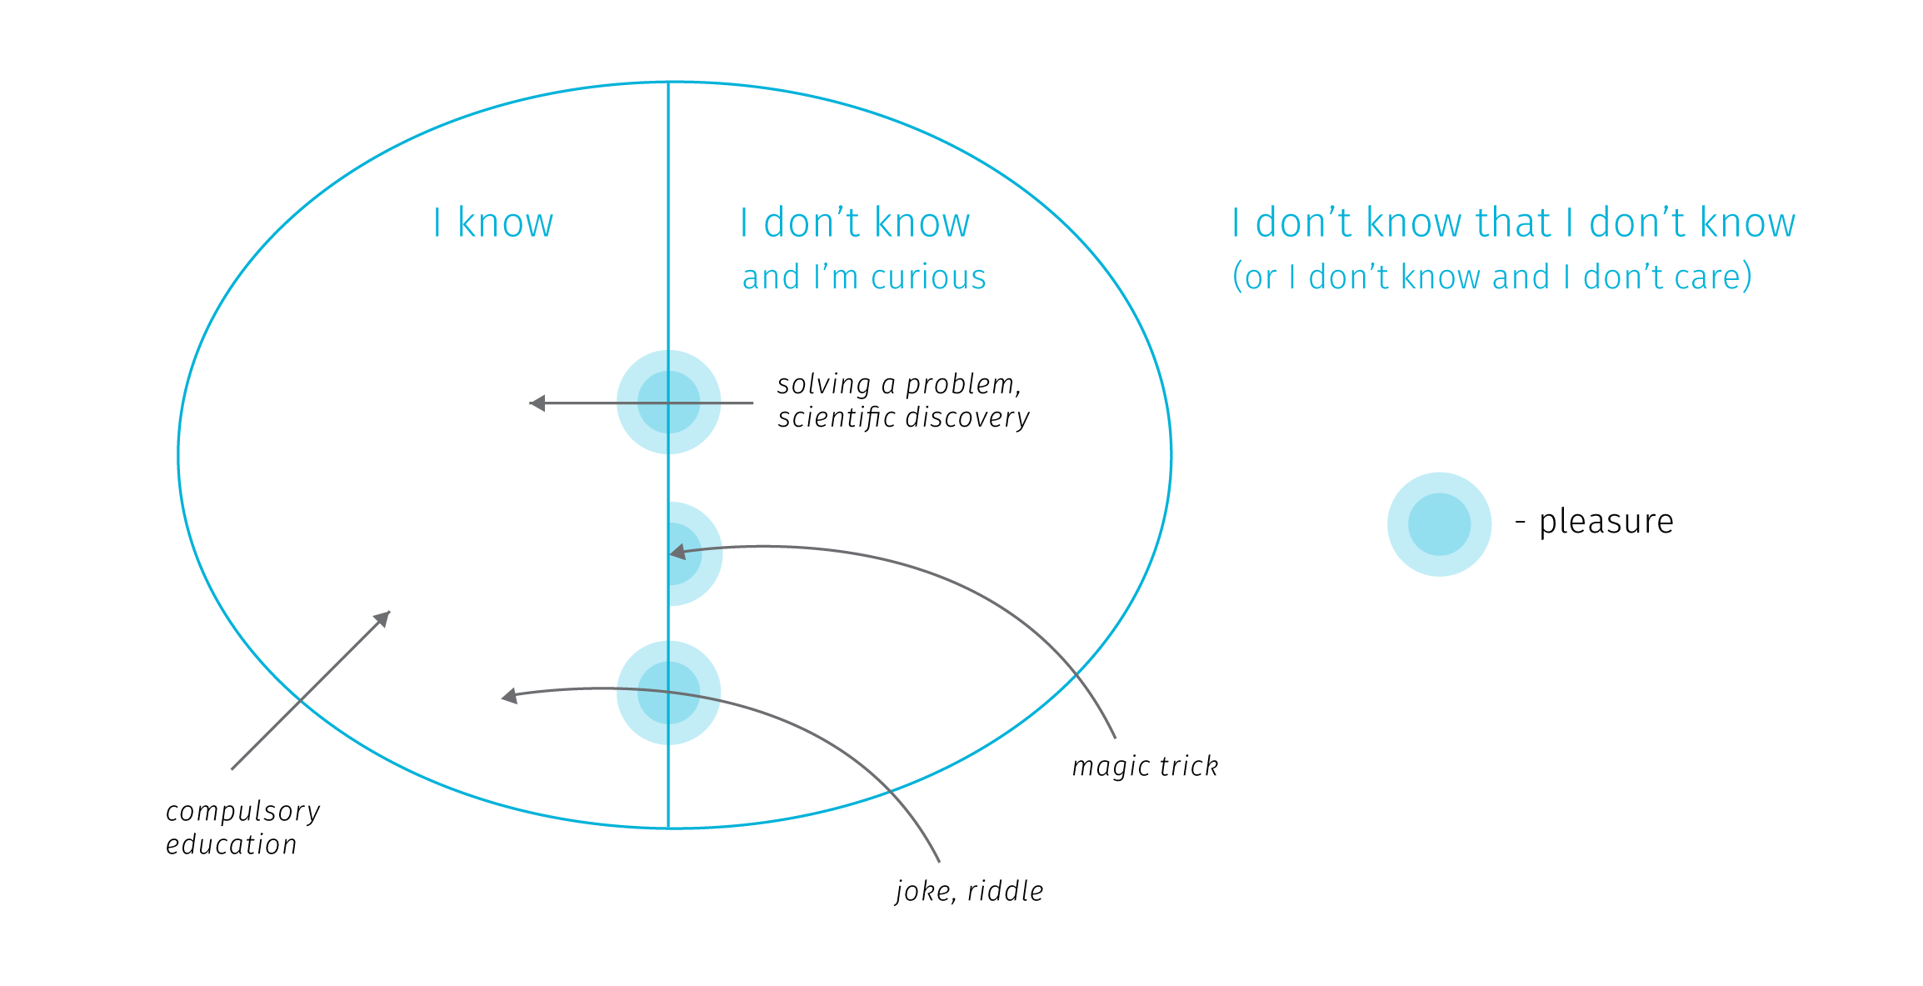

**Fig.** Various ways of expanding our mental model or the world can trigger pleasure. Adopted from Stanová (2016)

So how to trigger curiosity? According to Stanová (2016) (Fig), to set off the thrill, one needs to first get from the “I don’t know that I don’t know” zone to the “I don’t know and I’m curious” zone. Here we realize that there is something missing in our mental model of the world and we want to discover it. Crossing the border from “I don’t know” to “I know” creates pleasure and motivates further exploration (which is crossing back and forth between “I don’t know” and “I know”). Note that the “I know” zone doesn’t need to correspond to reality — exploring fictional worlds, gossips or conspiracy theories triggers pleasure just as well.

From the cartographic point of view, when we create maps for specialized audience, we target people who already are in the “don’t know + curious” zone. But when working for general audience, it is important to think about how to move users to the curious zone to encourage interacting with an application. Sometimes the compulsory education makes the mistake of revealing how something works before making pupils interested in the topic, resulting in low levels of engagement and remembering. The same problem can occur when the user lands straight at a complex web interface with intricate cartographic visualisation.

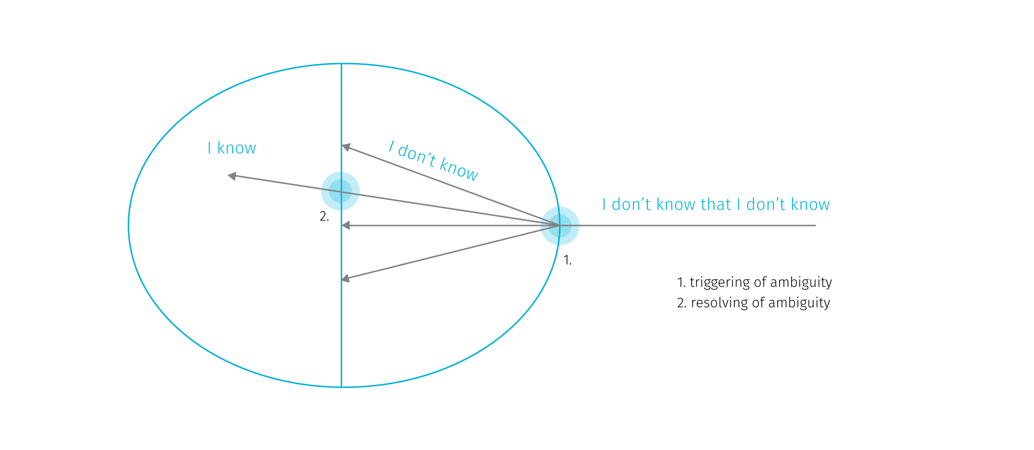

**Fig.** Pleasure points usually arise when ambiguity is triggered and when it is resolved. Adopted from Stanová (2016)

The thrills can arise also when crossing the I don’t know barrier, that is when the ambiguity is triggered (Fig). The pleasure here comes from the expectation of the potentially upcoming reward — resolving the ambiguity. However, note that the ambiguity doesn’t need to be resolved to set off thrills — for example, when watching a magic trick we don’t get to know how the magician does it but we can entertain ourselves in speculations. Similarly in exploratory cartographic interfaces the stimulation comes from exploring various aspects of the displayed data, fostering our curiosity about the nature of the phenomenon.

The related concept of *flow* describes the relationship between the skill of the user and the difficulty of the task at hand (Csikszentmihalyi (1997)). Flow is the mental state resulting form the right balance between the task difficulty and the user’s skills. The flow channel is rather narrow — if the difficulty is too high, anxiety arises, if it’s too low, user is bored. The task of the interface designer is not to dumb down the displayed content, but also not to create additional roadblocks with incomprehensible interaction modes.

Shaping the initial experience with an application is sometimes referred to as “user onboarding” (Baur (2017)). The onboardiding stage is far too often omitted in information visualisations on the web, though there is no wide consensus on how it should work, the basic aim should be at a minimum a short textual introduction to the presented data and the knowledge around it. Complex interfaces tend to offer an initial tour of controls that usually explains what individual UI elements do, less often it ventures into teaching people how to read and understand the presented visualizations. There are approaches like “scrollytelling” (Amabili (2019)) or explorable explanations (Victor (2017)) that embed interactive visualisations into larger body of text that gradually explains it.

The task is further complicated by the obvious fact that different people have different interests and understanding of the world. In web development, creators try to specify user personas to represent target audience and user stories to list supported user actions. To start modelling from considering users rather than data is certainly an advisable approach. However user stories are often too removed from the real life circumstances to perceive and prevent abusive uses of the system (so called “weaponisation” of design Diehm (2018)).

Tailoring the map interaction to intended users is definitely something digital cartography should aim for. While some customizations are technologically possible (e.g. the dark mode in transportation maps switching on for tunnels or night travel), the topic of accessibility of interactive maps is still fairly unexplored. While there are methods to ensure map is usable for people with color blindness, there is a wide range of vision impairments cartography is largely unprepared to adjust for.

## 2.4 Objections and Responses

Not surprisingly, data visualisation is seen as a great tool for achieving a desirable goal in most of the literature, this thesis included. But there are also voices raising objections against some naive expectations form data visualisation that may even get harmful with incorporation of big data. Such debates may shed some light on the possible future evolution of digital cartography, so let us briefly outline some of the main objections with possible responses to them.

**Hiding system complexity**

The first objection is related to modelling and visualizing complex systems. By reducing the complex system into comprehensible chunks, data visualisation may encourage confident predictions and estimations that may lead to decisions and interventions with harmful effects. The issue is that the used datasets and models may not include all aspects of reality, but absence of evidence is not evidence of absence. Incomplete models may rationalize decisions that despite claiming to be data-driven, actually stand on thin legs. This can lead to unpleasant surprises (for example, loosening of pandemic-related restrictions in Czech Republic before Christmas 2020 was based on models that did not account for the presence of a COVID-19 variant with increased transmissibility, leading to disastrous effects soon afterwards). Visualisation based on a bad model than acts basically as an accomplice, no matter how well crafted it is.

Apart from missing relevant information in models, there are some aspects of complex systems that render prediction efforts highly problematic. Nonlinear relationships between system parts produce disproportional responses to change in input parameters. The boundaries between system components may be hazy or even imaginary. When the relationships between system components are vaguely understood (which is often the case in complex systems), any naive intervention can trigger a chain of cascading second order effects that can accelerate harm (Meadows (2008), Taleb (2012)). Moreover, extracting trends from historical data offers no preparation for the so called Black Swan events — large-scale unpredictable and irregular events of massive consequence (Taleb (2007)).

What can be done in response to these concerns? Models and visualisations could be more explicit about their own limits — like the properties of data used, statistical assumptions, margins of error, sources of uncertainty and possible other explanations. Incorporation of uncertainty into visualisations should be done in a way that cannot be easily ignored by the users (Kale, Kay, & Hullman (2020), Correll, Moritz, & Heer (2018)). Visualisations shouldn’t simplify the depiction of data if it leads to hiding important aspects of the system. Overall, visualising interdependencies and feedback loops within a complex system poses an interesting challenge for visualisation community and for cartographers as well.

When it comes to reasoning about complex systems, visualisations can support a non-predictive approach that aims more at risk evaluation and moderating exposure to the possible harm coming from unprecedented events. In relation to man made systems in general, we could strive to make them more akin to natural systems that are not only robust to error, but can also adapt and benefit from certain doses of volatility (so called antifragile systems Taleb (2012)).

**Misinterpretation**

The second objection is related to the first one, but rather than looking at limits of models and visualisations, it is concerned with user’s ability to interpret them. It is long known that our intuitive thinking is influenced by biases in many tasks, including assigning probabilities to events, forecasting the future, assessing hypotheses and estimating frequencies (Kahneman (2011)). There is a long list of cognitive biases that correct the assumption of people being fully rational actors.

For example, biases about the reliability of different sources may lead us to discount information from sources that we don’t associate with (Thomas & Cook (2005)). When we form a preliminary judgment too early in the analytical process, we may hold firm to it long after the evidence invalidates it. Sometimes we settle for a “good enough” answer, stopping our analytical process before identifying critical information that would lead us to a different conclusion (Heuer (1999)). We are also challenged to think statistically compared to our abilities to think associatively, metaphorically or causally. Furthermore, there is our overconfidence in what we think we know, and inability to acknowledge the full extent of what we don’t know (Kahneman (2011)). We also underestimate the role of chance in events, we tend to assume causality between events that just happen to occur at the same time (Taleb (2012)), and so on, and so on.

To make the matters worse, experts who create visualisations are to susceptible to various biases. The design choices can drive results every bit as much as traditional “data-cleaning” choices. Hence visualization techniques contain embedded judgments (Bollier & Firestone (2010)). Then there is the “curse of knowledge”: the difficulty in imagining what it is like for someone else not to know something you know (Pinker (2015)). On the side of the application designer, it can lead to expecting the user to have same levels of skills and knowledge, but also the same values and views of the world.

What can be done in response to these concerns? First of all, we might benefit from a more realistic view of the impact of data visualisation. Insight comes from knowledge and experience and no data-driven tool can compensate for the lack of the two. Visualisation is a supporting tool, a mediator that can stimulate and amplify the thought process, but cannot act as a shortcut if no thinking is being done. Expecting to become an expert by looking at a picture is a false promise.

That being said, acknowledging the cognitive biases in the visualisation design process is definitely a right way to go. Visualisation designers have often little information on what judgements are triggered by their work. There is a growing body of research on user interactions with complex visualisation that could help us. Applications could incorporate tools to collect feedback from users, even evaluate usage data to find issues. Overall, judgement biases are systematic errors, therefore to some extent they are predictable, although maybe not preventable. The task is then to explore how to adjust the visual language to warn users that they might be biased.

**Non-human decision makers**

The third question is directed more at the future relevance of data visualisation in the face of artificial intelligence (AI). If more and more decisions will be carried out by algorithms the need for visualisations may diminish in many areas where it is deemed crucial nowadays, merely because computers, unlike human analysts, don’t need to visualize things to gain insight and understand the problem.

Having described the range of cognitive biases one might welcome computational assistance, and in many areas we already rely on it, navigation being a prominent example. One the other hand, we can point out the current deficiencies of machine learning algorithms. Contrary to popular beliefs, the technology is not ready to step in for humans for the majority of tasks. Current machine learning is about extracting rules from vast training data sets, which is susceptible to various kinds of issues: sensitivity to gaps and errors in data, confinement to the specifics of training data, or the tendency to take unwanted shortcuts (Shane (2019)). Furthermore, it is not certain that some breakthrough in artificial intelligence will come in the foreseeable future, either because its already large appetite for computing power will become economically, technically, and environmentally unsustainable (Thompson, Greenewald, Lee, & Manso (2020)), or because the demand for artificial collaborators will perish — we will simply want to design AI as tools not as collaborators (Dennett (2017)).

In a realistic view, the danger of AI is not in usurping us, but rather in us putting too much confidence into uncomprehending tools. But even if we will get to non-human decision makers, it wouldn’t mean a demise of visualisation, contrary, it could open new opportunities for using visual artefacts. First, as a communication interface between humans and machines. Second, as a way to inspect and verify the workings of decision-making algorithms. It is not possible to check upon a black box, nor to negotiate with it, so gaining insight into how and why automated systems arrived at a particular decision may become a new frontier for the data visualisation community.

Aigner, W., Miksch, S., Schumann, H., & Tominski, C. (2011). *Visualization of time-oriented data*. Springer Science & Business Media.

Allen, E., Edwards, G., & Bédard, Y. (1995). Qualitative causal modeling in temporal gis. In *International conference on spatial information theory* (pp. 397–412). Springer.

Allen, J. F. (1984). Towards a general theory of action and time. *Artificial intelligence*, *23*(2), 123–154. Elsevier.

Amabili, L. (2019). From storytelling to scrollytelling: A short introduction and beyond. *Available online at https://medium.com/nightingale/from-storytelling-to-scrollytelling-a-short-introduction-and-beyond-fbda32066964 (last accessed April 29, 2021)*.

Anderson, C. (2008). The end of theory: The data deluge makes the scientific method obsolete. *Wired magazine*, *16*(7), 16–07.

Andrienko, N., & Andrienko, G. (2006). *Exploratory analysis of spatial and temporal data: A systematic approach*. Springer Science & Business Media.

Atzori, L., Iera, A., & Morabito, G. (2010). The internet of things: A survey. *Computer networks*, *54*(15), 2787–2805. Elsevier.

Barnes, T. J. (2013). Big data, little history. *Dialogues in Human Geography*, *3*(3), 297–302. SAGE Publications Sage UK: London, England.

Baur, D. (2017). The death of interactive infographics? *Available online at https://medium.com/@dominikus/the-end-of-interactive-visualizations-52c585dcafcb (last accessed April 29, 2021)*.

Bleisch, S., Duckham, M., Galton, A., Laube, P., & Lyon, J. (2014). Mining candidate causal relationships in movement patterns. *International Journal of Geographical Information Science*, *28*(2), 363–382. Taylor & Francis.

Boellstorff, T., & Maurer, W. (2015). Introduction. In *Data, now bigger and better!* (pp. 1–6). Prickly Paradigm Press.

Bollier, D., & Firestone, C. M. (2010). *The promise and peril of big data*. Aspen Institute, Communications; Society Program Washington, DC.

Bort, J. (2014). There’s a new word being used in the computer industry: ’Brontobytes’. *Available online at http://www.businessinsider.com/new-big-data-word-brontobytes-2014-6 (last accessed May 30, 2018)*.

Boyd, D., & Crawford, K. (2012). Critical questions for big data: Provocations for a cultural, technological, and scholarly phenomenon. *Information, communication & society*, *15*(5), 662–679. Taylor & Francis.

Brunelli, M. (2011). Will your organization benefit from ’big data’ processing technology? *Available online at searchdatamanagement. techtarget. com/news/2240036228/Will-your-organization-benefit-from-big-data-processing-technology (last accessed December 29, 2016)*.

Burghardt, D., Duchêne, C., & Mackaness, W. (2016). *Abstracting geographic information in a data rich world*. Springer.

Clarke, V., & Pickles, R. (2015). *Map: Exploring the world*. Phaidon Press Limited.

Corporation, I. D. (2020). IDC’s global datasphere forecast shows continued steady growth in the creation and consumption of data. <https://www.idc.com/getdoc.jsp?containerId=prUS46286020>.

Correll, M., Moritz, D., & Heer, J. (2018). Value-suppressing uncertainty palettes. In *Proceedings of the 2018 chi conference on human factors in computing systems* (pp. 1–11).

Crampton, J. W. (2015). Collect it all: National security, big data and governance. *GeoJournal*, *80*(4), 519–531. Springer.

Crampton, J. W., Graham, M., Poorthuis, A., Shelton, T., Stephens, M., Wilson, M. W., & Zook, M. (2013). Beyond the geotag: Situating ‘big data’and leveraging the potential of the geoweb. *Cartography and geographic information science*, *40*(2), 130–139. Taylor & Francis.

Csikszentmihalyi, M. (1997). Flow and the psychology of discovery and invention. *HarperPerennial, New York*, *39*.

Davenport, T. (2014). *Big data at work: Dispelling the myths, uncovering the opportunities*. Harvard Business Review Press.

Demchenko, Y., De Laat, C., & Membrey, P. (2014). Defining architecture components of the big data ecosystem. In *Collaboration technologies and systems (cts), 2014 international conference on* (pp. 104–112). IEEE.

Dennett, D. C. (2017). *From bacteria to bach and back: The evolution of minds*. WW Norton & Company.

Diebold, F. X., Cheng, X., Diebold, S., Foster, D., Halperin, M., Lohr, S., Mashey, J., et al. (2012). A personal perspective on the origin (s) and development of “big data”: The phenomenon, the term, and the discipline∗. Citeseer.

Diehm, C. (2018). On weaponised design. *Available online at https://ourdataourselves.tacticaltech.org/posts/30-on-weaponised-design/ (last accessed September 16, 2018)*.

D’Ignazio, C. (2017). Creative data literacy: Bridging the gap between the data-haves and data-have nots. *Information Design Journal*, *23*(1), 6–18. John Benjamins.

Dodge, M., & Kitchin, R. (2005). Codes of life: Identification codes and the machine-readable world. *Environment and Planning D: Society and Space*, *23*(6), 851–881. SAGE Publications.

Egenhofer, M. J., & Franzosa, R. D. (1991). Point-set topological spatial relations. *International Journal of Geographical Information System*, *5*(2), 161–174. Taylor & Francis.

El-Geresy, B. A., Abdelmot, A. I., & Jones, C. B. (2002). Spatio-temporal geographic information systems: A causal perspective. In *East european conference on advances in databases and information systems* (pp. 191–203). Springer.

Fan, J., Han, F., & Liu, H. (2014). Challenges of big data analysis. *National science review*, *1*(2), 293–314. Oxford University Press.

Fischer, D. (2015). Why exploring big data is hard and what we can do about it. *Available online at www. youtube. com/watch?v=UP5412nU2lI (last accessed December 29, 2016)*.

Fisher, D., & Meyer, M. (2017). *Making data visual: A practical guide to using visualization for insight*. " O’Reilly Media, Inc.".

Florescu, D., Karlberg, M., Reis, F., Del Castillo, P. R., Skaliotis, M., & Wirthmann, A. (2014). Will “big data” transform official statistics? In *Q2014–european conference on quality in statistics*.

Galton, A. (2012). States, processes and events, and the ontology of causal relations. IOS Press.

Gandomi, A., & Haider, M. (2015). Beyond the hype: Big data concepts, methods, and analytics. *International Journal of Information Management*, *35*(2), 137–144. Elsevier.

Gantz, J., & Reinsel, D. (2011). Extracting value from chaos. *IDC iview*, *1142*(2011), 1–12.

Gartner. (2018a). What is big data? - gartner it glossary. *Available online at https://www.gartner.com/it-glossary/big-data/ (last accessed October 26, 2018)*.

Gartner. (2018b). Gartner special reports. *Available online at https://www.gartner.com/en/products/special-reports (last accessed August 26, 2018)*.

González-Bailón, S. (2013). Big data and the fabric of human geography. *Dialogues in Human Geography*, *3*(3), 292–296. SAGE Publications Sage UK: London, England.

Goodchild, M. F. (2007). Citizens as sensors: The world of volunteered geography. *GeoJournal*, *69*(4), 211–221. Springer.

Goodchild, M. F. (2013). The quality of big (geo) data. *Dialogues in Human Geography*, *3*(3), 280–284. SAGE Publications Sage UK: London, England.

Gorman, S. P. (2013). The danger of a big data episteme and the need to evolve geographic information systems. *Dialogues in Human Geography*, *3*(3), 285–291. SAGE Publications Sage UK: London, England.

Graham, M., & Shelton, T. (2013). Geography and the future of big data, big data and the future of geography. *Dialogues in Human Geography*, *3*(3), 255–261. SAGE Publications Sage UK: London, England.

Gray, J., Chambers, L., & Bounegru, L. (2012). *The data journalism handbook: How journalists can use data to improve the news*. " O’Reilly Media, Inc.".

Guo, D., Chen, J., MacEachren, A. M., & Liao, K. (2006). A visualization system for space-time and multivariate patterns (vis-stamp). *IEEE transactions on visualization and computer graphics*, *12*(6), 1461–1474. IEEE.

Hahmann, S., Burghardt, D., & Weber, B. (2011). “80% of all information is geospatially referenced”??? Towards a research framework: Using the semantic web for (in) validating this famous geo assertion. In *Proceedings of the 14th agile conference on geographic information science*.

Han, J., Pei, J., & Kamber, M. (2011). *Data mining: Concepts and techniques*. Elsevier.

Head, S. (2014). Worse than wal-mart: Amazon’s sick brutality and secret history of ruthlessly intimidating workers. *Salon*.

Heer, J., & Agrawala, M. (2008). Design considerations for collaborative visual analytics. *Information visualization*, *7*(1), 49–62. SAGE Publications Sage UK: London, England.

Helles, R., & Jensen, K. (2013). Making data—big data and beyond: Introduction to the special issue. *First Monday*, *18*(10).

Herland, M., Khoshgoftaar, T. M., & Wald, R. (2014). A review of data mining using big data in health informatics. *Journal of Big Data*, *1*(1), 2. Nature Publishing Group.

Heuer, R. J. (1999). *Psychology of intelligence analysis*. Center for the Study of Intelligence.

Hilbert, M., & López, P. (2011). The world’s technological capacity to store, communicate, and compute information. *science*, *332*(6025), 60–65. American Association for the Advancement of Science.

Hilbert, M., & López, P. (2012). How to measure the world’s technological capacity to communicate, store, and compute information part i: Results and scope. *International Journal of Communication (19328036)*, *6*.

Jiang, B. (2018). Spatial heterogeneity, scale, data character and sustainable transport in the big data era. *ISPRS International Journal of Geo-Information*, *7*(5), 167. MDPI AG.

Jiang, B., & Brandt, S. A. (2016). A fractal perspective on scale in geography. *ISPRS International Journal of Geo-Information*, *5*(6), 95. Multidisciplinary Digital Publishing Institute.

Jiang, Z., & Shekhar, S. (2017). *Spatial big data science: Classification techniques for earth observation imagery*. Springer.

Jin, X., Wah, B. W., Cheng, X., & Wang, Y. (2015). Significance and challenges of big data research. *Big Data Research*, *2*(2), 59–64. Elsevier.

Jung, V. (1995). Knowledge-based visualization design for geographic information systems. In *Proc. Of the 3rd acm int. Workshop on advances in geographic information systems (baltimore md* (pp. 101–108).

Kabakchieva, D., Stefanova, K., & others. (2015). Big data approach and dimensions for educational industry. *Economic Alternatives*, *4*, 47–59. University of National; World Economy, Sofia, Bulgaria.

Kahneman, D. (2011). *Thinking, fast and slow*. Macmillan.

Kale, A., Kay, M., & Hullman, J. (2020). Visual reasoning strategies for effect size judgments and decisions. *IEEE Transactions on Visualization and Computer Graphics*. IEEE.

Kambatla, K., Kollias, G., Kumar, V., & Grama, A. (2014). Trends in big data analytics. *Journal of Parallel and Distributed Computing*, *74*(7), 2561–2573. Elsevier.

Kayyali, B., Knott, D., & Van Kuiken, S. (2013). The big-data revolution in us health care: Accelerating value and innovation. *Mc Kinsey & Company*, 1–13.

Keim, D., Andrienko, G., Fekete, J.-D., Görg, C., Kohlhammer, J., & Melançon, G. (2008). Visual analytics: Definition, process, and challenges. In *Information visualization* (pp. 154–175). Springer.

Kitchin, R. (2013). Big data and human geography: Opportunities, challenges and risks. *Dialogues in human geography*, *3*(3), 262–267. Sage Publications Sage UK: London, England.

Kitchin, R. (2014). *The data revolution: Big data, open data, data infrastructures and their consequences*. Sage.

Kitchin, R. (2015). The opportunities, challenges and risks of big data for official statistics. *Statistical Journal of the IAOS*, *31*(3), 471–481. IOS Press.

Kitchin, R., & McArdle, G. (2016). What makes big data, big data? Exploring the ontological characteristics of 26 datasets. *Big Data & Society*, *3*(1), 2053951716631130. SAGE Publications.

Klanten, R., Ehmann, S., Bourquin, N., & Tissot, T. (2010). *Data flow: Visualising information in graphic design*. Gestalten.

Kreye, A. (2015). Moore’s law. In J. Brockman (Ed.), *This Idea Must Die: Scientific Theories That Are Blocking Progress (Edge Question Series)* (pp. 303–309). Harper Perennial: New York.

Laney, D. (2001). 3D data management: Controlling data volume, velocity and variety. *META Group Research Note*, *6*, 70.

Laube, P., Dennis, T., Forer, P., & Walker, M. (2007). Movement beyond the snapshot–dynamic analysis of geospatial lifelines. *Computers, Environment and Urban Systems*, *31*(5), 481–501. Elsevier.

Lee, J.-G., & Kang, M. (2015). Geospatial big data: Challenges and opportunities. *Big Data Research*, *2*(2), 74–81. Elsevier.

Leszczynski, A., & Crampton, J. (2016). Introduction: Spatial big data and everyday life. *Big Data & Society*, *3*(2), 2053951716661366. SAGE Publications Sage UK: London, England.

Lewis, S. C., & Westlund, O. (2015). Big data and journalism: Epistemology, expertise, economics, and ethics. *Digital Journalism*, *3*(3), 447–466. Taylor & Francis.

Li, S., Dragicevic, S., Castro, F. A., Sester, M., Winter, S., Coltekin, A., Pettit, C., et al. (2016). Geospatial big data handling theory and methods: A review and research challenges. *ISPRS Journal of Photogrammetry and Remote Sensing*, *115*, 119–133. Elsevier.

Lima, M. (2011). Visual complexity. Mapping patterns of information. Princeton: Princeton Architectural Press.

Lipton, Z. C., & Steinhardt, J. (2018). Troubling trends in machine learning scholarship. *arXiv preprint arXiv:1807.03341*.

Lupton, D. (2013). Swimming or drowning in the data ocean? Thoughts on the metaphors of big data. *Available online at https://simplysociology. wordpress. com/2012/10/29/swimming-or-drowning-in-the-data-ocean-thoughts-on-the-metaphors-of-big-data/ (last accessed December 29, 2016)*.

Lupton, D. (2015). The thirteen ps of big data. *Available online at https://simplysociology. wordpress. com/2015/05/11/the-thirteen-ps-of-big-data/ (last accessed December 29, 2016)*.

Manyika, J., Chui, M., Groves, P., Farrell, D., Van Kuiken, S., & Doshi, E. A. (2013). Open data: Unlocking innovation and performance with liquid information. *McKinsey Global Institute*, 21.

Marr, B. (2014). Big data: The 5 vs everyone must know. *LinkedIn. Available online at www. linkedin. com/pulse/20140306073407–64875646-bigdata-the-5-vs-everyone-must-know (last accessed December 29, 2016)*.

Marz, N., & Warren, J. (2012). *Big data: Principles and best practices of scalable realtime data systems*. MEAP Edition Manning Publications Co.

Mayer-Schönberger, V., & Cukier, K. (2013). *Big data: A revolution that will transform how we live, work, and think*. Houghton Mifflin Harcourt.

McLaren, D., & Agyeman, J. (2015). *Sharing cities: A case for truly smart and sustainable cities*. MIT Press.

McNulty, E. (2014). Understanding big data: The seven v’s. *Available online at dataconomy. com/2014/05/seven-vs-big-data/(last accessed December 29, 2016)*.

Meadows, D. H. (2008). *Thinking in systems: A primer*. chelsea green publishing.

Miller, H. J. (2015). Spatio-temporal knowledge discovery. *Geocomputation: A Practical Primer. SAGE Publications Ltd, Thousand Oaks, CA*, 97–109.

Moore, G. E. (2006). Cramming more components onto integrated circuits, reprinted from electronics, volume 38, number 8, april 19, 1965, pp. 114 ff. *IEEE Solid-State Circuits Society Newsletter*, *11*(3), 33–35. IEEE.

Morais, C. D. (2012). Where is the phrase “80% of data is geographic” from. *Available online at https://www.gislounge.com/80-percent-data-is-geographic/ (last accessed October 26, 2018)*.

Murthy, P., Bharadwaj, A., Subrahmanyam, P., Roy, A., & Rajan, S. (2014). Big data taxonomy. *Cloud Security Alliance (CSA), Tech. Rep*.

Network, C. A. (2018). Creative applications network. *Available online at http://www.creativeapplications.net/ (last accessed May 30, 2018)*.

Networking, C. V. (2018). Cisco global cloud index: Forecast and methodology, 2016-2021. White paper. *Cisco Public, San Jose*.

Nobre, G. C., & Tavares, E. (2017). Scientific literature analysis on big data and internet of things applications on circular economy: A bibliometric study. *Scientometrics*, *111*(1), 463–492. Springer.

Norvig, P. (2011). The unreasonable effectiveness of data - ubc distinguished lecture series. *Available online at https://www.youtube.com/watch?v=yvDCzhbjYWs (last accessed May 30, 2018)*.

Norvig, P. (2012). Warning signs in experimental design and interpretation. *Available online at https://norvig.com/experiment-design.html (last accessed May 30, 2020)*.

Nunberg, G. (2013). "The data are": How fetishism makes us stupid. *Available online at http://languagelog.ldc.upenn.edu/nll/?p=4396 (last accessed September 26, 2018)*.

Olshannikova, E., Ometov, A., Koucheryavy, Y., & Olsson, T. (2015). Visualizing big data with augmented and virtual reality: Challenges and research agenda. *Journal of Big Data*, *2*(1), 22. Nature Publishing Group.

Ovadia, S. (2013). The role of big data in the social sciences. *Behavioral & Social Sciences Librarian*, *32*(2), 130–134. Taylor & Francis.

Pääkkönen, P., & Pakkala, D. (2015). Reference architecture and classification of technologies, products and services for big data systems. *Big Data Research*, *2*(4), 166–186. Elsevier.

Peuquet, D. J. (1994). It’s about time: A conceptual framework for the representation of temporal dynamics in geographic information systems. *Annals of the Association of american Geographers*, *84*(3), 441–461. Taylor & Francis.

Pinker, S. (2015). *The sense of style: The thinking person’s guide to writing in the 21st century*. Penguin Books.

Puschmann, C., & Burgess, J. (2014). Big data, big questions| metaphors of big data. *International Journal of Communication*, *8*, 20.

Robinson, A. C., Demšar, U., Moore, A. B., Buckley, A., Jiang, B., Field, K., Kraak, M.-J., et al. (2017). Geospatial big data and cartography: Research challenges and opportunities for making maps that matter. *International Journal of Cartography*, 1–29. Taylor & Francis.

Rouse, M. (2018). Cloud computing. *Available online at https://searchcloudcomputing.techtarget.com/definition/cloud-computing (last accessed May 30, 2018)*.

Shane, J. (2019). *You look like a thing and i love you: How artificial intelligence works and why it’s making the world a weirder place*. Voracious.

Shekhar, S., Evans, M. R., Gunturi, V., Yang, K., & Cugler, D. C. (2014). Benchmarking spatial big data. In *Specifying big data benchmarks* (pp. 81–93). Springer.

Shekhar, S., Gunturi, V., Evans, M. R., & Yang, K. (2012). Spatial big-data challenges intersecting mobility and cloud computing. In *Proceedings of the eleventh acm international workshop on data engineering for wireless and mobile access* (pp. 1–6). ACM.

Shelton, T. (2017). Spatialities of data: Mapping social media “beyond the geotag”. *GeoJournal*, *82*(4), 721–734. Springer.

Shin, D.-H., & Choi, M. J. (2015). Ecological views of big data: Perspectives and issues. *Telematics and Informatics*, *32*(2), 311–320. Elsevier.

Siegfried, T. (2013). Why big data is bad for science. *Science News*, *26*.

Silver, N. (2012). *The signal and the noise: Why so many predictions fail–but some don’t*. Penguin.

Stanová, M. (2016). *Algorithms in art*. Academy of Fine Arts in Prague & CEE PhotoFund.

statista.com. (2018). Data center storage capacity worldwide from 2016 to 2021, by segment (in exabytes). *Available online at https://www.statista.com/statistics/638593/worldwide-data-center-storage-capacity-cloud-vs-traditional/ (last accessed May 30, 2018)*.

Stevens, S. S. (1946). On the theory of scales of measurement. *Science*. year.

Storm, D. (2012). Big data makes things better. *Available online at insights. dice. com/2012/08/03/big-data-makes-things-better/ (last accessed December 29, 2016)*.

Suthaharan, S. (2014). Big data classification: Problems and challenges in network intrusion prediction with machine learning. *ACM SIGMETRICS Performance Evaluation Review*, *41*(4), 70–73. ACM.

Swan, M. (2015). Philosophy of big data: Expanding the human-data relation with big data science services. In *Big data computing service and applications (bigdataservice), 2015 ieee first international conference on* (pp. 468–477). IEEE.

Taleb, N. N. (2007). *The black swan: The impact of the highly improbable* (Vol. 2). Random house.

Taleb, N. N. (2012). *Antifragile: Things that gain from disorder* (Vol. 3). Random House Incorporated.

Thakuriah, P. V., Tilahun, N. Y., & Zellner, M. (2017). Big data and urban informatics: Innovations and challenges to urban planning and knowledge discovery. In *Seeing cities through big data* (pp. 11–45). Springer.

Thatcher, J., Shears, A., & Eckert, J. (2018). *Thinking big data in geography: New regimes, new research*. U of Nebraska Press.

Thomas, J., & Cook, K. A. (2005). Illuminating the path: The r&D agenda for visual analytics national visualization and analytics center. *National Visualization and Analytics Center-US Department of Homeland Security*.

Thompson, N. C., Greenewald, K., Lee, K., & Manso, G. F. (2020). The computational limits of deep learning. *arXiv preprint arXiv:2007.05558*.

Tufte, E. R., McKay, S. R., Christian, W., & Matey, J. R. (1998). Visual explanations: Images and quantities, evidence and narrative. *Computers in Physics*, *12*(2), 146–148. AIP Publishing.

UNECE. (2013). UNECE - united nations economic commission for europe. *Available online at https://statswiki.unece.org/display/bigdata/Classification+of+Types+of+Big+Data (last accessed August 26, 2018)*.

Uprichard, E. (2013). Focus: Big data, little questions? *Discover Society*, (1). Social Research Publications.

Van Rijmenam, M. (2013). Why the 3v’s are not sufficient to describe big data. *Available online at http://www. bigdata-startups. com/3vs-sufficient-describe-big-data (last accessed December 29, 2016)*.

Van Wijk, J. J. (2005). The value of visualization. In *VIS 05. IEEE visualization, 2005.* (pp. 79–86). IEEE.

Verhein, F., & Chawla, S. (2008). Mining spatio-temporal patterns in object mobility databases. *Data mining and knowledge discovery*, *16*(1), 5–38. Springer.

Victor, B. (2017). Explorable explanations. *Available online at http://worrydream.com/ExplorableExplanations/ (last accessed April 29, 2021)*.

Walny, J., Frisson, C., West, M., Kosminsky, D., Knudsen, S., Carpendale, S., & Willett, W. (2019). Data changes everything: Challenges and opportunities in data visualization design handoff. *IEEE transactions on visualization and computer graphics*, *26*(1), 12–22. IEEE.

Wamba, S. F., Akter, S., Edwards, A., Chopin, G., & Gnanzou, D. (2015). How ‘big data’can make big impact: Findings from a systematic review and a longitudinal case study. *International Journal of Production Economics*, *165*, 234–246. Elsevier.

West, G. (2013). Big data needs a big theory to go with it. *Scientific American, May*, *15*.

Widman, J. (2014). When new relic says “data helps,” we’re saying it right. *Available online at https://blog.newrelic.com/culture/data-is-vs-data-are/ (last accessed September 26, 2018)*.

Wilson, A., Thompson, T. L., Watson, C., Drew, V., & Doyle, S. (2017). Big data and learning analytics: Singular or plural? *First Monday*, *22*(4).

Worboys, M. F., & Duckham, M. (2004). *GIS: A computing perspective*. CRC press.

Yang, C., Raskin, R., Goodchild, M., & Gahegan, M. (2010). Geospatial cyberinfrastructure: Past, present and future. *Computers, Environment and Urban Systems*, *34*(4), 264–277. Elsevier.

Yao, X., & Li, G. (2018). Big spatial vector data management: A review. *Big Earth Data*, *2*(1), 108–129. Taylor & Francis.

Zee, E. van der, & Scholten, H. (2014). Spatial dimensions of big data: Application of geographical concepts and spatial technology to the internet of things. In *Big data and internet of things: A roadmap for smart environments* (pp. 137–168). Springer.

1. Throughout the text we will treat the term as plural, without capitalization. Although there are strong arguments for “data” as singular (Widman (2014), Nunberg (2013), for counterargument emphasizing the plurality of big data see Wilson, Thompson, Watson, Drew, & Doyle (2017)) and some authors do capitalize, we chose to match with the majority of big data related literature. This does not apply to direct citations where we preserve the original author’s formulation.
2. for an alternative summary of definitions see Gandomi & Haider (2015), for bibliometric analysis of related scientific literature see Nobre & Tavares (2017).
3. Gordon Moore’s 1965 paper (reprint Moore, 2006) stated that the number of transistors on integrated circuits will double every two years. The prediction has proven accurate for several decades and became known as *Moore’s law*. The pace has slowed down with smaller transistors suggesting that the prediction is reaching its technological limit, though the opinions here vary. The overuse of the idea as a synonym of progress has been criticized as too simplistic for example by Kreye (2015)
4. *Cloud computing* enables companies to consume a compute resource, such as a virtual machine, storage or an application, as a utility rather than having to build and maintain computing infrastructures in house (Rouse, 2018). The cloud models include providing infrastructure, platform or application as a service; main vendors of public cloud solutions are Amazon Web Services, Google Cloud Platform or Microsoft Azure.
5. Processing and analytical frameworks designed for big data include Apache Hadoop, Apache Spark, or Apache Flink. No-SQL databases use a column, graph, document, key-value, or multi-model solution as an alternative to traditional relational database design.
6. Real world analogies may not be helpful here: for example the properties of gold are independent of the tools used to mine it. On the other hand, many forms of interaction with digital data are inseparable from the technical infrastructure.
7. This is close to holistic definitions discussed later in this chapter, though these tend to be less confined in technology realm and mixing in procedural aspects and wider societal implications.
8. 1 exabyte = 1 000 000 000 gigabytes
9. 1 brontobyte = 1 000 000 000 exabytes
10. Internet of Things (IoT) can be described as a vision of a network of devices, vehicles and home appliances that can connect, interact and exchange data. Similarly to big data, there are manifold definitions of the concept, for overview see Atzori, Iera, & Morabito (2010)
11. see Morais (2012) for discussion and Hahmann, Burghardt, & Weber (2011) for a validation attempt
12. This is most pressing when handling spatial data in discrete files (e.g. in Shapefile or GeoJSON formats). Using versioning systems like Git, which has become incredibly popular for handling software source code and text files, is not suitable for spatial data files as these often exceed repository size limits (though there is a project attempting to solve this called *geogig* <http://geogig.org/>). Handling spatial data within relational database provides more options for spatial data versioning, also there is a range of database project specialized on storing time series like InfluxDB or TimescaleDB.
13. for more on efforts in automated generalisation see for example Burghardt, Duchêne, & Mackaness (2016)
14. Spatial indices are used to optimize retrieval of spatial data from database. They decrease the time it takes to locate features that match a spatial query.
15. VGI is defined as “the harnessing of tools to create, assemble, and disseminate geographic data provided voluntarily by individuals” (Goodchild, 2007). This description fits for example the contributions to the Open Street Map project very well, but is less applicable to social media, where users are more likely indifferent to their data being collected, rather than contributing data as a primary goal.
16. Smart city is a concept of urban area that uses digital information to make more efficient use of physical infrastructure, engage effectively with people in local governance, and respond promptly to changing circumstances. For more information see McLaren & Agyeman (2015)
17. Named after Vilfredo Pareto who more than century ago noticed that in 20% of people in Italy owned 80% of land. The ratio of 20% of causes leading to 80% of consequences has been observed in many systems, though the distributions can be far more uneven, like that 99% of Internet traffic is attributable to 1% of sites (Taleb, 2012).
18. Hype cycles describe how expectations from emerging technologies evolve with time. Stages in the cycle are: *innovation trigger*, *peak of inflated expectations*, *trough of disillusionment*, *slope of enlightenment*, and *plateau of productivity*. The expected duration of the cycle differs per technology, and some technologies may not reach productivity in the foreseeable future. Hype cycles are a construction of the Gartner consultancy that issues regular reports, see for example Gartner (2018b)
19. Complex system’s collective characteristics cannot easily be predicted from underlying components: the whole is greater than, and often significantly different from, the sum of its parts. A city is much more than its buildings and people. Our bodies are more than the totality of our cells. This quality, is called *emergent behavior*. West (2013)
20. For other examples of such reflections see Lipton & Steinhardt (2018), Norvig (2012)
21. Legislation varies around the world, for European Union, the General Data Protection Regulation (GDPR), which governs how personal data of individuals in the EU may be processed and transferred came into being in 2018. For overview of digital privacy rules see <https://europa.eu/youreurope/citizens/consumers/internet-telecoms/data-protection-online-privacy/index_en.htm>.
22. *Journal of Big Data*, *Big Data Research*, *International Journal of Data Science and Analytics*, *Big Data & Society*, *Big Data Analytics*, *Big Data* are examples of scientific journals tracking cross-disciplinary efforts in the field.
23. We’ll use the term *point data* as a shorthand for “data with point spatial reference”.
24. see <https://waitbutwhy.com/2013/08/putting-time-in-perspective.html> for a visualisation of perspectives changing with time frame
25. See examples of such practice at <https://www.nytimes.com/interactive/2019/12/19/opinion/location-tracking-cell-phone.html>
26. There are notable global-scale exceptions like <https://globalfishingwatch.org/map/?locale=en> or <https://www.shipmap.org/>
27. For brevity, we will use the term *interactive maps* as a shorthand referring to maps based on dynamic data, allowing user interaction, consumed almost exclusively through the web, viewed on screens of various sizes. With the term *digital cartography* we will refer to the theory and practice of creating such maps.
28. International Cartographic Association
29. TODO explain these terms?