PYTHON ACTIVITY 1
CASE STUDIES 21–30

•Problem Statement
• Objectives
• Assumptions
• Algorithm
• Pseudocode
•Python Source Code
• Test Cases
• Output Screenshots
• Conclusion

QUESTION 21: Traffic Violation Penalty Calculator
1. PROBLEM STATEMENT
Process multiple offences, calculate their total fines and check a sample disqualification condition.

2. OBJECTIVES
Read vehicle and offence count • Find each base fine • Add repeat-offence surcharge • Add fines and check disqualification • Display total penalty and status

3. ASSUMPTIONS
speeding=Rs.1000; signal=Rs.1500; no_helmet=Rs.500. Repeat adds Rs.500. Signal offence or total >= Rs.3000 flags disqualification. Sample rules only.

4. ALGORITHM
1. Start → 2. Input vehicle and offence count → 3. Read offence and repeat status → 4. Find fine and add surcharge → 5. Add fine to total → 6. Signal offence or total >= 3000? → 7. Display penalty and status → 8. Stop

5. FLOWCHART
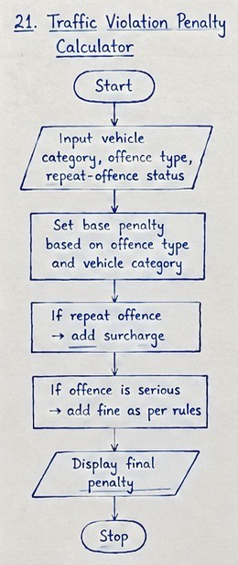

6. PSEUDOCODE
BEGIN
- Start
- Input vehicle and offence count
- Read offence and repeat status
- Find fine and add surcharge
- Add fine to total
- Signal offence or total >= 3000?
- Display penalty and status
- Stop
END

7. PYTHON SOURCE CODE
rules={"speeding":1000,"signal":1500,"no_helmet":500} total=0 disqualified=False vehicle=input("Vehicle (car/bike): ").lower() n=int(input("Number of offences: ")) for i in range(n):
offence=input("Offence: ").lower() repeat=input("Repeat? (yes/no): ").lower() if offence not in rules:
print("Invalid offence; skipped") continue fine=rules[offence]+(500 if repeat=="yes" else 0) total+=fine if offence=="signal" or total>=3000:
disqualified=True print("Vehicle:",vehicle) print("Total penalty: Rs.",total)
print("Disqualification:","YES" if disqualified else "NO")
8. TEST CASE
Sample: car; speeding once and repeat signal offence.

9. CODE AND OUTPUT SCREENSHOT
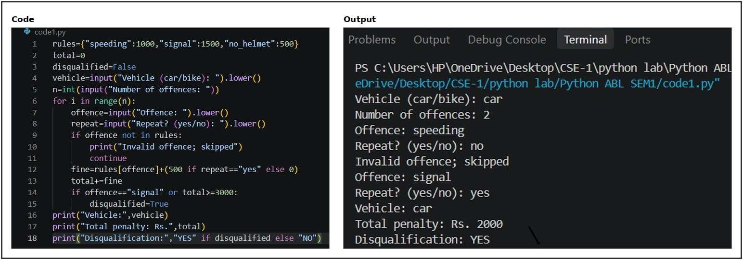
10. CONCLUSION
Program calculates total fines and checks the sample disqualification rule

QUESTION 22: Laboratory Chemical Inventory Validation
1. PROBLEM STATEMENT
Validate chemical category and quantity records and flag a sample incompatible pair.

2. OBJECTIVES
Read chemical name, category and quantity • Check category and maximum quantity • Flag unknown or invalid records • Check incompatible pair • Display report
3. ASSUMPTIONS
acid: corrosive, max 10 L; bleach: oxidizer, max 5 L; ethanol: flammable, max 8 L. Acid + bleach triggers sample warning.

4. ALGORITHM
1. Start → 2. Input chemical records → 3. Check known chemical/category → 4. Quantity within maximum? → 5. Mark valid or invalid → 6. Acid and bleach both present? → 7. Display report/warning → 8. Stop

5. FLOWCHART
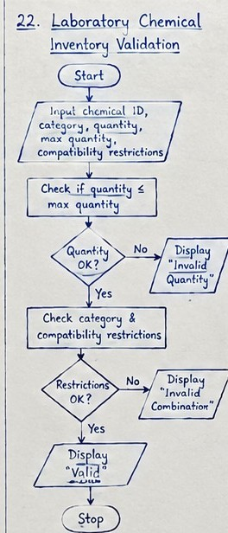

6. PSEUDOCODE
BEGIN
- Start
- Input chemical records
- Check known chemical/category
- Quantity within maximum?
- Mark valid or invalid
- Acid and bleach both present?
- Display report/warning
- Stop
END

7. PYTHON SOURCE CODE
rules={"acid":("corrosive",10),"bleach":("oxidizer",5),"ethanol":("flammable",8)} records=[] n=int(input("Number of records: ")) for i in range(n):
name=input("Chemical: ").lower() cat=input("Category: ").lower() qty=float(input("Quantity (L): ")) records.append((name,cat,qty)) for name,cat,qty in records:
if name not in rules: print(name,"UNKNOWN") elif cat!=rules[name][0] or qty>rules[name][1]: print(name,"INVALID") else: print(name,"VALID") names=[r[0] for r in records] if "acid" in names and "bleach" in names: print("WARNING: acid and bleach are incompatible")
8. TEST CASE
Sample: acid 4 L and bleach 2 L, with correct categories.

9. CODE AND OUTPUT SCREENSHOT
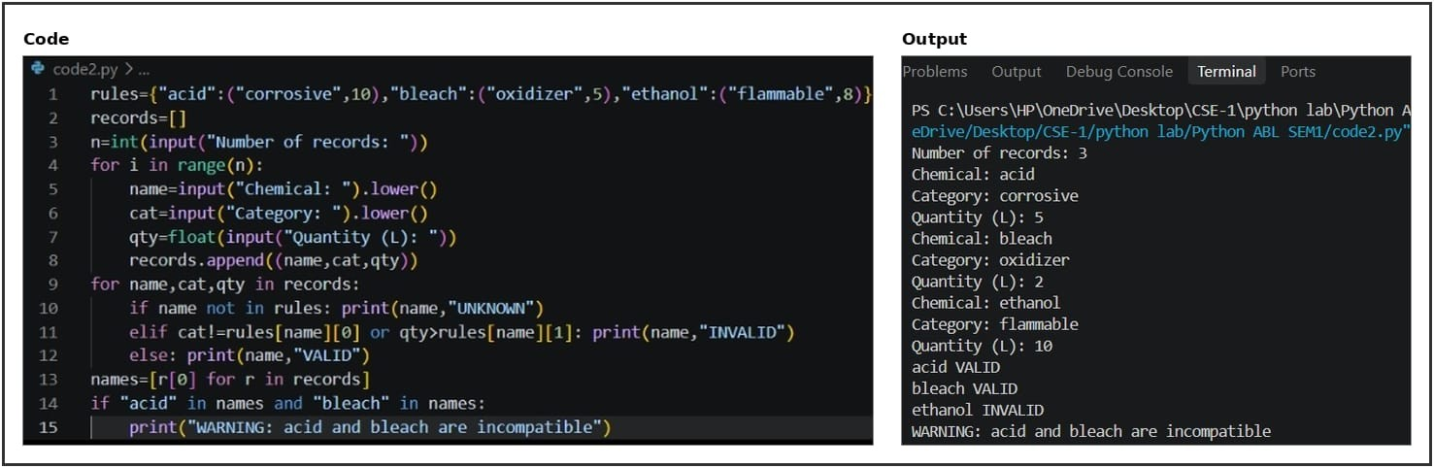
10. CONCLUSION
Program validates sample records and flags the specified incompatible pair.

QUESTION 23: Student Timetable Conflict Detection
1. PROBLEM STATEMENT
Detect overlapping course periods and courses assigned to unavailable rooms.

2. OBJECTIVES
Load course schedule and unavailable rooms • Compare every pair of classes • Detect overlap on the same day • Check unavailable rooms • Display timetable status
3. ASSUMPTIONS
Times are minutes after midnight. Two periods overlap if each starts before the other ends. R102 is unavailable in the sample.

4. ALGORITHM
1. Start → 2. Load schedules and unavailable rooms → 3. Compare same-day periods → 4. Periods overlap? → 5. Report time conflict → 6. Room unavailable? → 7. Display timetable status → 8. Stop

5. FLOWCHART
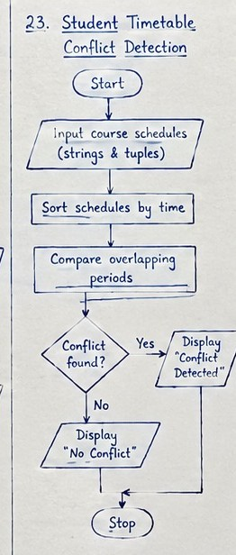

6. PSEUDOCODE
BEGIN
- Start
- Load schedules and unavailable rooms
- Compare same-day periods
- Periods overlap?
- Report time conflict
- Room unavailable?
- Display timetable status
- Stop
END

7. PYTHON SOURCE CODE
classes=[("Python","Mon",540,600,"R101"),("Maths","Mon",590,650,"R102"),("English","Tue",600,660,"R103")] unavailable=["R102"] bad=False for i in range(len(classes)): for j in range(i+1,len(classes)): a,b=classes[i],classes[j] if a[1]==b[1] and a[2]<b[3] and b[2]<a[3]:
print("Time conflict:",a[0],"and",b[0]); bad=True for course,day,start,end,room in classes: if room in unavailable:
print("Unavailable room:",room,"for",course); bad=True print("Timetable is","NOT valid" if bad else "valid")
8. TEST CASE
Sample: Python 09:00–10:00 and Maths 09:50–10:50 Monday; R102 unavailable.

9. CODE AND OUTPUT SCREENSHOT
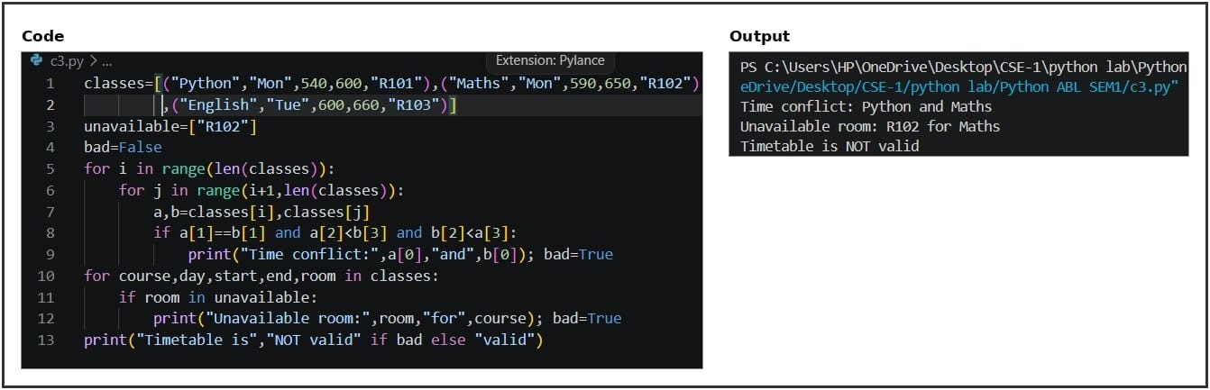
10. CONCLUSION
Program reports overlapping classes and unavailable rooms.

QUESTION 24: Courier Charge Optimization
- PROBLEM STATEMENT
Calculate sample courier prices and select the cheapest eligible service.
- OBJECTIVES
Read parcel details • Calculate volume • Check each service’s limits • Calculate eligible charges • Display cheapest service

3. ASSUMPTIONS
Sample rates: zone fees Rs.50/Rs.100/Rs.150; Rs.20 per kg; urgent surcharge Rs.100. Standard base Rs.40 (10 kg/50000 cm³); Express base Rs.80 (5 kg/30000 cm³). Restricted parcels rejected.

4. ALGORITHM
1. Start → 2. Input parcel details → 3. Calculate volume → 4. Check limits and restrictions → 5. Service eligible? → 6. Calculate charges and compare → 7. Display cheapest service → 8. Stop

5. FLOWCHART
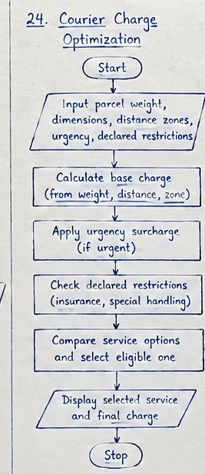

6. PSEUDOCODE
BEGIN
- Start
- Input parcel details
- Calculate volume
- Check limits and restrictions
- Service eligible?
- Calculate charges and compare
- Display cheapest service
- Stop
END

7. PYTHON SOURCE CODE
weight=float(input("Weight kg: ")) l=float(input("Length cm: ")); w=float(input("Width cm: ")); h=float(input("Height cm: ")) zone=int(input("Zone (1-3): ")) urgent=input("Urgent? (yes/no): ").lower() restricted=input("Restricted? (yes/no): ").lower() fees={1:50,2:100,3:150}; services={"Standard":(10,50000,40),"Express":(5,30000,80)} options=[]; volume=l*w*h if zone in fees and restricted=="no":
for name,(mw,mv,base) in services.items(): if weight<=mw and volume<=mv: cost=base+weight*20+fees[zone]+(100 if urgent=="yes" else 0) options.append((cost,name)) if options:
options.sort() for cost,name in options: print(name,"charge: Rs.",cost) print("Cheapest service:",options[0][1]) else: print("No eligible service")
8. TEST CASE
Sample: 2 kg, 20×10×10 cm, zone 1, not urgent/restricted.

9. CODE AND OUTPUT SCREENSHOT
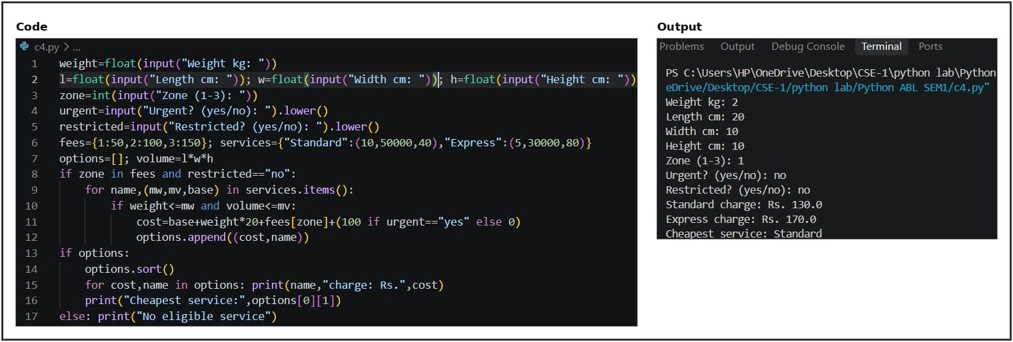
10. CONCLUSION
Program compares eligible sample services and selects the lowest charge.

QUESTION 25: Progressive Water Tariff Analysis
1. PROBLEM STATEMENT
Calculate household water bills using progressive slabs, fixed fees and a sample penalty.

2. OBJECTIVES
Read each household’s consumption • Apply each tariff slab progressively • Add fixed fee and penalty if needed • Display each bill • Find highest consumption

3. ASSUMPTIONS
Fixed fee Rs.50; first 10 units Rs.2/unit; next 10 units Rs.3/unit; above 20 units Rs.5/unit; usage above 30 units adds Rs.100. Sample rates only.

4. ALGORITHM
1. Start → 2. Input household and units → 3. Calculate slab-wise charge → 4. Add fixed fee/penalty → 5. Display bills → 6. Find highest usage →
7. Display highest consumption → 8. Stop

5. FLOWCHART
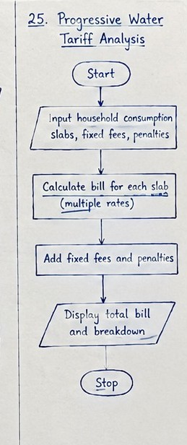

6. PSEUDOCODE
BEGIN
- Start
- Input household and units
- Calculate slab-wise charge
- Add fixed fee/penalty
- Display bills
- Find highest usage
- Display highest consumption
- Stop
END

7. PYTHON SOURCE CODE
def bill(u):
total=50+min(u,10)*2 if u>10: total+=min(u-10,10)*3 if u>20: total+=(u-20)*5 if u>30: total+=100 return total homes=[] n=int(input("Households: ")) for i in range(n):
name=input("Name: "); units=float(input("Units: ")) homes.append((name,units,bill(units))) for name,units,amount in homes:
print(name,"Units:",units,"Bill: Rs.",amount) if units>30: print("Penalty applied") if homes:
top=max(homes,key=lambda x:x[1])
print("Highest consumption:",top[0],top[1],"units")
8. TEST CASE
Sample: Asha uses 8 units; Ravi uses 35 units.

9. CODE AND OUTPUT SCREENSHOT
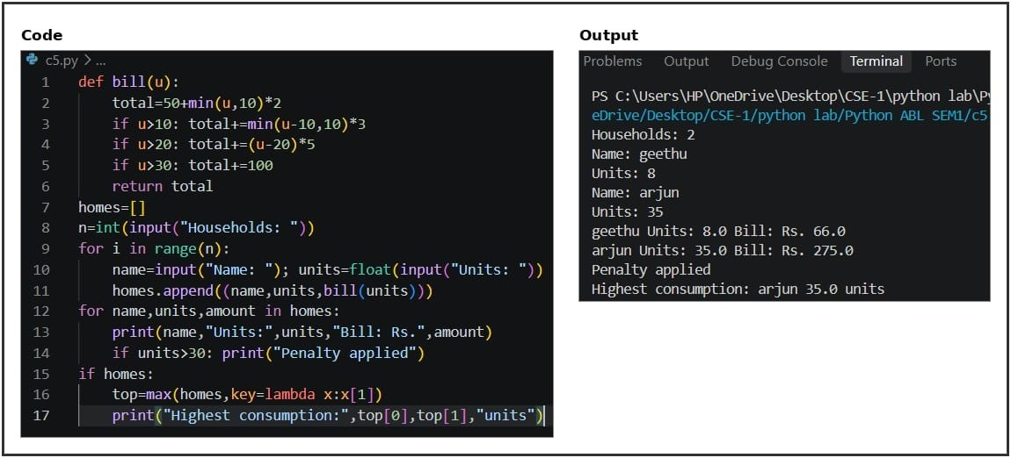
10. CONCLUSION
Program calculates progressive bills, applies the sample penalty and identifies highest use.

QUESTION 26: Nested Loop Examination Seating Generator
1. PROBLEM STATEMENT
Generate a seating chart with row/column labels, reserved seats and alternate empty seats.

2. OBJECTIVES
Read rows, columns and alternate rule • Use nested loops to visit seats • Mark reserved seats • Mark alternate seats empty if required • Display seating chart

3. ASSUMPTIONS
Row and column counts must be positive. Seat (1,2) is reserved in the sample. Alternate rule leaves even columns empty except reserved seats.

4. ALGORITHM
1. Start → 2. Input rows, columns and rule → 3. Visit seats using nested loops → 4. Seat reserved? → 5. Mark reserved seat → 6. Alternate seat empty? → 7. Mark empty/normal seat → 8. Display seating chart → 9. Stop

5. FLOWCHART
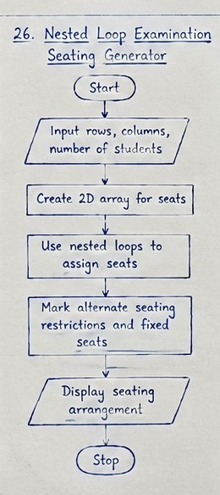

6. PSEUDOCODE
BEGIN
- Start
- Input rows, columns and rule
- Visit seats using nested loops
- Seat reserved?
- Mark reserved seat
- Alternate seat empty?
- Mark empty/normal seat
- Display seating chart
- Stop
END

7. PYTHON SOURCE CODE
rows=int(input("Rows: ")); cols=int(input("Seats per row: ")) alternate=input("Alternate seats empty? (yes/no): ").lower() reserved={(1,2)} if rows<=0 or cols<=0:
print("Rows and columns must be positive") else: for r in range(1,rows+1): for c in range(1,cols+1):
if (r,c) in reserved: seat="RES" elif alternate=="yes" and c%2==0: seat="EMPTY" else: seat=f"R{r}C{c}" print(f"{seat:8}",end="") print()
8. TEST CASE
Sample: 2 rows, 3 seats each, alternate seating enabled.

9. CODE AND OUTPUT SCREENSHOT
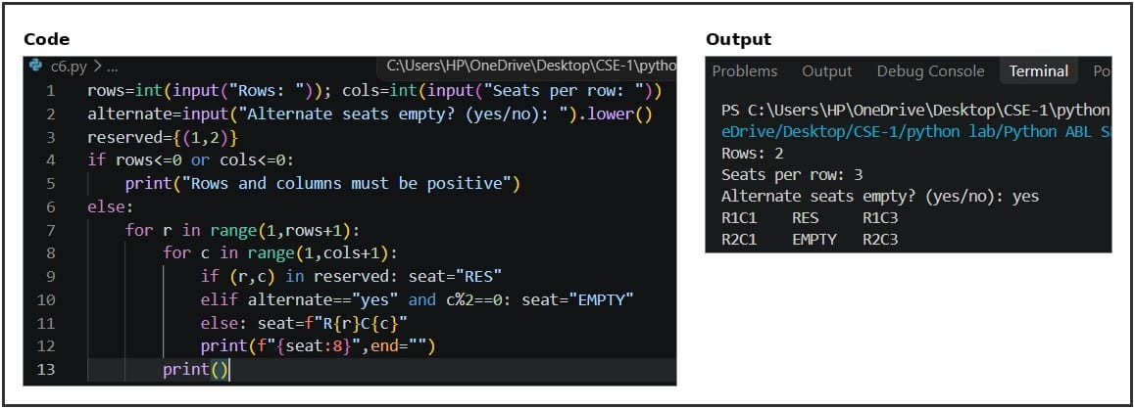
10. CONCLUSION
Program displays the seating plan while applying reserved and alternate seating rules.

QUESTION 27: Advanced Numeric Pattern Generator
1. PROBLEM STATEMENT
Validate a size and generate a symmetric hollow diamond pattern.

2. OBJECTIVES
Read the diamond size • Reject non-positive size • Print upper hollow-diamond rows • Print lower rows in reverse • Display pattern
3. ASSUMPTIONS
This solution prints a hollow star diamond as one valid interpretation of the pattern task. Size must be a positive integer.

4. ALGORITHM
1. Start → 2. Input diamond size → 3. Is size positive? → 4. If no, display error → 5. Print upper half → 6. Print lower half → 7. Display diamond → 8. Stop

5. FLOWCHART
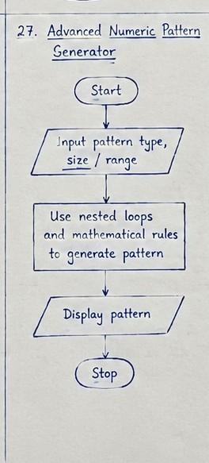

6. PSEUDOCODE
BEGIN
- Start
- Input diamond size
- Is size positive?
- If no, display error
- Print upper half
- Print lower half
- Display diamond
- Stop
END

7. PYTHON SOURCE CODE
n=int(input("Diamond size: ")) if n<=0:
print("Enter a positive size") else: for i in range(1,n+1):
s=" "*(n-i) print(s+"*" if i==1 else s+"*"+" "*(2*i-3)+"*") for i in range(n-1,0,-1):
s=" "*(n-i)
print(s+"*" if i==1 else s+"*"+" "*(2*i-3)+"*")
8. TEST CASE
Sample: diamond size 3.

9. CODE AND OUTPUT SCREENSHOT
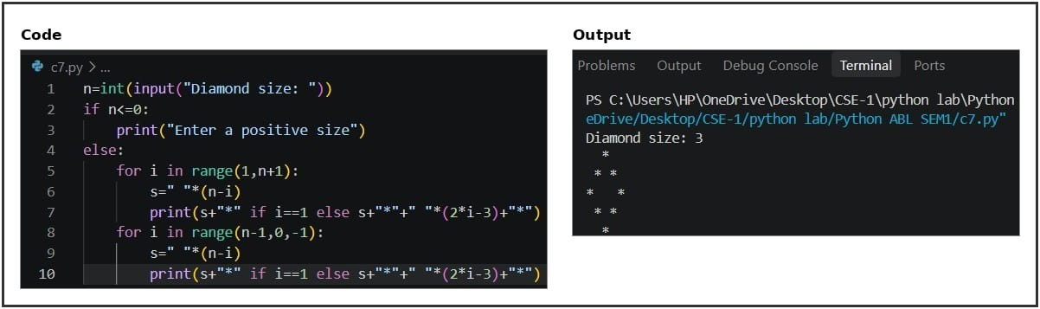
10. CONCLUSION
Program validates the size and prints a symmetric hollow diamond.

QUESTION 28: Repeated Transaction Detection
1. PROBLEM STATEMENT
Detect duplicate transaction IDs and amounts above a sample threshold.

2. OBJECTIVES
Load transaction IDs and amounts • Track IDs already seen • Flag repeated IDs • Flag amounts above threshold • Display suspicious transactions

3. ASSUMPTIONS
Sample transactions are included in the code. Threshold is Rs.2000. An item is suspicious if its ID repeats or its amount exceeds the threshold.

4. ALGORITHM
1. Start → 2. Load transaction list → 3. Check ID in seen set → 4. Duplicate ID? → 5. Flag duplicate → 6. Amount above threshold? → 7. Display suspicious transactions → 8. Stop

5. FLOWCHART
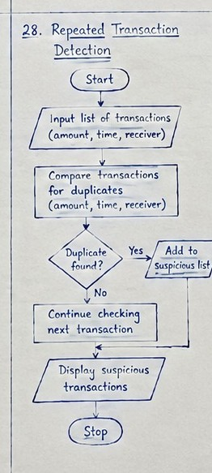

6. PSEUDOCODE
BEGIN
- Start
- Load transaction list
- Check ID in seen set
- Duplicate ID?
- Flag duplicate
- Amount above threshold?
- Display suspicious transactions
- Stop
END

7. PYTHON SOURCE CODE
transactions=[("T101",500),("T102",2500),("T101",500),("T103",1200)] threshold=2000 seen=set() for tid,amount in transactions:
reasons=[] if tid in seen: reasons.append("duplicate ID") else: seen.add(tid) if amount>threshold: reasons.append("amount above threshold") if reasons: print(tid,"Rs.",amount,"-",", ".join(reasons))
8. TEST CASE
Sample transactions include repeated T101 and T102 with amount Rs.2500.

9. CODE AND OUTPUT SCREENSHOT
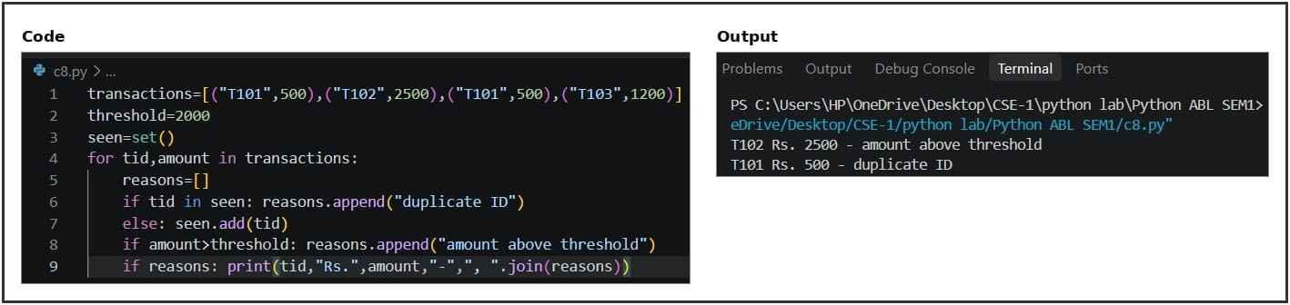
10. CONCLUSION
Program flags duplicate transaction IDs and amounts above the sample threshold.

QUESTION 29: Password Policy Validation Engine
1. PROBLEM STATEMENT
Check password length, character categories, repetition and prohibited text.

2. OBJECTIVES
Read sample password • Check minimum length and character groups • Check three repeated characters • Check prohibited substring • Display failures or valid status

3. ASSUMPTIONS
Sample rules: minimum 8 characters, uppercase, lowercase, digit and special character required; three identical consecutive characters and the word “password” are prohibited.

4. ALGORITHM
1. Start → 2. Input password → 3. Check length and character groups → 4. Check repeated characters → 5. Check prohibited substring → 6. All rules satisfied? → 7. Display status → 8. Stop

5. FLOWCHART
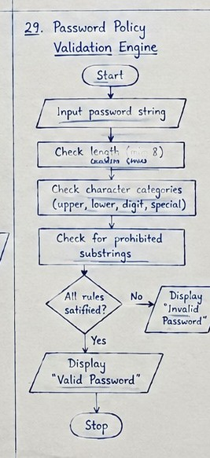

6. PSEUDOCODE
BEGIN
- Start
- Input password
- Check length and character groups
- Check repeated characters
- Check prohibited substring
- All rules satisfied?
- Display status
- Stop
END

7. PYTHON SOURCE CODE
p=input("Sample password: ") failed=[] if len(p)<8: failed.append("Minimum length is 8") if not any(c.isupper() for c in p): failed.append("Add uppercase") if not any(c.islower() for c in p): failed.append("Add lowercase") if not any(c.isdigit() for c in p): failed.append("Add digit") if not any(not c.isalnum() for c in p): failed.append("Add special character") if any(p[i]==p[i+1]==p[i+2] for i in range(len(p)-2)):
failed.append("Avoid 3 repeated characters") if "password" in p.lower(): failed.append("Avoid word password") if failed:
print("Password does not meet policy:") for item in failed: print("-",item) else: print("Password meets sample policy")
8. TEST CASE
Sample password: abc.

9. CODE AND OUTPUT SCREENSHOT
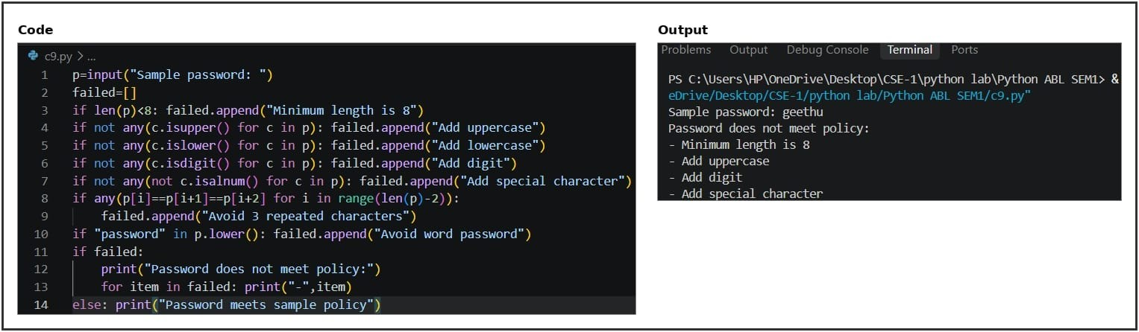
10. CONCLUSION
Program lists all sample password rules that are not satisfied.

QUESTION 30: Student Email and Identifier Validation
1. PROBLEM STATEMENT
Validate an email-like address and student registration ID using basic formatting rules.

2. OBJECTIVES
Read email and student ID • Check exactly one @ symbol • Check username and domain • Check student ID characters • Display errors or valid status

3. ASSUMPTIONS
Email requires exactly one @, a username, and a domain containing a dot; spaces are rejected. Student ID allows letters, digits and hyphens. Format checking does not prove existence.
4. ALGORITHM
1. Start → 2. Input email and student ID → 3. Validate email format → 4. Validate ID pattern → 5. Both valid? → 6. Display result → 7. Stop

5. FLOWCHART
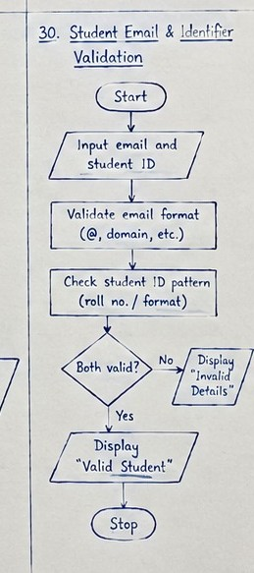

6. PSEUDOCODE
BEGIN
- Start
- Input email and student ID
- Validate email format
- Validate ID pattern
- Both valid?
- Display result
- Stop
END

7. PYTHON SOURCE CODE
email=input("Student email: ").strip() sid=input("Student ID: ").strip() errors=[] if email.count("@")!=1: errors.append("Email must contain exactly one @") else:
user,domain=email.split("@") if not user: errors.append("Username missing") if not domain or "." not in domain: errors.append("Invalid domain") if " " in email: errors.append("Email must not contain spaces") if not sid: errors.append("Student ID missing") elif not all(c.isalnum() or c=="-" for c in sid): errors.append("Invalid student ID characters") if errors:
print("Invalid details:") for e in errors: print("-",e) else: print("Email and student ID are valid")
8. TEST CASE
Sample: geetha@example.com and CSE-102.

9. CODE AND OUTPUT SCREENSHOT
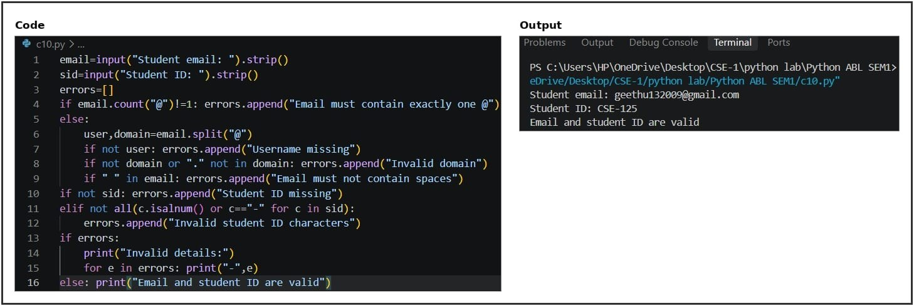

10. CONCLUSION
Program validates basic email and student-ID formatting.

