WEB DEVELOPMENT PROJECT EXPLANATIONS
Projects 6, 8 and 9
6. Online Shopping Website
An e-commerce website for browsing and buying products.
8. Online Food Ordering Website
A website for discovering restaurants and ordering food.
9. Bakery and Cake Shop Website
A website for showcasing bakery products and custom cakes.

6.Online Shopping Website

code:
<!DOCTYPE html>
<html>
<head>
<title>Online Shopping Website</title>
<style>
* {
margin: 0;
padding: 0;
box-sizing: border-box;
}
body {
font-family: Arial, sans-serif;
background-color: #f4f4f4;
}

/* Navigation Bar */
header {
background-color: #222;
color: white;
padding: 20px;
text-align: center;
}

nav {
background-color: #ff6600;
padding: 15px;
text-align: center;
}

nav a {
color: white;
text-decoration: none;
margin: 15px;
font-weight: bold;
}

/* Promotional Banner */
.banner {
background: linear-gradient(to right, orange, red);
color: white;
text-align: center;
padding: 40px;
}

.banner h2 {
font-size: 30px;
margin-bottom: 10px;
}

/* Categories */
.categories {
text-align: center;
padding: 20px;
}

.categories span {
background-color: #222;
color: white;
padding: 10px 18px;
margin: 5px;
display: inline-block;
border-radius: 5px;
}

/* Product Grid */
.products {
display: grid;
grid-template-columns: repeat(auto-fit, minmax(220px, 1fr));
gap: 20px;
padding: 25px;
}

.card {
background-color: white;
text-align: center;
padding: 15px;
border-radius: 10px;
box-shadow: 0 2px 8px gray;
}

.card img {
width: 100%;
height: 180px;
object-fit: contain;
}

.card h3 {
margin: 10px;
}

.price {
color: green;
font-size: 20px;
font-weight: bold;
}

.discount {
color: red;
margin: 8px;
}

.rating {
color: orange;
margin: 8px;
}

button {
background-color: #ff6600;
color: white;
border: none;
padding: 10px 20px;
margin-top: 10px;
border-radius: 5px;
cursor: pointer;
}

button:hover {
background-color: green;
}

/* Footer */
footer {
background-color: #222;
color::white;
text-align: center;
padding: 20px;
margin-top: 20px;
}

/* Mobile Responsive */
@media (max-width: 600px) {
nav a {
display: inline-block;
margin: 8px;
}

.banner h2 {
font-size: 23px;
}
}
</style>
</head>

<body>

<!-- Header -->
<header>
<h1>🛍️ My Shopping Store</h1>
<p>Your Favourite Online Shopping Destination</p>
</header>

<!-- Navigation -->
<nav>
<a href="#">Home</a>
<a href="#categories">Categories</a>
<a href="#products">Products</a>
<a href="#contact">Contact</a>
<a href="#">Cart 🛒</a>
</nav>

<!-- Promotional Banner -->
<section class="banner">
<h2>MEGA SHOPPING SALE!</h2>
<p>Get Up To 50% OFF on Selected Products</p>
<button onclick="alert('Welcome to Mega Sale!')">
Shop Now
</button>
</section>

<!-- Categories -->
<section class="categories" id="categories">
<h2>Product Categories</h2>
<br>
<span>Electronics</span>
<span>Fashion</span>
<span>Footwear</span>
<span>Accessories</span>
</section>

<!-- Products -->
<h2 style="text-align:center;">Our Products</h2>

<section class="products" id="products">

<div class="card">
<img src="https://images.unsplash.com/photo-1505740420928-5e560c06d30e?w=400" alt="Headphones">
<h3>Wireless Headphones</h3>
<p>High quality sound with comfortable design.</p>
<p class="price">₹999</p>
<p class="discount">30% OFF</p>
<p class="rating">⭐⭐⭐⭐⭐ (4.5)</p>
<button onclick="alert('Headphones added to cart!')">Add to Cart</button>
</div>

<div class="card">
<img src="https://images.unsplash.com/photo-1523275335684-37898b6baf30?w=400" alt="Watch">
<h3>Smart Watch</h3>
<p>Stylish watch with smart features.</p>
<p class="price">₹1499</p>
<p class="discount">25% OFF</p>
<p class="rating">⭐⭐⭐⭐⭐ (4.7)</p>
<button onclick="alert('Watch added to cart!')">Add to Cart</button>
</div>

<div class="card">
<img src="https://images.unsplash.com/photo-1542291026-7eec264c27ff?w=400" alt="Shoes">
<h3>Sports Shoes</h3>
<p>Comfortable shoes for everyday use.</p>
<p class="price">₹1199</p>
<p class="discount">40% OFF</p>
<p class="rating">⭐⭐⭐⭐ (4.2)</p>
<button onclick="alert('Shoes added to cart!')">Add to Cart</button>
</div>

<div class="card">
<img src="https://images.unsplash.com/photo-1548036328-c9fa89d128fa?w=400" alt="Handbag">
<h3>Fashion Handbag</h3>
<p>Beautiful handbag with modern design.</p>
<p class="price">₹899</p>
<p class="discount">20% OFF</p>
<p class="rating">⭐⭐⭐⭐⭐ (4.6)</p>
<button onclick="alert('Handbag added to cart!')">Add to Cart</button>
</div>

</section>

<!-- Footer -->
<footer id="contact">
<h3>My Shopping Store</h3>
<p>Email: myshopping@gmail.com</p>
<p>Contact: 9876543210</p>
<p>© 2026 My Shopping Store. All Rights Reserved.</p>
</footer>

</body>
</html>

Output:
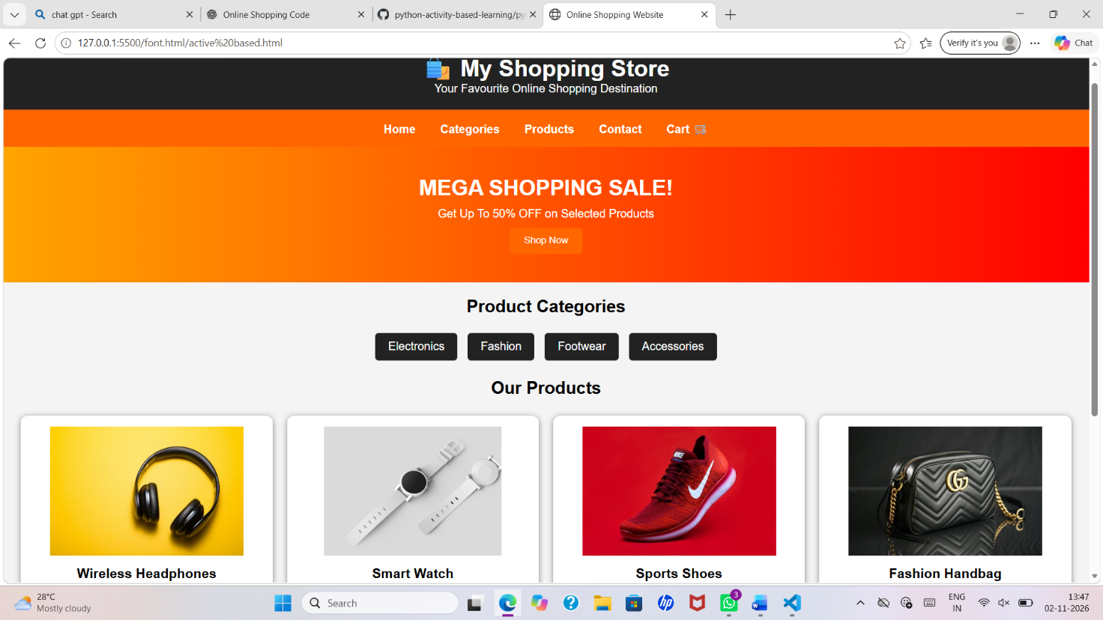

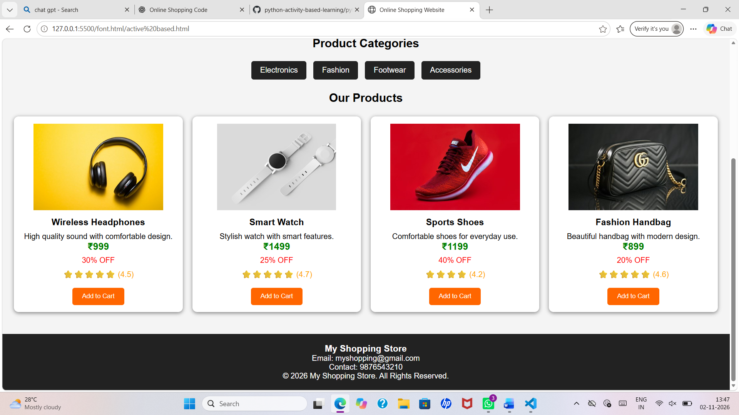

8.Online food Ordering website

Code:

<!DOCTYPE html>
<html>
<head>
<title>Foodie - Online Food Ordering</title>

<style>
* {
margin: 0;
padding: 0;
box-sizing: border-box;
}

body {
font-family: Arial, sans-serif;
background-color: #fff8f0;
}

header {
background-color: #ff5722;
color: white;
padding: 20px;
text-align: center;
}

nav {
background-color: #333;
padding: 15px;
text-align: center;
}

nav a {
color: white;
text-decoration: none;
margin: 15px;
font-size: 16px;
}

.banner {
background: linear-gradient(
rgba(0,0,0,0.5),
rgba(0,0,0,0.5)
), url("https://images.unsplash.com/photo-1504674900247-0877df9cc836?w=1200");
background-size: cover;
background-position: center;
color: white;
text-align: center;
padding: 80px 20px;
}

.banner h1 {
font-size: 40px;
margin-bottom: 15px;
}

.offer {
background-color: #ffe0b2;
text-align: center;
padding: 20px;
color: #d84315;
}

h2 {
text-align: center;
margin: 30px;
color: #e64a19;
}

.menu {
display: grid;
grid-template-columns: repeat(
auto-fit, minmax(220px, 1fr)
);
gap: 25px;
padding: 20px 40px;
}

.card {
background-color: white;
border-radius: 12px;
overflow: hidden;
text-align: center;
box-shadow: 0 3px 10px #ccc;
padding-bottom: 20px;
}

.card img {
width: 100%;
height: 180px;
object-fit: cover;
}

.card h3 {
margin: 12px;
}

.card p {
color: #555;
margin: 8px;
}

.price {
color: #e64a19;
font-weight: bold;
font-size: 20px;
}

button {
background-color: #ff5722;
color: white;
border: none;
padding: 10px 20px;
border-radius: 5px;
cursor: pointer;
margin-top: 10px;
}

button:hover {
background-color: #d84315;
}

.reviews {
background-color: #ffe0b2;
padding: 25px;
text-align: center;
}

footer {
background-color: #333;
color: white;
text-align: center;
padding: 20px;
margin-top: 20px;
}

@media(max-width: 600px) {
nav a {
display: inline-block;
margin: 8px;
}

.banner h1 {
font-size: 28px;
}

.menu {
padding: 15px;
}
}
</style>
</head>

<body>

<header>
<h1>🍕 FOODIE</h1>
<p>Delicious Food Delivered To Your Doorstep!</p>
</header>

<nav>
<a href="#home">Home</a>
<a href="#menu">Menu</a>
<a href="#offers">Offers</a>
<a href="#reviews">Reviews</a>
<a href="#contact">Contact</a>
</nav>

<section class="banner" id="home">
<h1>Welcome to Foodie!</h1>
<p>Enjoy tasty and fresh food anytime.</p>
<button onclick="document.getElementById('menu').scrollIntoView()">
Order Now
</button>
</section>

<section class="offer" id="offers">
<h2>🎉 Special Offer!</h2>
<h3>Get 20% OFF on Your First Order!</h3>
<p>Use Coupon Code: FOOD20</p>
</section>

<h2>Our Food Menu</h2>

<section class="menu" id="menu">

<div class="card">
<img src="https://images.unsplash.com/photo-1565299624946-b28f40a0ae38?w=500"
alt="Pizza">
<h3>Cheese Pizza</h3>
<p>Delicious cheesy pizza with fresh toppings.</p>
<p class="price">₹199</p>
<button onclick="alert('Pizza added to your order!')">
Order Now
</button>
</div>

<div class="card">
<img src="https://images.unsplash.com/photo-1568901346375-23c9450c58cd?w=500"
alt="Burger">
<h3>Veg Burger</h3>
<p>Fresh burger with vegetables and cheese.</p>
<p class="price">₹99</p>
<button onclick="alert('Burger added to your order!')">
Order Now
</button>
</div>

<div class="card">
<img src="https://images.unsplash.com/photo-1555939594-58d7cb561ad1?w=500"
alt="Biryani">
<h3>Chicken Biryani</h3>
<p>Spicy and tasty traditional biryani.</p>
<p class="price">₹249</p>
<button onclick="alert('Biryani added to your order!')">
Order Now
</button>
</div>

<div class="card">
<img src="https://images.unsplash.com/photo-1569718212165-3a8278d5f624?w=500"
alt="Noodles">
<h3>Veg Noodles</h3>
<p>Hot noodles with fresh vegetables.</p>
<p class="price">₹149</p>
<button onclick="alert('Noodles added to your order!')">
Order Now
</button>
</div>

<div class="card">
<img src="https://images.unsplash.com/photo-1578985545062-69928b1d9587?w=500"
alt="Cake">
<h3>Chocolate Cake</h3>
<p>Sweet and delicious chocolate cake.</p>
<p class="price">₹179</p>
<button onclick="alert('Cake added to your order!')">
Order Now
</button>
</div>

<div class="card">
<img src="https://images.unsplash.com/photo-1579954115545-a95591f28bfc?w=500"
alt="Ice Cream">
<h3>Ice Cream</h3>
<p>Cool and creamy dessert.</p>
<p class="price">₹79</p>
<button onclick="alert('Ice Cream added to your order!')">
Order Now
</button>
</div>

</section>

<section class="reviews" id="reviews">
<h2>Customer Reviews</h2>
<p>⭐⭐⭐⭐⭐ "Very tasty food and fast delivery!"</p>
<p>⭐⭐⭐⭐⭐ "Good quality and affordable prices."</p>
<p>⭐⭐⭐⭐ "Excellent service and delicious food."</p>
</section>

<footer id="contact">
<h3>Contact Us</h3>
<p>Email: foodie@gmail.com</p>
<p>Phone: 9876543210</p>
<p>© 2026 Foodie. All Rights Reserved.</p>
</footer>

</body>
</html>

Out put:
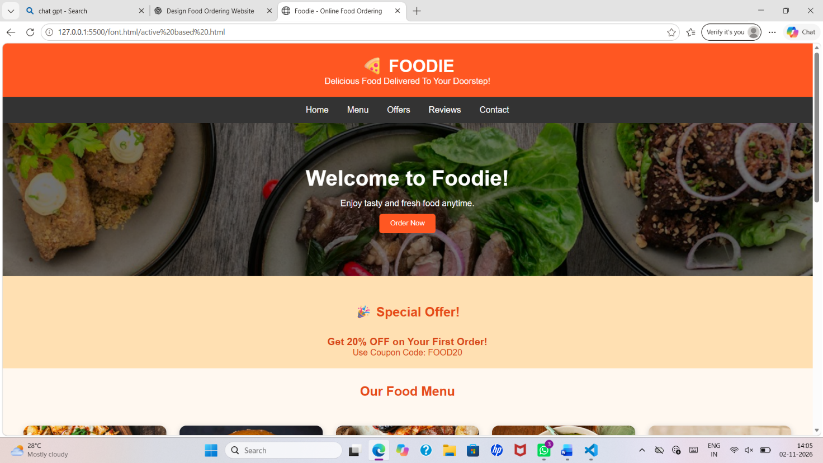

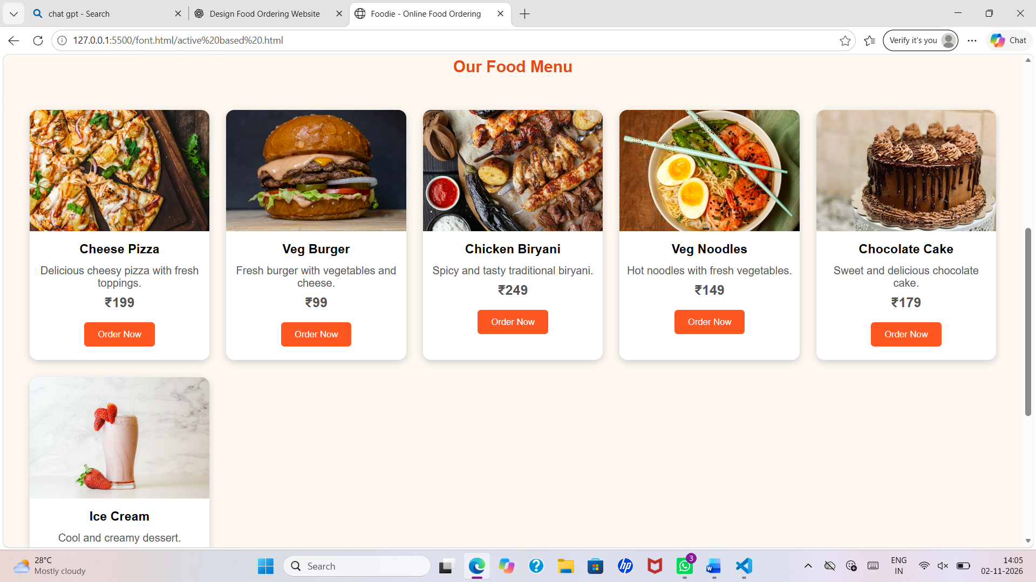

9.Bakery and Cake Shop Website

Code:

<!DOCTYPE html>
<html>
<head>
<title>Sweet Treats Bakery</title>

<style>
* {
margin: 0;
padding: 0;
box-sizing: border-box;
}

body {
font-family: Arial, sans-serif;
background-color: #fff5f5;
color: #4a2525;
}

header {
background-color: #e88b9c;
color: white;
text-align: center;
padding: 25px;
}

header h1 {
font-size: 35px;
}

nav {
background-color: #713c45;
padding: 15px;
text-align: center;
}

nav a {
color: white;
text-decoration: none;
margin: 15px;
font-weight: bold;
}

nav a:hover {
color: #ffc6d0;
}

.hero {
text-align: center;
padding: 60px 20px;
background-color: #ffe0e6;
}

.hero h2 {
font-size: 32px;
margin-bottom: 15px;
}

.hero p {
font-size: 18px;
}

.offer {
background-color: #713c45;
color: white;
text-align: center;
padding: 20px;
margin: 20px;
border-radius: 10px;
}

.container {
padding: 30px;
text-align: center;
}

.container h2 {
color: #b94e68;
margin-bottom: 25px;
}

.products {
display: grid;
grid-template-columns:
repeat(auto-fit, minmax(220px, 1fr));
gap: 25px;
}

.card {
background-color: white;
border-radius: 12px;
padding: 15px;
box-shadow: 0 3px 10px #d9b6b6;
}

.card img {
width: 100%;
height: 180px;
object-fit: cover;
border-radius: 10px;
}

.card h3 {
margin: 12px;
color: #a83f58;
}

.price {
color: #6b303d;
font-weight: bold;
margin: 10px;
}

button {
background-color: #e88b9c;
color: white;
border: none;
padding: 10px 20px;
border-radius: 20px;
cursor: pointer;
}

button:hover {
background-color: #713c45;
}

.contact {
background-color: #ffe0e6;
padding: 30px;
text-align: center;
line-height: 2;
}

footer {
background-color: #713c45;
color: white;
text-align: center;
padding: 20px;
}

@media(max-width: 600px) {
nav a {
display: inline-block;
margin: 8px;
}

.hero h2 {
font-size: 25px;
}
}
</style>
</head>

<body>

<header>
<h1>Sweet Treats Bakery</h1>
<p>Freshly Baked Happiness Every Day!</p>
</header>

<nav>
<a href="#home">Home</a>
<a href="#cakes">Cakes</a>
<a href="#pastries">Pastries</a>
<a href="#cookies">Cookies</a>
<a href="#contact">Contact</a>
</nav>

<section class="hero" id="home">
<h2>Welcome to Sweet Treats Bakery!</h2>
<p>Delicious Cakes, Pastries and Cookies Made with Love.</p>
<br>
<button onclick="alert('Welcome to Sweet Treats Bakery!')">
Explore Now
</button>
</section>

<section class="offer">
<h2>Special Seasonal Offer!</h2>
<p>Get 20% OFF on all cakes this season!</p>
</section>

<section class="container" id="cakes">
<h2>Our Delicious Cakes</h2>

<div class="products">

<div class="card">
<img src="https://images.unsplash.com/photo-1578985545062-69928b1d9587?w=500">
<h3>Chocolate Cake</h3>
<p>Rich and creamy chocolate cake.</p>
<p class="price">₹550</p>
<button onclick="alert('Chocolate Cake selected!')">Order Now</button>
</div>

<div class="card">
<img src="https://images.unsplash.com/photo-1565958011703-44f9829ba187?w=500">
<h3>Strawberry Cake</h3>
<p>Fresh strawberry cream cake.</p>
<p class="price">₹650</p>
<button onclick="alert('Strawberry Cake selected!')">Order Now</button>
</div>

<div class="card">
<img src="https://images.unsplash.com/photo-1464349095431-e9a21285b5f3?w=500">
<h3>Birthday Cake</h3>
<p>Beautiful cake for celebrations.</p>
<p class="price">₹800</p>
<button onclick="alert('Birthday Cake selected!')">Order Now</button>
</div>

</div>
</section>

<section class="container" id="pastries">
<h2>Our Pastries</h2>

<div class="products">

<div class="card">
<img src="https://images.unsplash.com/photo-1488477181946-6428a0291777?w=500">
<h3>Chocolate Pastry</h3>
<p>Soft and delicious pastry.</p>
<p class="price">₹90</p>
<button onclick="alert('Chocolate Pastry selected!')">Order Now</button>
</div>

<div class="card">
<img src="https://images.unsplash.com/photo-1486427944299-d1955d23e34d?w=500">
<h3>Cupcakes</h3>
<p>Sweet and colourful cupcakes.</p>
<p class="price">₹70</p>
<button onclick="alert('Cupcakes selected!')">Order Now</button>
</div>

</div>
</section>

<section class="container" id="cookies">
<h2>Cookies Collection</h2>

<div class="products">

<div class="card">
<img src="https://images.unsplash.com/photo-1499636136210-6f4ee915583e?w=500">
<h3>Chocolate Cookies</h3>
<p>Crunchy chocolate chip cookies.</p>
<p class="price">₹120</p>
<button onclick="alert('Cookies selected!')">Order Now</button>
</div>

<div class="card">
<img src="https://images.unsplash.com/photo-1558961363-fa8fdf82db35?w=500">
<h3>Butter Cookies</h3>
<p>Fresh and tasty butter cookies.</p>
<p class="price">₹100</p>
<button onclick="alert('Butter Cookies selected!')">Order Now</button>
</div>

</div>
</section>

<section class="container">
<h2>Custom Cake Designs</h2>
<div class="products">

<div class="card">
<img src="https://images.unsplash.com/photo-1535141192574-5d4897c12636?w=500">
<h3>Wedding Cake</h3>
<p>Beautiful cakes for special weddings.</p>
<p class="price">Starting ₹2500</p>
</div>

<div class="card">
<img src="https://images.unsplash.com/photo-1550617931-e17a7b70dce2?w=500">
<h3>Designer Cake</h3>
<p>Custom cakes made as you wish.</p>
<p class="price">Starting ₹1200</p>
</div>

</div>
</section>

<section class="contact" id="contact">
<h2>Contact Us</h2>
<p>Bakery Name: Sweet Treats Bakery</p>
<p>Address: MG Road, Vijayawada, Andhra Pradesh</p>
<p>Phone: +91 98765 43210</p>
<p>Email: sweettreats@gmail.com</p>
<p>Opening Hours: 9 AM - 9 PM</p>
</section>

<footer>
<p>© 2026 Sweet Treats Bakery</p>
<p>Made with Love ❤️</p>
</footer>

</body>
</html>

Out put:


