Exam Preparation with Adaptive Quizzes
A Project Report submitted in partial fulfilment of the requirements for the award of the degree of
BACHELOR OF TECHNOLOGY
In
DEPARTMENT OF COMPUTER SCIENCE AND ENGINEERING
Course: DATABASE SYSTEMS ENGINEERING AND DISTRIBUTED BACKEND DEVELOPMENT
By
TANVITHA – 2520030385
HEMASWI – 2520030069
VEDIKA – 2520030350
TEAM – 26
Under the Esteemed Guidance of
Dr. D. Ramya Krishna

Department of Computer Science and Engineering



K L (Deemed to be) University
DEPARTMENT OF COMPUTER SCIENCE AND ENGINEERING
Declaration
The Project Report entitled “Design and Development of an Exam Preparation System with Adaptive Quizzes” is a record of Bonafide work of TANVITHA – 2520030385, HEMASWI – 2520030069, VEDIKA – 2520030350 submitted in partial fulfilment for the award of B. Tech in Computer Science and Engineering to K L (Deemed to be) University. The results embodied in this report have not been copied from any other department, university or institute.

TANVITHA – 2520030385
HEMASWI – 2520030069
VEDIKA – 2520030350

K L (Deemed to be) University
DEPARTMENT OF COMPUTER SCIENCE AND ENGINEERING
CERTIFICATE
This is to certify that the project report entitled “Design and Development of an Exam Preparation System with Adaptive Quizzes” is a Bonafide work done and submitted by TANVITHA – 2520030385, HEMASWI – 2520030069, VEDIKA – 2520030350 in partial fulfilment of the requirements for the award of the degree of BACHELOR OF TECHNOLOGY in the Department of Computer Science and Engineering, K L (Deemed to be University), during the academic year 2026-2027.

Signature of the Guide

Signature of the Course Coordinator | Signature of the HOD

ACKNOWLEDGEMENT
The success of this project would not have been possible without the timely help and guidance of many people. We express our sincere thanks to all those who assisted us in one way or another in the completion of this work.
Our greatest appreciation goes to our Course Coordinator Dr. R. Sateesh Kumar our project guide, Dr. D. Ramya Krishna Department of Computer Science and Engineering, whose tremendous support, encouragement and guidance cannot be expressed in words.
We express our gratitude to the Head of the Department of Computer Science and Engineering for providing us with adequate facilities, ways and means by which we were able to complete this project for the course Database Systems Engineering and Distributed Backend Development.
We thank all the teaching and non-teaching staff members who assisted us directly or indirectly in the successful completion of this project. Finally, we sincerely thank our parents, friends and classmates for their kind help and cooperation during our work.

TANVITHA – 2520030385
HEMASWI – 2520030069
VEDIKA – 2520030350

ABSTRACT
Traditional exam preparation relies on static question banks and fixed-difficulty mock tests that treat every student identically, regardless of individual strengths and weaknesses. Learners repeat questions they have already mastered, discover weak topics only in the final exam, and receive feedback that is delayed and generic.
This project, Exam Preparation with Adaptive Quizzes, proposes an adaptive quiz system that continuously analyses a learner's responses to select questions matched to their current proficiency. It combines topic-wise performance tracking with an adaptive difficulty engine to identify weak areas in real time and to steer practice toward them.
A student logs in and takes a fixed diagnostic quiz. The result is evaluated against a threshold for each topic. Learners who score well continue to the next quiz or level; learners who score low see their result with a call to action to practise more, and are served a question bank filtered to weak topics only, followed by an optional retake to re-check improvement.
The system is built with React / React Native for the web and mobile interface, Python (Flask / Django) for backend and API services, Scikit-learn / TensorFlow for the adaptive difficulty model, MySQL / Firebase for student profiles and the question bank, and AWS / Google Cloud for hosting, with Git and GitHub for version control.
The result is a personalised, efficient revision experience that replaces one-size-fits-all practice with a targeted path, improving retention, saving preparation time and giving learners clear visibility into their exam readiness.
Project goals
3x faster targeting of weak topics | 100% personalised question sequencing | Real-time feedback and progress insight

INDEX
S. No | Chapters | Topics | Page no.
Acknowledgement
Abstract
1 | Introduction | 1.1 Background of the project  1.2 Problem statement  1.3 Scope of the project  1.4 Objectives  1.5 Importance of the application  1.6 Target users / audience | 7–10
2 | System Requirements | 2.1 Hardware requirements  2.2 Software requirements  2.3 Development tools and frameworks | 11–12
3 | Technology Stack | 3.1 Front-end design  3.2 Back-end design  3.3 Database design  3.4 Adaptive engine and ML libraries  3.5 Version control  3.6 Cloud hosting and external services | 13–15
4 | System Architecture | 4.1 High-level architecture diagram  4.2 Description of each layer  4.3 Deployment architecture (cloud, local, CI/CD) | 16–18
5 | Design | 5.1 Existing vs proposed system  5.2 ER diagram / database schema  5.3 Data flow diagram  5.4 Adaptive algorithm design | 19–22
6 | Implementation | 6.1 Module-wise implementation  6.2 Front-end logic  6.3 API integration  6.4 Authentication and authorisation | 23–25
7 | Features | 7.1 List of main features  7.2 How each feature works | 26–27
8 | Testing | 8.1 Postman testing  8.2 Integration testing  8.3 Tools used for testing  8.4 Test cases and expected results | 28–29
9 | Deployment | 9.1 Steps to deploy  9.2 Environment configuration  9.3 Hosting of frontend and backend | 30
10 | Challenges and Limitations | 10.1 Design and development challenges  10.2 Solutions applied  10.3 Current limitations | 31
11 | Future Enhancements | 11.1 Planned features  11.2 Possible integrations or optimisations | 32
12 | Conclusion | 12.1 Summary of the project  12.2 What was achieved  12.3 Skills learned during development | 33
13 | References | Books, papers and documentation sites used | 34
14 | Appendices | Screenshots of the app  Sample code snippets  Installation / setup instructions  User manual  Review forms with guide signatures | 35–36

CHAPTER 1 – INTRODUCTION

1.1 Background of the Project
Examinations remain the principal way in which universities, boards and competitive-entry bodies measure what a learner knows. Preparing for them has traditionally meant working through textbooks, previous-year papers and printed question banks. The arrival of online learning platforms has made practice material far easier to reach, but the way that material is delivered has barely changed: most platforms still present a fixed list of questions, in a fixed order, at a fixed level of difficulty, to every learner who logs in.
Learners, however, are not identical. One student may be strong in normalisation but weak in transaction management; another may be the reverse. A third may know the theory but lose marks on application-style questions. When everyone receives the same practice set, the strong student wastes time on questions that are already mastered, while the weak student is overwhelmed by questions that are too difficult too soon. Both end up with an inefficient revision cycle.
Adaptive learning addresses this gap. In an adaptive system, each response a learner gives is treated as evidence about their current proficiency. That evidence is used immediately to decide what the learner should see next: a harder question when they are doing well, an easier or more foundational one when they are struggling, and more questions from any topic in which their performance is weak.
This project, Exam Preparation with Adaptive Quizzes, applies that idea to exam revision. The system begins with a fixed diagnostic quiz, evaluates the result topic by topic against a threshold, and then decides the learner's path. Learners who score well continue to the next quiz or level. Learners who score low are shown their result with a clear call to action to practise more, and are then served a question bank that is filtered to their weak topics only. An optional retake lets them re-check whether the weak areas have improved.
The project is developed as part of the course Database Systems Engineering and Distributed Backend Development. It therefore places particular emphasis on a well-designed relational schema for storing questions, attempts and proficiency, and on a distributed, API-driven backend that can serve many learners at the same time.
From an engineering perspective, the project combines several core areas of computer science:
- Database engineering: modelling students, topics, questions, attempts and responses, and querying them efficiently for topic-wise analytics.
- Distributed backend development: stateless REST services that can be replicated behind a load balancer and deployed on the cloud.
- Machine learning: a lightweight adaptive-difficulty model that estimates proficiency and chooses the next question.
- Web and mobile interface design: a responsive quiz experience delivered through React and React Native.
- Software engineering practice: version control, modular design, automated testing and continuous delivery.

1.2 Problem Statement
Traditional exam-preparation tools rely on static question banks and fixed-difficulty mock tests that treat every student identically, regardless of individual strengths and weaknesses. Four concrete shortcomings follow from this design.
Problem | Description
One-size-fits-all practice | Every learner receives the same fixed set of questions and difficulty level, ignoring differences in ability and pace.
Time wasted on mastered topics | Students keep re-solving questions they have already mastered instead of focusing effort on weak areas.
No real-time proficiency tracking | Progress is rarely measured topic-wise during preparation, so weak spots surface only in the final exam.
Delayed, generic feedback | Static tools give scores after the fact with little explanation, limiting how much a student can learn from mistakes.

The central problem addressed by this project is therefore the absence of a system that continuously analyses a learner's responses and steers practice toward what that learner actually needs. Without such a system, students must diagnose their own weak areas by guesswork, and that guesswork is usually wrong: learners tend to over-practise topics they enjoy and avoid the ones they find difficult.
The project aims to resolve the problem in five ways:
- Replace one-size-fits-all practice with a personalised question sequence for each learner.
- Stop re-serving mastered material by filtering the question bank to weak topics.
- Track proficiency topic by topic in real time rather than only at the end of preparation.
- Provide instant feedback and an explanation straight after each question.
- Give learners a clear view of their exam readiness through a progress dashboard.

1.3 Scope of the Project
The scope of the project covers the design and development of a web and mobile application through which students prepare for examinations using adaptive quizzes. The system is built around a diagnostic quiz, a threshold-based evaluation of performance per topic, a filtered question bank for weak topics, and an optional retake to verify improvement.

Technical scope
- A React / React Native client for web and mobile quiz interaction.
- A Python (Flask / Django) backend that exposes REST APIs for authentication, quiz delivery, evaluation and analytics.
- An adaptive difficulty and machine-learning component built with Scikit-learn / TensorFlow.
- A MySQL / Firebase data layer holding student profiles, the question bank, attempts and topic-wise scores.
- Hosting on AWS / Google Cloud, with Git and GitHub for version control and collaboration.

Functional scope
- Student registration, login and profile management.
- A fixed diagnostic quiz taken at the start of the preparation cycle.
- Per-topic evaluation of the result against a pass threshold.
- Progression to the next quiz or level for learners who meet the threshold.
- A practice path through a weak-topic-only question bank for learners who do not.
- Instant feedback with explanations, and an optional retake to re-check progress.
- A progress dashboard showing topic-wise proficiency and overall readiness.

Limitations and exclusions
The initial version does not include live proctoring, subjective (essay) answer evaluation, or a teacher-facing authoring console for bulk question upload. Questions are objective in nature (multiple choice), because these can be graded automatically and instantly. These items are recorded as future enhancements in Chapter 11.

1.4 Objectives of the Project
The main objective is to build an adaptive quiz system that continuously analyses a learner's responses and selects questions matched to their current proficiency, so that revision time is spent where it is most needed. The specific objectives are listed below.
- To design and develop an adaptive quiz system for exam preparation with a diagnostic first quiz.
- To track topic-wise performance of every learner and identify weak areas in real time.
- To implement an adaptive difficulty engine that tunes each question to the learner's current skill.
- To restrict the question bank to weak topics for learners who score below the threshold.
- To give instant feedback and explanations immediately after each question.
- To provide an automated analytics dashboard that updates continuously.
- To generate a personalised study path for each student and each weak area.
- To build a scalable, stateless backend that can be deployed on the cloud.
- To demonstrate the application of database design and distributed backend principles taught in the course.
Targeted outcomes
The project sets three headline goals: faster targeting of weak topics (the project target is up to 3x faster than self-directed revision), 100% personalised question sequencing, and real-time feedback and progress insight.

1.5 Importance of the Application
The application is important because it changes revision from a passive, repetitive activity into a guided and measurable one. Instead of asking learners to decide what to practise, the system tells them, and it does so using evidence from their own answers.
- Saves preparation time. Learners stop repeating questions they have already mastered and concentrate effort on weak topics.
- Improves retention. Practice that targets weak topics, followed by an optional retake, reinforces learning through retrieval and repetition.
- Reduces exam anxiety. Clear, topic-wise visibility of readiness replaces uncertainty about what is left to study.
- Gives better feedback. Explanations arrive at the moment a mistake is made, when they are most useful.
- Supports educators. The same analytics can show which topics a class finds most difficult.
- Academic value. The project is a practical case study of relational database design, REST backends and applied machine learning working together.

1.6 Target Users / Audience
The primary users are university and school students who are preparing for semester examinations, entrance tests or certification exams and who want efficient, personalised practice.
The secondary users are faculty and course coordinators, who can use the topic-wise analytics to understand where a cohort is struggling, and academic institutions that want to offer a structured self-study tool alongside classroom teaching.
User group | How they use the system | Main benefit
Students | Take the diagnostic quiz, practise weak topics, retake to re-check | Targeted, time-efficient revision
Competitive-exam aspirants | Use level-based quizzes that progress with their score | Steady, measurable improvement
Faculty / coordinators | Review topic-wise results of a class | Evidence for revision sessions
Institutions | Offer the platform as a self-study resource | Better exam readiness across cohorts

CHAPTER 2 – SYSTEM REQUIREMENTS

2.1 Hardware Requirements
Hardware requirements describe the physical resources needed to develop, test and use the system. They are divided into those needed by developers during design and testing, and those needed by learners to use the deployed application.

Development machine
Component | Minimum | Recommended
Processor | Intel Core i5 / AMD Ryzen 5, 2.4 GHz | Intel Core i7 / AMD Ryzen 7 (multi-core)
Memory (RAM) | 8 GB | 16 GB (for ML training and local database together)
Storage | 250 GB HDD | 256 GB or larger SSD plus cloud / external backup
Network | 10 Mbps broadband | 50 Mbps or higher for cloud and API testing
Display | 1366 x 768 | 1920 x 1080 for side-by-side editor and browser

End-user device
Device | Requirement
Laptop / desktop | Any modern computer with an up-to-date browser (Chrome, Firefox or Edge) and a stable internet connection
Smartphone / tablet | Android 8 or later, or iOS 13 or later, for the React Native mobile build
Network | A basic broadband or mobile data connection; quiz payloads are small and text-based

2.2 Software Requirements
Category | Software
Operating system | Windows 10 / 11, Ubuntu Linux or macOS
Front-end | Node.js and npm, React, React Native (Expo)
Back-end | Python 3.10+, Flask or Django, pip and virtual environments
Machine learning | Scikit-learn, TensorFlow, NumPy, pandas
Database | MySQL Server and MySQL Workbench; Firebase (cloud) as an alternative store
Version control | Git and a GitHub account
Testing | Postman for API testing; PyTest for backend unit tests; Jest for front-end tests
Cloud | AWS or Google Cloud account for hosting and deployment
Browser | Latest Google Chrome, Mozilla Firefox or Microsoft Edge

2.3 Development Tools and Frameworks
A small set of widely used tools was chosen so that every team member can contribute without special setup, and so that each tool has strong community documentation.
Tool | Purpose
Visual Studio Code | Primary editor for Python, JavaScript and SQL
Postman | Designing, sending and automating API requests
MySQL Workbench | Schema design, ER modelling and query tuning
Git / GitHub | Branching, pull requests, code review and issue tracking
Jupyter Notebook | Prototyping and evaluating the adaptive model
Expo / Android Studio | Running and debugging the React Native build

CHAPTER 3 – TECHNOLOGY STACK
The technology stack spans the front end, back end, adaptive engine, data store and hosting. Each choice was made to keep the system modular, so that any single layer can be improved or replaced without rewriting the others.
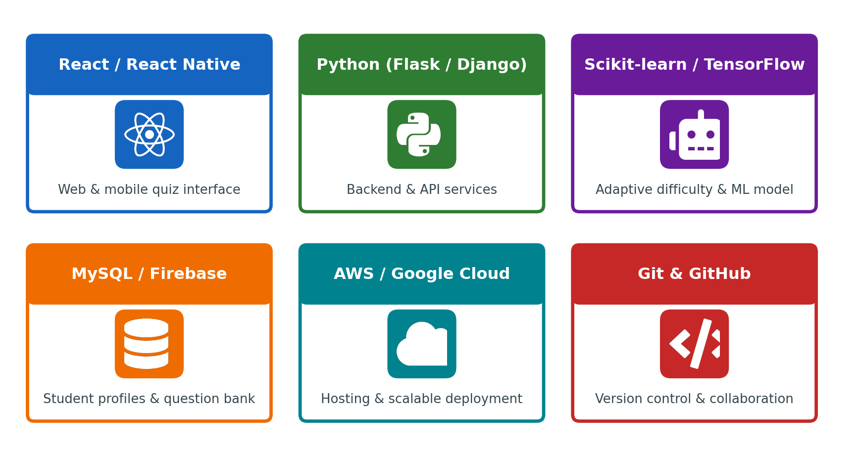
Figure 3.1: Technology stack of the Exam Preparation System

3.1 Front-End Design
The user interface is built with React for the web and React Native for mobile. React's component model suits a quiz interface well: a question card, an option list, a timer, a feedback panel and a result summary are each small, reusable components that update independently when state changes.
- Responsive layout: the same design adapts to laptops, tablets and phones.
- State management: quiz progress, the current question and the running score are held in client state and synchronised with the server after each answer.
- Instant feedback: after a response is submitted the interface shows whether it was correct and displays the explanation immediately.
- Dashboard widgets: topic-wise proficiency is shown as progress bars and charts so that weak areas are visible at a glance.

3.2 Back-End Design
The back end is written in Python using Flask or Django. It exposes a REST API that the React and React Native clients call over HTTPS. Services are stateless: every request carries a token that identifies the learner, so any server instance can handle any request. This is the property that makes it possible to run several instances behind a load balancer, which is a core idea of distributed backend development.
Service | Responsibility
Auth service | Registration, login, token issue and verification
Quiz service | Serves the diagnostic quiz, the next quiz or level, and weak-topic practice questions
Evaluation service | Scores each attempt and computes topic-wise results against the threshold
Adaptive service | Updates proficiency and selects the next question difficulty
Analytics service | Feeds the progress dashboard with topic-wise and overall readiness data

3.3 Database Design
MySQL is the primary relational store, holding student profiles, the question bank, quiz attempts, individual responses and topic-wise proficiency. A relational database is a natural fit because the data is highly structured and the analytics depend on joins and aggregations, for example computing the percentage of correct answers per topic for a student. Firebase is supported as a cloud alternative when real-time synchronisation or serverless hosting is preferred.
- Primary and foreign keys enforce integrity between students, attempts, responses, questions and topics.
- Indexes on student_id, topic_id and difficulty keep question selection and score aggregation fast.
- The question bank is normalised so that each question belongs to exactly one topic and carries a difficulty rating.
- Transactions ensure that a response and the updated proficiency are saved together or not at all.

3.4 Adaptive Engine and Machine-Learning Libraries
The adaptive component uses Scikit-learn and TensorFlow. Scikit-learn provides well-tested implementations of models such as logistic regression, which can estimate the probability that a learner answers a question of a given difficulty correctly. TensorFlow is available for experiments with richer sequence models if the simple approach proves insufficient.
The engine consumes recent responses, correctness, time taken and question difficulty. It outputs an updated proficiency estimate for the topic and a recommended difficulty for the next question. Chapter 5 describes the algorithm in detail.

3.5 Version Control
Git and GitHub are used for version control and collaboration. Each team member works on a feature branch, opens a pull request, and merges into the main branch after review. This keeps the history auditable, allows work on the front end, back end and adaptive model to proceed in parallel, and provides the hook for continuous integration.
Practice | Description
Branching | main for stable releases; feature branches for each module
Pull requests | Every change is reviewed by at least one other team member
Commit messages | Short, imperative summaries that reference the module changed
Issues | Bugs and tasks are tracked on GitHub Issues

3.6 Cloud Hosting and External Services
AWS or Google Cloud hosts the back end, the database and the static front-end assets, which provides scalable deployment without the team managing physical servers. Managed services reduce operational effort: a managed MySQL instance handles backups, and a load balancer distributes traffic across API servers.
- Authentication: token-based sessions; Firebase Authentication can be used as an external identity provider.
- Object storage: static assets and exported reports.
- Monitoring: cloud-provider logs and metrics to observe latency and errors.

CHAPTER 4 – SYSTEM ARCHITECTURE

4.1 High-Level Architecture Diagram
The proposed system architecture is expressed as a decision flow that begins when a student logs in and ends with an optional retake. Its defining feature is that the question bank is consulted only when it is needed: a learner who performs well continues through quizzes and levels without it, while a learner who performs poorly is routed into a bank filtered to their weak topics.
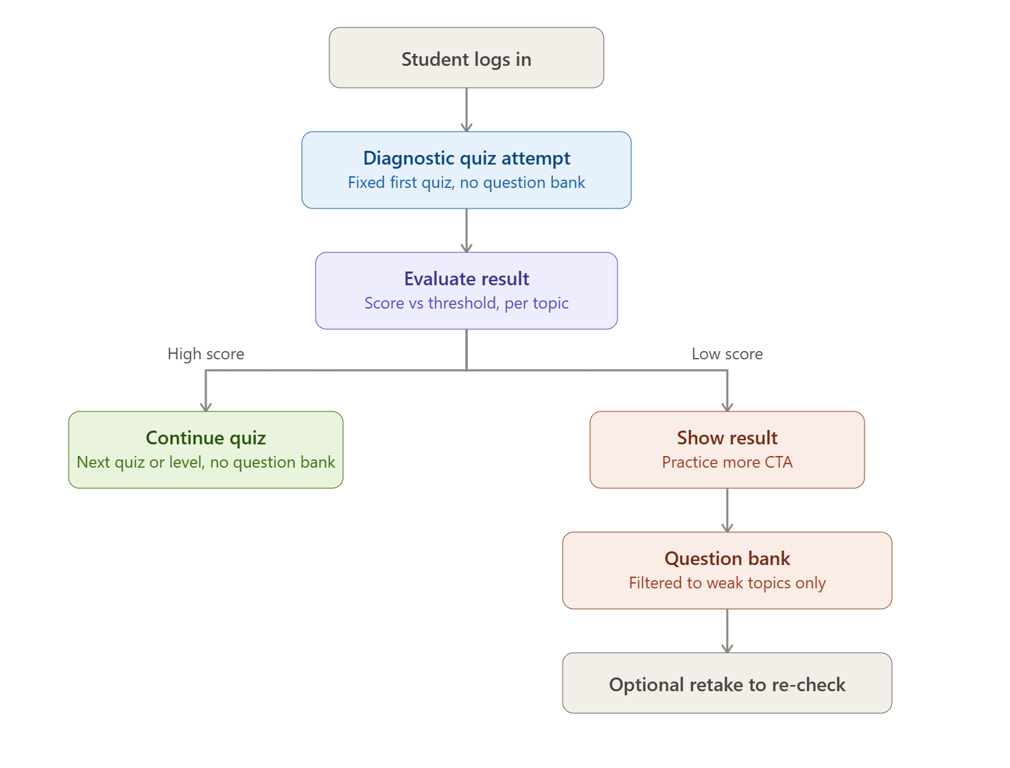
Figure 4.1: Proposed system architecture – adaptive quiz workflow
Step | Stage | What happens
1 | Student logs in | The learner authenticates and a token is issued.
2 | Diagnostic quiz attempt | A fixed first quiz is served; no question bank is used at this stage.
3 | Evaluate result | The score is compared with the threshold, topic by topic.
4a | High score | The learner continues to the next quiz or level; the question bank is still not used.
4b | Low score | The result is shown with a Practice-more call to action.
5 | Question bank | Practice questions are drawn from the weak topics only.
6 | Optional retake | The learner can retake a quiz to re-check improvement.

The same behaviour is organised into five software layers, shown below. Every request from the learner travels down through the layers and the response travels back up.
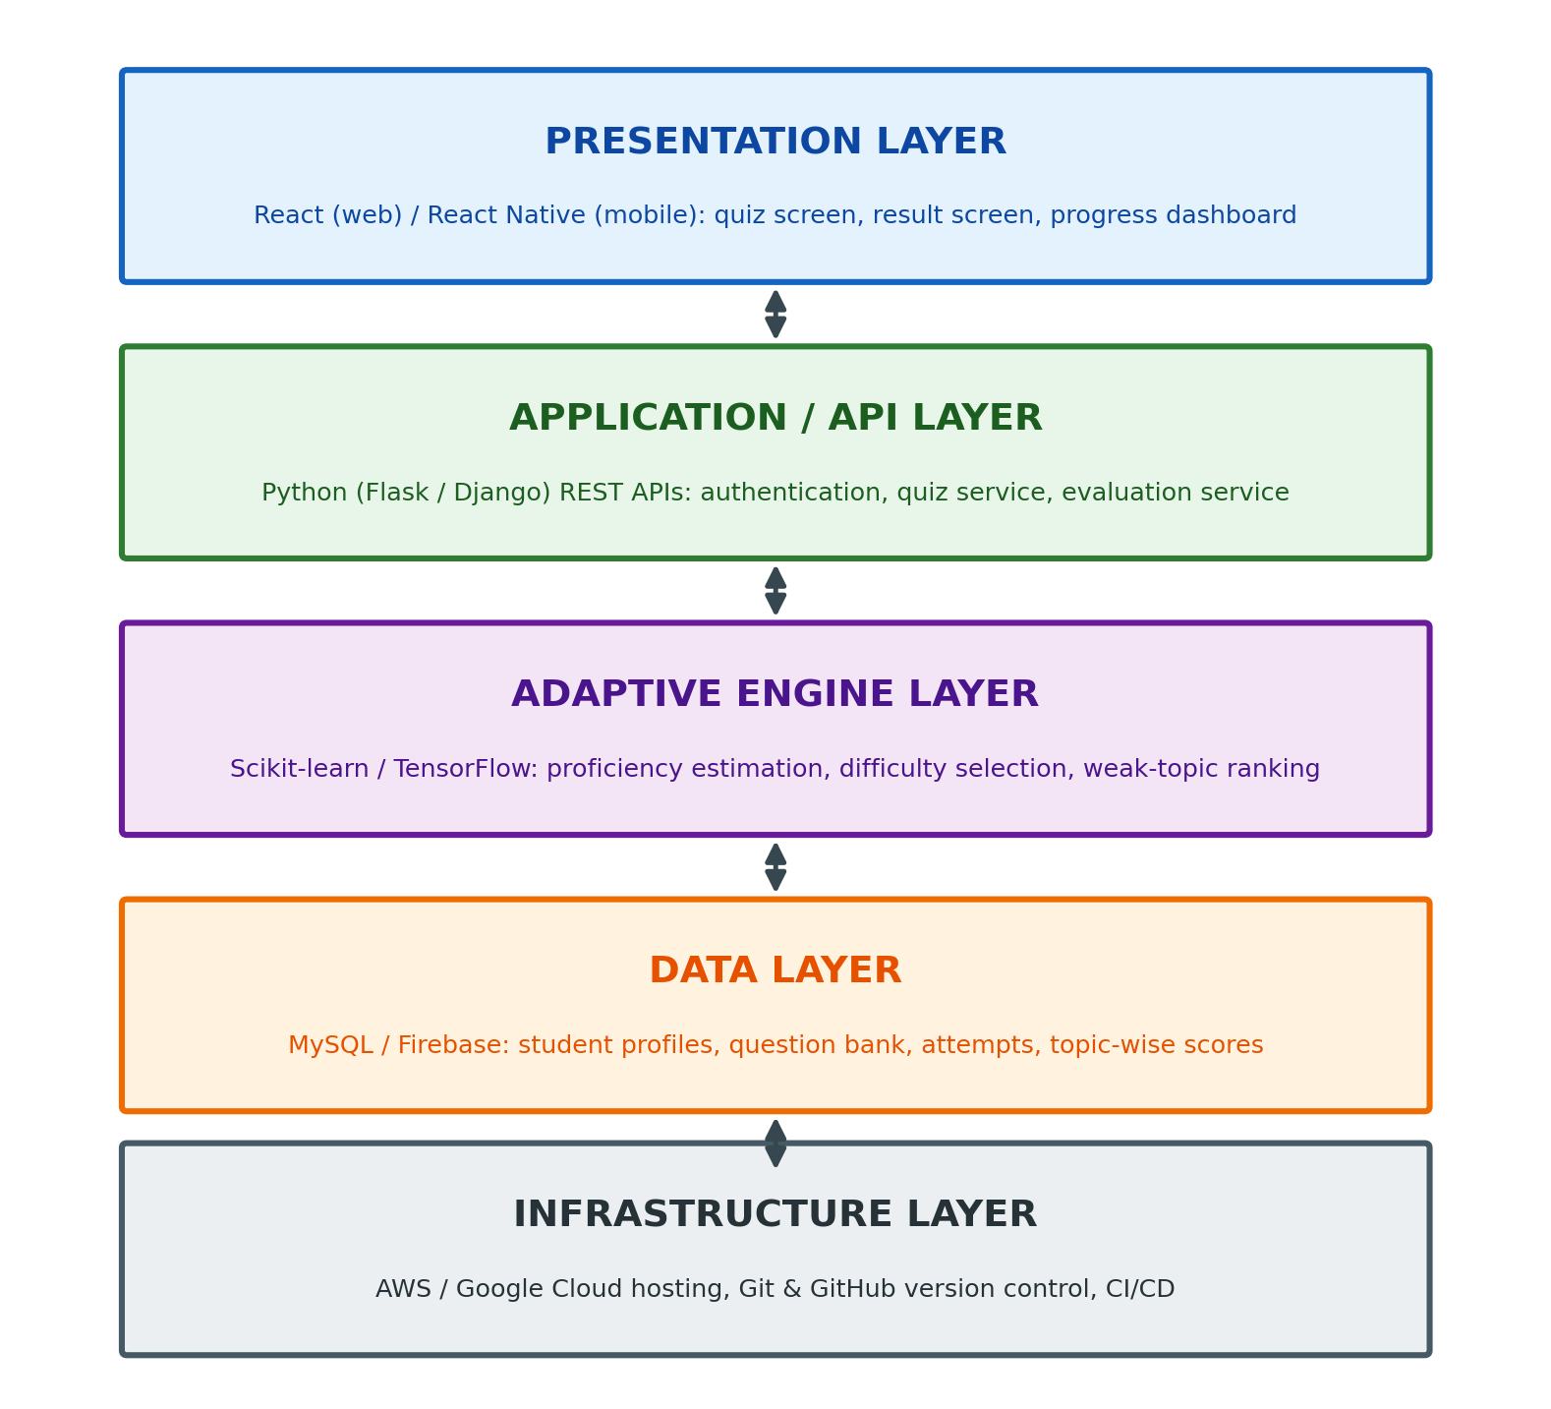
Figure 4.2: Layered architecture of the system

4.2 Description of Each Layer

Presentation layer (front end)
The React web application and the React Native mobile application present the quiz, the result screen with its Practice-more action, and the progress dashboard. The layer holds no business rules; it renders what the API returns and posts the learner's answers back.

Application / API layer (back end)
Flask or Django services implement the REST API. This layer authenticates requests, validates input, orchestrates the quiz flow shown in Figure 4.1 and calls the adaptive and data layers. Because it is stateless, it can be replicated to serve more learners.

Adaptive engine layer
The adaptive engine receives each response and updates the learner's proficiency estimate for the topic. It returns the recommended difficulty of the next question and ranks weak topics for the practice path.

Data layer (database)
MySQL or Firebase stores student profiles, the question bank, attempts, responses and topic-wise proficiency. The schema is described in Chapter 5.

Infrastructure layer
AWS or Google Cloud provides compute, managed database, load balancing and storage. Git and GitHub provide version control and the pipeline that builds and deploys the application.

4.3 Deployment Architecture (Cloud, Local, CI/CD Pipelines)
In production, learners reach the system through HTTPS. A load balancer distributes requests across two or more identical API servers. The API servers call a separate machine-learning service for adaptive decisions and read and write a managed database.
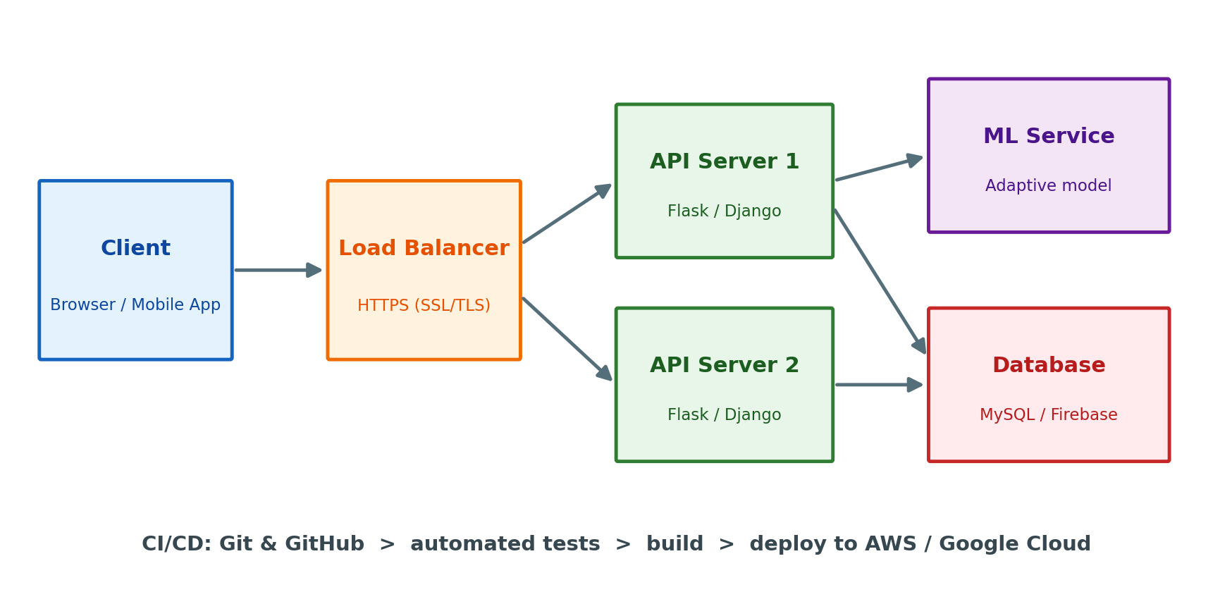
Figure 4.3: Deployment architecture and CI/CD flow
Environment | Purpose | Notes
Local | Day-to-day development | Flask / Django dev server, local MySQL, React dev server
Staging | Integration testing and review | Cloud-hosted copy with test data
Production | Live use by learners | Load-balanced API servers, managed database, HTTPS

A CI/CD pipeline on GitHub runs the automated tests on every pull request. When changes are merged into the main branch, the pipeline builds the front end, packages the back end and deploys them to the cloud environment. This shortens the time from a fix to a live release and reduces manual deployment errors.

CHAPTER 5 – DESIGN

5.1 Existing System versus Proposed System
The design of the proposed system is best understood by comparing it with the static exam-preparation tools it is meant to replace.
Aspect | Existing system | Proposed system
Question selection | Fixed question bank – same set and order for every student | Dynamic selection driven by live performance data
Difficulty | Uniform difficulty; no adjustment to learner ability | Adaptive difficulty engine tunes each question to current skill
Progress tracking | Manual, infrequent, with limited analytics | Automated topic-wise analytics dashboard, updated continuously
Study material | Generic, not mapped to individual gaps | Personalised study path per student, per weak area
Feedback | Delayed until after the test, with little explanation | Instant feedback and explanation after each question

5.2 ER Diagram / Database Schema
The schema contains six entities. A Student takes many Quiz Attempts; each attempt consists of many Responses; each response answers one Question; each question belongs to one Topic; and Topic Proficiency records how well a given student currently performs in a given topic.
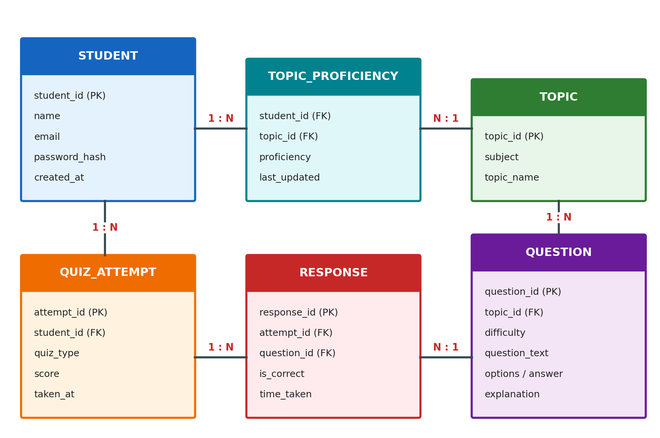
Figure 5.1: Entity–relationship diagram
Table | Key columns | Purpose
student | student_id (PK), name, email, password_hash, created_at | Learner accounts
topic | topic_id (PK), subject, topic_name | Syllabus topics used for tagging and analytics
question | question_id (PK), topic_id (FK), difficulty, question_text, options, correct_answer, explanation | Question bank
quiz_attempt | attempt_id (PK), student_id (FK), quiz_type, score, taken_at | One row per quiz taken
response | response_id (PK), attempt_id (FK), question_id (FK), is_correct, time_taken | One row per answered question
topic_proficiency | student_id (FK), topic_id (FK), proficiency, last_updated | Current estimate per student and topic

Sample table definition
CREATE TABLE question (
question_id INT AUTO_INCREMENT PRIMARY KEY,
topic_id INT NOT NULL,
difficulty TINYINT NOT NULL CHECK (difficulty BETWEEN 1 AND 5),
question_text TEXT NOT NULL,
options JSON NOT NULL,
correct_answer VARCHAR(255) NOT NULL,
explanation TEXT,
FOREIGN KEY (topic_id) REFERENCES topic(topic_id),
INDEX idx_topic_difficulty (topic_id, difficulty)
);

5.3 Data Flow Diagram
Figure 5.2 shows the main processes and data stores. The student interacts with login, quiz delivery and the dashboard. Evaluation results feed the adaptive engine, which reads the question bank to choose what to serve next and writes updated proficiency to the attempts store.
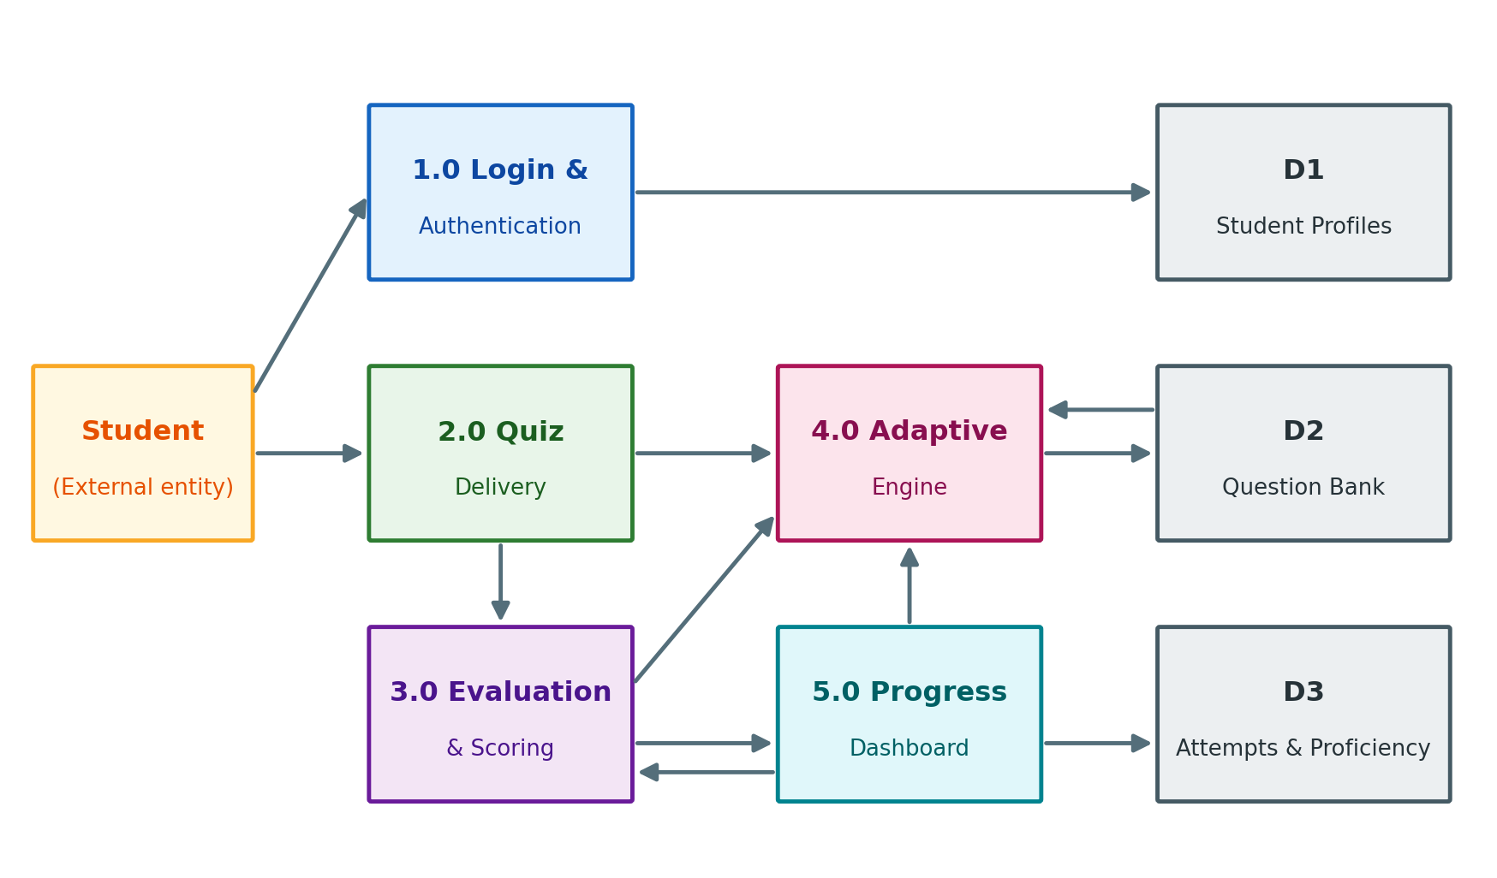
Figure 5.2: Data flow diagram (Level 1)

5.4 Adaptive Algorithm Design
The adaptive logic has two parts: a threshold evaluation after each quiz and an adaptive difficulty update after each answer.

Threshold evaluation
- For each topic in the quiz, compute the fraction of questions answered correctly.
- Compare each fraction with the pass threshold (a configurable value; a default of 60% is used in the design).
- If all topics meet the threshold, the learner continues to the next quiz or level.
- Otherwise the topics below the threshold are marked weak, ordered from weakest to strongest, and the Practice-more path is offered.

Adaptive difficulty update
Proficiency p and difficulty d are both expressed on a 0 to 1 scale. After each answer the engine compares the learner's actual result with the result it expected, and nudges p accordingly. A correct answer to a hard question raises p more than a correct answer to an easy one; a wrong answer to an easy question lowers it more than a wrong answer to a hard one.
expected = 1 / (1 + exp(-6 * (p - d))) # probability of a correct answer
p_new = clamp(p + 0.15 * (result - expected), 0, 1)

# result = 1 if the answer was correct, otherwise 0
# next question difficulty = level closest to (p_new + 0.1)

Aiming slightly above the learner's current proficiency keeps questions challenging without being discouraging. The constants (learning rate 0.15, slope 6, stretch 0.1) are tunable parameters; Scikit-learn can later be used to fit them from real response data.

CHAPTER 6 – IMPLEMENTATION

6.1 Module-wise Implementation
Module | Function | Main technologies
Authentication | Register, log in, issue and verify tokens | Flask / Django, password hashing, JWT
Diagnostic quiz | Serve the fixed first quiz and record answers | REST API, MySQL
Evaluation | Score the attempt and compute topic-wise results versus the threshold | Python
Weak-topic practice | Serve questions from the bank filtered to weak topics | SQL queries, REST API
Adaptive engine | Update proficiency and choose next difficulty | Scikit-learn / TensorFlow
Progress dashboard | Show topic-wise proficiency and readiness | React, charts

Evaluation module
def evaluate_attempt(responses, threshold=0.60):
"""responses: list of {topic_id, is_correct}. Returns (scores, weak_topics)."""
totals = {}
for r in responses:
correct, count = totals.get(r["topic_id"], (0, 0))
totals[r["topic_id"]] = (correct + (1 if r["is_correct"] else 0), count + 1)
scores = {t: c / n for t, (c, n) in totals.items()}
weak = sorted((t for t, s in scores.items() if s < threshold),
key=lambda t: scores[t]) # weakest first
return scores, weak

Adaptive engine module
import math

def update_proficiency(p, difficulty, correct, lr=0.15):
expected = 1 / (1 + math.exp(-6 * (p - difficulty)))
return min(1.0, max(0.0, p + lr * ((1 if correct else 0) - expected)))

def next_difficulty(p, levels=(0.2, 0.4, 0.6, 0.8, 1.0)):
target = min(1.0, p + 0.1)
return min(levels, key=lambda d: abs(d - target))

6.2 Front-End Logic (UI Rendering, State Management)
The quiz screen is a small state machine. It moves through the states loading, answering, feedback and finished. In the answering state the learner picks an option; on submission the client posts the answer and moves to the feedback state, where correctness and the explanation are displayed; pressing Next requests the following question. When the server reports that the quiz is complete, the client shows the result screen.
Component | Responsibility
QuizScreen | Owns quiz state and calls the API
QuestionCard | Renders the question text and answer options
FeedbackPanel | Shows correct / incorrect and the explanation
ResultSummary | Shows topic-wise score and the Practice-more action when needed
Dashboard | Charts topic-wise proficiency over time

6.3 API Integration
The clients communicate with the back end through a REST API using JSON over HTTPS. The principal endpoints are listed below.
Method | Endpoint | Description
POST | /api/auth/register | Create a student account
POST | /api/auth/login | Authenticate and return a token
GET | /api/quiz/diagnostic | Start the fixed diagnostic quiz
POST | /api/quiz/{attempt_id}/answer | Submit an answer; returns correctness and explanation
POST | /api/quiz/{attempt_id}/finish | Close the attempt and return topic-wise result
GET | /api/practice/questions | Get questions from weak topics only
GET | /api/progress | Get topic-wise proficiency for the dashboard

Sample request and response
POST /api/quiz/42/answer
{ "question_id": 311, "selected": "B", "time_taken": 18 }

200 OK
{ "correct": false,
"correct_answer": "C",
"explanation": "A foreign key must reference a candidate key of the parent table." }

6.4 Authentication and Authorisation
- Password security: passwords are never stored in plain text; only a salted hash is saved.
- Token-based sessions: after login the server returns a signed token that the client sends with each request, which keeps the API stateless.
- Authorisation: a learner can read and write only their own attempts and proficiency; an instructor role can view aggregated class analytics.
- Transport security: all traffic uses HTTPS (SSL/TLS).
- Input validation: the API validates all inputs and uses parameterised queries to prevent SQL injection.

CHAPTER 7 – FEATURES

7.1 List of Main Features
# | Feature | Benefit
1 | Diagnostic first quiz | Establishes a starting picture of each topic
2 | Topic-wise evaluation against a threshold | Identifies weak areas precisely
3 | Adaptive difficulty engine | Each question matches current skill
4 | Weak-topic question bank | Practice is focused where it is needed
5 | Instant feedback and explanations | Learners learn from each mistake immediately
6 | Automated progress dashboard | Continuous view of readiness
7 | Personalised study path | A route per student and per weak area
8 | Optional retake | Confirms that weak areas have improved

7.2 How Each Feature Works

Diagnostic first quiz
User perspective: After logging in, the student takes a fixed first quiz covering the main topics.
Technical description: The quiz service returns a predefined set of questions without using the question bank, and every answer is stored as a response row.

Topic-wise evaluation
User perspective: At the end of the quiz the student sees a score for every topic, not just one total.
Technical description: The evaluation module aggregates responses by topic and compares each fraction with the threshold, producing a list of weak topics.

Adaptive difficulty
User perspective: Questions become harder when the student is doing well and easier when they are struggling.
Technical description: After each response the engine updates the proficiency estimate and returns the difficulty level closest to the new target.

Weak-topic question bank
User perspective: A student with a low score is invited to Practice more and sees questions only from topics they need to improve.
Technical description: The practice endpoint filters the question table by the weak topic ids and orders by the recommended difficulty.

Instant feedback
User perspective: After every answer the student sees whether it was right and why.
Technical description: The answer endpoint returns correctness, the right option and the stored explanation in the same response.

Progress dashboard
User perspective: A dashboard shows strong and weak topics and overall exam readiness.
Technical description: The analytics service reads the topic-proficiency table and returns series that the front end draws as charts.

Optional retake
User perspective: After practice the student can retake a quiz to confirm improvement.
Technical description: A retake creates a new attempt, and the proficiency table is updated from the new responses.

CHAPTER 8 – TESTING
Testing verifies that each module behaves correctly on its own and that the modules work together. The strategy has three levels: unit tests for the evaluation and adaptive functions, API tests with Postman, and end-to-end integration tests of the complete learner journey.

8.1 Postman Testing (Front-end / Back-end)
Postman is used to exercise every endpoint without the user interface, so that back-end defects can be separated from front-end defects. A Postman collection is organised by module and run with an environment holding the base URL and a test token.
Request | Input | Expected response
POST /api/auth/register | Valid name, email, password | 201 Created; student_id returned
POST /api/auth/login | Correct credentials | 200 OK; token returned
POST /api/auth/login | Wrong password | 401 Unauthorized
GET /api/quiz/diagnostic | Valid token | 200 OK; fixed question list
GET /api/quiz/diagnostic | No token | 401 Unauthorized
POST /api/quiz/{id}/answer | Valid question and option | 200 OK; correctness and explanation
GET /api/practice/questions | Student with weak topics | Questions only from weak topics
GET /api/progress | Valid token | Topic-wise proficiency values

8.2 Integration Testing
Integration tests follow the two paths of Figure 4.1 from end to end.
- High-score path: login, take the diagnostic quiz, score at or above the threshold in every topic, continue to the next quiz or level; verify that the question bank is not used.
- Low-score path: login, take the diagnostic quiz, score below the threshold in at least one topic, see the Practice-more action, receive questions only from the weak topics, retake, and verify that the proficiency values are updated.
- Cross-layer check: confirm that a response saved by the API appears in the database and is reflected in the dashboard.

8.3 Tools Used for Testing
Tool | Used for
Postman | API request and response testing and collection runs
PyTest | Unit tests for evaluation and adaptive functions
Jest / React Testing Library | Front-end component tests
MySQL Workbench | Verifying stored data after API calls
Browser developer tools | Inspecting network calls and responsive layout
GitHub Actions | Running the test suite automatically on every pull request

8.4 Test Cases and Expected Results
ID | Test case | Expected result
TC-01 | Register with valid details | Account is created
TC-02 | Log in with correct credentials | Token is issued and the quiz page opens
TC-03 | Log in with wrong password | Login is rejected with an error message
TC-04 | Start diagnostic quiz | Fixed first quiz is displayed
TC-05 | Submit a correct answer | Marked correct; explanation shown
TC-06 | Submit a wrong answer | Marked wrong; correct option and explanation shown
TC-07 | Finish quiz with all topics at or above threshold | Next quiz or level is offered; question bank not used
TC-08 | Finish quiz with a topic below threshold | Result and Practice-more action shown
TC-09 | Open practice questions after a low score | Only weak-topic questions are served
TC-10 | Answer a run of questions correctly | Next question difficulty rises
TC-11 | Answer a run of questions wrongly | Next question difficulty falls
TC-12 | Retake after practice | New attempt saved; proficiency updated
TC-13 | Open dashboard | Topic-wise proficiency matches stored data
TC-14 | Access another student's attempt | Request is refused

CHAPTER 9 – DEPLOYMENT

9.1 Steps to Deploy
- Prepare the repository. Merge all reviewed changes into the main branch of the GitHub repository and tag the release.
- Provision the database. Create a managed MySQL instance (or a Firebase project), run the schema scripts and load the initial topics and question bank.
- Configure the back end. Set environment variables, install the Python dependencies in a virtual environment and run database migrations.
- Deploy the API servers. Start two or more instances of the Flask / Django application behind a load balancer and attach the HTTPS certificate.
- Deploy the adaptive service. Package the trained model with its serving code and expose it to the API servers on a private network.
- Build and publish the front end. Create the production React build and upload it to static hosting; build the React Native app for Android and iOS.
- Smoke test and monitor. Run the Postman collection against the live URL, complete both quiz paths manually, then enable logging and alerts for errors and latency.

9.2 Environment Configuration
Configuration is kept outside the source code in environment variables, so the same build can run in local, staging and production environments. Secrets are never committed to GitHub.
Variable | Purpose | Example (non-secret)
DB_HOST / DB_NAME | Database location | db.internal / examprep
DB_USER / DB_PASSWORD | Database credentials | Stored in the secrets manager
JWT_SECRET | Signing key for tokens | Stored in the secrets manager
PASS_THRESHOLD | Topic pass threshold | 0.60
MODEL_PATH | Location of the adaptive model | /models/adaptive_v1.pkl
ALLOWED_ORIGINS | Origins allowed by CORS | https://examprep.example

9.3 Hosting of Frontend and Backend
Component | Hosting | Reason
React web app | Static hosting with a CDN on AWS / Google Cloud | Fast delivery to learners; no server to manage
React Native app | Android and iOS app stores | Native installation on phones
Flask / Django API and adaptive service | Virtual machines or managed containers behind a load balancer | Horizontal scaling for many concurrent learners
MySQL / Firebase | Managed database service | Automatic backups and patching

CHAPTER 10 – CHALLENGES AND LIMITATIONS

10.1 Design and Development Challenges
Challenge | Why it matters
Cold start | A new learner has no history, so the system cannot yet judge proficiency.
Question difficulty labels | Adaptive selection is only as good as the difficulty rating on each question.
Choosing the threshold | A threshold that is too high frustrates learners; too low hides weak areas.
Narrow practice | Showing only weak topics could cause a learner to neglect topics they already know.
Consistency of data | A response and the updated proficiency must be saved together.
Many learners at once | Quiz traffic is bursty, especially before examinations.

10.2 Solutions Applied
Challenge | Solution
Cold start | A fixed diagnostic quiz at the start gives the engine its first evidence about every topic.
Question difficulty labels | Questions are tagged with five difficulty levels, and the model can later recalibrate them from real response data.
Choosing the threshold | The threshold is a configuration value (default 60%) that can be tuned without changing code.
Narrow practice | The optional retake re-checks learners across topics, and the dashboard keeps every topic visible.
Consistency of data | Database transactions save the response and the updated proficiency as a single unit.
Many learners at once | Stateless API servers behind a load balancer can be scaled out on demand.

10.3 Current Limitations
- Only objective (multiple-choice) questions are supported; essay-style answers are not graded.
- The adaptive model is simple and needs real response data to be tuned well.
- The quality of the system depends on the size and quality of the question bank.
- There is no live proctoring, so the system is intended for practice rather than formal assessment.
- There is no offline mode; a network connection is needed during a quiz.

CHAPTER 11 – FUTURE ENHANCEMENTS

11.1 Planned Features
Feature | Description
Instructor console | Let faculty upload questions in bulk, assign difficulty and view class analytics.
Spaced repetition | Re-introduce previously weak topics at increasing intervals to strengthen retention.
Subjective answers | Evaluate short-answer responses with text-similarity or language models.
Gamification | Streaks, badges and leaderboards to sustain motivation.
Offline mode | Cache a quiz on the device so practice can continue without a connection.
Multi-language support | Offer questions and the interface in regional languages.

11.2 Possible Integrations or Optimisations
- Learning-management systems: integrate with the university's LMS so that results appear alongside course records.
- Knowledge-tracing models: replace the simple update rule with Bayesian knowledge tracing or a neural sequence model trained with TensorFlow.
- Caching: use an in-memory cache for frequently requested questions and dashboard summaries.
- Containerisation: package services with Docker and orchestrate them with Kubernetes for easier scaling.
- Analytics export: allow results to be exported as reports for faculty and learners.

CHAPTER 12 – CONCLUSION

12.1 Summary of the Project
This project set out to replace one-size-fits-all exam practice with a personalised, evidence-driven alternative. Exam Preparation with Adaptive Quizzes begins with a diagnostic quiz, evaluates performance topic by topic against a threshold, and then routes the learner: a strong result moves them on to the next quiz or level, while a weak result leads to a question bank filtered to their weak topics, followed by an optional retake.
The system is built on a layered architecture with a React / React Native front end, a Python (Flask / Django) back end, an adaptive engine using Scikit-learn / TensorFlow, a MySQL / Firebase data layer and AWS / Google Cloud hosting, with Git and GitHub supporting collaboration. The design emphasises a clean relational schema and stateless services, in line with the course on Database Systems Engineering and Distributed Backend Development.

12.2 What Was Achieved
Objective | Outcome
Adaptive quiz system with diagnostic first quiz | Quiz workflow designed and documented end to end
Topic-wise tracking of weak areas | Schema and evaluation logic defined for per-topic scoring
Adaptive difficulty engine | Proficiency update rule and next-difficulty selection specified
Weak-topic-only question bank | Filtered practice path included in the architecture
Instant feedback | Answer API returns correctness and explanation immediately
Progress dashboard | Analytics service and dashboard components designed
Scalable backend | Stateless services with a load-balanced deployment architecture

12.3 Skills Learned During Development
- Relational database design, normalisation, indexing and transactions.
- Designing and documenting REST APIs for a distributed, stateless backend.
- Applying machine-learning ideas to a practical personalisation problem.
- Building responsive web and mobile interfaces with React and React Native.
- Using Git and GitHub for branching, review and collaboration.
- Planning tests, deployment and cloud hosting, and working as a team on design, writing and presentation.

CHAPTER 13 – REFERENCES
- Pedregosa, F. et al. “Scikit-learn: Machine Learning in Python.” Journal of Machine Learning Research, 12, 2011, pp. 2825–2830.
- Abadi, M. et al. “TensorFlow: Large-Scale Machine Learning on Heterogeneous Systems.” 2015. Available at https://www.tensorflow.org.
- Lord, F. M. Applications of Item Response Theory to Practical Testing Problems. Lawrence Erlbaum Associates, 1980.
- Corbett, A. T. and Anderson, J. R. “Knowledge tracing: Modeling the acquisition of procedural knowledge.” User Modeling and User-Adapted Interaction, 4(4), 1994, pp. 253–278.
- Fielding, R. T. “Architectural Styles and the Design of Network-based Software Architectures.” Doctoral dissertation, University of California, Irvine, 2000.
- Chacon, S. and Straub, B. Pro Git, 2nd ed. Apress, 2014. Available at https://git-scm.com/book.
- React Documentation. https://react.dev
- React Native Documentation. https://reactnative.dev
- Flask Documentation. https://flask.palletsprojects.com
- Django Documentation. https://docs.djangoproject.com
- MySQL Reference Manual. https://dev.mysql.com/doc
- Firebase Documentation. https://firebase.google.com/docs
- Amazon Web Services Documentation. https://docs.aws.amazon.com
- Google Cloud Documentation. https://cloud.google.com/docs
- Postman Learning Center. https://learning.postman.com

CHAPTER 14 – APPENDICES

Appendix A – Screenshots of the Application
Screenshots of the main screens are to be pasted in the frames below before the report is printed.
Login page | Diagnostic quiz
Result with Practice-more action | Progress dashboard

Appendix B – Sample Code Snippets
The evaluation and adaptive functions are shown in Chapter 6. The answer endpoint is shown below.
@app.post("/api/quiz/<int:attempt_id>/answer")
@jwt_required()
def submit_answer(attempt_id):
data = request.get_json()
q = Question.query.get_or_404(data["question_id"])
correct = (data["selected"] == q.correct_answer)
with db.session.begin_nested(): # saved together
db.session.add(Response(attempt_id=attempt_id,
question_id=q.question_id, is_correct=correct))
update_topic_proficiency(current_user_id(), q.topic_id,
q.difficulty, correct)
db.session.commit()
return jsonify(correct=correct, correct_answer=q.correct_answer,
explanation=q.explanation)

Appendix C – Installation and Setup Instructions

Back end
git clone <repository-url>
cd exam-prep/backend
python -m venv venv
source venv/bin/activate # Windows: venv\Scripts\activate
pip install -r requirements.txt
export DB_HOST=localhost DB_NAME=examprep JWT_SECRET=<secret>
flask db upgrade
flask run

Front end
cd exam-prep/frontend
npm install
npm start # web
npx expo start # mobile (React Native)

Appendix D – User Manual
- Open the web page or mobile app and register with your name, email and password.
- Log in. The diagnostic quiz starts automatically for a new learner.
- Select one option for each question and submit. Read the feedback and explanation, then press Next.
- When the quiz ends, review your topic-wise result.
- If every topic meets the threshold, continue to the next quiz or level.
- If any topic is below the threshold, press Practice more to get questions from those topics only.
- After practising, use Retake to check your improvement.
- Open the Dashboard at any time to see your topic-wise proficiency and overall readiness.

Appendix E – Review Forms with Guide Signatures
Review | Date | Work reviewed | Guide remarks | Guide signature
Project Review – 1
Project Review – 2 |  | Abstract, problem statement, existing vs proposed system, architecture, tools
Project Review – 3

Geo-tagged photographs of project work sessions, where required by the department, are attached after this page.

