Week1_First_LLM_API_Call USING GEMINI

Step-1: Project Folder Creation
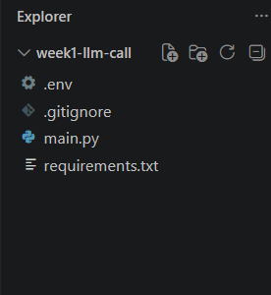

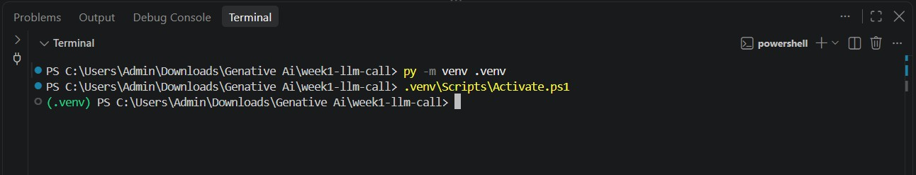
Step-2: Virtual Environment Creation and Activation.

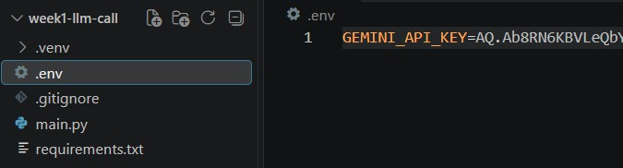

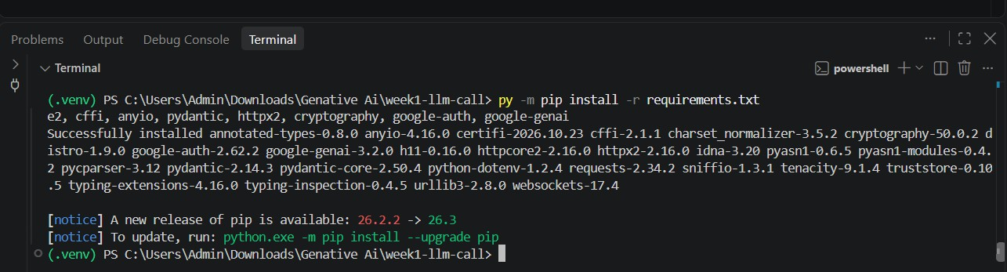
Step-4: Install Required Packages.

Step-5: Git Ignore Configuration

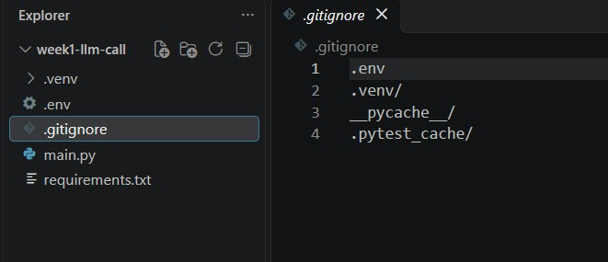

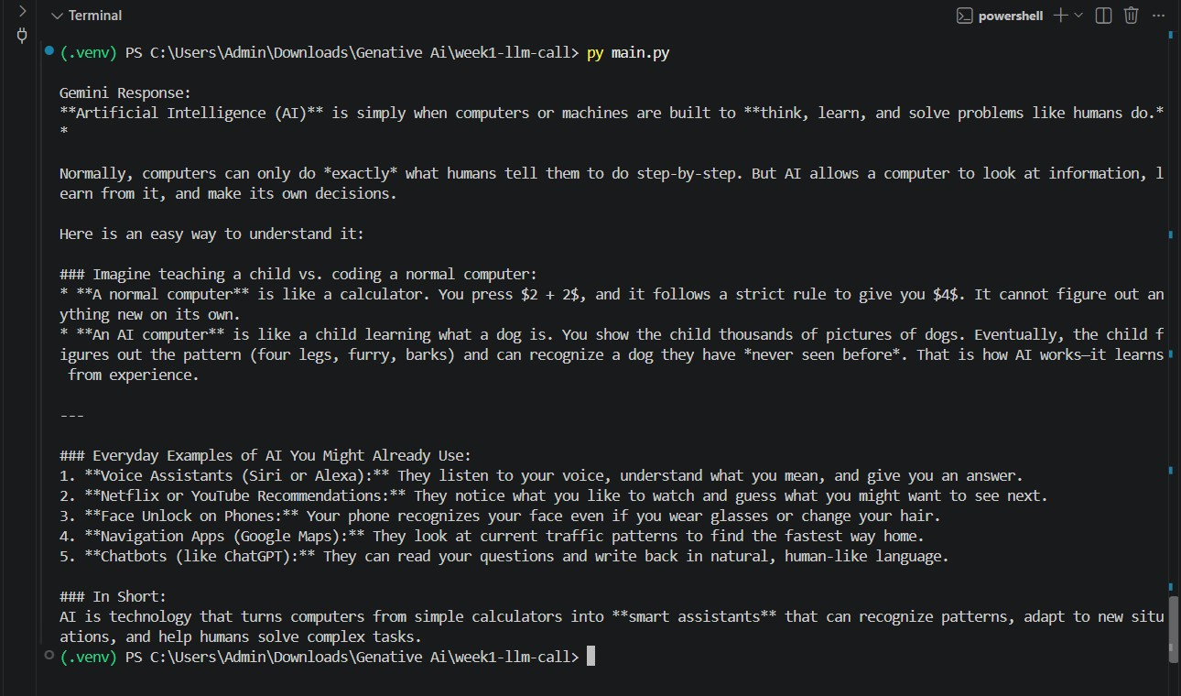
Step-7: Execution of Gemini API Program
[Insert Successful Gemini API Output Screenshot]

Step-8: Git Initialization and Commit.
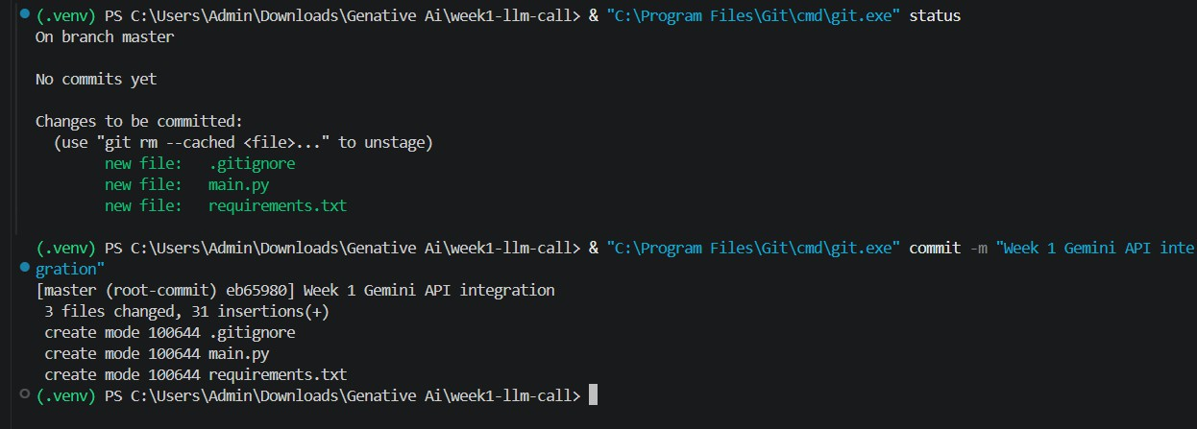
[Insert Git Commit Confirmation Screenshot]

[Insert Successful GitHub Push Screenshot]
Step-10: Verification of Files in GitHub Repository
[Insert GitHub Repository Screenshot]

