WEEK 4 – TOKENIZER LAB

Step-01: WEEK4 folder creation

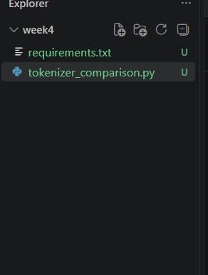

Step-02: Move to the WEEK 4 folder.
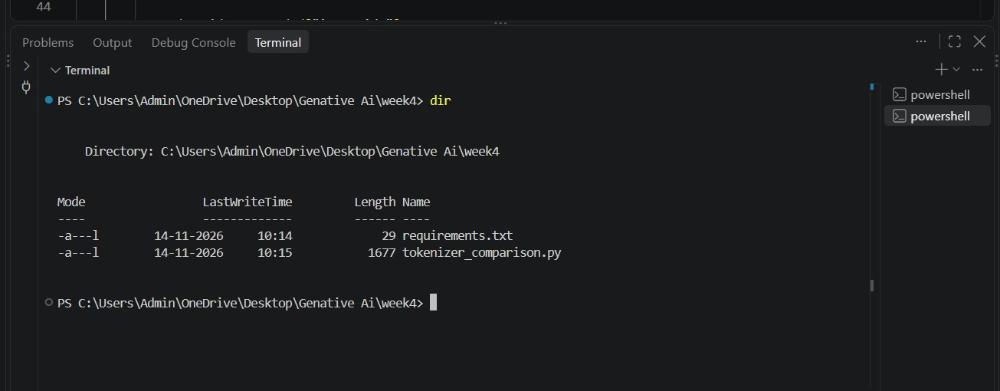

Step-03: Activate the virtual environment.

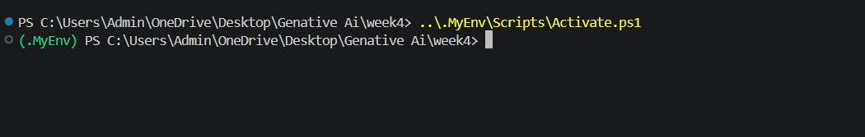

Step-04: Install the required libraries.

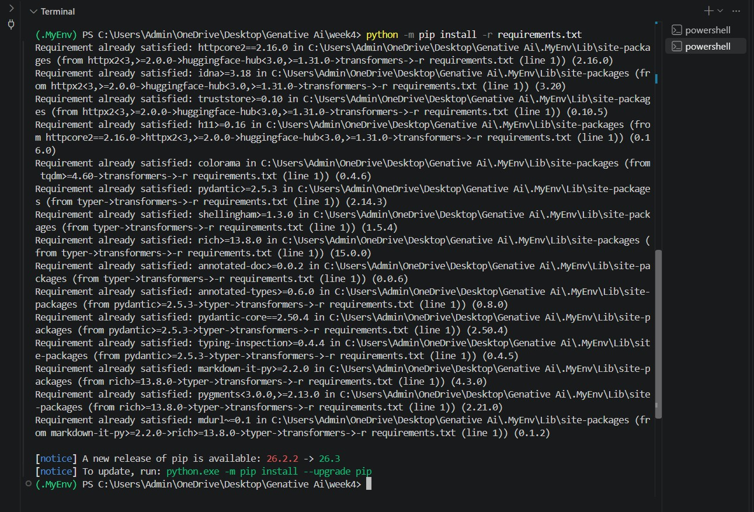

Step-05: Check the installed libraries.

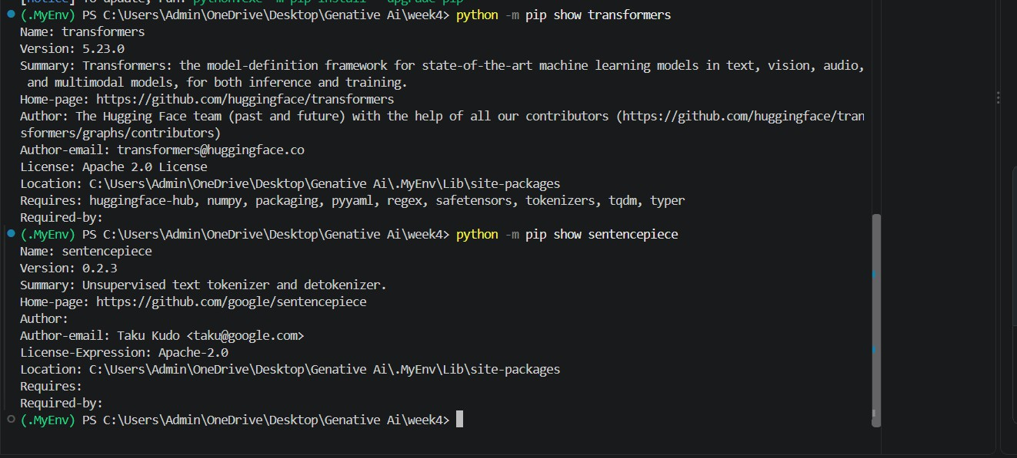
Step-06: Run the tokenizer comparison program.
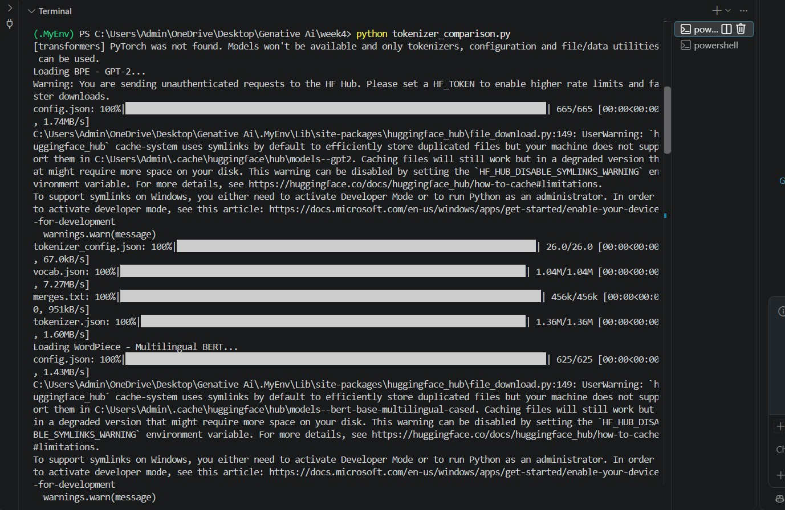

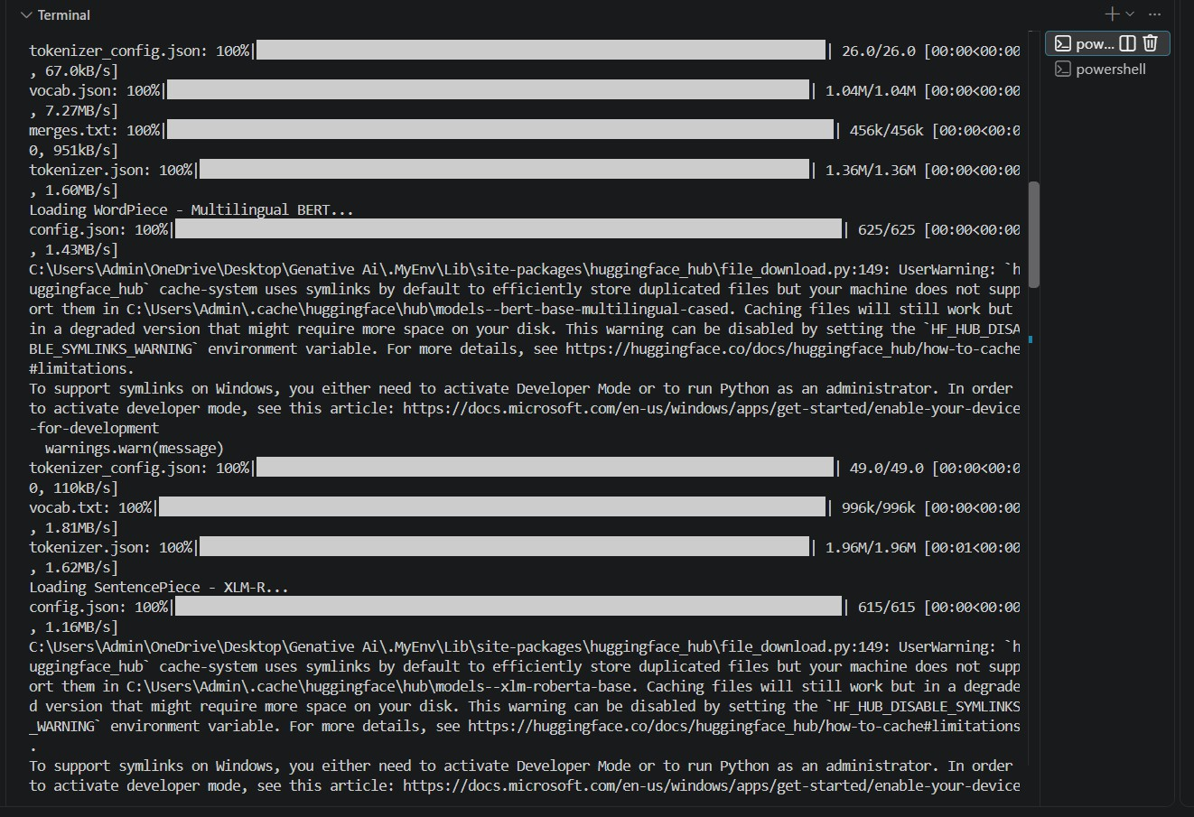

Step-07: Verify the output.

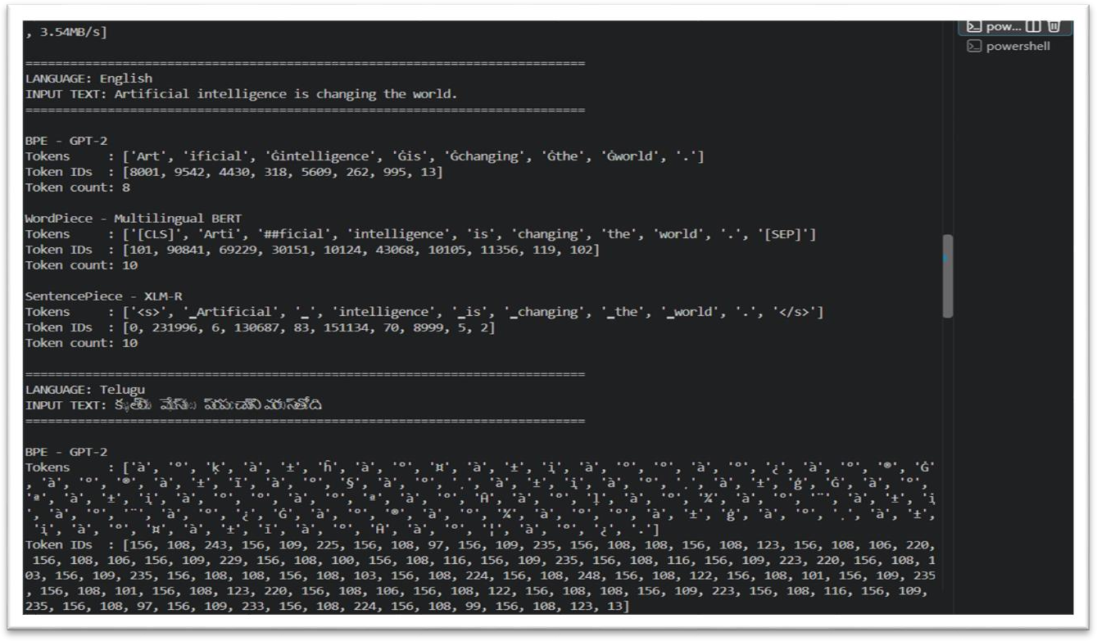

Step-08: Record the token counts.

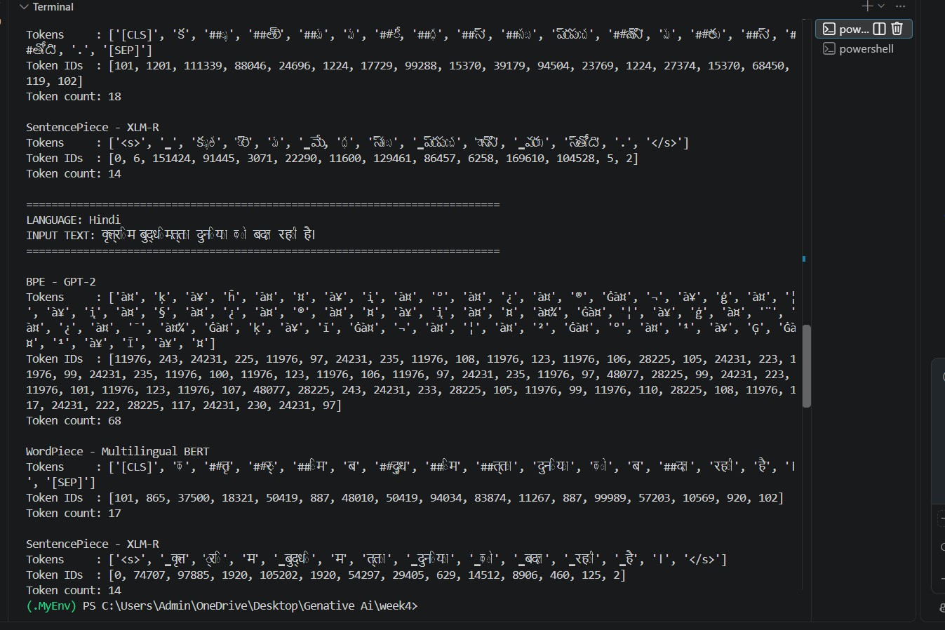

Step9: put in GitHub.

