WEEK 3 – MONGODB CONNECTIVITY

Step-01: Download MongoDB Compass and Community Server
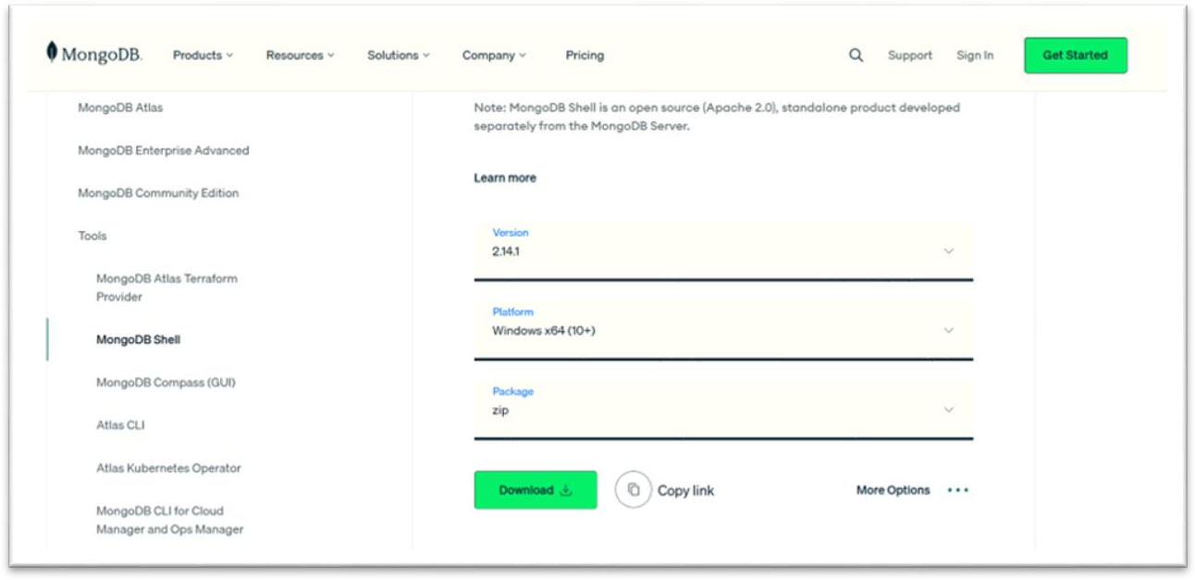

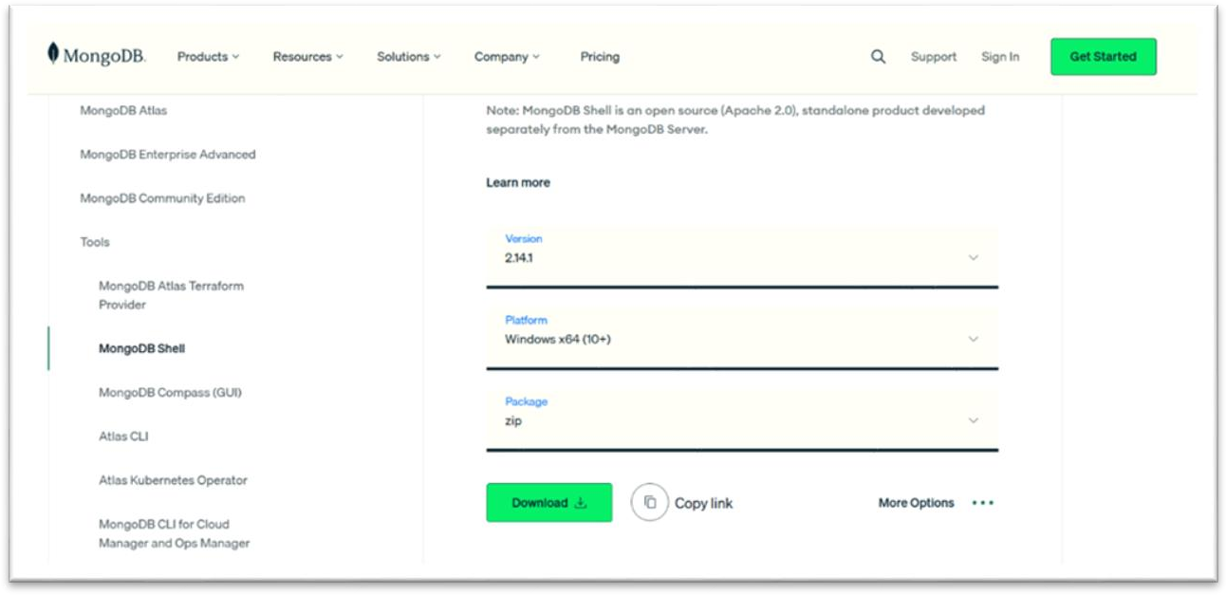

Step-02: Verify MongoDB Installation

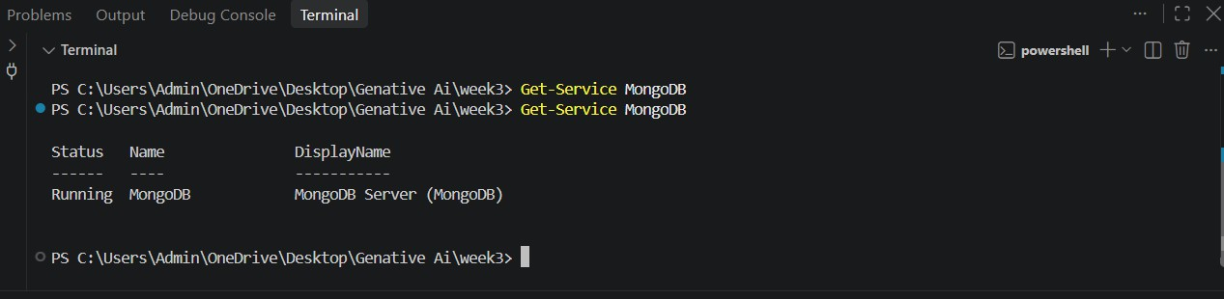

Step-03: Create MongoDB Database and Collection

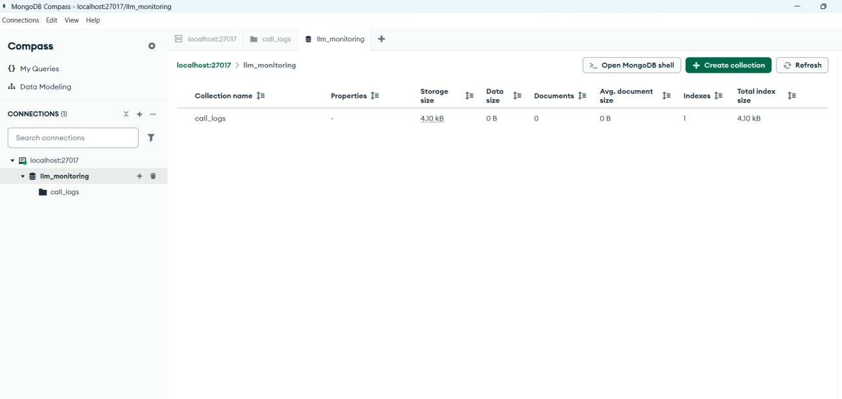

Step-05: Download Llama 3.2 Model

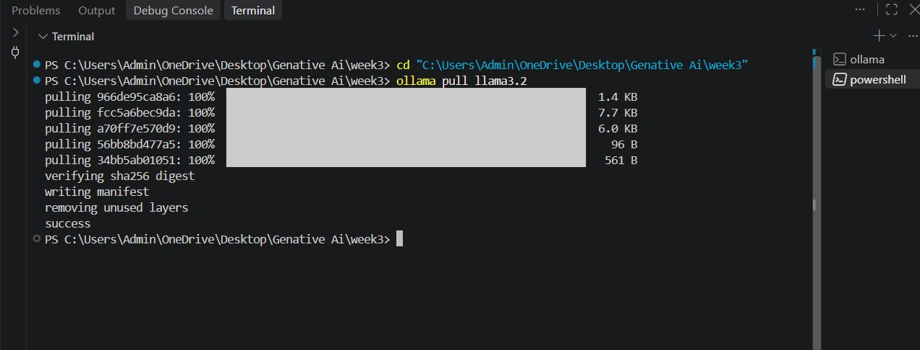

Step-06: Create Week-3 Project Files

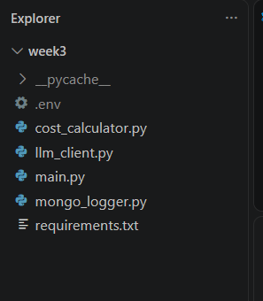

Step-07: Implement Cost Calculator

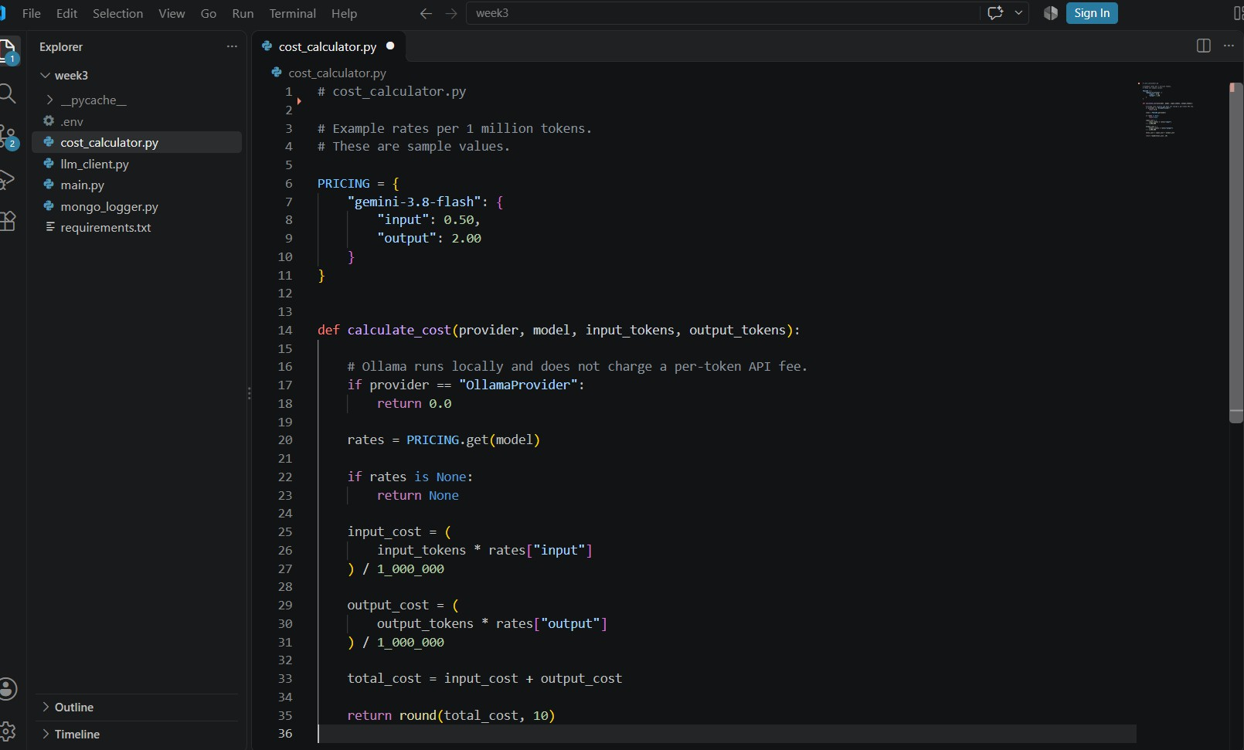

Step-08: Implement LLM Client.

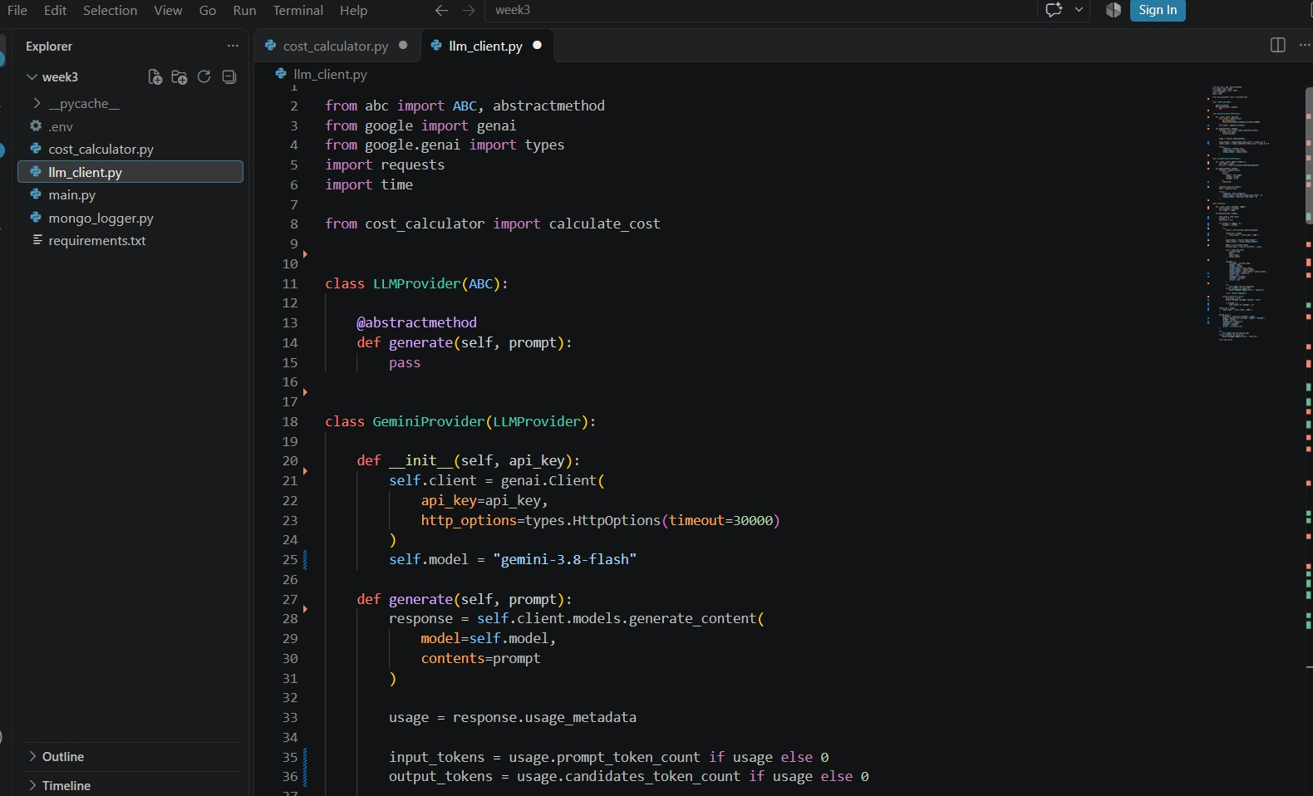

Step-09: Implement MongoDB Logger

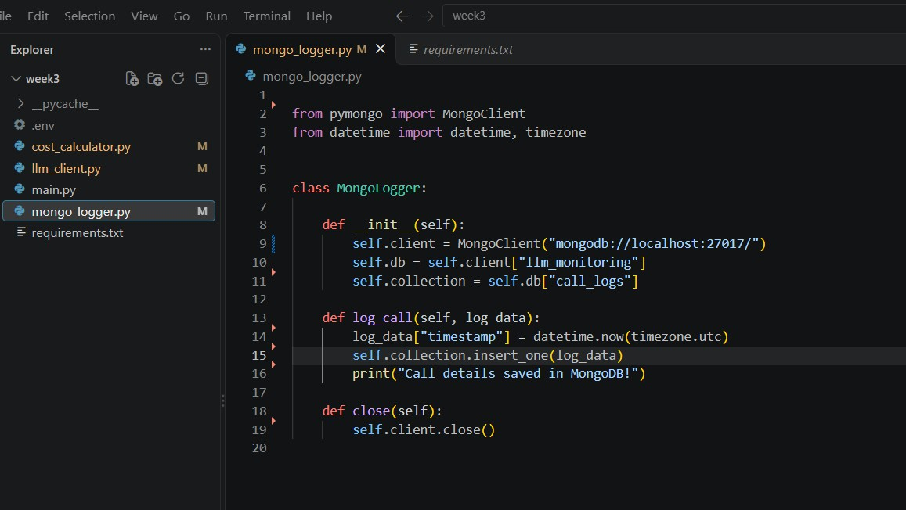
Step-10: Configure Environment Variables.

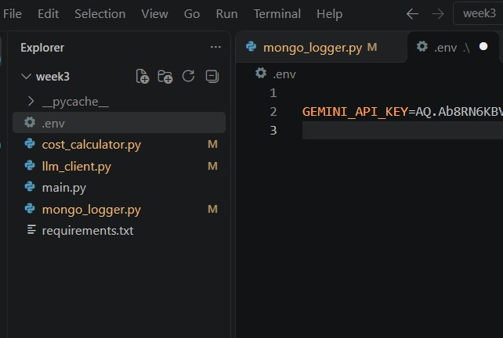
Step-11: Implement Main Program

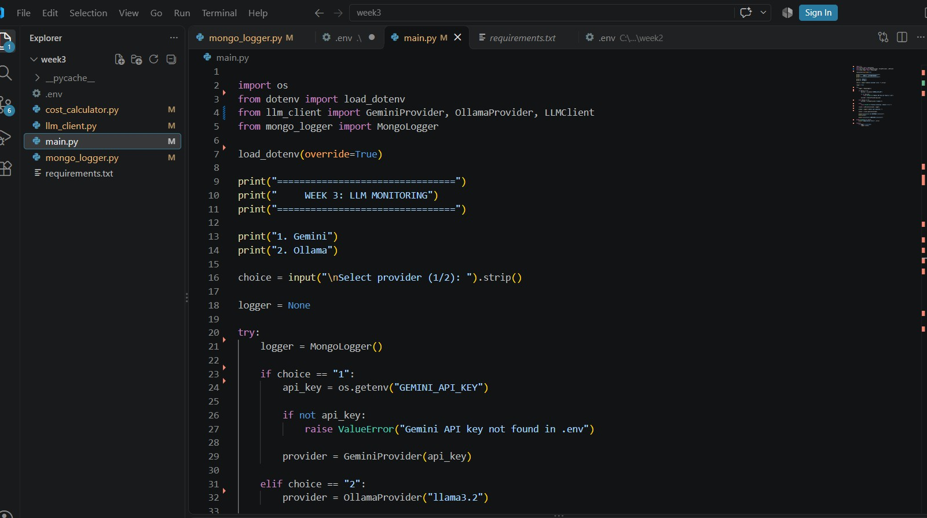

Step-12: Install Dependencies

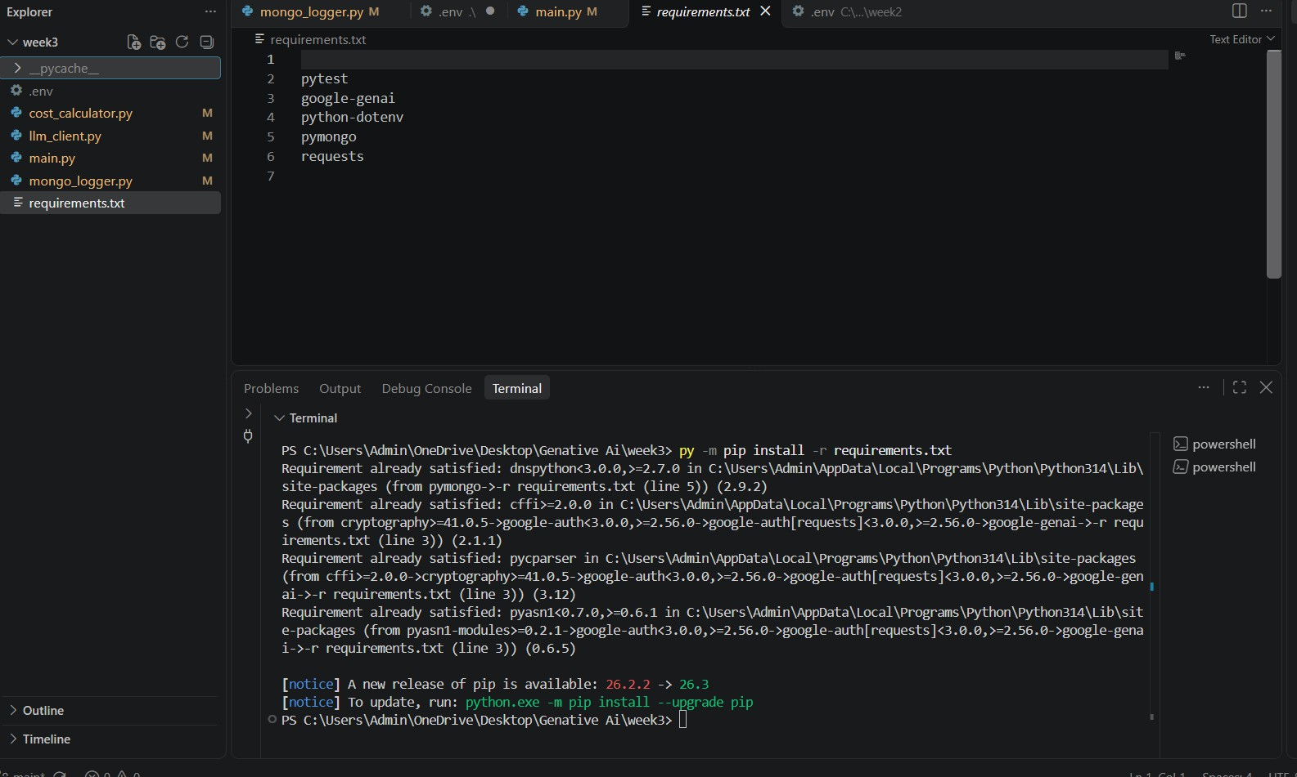

Step-13: Execute and Test Application

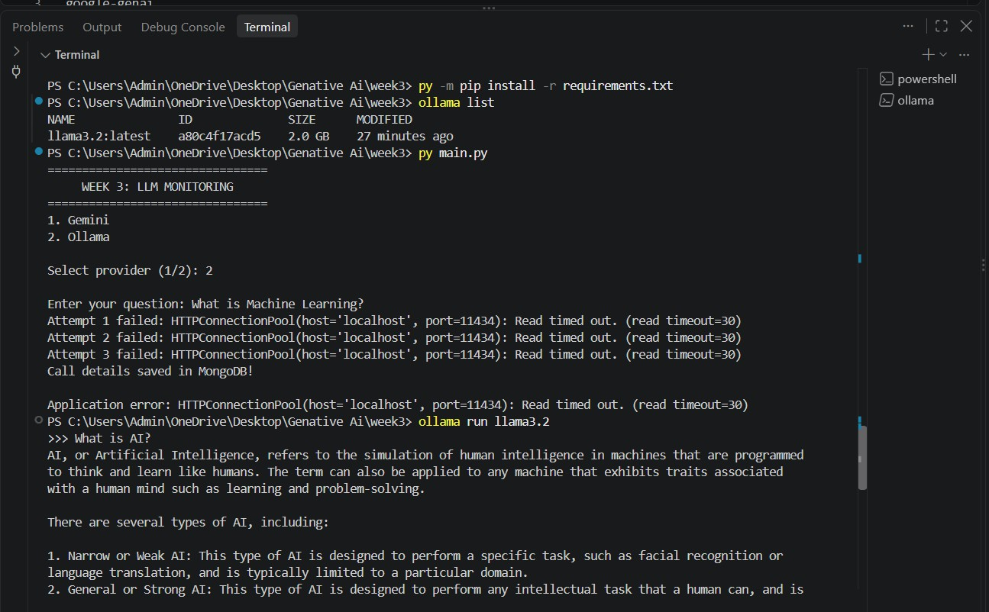
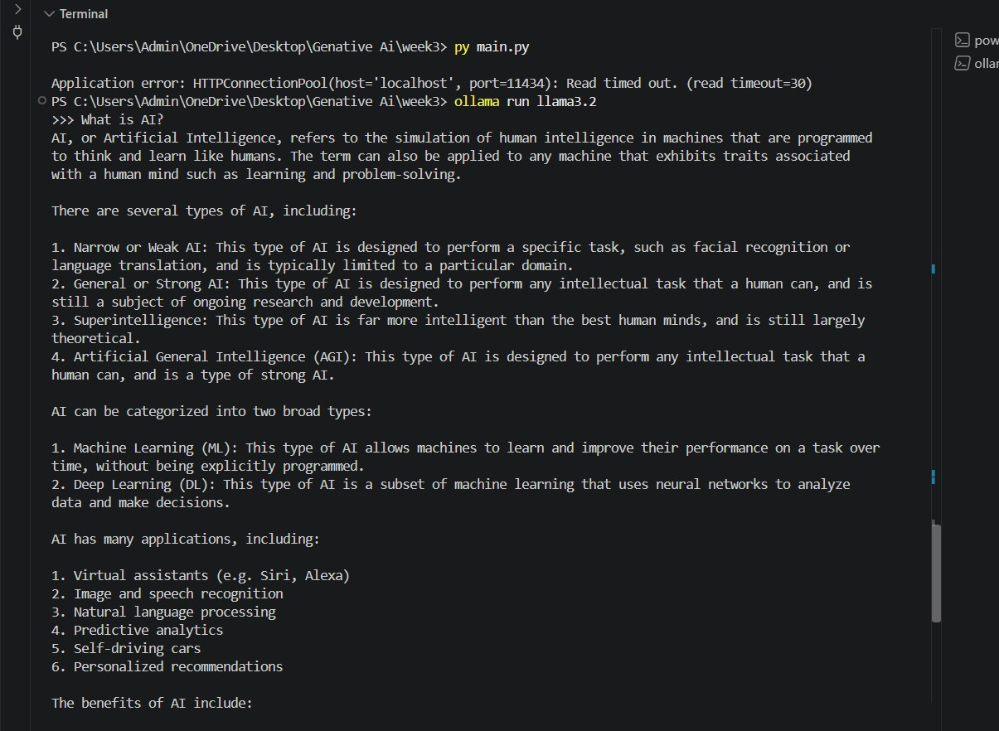

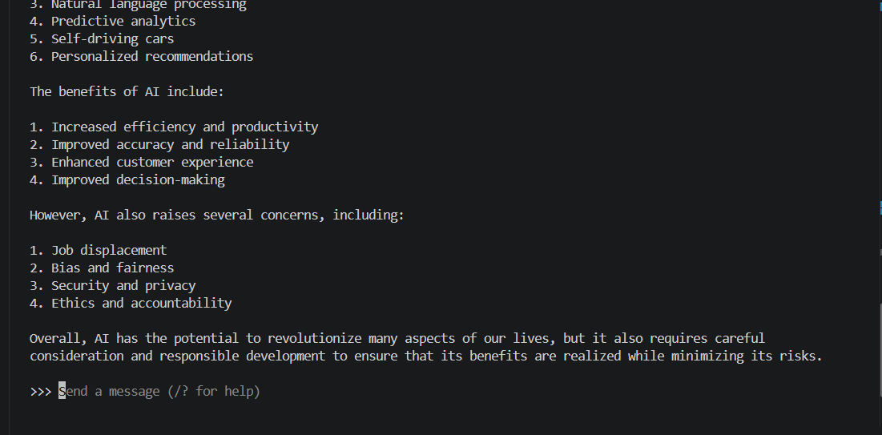
Step-14: Verify MongoDB Logs

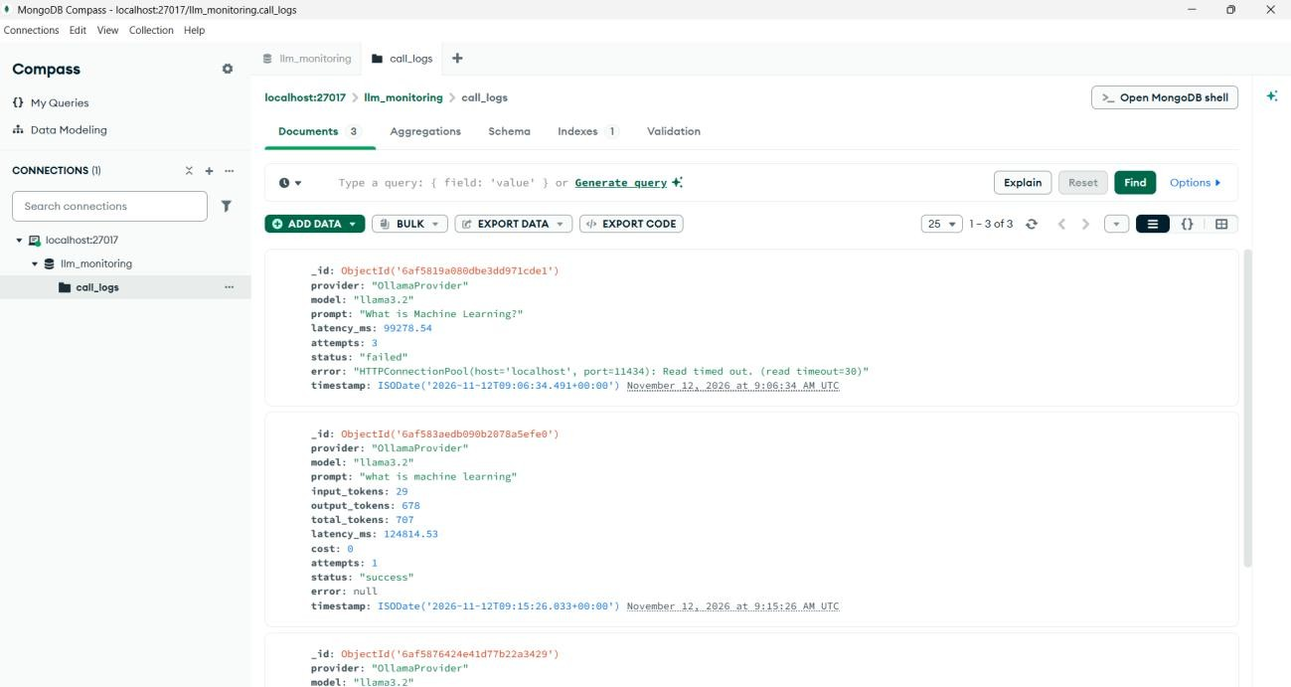
Step-15: Push Week 3 to GitHub
[successfully Week3 has uploaded in GitHub]

