WEEK 5 – Token Economics: Cost and Rate-Limit Budgeting

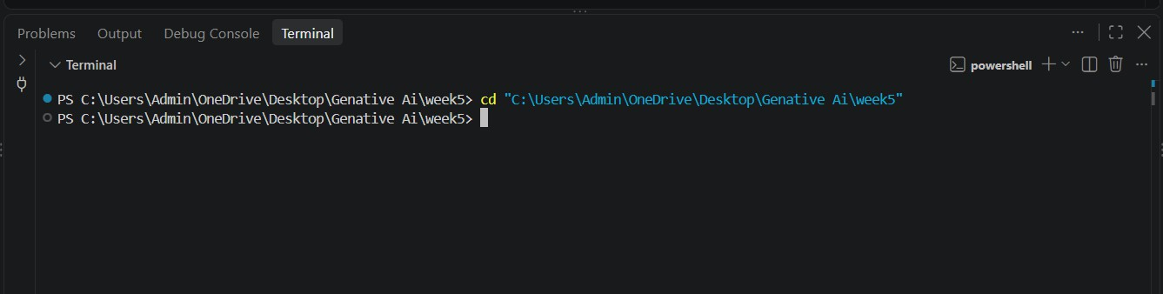
Step 1: Open the Week 5 project folder

Step 2: Activate the Virtual Environment.
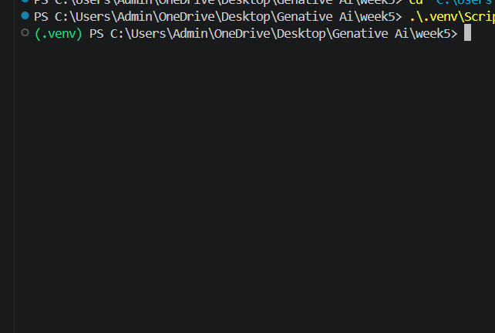

Step 3: Install Required Packages

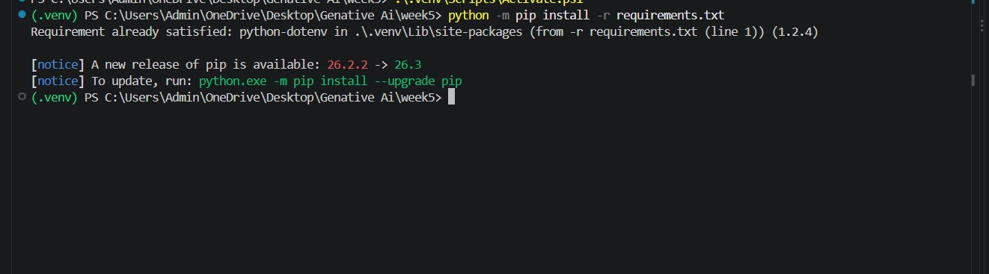

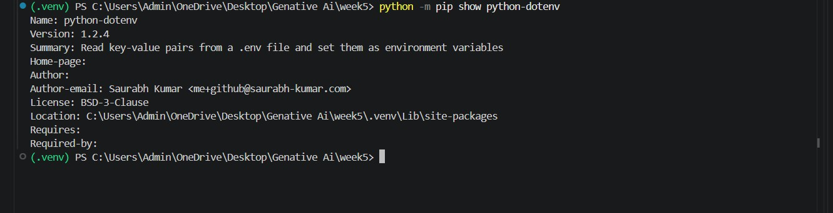
Step 4: Verify Package Installation

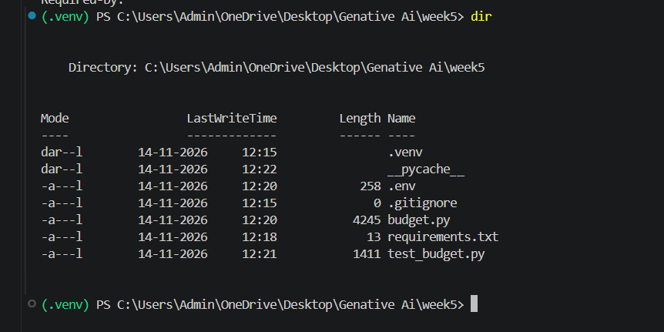
Step 5: Check Project Files

Step 6: Execute the Main Python Program

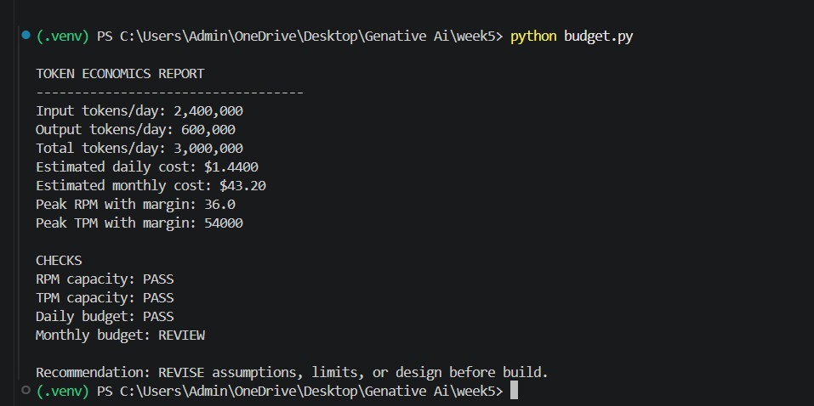

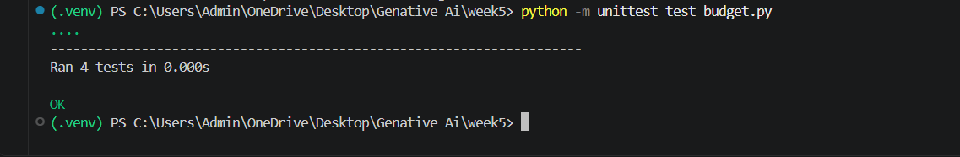
Step 8: Execute the Unit Test Program

Step 10: Display the Complete Project Structure

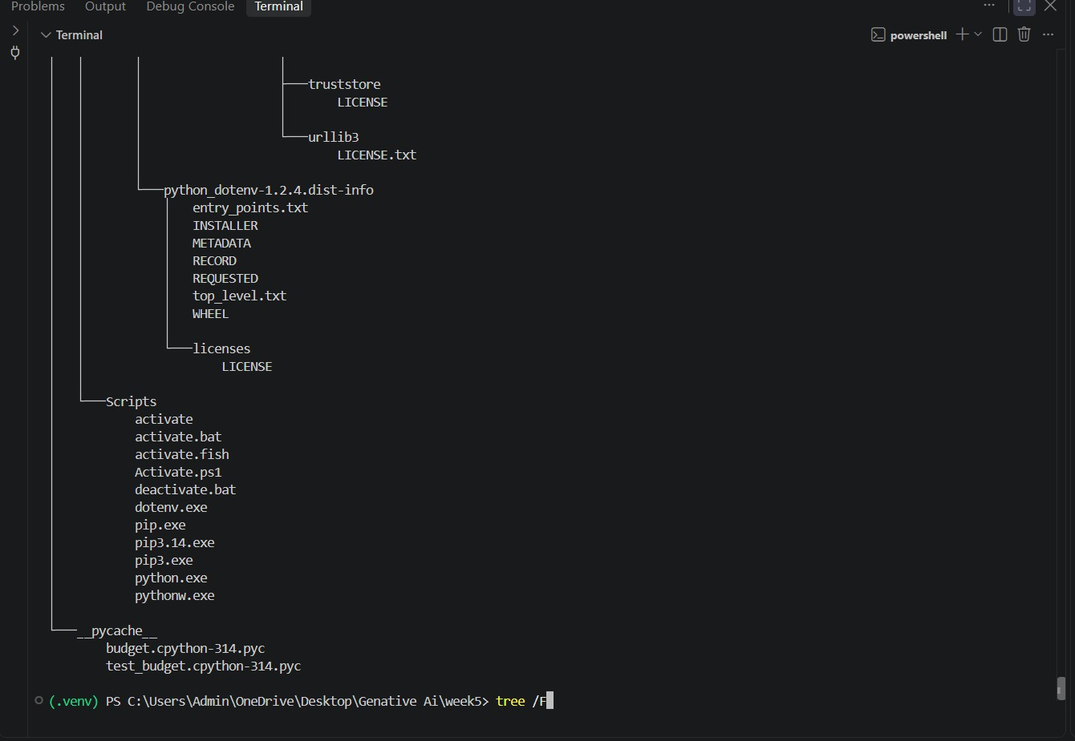

Step 11: Push into GitHub.
[ Successfully pushed into GitHub]

