## Overview

This project is implemented on,

- HTML, CSS, JS

- Bootstrap v5.2

For Bootstrap dashboard template may refer to

https://getbootstrap.com/docs/5.2/examples/dashboard/

You may modify the CSS to suits ur project needs.

Templates:

- Login Page (Done)

- Master Dashboard (Done)

- Domain Dashboard

- Order Management

## Login Page



Notes: This is for the user to login to the page.

## Master Dashboard

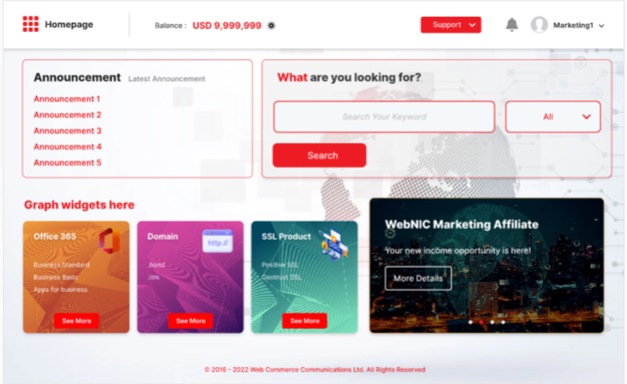

Notes: This is the first page that users see after login. This page will include all products in WebNIC.

## Domain Dashboard

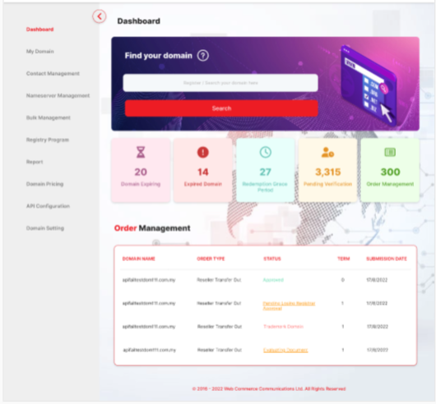

Notes: This is the domain dashboard, it allows users to query domain, view their domain status, manage their domains.

## Order Management

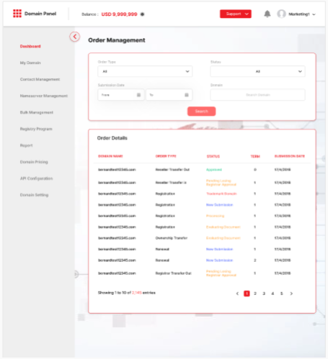

Notes: This is the order management page where user can manage all of their orders.