**PlayUAVOSD**

* **Introduction**

OSD （On-screen Display）is an image superimposed on a screen picture. When used by a model airplane, it enables the flight data to be superimposed on the camera video and passed to the receiver by video transmitter. The receiver can supervise the flight condition with the real-time image and data.

**Features：**

* Dual video inputs, front and rear cameras(real time switch via the remote control)
* Support multiple types of flight control, such as the mavlink protocol used by APM2.x and pixhawk, UAVTalk protocol used by CC3D and revolution (Beta version), as well as the CAN protocol of DJI (under development).
* A standard video signal will emerge to be superimposed upon the OSD information in case of failed video input caused by absence of camera or camera breakdown.
* Graphical interface makes the receiving of flight data easier and more intuitive and reduces brain computing.
* Firmware can be updated with the configuration tools while parameter setting can be done via USB directly.
* Data transmission is realized with the audio port and ground receiver(such as the tracking antenna). The transmission distance is much longer than radio(under development).
* **Size**

33mm*26mm

* **Hardware**

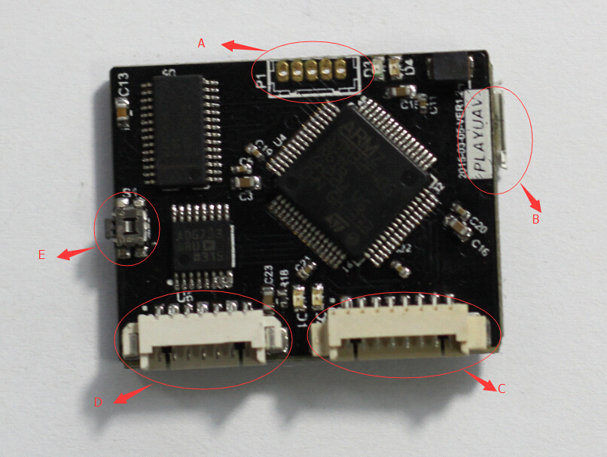

**A：SWD**

From right to left 1,2,3,4,5

|  |  |
| --- | --- |
| 1 | +3.3V |
| 2 | GND |
| 3 | SWDIO |
| 4 | SWCLK |
| 5 | NRST |

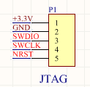

**B：micro-USB port**

For firmware upgrade and parameter setting.

**C：8 Pins**

From left to right1,2,3,4,5,6,7,8

|  |  |
| --- | --- |
| 1 | GND |
| 2 | CANH to CANH of FC |
| 3 | CANL to CANL of FC |
| 4 | Reserved |
| 5 | Reserved |
| 6 | TX to RX of FC |
| 7 | RX to TX of FC |
| 8 | +5V |

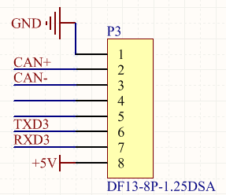

**D：7pins**

From left to right 1,2,3,4,5,6,7

|  |  |
| --- | --- |
| 1 | Video 2 signal input |
| 2 | Video 2 GND |
| 3 | Video 1 signal input |
| 4 | Video 1 GND |
| 5 | Video out signal with OSD |
| 6 | Video out GND |
| 7 | connected to the audio pin of video transmitter for data transmission |

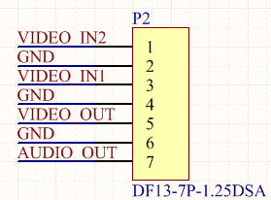

**E：Reset Switch**

* **Instruction**

**3-1）Wire**

Please refer to the above hardware instructions. The input is classified into video input and data input. Data transmission varies according to the types of flight controllers, specifically, some data is transmitted via serial port while others via CAN. Output can also be classified into video output and data output, both are connected to the video transmitter.

**3-2） Firmware Update**

3-2-1）We use the USB drive of pixhawk . If you have not installed the driver, please goto the website of pixhawk to get the laste driver. If the driver has been installed correctly, you will find the descriptions as quoted below in the Device Manager.

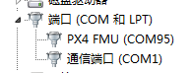

Open the configuration tool, choose your port and click “Firmware Update” to install or update the firmware. The latest version will be downloaded and installed automatically. If you are already using the latest version, the program will verify it anyway.

**3-3）Parameter Setting**

When open the configuration tool, you will see the default parameters instead of the parameters saved on the OSD board.

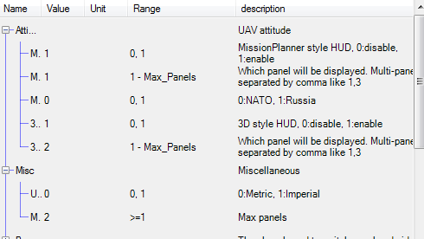

The configuration tool has a HUD to simulate the screen display. It means you need not plug your OSD board to FC and screen. You can write the parameters to OSD board until you get a favorite HUB.(NOTE THAT-it is just a simulation. There will be slight different from the actually screen)

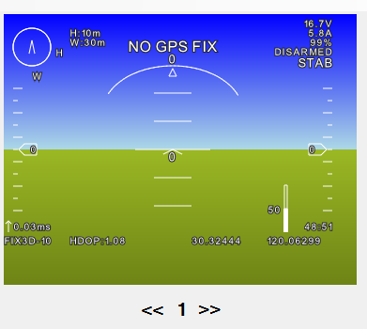

You can choose to display or not to display the parameters, the specific display position and page, font size, and the alignment. Please refer to the instruction below for particular use.

On the right side of the page, you will find some buttons. Below is the use of each button.

* **Parameter Reading-**Read the parameters saved on the board. Generally before configuration, you should read the parameters and then modify as per your need.
* **Save in Memory ---** Usually parameters setting cannot be done in one step, especially the adjustment of display position. When you finish, click this button to have your setting saved in the memory of the board. Connect to the screen and you will see the settings work**.**
* Save in EEPROM --- To click this button, the parameters will be written in the flash of OSD board. The use of this function will wipe chip flash. Frequent use is not recommended. Modify your parameters and save them in the memory repeatedly until you are satisfied. Then click the “Save in EEPROM” button.

Instruction on particular items on the menu

**File-Save Parameter File**:

To save the parameters displayed on the current interface into a file.

**File-Load Parameter File**:

Read parameters from saved parameter files.

**Option-Language**:

Choose the interface language.

**Instruction of Parameters**

General parameter attributes include: display or not, display panel, display position, font size and alignment.

**Flying attitude**

There are two ways to demonstrate the flying attitude of the aircraft(yaw, roll, and pitch). One is similar to Mission Planner. The other is 3D. Currently the 3D mode needs further improvement. Choose the one you like. Or you can start both but put them in different pages.

**Miscellaneous –Unit**： You can choose Metric unit or Imperial unit.

Metric Unit：

|  |  |
| --- | --- |
| Speed | m/s |
| Height | Metre |
| Distance | Metre |

Imperial Unit：

|  |  |
| --- | --- |
| Speed | foot per second |
| Height | Foot |
| Distance | Foot |

**Miscellaneous** - Maximum page number: Page switch is realized through cyclical pattern. When specify page for information display, do not input a number larger than the maximum number, or it cannot be displayed.

**PWM:** Dual video switch and display page switch are both realized with the remote control channels through cyclical pattern. If you do not have the dual video, or you do not want to have multi-page display, disable relevant functions. **Channel** is to set which channel of the RC should be used for switch. **Channel Value** is a value that when the channel input is larger than it, the switch function will be triggered. The default value of 1200 is applicable for most RCs. You can have the value tested on ground by connecting the OSD, the flight controller(battery power recommended) and the screen.

**Height&Speed:** There are two ways to display height and speed, one is the scroll bar, and the other is digit. Configure according to your preferences. The **height** here is not the elevation value, but height from Home. The **speed** refers to the ground velocity.

Orientation, Home Direction, Waypoint Direction: We display the three directions together in two ways, one is the track bar, and the other is the map-like way, with north on the top. Configure according to your preferences.

Scale Bar

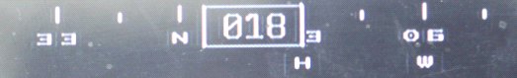

In the above diagram, the aircraft is flying at northeast 1 degree. The home(H) is at northeast 30 degrees. The next waypoint(W) is at northeast 60 degrees.

Map-like Orientation:

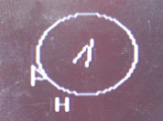

This method can only display the general direction. There is no precise number. From the above diagram we can see that the aircraft is flying toward northeast and the home(H) is located at its south by southwest. The next waypoint(flag) is at its west by southwest.