1



2

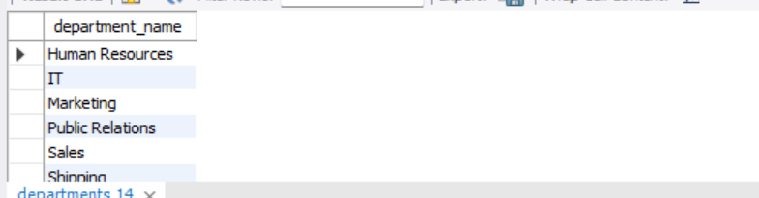



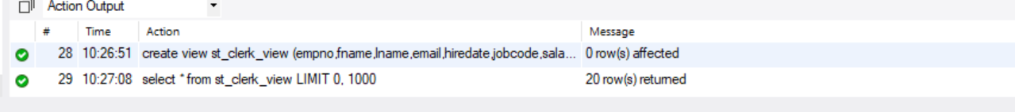

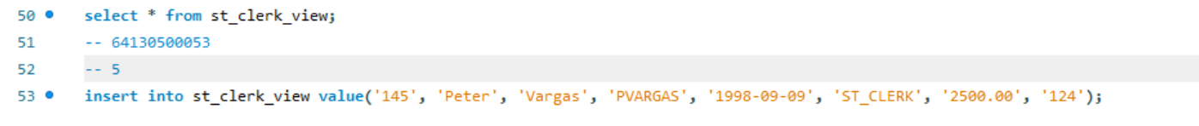



เป็น Non-updatabal

7 



- The NOT NULL columns of the “st_clerk_121_122_view” table