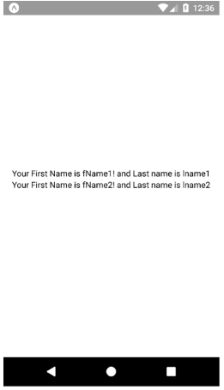

import React, { Component } from 'react';

import { Text, View } from 'react-native';

// We are making our custom component to make use of it everywhere we want

class MyCustomTextWith extends Component {

render() {

return (

<View>

<Text>

Your First Name is {this.props.firstname}! and Last name is{' '}

{this.props.secondname}

</Text>

</View>

);

}

}

export default class App extends Component {

render() {

return (

<View style={{ justifyContent: 'center', alignItems: 'center', flex: 1 }}>

{/\*Use of our custom component MyCustomTextWith\*/}

<MyCustomTextWith firstname="fName1" secondname="lname1" />

{/\*We are setting the props dynamically from the main UI where we want to use it. We candynamically set the value using props from master every time\*/}

<MyCustomTextWith firstname="fName2" secondname="lname2" />

</View>

);

}

}