**React Native Safe Area**

In this post, you will see the React Native SafeAreaView for [Safe Area Boundaries](https://medium.com/rosberryapps/ios-safe-area-ca10e919526f). According to the definition, a SafeAreaView renders nested content and automatically applies paddings to reflect the portion of the view that is not covered by navigation bars, tab bars, toolbars, and other ancestor views.

https://aboutreact.com/react-native-safeareaview/

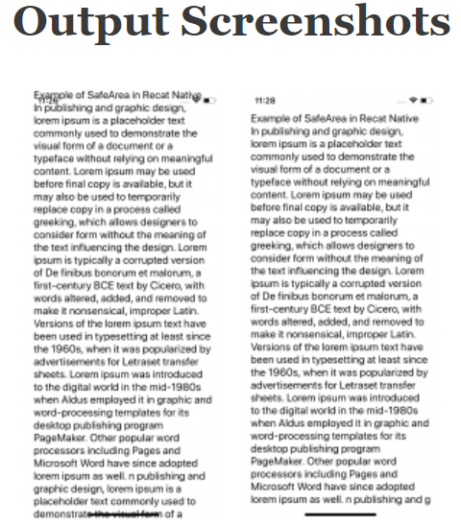

import React from 'react';

import { Text, View, SafeAreaView } from 'react-native';

export default function App() {

return (

<SafeAreaView style={{ flex: 1 }}>

<View style={{ flex: 1, paddingHorizontal: 20 }}>

<Text style={{ fontSize: 20 }}>

Example of SafeArea in Recat Native

</Text>

<Text style={{ fontSize: 20 }}>

In publishing and graphic design, lorem ipsum is a placeholder text

commonly used to demonstrate the visual form of a document or a

typeface without relying on meaningful content. Lorem ipsum may be

used before final copy is available, but it may also be used to

temporarily replace copy in a process called greeking, which allows

designers to consider form without the meaning of the text influencing

the design. Lorem ipsum is typically a corrupted version of De finibus

bonorum et malorum, a first-century BCE text by Cicero, with words

altered, added, and removed to make it nonsensical, improper Latin.

Versions of the lorem ipsum text have been used in typesetting at

least since the 1960s, when it was popularized by advertisements for

Letraset transfer sheets. Lorem ipsum was introduced to the digital

world in the mid-1980s when Aldus employed it in graphic and

word-processing templates for its desktop publishing program

PageMaker. Other popular word processors including Pages and Microsoft

Word have since adopted lorem ipsum as well. n publishing and graphic

design, lorem ipsum is a placeholder text commonly used to demonstrate

the visual form of a document or a typeface without relying on

meaningful content. Lorem ipsum may be used before final copy is

available, but it may also be used to temporarily replace copy in a

process called greeking, which allows designers to consider form

without the meaning of the text influencing the design. Lorem ipsum is

typically a corrupted version of De finibus bonorum et malorum, a

first-century BCE text by Cicero, with words altered, added, and

removed to make it nonsensical, improper Latin. Versions of the lorem

ipsum text have been used in typesetting at least since the 1960s,

when it was popularized by advertisements for Letraset transfer

sheets. Lorem ipsum was introduced to the digital world in the

mid-1980s when Aldus employed it in graphic and word-processing

templates for its desktop publishing program PageMaker. Other popular

word processors including Pages and Microsoft Word have since adopted

lorem ipsum as well.

</Text>

</View>

</SafeAreaView>

);

}

I can not be sure about the Android Emulator or iOS simulator as they can show it differently but yeah when you test the app on the real devices then you will see most of the devices will have no problem other than the notch devices like iOS 11. So for that either we can give the top padding of can use SafeAreaView which will do all these things for us. SafeAreaView will create a proper space and save the content overriding from the safe area.