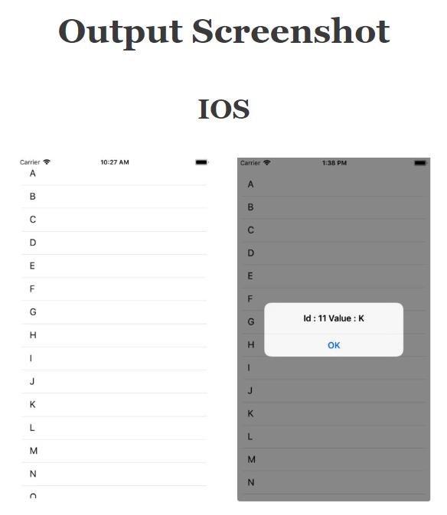

//This is an example code for FlatList//

import React from 'react';

//import react in our code.

import { StyleSheet, FlatList, Text, View, Alert } from 'react-native';

//import all the components we are going to use.

export default class App extends React.Component {

constructor(props) {

super(props);

this.state = {

FlatListItems: [

{ id: '1', value: 'A' },

{ id: '2', value: 'B' },

{ id: '3', value: 'C' },

{ id: '4', value: 'D' },

{ id: '5', value: 'E' },

{ id: '6', value: 'F' },

{ id: '7', value: 'G' },

{ id: '8', value: 'H' },

{ id: '9', value: 'I' },

{ id: '10', value: 'J' },

{ id: '11', value: 'K' },

{ id: '12', value: 'L' },

{ id: '13', value: 'M' },

{ id: '14', value: 'N' },

{ id: '15', value: 'O' },

{ id: '16', value: 'P' },

{ id: '17', value: 'Q' },

{ id: '18', value: 'R' },

{ id: '19', value: 'S' },

{ id: '20', value: 'T' },

{ id: '21', value: 'U' },

{ id: '22', value: 'V' },

{ id: '23', value: 'W' },

{ id: '24', value: 'X' },

{ id: '25', value: 'Y' },

{ id: '26', value: 'Z' },

],

};

}

FlatListItemSeparator = () => {

return (

//Item Separator

<View

style={{ height: 0.5, width: '100%', backgroundColor: '#C8C8C8' }}

/>

);

};

GetItem(item) {

//Function for click on an item

Alert.alert(item);

}

render() {

return (

<View style={styles.MainContainer}>

<FlatList

data={this.state.FlatListItems}

//data defined in constructor

ItemSeparatorComponent={this.FlatListItemSeparator}

//Item Separator View

renderItem={({ item }) => (

// Single Comes here which will be repeatative for the FlatListItems

<View>

<Text

style={styles.item}

onPress={this.GetItem.bind(

this,

'Id : ' + item.id + ' Value : ' + item.value

)}>

{item.value}

</Text>

</View>

)}

/>

</View>

);

}

}

const styles = StyleSheet.create({

MainContainer: {

justifyContent: 'center',

flex: 1,

marginLeft: 10,

marginRight: 10,

marginBottom: 10,

marginTop: 30,

},

item: {

padding: 10,

fontSize: 18,

height: 44,

},

});