**Touchables**

In this post, you will see **4 Different Type of React Native ‘Touchable’.** React Native Touchable is a component to overcome the limitation of the styling of the button component. There are four types of Touchables. Which are

|  |  |  |
| --- | --- | --- |
| **S. No.** | **Touchable** | **Available For** |
| 1. | TouchableNativeFeedback | Only For Android |
| 2. | TouchableHighlight | For Android/IOS Both |
| 3. | TouchableOpacity | For Android/IOS Both |
| 4. | TouchableWithoutFeedback | For Android/IOS Both |

**1. TouchableNativeFeedback**

A wrapper for making views respond properly to touches (Android only). On Android, this component uses native state drawable to display touch feedback.

### 2. TouchableHighlight

A wrapper for making views respond properly to touches. On key down, the opacity of the wrapped view is decreased, which allows the underlying color to show through, darkening or tinting the view.

### 3. TouchableOpacity

A wrapper for making views respond properly to touches. On key down, the opacity of the wrapped view is decreased, dimming it.

### 4. TouchableWithoutFeedback

Don’t use unless you have a very good reason. All elements that respond to press should have visual feedback when touched but it doesn’t have any.

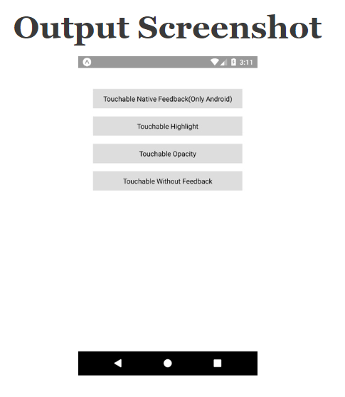

//This is an example code to understand Touchable//

import React, { Component } from 'react';

//import react in our code.

import {

TouchableNativeFeedback,

TouchableHighlight,

TouchableOpacity,

TouchableWithoutFeedback,

View,

Text,

StyleSheet,

} from 'react-native';

//import all the components we are going to use.

export default class App extends Component {

onPress() {

//Do what you want

}

render() {

return (

<View style={styles.container}>

{/*Only for android If you trieng to run in IOS please remove TouchableNativeFeedback section*/}

<TouchableNativeFeedback

onPress={this.onPress}

background={TouchableNativeFeedback.SelectableBackground()}>

<View style={styles.button}>

<Text>Touchable Native Feedback(Only Android)</Text>

</View>

</TouchableNativeFeedback>

<TouchableHighlight style={styles.button} onPress={this.onPress}>

<Text>Touchable Highlight</Text>

</TouchableHighlight>

<TouchableOpacity style={styles.button} onPress={this.onPress}>

<Text>Touchable Opacity</Text>

</TouchableOpacity>

<TouchableWithoutFeedback style={styles.button} onPress={this.onPress}>

<View style={styles.button}>

<Text>Touchable Without Feedback</Text>

</View>

</TouchableWithoutFeedback>

</View>

);

}

}

const styles = StyleSheet.create({

container: {

flex: 1,

alignItems: 'center',

marginTop: 50,

},

button: {

alignItems: 'center',

backgroundColor: '#DDDDDD',

padding: 10,

width: 300,

marginTop: 16,

},

});