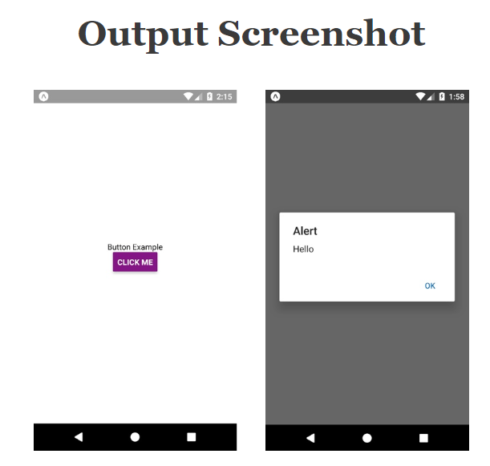

//This is an example code to understand Button//

import React from 'react';

//import react in our code.

import { Button, View, StyleSheet, Text } from 'react-native';

//import all the components we are going to use.

export default class App extends React.Component {

onPressLearnMore() {

//For generating alert on buttton click

alert('Hello');

}

render() {

return (

// enclose all components in this View tag

<View style={styles.container}>

{/\* View is used here to wrap all component in one \*/}

<Text>Button Example</Text>

{/\* Button whith handler function named onPressLearnMore\*/}

<Button

onPress={this.onPressLearnMore}

title="Click Me"

color="#841584"

/>

</View>

);

}

}

const styles = StyleSheet.create({

container: {

flex: 1,

alignItems: 'center',

justifyContent: 'center',

},

});