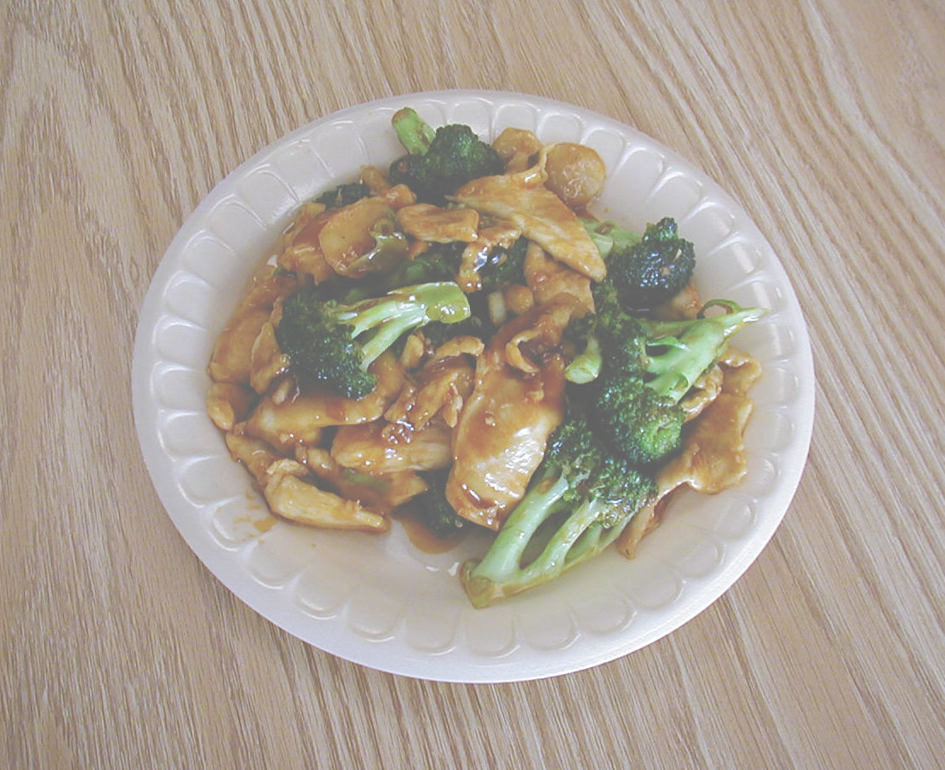
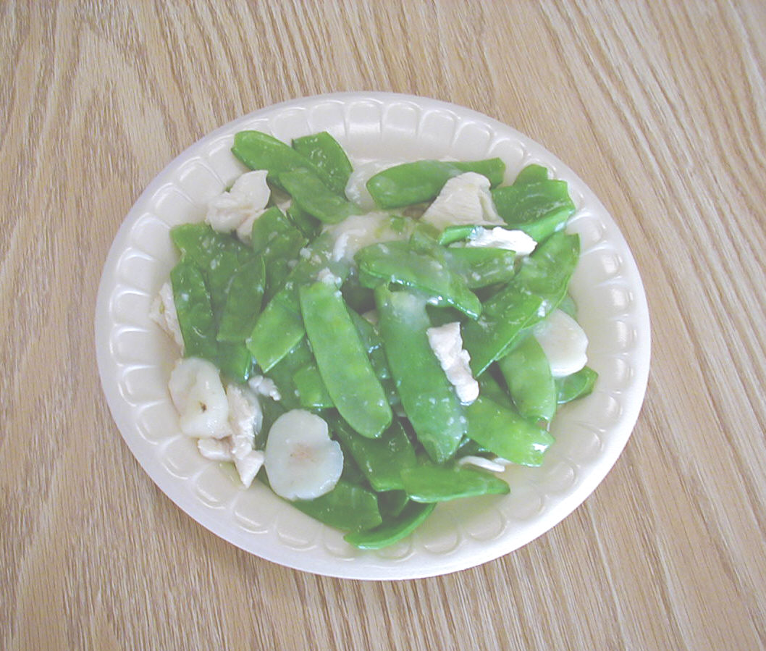
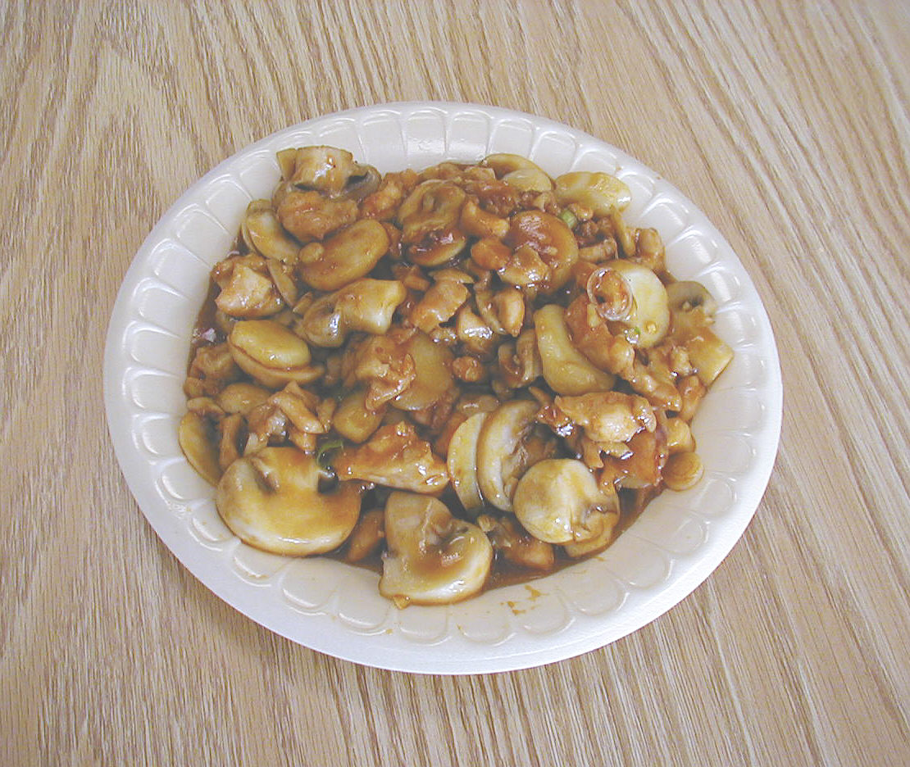
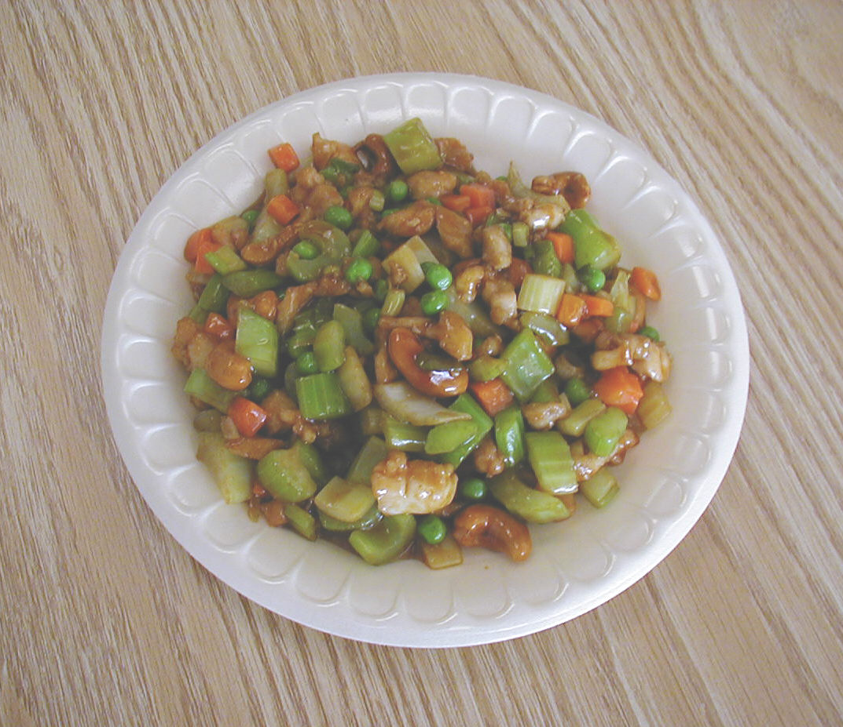
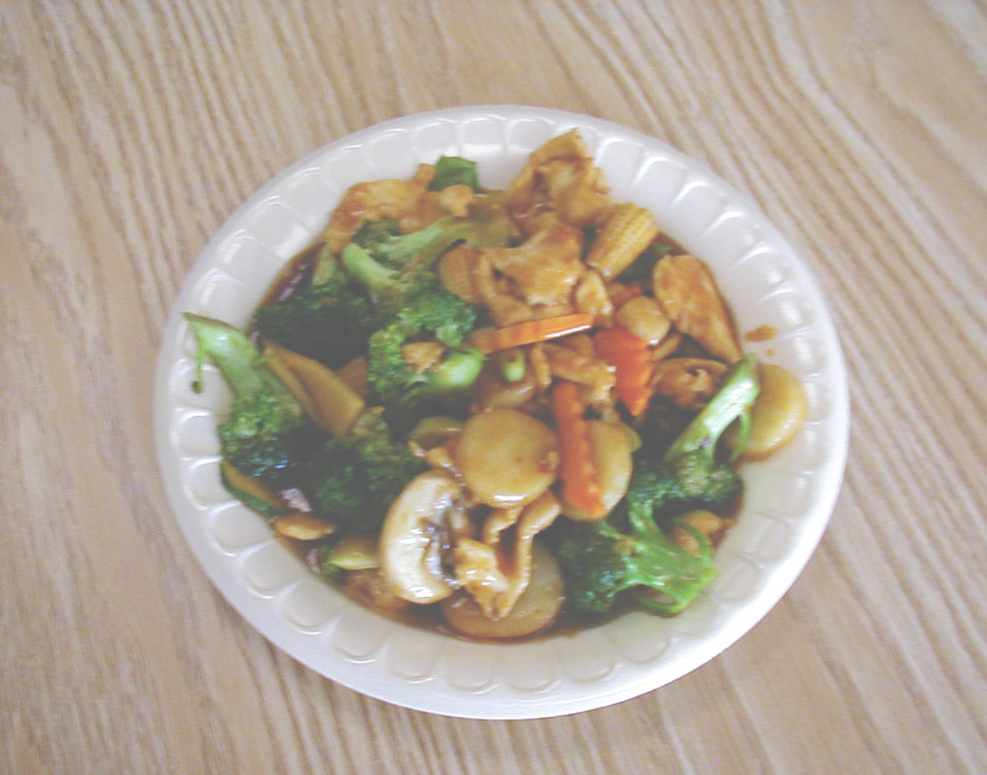
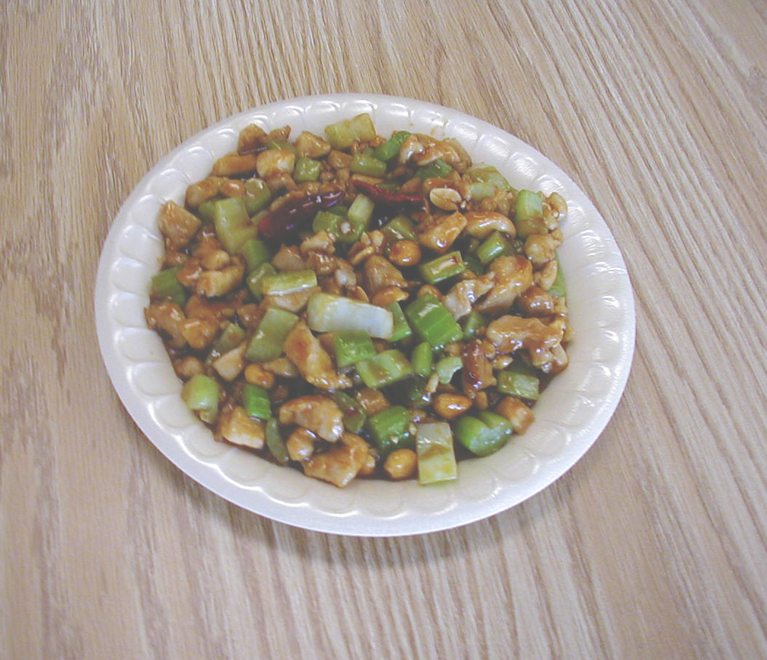
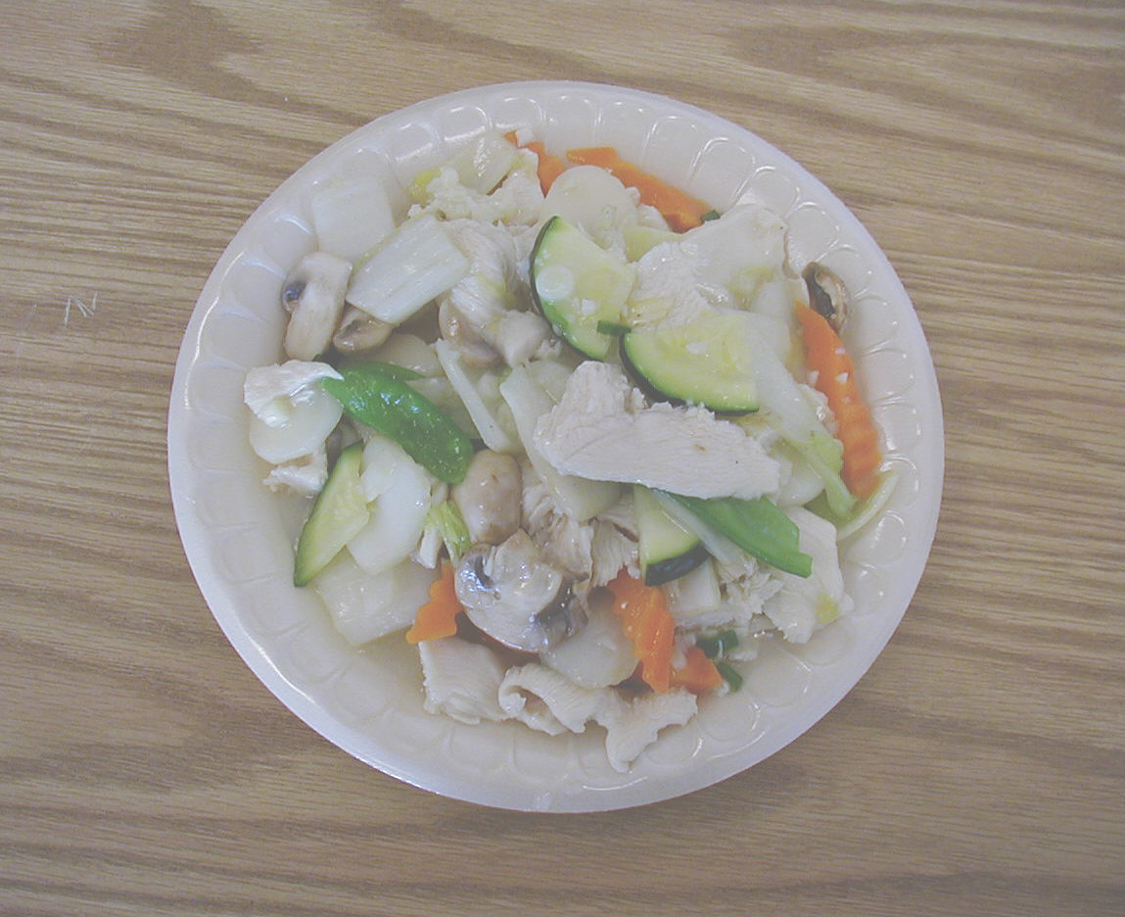
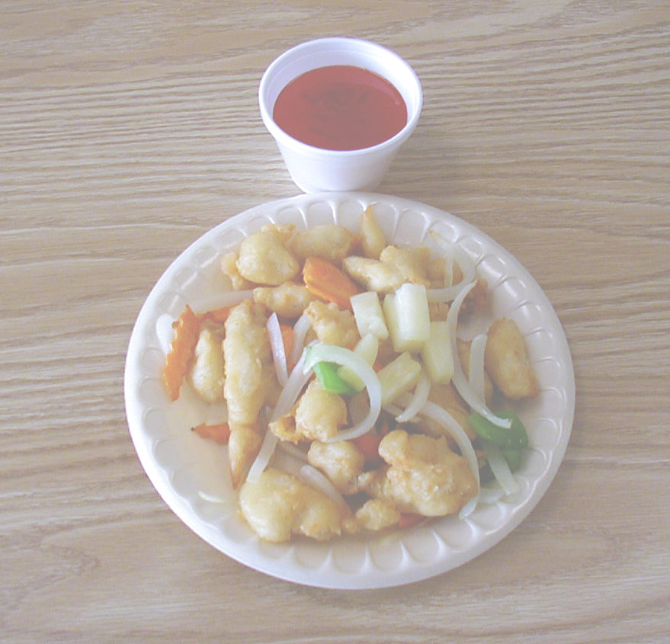
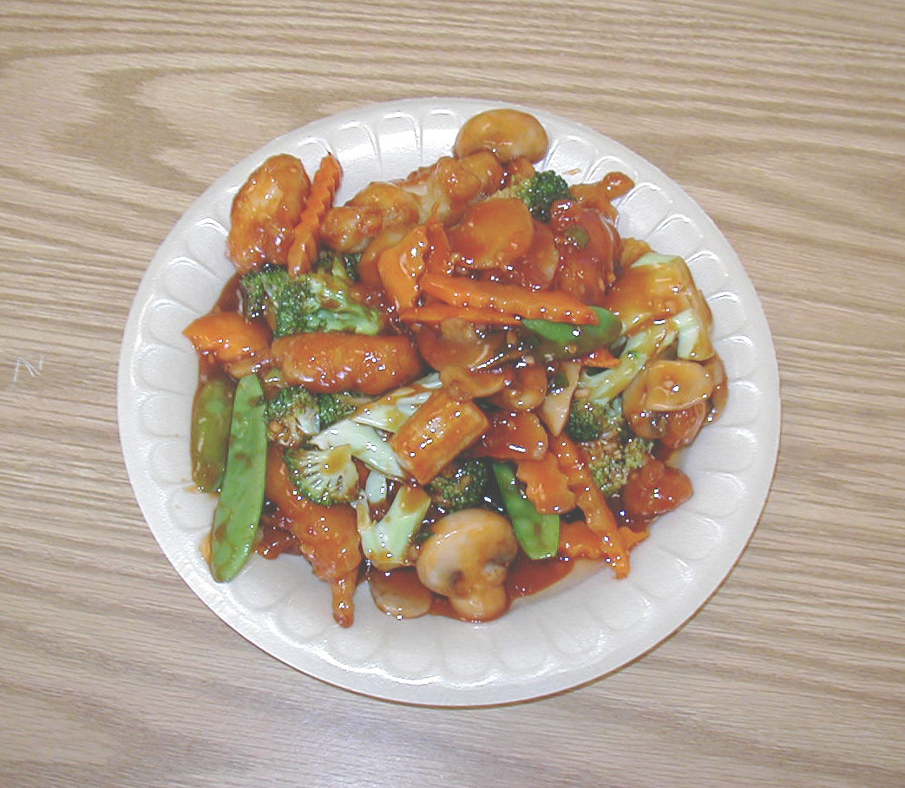
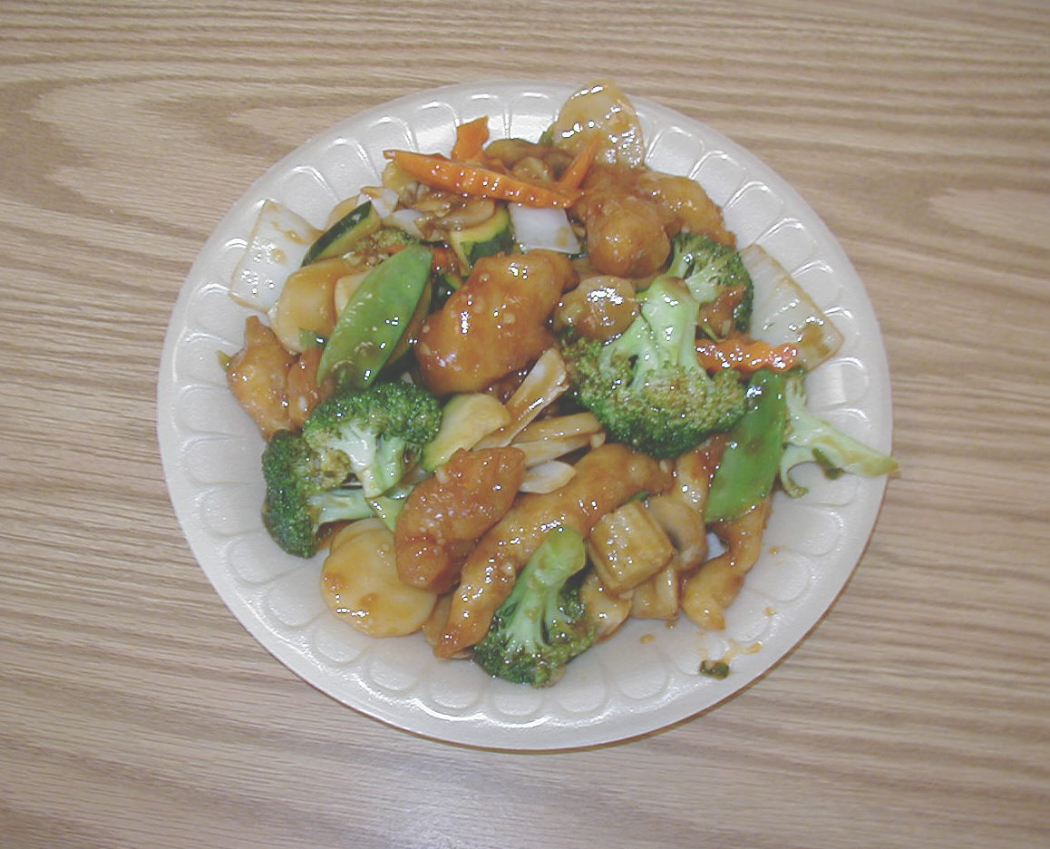
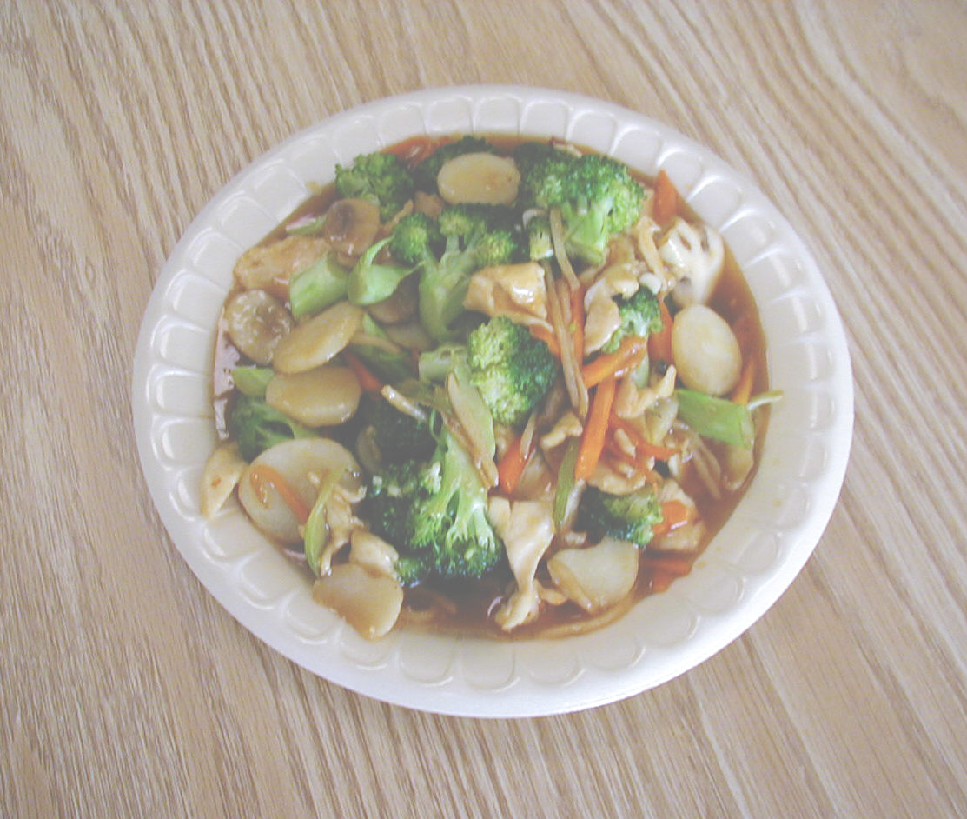
11. CHICKEN WITH BROCCOLI
12. CHICKEN WITH SNOW PEAS
13. CHICKEN WITH MUSHROOMS
14. CHICKEN WITH CASHEW NUTS
15. KON BO CHICKEN
16 HUNAN CHICKEN
17 SWEET & SOUR CHICKEN
10. MOO GOO GAI PAN
16. HUNAN CHICKEN
17. SWEET & SOUR CHICKEN
18. EMPRESS CHICKEN
19. BONELESS CHICKEN
20. YU-SHANG CHICKEN

