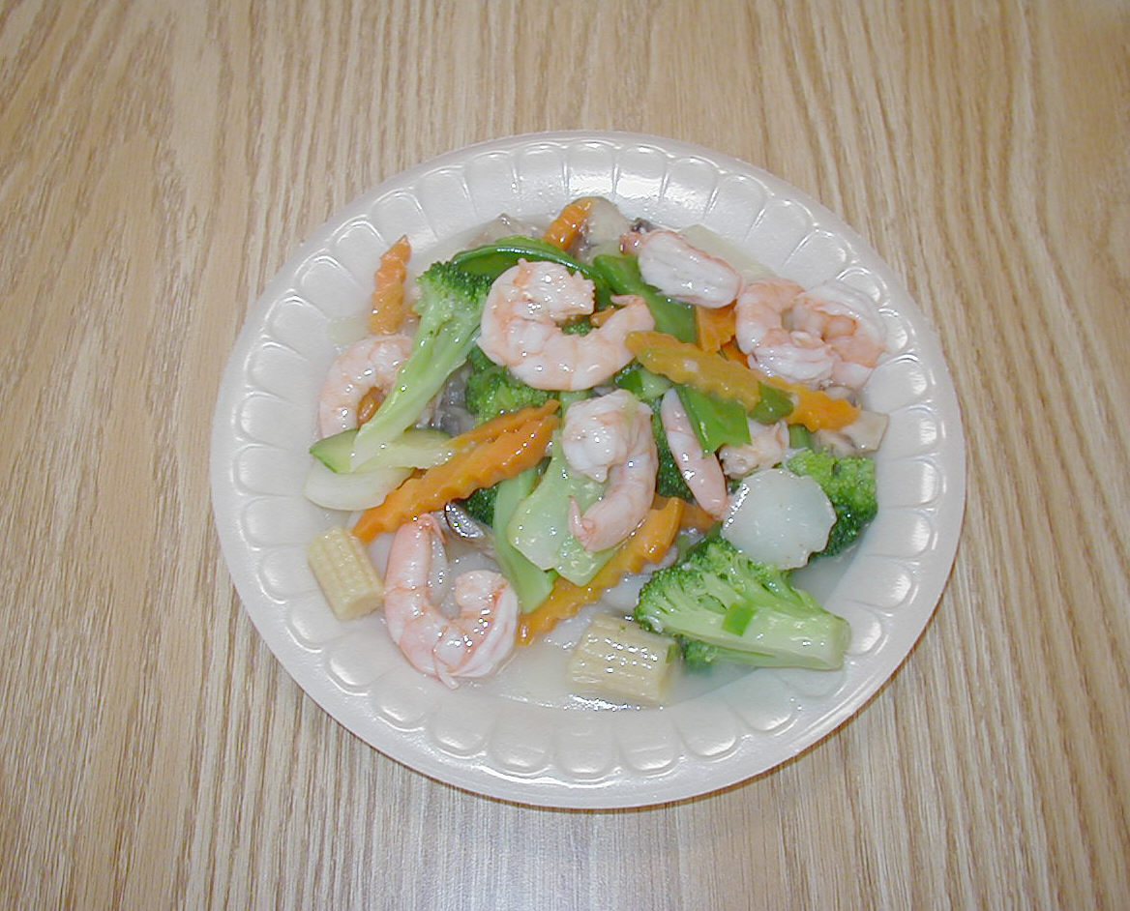
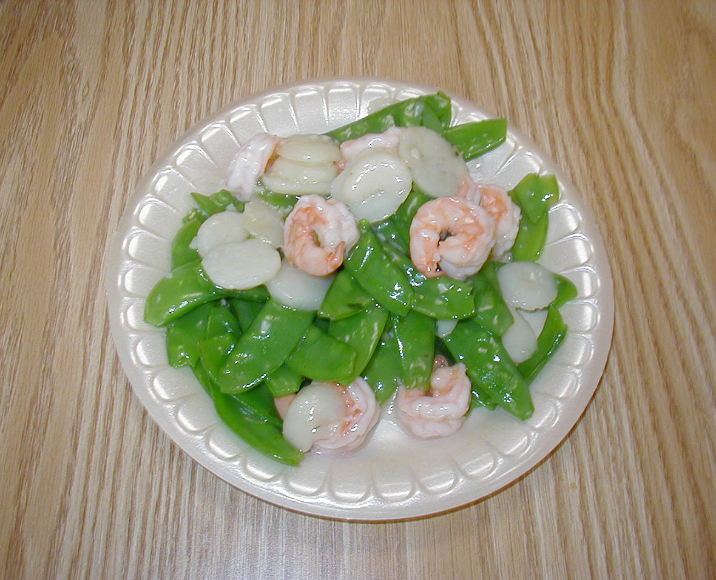
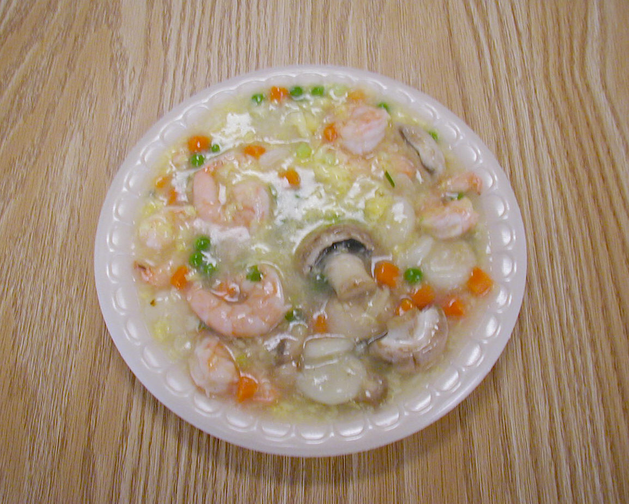
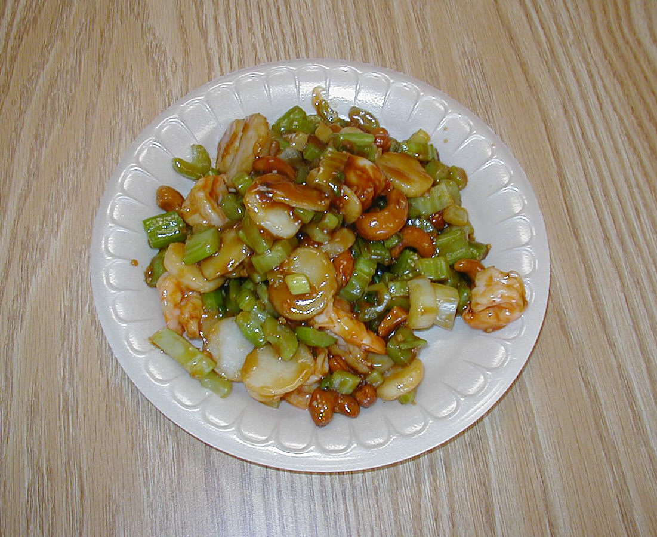
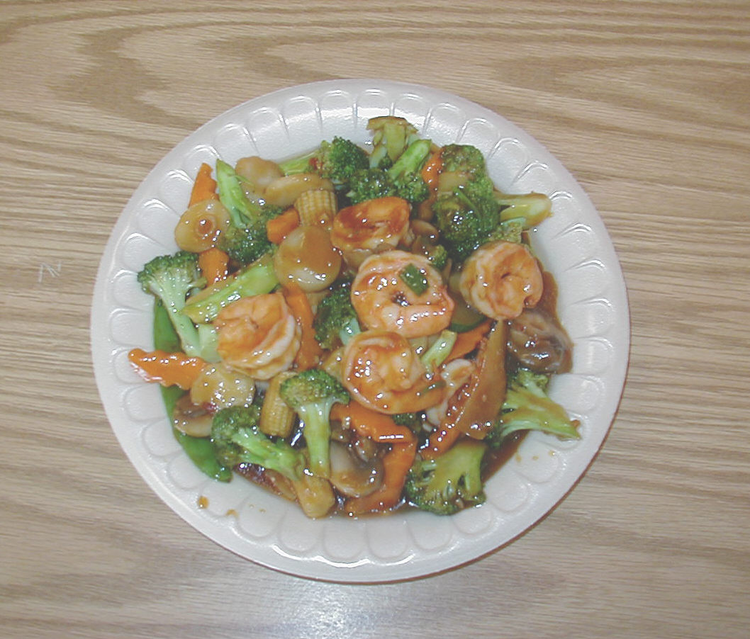
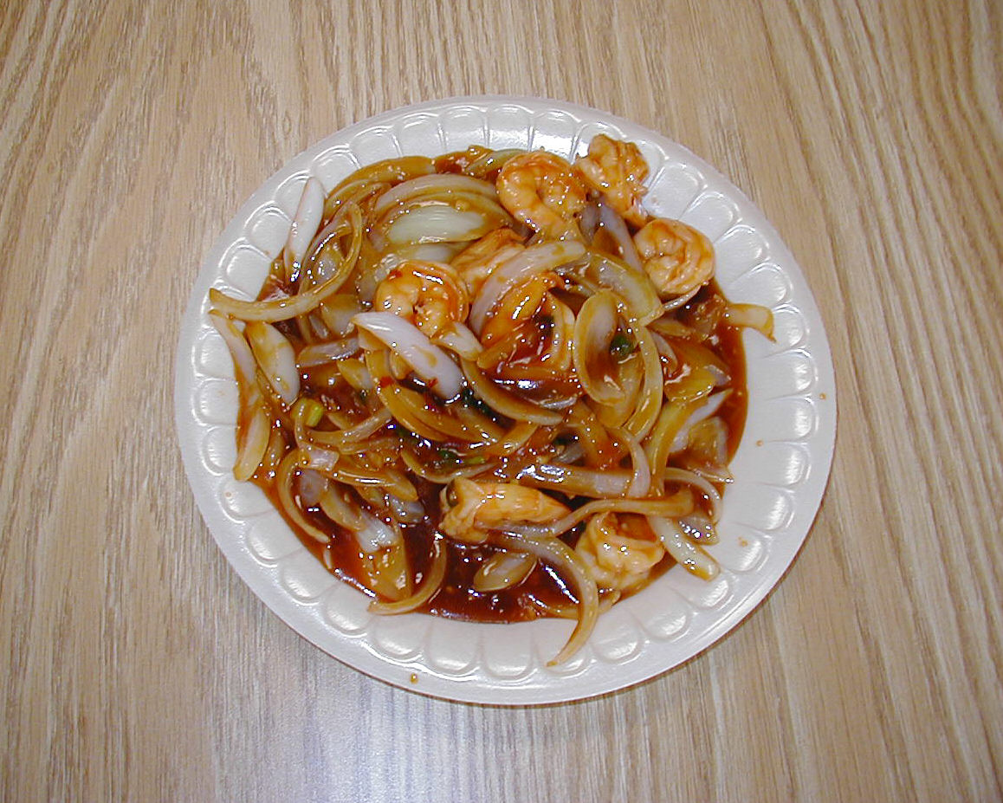
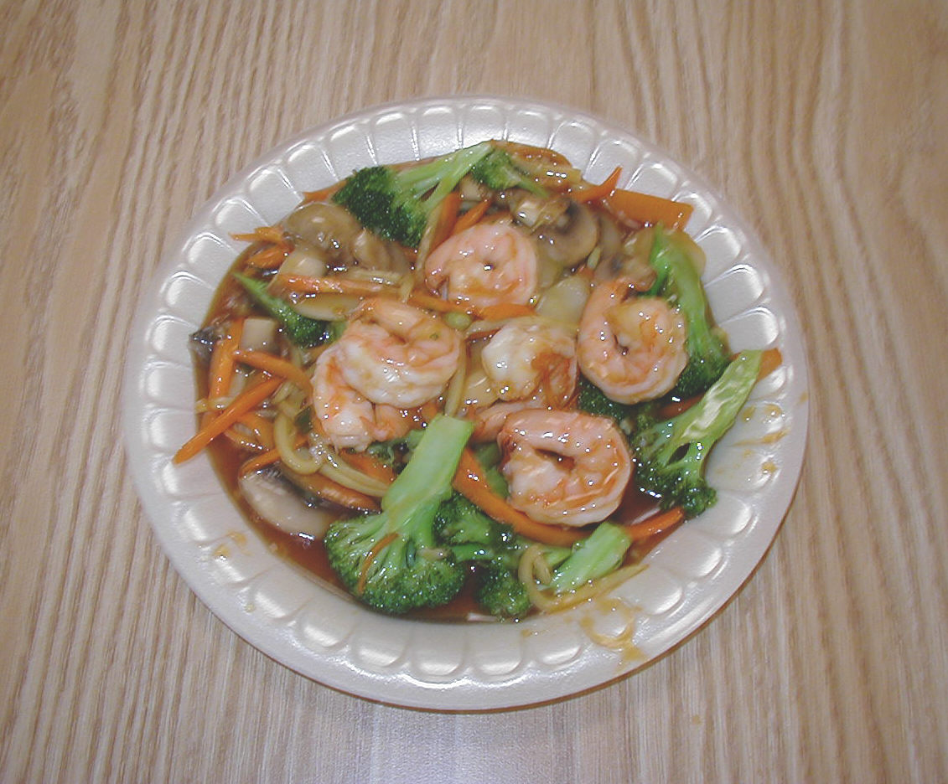
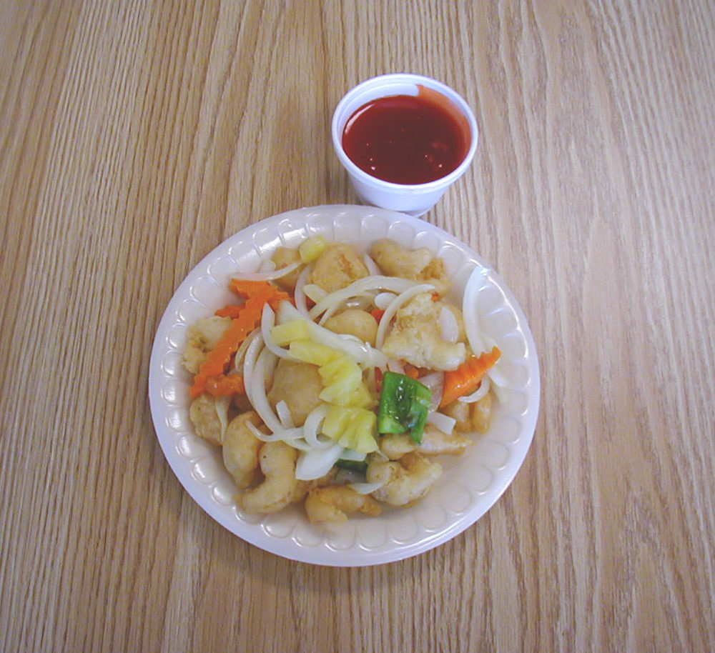
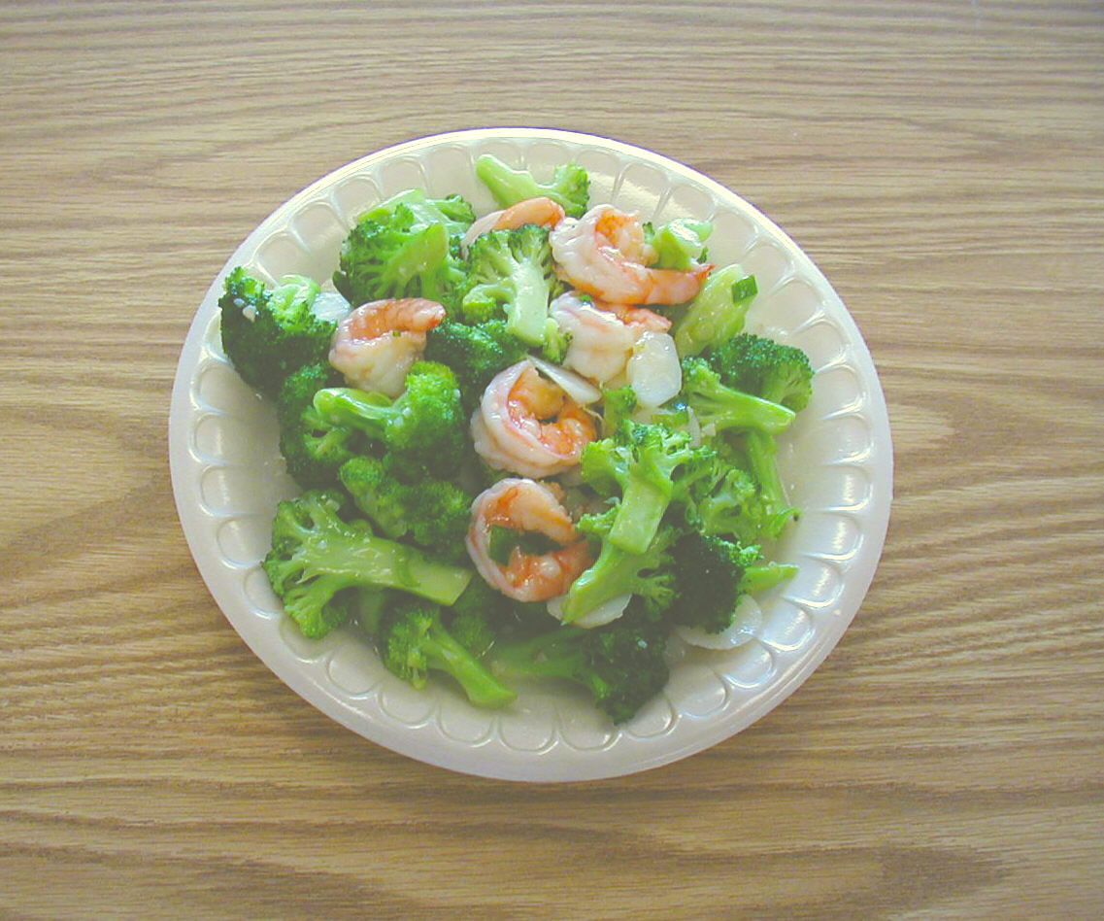
22. SHRIMP WITH MIXED VEGETABLES
23. SHRIMP WITH SNOW PEAS
21. SHRIMP WITH BROCCOLI
24. SHRIMP IN LOBSTER SAUCE
25. SHRIMP WITH CASHEW NUTS
26. HUNAN SHRIMP
27. SHRIMP WITH CHILI SAUCE
28. YU-SHANG SHRIMP
29. SWEET & SOUR SHRIMP

